A picture containing indoor, person, computer, desk

Description generated with very high confidence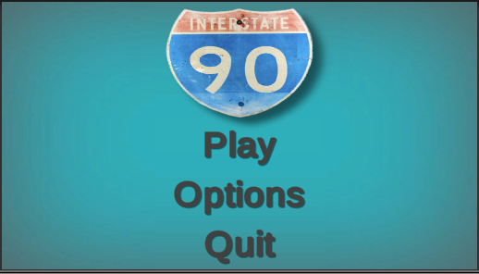I-90

By PEP

How to play

The goal of the game is to get to level 6 and defeat the boss

Choose level by point and click with mouse

The levels get harder as you go up in value you may need to repeat some levels to get stronger gear

Move the character by WASD or Up, Down, Left, Right

Attack left click on mouse

Open Inventory I Key