Currently, the design of this app is fairly simple. This is just the framework for the work that will be coming up in the next couple weeks.

Immediately upon opening the app, you will be brought to the Home page, where the Action Bar title says Home, the screen says Home, and the Home icon and navigation label are highlighted in the navigation bar.

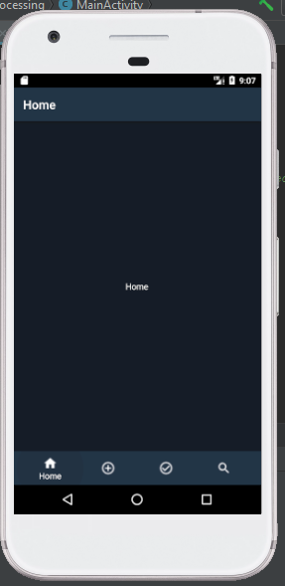

If you tap on the + icon, you will be brought to the Process a Package page. The title and screen text will change accordingly, and the icon and label on the navigation bar will be highlighted.

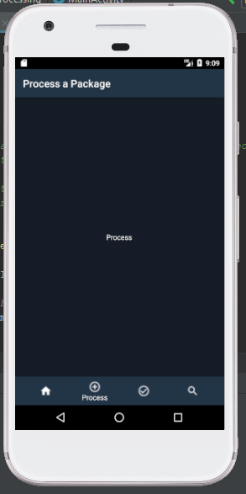

The same is true if you tap the check icon, which will bring you to the Checkout a Package screen, and if you tap the magnifying glass icon, which will bring you to the Search screen. The text of the Action Bar title and screen text will change accordingly.

