For this week, we will take a look at the Process tab of this app.

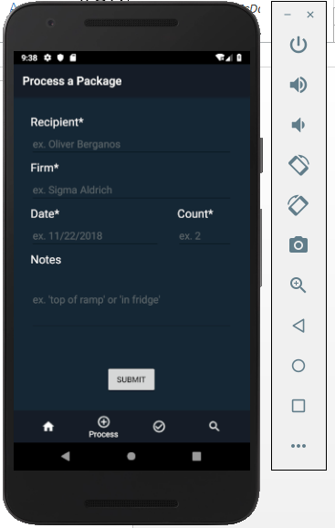

If you click the submit button, you will get a notification that the form was not submitted because some required fields are empty.

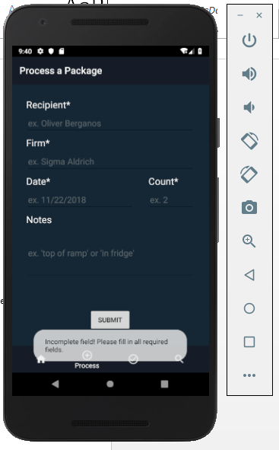

You will get the same notification if some of the required fields are still missing input.

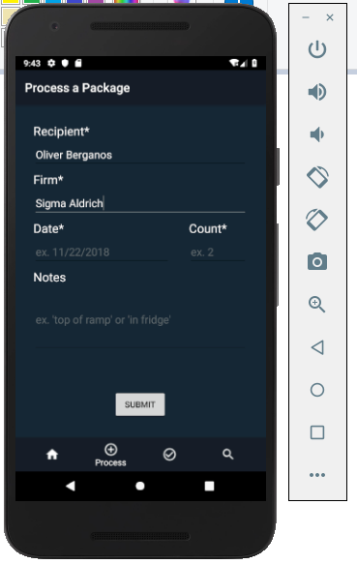

If all of the required fields have input and you click the Submit, you will get a notification that your package has been processed.

