Once the Checkout Tab is tapped, you will be brought to the Checkout a Package page. This page will display a list of packages that have not been picked up yet.

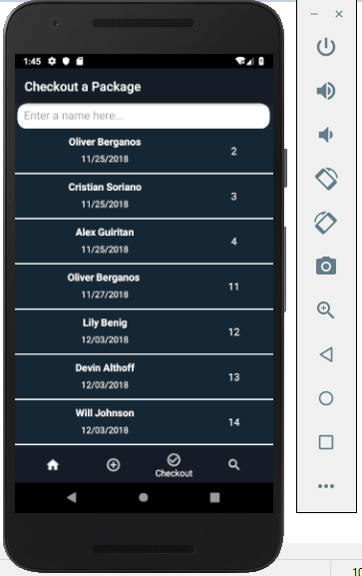

If you type in characters in a recipient’s name, the list of packages will filter accordingly. If there are no matches, no packages will display.

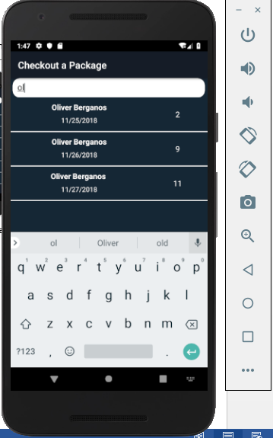 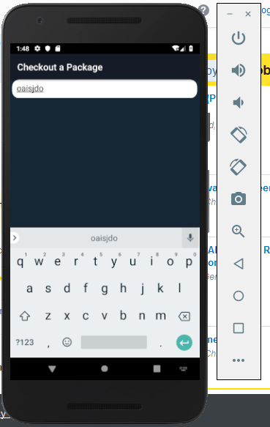

If you tap on a package, you will be brought to its checkout page. This page displays relevant information about the package that is being checked out and contains the checkout form the user must fill out.

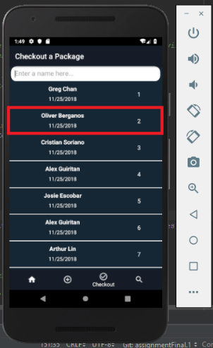 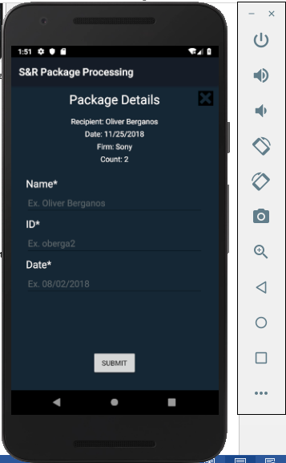

If the you wish to exit and look at the list of packages again, you can tap the exit button on the top right corner of the page.

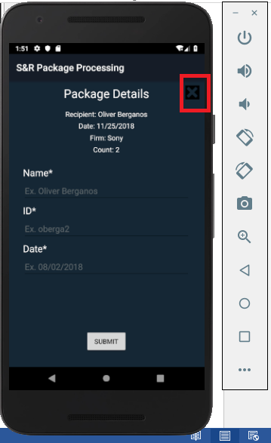

If you try to submit the form without filling anything out, you will get a notification saying you must fill out all required fields. This will also occur if you fill out some, but not all of the required fields.

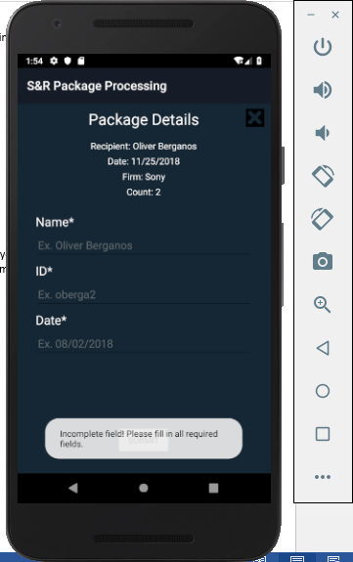

If you fill out all required fields and submit the form, you will get a notification that you have checked out a package successfully. The form will also be locked after a successful checkout so you can’t accidentally check out a package twice.

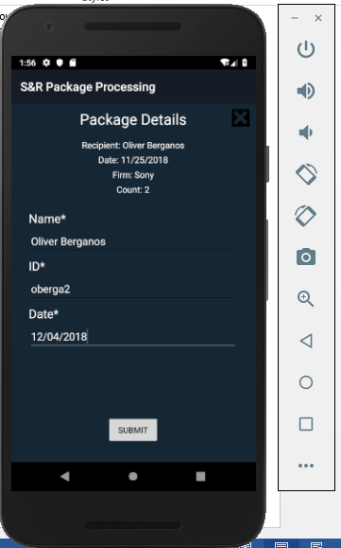 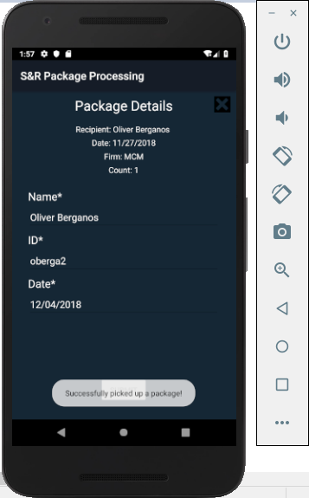 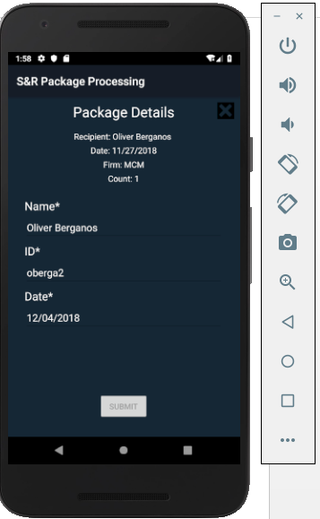

When you return to the Checkout a Package page, the package that you just picked up will not be displayed in the list because it has been picked up.

