A new Home page has been implemented with information about the app. The page is scrollable.

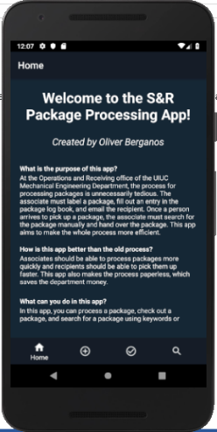

The Advanced Search page has also been implemented. Once you click on the tab, you will be brought to the advanced search form.

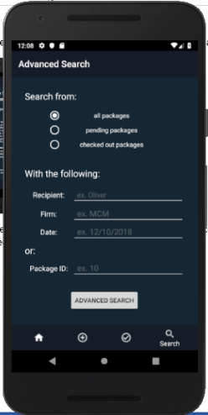

The Advanced Search page has three radio buttons. If you select “all packages,” the search will be performed through all packages. If you select “pending packages,” the search will be performed through packages that have not been picked up yet. If you select “checked out packages,” the search will be performed through packages that have been picked up.

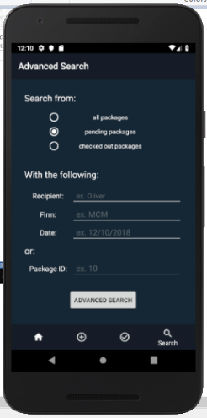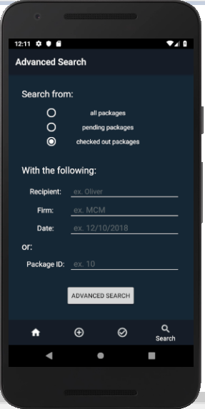

There are two ways to search for packages. The first way is by keywords. You can search by recipient name, package firm, and process date. Click on the “Advanced Search” button to see results.

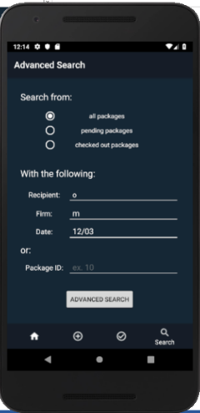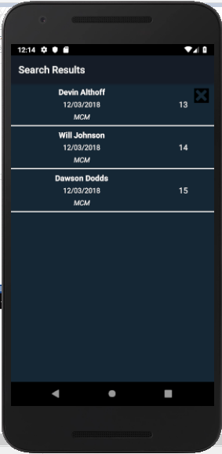

The second way to search for a package is by Package ID. Click on the “Advanced Search” button to see results.

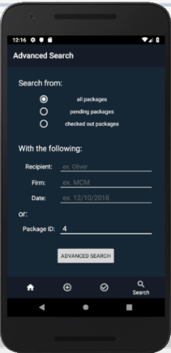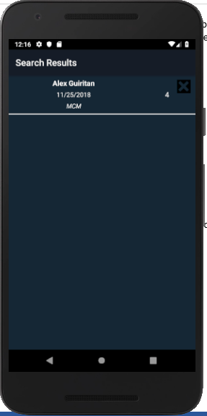

If you click on a package, you will be brought to its checkout form. If the package hasn’t been picked up yet, you can fill out the form and check out the package.

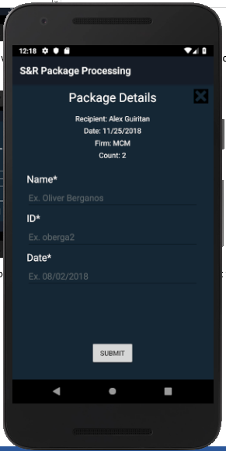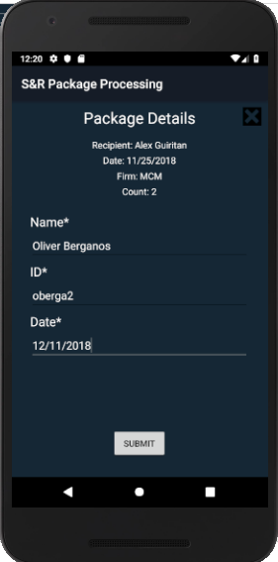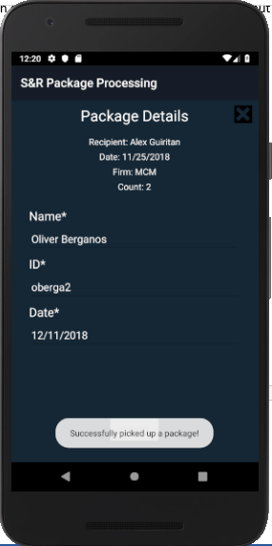

If the package has been picked up, the pick-up information will be displayed as well.

