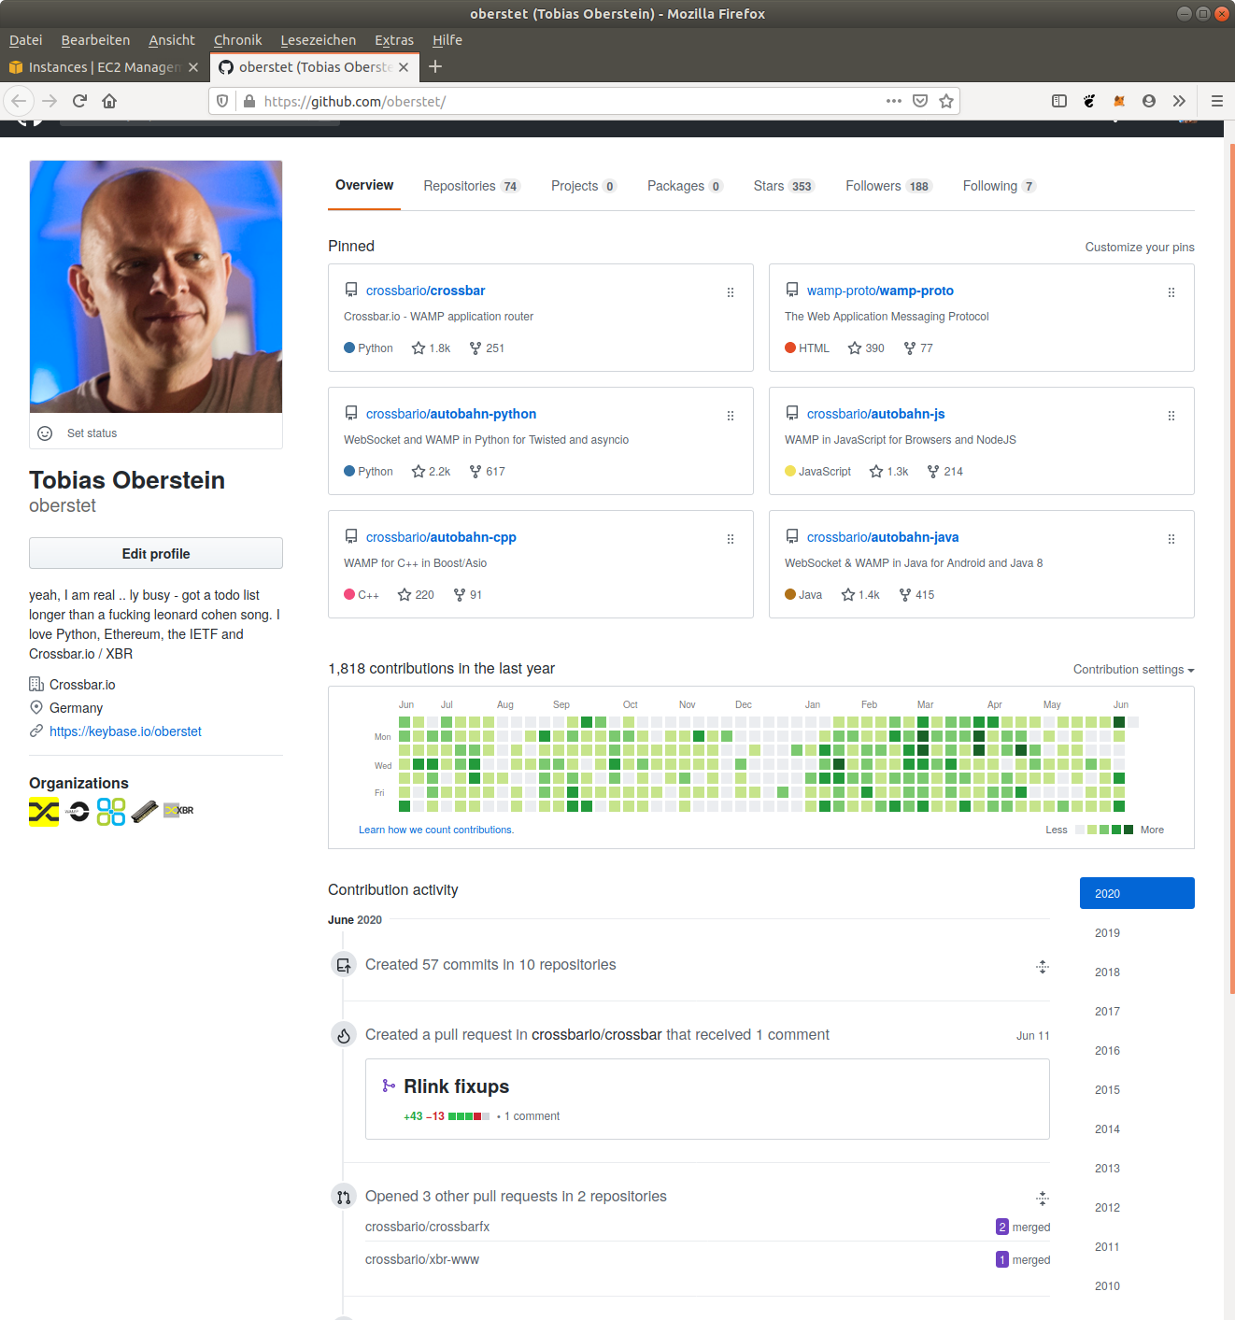
Profile Tobias Oberstein (oberstet)

Current as of 2020/06/14

GitHub
https://github.com/oberstet/

StackOverflow
https://stackoverflow.com/users/884770/oberstet

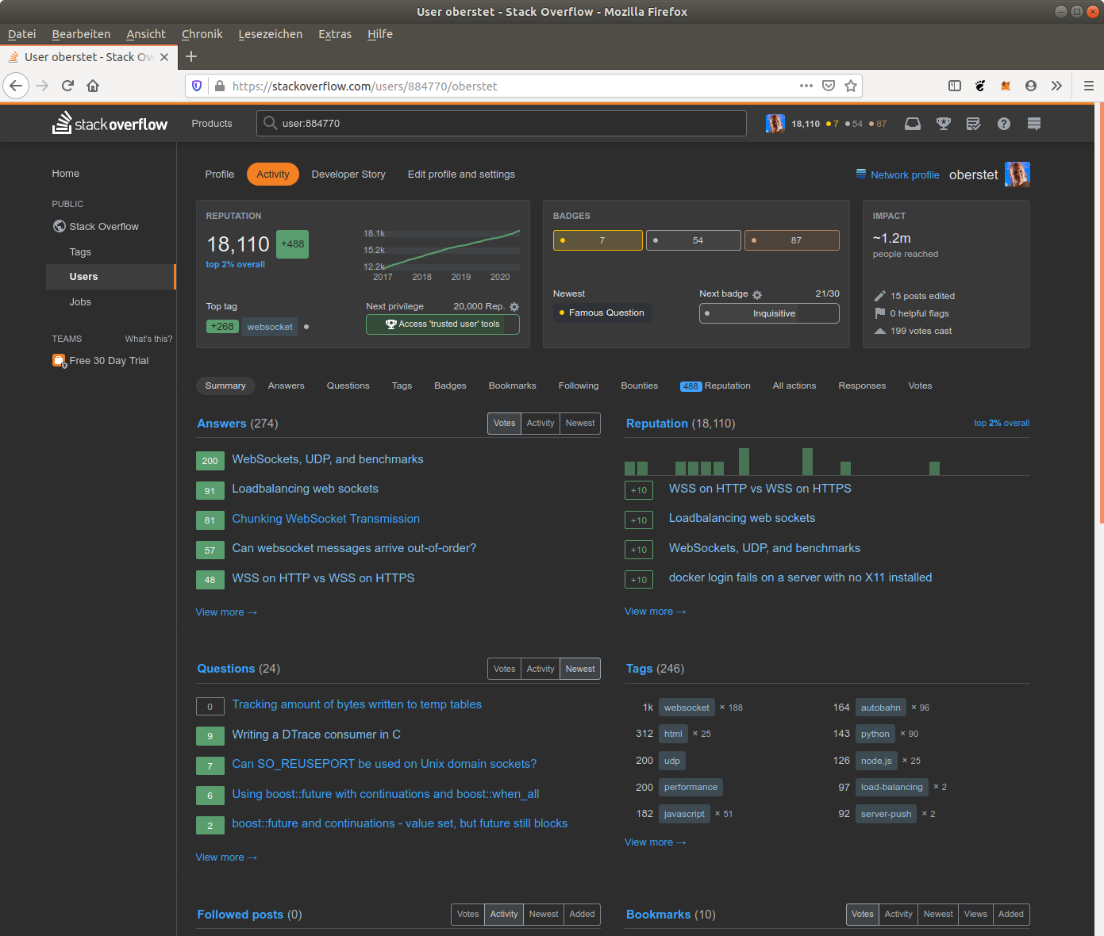

Keybase
https://keybase.io/oberstet

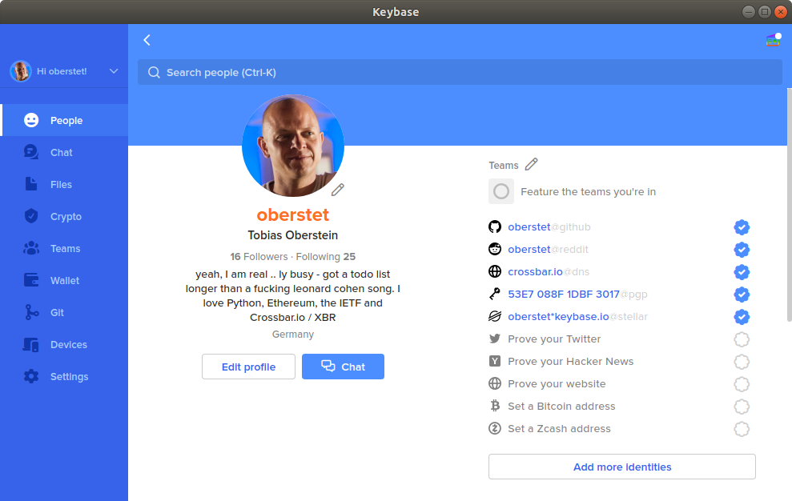

Linkedin
https://www.linkedin.com/in/oberstet/

