**Udacity VR : My Puzzler Project**

**Introduction**

As part of the VR Nanodegree Program at Udacity, a Puzzler project is proposed in order to guide the students in the process of design a functional VR app from scratch.

Having the user experience in mind, we will conduct user testing to get feedback frequently, so that changes are easier to make in early stages of development. Also, it is important to note that we take ergonomics, aural and visual stimuli into account because our unique consideration was the game needed to be intuitive to play, the environment had to be be built to scale and VR motion sickness should be avoided.

**Key features**

The key game mechanics of this game is similar to *Simon Says game*, where orbs play a sequence that user needs to repeat. In that we try to follow a sequence of the clicking on orbs in a specific order after watching the game system go through the random sequence. Users who successfully follow will win the game, otherwise they will need to restart.

**Puzzler**

The project evolved into a fun, intuitive and immersive game. User experiences were very positive during testing while providing useful information needed to iterate and improve the game, which was created in Unity for Google Cardboard on the Android and iOS mobile platforms.

**[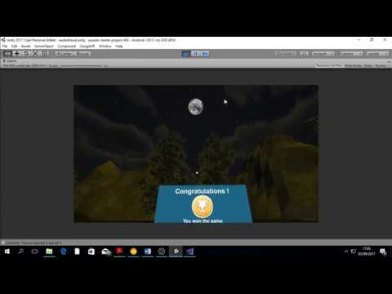](https://www.youtube.com/watch?v=Hu4uIt9bp6w)**

**Design Process**

***Statement of Purpose:****Puzzler is a mobile VR application for new VR users which challenges them to solve a familiar type of puzzle in a new way.*

**Persona**

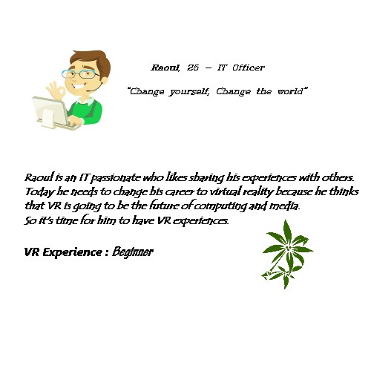

**Sketches**

Below are some of the sketches that were considered for the dungeon on this project.

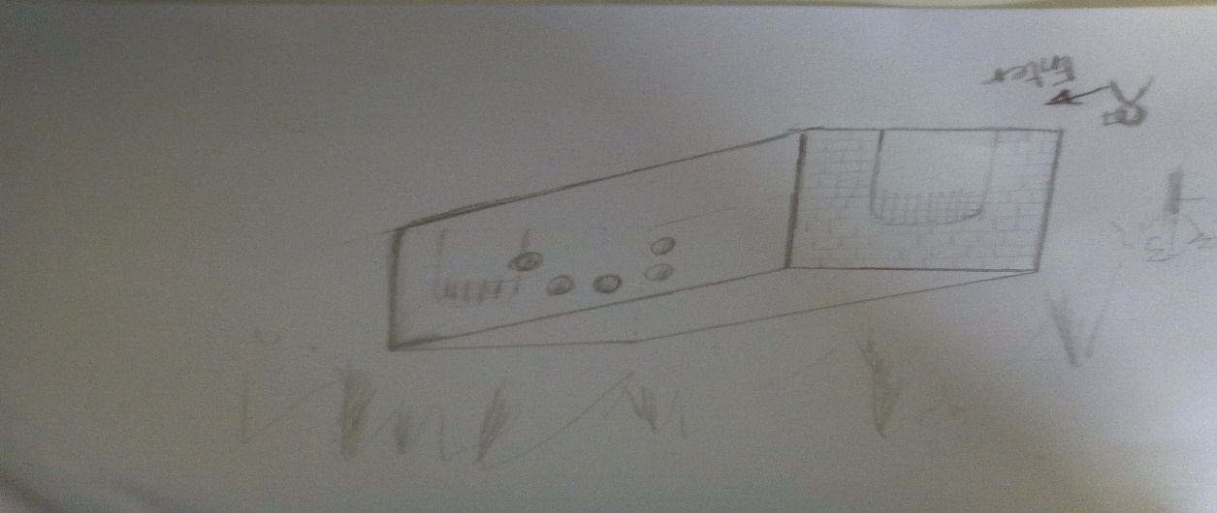

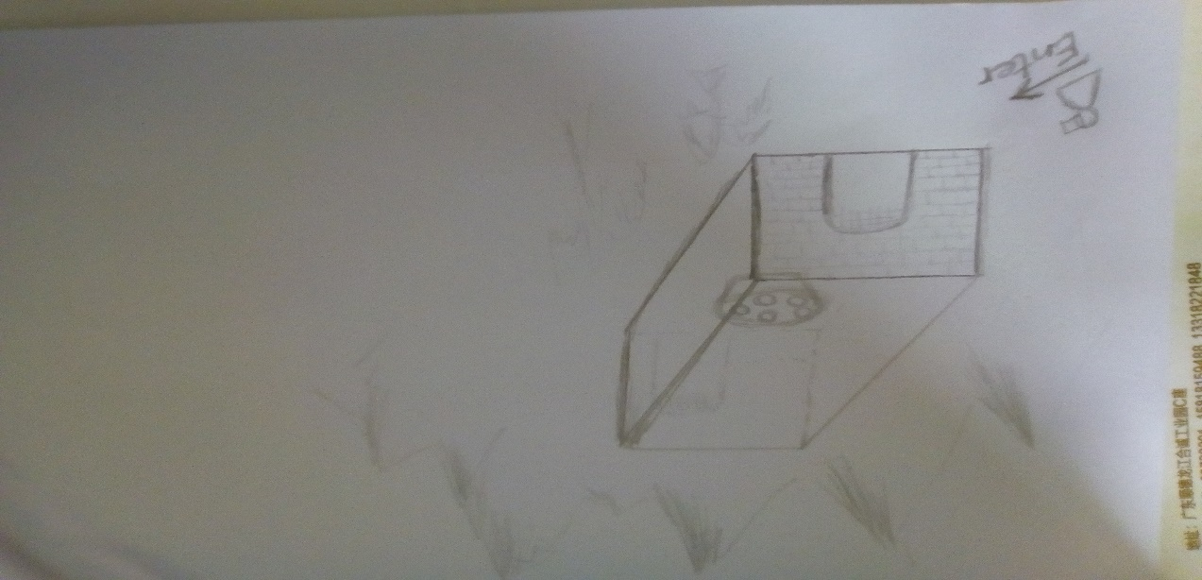

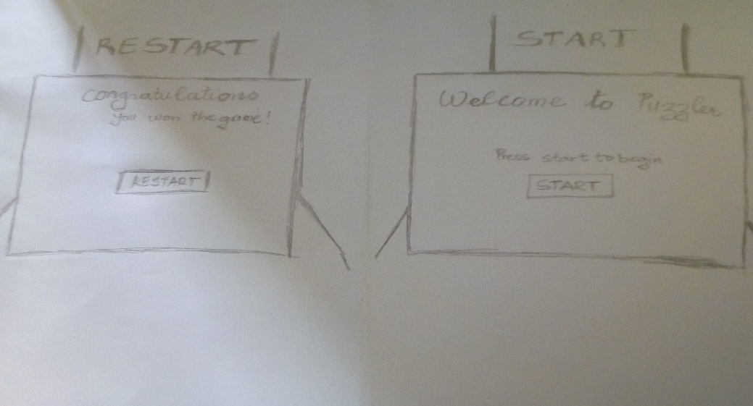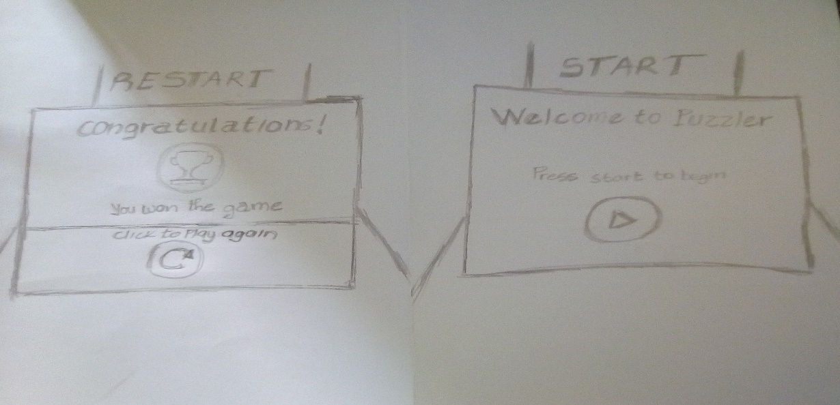

Below are some of the sketches that were considered for the start and restart canvas on this project.

**User Testing**

The game was tested with an user (my friend) with no experience in VR in order to understand if a beginner could use the game and find it intuitive.

**User test 1 : scene and atmosphere**

For my first user test, I asked the user the questions below to help judge if the scale of the building and objects in the scene felt appropriate.

*Q: How big do you feel in this scene?*

*A: I think is ok , I like*

*Q: Do any of the specific objects in the scene feel too big or too small?*

*A: No, but your torch does not have fire ?*

*Q: Is any part of the scene difficult to see or uncomfortable?*

*A: No, it’s cool but you can add other models for amazing*

**Improvements**

Based on user feedback, I decided to learn particle system to design a fire.

And modified skybox, added trees, mountain and others environments models

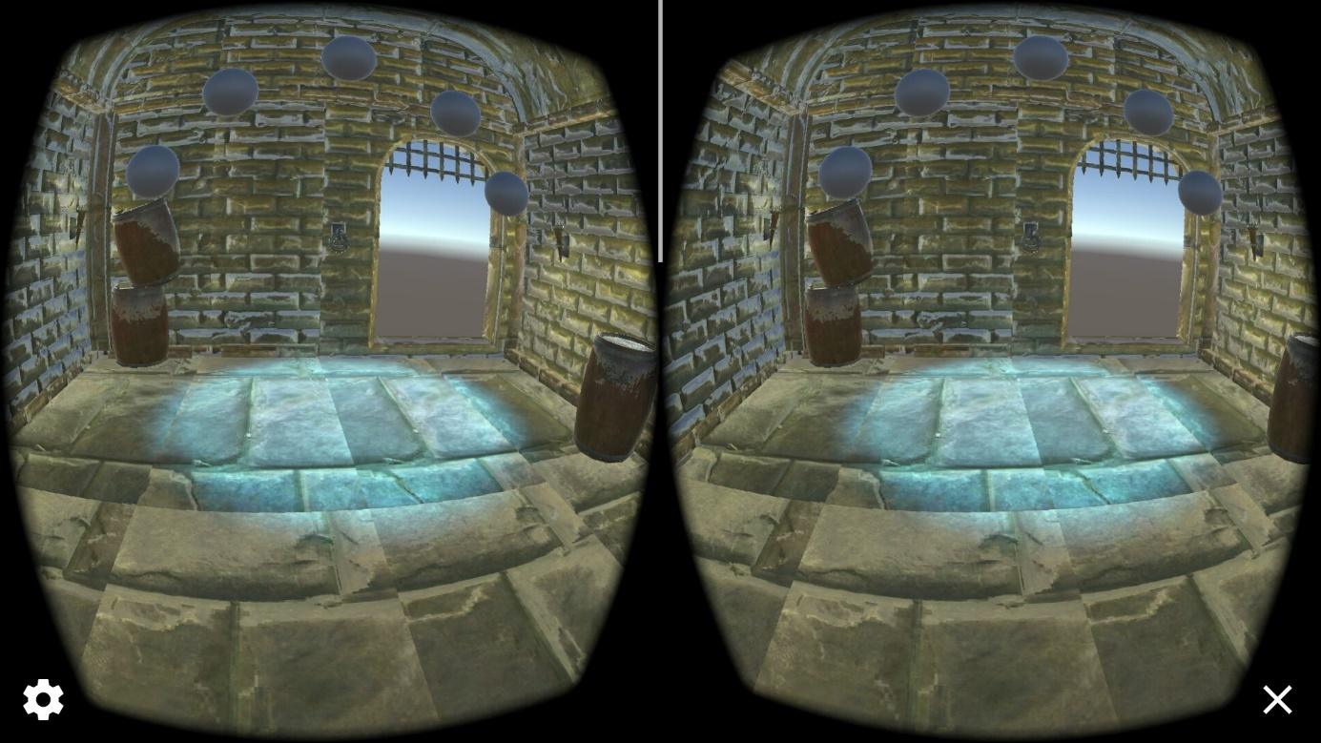

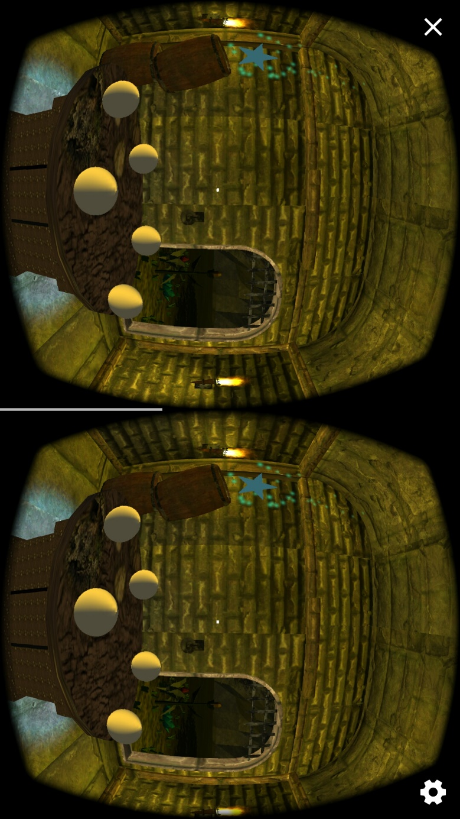

**User test 2 :** **Testing the UI**

For my second user test, I asked the same user some questions, to help me gauge the user interface at the beginning and end of the puzzler.

*Q: What do you see in this scene?*

*A: Welcome to the puzzler and button to start*

*Q: What would you do to start the puzzler?*

*A: Click the start button — it’s realling cool it changes color when hovering*

*Q: What about size of UI?*

*A: Good size, but it is too dark  ?*

**Improvements**

Based on user feedback, I changed color of the start and restart UI .

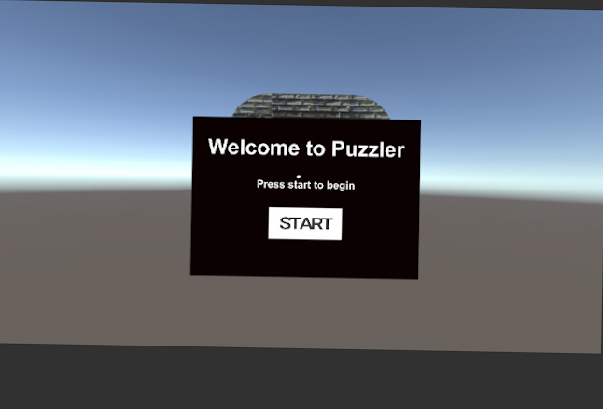

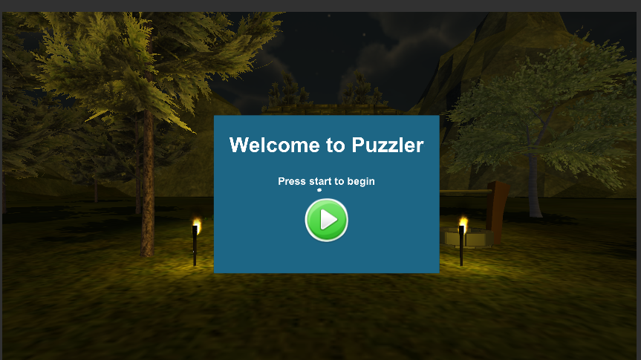

**User test 3 : Testing movement**

My third user test was focused on the movement into the dungeon after clicking start, and out of the dungeon after completing the puzzle.

*Q: How does the speed of movement feel after clicking the start button?*

*A: It is good*

*Q: Are you feeling sick or dizzy?*

*A: No, it’s cool*

**Improvements**

No change.

**User test 4 : Implementing the game mechanics**

For my fourth and final user test, I asked user to review the game play mechanics*.*

*Q: Were there any issues with the game mechanics?*

*A: No it is correct*

*Q: Any other issues or comments with the scene or gameplay?*

*A: No, it was fun! Maybe put a help UI to explain user a purpose of the game?*

**Improvements**

Added a help UI to explain the user a purpose of the game when clicking to « Star animation »

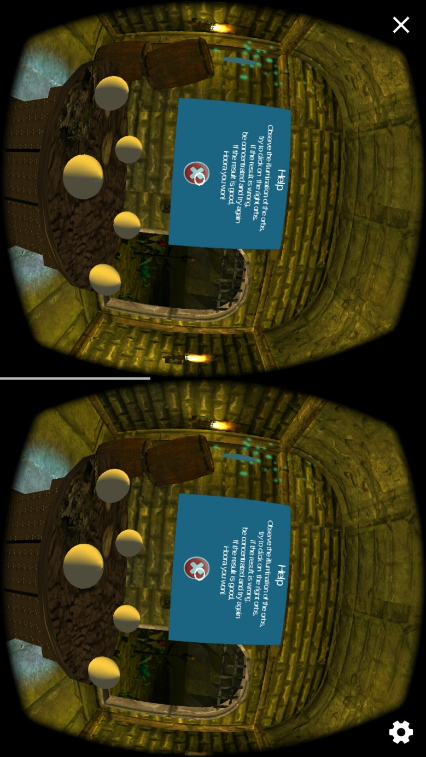

**Break down of the final piece**

Throughout the project I changed some things after the user tests and another changes were because I thought they would make my project better and a work that I would be proud of.

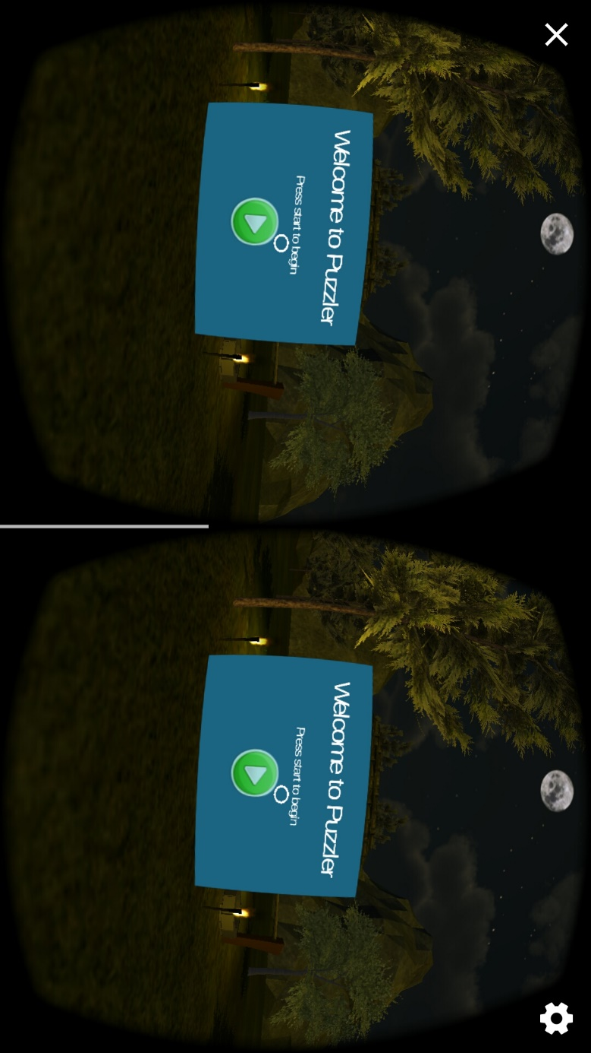

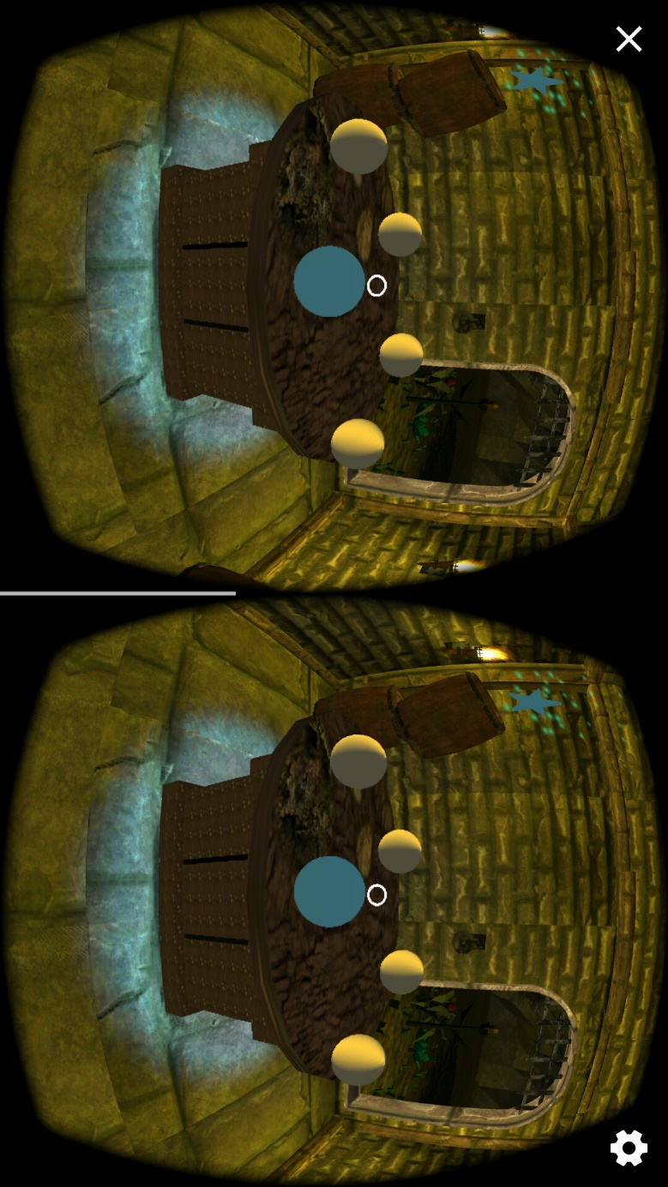

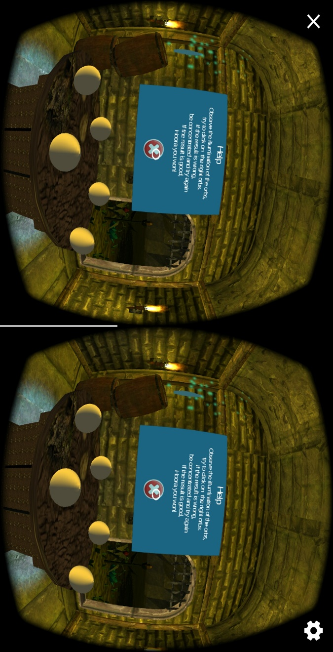

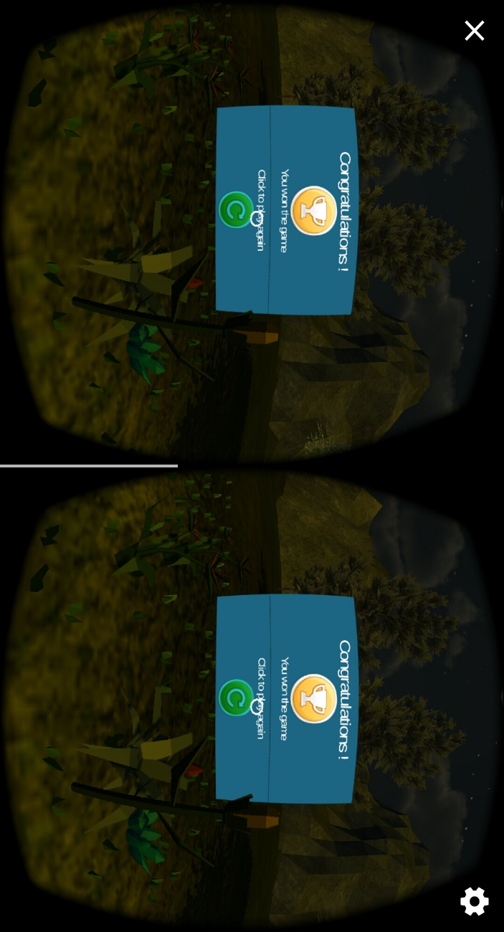

**Conclusion**

This app was a great way to learn about using the iterative process when developing a VR app to help influence the design of the app, and make the UI comfortable and intuitive for both experienced users, and players who are new to VR. The persona and sketches were a great way to begin the design process, and as a reference when I started creating the app in Unity. I also learned a lot about several key design aspects in virtual reality, like scale, game mechanics, movement, and visual cues.

**Next steps**

We would like to expand the feature set to allow for different levels in difficulty along with ways to store a scoreboard of the past games played. Ideally we would also like to connect to social media and allow users to share their scores with their friends and other gamers.

**Link to additional work**

The complete source code and documentation can be accessed here: