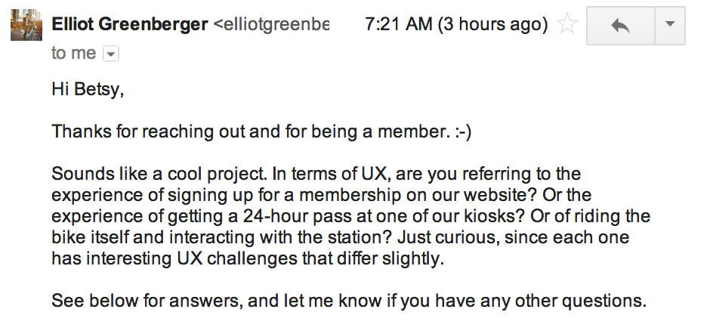

**What are Divvy's key business objectives?**

Our goal is to be the most convenient, fast, fun, and affordable way to get around Chicago. Therefore, our key objectives are to increase the number of people who consider or use Divvy as a primary mode of transit. That means selling more memberships (at DivvyBikes.com) and selling more 24-hour passes (at any station kiosk).

**What are Divvy's business goals for user experience?**

I suppose this depends on what you define as the user experience. In any case, a few key goals would be: (1) make sure riders understand the pricing model (2) make it easy for riders to get a membership or pass (3) ensure bike is safe for riding and bikes/docks are available at origin/destination points (4) help riders by educating them on safety/rules of the road and knowing where other stations are.

**Who is Divvy's target audience?**

We're intended for both Chicago residents and visitors, and our audience ranges from young professionals to retired tourists to suburban moms. We aim to be a bike share system for all of the city.