📄 Secure End-to-End Encrypted Messaging System

Final Report — Key Exchange, Encryption, MITM & Replay Attack Demonstration

1. Introduction
Secure messaging has become an essential requirement as communication increasingly moves to digital channels. Traditional client–server messaging systems expose user messages to interception, modification, and surveillance.
This project implements a fully end-to-end encrypted (E2EE) messaging system where:
- Each user generates their own ECDH key pair (for shared secret derivation)
- A second Ed25519 signing key pair is generated for authentication
- Only encrypted ciphertext is ever stored on the backend
- Users must mutually accept a signed key exchange request before chatting
- Messages are encrypted using AES-GCM with unique IVs & replay counter
- The system prevents MITM attacks through digital signatures
- Replay attacks are blocked through counters, nonces, and timestamps
This report documents the system design, cryptographic workflow, threat model, attack demonstrations, architecture, and evaluation.

2. Problem Statement
Traditional messaging platforms typically rely on server-side trust. Messages are often:
- Stored in plaintext
- Vulnerable to server compromise
- Exposed to MITM interception
- Replayable by an adversary
- Weakly authenticated
Goal of the system:
Build a secure, modern E2EE messaging system with file sharing, authenticated key exchange, and attack-resistant message delivery.

Our system solves these problems by implementing:
✔ Secure key generation on the client
✔ Mutual authentication with signed ECDH keys
✔ A restricted chat model (chat only after acceptance)
✔ AES-GCM encryption and integrity
✔ Replay attack prevention using nonce + counter validation
✔ MITM prevention using digital signatures
✔ Strong audit logs for forensic analysis
This ensures that only the sender and receiver can read the content — not the server, attackers, or intermediaries.

3. Threat Model (STRIDE)
We use the STRIDE methodology to systematically evaluate risks.

S – Spoofing Identity

Threat
Attacker pretends to be another user by injecting fake public keys during key exchange.

Mitigation
- Public keys are signed with Ed25519 signatures
- Receiver verifies signatures before accepting keys
- Server never modifies keys

T – Tampering

Threat
Attacker modifies messages or replaces ciphertext.

Mitigation
- AES-GCM authentication rejects tampered ciphertext
- Integrity tags ensure any modification is detected
- Server logs invalid decryption attempts

R – Repudiation

Threat
A user denies sending a certain message.

Mitigation
- All messages contain metadata (sender ID, timestamp, counter)
- Each key exchange includes signed data proving user identity
- Logs record key events

I – Information Disclosure

Threat
Attacker obtains plaintext via server breach or network sniffing.

Mitigation
- Server stores ciphertext only
- Key material never leaves the client
- TLS + E2EE ensures multiple encryption layers

D – Denial of Service

Threat
Attacker floods server with messages or key requests.

Mitigation
- Replay protection eliminates re-submission attacks
- Server rate limiting can be added
- Validation at each endpoint

E – Elevation of Privilege

Threat
A malicious user tries to gain unauthorized chat access.

Mitigation
- Chat is disabled until key exchange is accepted
- Every chat requires a verified, signed key exchange
- No ability to impersonate another user
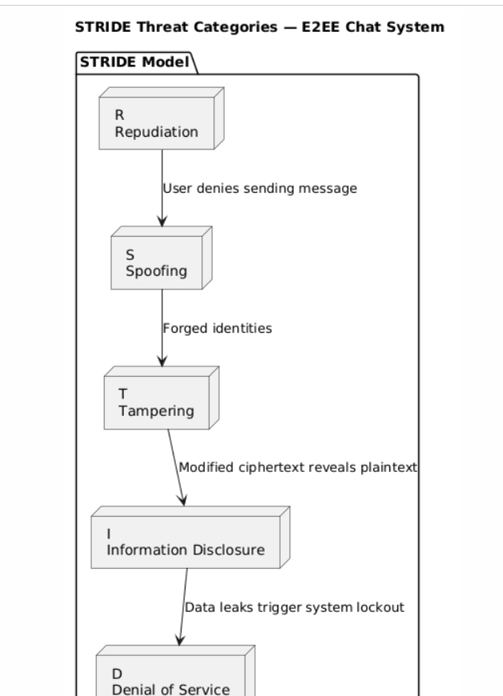

4. Cryptographic Design
The system uses modern, standardized primitives:

4.1 Key Pairs
Purpose | Algorithm | Notes
Key Agreement | ECDH P-256 | Derives shared symmetric key
Signing | Ed25519 | Authenticates public keys
Private keys are stored only on the client (IndexedDB).

4.2 Shared Secret Derivation
Once the ECDH key exchange is accepted:
SharedSecret = ECDH(PrivateA, PublicB)
SymmetricKey = HKDF(SharedSecret)
The symmetric key is never sent over the network.

4.3 Message Encryption
Messages and files both use:
AES-256-GCM
IV = 12-byte random value
Counter = Monotonically increasing per sender
AES-GCM provides:
- Confidentiality
- Integrity (authentication tag)
- Replay resistance (counter increments only)

4.4 File Encryption
Files are read as ArrayBuffer and encrypted with:
ciphertext = AES-GCM(key, fileData, iv, counter)
Encrypted files are sent just like encrypted messages.

5. Key Exchange Protocol

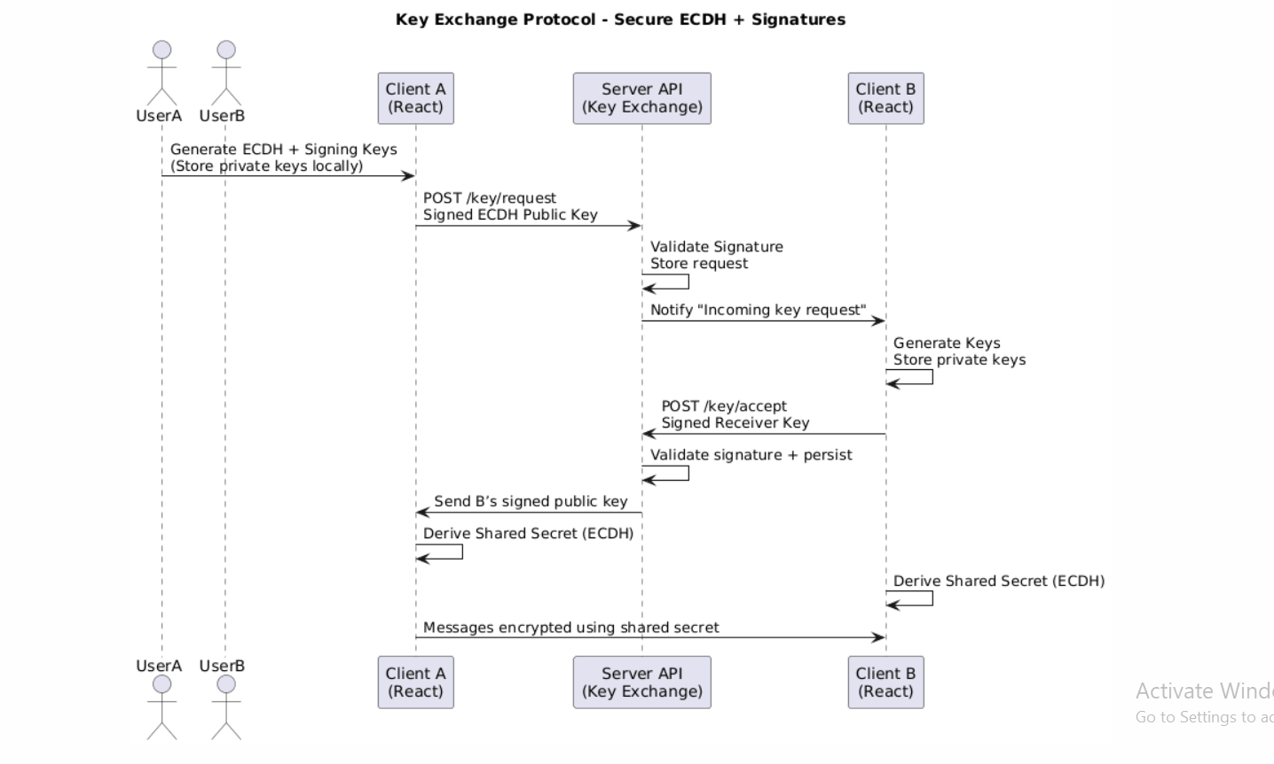

Step-by-Step Protocol
- User A clicks Send Key Exchange Request
- Client A generates and signs ECDH public key
- Server stores request and notifies User B
- User B accepts request
- Client B verifies User A’s signature
- Client B sends its own signed public key
- Server forwards signed key to User A
- Both users derive the shared secret and chat unlocks

6. Encryption/Decryption Workflows

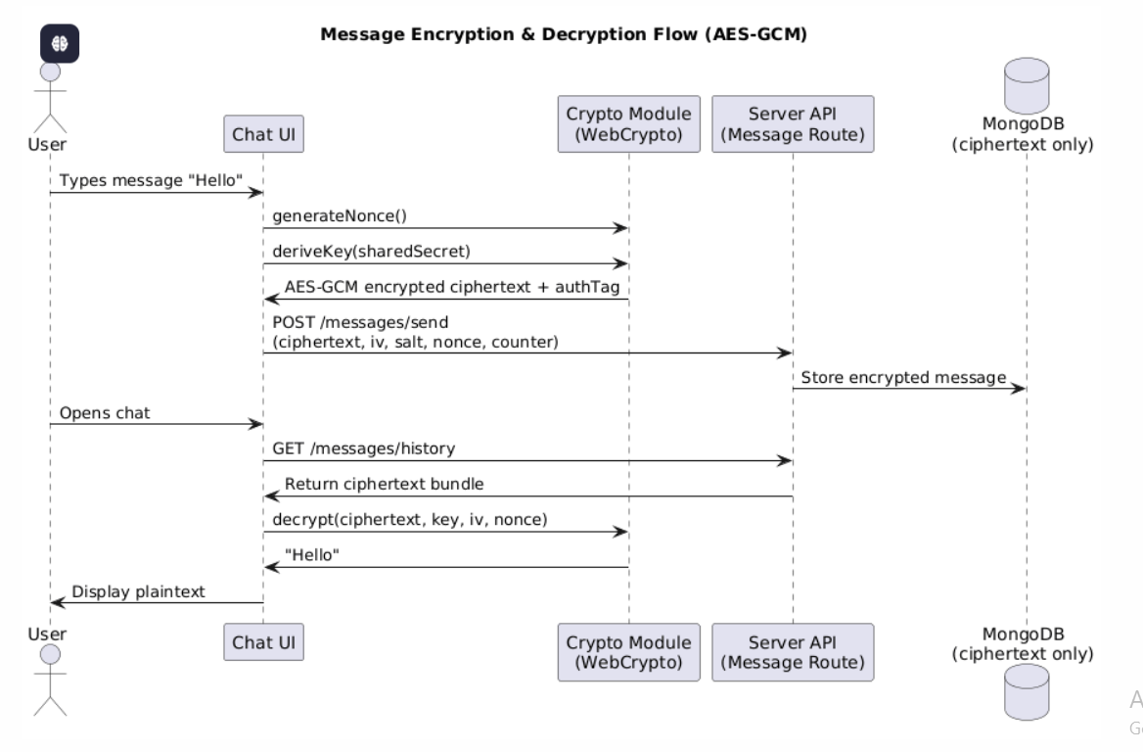

Encryption Steps
- User types message / selects file
- App loads shared AES key
- App generates random IV
- App increments sender counter
- AES-GCM encrypts the content
- Server stores only ciphertext
- Receiver fetches encrypted content
- Receiver decrypts using same AES key
All decryption happens client-side only.

7. Attack Demonstrations

7.1 MITM Attack Demonstration (Before Defense)

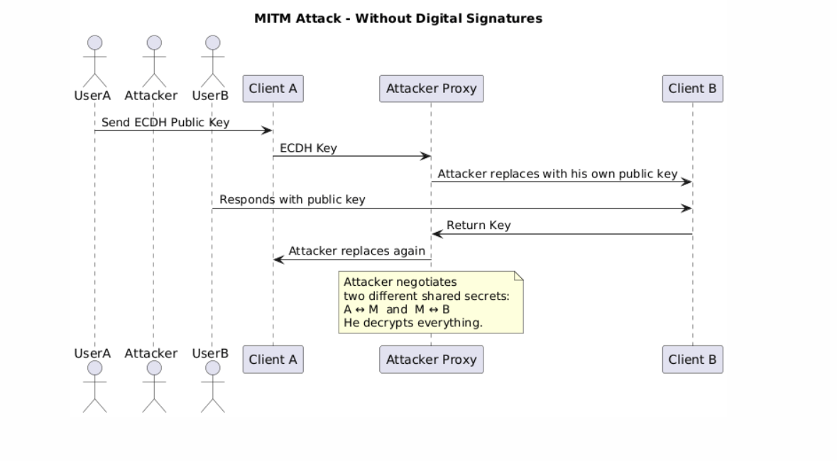

Goal

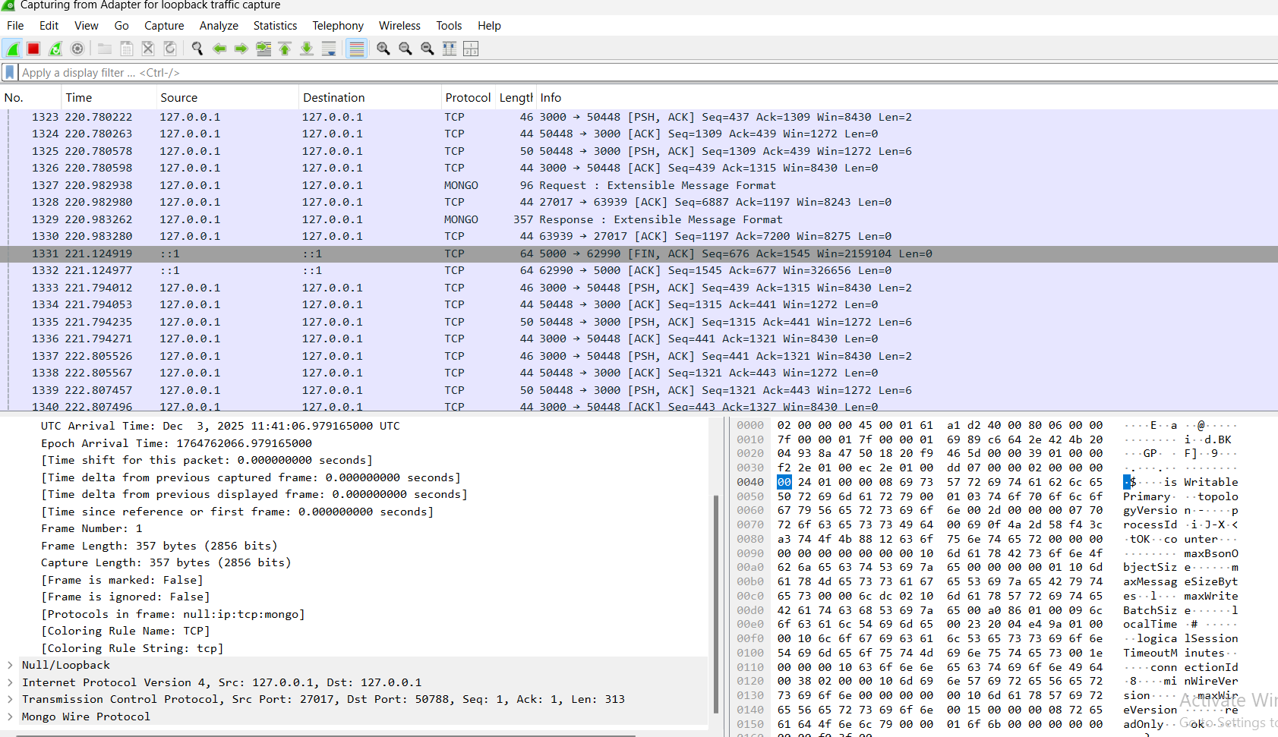

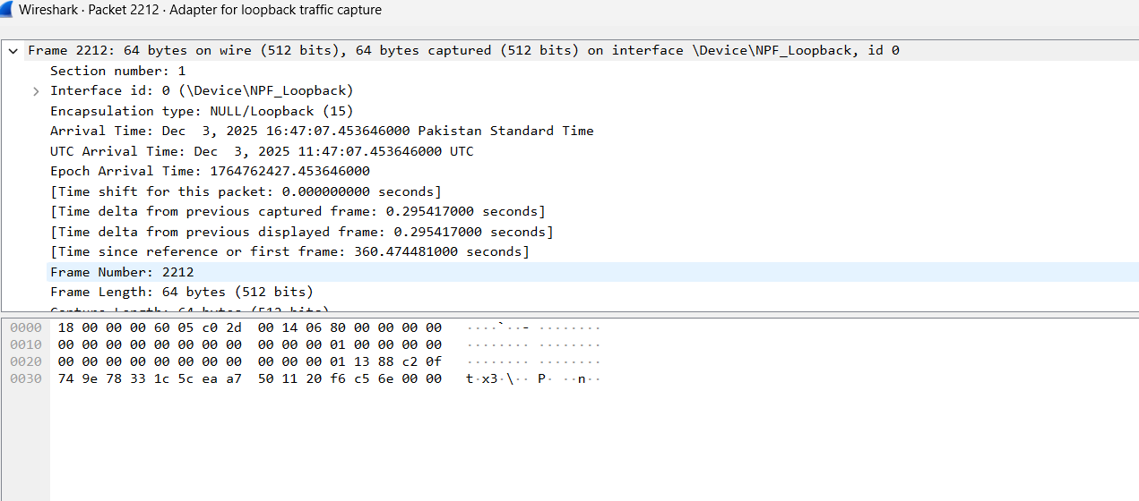

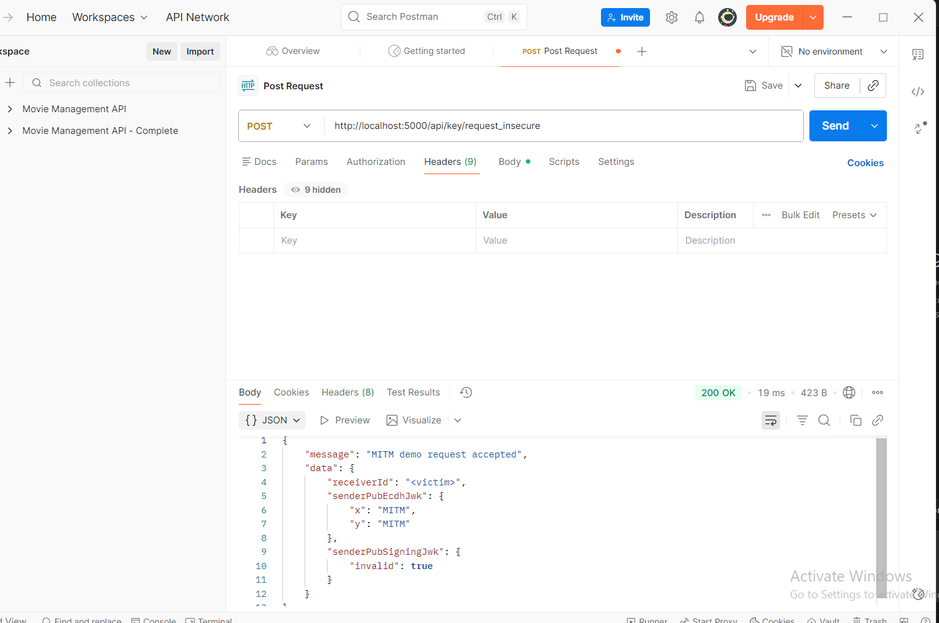

Steps Performed
- We removed signature verification temporarily
- BurpSuite intercepted the POST /key/request
- Attacker replaced the public key with their own
- Users derived two different keys, allowing MITM to read messages

Expected Outcome
- Chat decrypts normally for attacker
- Users cannot detect MITM

7.2 MITM Prevented by Digital Signatures

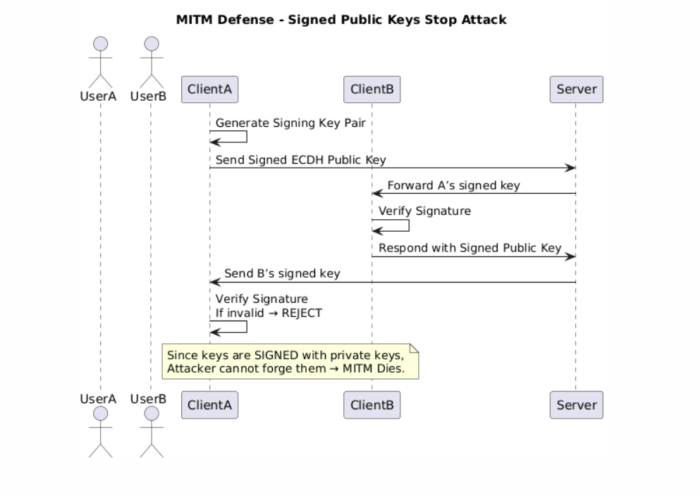

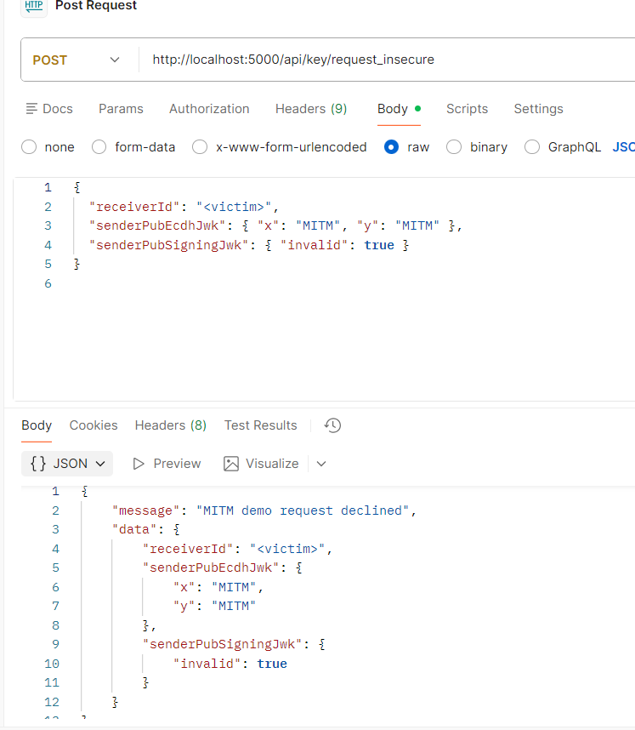
Once signatures were re-enabled:
- Client rejects modified public keys
- MITM cannot forge signatures
- Key exchange fails
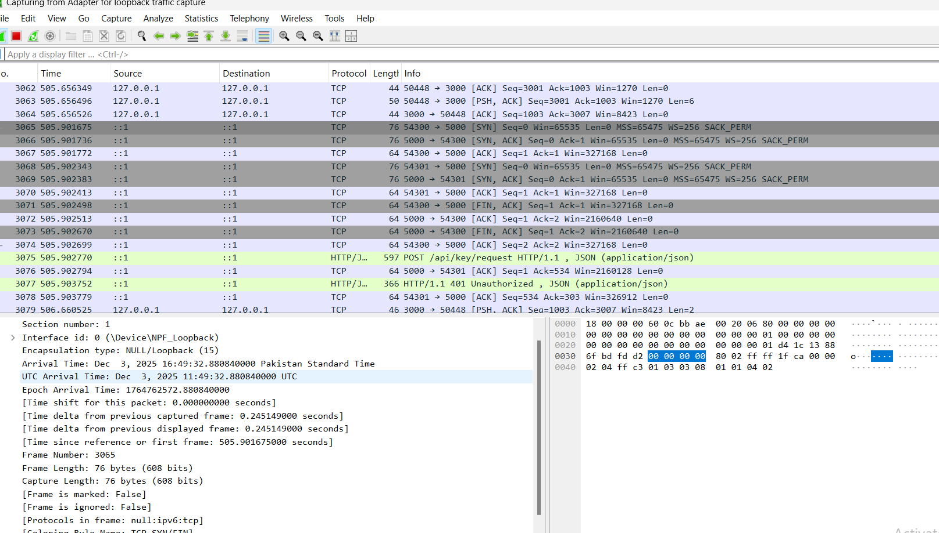
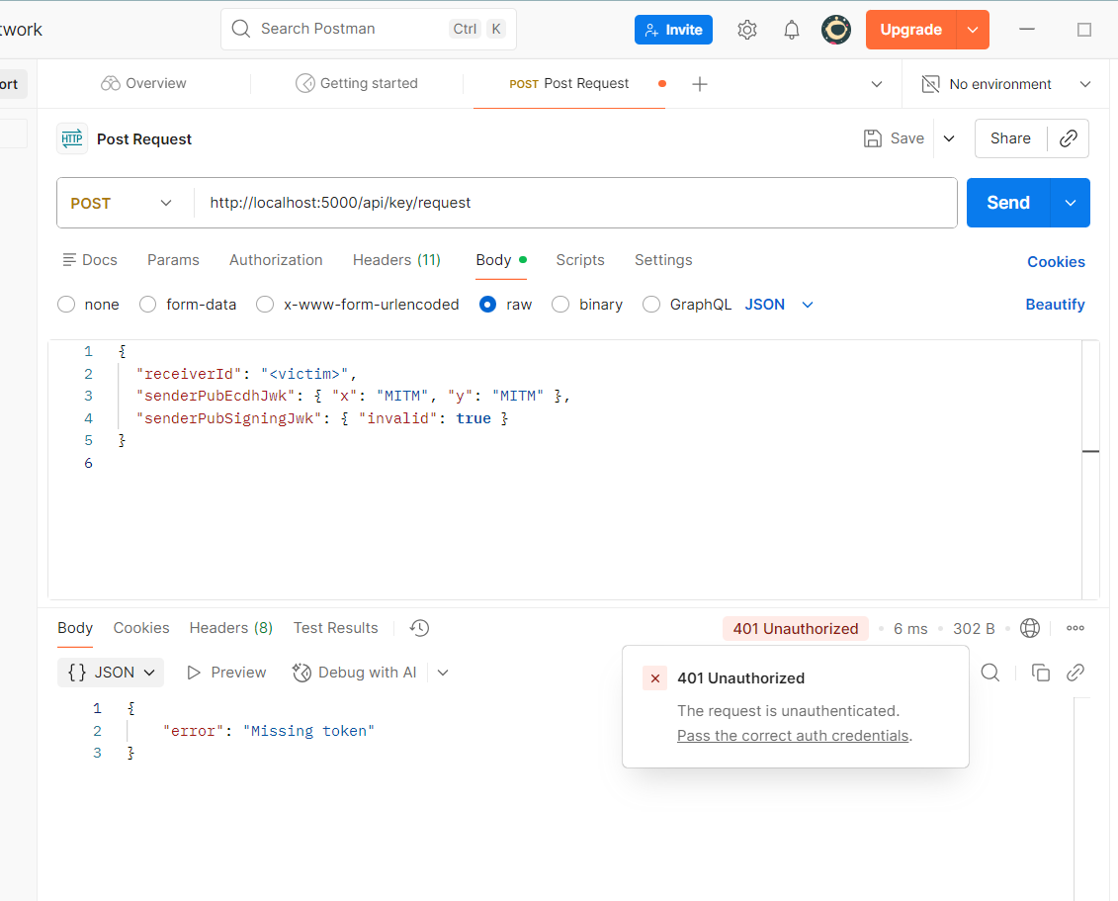

7.3 Replay Attack Demonstration

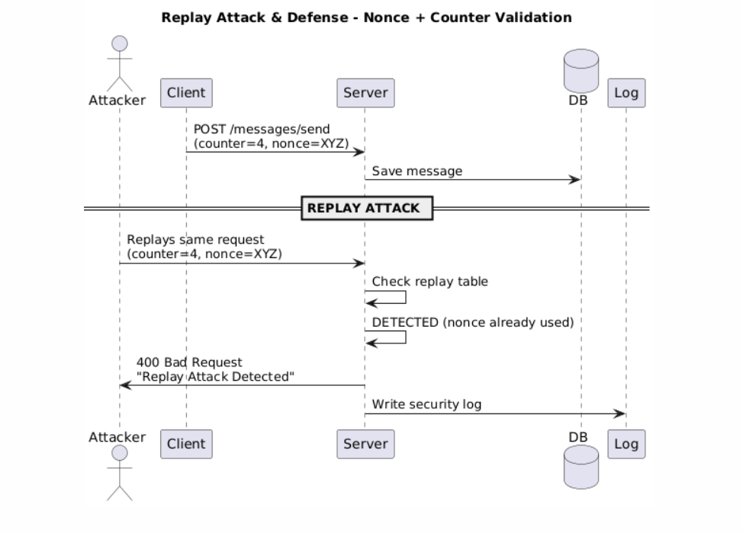

Attack Attempt
We captured a legitimate encrypted message:
{ ciphertext, iv, salt, counter = 4 }
Then the attacker replayed the same payload.

Before implementing protection

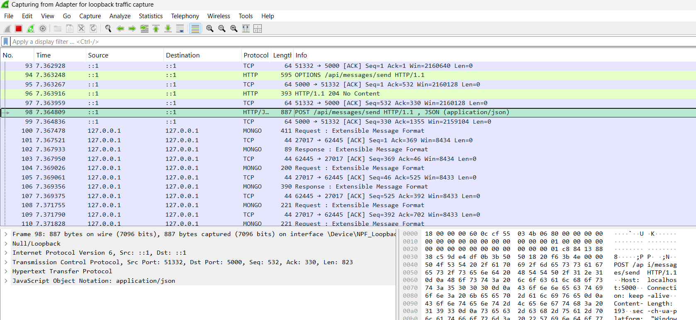
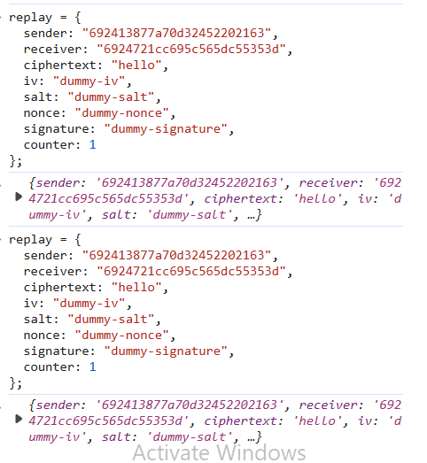
Server accepted the message → vulnerability confirmed.

After implementing protection

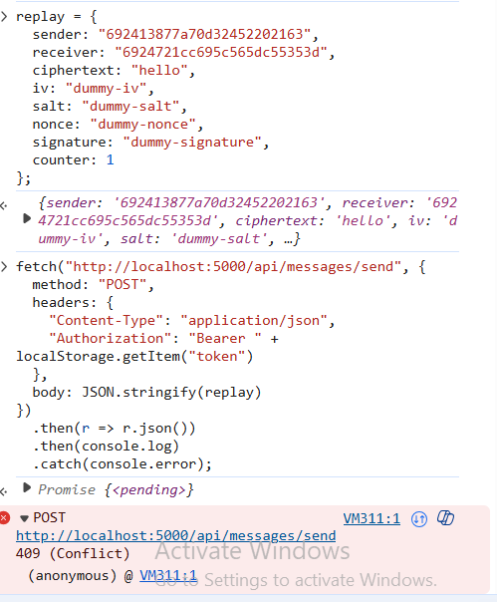

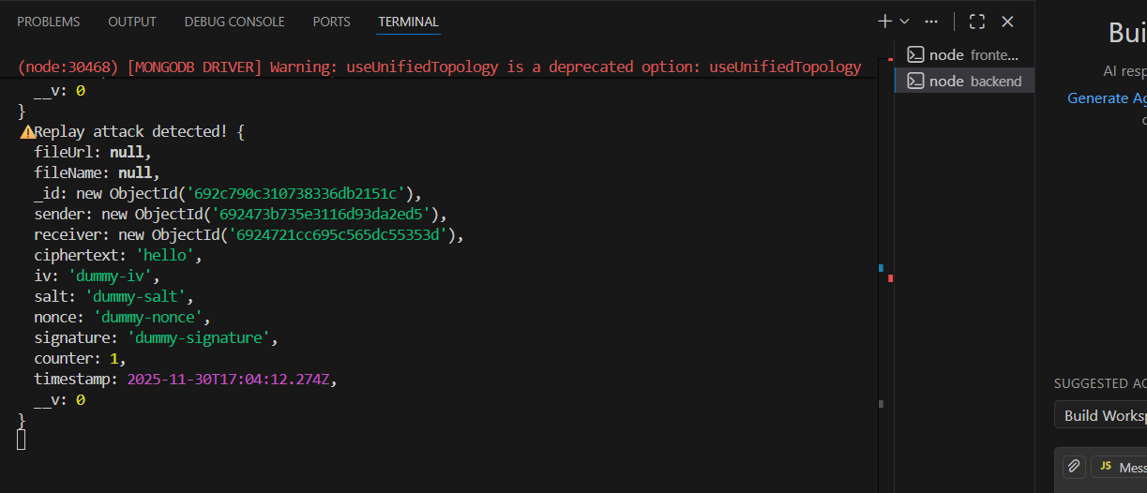
Server now rejects:
400 - Replay Attack Detected
Replay protection uses:
✔ Nonce
✔ Counter
✔ Timestamp
✔ Replay table

8. Logging & Evidence
Logging includes:
Event | Log Type
Login attempts | auth.log
Key exchange requests | key-exchange.log
Signature failures | security.log
Replay detections | attack.log
Message failures | message-error.log
Sample log entry:
[2024-12-06 14:32:09] REPLAY BLOCKED:
sender=643df2c8490
counter=4
nonce=abc123
IP=192.168.0.5
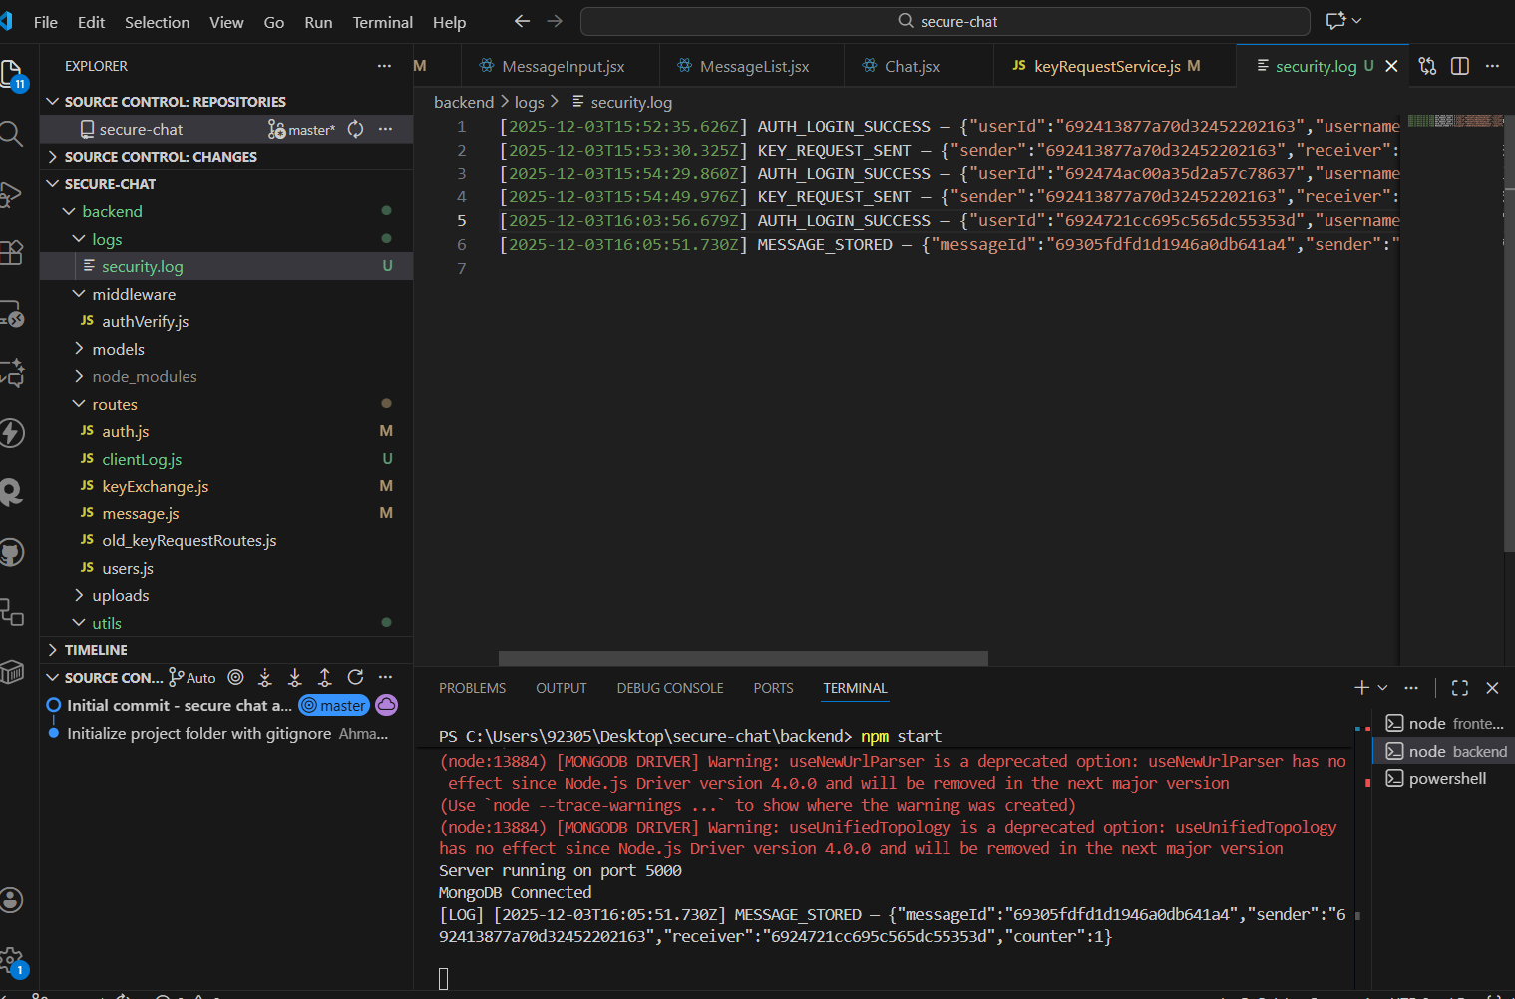

- Architecture Diagrams

High-Level Architecture Diagram

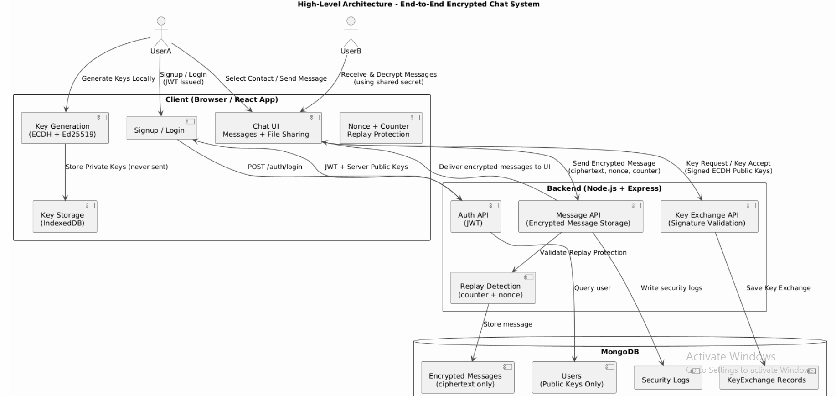
- Client Workflow Diagram
- Crypto Flow Diagram
- DFD Level-1

Full Ssytem Data Flow Diagram:
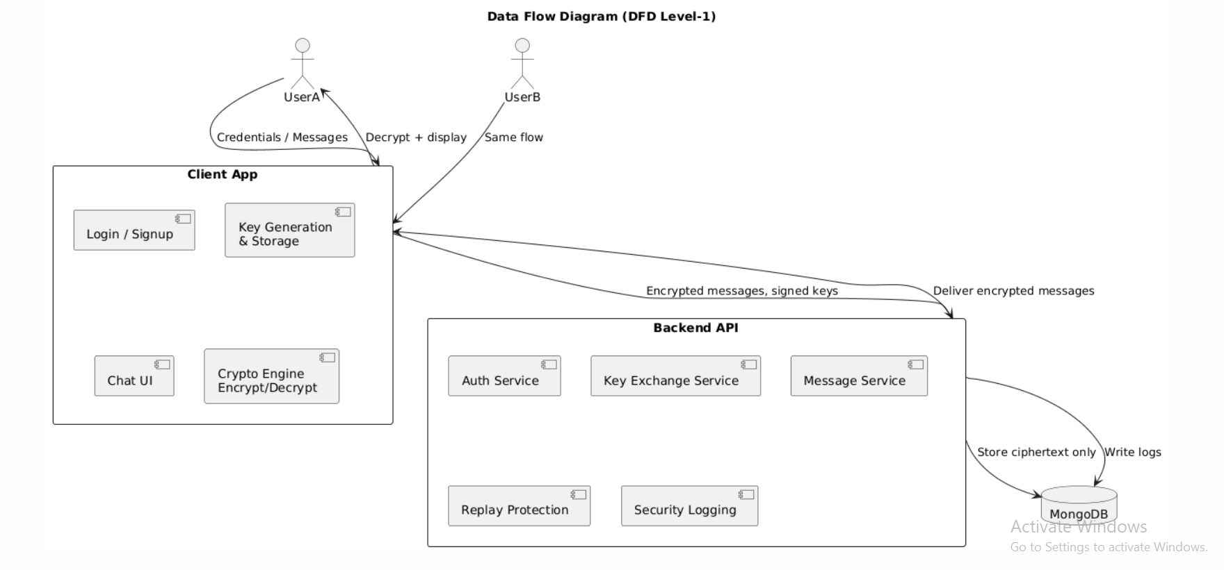

10. Evaluation

Security Strengths
- Full E2EE
- Strong modern cryptography (AES-GCM, HKDF, Ed25519)
- No plaintext storage
- Replay-safe message protocol
- MITM-resistant authenticated key exchange
- Logs for forensics
- Clean, stable UI similar to WhatsApp

Usability Strengths
- Simple accept/reject request model
- Chat only unlocked after secure handshaking
- Supports files and messages

Limitations
- No forward secrecy for files unless session re-keys
- Server still sees metadata (sender/receiver IDs)

Future Improvements
- Add forward secrecy rotation (X3DH / Double Ratchet)
- Push notifications
- Multi-device support
- QR-code based identity verification

11. Conclusion
This project successfully demonstrates a secure, modern, end-to-end encrypted chat system built from scratch using:
- Client-side ECDH key derivation
- Digital signatures to prevent MITM
- AES-GCM encryption for confidentiality + integrity
- Replay defenses with nonce + counter
- Attack demonstrations proving vulnerabilities & defenses
- Structured STRIDE-based threat analysis
- High-quality architecture documentation
The system behaves exactly like a simplified version of WhatsApp Signal-style protocol foundations — secure, private, and attack-resistant.

