Modeling biomedical experimental processes with OBI
[the latest authors list and acknowledgments should be taken from the SIG webpage]
Part of the OBI consortium (in alphabetical order): Ryan Brinkman¹, Mélanie Courtot¹, Dirk Derom⁴, Jennifer Fostel⁸, Yongqun He¹¹, James Malone³, Helen Parkinson³, Bjoern Peters¹⁰, Philippe Rocca-Serra³, Alan Ruttenberg¹³, Susanna-Assunta Sansone³, Larisa N. Soldatova*¹⁶, Christian J. Stoeckert Jr.¹⁷, Jessica Turner¹⁹, Jie Zheng¹⁷ and the OBI consortium.

¹British Columbia Cancer Research Center, Vancouver, Canada; ³The European Bioinformatics Institute, Cambridge, UK; ⁴Victoria University of Wellington, New Zealand; ⁵ISB, Seattle, WA, USA; ⁸SRA Global Health Sector, Durham, NC, USA; ⁹Abcam plc, Cambridge, UK; ¹⁰La Jolla Institute for Allergy and Immunology, La Jolla, CA, USA; ¹¹University of Michigan, Ann Arbor, USA; ¹³Science Commons, Cambridge, MA, USA; UT, ¹⁶Aberystwyth University, Wales, UK; ¹⁷Department of Genetics and Center for Bioinformatics, University of Pennsylvania School of Medicine, Philadelphia, PA, USA, ¹⁹ Department of Psychiatry and Human Behavior, University of California, Irvine, CA, USA.

*Corresponding author
LSS: lss@aber.ac.uk

Email addresses: (NOTE: All authors’ email addresses are needed: http://www.jbiomedsem.com/info/instructions/ )
CJS: stoeckrt@pcbi.upenn.edu
MC: mcourtot@gmail.com
YH: yongqunh@med.umich.edu
JM: malone@ebi.ac.uk
HP: parkinson@ebi.ac.uk
RB:
DD:
JF:
BP:
PRS:
AR:
SAS: sa.sansone@gmail.com
JT: Jessica.turner@uci.edu
JZ:
The OBI Consortium: obi-users@googlegroups.com

NOTEs:

http://www.jbiomedsem.com/info/instructions/

http://obi-ontology.org/page/Sig_paper_vote

NOTE: If you don’t see your name in the author list, please acknowledge in the above website and then put your name in the author list.

Abstract

Background
Experimental descriptions are typically stored as free text without using standardized terminology, creating challenges in comparison, reproduction and analysis. These difficulties impose limitations on data exchange and information retrieval.

Results
The Ontology for Biomedical Investigations (OBI), developed as a global, cross-community effort, provides a resource which represents biomedical investigations in an explicit and integrative framework Here we detail three real-world applications of OBI, provide detailed modeling information and explain how to use OBI.

Conclusion

We demonstrate how OBI can be applied to different biomedical investigations to facilitate interpretation of the experimental process, but also to increase the computational processing and integration within the semantic web. The logical definitions of the entities involved allow computers to unambiguously understand and integrate different biological experimental processes and their relevant components.

Availability
OBI is available at http://purl.obolibrary.org/obo/obi

Background

Biomedical investigations use empirical approaches to investigate causal relationships among a large range of variables. The breadth of investigations presents a number of challenges when attempting to describe experimental processes. There are varying levels of complexity, granularity, a wide range of material and equipment used. Furthermore, the use of different terminology by different community makes data integration problematic when representing and integrating biomedical investigations, regardless of the field of study. Use of ontologies has been successful in biological data integration and representation [the GO consortium, 2000; Matos et.al., 2006]. There are multiple efforts developing ontologies to increase semantic content and standardization (GO, MGED, LABORS, MSI ontology) [Whetzel et.al., 2006; King et. al., 2009; Sansone et.al., 2007]. Work by transcriptomics, proteomics and metabolomics communities developed in parallel, producing similar ontologies with overlapping scope. Though each focuses on particular types of experimental processes, many generic terms such as investigation, assay or are common to all. Merging common aspects of these formalisms is useful as it provides a mechanism by which a class can be defined and understood by all, removing ambiguity and potential conflict. This practice is endorsed by policy providers such as the OBO Foundry [Smith et.al., 2007] which requires all member ontologies to define a single class only once among them (orthogonality). OBO Foundry members use the same defined set of relations from the Relations Ontology [Smith et.al., 2005], and the upper level ontology BFO [Grenon et.al, 2004] in order to facilitate cross ontology integration and to promote automated reasoning and adhere to common naming conventions [Schober et al. 2009]. Relations that may be used within an OBO Foundry-compliant ontology are imported from the Relation Ontology (RO).

The Ontology for Biomedical Investigations (OBI) addresses the need for a common, integrated ontology for the description of biological and clinical investigations (Whetzel, Brinkman et al. 2006). OBI is collaboratively developed by representatives from 19 biomedical communities and is a candidate ontology for the OBO Foundry and as therefore uses both RO and BFO. OBI provides a set of 'universal' semantic identifiers applicable across various biomedical and technological domains, for example, assay (the planned process of producing data about) and also provides domain-specific terms relevant only to a given domain, for example – T cell epitop recognition assay used by the IEDB databases to described experimental data extracted from the literature [ref IEDB]. OBI represents experimental processes e.g., investigation, study, assay, and the entities involved into those processes e.g., the study design, the protocols and instrumentation used, biological material, data generated and analyses performed on the data. OBI therefore supports the logically consistent annotation of biomedical experimental processes regardless of the particular field of study. In this paper, OBI v. 0.9 is applied to three exemplar use cases, originating from three communities: 1) neuroscience, 2) vaccine protection, and 3) functional genomics. OBI release 0.9 can be accessed via BioPortal (http://bioportal.bioontology.org/) and details of OBI design are described at http://www.purl.obolibrary.org/obo/obi.

Results

Biomedical experimental processes involve numerous sub-processes, each of them involving experimental materials e.g whole organisms, organ sections, cell culture and instrument. These are represented as OBI specific child classes of the BFO class ‘material_entity’. OBI defines an investigation as a process with the objective to generate information by planning an overall study design, executing it, and documenting the results. An investigation can include a study interpretation, or a sub process of interpreting the data to draw conclusions. There may be multiple study designs in one investigation and investigations can be parts of another investigation. Material entity is defined in OBI as an ‘independent continuant’ that is spatially extended whose identity is independent of that of other entities and can be maintained through time (e.g. an organism). Material entity subsumes BFO derived object, fiat object part, and object aggregate, because the three level theory of granularity in BFO [bfo ref] is inadequate for complex biological use cases. Material entities bear distinct roles which are realized in the context of a process, e.g. study subject role, host role, specimen role, patient role; and distinct functions inhering in their physical structure e.g. measure, separation, environment control.
To assess the completeness of OBI (release 0.9, revision x) and to demonstrate the use of OBI for annotation, we present three representative use cases. These demonstrate how to model entities and relations between entities involved in experimental processes using OBI. The first use case models a neuroscience experiment pulled from the literature, and shows how logical definitions are constructed using parts of external ontologies imported into OBI. The second use case details how OBI is used to model vaccine studies; the third describes the Robot Scientist [ref] which designs and executes functional genomics experiments.

Use case 1: Neuroscience investigation use case
This investigation studied the role of the primate caudate nucleus in the expectation of reward following action (Lauweyrens et al., 2002). While the caudate nucleus responds preferentially to eye movements in different directions, the response begins prior to eye movement and is dramatically increased when there is expectation of reward for the preferred direction. Here we model a single trial in which the visual target, a light, is presented to the animal and the neural response is recorded as data. This single trial model contains three processes:
- Presentation of stimulus to a study subject, a Macaque fuscata monkey, during a measuring neural activity in the caudate nucleus assay.
- Stimulating monkey with light, which is an example of presenting stimulus to study subject, having the participants Japanese Macaque monkey and light.
- Measuring neural activity in the caudate nucleus: This process is a sub class of extracellular electrophysiology recording process which unfolds_in the caudate nucleus being part of the monkey. The anatomical term caudate nucleus is imported from the NIFSTD (Bug et al., 2008) to complete the logical definition of the assay.
The light on the tangent screen here is a light used to present the stimulus to the study subject. The function of the microelectrode used to measure the neural activity is realized as a measure function which inheres in the single unit recorder, itself a device. The process measuring neural activity in the caudate nucleus has the specified input from a neuron and the specified output of a neuronal spike train measurement, a neuronal spike train datum.

Use case 2: Vaccine protection investigation:
A vaccine protection investigation (also known as a vaccine challenge experiment) measures how efficiently a vaccine or vaccine candidate induces protection against a virulent pathogen infection in vivo. Figure 2 demonstrates how to use OBI to represent a typical vaccine protection investigation via the following three sub-processes:
- vaccination is modeled as administering substance in vivo that realizes some material to be added role borne by some vaccine (e.g., VacX) and bears some target of material role borne by some organism that also bears a host role (e.g., mouse). The term vaccination is a term imported from the Vaccine Ontology (http://www.violinet.org/vaccineontology).
- pathogen challenge is also an administering substance in vivo process that realizes some material to be added role borne by some ‘organism’ and bears some ‘pathogen role’ (e.g., Influenza Virus) and realizes some target of material role borne by some organism that bears some host (e.g., mouse).
- survival assessment is an assay that measures the survival rate (occurrence of death events) in one or more organisms that are monitored over time. The survival assessment a common protection efficiency assay that has specified input some organism (e.g., mouse) and has specified output some survival rate, in this case, 75% of mice survived from pathogen challenge.

Use case 3: An automated functional genomics investigation

Robot Scientist “Adam” is designed to perform high-throughput growth curves measurements (phenotypes) of selected microbial strains (genotypes) in a defined media (environment). Robots require a complete, precise, and fully formalized description of all experiment actions and provide a use case for OBI in modeling experimental automation. Here we have modeled investigation in which Adam abduces hypotheses about which metabolites can restore a function of the removed yeast gene (Figure 3)

- planning is modeled as a realization of a plan specification which has an objective to test a hypothesis. This hypothesis is_about whether metabolite will affect yeast strain growth. Adam designs an assay to test this hypothesis: to grow yeast with and without addition of the metabolite
- automated investigation of the enzyme EC.6.1.39 is modeled as a hypothesis driven investigation with the objective to test the hypotheses specified in the planning process (we represent a single hypothesis which serves as a design pattern). The hypothesis is the specified input for the investigation. The specified output of the investigation is the study result – whether the metabolite affected the growth of the yeast strain (Panel X, Figure 3. The upper growth curve shows the growth rate with the addition of the metabolite, and the lower curve shows the rate with no metabolite. The result interpretation is that the hypothesis has been confirmed and the robot can update its background knowledge.
- The investigation process has part an assay to test the hypothesis. The assay has specified input of the metabolite and the yeast strain defined by the hypothesis, and specified output of optical density measurements modeled as a data set. The yeast has role of evaluant role.

Discussion

OBI aims for a robust and versatile symbolic representation of biomedical investigations. Three distinct biological use cases are modeled by representing statements using entities defined in OBI. Individual experimental steps are modeled as processes and its subclasses in OBI. The two processes in the neuroscience use case assay and the three processes in the vaccine protection study all fall under planned process in OBI. The processes vaccination and pathogen challenge are disjoint subclasses of administering substance in vivo, which is a subclass of material combination. Survival assessment is a type of assay (Table 1). Therefore, although different use cases focus on different biomedical domains, they can all be represented in OBI.

All these processes, as well as all other entities described in the use cases could be represented using OBI, and we have provided specific sub classes under material entity, assay, process and role where necessary to provided greater granularity. For example vaccines are types of material entity, host role, subject, pathogen role, and material to be added are types of role. In the case of the neuroscience investigation use case, the construction of a logical definition of this experimental process required us to ask a series of questions of the domain experts and which are not explicit in the publication. For example, is the location of the micro-electrode extra or intracellular? Are all spike train data generated from the caudate nucleus? How does a spike train relate to the GO biological process regulation of action potential [ref]? This resulted in the extension of OBI’s existing assays, and the import of several terms from external ontologies, specifically NIFSTD. Decisions on the appropriate level of granularity are challenging: in this use case we have not included instances of our classes in the ontology itself, and have specifically added general entities so that these can be re-used for other use cases and communities. The classes added served as design patterns for other neuroscience assays. We also use some relations from ro_proposed [ref]: in this case we chose to import ‘unfolds_in’ to specify that an occurrent (process) happens in a certain location (i.e., the assay of spike trains in the caudate nucleus) rather than ‘located_in’ currently in RO which relates only continuants. Finally, we use the NCBI taxonomy [ref] to describe the species involved in this experiment. Reuse of external resources fulfills two purposes; firstly we rely on domain experts in specific areas to model the information, thus avoiding duplication of efforts. Secondly by re using existing resources, we improve future data integration by preventing the need for mapping between several identifiers denoting the same entity.
OBI descriptions of experimental processes can be used for different applications and domains. Approximately 400 vaccines have been manually curated and stored in the VIOLIN vaccine database system [Xiang et.al., 2008]. The vaccine protection experimental data in VIOLIN is currently stored in plain text without ontological definitions or term hierarchy. The lack of a common ontology support limits full use of the VIOLIN vaccine data for advanced querying and for the task of integration with data from other data sources. This paper describes how this data can be modeled using OBI. Once this representation has been applied to existing vaccine protection data and other biomedical communities represent their data using OBI data exchange and query will be possible across domains. For example, a vaccine candidate against Alzheimer disease may induce specific changes on the brains of transgenic mice or human patients (Reference: http://www.ncbi.nlm.nih.gov/pubmed/12379846 ). Therefore, a study cross the domains of vaccinology and neuroscience may be needed to conduct such research. A robot experiment may be required for high throughput and automated studies. Further DNA microarray experiments may also be performed using robots in order to check the transcriptomic gene expression level of brains or other tissues. Therefore, the data may also be linked to Gene Ontology (GO) or other ontologies for better gene expression data analysis.
For example [lss- put here how Robot Scientist representation was used][???]

Conclusions
Here we provide three real world use cases as examples of how to model experimental processes with OBI. This process provides us with a validation of OBI, refinement of existing classes and provides both generic and domain specific extensions. It also generates competency questions which allow us to identify parts of OBI which are insufficiently expressive. Here we have imported an additional relationship from RO proposed ‘unfolds_in’ and used it to develop a design pattern for neural assays. We also redefined assays to be more generic and hence extensible. A major challenge is the requirement to import terms from other ontologies to construct logical definitions. There is a well described process for this [ref MIREOT] which preserves namespaces of imported terms and allows construction of logical definitions. However, there is a significant cost when very large imports are made, as reasoning becomes slower and the ontology is harder to navigate. We expect view technology [ref Brinkley] and improvements in existing reasoners will address these issues. OBI will be further developed to expand the coverage and depth of biomedical investigations and the forthcoming release candidate 1.0 version which this paper tests is deployed – where?

List of abbreviations

GO: Gene Ontology
IAO: Information Artifact Ontology
LABORS
MGED
MSI: Metabolomics Standards Initiative
NCBI: National Center for Biotechnology Information
NCBI_Taxon: NCBI Taxonomy
OBI: Ontology for Biomedical Investigations
OBO: Open Biomedical Ontologies
VO: Vaccine Ontology

Competing interests
There are no competing interests.

Authors' contributions
The three use cases were primarily provided by DD/JT, YH, and LNS. All authors contributed to the development of OBI.

Acknowledgements
This work is partially supported by grant funding from the National Institute of Biomedical Imaging and Bioengineering, National Human Genome Institute, NIH (R01EB005034, NIH P41 HG003619), NIH-NIAID R01AI081062, EC EMERALD project (LSHG-CT-2006-037686), EC FELICS, MUGEN, BBSRC (BB/E025080/1, BB/C008200/1), RC UK, NERC-NEBC, EU IP CarcinoGenomics (PL 037712), EU NoE NuGO (NoE 503630), CARMEN project EPSRC (EP/E002331/1), the Michael Smith Foundation for Health Research, the Public Health Agency of Canada / Canadian Institutes of Health Research Influenza Research Network (PCIRN). We thank Midori Harris, David Hill, Jane Lomax and Maryann Martone for discussions on the neuroscience use case.
NOTE: need to add list of consortium people

References
1. Shuman S: Structure, mechanism, and evolution of the mRNA capping apparatus. Prog. Nucleic Acid Res. Mol. Biol 2000, 66:1-40
(NOTE: The above reference is not a reference for this paper. Instead, it is from the reference template)

Brazma, A., Hingamp, P., Quackenbush, J., Sherlock, G., Spellman, P., et al. (2001) Minimum information about a microarray experiment (MIAME) - toward standards for microarray data. Nat Genet, 4: 365-371.
Grenon, P., Smith, B., and Goldberg, L. (2004) Biodynamic Ontology: Applying BFO in the Biomedical Domain, Ontologies in Medicine, IOS Press: 20-32.
King et al. (2009) The Automation of Science. Science, 324/ 5923: 85-89.
Matos, P., Ennis, M., Darsow, M., Guedj, M., Degtyarenko K. and Apweiler R. (2006) ChEBI - Chemical Entities of Biological Interest. Nucleic Acids Research, Database Summary paper 646.
Sansone et al. (2007) Metabolomics Standards Initiative - Ontology Working Group. Work in Progress. Metabolomics, 3(3): 249-256.
Schober D. Smith B, Lewis S, Kusnierczyk W, Lomax J, Mungall C, Taylor C, Rocca-Serra P, Sansone AS: Naming Conventions for OBO Foundry Ontology engineering. BMC Bioinformatics 2009, 10:125, http://www.biomedcentral.com/1471-2105/10/125
Smith B, Ceusters W, Klagges B, Kohler J, Kumar A, Lomax J, Mungall CJ, Neuhaus F, Rector A, Rosse C (2005) Relations in Biomedical Ontologies. Genome Biology, 6: R46
Smith et al. (2007) The OBO Foundry: coordinated evolution of ontologies to support biomedical data integration, Nature Biotechnology, 25: 1251 - 1255.
The Gene Ontology Consortium (2000) Gene Ontology: Tool for the Unification of Biology. Nature Genetics, 25: 25-29.
Whetzel, P. L., Parkinson, H. E, Causton, H. C., Fan, L., Fostel, J., et al. (2006) The MGED Ontology: a resource for semantics-based description of microarray experiments. Bioinformatics, 7: 866-873.
Whetzel, P. L., R. R. Brinkman, et al. (2006). "Development of FuGO: an ontology for functional genomics investigations." Omics 10(2): 199-204.
Xiang Z, Todd T, Ku KP, Kovacic BL, Larson CB, et al. (2008) VIOLIN: vaccine investigation and online information network. Nucleic Acids Res. 36 (Database issue): D923-8.
The OBI Consortium. http://purl.obofoundry.org/obo/obi
VO. http://www.violinet.org/vaccineontology.
King, et al. (2009) Make Way for Robot Scientists. Science 325: 945.
Johan Lauwereyns, Katsumi Watanabe, Brian Coe, & Okihide Hikosaka (2002). A neural correlate of response bias in monkey caudate nucleus. Nature, 418, 413-417. doi:10.1038/nature00892
Bug, W., G. A. Ascoli, et al. (2008). "The NIFSTD and BIRNLex Vocabularies: Building Comprehensive Ontologies for Neuroscience." Journal of Neuroinformatics 6: 175-194.

Sayers EW, Barrett T, Benson DA, Bryant SH, Canese K, Chetvernin V, Church DM, DiCuccio M, Edgar R, Federhen S, Feolo M, Geer LY,
Helmberg W, Kapustin Y, Landsman D, Lipman DJ, Madden TL, Maglott DR,Miller V, Mizrachi I, Ostell J, Pruitt KD, Schuler GD, Sequeira E,
herry ST, Shumway M, Sirotkin K, Souvorov A, Starchenko G, Tatusova TA, Wagner L, Yaschenko E, Ye J (2009). Database resources of the National Center for Biotechnology Information. Nucleic Acids
Res. 2009 Jan;37(Database issue):D5-15. Epub 2008 Oct 21.
Table 1. Ontology terms used in the three use cases:
Ontology terms |  | Sources and term IDs | Parent class | Use cases
Classes
study subject_role |  | OBI: OBI_0000097 |  | 1
presentation of stimulus |  | OBI: NEED ID |  | 1
Macaca fuscata |  | NCBI_Taxon: NCBITaxon_9542 |  | 1
light source |  | OBI: OBI_0400065 |  | 1
measuring neural activity in the caudate nucleus |  | OBI: NEED ID |  | 1
caudate nucleus |  | NeuroLex: birnlex_1373 |  | 1
extra cellular electrophysiology recording |  | OBI: OBI_0000454 |  | 1
micro electrode |  | OBI: NEED ID |  | 1
measurement datum |  | IAO: IAO_0000109
administering substance in vivo |  | OBI: OBI_0600007 |  | 2
material to be added role |  | OBI: OBI_0000319 |  | 2
pathogen role |  |  |  | 2
target of material addition role |  | OBI: OBI_0000444 |  | 2
host role |  | OBI: OBI_0000725 |  | 2
pathogen role |  | OBI: OBI_0000718 |  | 2
pathogen challenge |  | OBI: OBI_0000712 |  | 2
survival assessment |  | OBI: OBI_0000699 |  | 2
survival rate |  |  |  | 2
syringe |  | OBI: OBI_0000422 |  | 2
Mus musculus |  | NCBI_Taxon: NCBITaxon_10090 |  | 2
vaccine |  | VO: VO_0000001 |  | 2
vaccination |  | VO: VO_0000002 |  | 2
hypothesis driven investigation |  | OBI_0000355 |  | 2
study design execution |  | OBI_0000471 |  | 3
study interpretation |  | IAO_0000035 |  | 3
evaluant role |  | OBI_0000067 |  | 3
Saccharomyces cerevisiae |  | NCBITaxon_4932 |  | 3
device |  | OBI_0400002 |  | 3
plan specification |  | IAO_0000104 |  | 3
objective specification |  | IAO_0000005 |  | 3
assay |  | OBI_0000070 |  | 3
planning |  | OBI_0000339 |  | 3
metabolite C00449 |  | CHEBI:16927 |  | 3
Relation terms
is_a |  | RO:
inheres_in |  | RO: OBO_REL#inheres_in |  | 1,2
is_realized_by |  | IAO: IAO_0000122 |  | 1, 2, 3
has_specified_input |  | OBI: OBI_0000293 |  | 1,2
has_specified_output |  | OBI: OBI_0000299 |  | 1,2
participates_in |  | ro.owl#participates_in |  | 3
has_part |  | ro.owl#has_part |  | 3

NOTE: light source in OBI is a device. In use case 2, we need a term ‘light’, which may not be a device;
NOTE: Larisa, please add your use case terms in the above table.
NOTE: need to say those not listed are instances (e.g., VacX).
Jie: We need to add parent classes for each term.

Figures
Figure 1. OBI modeling of a single trial in the neuroscience study. Processes in this experimental trial are shown in bold (e.g., stimulating monkey with light, measuring neural activity), while terms for objects, roles, or processes (e.g., macaque, stimulus role, extracellular electrophysiology recording) are shown in regular font and relationships are in italics (e.g., is_realized_by, has_specific_input). Diagrams such as those for the light, or the monkey, or the neuron indicate that those are instances of the ontological classes.

Figure 2. OBI modeling of vaccine protection investigation.

Figure 3. OBI modeling of RS automated investigation.

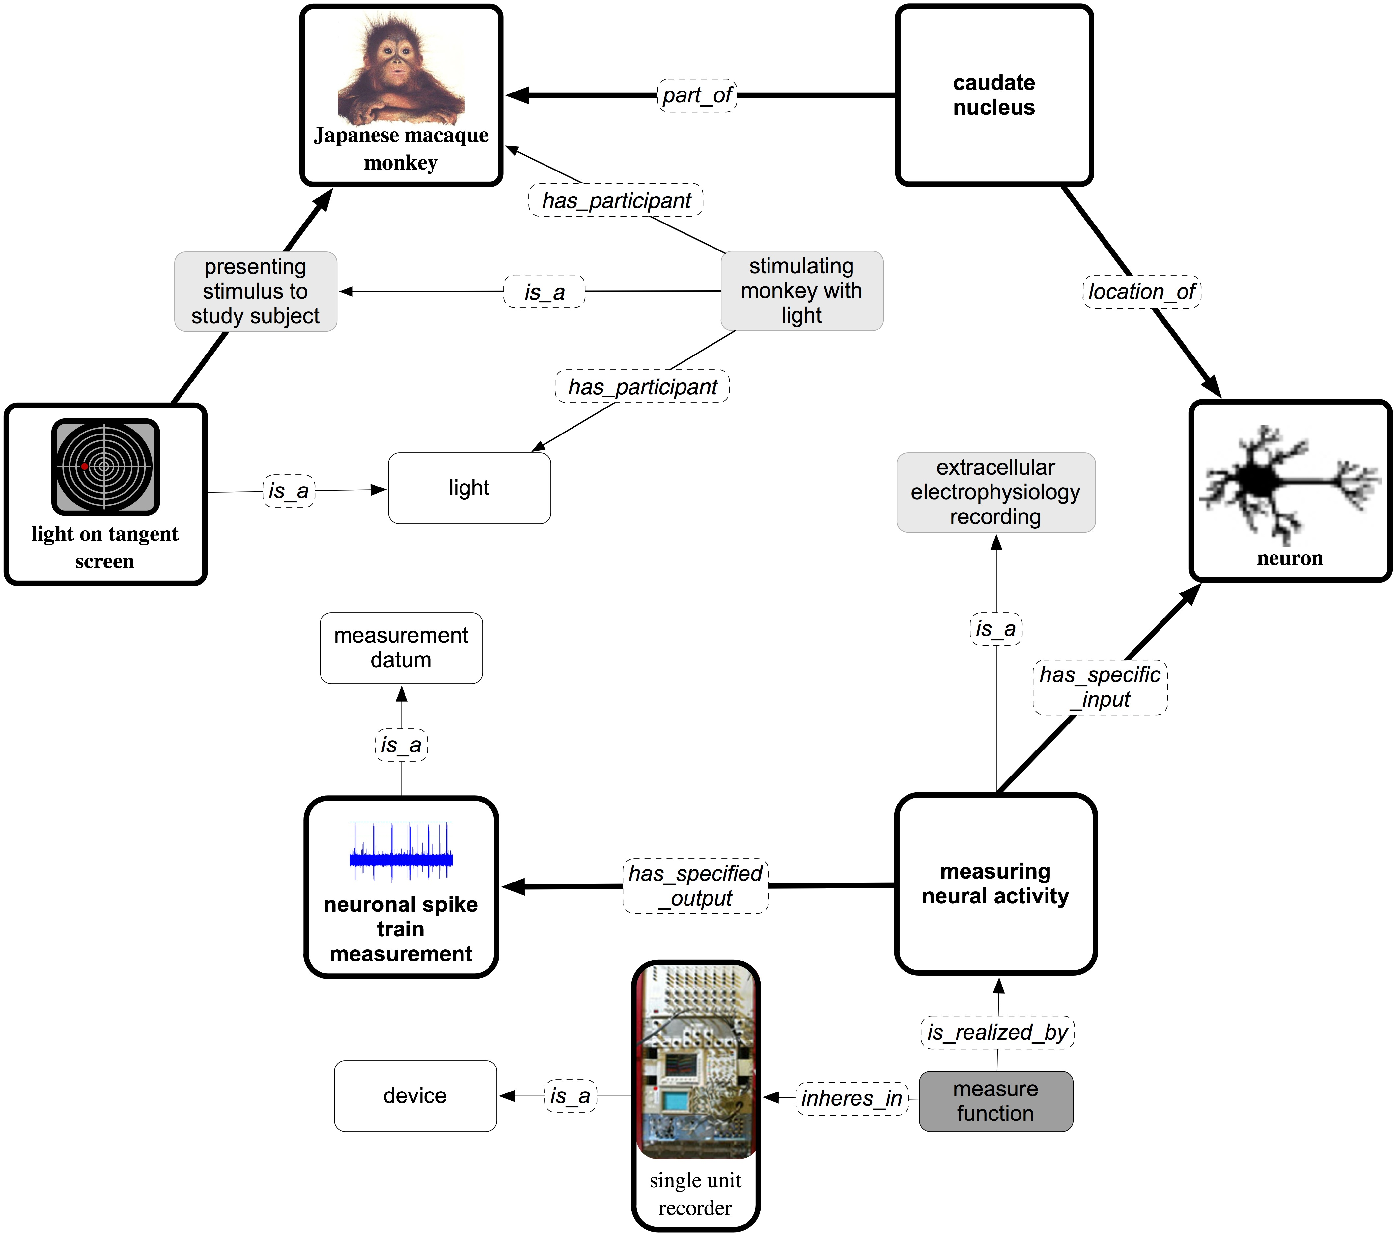

Figure 1. OBI modeling of a single trial in the neuroscience study. Processes in this experimental trial are shown in bold (e.g., stimulating monkey with light, measuring neural activity), while terms for objects, roles, or processes (e.g., macaque, stimulus role, extracellular electrophysiology recording) are shown in regular font and relationships are in italics (e.g., is_realized_by, has_specific_input). Diagrams such as those for the light, or the monkey, or the neuron indicate that those are instances of the ontological classes.

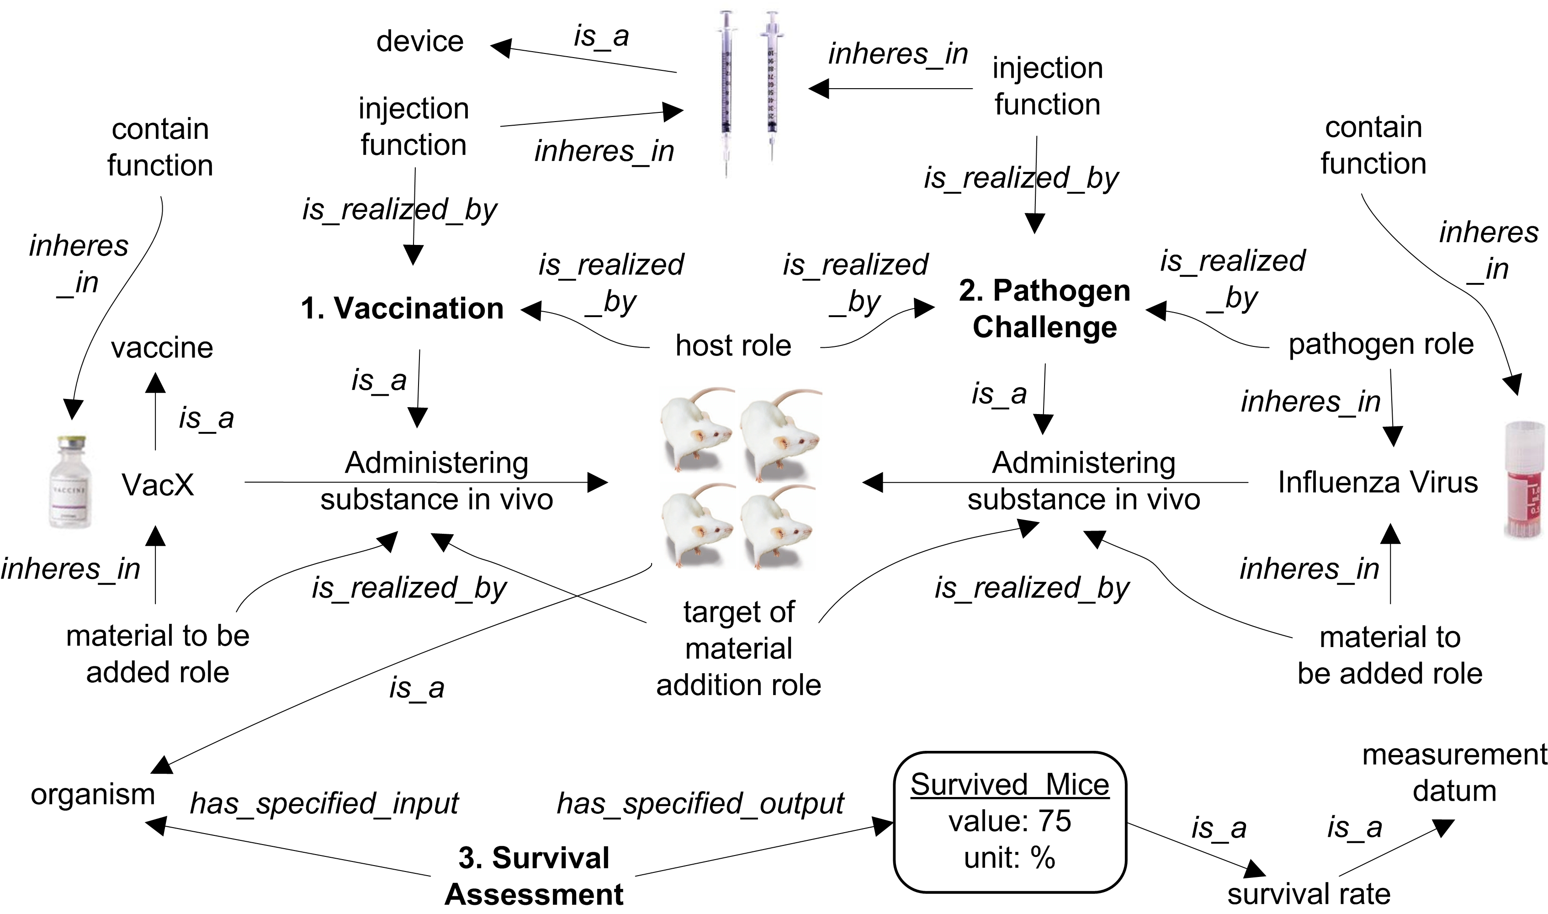

Figure 2. OBI modeling of vaccine protection investigation.

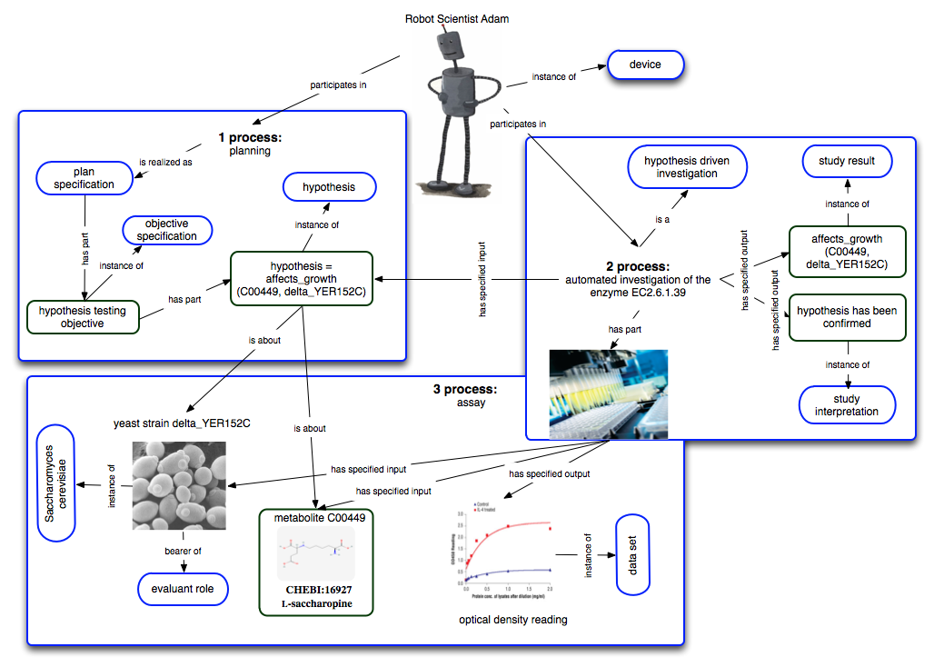

Figure 3. OBI modeling of vaccine protection investigation.

