An Ontology of Biomedical Investigations

Authors
The OBI consortium (in alphabetical order): Ryan Brinkman¹, Bill Bug², Helen Causton³, Kevin Clancy, Cristian Cocos, Mélanie Courtot¹, Dirk Derom⁴, Eric Deutsch⁵, Liju Fan⁶, Dawn Field⁷, Jennifer Fostel⁸, Gilberto Fragoso³, Frank Gibson⁹, Tanya Gray, Jason Greenbaum¹⁰, Pierre Grenon, Jeff Grethe⁷, Yongqun He¹¹, Mervi Heiskanen, Tina Hernandez-Boussard⁷, Philip Lord²⁰, Allyson Lister^{12,20}, James Malone, Elisabetta Manduchi, Luisa Montecchi, Norman Morrison³, Chris Mungall¹³, Helen Parkinson³, Bjoern Peters¹⁰, Matthew Pocock, Philippe Rocca-Serra³, Daniel Rubin, Alan Ruttenberg¹⁴, Susanna-Assunta Sansone³, Richard Scheuermann¹⁵, Daniel Schober¹⁶, Barry Smith¹⁷, Larisa N. Soldatova¹⁸, Holger Stenzhorn, Christian J. Stoeckert Jr.¹⁹, Chris Taylor³, Randi Vita¹⁰, John Westbrook, Joe White, Patricia L. Whetzel⁷, Stefan Wiemann, Jie Zheng¹⁹

Affiliations
¹BC Cancer Agency, Vancouver, Canada; ²National Center for Microscopy Imaging Research, UCSD, CA, USA; ³The European Bioinformatics Institute, Cambridge, UK; ⁴Victoria University of Wellington, New Zealand; ⁵ISB, Seattle, WA, USA; ⁶Ontology Workshop, LLC, Columbia, MD, USA; ⁷Stanford University Medical School, Stanford, CA, USA; ⁸SRA Global Health Sector, Durham, NC, USA; ⁹Abcam plc, Cambridge, UK; ¹⁰La Jolla Institute for Allergy and Immunology, La Jolla, CA, USA; ¹¹University of Michigan, Ann Arbor, USA; ¹²Centre for Integrated Systems Biology of Ageing and Nutrition, Newcastle University, UK; ¹³Lawrence Berkely National Lab, Berkely, CA, USA;¹⁴Science Commons, Cambridge, MA, USA; ¹⁵Southwestern Medical Center, USA; ¹⁶IMBI, University Medical Center, Freiburg, Germany; ¹⁷University at Buffalo, Buffalo, NY, USA; ¹⁸Aberystwyth University, Wales, UK; ¹⁹University of Pennsylvania School of Medicine, Philadelphia, PA, USA; School of Computing Science, Newcastle University, UK

Abstract
The goal of OBI is to enable a formal representation of biomedical investigations that captures the experimental evidence on which their findings are based. The scope of OBI includes: materials made in and produced for investigations, research objectives, experimental protocols, roles of people in investigations and processing and publication of data gathered in investigations. The OBI project is a joined effort of the 19 research communities. OBI follows the principles laid out by the OBO foundry, and integrates tightly with other foundry candidate ontologies such as GO and ChEBI , whose terms are used to describe biological reality. The paper reports the results of three years development, presents the key OBI classes and relations, and demonstrates applications of OBI for four use cases. The paper also discusses the challenges the OBI project faced with and possible solutions. The use of OBI by the scientific community to represent or annotate their investigations within electronic data resources will facilitate interdisciplinary data synthesis, enable access to their data on the semantic web and improve third-party understanding of information related to life-science and clinical investigations. Use of OBI will allow comparison of experimental data from the wide array of scientific disciplines represented by domain experts in the OBI consortium.

Introduction
Information derived in biomedical investigations is increasingly being captured in structured electronic format and made available through public database resources as a complement to its reporting in traditional print journal publications. For many years, different formats to describe experiments have been developed in parallel, as research communities tended to focus on one type of methodology at a time [1, 2]. However, even though the ‘many communities – many standards’ development methodology meant that each community could create something focused on their needs, these standards overlapped - the common features of different investigations were being described in different ways. This situation lead to difficulty for representing cross- disciplinary experiments, and for those who would do integrative meta-analyses that spanned the work of multiples scientific communities, such as translational medicine efforts. In order to work with different database systems, key features of an investigation need to be described in a common, unambiguous manner. Minimally, this requires shared standards for the representation of the source and preparation of samples used in an investigation, assay methods, and data analyses applied in the course of coming to published conclusions.
To address this need, here we report the development of the Ontology for Biomedical Investigations (OBI; http://purl.obolibrary.org/obo/obi.owl), designed to enable consistent representation of investigations across the full range of experiment-based biomedical research. For those unfamiliar with the use of ontologies OBI functions first as a well-designed terminology. As such, OBI provides a standardized vocabulary for entities in biomedical investigations and a textual definition for each entity and is therefore suitable for term or keyword based indexing of data associated with investigations. OBI goes beyond being simply a terminology by also including logical definition that formally describe how different entities relate to each other, and which support more powerful computational use, such as enhanced querying capability. The terms and relations in OBI were defined in an open, community-driven process, which follows the principles promulgated by the Open Biomedical Ontology (OBO) Foundry [3]. With participation from 19 different experimental communities, OBI strives for a cross-disciplinary consensus covering investigations involving basic, translational and clinical research.
The ability of OBI to represent investigations within electronic data resources will enable multiple applications. OBI allows representation of entire investigations, thereby placing individual data items such as measurements into context, and enabling third-party understanding of the reported data. OBI provides a rich query language for data repositories that apply it, enabling semantic web searches. OBI enables tools for standard compliant annotation of data by community scientists, including the capacity for error checking, while at the same time hiding the complexity of working with a logical description language from the end-user. Also, OBI enables the construction and consistency checking of workflows. Several such applications of OBI are used in practice or are in the final stages of development, and their specific needs are covered well by OBI. Enhancements of OBI in terms of breadth and depth of coverage are driven by the participating consortium members, and we want to welcome and encourage broader community participation in this effort.

Results

Development process and framework
OBI was developed to be complementary to, and integrated with, a framework of existing ontologies in the biomedical domain. For example, if an investigation includes taking a human tissue sample from a specified anatomical entity, the definition of the anatomical entity is referenced from the Foundational Model of Anatomy [4]. New terms are only created in OBI if they denote entities specifically related to investigations, such as the process of collecting a specimen from an organism.
Re-using existing ontologies and integrating them into a single framework poses several challenges. Contacts from OBI to other ontology development activities were necessarily established early, and OBI became one of the driving projects in the establishment of the OBO Foundry [3]. The OBO Foundry oversees and maintains a set of key principles designed to facilitate integration of biomedical ontologies. Any ontology developed within the OBO Foundry is made freely available in a standardized format, is developed with broad representation and input by the relevant communities, and is orthogonal to the domains covered by other OBO Foundry ontologies. This latter principle ensures that disparate communities do not develop multiple terms referring to the same entity. OBI will tie together entities from different OBO Foundry projects and apply them to the annotation of biomedical investigations.
To provide a foundation upon which to anchor OBI development, BFO [5] was used as a top level classification of entities. Relations were taken from the OBO relations ontology (RO, [6]), including relations which have been proposed for inclusion into RO but are not yet released (RO_proposed). When new relations were defined between classes in OBI, these were based on RO relations wherever possible. OBI-created relations are in effect proposals for inclusion in RO. These upper-level ontologies ease interoperability of OBI terms with external ontologies based on the same foundation. BFO and RO were chosen specifically as they were most aligned with other OBO Foundry candidate ontologies.
Terms were collected by each of the 19 community within the OBI consortium. In addition, term submissions were also accepted through a public tracker. Before terms were incorporated as entities into OBI, they were checked to ensure that they are in scope, not already present, and sufficiently well defined.
A detailed description of the import processes, the metadata and ID policies, the distributed development process, conflict resolution, the release process, tools used for versioning and the use of automated reasoners is given in the Methods section.

OBI classes and relations
The OBI 1.0 release has XXX classes and YYY relations. The high level class organization of OBI is depicted in Figure 1. The upper level consists of the BFO classes material entity, process, role and function, and the class information content entity. Throughout this text, italics are used to indicate a term denoting a class, instance or relation in an ontology. Supplemental Table 1 identifies the source ontology, identifier, and formal textual definitions for each term. For readability, the plural of the class label is sometimes used in the text, but the official OBI class labels are singular. This section gives an overview of several higher-level OBI classes that outline the scope of OBI and illustrate the modeling approach.
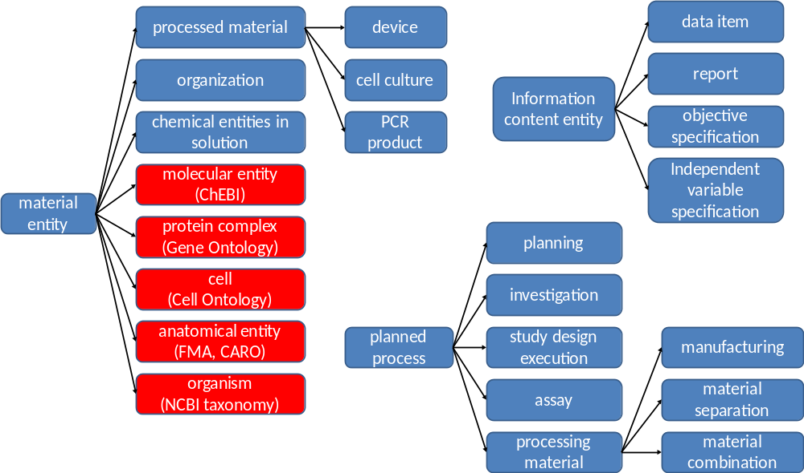
Figure 1 – High level structure of OBI classes

Material entity
The class material entity encompasses all entities made up of matter. It was created in BFO at the request of OBI developers as the union of object, object part and object aggregate. Use of these BFO classes is appropriate if all entities are of similar scale and a simple representation of granularity at three levels is adequate. However entities relevant to the domain of biomedical investigations span sizes from molecule to ecosystem. Depending on the level of granularity chosen, these might be considered unitary objects or aggregates of smaller parts. By using material entity as our root class we avoid committing to the currently inadequate granularity schema in BFO.
Several subclasses of material entity are imported from external ontologies: Classes under organism are imported from the NCBI taxonomy [7], anatomical entity and its subclasses are imported from the Foundational Model of Anatomy [4] or the Common Anatomy Reference Ontology [8], and the molecular entities hierarchy is imported from ChEBI [9]. Based on these imports, OBI-specific sub-classes were constructed. For example, chemical solution such as a PBS buffer can be defined by referencing the molecules from which they are made of (defined in ChEBI), and specifying their molecular concentration as a quality. Table 1 gives the complete class definition of PBS buffer.
Table 1: Example meta data for class OBI_0100046. * indicates mandatory meta data.
Annotation property | Example | Useage
Preferred Term* | phosphate buffered saline solution | The concise, meaningful, and human-friendly name for a class or property preferred by the ontology developers that reflects community usage, or disambiguates the term if necessary
Definition* | Phosphate buffered saline (abbreviated PBS) is a buffer solution commonly used in biochemistry. It is a salty solution containing sodium chloride, sodium phosphate and potassium phosphate. The buffer helps to maintain a constant pH. The concentration usually matches the human body (isotonic). | The official OBI Aristotelian definition, explaining the meaning of a class or property
Definition editor* | PERSON: Philippe Rocca-Serra; PERSON: Tina Boussard; PERSON: Melanie Courtot | The name of the editor
Definition Source* | WEB: http://en.wikipedia.org/wiki /Phosphate_buffered_saline | An unambiguous and traceable reference to the source of the definition
Curation Status* | Ready for release | The curation status of a class or property, one of uncurated, meta data incomplete, meta data complete, pending final vetting, ready for release
Example | PMID: 16279733.Dent Mater J. 2005 Sep;24(3):414-21.PBS buffer solutions with different pH values can change porosity of DNA-chitosan complexes. | A phrase describing how a term should be used
Alternative term | PBS buffer | A synonym for the class or property

Material entities that come into existence as the result of intentional acts are processed material. For example a blood specimen collected in a clinical protocol is a processed material as is a device such as a flow cytometer which is manufactured with the intent to perform a function. Some material entities such as a protein can be produced by intentional acts, for example in a recombinant expression system, but are also naturally expressed in an organism. In order to avoid a class hierarchy with multiple inheritance which can become difficult to maintain consistently, processed material is logically defined with necessary and sufficient conditions, namely as exactly those material entities that are the specified output of a process of material processing. When OBI is run through an automated reasoner, any class for which every instance meets this condition will be inferred as a subclass of processed material.

Process
OBI’s definition of material processing is an example of a planned process. Such processes are initiated by an agent (typically a person) in order to achieve a certain goal. OBI captures such goals by defining a subclass of information content entity – objective specification – subclasses of which specify these goals. An example of such a specification is the header “Hybridize RNA to chip” in a manuscript describing a microarray gene expression protocol [10]. A process that is carried out to meet an objective specification is a planned process., The majority of processes represented in OBI belong to this class. OBI defines the relation achieves planned objective as holding between an instance of planned process and the corresponding objective specification.
It is OBI’s scope to represent successfully completed investigations, a type of planned process. A successful investigation may produce negative results, but processes that result in falsified data or during which there were gross errors are considered to be out of scope for OBI. For example, if a polymerase chain reaction (PCR) assay fails to detect viral DNA in a blood specimen that assay is in the scope of OBI. However, if controls performed as part of the PCR assay indicate that an error occurred then OBI would no longer consider the process an instance of a PCR assay.
Near the top of OBI’s process hierarchy are several classes that represent realizations of broad objectives, including material component separation, instances of which are processes such as those where a cell sorter is used to separate out CD8+ cells from a blood specimen, material combination, instances of which are processes such as when a chemical is added to a cell culture.
While processes can have many participants, objective and plan specifications typically explicitly identify participants that are particularly important. OBI defines two relations, has specified input and has specified output, relating process instances to such participants. Other than the fact that these participants are listed in plan specifications, we can infer that specified outputs must necessarily be present at the end of the planned process in which they participate in order to achieve its objective specification. Specified inputs are participants identified in the plan specification such as specimens, reagents, devices or workers which exist before they start participating in the planned process, and which are not created during the process. Figure 2 gives an example how two planned processes, drawing blood and measuring the glucose concentration in it, are modeled in OBI.
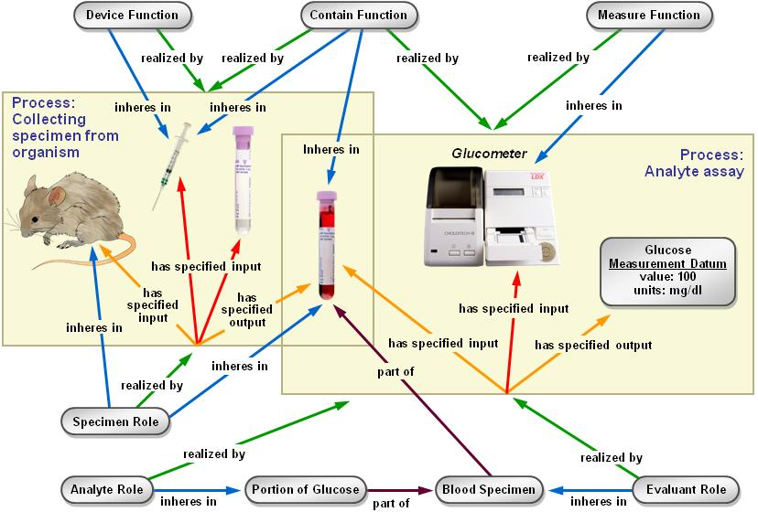
Figure 2. Measuring the glucose concentration in blood. The large boxes represent processes and contain their participants. The collecting specimen from organism process takes place first. In this process, a syringe is used as a device to draw blood from the mouse which bears the specimen role. At the end of this process, a tube contains the blood specimen. In a second process, the blood specimen will be used as evaluant in an analyte assay in which the concentration of glucose in the blood will be measured. A glucometer device is used to make this measurement. The analyte role inheres in the glucose molecules scattered throughout the blood specimen. The objective of this planned process is to determine the concentration of the analyte (glucose). This modeling of a specific use case is used as the basis for generation of pattern templates [ref QuickTerms] allowing us to speed up the addition of similar analyte measuring assays.
Information processing is a subclass of planned process distinguished by having information as the input and output of the process. For example, the OBI class Kaplan Meier analysis is defined as a process which takes as input data item and performs a survival analysis. Kaplan Meier analysis typically achieves two objectives; both to analyse longitudinal data and perform survival analysis. A hierarchy of planned processes based on their achieved objective permits the user to see immediately how information processing processes can be applied to achieve an objective specification.
Information artifacts
Any ontology of biomedical investigations needs to cover entities related to information, such as the collected data, design of the investigation, and reports of investigation results. Such entities were not originally in the scope of BFO, and they pose challenges to a realism-based ontology because of X. To facilitate the inclusion of information related entities in OBI while at the same time ensuring that this work will be generally usable outside of the context of biomedical research, the Information Artifact Ontology (IAO, [ref]) was created to serve as a high-level layer between BFO and OBI. IAO is maintained by OBI developers together with other scientists interested in modelling information. It encompasses terms such as plan specification and objective specification, which capture the information content of a plan or objective as it could be found, for example, as written down on a piece of paper. IAO also includes report such as the content of a journal article or a patent application, report elements such as report table, report figure, scatterplot, and software.
Terms for information artifacts that relate specifically to investigations are maintained in OBI. They include protocol and study design, which are types of plans specifications for either a single procedure or an entire investigation. An important part of many study designs is the identification of dependent and independent variables. Also central to an investigation is the data generated. This includes measured data item, which is obtained directly in an assay, and derived data item, which is processed through further data transformations. The information generated as the outcome of an investigation is captured by study result and study interpretation, which follows the distinction typically made in journal articles between the Result and Conclusion section.

Roles and Functions
A role is defined in OBI through two properties: first, by the entity which bears the role, and second by the process through which the role is realized. A role is not essential to the entity bearing the role, but rather is defined by the circumstances under which the role is realized. For example, humans can bear specific roles relating to investigations. These roles include the principal investigator role, realized by leading an investigation, and the author role, realized by writing a report. Additionally, OBI contains roles defined by the study design of an investigation, such as study subject role which can inhere in humans, plants, sections of tissue, molecules, or any other material entity which the results generated in executing the study design are about. Similarly, the reference role can be borne by different entities specified in the study design that are used included to support the observation of similarities, differences, relative magnitude of change for other entities being studied, such as a placebo. OBI also contains roles defined in specific experimental procedures, such as the cloning insert role or reagent role.
Functions differ from roles in BFO in that they are intrinsic to an entity based on its structural organization[11]. Functions within the scope of OBI inhere in devices created for research purposes. For example, a polysterene tube and an animal cage have the contain function, which maintain certain material entities in space, while a preparative centrifuge has a separation function is to separate material entities.

Organization
Organizations need to be modeled in OBI to identify for example Affymetrix as the manufacturer of a certain device or reagent. Placing organization into the BFO hierarchy proved controversial, as good arguments were made for treating it either as a material entity or an immaterial kind of social construct (related to other legal entities, which are not currently well described in BFO). To end this controversy, we defined an organization by all the things that are true about it: an organization is a continuant entity which can play roles, has members, and has a set of organization rules. Members of organizations are either organizations themselves or individual people. Members can play specific organization member roles as determined by rules specific to the organization.

Use Cases
In order to evaluate OBI, we performed tests of the ontology against four use cases. The first uses the ontology to enable workflow construction via restrictions placed on ontology classes, the second explores query mechanisms on a database enabled by the ontology, the third tests the coverage OBI provides for annotating entire investigations, and the fourth uses the ontology to annotate experiments in a standard compliant fashion at the community level.

Constructing a Genomic Data Analysis Workflow
Our first use case focuses on the annotation of a GenePattern software module for the purposes of creating a data analysis workflow. GenePattern is a powerful scientific platform which provides interoperable access to over 90 genomic analytic and visualization tools including GeneCluster, Matlab, Bioconductor and many others [12]. Of particular interest to users of this resource is the ability to define a protocol using generic terms that can give appropriate options for each step.

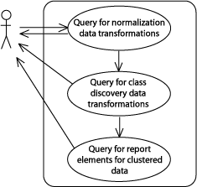
Figure 3. The GenePattern use case for defining a workflow using OBI classes.The figure illustrates how a user would create a workflow from data transformations selected based on queries of the OBI ontology. The queries are implemented as three defined classes in OBI, namely normalization data transformation, class discovery data transformation, and clustered data visualization. The respective child classes of these are returned as choices for the user.
For the use case considered here, the user wishes to define a workflow in which the steps 'normalization' then 'class discovery' occur and then finally, visualization of these results. Figure 3 illustrates the workflow steps for this use case. In OBI, data transformation classes are minimally defined by the following elements: the input data; the output data produced from this process; and the objective specification which the data transformation is used to achieve. Note that within OBI, data transformations can have more than one objective, reflecting the fact that a single process can be used to achieve different goals. For this query, data transformations with the objective of normalization and, subsequently, classes with the objective class discovery are required. Finally, data visualization classes that are able to render clustered data (i.e. the output of a class discovery data transformation) are required to satisfy the use case. This is made possible because the output and input data types are modeled explicitly in OBI and relevant restrictions placed on each data transformation class. To complete this workflow, the query of data visualization classes where input data type is clustered data is used.
Importantly, the user is able to define generic protocols referencing OBI concepts, instead of specific identifiers such as LSIDs, for the workflow steps. This provides the advantage of a rich set of results (e.g. all class discovery data transformations) and ensures only valid classes that satisfy the query are returned (e.g. only those data visualizations that are able to render clustered data), filtering out the invalid and thereby ensuring that answers are accurate.

Use-Case #2: Querying a database of curated investigations
As a second use case, we draw on OBI to construct queries of the Immune Epitope Database (IEDB, [13]), which is devoted to cataloging information about experiments characterizing epitopes targeted by adaptive immune responses. Information in the IEDB is manually curated from the literature and currently encompasses over 286,000 experiments characterizing over 51,000 epitopes. The IEDB website provides the ability to query the curated data using a form based ‘fill in the blank’ interface. However, this interface necessarily limits the kinds of questions users can ask to those values used in the database
Query class expression:
‘journal article’ and is_about some (investigation
and has_part some (assay and has_specified_output some (‘measurement datum’ and is_about some ‘IFN-gamma production’)
and has_part some (assay and has_specified_output some (‘measurement datum’ and is_about some ‘T cell mediated cytotoxicity’))
Classified results:
XXXX…

Figure 4 – The IEDB use case for formulating database queries using OBI
For the use case considered here, the user wishes to perform queries that are not directly possible on the IEDB website, namely for publications in which the journal article content describes investigations in which both cytokine responses and T cell mediated cytotoxicity were measured. An export of the majority of IEDB data into instances of OBI in OWL format has been completed [14]. This export enables answering any question that can be formulated as a class expression in OWL, or as a SPARQL [15] query, using the vocabulary provided by OBI and its imported terms. For this specific use case, the user constructs a query class as shown in Figure 4. When running an automated reasoner on data exported from the IEDB in OWL format (Supplemental file X), instances of journal articles that meet the query criteria are classified as instances of the query class.

Use-Case #3 Representing a clinical investigation
Investigations typically tie together individual assays in a larger process which crucially impacts how measurements can be interpreted. It is OBI’s goal to represent the different parts of investigations that impact data interpretation, such as enrollment of study subjects or the types of controls used. OBI also aims to capture information about investigations that is useful for analyzing regulatory compliance, adherence to ethical standards for treatment of animals and human subjects, and determining the scope of the consent under which data was gathered.
This use case is designed ot test whicih aspects can be covered in OBI, and is based on a study reported by [ref] with an additional reference group added. Figure 5 illustrates the use of OBI classes, and Supplemental File X contains the example modeled in OWL.. Briefly, the investigation consists of a planning phase in which the study design is created. The study design goes through a approving process, before the execution of study design phase begins. In the execution phase, study subjects are recruited, and assigned to cohorts. The independent variable is treatment with fucoidin, using aspirin as a positive control, and guar gum as a placebo. The dependent variable is measurements of the time it takes blood to clot (prothrombin time). The measured data undergoes a statistical test which outputs a p-value evaluating differences between the three cohorts, which is the ultimate study result. The study design execution is followed by a study result interpretation phase, which leads to study conclusions. Finally, the investigation is documented in a report, which is ultimately published as a journal article.
ref = Irhimeh MR, Fitton JH, Lowenthal RM. Pilot clinical study to evaluate the anticoagulant activity of fucoidan.Blood Coagul Fibrinolysis. 2009 Aug 18. [Epub ahead of print]
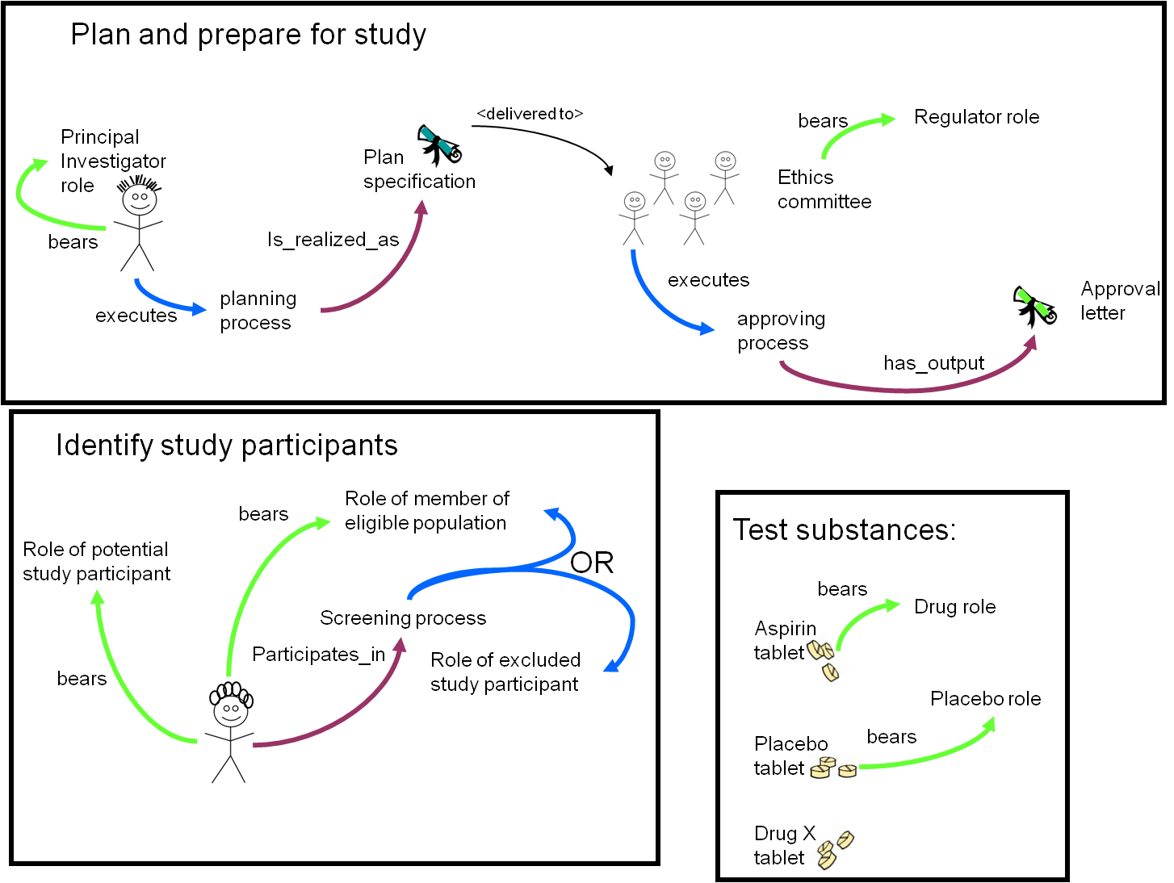

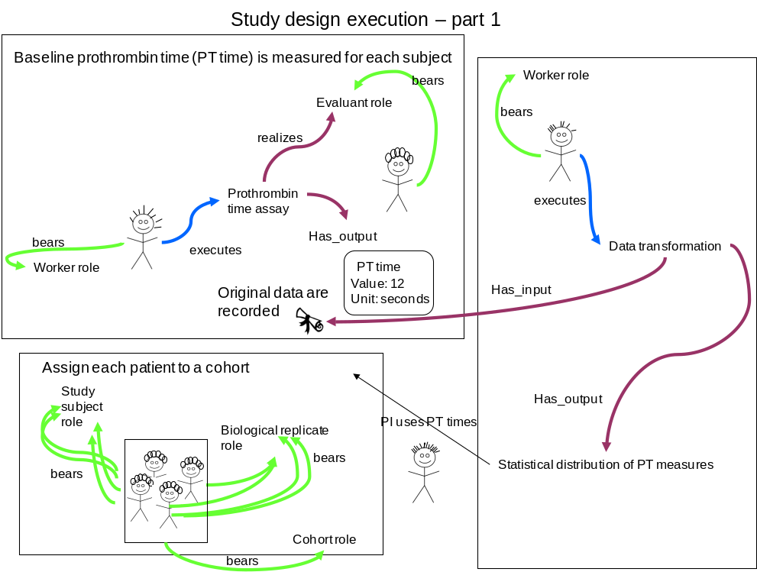
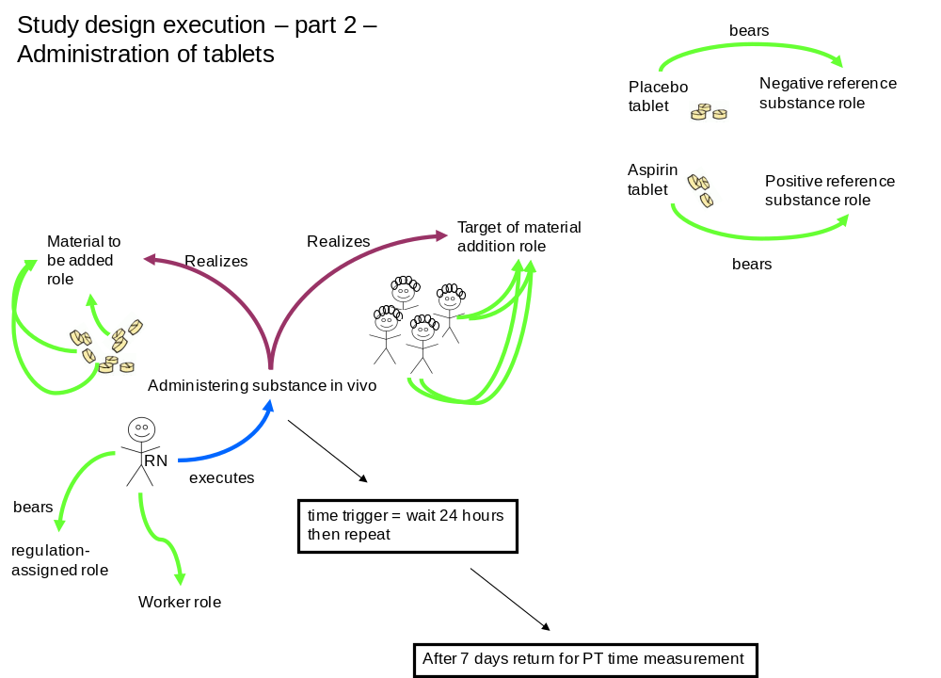
Figure 5: The clinical investigation use case to test OBI coverage. In panel 1, the principal investigator plans the study, secures approval from the institutional ethics committee, and selects patients using inclusion and exclusion criteria defined in the study. The principal investigator has assembled the materials for the study, the three tablets which have been manufactured to have similar appearance so that the study personnel, the agents who carry out the study, are blinded to each treatment. In panel 2, a baseline prothrombin time is measured for each participating patient. This produces original measured data which are given to a statistician who carries out a data transformation to produce a statistical description of the PT times. The PI uses this information to assign patients to cohorts with similar ranges in PT. In panel 3, a registered nurse (RN) gives each subject a tablet every day for 12 days. At the end of this time the PT time is measured and used for analysis for significant changes associated with the three regimens. The results are then reported in a journal article. By representing this use case in OBI we are able to associate the details of the study design and execution with the journal article reporting the conclusion. OBI captures the details of tablet appearance, tablet composition, role of the tablets (test substance, positive control, negative control), and the roles of the study subjects. The qualifications of the study personnel (registered nurse is a qualification regulated by the government; the PI has secured approval from an institutional ethics committee) are also captured so that the data can be re-used by others without questioning the appropriateness of the study execution. The time trigger allows OBI to refer to sequential events in the study (which of the PT time measurements were taken before or after the treatment, the relative timing of any adverse events noted by the RN). The data associated with each patient and the details of the data transformation can also be captured in OBI.

Use Case #4: Enabling tools for standard-compliant annotation of experiments
Biology has become a data intensive field of science through the emergence of high throughput experimental techniques. This has posed new challenges, as the data gathered is only useful when decorated with contextual experimental information. One solution to this problem is the use of professional curators who annotate experimental data after it is published in specialized databases. However, that process is expensive, and often not all information necessary to understand experimental information is published. An alternative approach is to enable annotation of experimental data at the source, by those investigators who are generating the data. The crux here lies in achieving consistent and sufficient recording of information while not placing too high a burden on the experimentalists annotating the data. For this purpose, communities have established checklists of minimal information that are required to report an array of experimental techniques including microarrays [16] and proteomics [17]. However, achieving consistency across such different community reporting standards requires bringing them together in a common framework. This is the goal of the MIBBI project [18], which aims to standardize the syntax and semantics of data gathered according different minimal information checklists.
In this specific use case, OBI is applied in the definition of a minimal information checklist according to MIBBI requirements, followed by completing such a checklist for a specific experiment. This functionality is implemented in a suite of tools available from http://isatab.sf.net. As shown in Figure 6, the ISAconfigurator tool enables defining a checklist following MIBBI requirements in the ISA-Tab syntax [19]. Data entry fields (ISA-Tab elements) can be configured to consume ontological artifacts, available from brokering services such as OLS [20] and Bioportal [21], for example, the instrument class and its children from OBI. Once community vetted the implementation of the checklist can be distributed and completed using the ISAcreator tool.
Figure 6: Using ISA-configurator to define and ISAcreator to complete minimal information checklists

Discussion
OBI is a large-scale, community-driven ontology developed to merge representations of investigations across disparate biological disciplines as well as to maximize the re-use of complementary ontologies outside of the scope of OBI. OBI describes devices, specimens, planned processes, roles, functions and information content entities that comprise biomedical investigations. In the same way that GO has opened up a whole new level of searching and analysis via the annotation of genes and gene products, OBI provides a method of tagging experimental descriptions with terms that are both understandable to the human reading about the experiment and the computer program designed to analyze thousands of experiments. As demonstrated in the use-cases, OBI represents entire investigations, provides a rich query language for annotated data and enables tools that construct experimental workflows and allow community annotation of experimental data. A number of applications for OBI are currently under development. Four examples are of particular relevance to the scientific community. Firstly, existing reporting standards are implementing the use of OBI terms. The MGED Society is in the process of migrating from the MGED Ontology to OBI. Further, the ArrayExpress database will be converted to the use of OBI Experimental factors. Secondly, OBI enables cross-database queries. Notably, if multiple information resources are mapped to the same underlying ontology, queries can then be formulated across the different resources. For example, once the OWL export of the IEDB is integrated into the Neurocommons triple store [22], it becomes possible to answer queries linking incorporated databases such as GO. A query could discover known immune epitopes in kinases by linking a protein identified as the source of an epitope in the IEDB with GO Annotations for that protein [23]. Similarly, the BioInvestigation Index database (http://www.ebi.ac.uk/bioinvindex/) aims to move away from technology-centric data silos and towards metadata capture irrespective of experiment type. Assembly of candidate datasets for meta analysis will occur instead through MIBBI compliance and reliance on OBI. This method potentially allows users to search repositories more effectively, such as the identification of all experiments focusing on protein profiling irrespective of the technique used.
Thirdly, OBI can aid the identification of errors in annotations. If a model of an experiment is created using OBI, inconsistencies in annotations can be discovered through the use of automated reasoners, as described earlier in this document. Such error identification has already been used in the development of the IEDB. Finally, OBI may be used to convert and extend GO evidence codes. Evidence codes indicate the basis, or proof, upon which statements such as “protein A interacts with protein B” are made. They provide a high level classification on the type of experiments, computational analysis, or quality of annotation performed. Through the use of OBI, these annotations can be made much more expressive, in principle allow any kind of detail to be captured.
Several alternative efforts for formal representations of investigations exist. EXPO [24] and the MGED Ontology [25] are also formal ontologies created to model experiments. In comparison the broad scope of OBI, however, these ontologies are more community specific, and developers from both projects are now actively participating in OBI development. Other alternatives are provided by controlled medical terminologies, such as SNOMED [ref] and LOINC [ref]. These provide broad coverage of existing tests, and are in widespread practical use. Contacts have been made in order to explore mapping of codes from these terminologies into OBI classes. Such a collaboration would aid developers on all sides; the coverage of OBI would be greatly enhanced, while the other terminologies would gain a deeper semantic meaning based on the more expressive definitions used in OBI.
OBI is the first OBO Foundry ontology to address the challenge of producing an orthogonal ontology in the face of many overlapping existing ontologies. As such, a number of challenges were encountered. Firstly, working with very large ontologies such as the NCBI Taxonomy [3] can be difficult and sometimes impossible with current technology. There are technical challenges such as running out of memory or processing power when attempting to load very large ontologies into the most commonly-used editors. Semantic challenges are also faced when importing large or incompatible ontologies in their entirety; such large-scale imports could lead to inconsistencies or unintended inferences. To address this challenge, the OBI Consortium developed the MIREOT import mechanism [ref]. MIREOT defines how to partially import an external ontology into OBI or any other ontology implementing its guidelines, providing access to the wealth of terms available in very large external ontologies.
Secondly, working with ontologies that are not necessarily aligned with OBI’s design. Such misalignment may occur if BFO is not used as a ULO, or OWL-DL is not used as a language. Such cases must be studied individually, but there are a number of solutions that exist. For instance, if the ontology to be incorporated within OBI is associated with the OBO Foundry, then eventual alignment with BFO is required, and OBI can work with the developers of that ontology to hasten compliance. To address incompatibility of language rather than semantics, conversion to OWL-DL may be possible and indeed trivial. If the ontology to be aligned is written in OBO, for example, there are converters between the two formats [ref]. If all other procedures fail, the use of MIREOT on an ontology of any size can provide a solution. A third challenge was the past incompatibility of BFO with information artifacts such as a text document or a TIFF image. When it became apparent that BFO did not contain the necessary concepts to describe them, IAO was developed to include these information artifacts within the BFO structure.
Several challenges remain that are best addressed in the OBO foundry network. Specifically, there is a need for cross-species anatomical terms. For example, descriptions of experimental protocols working with human or mouse blood tend not to distinguish between the two. However, there is no generic term ‘blood’ that can be used for this purpose, but only e.g. ‘human blood’ in the FMA. Resolving this issue is outside the scope of OBI, and working through the foundry provides modes of communication.
Concerns that have been expressed about the use of OBI include questions over its complexity and seemingly non-standard terminology. A model, such as OBI, that is complete enough to describe experimental processes will necessarily contain some amount of complexity. However, there are ways of hiding such complexity from those who do not wish it. Tools such as ISACreator [ref] allow community scientists to create fully annotated investigations, while hiding the complexity of working with the ontology in OWL. Terminologies differ among communities, and OBI strives to ignore community-specific meanings and usages of widely-used terms by employing labels and definitions designed to avoid these confusions. This sometimes results in terms that do not sound “natural”, or terms that sound as though they were written primarily for computers. To address human accessibility without losing precision, OBI will employ, and users can request, annotation properties such as ‘alternative_term’. These properties provide a method for communities to provide a synonym for any OBI term to suit their needs and preferences.
There are many shared concepts for describing investigations across the entirety of the scientific community: there are protocols to be followed, analyses to be run and equipment to be used in the application of these protocols. OBI is the first semantically-meaningful model for describing these common structures, irrespective of experiment type. Without this shared description, data sharing and integration becomes difficult, reducing the ability of researchers to make use of data from other communities. Instead of many standards from many communities, the use of OBI either on its own or in conjunction with complementary formats such as FuGE or ISA-TAB, provides a new ‘many communities – one standard’ model that simplifies experimental description. Further, MIBBI checklists complement OBI, providing a structure against which researchers can compare their annotations and know when they have reached a minimal level of descriptiveness. OBI provides researchers with a single semantic standard for experimental description, thus easing computational analyses, encouraging collaborations, and aiding reproducibility of experiments.OBI is a framework upon which any scientific experiment can be modeled and described, providing a single point of commonality and an integration point across disciplines.
Formal representations of experiments and investigations are not limited to those ontologies already discussed. There are OBI not only provides a semantic description of experiments that can be used across scientific communities. FuGE [ref] (http://fuge.sourceforge.net) provides a schema expressed in both UML and XML that, like OBI, is generic enough to describe any scientific investigation. ISA-TAB is a complementary scheme that provides a more limited, but still generic, method of describing experiments in a tabular format. Both FuGE and ISA-TAB have been developed with OBI in mind as a major contributor of ontology terms. As such, both FuGE and ISA-TAB can be used to store experimental metadata in the more traditional XML or tabular formats while at the same time linking to OBI terms. However, neither are able to semantically capture experimental information. MIBBI (http://www.mibbi.org) provides a registry of experiment-specific checklists for researchers which, when complied with, makes it possible for others to understand and replicate their work [ref].

Acknowledgments
This work is partially supported by grant funding from the National Institute of Biomedical Imaging and Bioengineering, National Human Genome Institute, NIH ( R01EB005034, NIH P41 HG003619, HHSN26620040006C), EC EMERALD project (LSHG-CT-2006-037686), EC FELICS, MUGEN, BBSRC (BB/E025080/1, BB/C008200/1), NERC-NEBC, EU IP CarcinoGenomics (PL 037712), EU NoE NuGO (NoE 503630), CARMEN project EPSRC (EP/E002331/1), RC UK, the Michael Smith Foundation for Health Research JF’s contributions to this work are supported by the Intramural Research Program of the NIH and NIEHS, under contract HHSN273200700046U

Methodology

Choice of language and metadata conventions
OBI development has spanned the last 5 years and is achieved by means of weekly teleconferences and twice yearly face-to-face meetings. To date 19 communities and XXX researchers have been actively involved in the development process. The requirement for remote development required formalization of the concept meta data (per concept author, progress information etc) conventions as a lightweight meta data schema tailored to development needs. The complete specification of the metadata scheme is available [http://obi-ontology.org/page/OBI_Minimal_metadata].
OBI is developed using the Ontology Web Language 1.0 (OWL) [26] as OWL provides richer semantic support than OBO format - the other commonly used alternative in the biomedical domain. The OWL-DL subset was selected to gain maximum expressivity while allowing machine readabilility and use of reasoning for maintenance and development. The metadata scheme is implemented as OWL annotation type properties.
Concurrent development of OBI is necessary given the number of developers. OBI development is therefore organized into branches, with each sub-team working independently. Each branch is organized by subject area, such as data transformations, instruments or roles. Using this strategy tasks such as redundancy or inconsistency checking are manageable, as members in each branch can focus on a subset of terms.
We also required version control, offline development, use of different tools and editors, and script-based augmentation of the ontology content. A review of the existing collaborative ontology development tools failed to identify a single application that met OBI’s requirements. Instead, we split the ontology into multiple OWL files, one per branch, and rely on subversion to manage version control, distributed and offline development, as well as logging history for change management. The current development version of OBI is available from subversion at [ref].

Integration with existing ontologies
OBI was developed to be complementary to, and integrated with, a framework of existing ontologies in the biomedical domain. The description of experiments and investigations provided by OBI ties into the description of ‘natural’ biomedical information, as produced by the Gene Ontology for gene function [27] and others for example in for cell types and anatomy. Contacts to other ontology development activities were therefore established early, and OBI was one of the driving projects in the establishment of the OBO Foundry [3]. The desire to re-use existing diverse ontologies and integrating them into a single framework posed several challenges.
A top level ontology can provide guidance in how individual terms or whole ontologies interrelate and is useful when integrating external ontologies. BFO [ref] was chosen as the top level ontology as it is stable, publicly available in OWL syntax, aligned to existing OBO Foundry ontologies, and because there is a responsive community of developers and users of it [cite bfo-discuss list]. The OBO Relations ontology[ref] was chosen provide relations for OBI, and these were extended where required.
Four key ontologies are directly imported using the owl:import mechanism, including BFO and RO mentioned above, plus the ro_bfo bridge mapping to set ranges and domains for properties using BFO classes, and the Information Artifact Ontology (IAO, [ref]).
The owl:imports mechanism was not suitable for all external ontologies for several reasons: Firstly, current editing tools are not effective for working with very large ontologies such as the NCBI Taxonomy [3], therefore direct OWL import is impractical. Secondly, some ontologies used by OBI are activly develoed and may not be aligned with OBI’s design (e.g., not using BFO as an upper ontology, or not using OWL DL). Importing such ontologies as a whole could lead to inconsistencies or unintended inferences. Instead, the MIREOT import mechanism was developed [ref], which is based on the practice of the Gene Ontology (GO) [5] in that the intended meanings of classes remain stable. Even when the source ontology is repaired or reorganized, the effects of such modifications do not change the intended meaning of terms.

Term requests and triaging for concurrent development
The majority of terms in OBI were collected from the various communities that intend to use it. Term lists were solicited and collated by a representative of each community (OBI consortium page] and terms were also submitted through a public term tracker [(http://sourceforge.net/tracker/?group_id=177891&atid=886178). Each term was then assessed to determine if it was in the scope of OBI. For example, terms like ‘peptide’ and ‘antibody’ are needed to describe immunological experiments describe an experiment, but were available in ChEBI [9] and GO respectively, and were therefore imported (see above) rather than added to OBI directly.
Submitted terms were distributed to an appropriate OBI branch for curation and inclusion in the OWL file and interaction between branches was achieved through conference calls.

Release and Quality Control
Users require a traceable, static version of OBI. We have therefore established a monthly release process where multiple branch development OWL files are merged into a single file, which makes it easier to use and view the ontology in currently available tools. A second version of the ontology is released in which classes are organized in the inferred hierarchy. Each release is versioned, and is available from a specific URI using the release date as a tag. The most up-to-date file prior to monthly release is always available from http://purl.obolibary.org/obo/obi.owl. Releases of OBI are also uploaded to the NCBO BioPortal [28] and the OBO Foundry repository [3].
Checks are made prior to release to assure compliance of the released version with OBI policies. Specifically, classes are identified that do not comply with the minimal metadata policy, have invalid OWL syntax or lead to inconsistency when reasoning using Pellet [29] or Fact++[ http://owl.man.ac.uk/factplusplus/]. Identifier format and deprecation policies are also enforced. OBI identifiers are prefixed with “New classes are automatically assigned a permanent identifier in the format OBI_0000001” on their first release. Similarly, the release process verifies that all IDs that were present in the previous release are still in use. This conforms with the GO deprecation policy that OBI has adopted. Deleted classes are moved under the ObsoleteClass in the OBI hierarchy and stored in a separate file.

References

1. Jones, A.R., et al., The Functional Genomics Experiment model (FuGE): an extensible framework for standards in functional genomics. Nat Biotechnol, 2007. 25(10): p. 1127-33.
2. Spellman, P.T., et al., Design and implementation of microarray gene expression markup language (MAGE-ML). Genome Biol, 2002. 3(9): p. RESEARCH0046.
3. Smith, B., et al., The OBO Foundry: coordinated evolution of ontologies to support biomedical data integration. Nat Biotechnol, 2007. 25(11): p. 1251-5.
4. Rosse, C.a. and J.L. Mejino, Jr., A reference ontology for biomedical informatics: the Foundational Model of Anatomy. J Biomed Inform, 2003. 36(6): p. 478-500.
5. Grenon, P. and B. Smith, SNAP and SPAN: Towards Dynamic Spatial Ontology. Spatial Cognition & Computation: An Interdisciplinary Journal, 2004. 4(1): p. 69-104.
6. Smith, B., et al., Relations in biomedical ontologies. Genome Biol, 2005. 6(5): p. R46.
7. Wheeler, D.L., et al., Database resources of the National Center for Biotechnology Information. Nucleic Acids Res, 2006. 34(Database issue): p. D173-80.
8. Haendel, M.A., Neuhaus, F., Osumi-Sutherland, D., Mabee,P.M. and M. Mejino Jr. J.L.V., C.J. and Smith, B., CARO - The Common Anatomy Reference Ontology, in Anatomy Ontologies for Bioinformatics: Principles and Practice, D.D.a.R.B. Albert Burger, Editor. 2008, Springer: New York.
9. Degtyarenko, K., et al., ChEBI: a database and ontology for chemical entities of biological interest. Nucleic Acids Res, 2008. 36(Database issue): p. D344-50.
10. Byrne, M.C., M.Z. Whitley, and M.T. Follettie, Oligonucleotide arrays for expression monitoring. Curr Protoc Hum Genet, 2001. Chapter 11: p. Unit 11 2.
11. Arp, R. and B. Smith (2008) Function, Role, and Disposition in Basic Formal Ontology. Nature Precedings.
12. Reich, M., et al., GenePattern 2.0. Nat Genet, 2006. 38(5): p. 500-1.
13. Peters, B. and A. Sette, Integrating epitope data into the emerging web of biomedical knowledge resources. Nat Rev Immunol, 2007. 7(6): p. 485-90.
14. Greenbaum, J.A., et al. Representing the Immune Epitope Database in OWL. in ISMB. 2009. Stockholm, Sweden.
15. Prud’Hommeaux, E. and A. Seaborne, SPARQL query language for RDF. W3C working draft, 2006. 4.
16. Brazma, A., et al., Minimum information about a microarray experiment (MIAME)-toward standards for microarray data. Nat Genet, 2001. 29(4): p. 365-71.
17. Taylor, C.F., et al., The minimum information about a proteomics experiment (MIAPE). Nat Biotechnol, 2007. 25(8): p. 887-93.
18. Taylor, C.F., et al., Promoting coherent minimum reporting guidelines for biological and biomedical investigations: the MIBBI project. Nat Biotechnol, 2008. 26(8): p. 889-96.
19. Sansone, S.A., et al., The first RSBI (ISA-TAB) workshop: "can a simple format work for complex studies?". OMICS, 2008. 12(2): p. 143-9.
20. Cote, R.G., et al., The Ontology Lookup Service: more data and better tools for controlled vocabulary queries. Nucleic Acids Res, 2008. 36(Web Server issue): p. W372-6.
21. Noy, N.F., et al., BioPortal: ontologies and integrated data resources at the click of a mouse. Nucleic Acids Res, 2009. 37(Web Server issue): p. W170-3.
22. Ruttenberg, A., et al., Life sciences on the Semantic Web: the Neurocommons and beyond. Brief Bioinform, 2009. 10(2): p. 193-204.
23. Barrell, D., et al., The GOA database in 2009--an integrated Gene Ontology Annotation resource. Nucleic Acids Res, 2009. 37(Database issue): p. D396-403.
24. Soldatova, L.N., et al., An ontology for a Robot Scientist. Bioinformatics, 2006. 22(14): p. e464-71.
25. Whetzel, P.L., et al., The MGED Ontology: a resource for semantics-based description of microarray experiments. Bioinformatics, 2006. 22(7): p. 866-73.
26. Horrocks, I., Patel-Schneider,P.F and van Harmelen, F., From SHIQ and RDF to OWL: The making of a web ontology language. Journal of Web Semantics, 2003. 1(1): p. 7-26.
27. Blake, J.A. and M.A. Harris, The Gene Ontology (GO) project: structured vocabularies for molecular biology and their application to genome and expression analysis. Curr Protoc Bioinformatics, 2008. Chapter 7: p. Unit 7 2.
28. Musen, M., et al., BioPortal: Ontologies and Data Resources with the Click of a Mouse. AMIA Annu Symp Proc, 2008: p. 1223-4.
29. Evren Sirin, B.P., Bernardo C Grau, Aditya Kalyanpur, Yarden Katz, Pellet: A practical OWL-DL reasoner Web Semantics: Science, Services and Agents on the World Wide Web, 2007. 5(2): p. 51-53.

Supplemental Table 1 – OBI terms, IDs and definitions. See Excel File ‘OBITerm-ids.xls’

We represent an objective specification rather than an objective because we understand the former better than the latter. This is a case of a repeated pattern in OBI – when faced with difficult representation problems we sometimes define related terms that might be better understood, and which are still adequate to fulfil anticipated use cases.

