An Ontology of Biomedical Investigations

Authors
The OBI consortium (in alphabetical order): Ryan Brinkman¹, Bill Bug², Helen Causton³, Kevin Clancy, Christian Cocos, Mélanie Courtot¹, Dirk Derom⁴, Eric Deutsch⁵, Liju Fan⁶, Dawn Field⁷, Jennifer Fostel⁸, Gilberto Fragoso³, Frank Gibson⁹, Tanya Gray, Jason Greenbaum¹⁰, Pierre Grenon, Jeff Grethe⁷, Yongqun He¹¹, Mervi Heiskanen, Tina Hernandez-Boussard⁷, Philip Lord, Allyson Lister¹², James Malone, Elisabetta Manduchi, Luisa Montecchi, Norman Morrison³, Chris Mungall¹³, Helen Parkinson³, Bjoern Peters¹⁰, Matthew Pocock, Philippe Rocca-Serra³, Daniel Rubin, Alan Ruttenberg¹⁴, Susanna-Assunta Sansone³, Richard Scheuermann¹⁵, Daniel Schober¹⁶, Barry Smith¹⁷, Larisa N. Soldatova¹⁸, Holger Stenzhorn, Chris Stoeckert¹⁹, Chris Taylor³, Randi Vita¹⁰, John Westbrook, Joe White, Patricia L. Whetzel⁷, Stefan Wiemann, Jie Zheng¹⁹

Affiliations
¹BC Cancer Agency, Vancouver, Canada; ²National Center for Microscopy Imaging Research, UCSD, CA, USA; ³The European Bioinformatics Institute, Cambridge, UK; ⁴Victoria University of Wellington, New Zealand; ⁵ISB, Seattle, WA, USA; ⁶Ontology Workshop, LLC, Columbia, MD, USA; ⁷Stanford University Medical School, Stanford, CA, USA; ⁸SRA Global Health Sector, Durham, NC, USA; ⁹Abcam plc, Cambridge, UK; ¹⁰La Jolla Institute for Allergy and Immunology, La Jolla, CA, USA; ¹¹University of Michigan, Ann Arbor, USA; ¹²Newcastle University, Newcastle upon Tyne, UK; ¹³Lawrence Berkely National Lab, Berkely, CA, USA;¹⁴Science Commons, Cambridge, MA, USA; ¹⁵Southwestern Medical Center, USA; ¹⁶IMBI, University Medical Center, Freiburg, Germany; ¹⁷University at Buffalo, Buffalo, NY, USA; ¹⁸Aberystwyth University, Wales, UK; ¹⁹University of Pennsylvania School of Medicine, Philadelphia, PA, USA

General
Avoid ‘experiment’, use ‘investigation’ instead, or specifically point out ‘material transformation’, ‘assay’, etc.
Use ‘entity’ instead of ‘term’ or ‘representational unit’

Abstract
write at the end

Introduction
Information derived in biomedical investigations is increasingly being captured in structured electronic format and made available through public database resources as a complement to its reporting in traditional print journal publications. For many years, multiple formats to describe specific experiments have been developed in parallel, as research communities tended to focus on one type of methodology at a time [Ref MGED and PSI as examples]. However, even though the ‘many communities – many standards’ development methodology meant that each community could create something perfectly suited to their needs, the increase in the number of cross-disciplinary investigations meant that those same standards were now overlapping and the common features of different investigations were being described in different ways. In order to connect such information among different database systems, and ensure it is accurately understood by scientists, it is important that the key features of an investigation are described unambiguously. Such key features include the source and preparation of samples used in an investigation, the assay methodologies applied and data analyses performed.
To address this need, here we report the development of the Ontology for Biomedical Investigations (OBI; http://purl.obofoundry.org/obo/obi.owl), designed to enable consistent annotation of investigations in the entire biomedical domain. As an ontology, OBI provides a standardized vocabulary for entities in biomedical investigations, a textual definition for each entity, and a logical definition that formally describes how different entities relate to each other. The terms and relations in OBI were defined in an open, community-driven process, which follows the principles promulgated by the Open Biomedical Ontology (OBO) Foundry [Smith 2007]. With participation from 19 different experimental communities, OBI strives for a cross-disciplinary consensus covering investigations involving basic, translational and clinical research.
The use of OBI by the scientific community to annotate their investigations within electronic data resources such as public data repositories and laboratory information management systems (LIMs) will facilitate text mining, semantic web searches and third-party understanding of information related to life-science and clinical investigations. While many of the members of the OBI Consortium are involved in the development of public data repositories where OBI is already being incorporated, we welcome and encourage broader community participation in this effort.

Results

Development process and framework
OBI was developed to be complementary to, and integrated with, a framework of existing ontologies in the biomedical domain. For example, if an investigation includes taking a human tissue sample from a specified anatomical entity, the definition of the anatomical entity is referenced from the Foundational Model of Anatomy (Rosse and Mejino 2003). New entities are only created in OBI if they are specific for investigations, such as the process of taking a sample from an organism.
Re-using existing ontologies and integrating them into a single framework poses several challenges. Contacts from OBI to other ontology development activities were necessarily established early, and OBI became one of the driving projects in the establishment of the OBO Foundry (Smith, Ashburner et al. 2007).The OBO Foundry oversees and maintains a set of key principles designed to facilitate integration of biomedical ontologies. Any ontology developed within the OBO Foundry is made freely available in a standardized format, is developed with broad representation and input by the relevant communities, and is orthogonal to the domains covered by other OBO Foundry ontologies. This latter principle ensures that disparate communities do not develop multiple terms for the same concept.
To provide a foundation upon which to anchor OBI development , three top level ontologies are used: BFO [ref], the OBO Relations ontology (RO) [ref], and the Information Artifact Ontology (IAO, ref). These upper-level ontologies (ULOs) allow straightforward interoperability of OBI terms with external ontologies sharing the same ULO. BFO was chosen as the top level classification of entities, while RO provides relations common across the OBO Foundry. The IAO provides a structure for the inclusion of information-related entities. These ULOs are stable, publicly available and aligned with existing OBO Foundry ontologies.
Terms were collected by each community within the OBI consortium [http://obi-ontology.org/page/Consortium]. In addition, terms were also accepted through a public tracker [http://sourceforge.net/tracker/?group_id=177891&atid=886178]. Before terms were incorporated as entities into OBI, they were checked to ensure that they are in scope, not already present, and sufficiently well defined.
A detailed description of the import processes, the metadata and ID policies, the distributed development process, conflict resolution, the release process, tools used for versioning and the use of automated reasoners is given in the Methods section.

OBI classes and relations
The OBI 1.0 release has XXX classes and YYY relations. The high level class organization of OBI is depicted in Figure 1. The upper level consists of the BFO classes material entity, process, role and function, and the class information content entity. . Throughout this text, italics are used to indicate a reference to a class or a relation. This section gives an overview of several higher-level OBI classes and relations that outline the scope of OBI and illustrate the modeling approach. Formal textual and logical definitions of each class are provided in the Supplemental Material.

Material entity
The class material entity encompasses all entities made up of matter. It was created in BFO at the request of OBI developers as the union of object, object part and object aggregate. The BFO distinction between the latter is useful if all the objects dealt with in an ontology are of similar scale. In biomedical investigations, however, organisms, cells and other entities can either be described as objects or aggregates of smaller parts and material entity satisfies this.
Several subclasses of material entity are imported from external ontologies: Classes under organism are imported from the NCBI taxonomy (Wheeler, Barrett et al. 2006), anatomical entity and its subclasses are imported from the Foundational Model of Anatomy (Rosse and Mejino 2003) or the Common Anatomy Reference Ontology (Haendel and Mejino Jr. J.L.V. 2008), and molecular entities hierarchy are imported from ChEBI [ref]. Based on these imports, OBI-specific sub-classes were constructed. For example, chemical entities in solution such as a PBS buffer can be defined by referencing the molecules from which they are made of (defined in ChEBI), and specifying their molecular concentration as a quality. Table X gives the complete class definition of PBS buffer.
ID | XXX
Label | PBS buffer
Definition | XXX
Example | XXX
…
Table X – Definition of PBS buffer – complete definition
Material entities that were intentionally created are types of processed material. This covers specimens such as a blood sample which are tied to a collection process as well as device which is manufactured with the intent to perform a function such as a flow cytometer. Some material entities such as a protein can either be intentionally created, for example in a recombinant expression system, or naturally expressed in an organism. The processed material class is therefore logically defined with the necessary and sufficient condition that the material is the desired output of an intentional creation process, and only those classes for which every instance is intentionally created will be classified as a processed material.
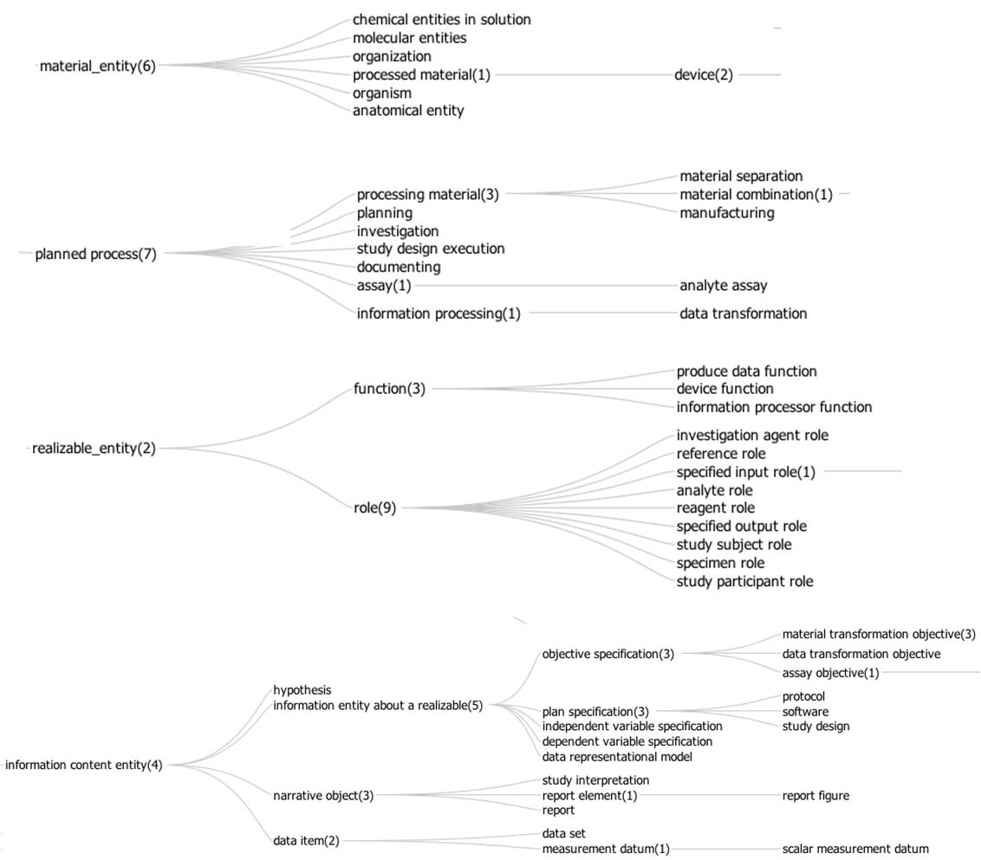

Figure 1 – High level structure of OBI classes

Process
OBI’s definition of processed material requires a process by which something is intentionally created. The intentionality requires that the process is initiated by an agent in order to achieve a certain goal, which is captured in an objective specification. All processes meeting these criteria are planned processes, which constitute the majority of processes in OBI’s scope. There are several subclasses of this objective and associated processes, including material separation such as using a cell sorter to separate out CD8+ cells from a blood sample, or material combination such as adding a chemical to a cell culture.
OBI’s scope is limited to successfully completed investigations, which are a type of planned process. This includes investigations with negative results, but not those which involve falsifications or gross errors. Therefore, every planned process can be assumed to achieve one or more goals, which are specified via the achieves planned objective relation. The entities necessarily present at the end of a planned process in order to achieve the objective are specified through the has specified output relation. The focus on the desired result of a process allows the use of OBI to model exchangeable paths to a similar outcome.
Figure 2 gives an example how several planned processes of drawing blood and measuring the glucose concentration in it are modeled in OBI.
Information processing is a subclass of planned process distinguished by having information as the input and output of the process. For example, the OBI class hierarchical clustering is defined as a process which takes as input a collection of objects and builds a hierarchy of clusters. Hierarchical clustering, in practice, can be used to achieve two different objectives; to cluster data (OBI class: class discovery data transformation) and to partition data (OBI class: partitioning data transformation). A hierarchy of planned processes based on their achieved objective permits the user to see immediately how information processing processes can be applied to achieve an objective specification.

Information artifacts
Any ontology of biomedical investigations needs to cover entities related to information, such as the design of the investigation, collected data, and reports of investigation results. Such entities were not originally in the scope of BFO, and they pose challenges to a realism-based ontology because of X. To facilitate the inclusion of information related entities in OBI while at the same time ensuring that this work will be generally usable outside of the context of biomedical research, the Information Artifact Ontology (IAO, [ref]) was created to serve as a high-level layer between BFO and OBI. IAO is maintained by OBI developers together with other scientists interested in modelling information. It encompasses terms such as plan specification and objective specifications, which capture the information content of a plan / objective as can be written down on paper. IAO also includes report such as the content of a journal article or a patent application, report elements such as report table, report figure, scatterplots, and software, which is a series of encoded instructions that can be directly executed by a CPU, or transformed into a form that can be.
Terms for information artifacts that relate specifically to investigations are maintained in OBI. They include protocol and study design, which are types of plans specifications for either a single procedure or an entire investigation. An important part of many study designs is the identification of dependent and independent variables. Also central to an investigation is the data generated. This includes measured data item, which is obtained directly in an assay, and derived data item, which is processed through further data transformations. The information generated as the outcome of an investigation is captured by study result and study interpretation, which follows the distinction typically made in journal articles between the Result and Conclusion section.
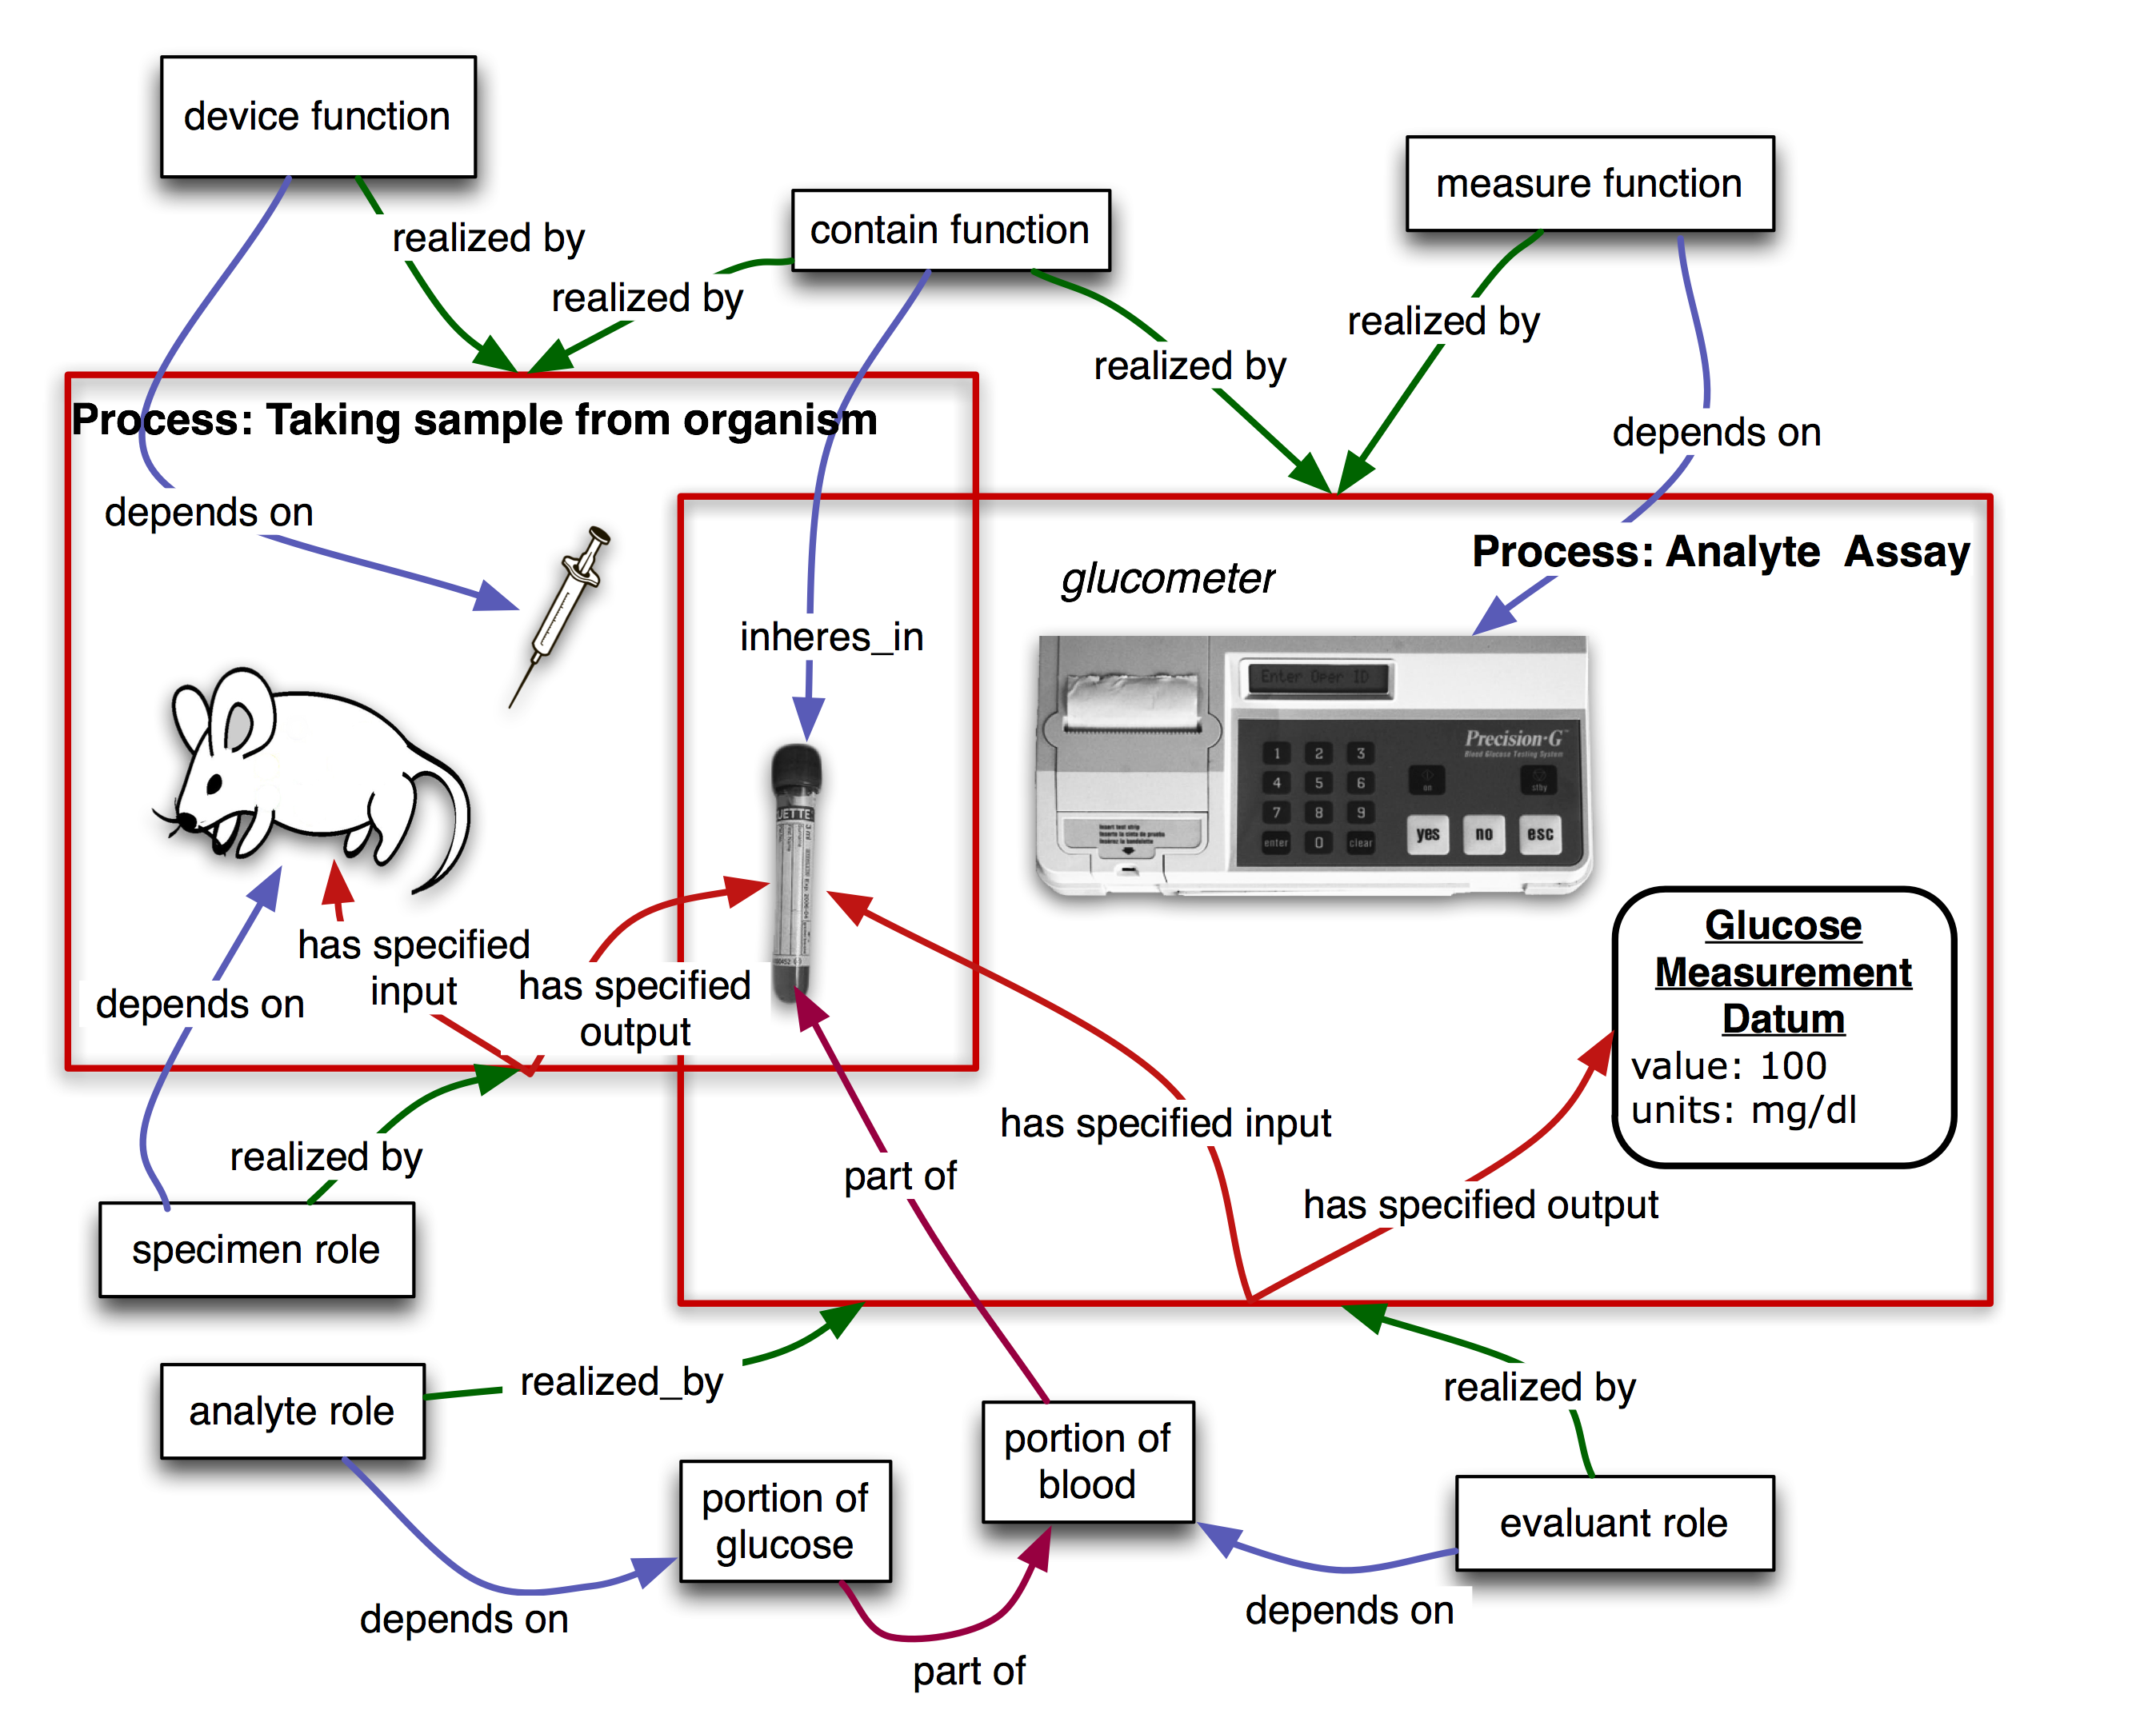
Figure 2. Measuring the glucose concentration in blood. The large boxes represent processes and contain their participants. The taking sample from organism process takes place first. In this process, a syringe is used as a device to draw blood from the mouse which bears the specimen role. At the end of this process, a tube contains the blood specimen. In a second step, that blood will be used as the evaluant in an analyte assay in which the concentration of glucose in the blood is measured. A glucometer device is used to make this measurement. The analyte role inheres in the glucose molecules scattered throughout the blood specimen. The objective of this planned process is to analyze the analyte (glucose) concentration. This modeling of a specific use case is used as the basis for generation of pattern templates [ref QuickTerms] allowing us to automate following additions of similar processes"

Roles and Functions
A role is defined in OBI through two properties:firstly, by the entity which bears the role and secondly, by the process through which the role is realized. A role is not essential to the entity bearing the role, but rather is defined by the circumstances under which the role is realized. For example, humans can bear specific roles relating to investigations. These roles include the principal investigator role, realized by leading an investigation, and the author role, realized by writing a report. Additionally, OBI contains roles defined by the study design of an investigation, such as study subject role which can inhere in humans, rodents, plants, sections of tissue, or any object of the study design. Similarly, the reference role can be borne by different entities that are used as a reference for other entities being studied. OBI also contains roles defined in specific experimental procedures, such as the cloning insert role or administered material role.

Functions differ from roles in that they are intrinsic to an entity based on its structural organization. Thus the function of a heart to pump blood is true for all living hearts. Functions within the scope of OBI inhere in devices created for research purposes. For example, a test tube and a cage have the contain function, which maintain certain material entities in space, while a preparative centrifuge has a separation function is to separate material entities.

.

Organization
Organizations such as companies, regulatory agencies, and research institutes need to be modeled in OBI. Placing organization into the BFO hierarchy proved controversial, as good arguments were made for treating it either as a material entity or an immaterial kind of social construct (related to other legal entities, which are not currently well described in BFO). To end this controversy, we defined an organization by all the things that are true about it: an organization is a continuant entity which can play roles, has members, and has a set of organization rules. Members of organizations are either organizations themselves or individual people. Members can play specific organization member roles that are determined in the organization rules. The organization rules also determine how decisions are made on behalf of the organization by the organization members.

Relations
Most of the relations used in OBI are taken from RO including relations which have been proposed for inclusion into RO but are not yet released (RO_proposed). When new relations are defined between classes in OBI, these are based on RO relations wherever possible. For example, OBI defines the relation has specified output information as a sub-relation of the RO relation has participant, which relates a process, a continuant, and a time at which the continuant participates in some way in the process [Smith, 2005. Has specified output information more specifically requires that the process is a planned process, that the participating continuant is an information content entity, that time t is at the end of the process, and that the presence of the information is required in the plan specification which is realized by the planned process.
Another example for an OBI relation is the is proxy for relation between two continuant instances c1 and c2, where, within a protocol application, measurement of c1 is used to determine the measurement of c2. A position on a gel is proxy for mass and charge of molecule, and a measurement of glucose oxidase activity is proxy for the glucose present in a sample.
The OBI-created relations are in effect proposals for inclusion in RO. If over time a relation in OBI is accepted in RO, then OBI will deprecate its own relation and use the one provided by the import of the relation from RO.

Use Cases

Use Case #1: GenePattern (JM)
Use Case #1 focuses on the annotation of a GenePattern software module. GenePattern is a powerful scientific workflow platform which provides access to over 90 genomic analytic and visualization tools (Reich M, Liefeld T, Gould J, Lerner J, Tamayo P, Mesirov JP GenePattern 2.0 Nature Genetics 38 no. 5 (2006): pp500-501). This provides interoperability between many popularly used tools within in silico analysis, including GeneCluster, Matlab, Bioconductor and many others.
Of particular interest to users of this resource is the ability to define a protocol using generic terms that can give appropriate options for each step. For example, a user may wish to define a protocol in which steps such as 'normalization' and 'clustering' occur during the workflow. The ability to use such general terms and be presented with choices for processes that can perform these steps would be advantageous to users.
The specific use case we consider here is as follows:
The user is able to define generic protocols referencing OBI concepts, instead nof specific LSIDs, for the following workflow steps:
- Normalize data - the user is able to select from a range of process which can be used to normalize data. This might include, for example, mean centering, loess transformation, and so on.
- Cluster data - the user is able to select from a range of process which can be used to cluster the normalized data. This might include k-means clustering, hierarchical clustering and so on.
- Visualize data - the user is able to select from a range of process which are able to visualize data based on the results from step 2, for example histogram, scatterplot and so on.
Such protocols should be tool-independent such that any software that is able to perform a given process can be selected to perform the step.
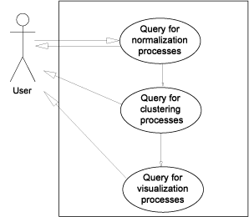
Figure XX. The GenePattern use case for defining a pipeline using ontology classes.
In order to demonstrate this use case using OBI, we must first consider the annotation of processes that can be considered as a valid option in one or more of the three generic protocol steps above. Firstly, normalize data. In OBI, data transformation classes are minimally defined by the following elements: the input data; the output data produced from this process; and the objective specification which the data transformation is used to achieve. Note that within OBI, data transformations can have more than one objective, reflecting the fact that a single process can be used to achieve different goals. For this query, data transformations with the objective of normalization are required as these satisfy the use case. Table 1 describes the data transformation processes currently captured in OBI that serve this query.
Table 1. Queries from the GenePattern use case, and the returned OBI terms
User Query | OBI returned terms
Normalization Processes | b transformation  biexponential transformation  box-cox transformation  cosine transformation  eh transformation  exponential transformation  hyperlog transformation  linlog transformation  loess transformation  mean centering  median centering  pareto scaling  quantile transformation  replicate analysis  s transformation  sine transformation  SIMCA  total intensity transformation paired  total intensity transformation single  unit-variance scaling  variance stabilizing transformation
Clustering Processes (in OBI class discovery data  transformations) where input data is normalized | discriminant function analysis  hierarchical clustering  k-means clustering  linear discriminant functional analysis  principal component regression
Visualization Processes where input is clustered data | dendogram  heatmap  scatterplot  histogram
There are a wide range of data transformations in OBI that fall within normalization processes. However, the next step requires processes that can perform clustering,called class discovery in OBI. In the specific form of class discovery for this use case, the input must be normalized data such as that produced by the normalization process described in the previous step. The appropriate data transformation (in OBI we use the achieves_planned_objective relation to tie a process to an objective specification) will therefore have an objective specification of class discovery which must have an input of the type normalized data set.
Table 1 demonstrates the results of this query on OBI and the classes returned. From the results, we can see that appropriate data transformations have been returned. Finally, we consider the visualizations that are capable of rendering the clustered data. Again, we use the ontology to restrict the results to visualizations that are able to render clustered data into an image and we see in Table 1 that this subset meets this restriction. Perhaps more interesting is those data transformations that are not returned as valid results; clearly it is impractical and not useful to list all of the inappropriate data transformations, suffice to say that there are ~200 classes, hence a large number were rejected as they did not fulfill the query. This is demonstrable of a key advantage of ontologies, that results should both return valid classes that satisfy the query, but should also filter out the invalid and thereby ensure that answers are accurate.

Use-Case #2: The Immune Epitope Database
As a second use case, we chose the Immune Epitope Database (IEDB, Peters, Nat Rev Immunol. 2007 Jun;7(6):485-90), which catalogs experiments manually curated from the scientific literature that characterize immune epitopes. Over 250,000 experiments from over 6,000 literature references have thus far been entered into the database. Each experiment is described by entries in over 300 database table columns. The IEDB website implements a comprehensive query by example interface to retrieve this data. However, many queries cannot be formulated directly as query by examples, and can require extensive manual post-processing.
It is therefore desirable to allow the user to formulate more expressive queries against the IEDB. As a translation of IEDB data into OBI format exists, this use case evaluates if meaningful queries can be formulated directly in OBI. BP to ADD: To achieve this application specific extension ontology was build extending OBI, but within the OBI ID space. The specific queries considered in this use case are: 1) what assays have been used to measure IFN-gamma production? 2) what investigations have been used to study both human and non-human T cell responses?
assay and has_specified_output some ‘measurement datum’ and ‘is about’ some ‘IFN-gamma production’
investigation and has_part some (realizes some ‘host role’ and ‘role of’ some ‘homo sapiens’) and has part some (realizes some ‘host role’ and ‘role of’ some ‘mus musculus)
The IFN-gamma production term is taken from GO, the organism terms (homo sapiens, mus musculus) reference the NCBI taxonomy, while the remaining terms are taken from OBI. Executing this query retrieves XXX (need to finalize results as we finish export. We are struggling with Protégé’s ability to handle large files).
Importantly, such a query mechanism can also be used to seamlessly query across multiple resources. For example, it would be possible to query for certain processes in GO, and link that to a query of the IEDB for assays that give information about these processes.
Alternative / secondary IEDB use case: To achieve validity and consistency of the manual curation between the different members of the curation team, a set of curation rules was established (Vita, Cytometry A. 2008 Nov;73(11):1066-70) which is enforced through peer review. It is desirable to enforce curation rules computationally in order to reduce the time spent on peer review, and to decrease the likelihood of curation errors being overlooked. In order to unequivocally communicate such rules between curators and system engineers, the rules are expressed as OBI statements which are meaningful to domain experts, and exact enough to be translated into code by programmers. The specific use case we consider is to formulate a curation rule on how to curate the assay antigen in an infectious challenge assay in OBI. Challenge assays measure the protective efficacy of an immune response against an infectious agent by exposing the host to the infectious agent, and measuring’.

Use-Case #3 JF
Our third use case involves an investigation in which a clinician wishes to compare the effects of drug X on blood clotting to those of aspirin and placebo. The investigsation has the following steps: (1) Plan the study and secure approval from the ethics committee, (2) enroll balanced cohorts of patients, (3) prepare the tablets for drug X, aspirin and placebo, (4) carry out study: administer one of the three treatments to patients in a cohort, wait 2 hours, measure prothrombin time and analyze data. This information can be represented using OBI terms, as is shown graphically in Figure XX. Expressing the investigation design and results using OBi makes it possible to exchange and integrate the investigation with others in electronic databases, facilitating queries of the investigation design, personnel, results and methods.

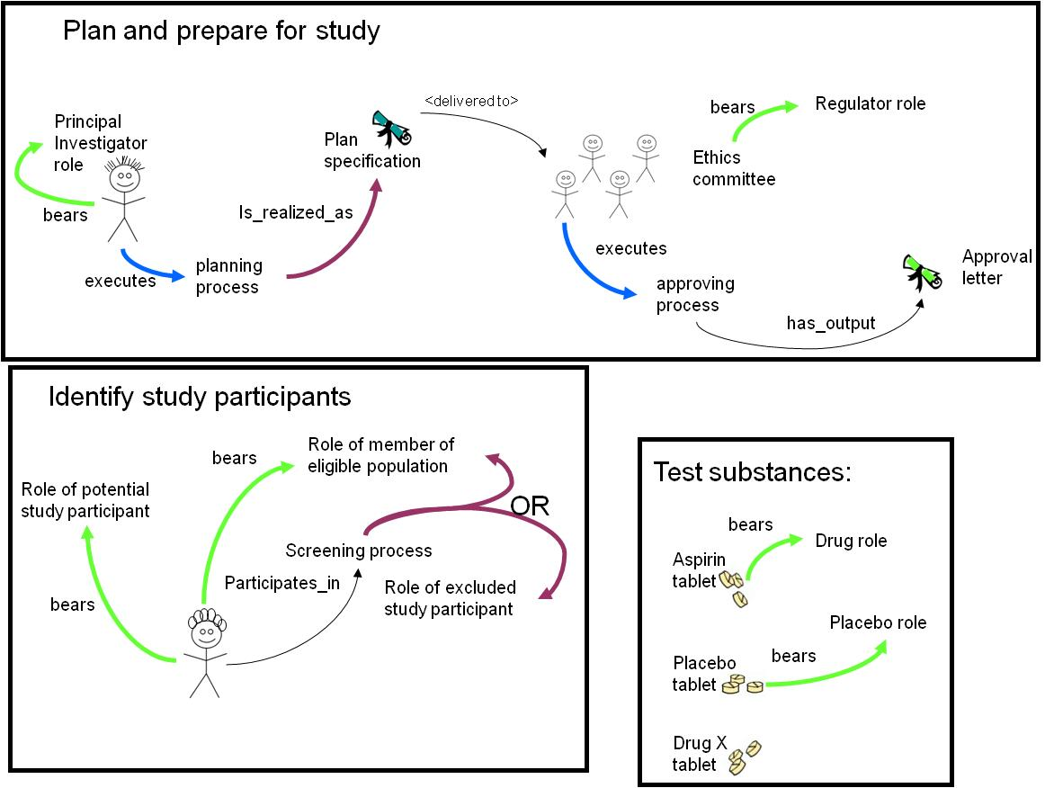
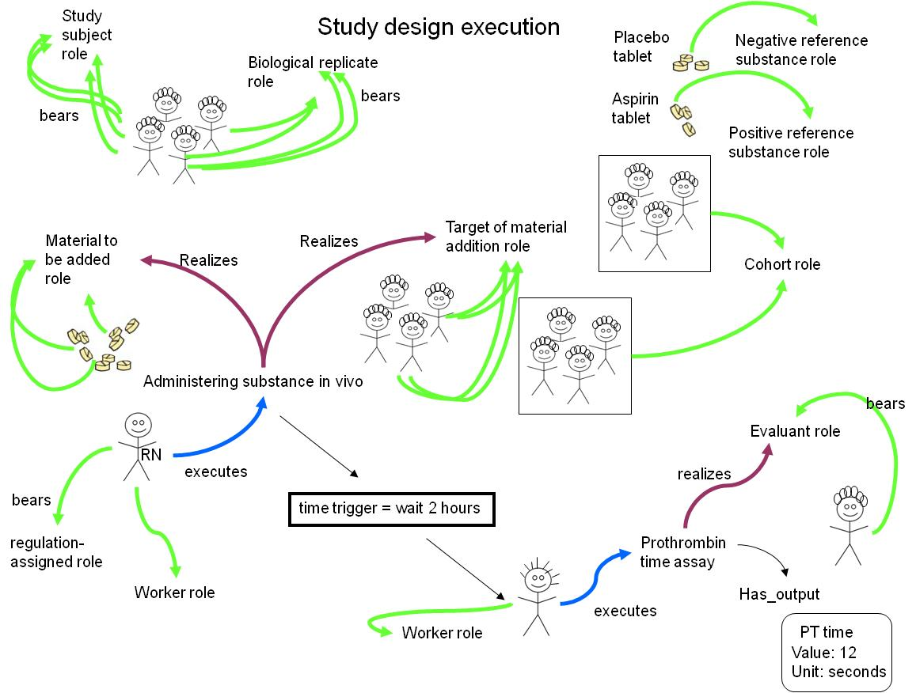

Use-Case #4: PRS

Discussion

(Section editor:.... and ...,AL,JM, TB...)*we rock* (Garth and Wayne, 2008)
Existing alternatives to OBI are: EXPO, MGED (but community specific and limited), ...?

OBI provides a way of sharing a common meaning, or semantics, when describing experiments produced by different research groups, institutes, or even experiment types. OBI is a large-scale, community-driven ontology developed to merge experimental terminology across disparate biological disciplines as well as maximize the re-use of existing ontologies outside of the scope of OBI. This is the first OBO Foundry ontology to address the challenge of producing an orthologonal ontology where many overlapping ontologies already existed. As such, a number of challenges were encountered: limitations in the OWL language were discovered and addressed, gaps in the chosen ULOs were identified and filled , and a method for the ongoing collaborative creation, maintenance and release of OBI in a decentralized setting was developed.
During the development of OBI, it was discovered that there were some inherent limitations with the importing of entire ontologies in OWL. Firstly, current editing tools are not effective for working with very large ontologies such as the NCBI Taxonomy [3]. Secondly, some ontologies used by OBI may not be aligned with OBI’s design, for instance if BFO is not used as a ULO or OWL-DL is not used as a language. Importing large or incompatible ontologies in their entirety could lead to inconsistencies or unintended inferences. Instead, the MIREOT import mechanism was developed [ref], which allows for the partial import of external ontology terms into OBI. IAO was developed to include information artifacts within the BFO structure when it became apparent that BFO did not contain the necessary concepts. Collaboration across multiple countries and time zones is problematic for small groups, and becomes quickly unmanageable when 19 communities are involved. In order to efficiently discuss and develop OBI, a combination of teleconferences, versioning and division of labor was used. Additionally, integrating classes from other ontologies raised the need for cross-talk between the different teams building OBO Foundry resources and not just those building OBI. This led to the organization of an OBI / OBO Foundry development meeting to precisely identify common issues faced by practitioners and developers. This OBO Foundry/ OBI joint meeting will be held at EBI with support from BBSRC and possibly ELIXIR project (Sansone).

By providing standard methods of describing (the semantics of OBI) and structuring (FuGE, http://fuge.sourceforge.net [ref]) data, as well as suggesting a minimal content checklist (MIBBI, http://www.mibbi.org [ref]), sharing experimental data and metadata irrespective of data type becomes easier and more productive. Instead of many standards from many communities, OBI, FuGE and MIBBI provide a new ‘many communities – one standard’ model that simplifies experimental description. Providing researchers with a standard syntax, semantics, and content for experimental description eases computational analyses, encourages collaborations, and aids reproducibility of experiments.
Prior to the development of OBI, researchers could not use a single common language to describe life-science. Instead, terms were distributed across multiple ontologies and controlled vocabularies from different biological communities.
OBI can be used to tag existing data, and provides computationally-amenable definitions for more complex programmatic usages of OBI. In the same way that GO has opened up a whole new level of searching and analysis via the annotation of genes and gene products, OBI provides a method of tagging experimental descriptions with terms that are both understandable to the human reading about the experiment and the computer program designed to analyse 1000s of experiments.
OBI was created to be extensible, and to make use of existing ontologies wherever possible. OBI supports future developments of new technologies for use in the biomedical research domain.

Acknowledgments
This work is partially supported by grant funding from the National Institute of Biomedical Imaging and Bioengineering, National Human Genome Institute, NIH (R01EB005034, NIH P41 HG003619), EC EMERALD project (LSHG-CT-2006-037686), EC FELICS, MUGEN, BBSRC (BB/E025080/1, BB/C008200/1), NERC-NEBC, EU IP CarcinoGenomics (PL 037712), EU NoE NuGO (NoE 503630), CARMEN project EPSRC (EP/E002331/1), the Michael Smith Foundation for Health Research

Methodology

Choice of language and metadata conventions
OBI has development spanned the last 5 years and is achieved by means of weekly teleconferences and twice yearly face-to-face meetings. To date 19 communities and XXX researchers have been actively involved in the development process. The requirement for remote development required formalization of the concept meta data (per concept author, progress information etc) conventions as a lightweight meta data schema tailored to development needs. The complete specification of the metadata scheme is available [http://obi-ontology.org/page/OBI_Minimal_metadata].
OBI is developed using the Ontology Web Language 1.0 (OWL) (Horrocks 2003) as OWL provides richer semantic support than OBO format - the other commonly used alternative in the biomedical domain. The OWL-DL subset was selected to gain maximum expressivity while allowing machine readabilility and use of reasoning for maintenance and development. The metadata scheme is implemented as OWL annotation type properties.
Concurrent development of OBI is necessary given the number of developers. OBI development is therefore organized into branches, with each sub-team working independently. Each branch is organized by subject area, such as data transformations, instruments or roles. Using this strategy tasks such as redundancy or inconsistency checking are manageable, as members in each branch can focus on a subset of terms.
We also required version control, offline development, use of different tools and editors, and script-based augmentation of the ontology content. A review of the existing collaborative ontology development tools failed to identify a single application that met OBI’s requirements. Instead, we split the ontology into multiple OWL files, one per branch, and rely on subversion to manage version control, distributed and offline development, as well as logging history for change management. The current development version of OBI is available from subversion at [ref].

Integration with existing ontologies
OBI was developed to be complementary to, and integrated with, a framework of existing ontologies in the biomedical domain. The description of experiments and investigations provided by OBI ties into the description of ‘natural’ biomedical information, as produced by the Gene Ontology for gene function (Blake and Harris 2008) and others for example in for cell types and anatomy. Contacts to other ontology development activities were therefore established early, and OBI was one of the driving projects in the establishment of the OBO Foundry (Smith, Ashburner et al. 2007). The desire to re-use existing diverse ontologies and integrating them into a single framework posed several challenges.
A top level ontology can provide guidance in how individual terms or whole ontologies interrelate and is useful when integrating external ontologies. BFO [ref] was chosen as the top level ontology as it is stable, publicly available in OWL syntax, and aligned to existing OBO Foundry ontologies. The OBO Relations ontology[ref] was chosen provide relations for OBI, and these were extended where required.
Four key ontologies are directly imported using the owl:import mechanism, including BFO and RO mentioned above, plus the ro_bfo bridge mapping to set ranges and domains for properties using BFO classes, and the Information Artifact Ontology (IAO, [ref]).
The owl:imports mechanism was not suitable for all external ontologies for several reasons: Firstly, current editing tools are not effective for working with very large ontologies such as the NCBI Taxonomy [3], therefore direct OWL import is impractical. Secondly, some ontologies used by OBI are activly develoed and may not be aligned with OBI’s design (e.g., not using BFO as an upper ontology, or not using OWL DL). Importing such ontologies as a whole could lead to inconsistencies or unintended inferences. Instead, the MIREOT import mechanism was developed [ref], which is based on the practice of the Gene Ontology (GO) [5] in that the intended meanings of classes remain stable. Even when the source ontology is repaired or reorganized, the effects of such modifications do not change the intended meaning of terms.

Term requests and triaging for concurrent development
The majority of terms in OBI were collected from the various communities that intend to use it. Term lists were solicited and collated by a representative of each community (OBI consortium page] and terms were also submitted through a public term tracker [(http://sourceforge.net/tracker/?group_id=177891&atid=886178). Each term was then assessed to determine if it was in the scope of OBI. For example, terms like ‘peptide’ and ‘antibody’ are needed to describe immunological experiments describe an experiment, but were available in ChEBI (Degtyarenko, de Matos et al. 2008) and GO respectively, and were therefore imported (see above) rather than added to OBI directly.
Submitted terms were distributed to an appropriate OBI branch for curation and inclusion in the OWL file and interaction between branches was achieved through conference calls.

Release and Quality Control
Users require a traceable, static version of OBI. We have therefore established a monthly release process where multiple branch development OLW files are merged into a single file, which makes it easier to view the ontology in common tools. A second version of the ontology is released in which classes are organized in the inferred hierarchy. Each release is versioned, and is available from a specific URI using the release date as a tag. The most up-to-date file prior to monthly release is always available from http://purl.obofoundry.org/obo/obi.owl. Releases of OBI are also uploaded to the NCBO BioPortal (Musen, Shah et al. 2008) and the OBO Foundry repository (Smith, Ashburner et al. 2007).
Checks are made prior to release to assure compliance of the released version with OBI policies. Specifically, classes are identified that do not comply with the minimal metadata policy, have invalid OWL syntax or lead to inconsistency when reasoning using Pellet (Evren Sirin 2007) or Fact++[ http://owl.man.ac.uk/factplusplus/]. Identifier format and deprecation policies are also enforced. OBI identifiers are prefixed with “New classes are automatically assigned a permanent identifier in the format OBI0000001” on their first release. Similarly, the release process verifies that all IDs that were present in the previous release are still in use. This conforms with the GO deprecation policy that OBI has adopted. Deleted classes are moved under the ObsoleteClass in the OBI hierarchy and stored in a separate file.

References
Blake, J. A. and M. A. Harris (2008). "The Gene Ontology (GO) project: structured vocabularies for molecular biology and their application to genome and expression analysis." Curr Protoc Bioinformatics Chapter 7: Unit 7 2.
Degtyarenko, K., P. de Matos, et al. (2008). "ChEBI: a database and ontology for chemical entities of biological interest." Nucleic Acids Res 36(Database issue): D344-50.
Evren Sirin, B. P., Bernardo C Grau, Aditya Kalyanpur, Yarden Katz (2007). "Pellet: A practical OWL-DL reasoner " Web Semantics: Science, Services and Agents on the World Wide Web 5(2): 51-53.
Haendel, M. A., Neuhaus, F., Osumi-Sutherland, D., Mabee,P.M. and M. Mejino Jr. J.L.V., C.J. and Smith, B. (2008). CARO - The Common Anatomy Reference Ontology. Anatomy Ontologies for Bioinformatics: Principles and Practice. D. D. a. R. B. Albert Burger. New York, Springer.
Horrocks, I., Patel-Schneider,P.F and van Harmelen, F. (2003). "From SHIQ and RDF to OWL: The making of a web ontology language." Journal of Web Semantics 1(1): 7-26.
Musen, M., N. Shah, et al. (2008). "BioPortal: Ontologies and Data Resources with the Click of a Mouse." AMIA Annu Symp Proc: 1223-4.
Rosse, C. a. and J. L. Mejino, Jr. (2003). "A reference ontology for biomedical informatics: the Foundational Model of Anatomy." J Biomed Inform 36(6): 478-500.
Smith, B., M. Ashburner, et al. (2007). "The OBO Foundry: coordinated evolution of ontologies to support biomedical data integration." Nat Biotechnol 25(11): 1251-5.
Wheeler, D. L., T. Barrett, et al. (2006). "Database resources of the National Center for Biotechnology Information." Nucleic Acids Res 34(Database issue): D173-80.

