Results

Development process and framework
OBI was developed to be complementary to, and integrated with, a framework of existing ontologies in the biomedical domain. For example, if an investigation includes taking a human tissue sample from a specified anatomical entity, the definition of the anatomical entity is referenced from the Foundational Model of Anatomy (Rosse and Mejino 2003). New terms are only created in OBI if they denote entities specifically related to investigations, such as the process of taking a sample from an organism.
Re-using existing ontologies and integrating them into a single framework poses several challenges. Contacts from OBI to other ontology development activities were necessarily established early, and OBI became one of the driving projects in the establishment of the OBO Foundry (Smith, Ashburner et al. 2007).The OBO Foundry oversees and maintains a set of key principles designed to facilitate integration of biomedical ontologies. Any ontology developed within the OBO Foundry is made freely available in a standardized format, is developed with broad representation and input by the relevant communities, and is orthogonal to the domains covered by other OBO Foundry ontologies. This latter principle ensures that disparate communities do not develop multiple terms for the same concept.
To provide a foundation upon which to anchor OBI development , three top level ontologies are used: BFO [ref], the OBO Relations ontology (RO) [ref], and the Information Artifact Ontology (IAO, ref). These upper-level ontologies (ULOs) allow straightforward interoperability of OBI terms with external ontologies sharing the same ULO. BFO was chosen as the top level classification of entities, while RO provides relations common across the OBO Foundry. The IAO provides a structure for the inclusion of information-related entities. These ULOs are stable, publicly available and aligned with existing OBO Foundry ontologies.
Terms were collected by each community within the OBI consortium [http://obi-ontology.org/page/Consortium]. In addition, terms were also accepted through a public tracker [http://sourceforge.net/tracker/?group_id=177891&atid=886178]. Before terms were incorporated as entities into OBI, they were checked to ensure that they are in scope, not already present, and sufficiently well defined.
A detailed description of the import processes, the metadata and ID policies, the distributed development process, conflict resolution, the release process, tools used for versioning and the use of automated reasoners is given in the Methods section.

OBI classes and relations
The OBI 1.0 release has XXX classes and YYY relations. The high level class organization of OBI is depicted in Figure 1. The upper level consists of the BFO classes material entity, process, role and function, and the class information content entity. . Throughout this text, italics are used to indicate a reference to a class or a relation. This section gives an overview of several higher-level OBI classes and relations that outline the scope of OBI and illustrate the modeling approach. Formal textual and logical definitions of each class are provided in the Supplemental Material.

Material entity
The class material entity encompasses all entities made up of matter. It was created in BFO at the request of OBI developers as the union of object, object part and object aggregate. Use of these BFO classes is appropriate if all entities are of similar scale and a simple three level of granularity representation is adequate. However entities relevant to the domain of biomedical investigations, span sizes from molecule to ecosystem. Depending on the level of granularity chosen these might be considered unitary objects or aggregates of smaller parts. By using material entity as our root class we avoid committing to the currently inadequate granularity schema in BFO.
Several subclasses of material entity are imported from external ontologies: Classes under organism are imported from the NCBI taxonomy (Wheeler, Barrett et al. 2006), anatomical entity and its subclasses are imported from the Foundational Model of Anatomy (Rosse and Mejino 2003) or the Common Anatomy Reference Ontology (Haendel and Mejino Jr. J.L.V. 2008), and molecular entities hierarchy are imported from ChEBI [ref]. Based on these imports, OBI-specific sub-classes were constructed. For example, chemical entities in solution such as a PBS buffer can be defined by referencing the molecules from which they are made of (defined in ChEBI), and specifying their molecular concentration as a quality. Table X gives the complete class definition of PBS buffer.
ID | XXX
Label | PBS buffer
Definition | XXX
Example | XXX
…
Table X – Definition of PBS buffer – complete definition
Material entities that come into existence as the result of intentional acts, for example in as the output of some protocol, or which are manufactured, are processed material. For example a specimen such as a blood sample collected in a clinical protocol is a processed material as is a device which is manufactured with the intent to perform a function such as a flow cytometer. Some material entities such as a protein can be produced as the result of applying a protocol, or even manufactured, for example in a recombinant expression system or by synthesis, but are also naturally expressed in an organism. In order to avoid having to assert multiple superclasses, processed material is logically defined with necessary and sufficient conditions, namely as exactly those material entities that are specified output of an intentional process. When OBI is classified, any class for which it can be determined that every member is intentionally created will be classified as a subclass of processed material.
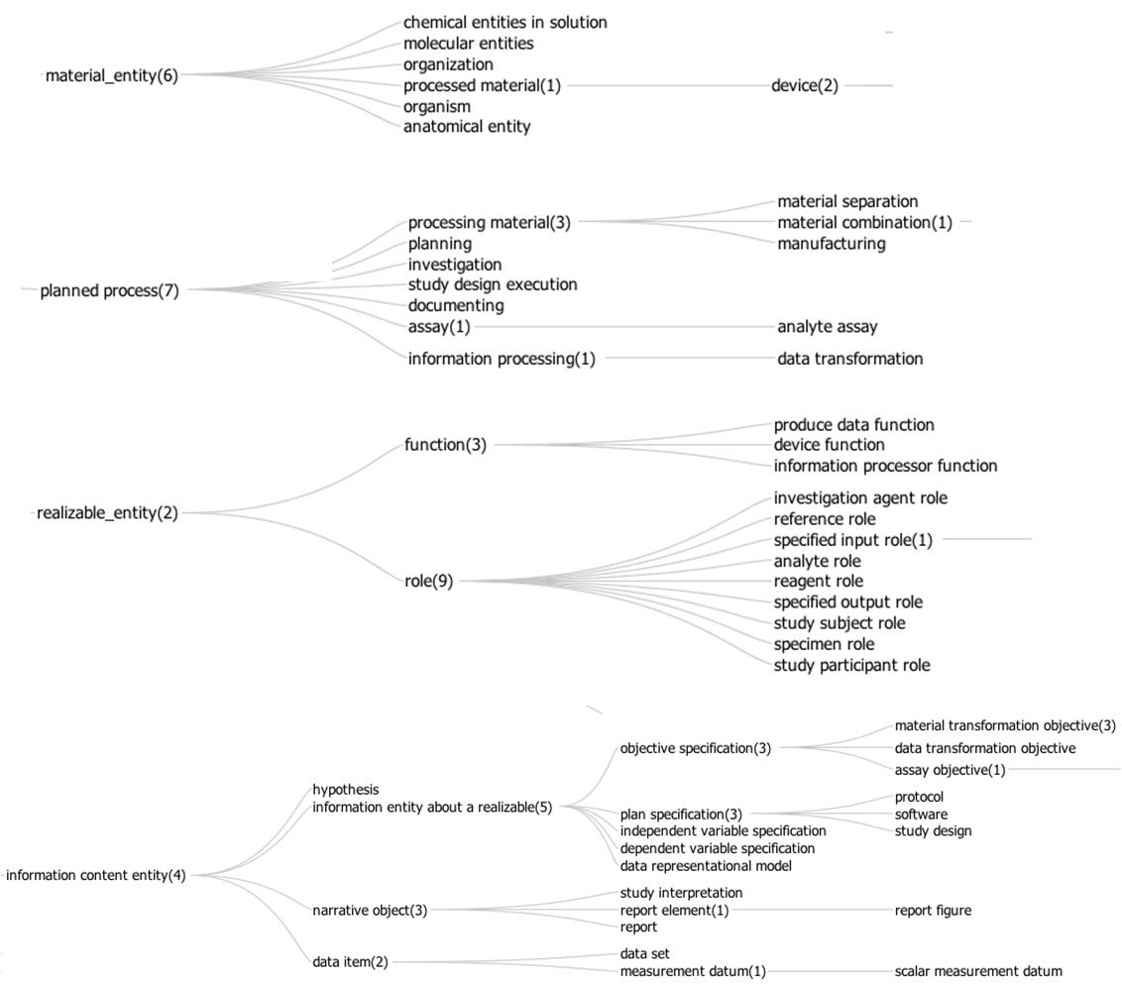

Figure 1 – High level structure of OBI classes

Process
Informally speaking, OBI’s definition of processed material implies the existence of a process by which something is intentionally made. We mean, by intentional, that a process is initiated by an agent (typically a person) in order to achieve a certain goal. OBI captures such goals by defining a subclass of information content entity – objective specification – instances of which specify these goals. An example of such a specification is the sentence “Transform the final reaction into competent cells.” part of a site directed mutagenesis protocol. Processes that are carried out to meet objective specifications are planned processes, and constitute the majority of processes represented by terms in OBI.
Near the top of OBI’s process hierarchy there are several classes that represent realizations of broad objectives, including material separation, instances of which are processes such as those where a cell sorter is used to separate out CD8+ cells from a blood sample, and material combination, instances of which are processes such as when a chemical is added to a cell culture.
It is within OBI’s scope to represent to successfully completed investigations, a type of planned process. Successful investigations may produce negative results, but processes that result in falsified data or during which there gross errors are not considered successful investigations and are therefore considered to be out of scope for OBI. Therefore, every planned process, since it is successful, has achieved one or more goals. OBI defines the relation achieves planned objective as holding between instances of planned processes and the corresponding objective specifications.
While processes can have many participants, objective and plan specifications typically specify which participants are particularly important, calling them inputs and outputs. OBO defines two other relations, has specified input and has specified output, relating process instances to such participants. Other than that these participants are mentioned in plan specifications, we can infer that specified outputs must necessarily be present at the end of the planned process in which they participate. The focus on the desired result of a process allows the use of OBI to model exchangeable paths to a similar outcome.
Figure 2 gives an example how several planned processes of drawing blood and measuring the glucose concentration in it are modeled in OBI.
Information processing is a subclass of planned process distinguished by having information as the input and output of the process. For example, the OBI class hierarchical clustering is defined as a process which takes as input a collection of objects and builds a hierarchy of clusters. Hierarchical clustering, in practice, can be used to achieve two different objectives; to cluster data (OBI class: class discovery data transformation) and to partition data (OBI class: partitioning data transformation). A hierarchy of planned processes based on their achieved objective permits the user to see immediately how information processing processes can be applied to achieve an objective specification.

Information artifacts
Any ontology of biomedical investigations needs to cover entities related to information, such as the design of the investigation, collected data, and reports of investigation results. Such entities were not originally in the scope of BFO, and they pose challenges to a realism-based ontology because of X. To facilitate the inclusion of information related entities in OBI while at the same time ensuring that this work will be generally usable outside of the context of biomedical research, the Information Artifact Ontology (IAO, [ref]) was created to serve as a high-level layer between BFO and OBI. IAO is maintained by OBI developers together with other scientists interested in modelling information. It encompasses terms such as plan specification and objective specifications, which capture the information content of a plan / objective as can be written down on paper. IAO also includes report such as the content of a journal article or a patent application, report elements such as report table, report figure, scatterplots, and software, which is a series of encoded instructions that can be directly executed by a CPU, or transformed into a form that can be.
Terms for information artefacts that relate specifically to investigations are maintained in OBI. They include protocol and study design, which are types of plans specifications for either a single procedure or an entire investigation. An important part of many study designs is the identification of dependent and independent variables. Also central to an investigation is the data generated. This includes measured data item, which is obtained directly in an assay, and derived data item, which is processed through further data transformations. The information generated as the outcome of an investigation is captured by study result and study interpretation, which follows the distinction typically made in journal articles between the Result and Conclusion section.
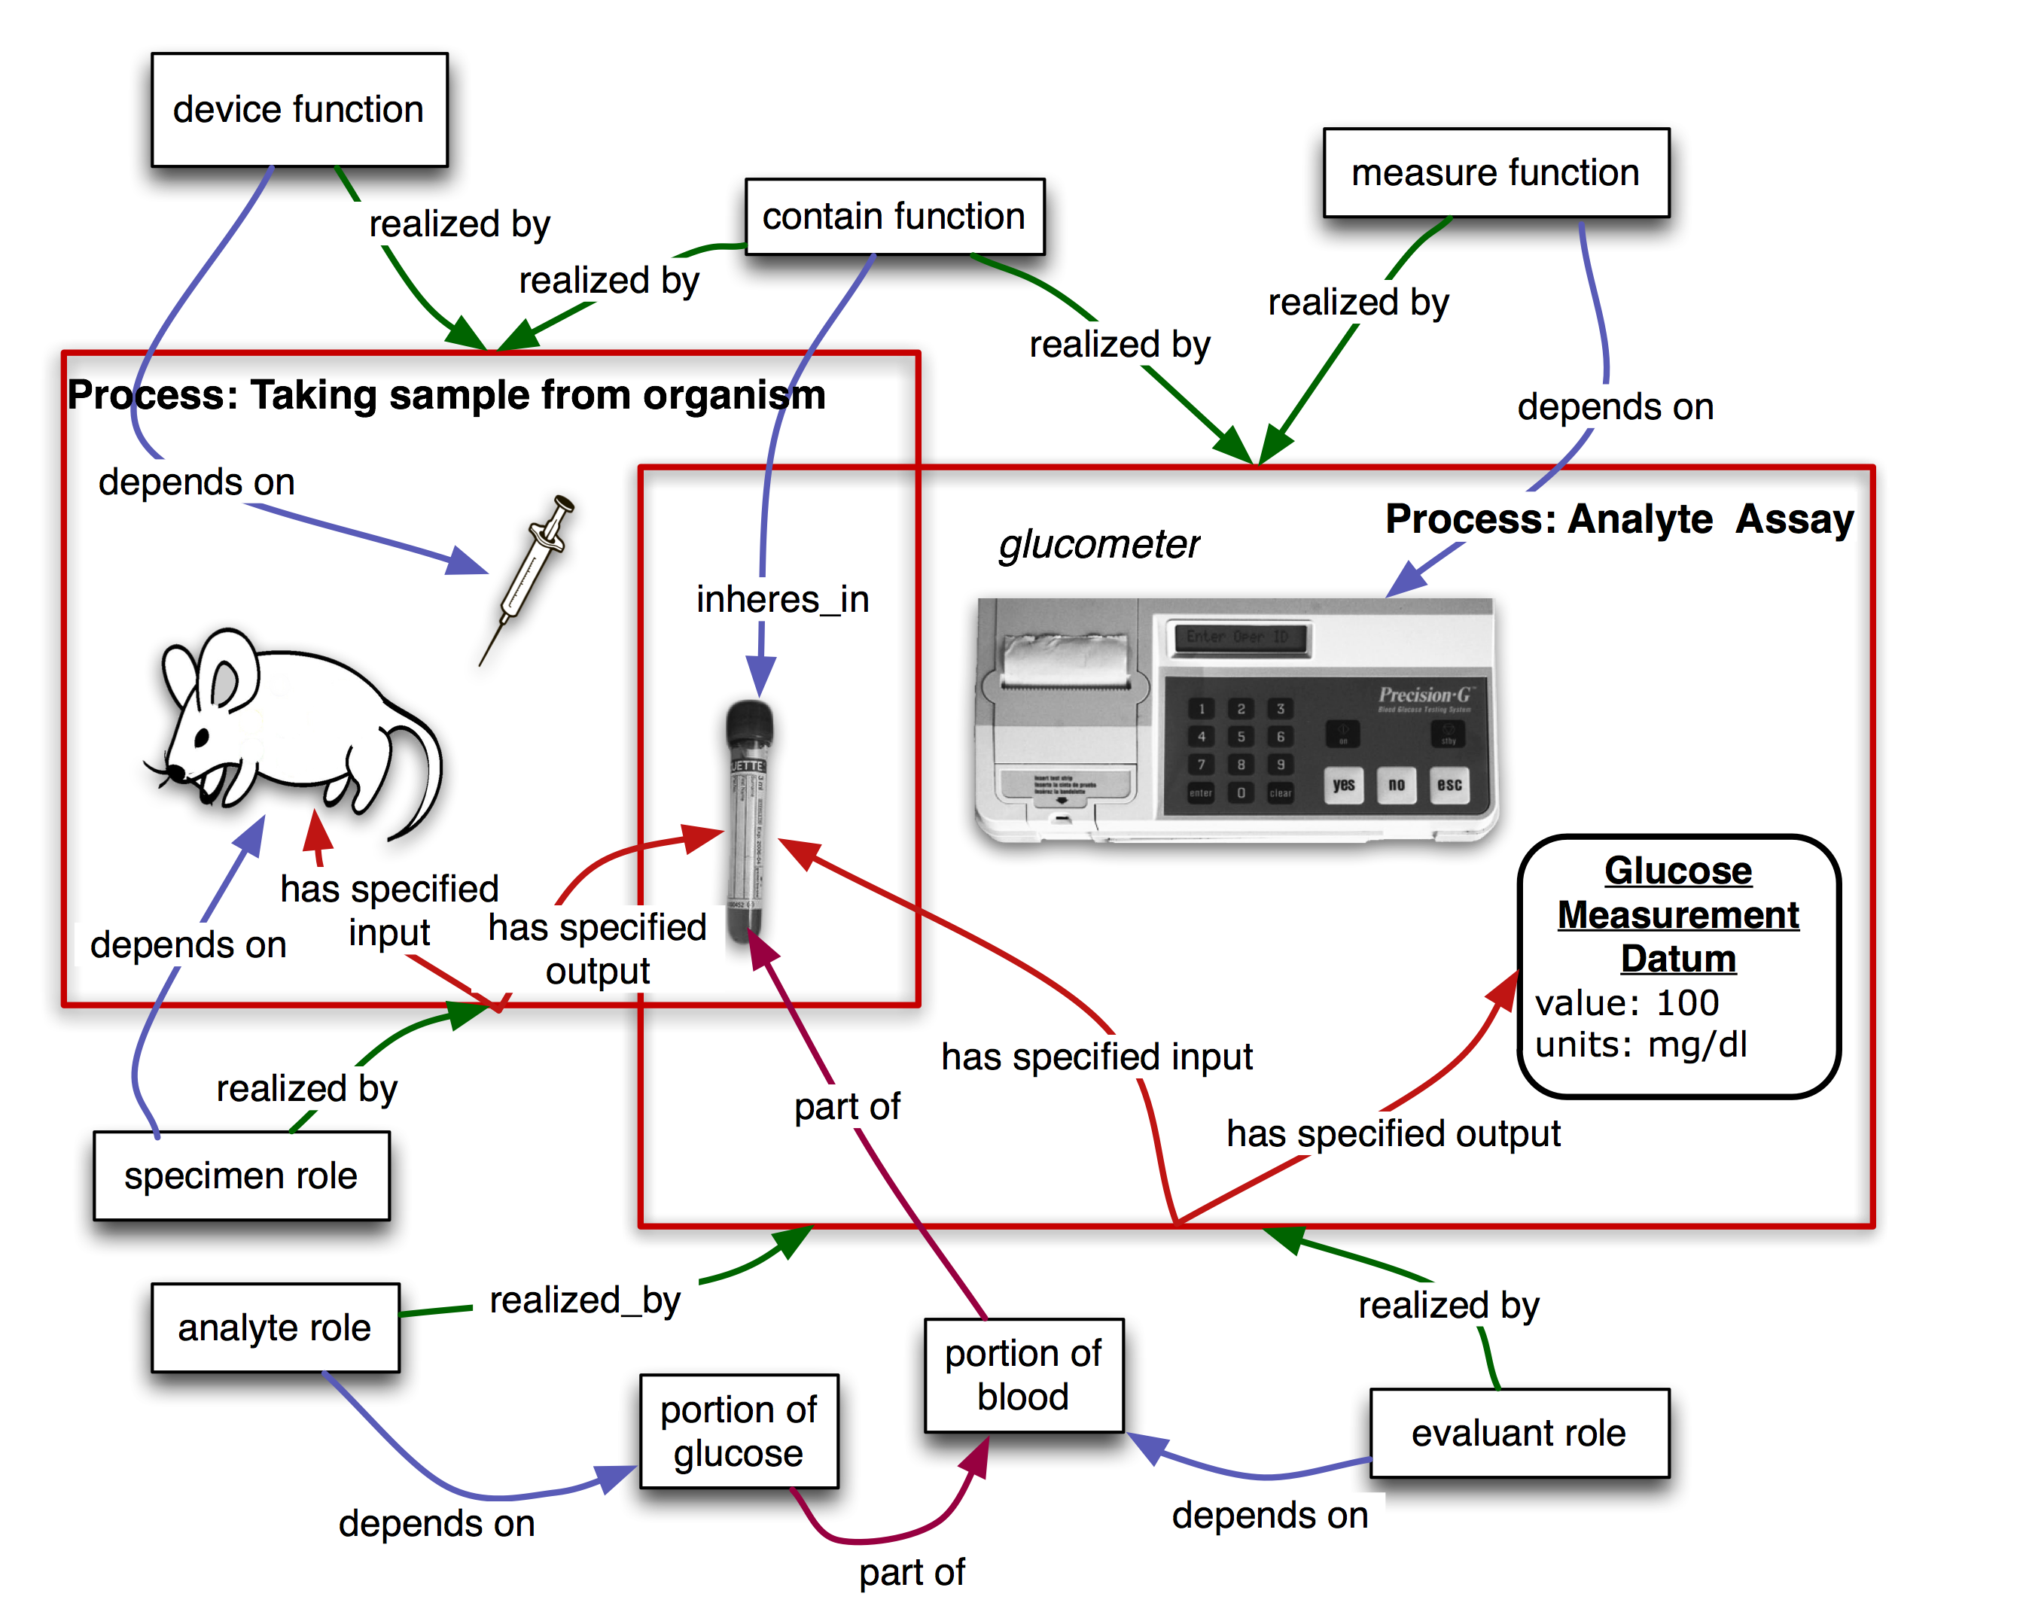
Figure 2. Measuring the glucose concentration in blood. The large boxes represent processes and contain their participants. The taking sample from organism process takes place first. In this process, a syringe is used as a device to draw blood from the mouse which bears the specimen role. At the end of this process, a tube contains the blood specimen. In a second step, that blood will be used as the evaluant in an analyte assay in which the concentration of glucose in the blood is measured. A glucometer device is used to make this measurement. The analyte role inheres in the glucose molecules scattered throughout the blood specimen. The objective of this planned process is to analyze the analyte (glucose) concentration. This modeling of a specific use case is used as the basis for generation of pattern templates [ref QuickTerms] allowing us to automate following additions of similar processes"

Roles and Functions
A role is defined in OBI through two properties:firstly, by the entity which bears the role and secondly, by the process through which the role is realized. A role is not essential to the entity bearing the role, but rather is defined by the circumstances under which the role is realized. For example, humans can bear specific roles relating to investigations. These roles include the principal investigator role, realized by leading an investigation, and the author role, realized by writing a report. Additionally, OBI contains roles defined by the study design of an investigation, such as study subject role which can inhere in humans, rodents, plants, sections of tissue, or any object of the study design. Similarly, the reference role can be borne by different entities that are used as a reference for other entities being studied. OBI also contains roles defined in specific experimental procedures, such as the cloning insert role or administered material role.
Functions differ from roles in that they are intrinsic to an entity based on its structural organization. Thus the function of a heart to pump blood is true for all living hearts. Functions within the scope of OBI inhere in devices created for research purposes. For example, a test tube and a cage have the contain function, which maintain certain material entities in space, while a preparative centrifuge has a separation function is to separate material entities.

Organization
Organizations such as companies, regulatory agencies, and research institutes need to be modeled in OBI. Placing organization into the BFO hierarchy proved controversial, as good arguments were made for treating it either as a material entity or an immaterial kind of social construct (related to other legal entities, which are not currently well described in BFO). To end this controversy, we defined an organization by all the things that are true about it: an organization is a continuant entity which can play roles, has members, and has a set of organization rules. Members of organizations are either organizations themselves or individual people. Members can play specific organization member roles that are determined in the organization rules. The organization rules also determine how decisions are made on behalf of the organization by the organization members.

Relations
Most of the relations used in OBI are taken from RO including relations which have been proposed for inclusion into RO but are not yet released (RO_proposed). When new relations are defined between classes in OBI, these are based on RO relations wherever possible. For example, OBI defines the relation has specified output as a sub-relation of the RO relation has participant, which relates a process, a continuant, and a time at which the continuant participates in some way in the process [Smith, 2005]. Has specified output more specifically requires that the process is a planned process, that time t is at the end of the process, and that the presence of the participant is required in the plan specification which is realized by the planned process.
Another example for an OBI relation is the is proxy for relation between two continuant instances c1 and c2, where, within a protocol application, measurement of c1 is used to determine the measurement of c2. A position on a gel is proxy for mass and charge of molecule, and a measurement of glucose oxidase activity is proxy for the glucose present in a sample.
The OBI-created relations are in effect proposals for inclusion in RO. If over time a relation in OBI is accepted in RO, then OBI will deprecate its own relation and use the one provided by the import of the relation from RO.

Use Cases

Use Case #1: GenePattern (JM)
Use Case #1 focuses on the annotation of a GenePattern software module. GenePattern is a powerful scientific workflow platform which provides access to over 90 genomic analytic and visualization tools (Reich M, Liefeld T, Gould J, Lerner J, Tamayo P, Mesirov JP GenePattern 2.0 Nature Genetics 38 no. 5 (2006): pp500-501). This provides interoperability between many popularly used tools within in silico analysis, including GeneCluster, Matlab, Bioconductor and many others.
Of particular interest to users of this resource is the ability to define a protocol using generic terms that can give appropriate options for each step. For example, a user may wish to define a protocol in which steps such as 'normalization' and 'clustering' occur during the workflow. The ability to use such general terms and be presented with choices for processes that can perform these steps would be advantageous to users.
The specific use case we consider here is as follows:
The user is able to define generic protocols referencing OBI concepts, instead nof specific LSIDs, for the following workflow steps:
- Normalize data - the user is able to select from a range of process which can be used to normalize data. This might include, for example, mean centering, loess transformation, and so on.
- Cluster data - the user is able to select from a range of process which can be used to cluster the normalized data. This might include k-means clustering, hierarchical clustering and so on.
- Visualize data - the user is able to select from a range of process which are able to visualize data based on the results from step 2, for example histogram, scatterplot and so on.
Such protocols should be tool-independent such that any software that is able to perform a given process can be selected to perform the step.
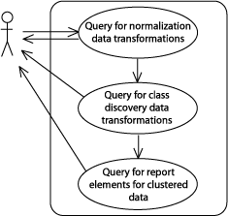
Figure XX. The GenePattern use case for defining a pipeline using ontology classes.
In order to demonstrate this use case using OBI, we must first consider the annotation of processes that can be considered as a valid option in one or more of the three generic protocol steps above. Firstly, normalize data. In OBI, data transformation classes are minimally defined by the following elements: the input data; the output data produced from this process; and the objective specification which the data transformation is used to achieve. Note that within OBI, data transformations can have more than one objective, reflecting the fact that a single process can be used to achieve different goals. For this query, data transformations with the objective of normalization are required as these satisfy the use case. Table 1 describes the data transformation processes currently captured in OBI that serve this query.
Table 1. Queries from the GenePattern use case, and the returned OBI terms
User Query | OBI returned terms
Normalization Processes | b transformation  biexponential transformation  box-cox transformation  cosine transformation  eh transformation  exponential transformation  hyperlog transformation  linlog transformation  loess transformation  mean centering  median centering  pareto scaling  quantile transformation  replicate analysis  s transformation  sine transformation  SIMCA  total intensity transformation paired  total intensity transformation single  unit-variance scaling  variance stabilizing transformation
Clustering Processes (in OBI class discovery data  transformations) where input data is normalized | discriminant function analysis  hierarchical clustering  k-means clustering  linear discriminant functional analysis  principal component regression
Visualization Processes where input is clustered data | dendogram  heatmap  scatterplot  histogram
There are a wide range of data transformations in OBI that fall within normalization processes. However, the next step requires processes that can perform clustering,called class discovery in OBI. In the specific form of class discovery for this use case, the input must be normalized data such as that produced by the normalization process described in the previous step. The appropriate data transformation (in OBI we use the achieves_planned_objective relation to tie a process to an objective specification) will therefore have an objective specification of class discovery which must have an input of the type normalized data set.
Table 1 demonstrates the results of this query on OBI and the classes returned. From the results, we can see that appropriate data transformations have been returned. Finally, we consider the visualizations that are capable of rendering the clustered data. Again, we use the ontology to restrict the results to visualizations that are able to render clustered data into an image and we see in Table 1 that this subset meets this restriction. Perhaps more interesting is those data transformations that are not returned as valid results; clearly it is impractical and not useful to list all of the inappropriate data transformations, suffice to say that there are ~200 classes, hence a large number were rejected as they did not fulfill the query. This is demonstrable of a key advantage of ontologies, that results should both return valid classes that satisfy the query, but should also filter out the invalid and thereby ensure that answers are accurate.

Use-Case #2: The Immune Epitope Database
As a second use case, we chose the Immune Epitope Database (IEDB, Peters, Nat Rev Immunol. 2007 Jun;7(6):485-90), which catalogs experiments manually curated from the scientific literature that characterize immune epitopes. Over 250,000 experiments from over 6,000 literature references have thus far been entered into the database. Each experiment is described by entries in over 300 database table columns. The IEDB website implements a comprehensive query by example interface to retrieve this data. However, many queries cannot be formulated directly as query by examples, and can require extensive manual post-processing.
It is therefore desirable to allow the user to formulate more expressive queries against the IEDB. As a translation of IEDB data into OBI format exists, this use case evaluates if meaningful queries can be formulated directly in OBI. BP to ADD: To achieve this application specific extension ontology was build extending OBI, but within the OBI ID space. The specific queries considered in this use case are: 1) what assays have been used to measure IFN-gamma production? 2) what investigations have been used to study both human and non-human T cell responses?
assay and has_specified_output some ‘measurement datum’ and ‘is about’ some ‘IFN-gamma production’
investigation and has_part some (realizes some ‘host role’ and ‘role of’ some ‘homo sapiens’) and has part some (realizes some ‘host role’ and ‘role of’ some ‘mus musculus)
The IFN-gamma production term is taken from GO, the organism terms (homo sapiens, mus musculus) reference the NCBI taxonomy, while the remaining terms are taken from OBI. Executing this query retrieves XXX (need to finalize results as we finish export. We are struggling with Protégé’s ability to handle large files).
Importantly, such a query mechanism can also be used to seamlessly query across multiple resources. For example, it would be possible to query for certain processes in GO, and link that to a query of the IEDB for assays that give information about these processes.
Alternative / secondary IEDB use case: To achieve validity and consistency of the manual curation between the different members of the curation team, a set of curation rules was established (Vita, Cytometry A. 2008 Nov;73(11):1066-70) which is enforced through peer review. It is desirable to enforce curation rules computationally in order to reduce the time spent on peer review, and to decrease the likelihood of curation errors being overlooked. In order to unequivocally communicate such rules between curators and system engineers, the rules are expressed as OBI statements which are meaningful to domain experts, and exact enough to be translated into code by programmers. The specific use case we consider is to formulate a curation rule on how to curate the assay antigen in an infectious challenge assay in OBI. Challenge assays measure the protective efficacy of an immune response against an infectious agent by exposing the host to the infectious agent, and measuring’.

Use-Case #3 JF
Our third use case involves an investigation in which a clinician wishes to compare the effects of drug X on blood clotting to those of aspirin and placebo. The investigsation has the following steps: (1) Plan the study and secure approval from the ethics committee, (2) enroll balanced cohorts of patients, (3) prepare the tablets for drug X, aspirin and placebo, (4) carry out study: administer one of the three treatments to patients in a cohort, wait 2 hours, measure prothrombin time and analyze data. This information can be represented using OBI terms, as is shown graphically in Figure XX. Expressing the investigation design and results using OBi makes it possible to exchange and integrate the investigation with others in electronic databases, facilitating queries of the investigation design, personnel, results and methods.
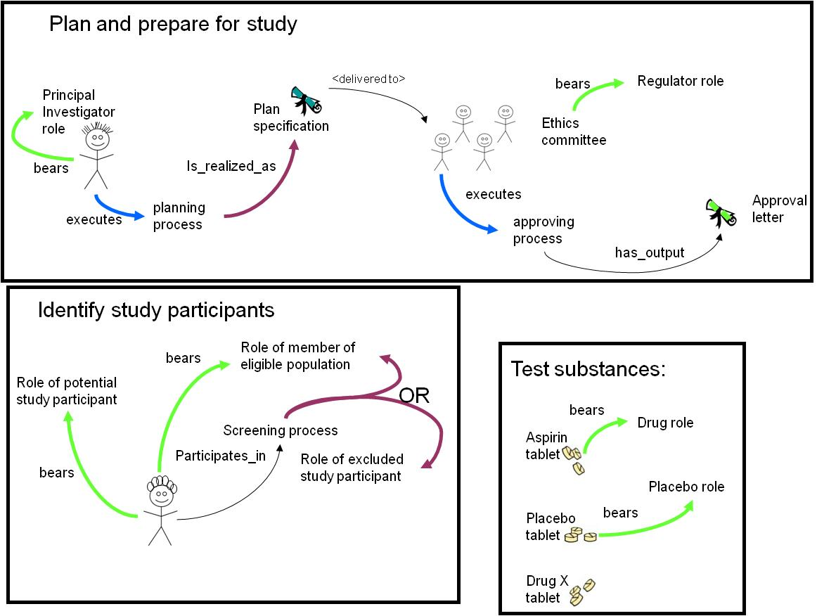
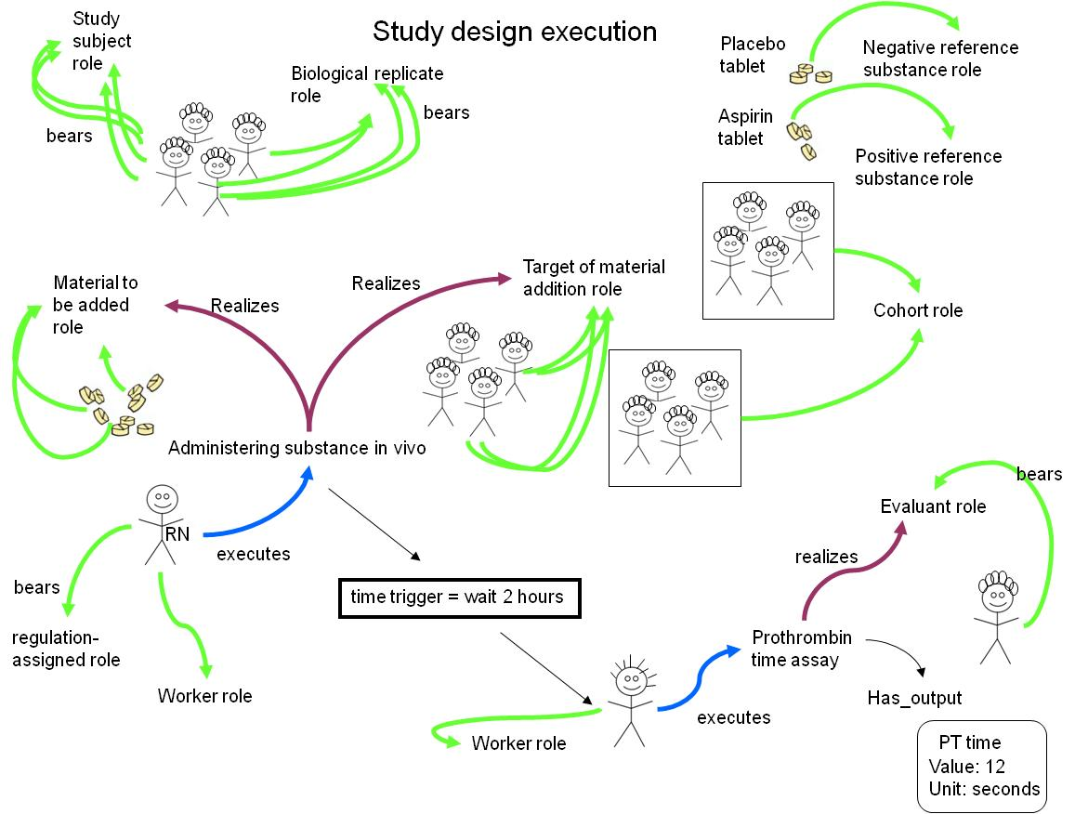

Use-Case #4: PRS

We represent objective specifications rather than objectives because we understand the former better than the latter. This is a case of a repeated pattern in OBI – when faced with difficult representation problems we sometimes define related terms that might be better understood, and which are still adequate anticipated uses cases.
http://www.stanford.edu/~loening/protocols/Site_Directed_Mutagenesis.pdf

