Modeling biomedical experimental processes with OBI
(In alphabetical order): Ryan R. Brinkman¹, Mélanie Courtot¹, Dirk Derom², Jennifer M. Fostel³, Yongqun He⁴, Phillip Lord⁵, James Malone⁶, Helen Parkinson⁶, Bjoern Peters⁷, Philippe Rocca-Serra⁶, Alan Ruttenberg⁸, Susanna-Assunta Sansone⁶, Larisa N. Soldatova*⁹, Christian J. Stoeckert Jr.¹⁰, Jessica Turner¹¹, Jie Zheng¹⁰ and the OBI consortium

¹British Columbia Cancer Agency, Vancouver, Canada; ²Victoria University of Wellington, New Zealand; ³ Global Health Sector, SRA International, Inc, Durham, NC, USA; ⁴ University of Michigan Medical School, Ann Arbor, USA; ⁵School of Computing Science, Newcastle University, UK; ⁶The European Bioinformatics Institute, Cambridge, UK; ⁷La Jolla Institute for Allergy and Immunology, La Jolla, CA, USA; ⁸Science Commons, Cambridge, MA, USA; ⁹Aberystwyth University, Wales, UK; ¹⁰Center for Bioinformatics, Department of Genetics, University of Pennsylvania School of Medicine, Philadelphia, PA, USA, ¹¹Department of Psychiatry and Human Behavior, University of California, Irvine, CA, USA.

*Corresponding author LNS: lss@aber.ac.uk
Email addresses:
RB: rbrinkman@bccrc.ca; MC: mcourtot@gmail.com; DD: dirk.derom@gmail.com;
JF: fostel@niehs.nih.gov; YH: yongqunh@med.umich.edu;
PL: phillip.lord@newcastle.ac.uk; JM: malone@ebi.ac.uk; HP: parkinson@ebi.ac.uk;
BP: bpeters@liai.org; PRS: rocca@ebi.ac.uk; AR: alanruttenberg@gmail.com;
SAS: sa.sansone@gmail.com; CJS: stoeckrt@pcbi.upenn.edu;
JT: Jessica.turner@uci.edu; JZ: jiezheng@pcbi.upenn.edu;
The OBI Consortium: obi-users@googlegroups.com

Abstract

Background
Experimental descriptions are typically stored as free text without using standardized terminology, creating challenges in comparison, reproduction and analysis. These difficulties impose limitations on data exchange and information retrieval.

Results
The Ontology for Biomedical Investigations (OBI), developed as a global, cross-community effort, provides a resource that represents biomedical investigations in an explicit and integrative framework. Here we detail three real-world applications of OBI, provide detailed modeling information and explain how to use OBI.

Conclusion

We demonstrate how OBI can be applied to different biomedical investigations to both facilitate interpretation of the experimental process and increase the computational processing and integration within the semantic web. The logical definitions of the entities involved allow computers to unambiguously understand and integrate different biological experimental processes and their relevant components.

Availability
OBI is available at http://purl.obolibrary.org/obo/obi/2009-11-02/obi.owl

Background

Biomedical investigations use empirical approaches to investigate causal relationships among a large range of variables. The wide range of possible investigations presents a number of challenges when building tools to describe experimental processes. There are varying levels of complexity and granularity and a wide range of material and equipment is used. Furthermore, the use of varying terminology by different communities makes data integration problematic when representing and integrating biomedical investigations across different fields of study. The use of ontologies has been successful in biological data integration and representation [the GO consortium, 2000; Matos et al., 2006] and there have been multiple efforts to develop ontologies aimed at providing clearer semantics for data (GO, FuGO, MGED, LABORS, MSI ontology) [Whetzel et al., 2006(a); Whetzel et al., 2006(b), King et al., 2009; Sansone et al., 2007]. Work in the transcriptomics, proteomics and metabolomics communities has proceeded in parallel, producing ontologies with overlapping scopes.
Though each focuses on particular types of experimental processes, many terms, such as investigation and assay, are common to all. Merging common aspects of these formalisms is useful as it provides a mechanism by which terms can be used and understood by all, reducing ambiguity and difficulties associated with post-hoc attempts to integrate data. The practice of consolidating representations is endorsed by organizations such as the OBO Foundry [Smith et al., 2007] which requires all member ontologies to define a term only once among them (orthogonality). OBO Foundry members use a common set of relations from the Relations Ontology [Smith et.al., 2005], and the upper level Basic Formal Ontology (BFO) [Grenon et al, 2004] in order to facilitate cross ontology consistency and to support automated reasoning. OBO ontologies adhere to common naming conventions [Schober et al. 2009] in order to make it easier to learn and understand them.
The Ontology for Biomedical Investigations (OBI) addresses the need for a common, integrated ontology for the description of biological and clinical investigations. OBI is collaboratively developed by representatives from 19 biomedical communities and has been submitted as a candidate for the OBO Foundry. It uses other OBO ontologies wherever possible. OBI defines a set of broadly applicable terms that span biomedical and technological domains, for example, assay (the planned process of producing data about something) as well as domain-specific terms relevant to smaller areas of study, for example T cell epitope recognition assay, used by the IEDB database to describe experimental data extracted from articles investigating immune epitopes [Peters et al., 2005].
OBI represents experimental processes e.g., investigation, assay, and the entities involved in preparing for, executing, and interpreting those processes e.g., study design, protocols, instrumentation, biological material, collected data and analyses performed on that data. OBI therefore supports consistent annotation of biomedical experimental processes regardless of the field of study. In this paper, the OBI release of 2009-11-02 is applied to three exemplar use cases, originating from three communities: 1) neuroscience, 2) vaccine protection, and 3) functional genomics. The OBI release of 2009-11-02 is available at http://purl.obolibrary.org/obo/obi/2009-11-02/obi.owl, it also can be accessed via BioPortal (http://bioportal.bioontology.org/) and details of OBI design are described at http://purl.obolibrary.org/obo/obi.

Results

Biomedical experimental processes involve numerous sub-processes, involving experimental materials such as whole organisms, organ sections and cell cultures. These are represented as subclasses of the BFO class material entity. OBI defines an investigation as a process with several parts including planning an overall study design, executing the designed study, and documenting the results. An investigation typically includes interpreting data to draw conclusions. OBI uses BFO’s material entity as the basis for defining physical things. Material entities are independent continuants, entities that are spatially extended, whose identity is independent of that of other entities, and which persist through time, for example organisms, test tubes, and centrifuges. Material entities can bear roles, typically socially defined, which are realized in the context of a process, e.g. study subject role, host role, specimen role, patient role; and functions, results of design or evolution that depend on their physical structure e.g. measure function, separation function and environment control function.
To assess the completeness of the OBI release of 2009-11-02 and to demonstrate the use of OBI for annotation, we present three representative use cases. These demonstrate how to model entities and relations between entities involved in experimental processes using OBI. The first use case models a neuroscience experiment described in a journal article [Lauweyrens et al., 2002] and shows how logical definitions are constructed using parts of external ontologies imported into OBI. The second use case details how OBI is used to model vaccine studies; the third describes an investigation run by a Robot Scientist which designs and executes functional genomics experiments.

Use case 1: Neuroscience investigation
This investigation studied the role of the primate caudate nucleus in the expectation of reward following action [Lauweyrens et al., 2002]. While the caudate nucleus responds preferentially to eye movements in different directions, the response begins prior to eye movement and is dramatically increased when there is expectation of reward for the preferred direction. Here we represent a single trial in which the visual target, a light, is presented to the animal and the neural response is recorded as data. This single trial model contains two processes (Figure 1):
- Stimulating monkey with a light source, which is an example of presentation of stimulus to study subject, having the participants Japanese macaque monkey and light source, during a measuring neural activity in the caudate nucleus assay.
- Measuring neural activity in the caudate nucleus: This process is a subclass of extracellular electrophysiology recording process which unfolds_in the caudate nucleus that is part of the Macaca fuscata, for which the Japanese macaque monkey is an example. The anatomical term caudate nucleus is imported from the Neuroscience Information Framework standardized (NIFSTD) ontology [Bug et.al., 2008] and used in the logical definition of the assay.
The light on the tangent screen here is a light source used to present the stimulus to the study subject. The function of the microelectrode, part of the single unit recorder (an example of processed material), is realized in the measuring neural activity in the caudate nucleus process The process measuring neural activity in the caudate nucleus has the specified input a neuron and the specified output a neuronal spike train datum.

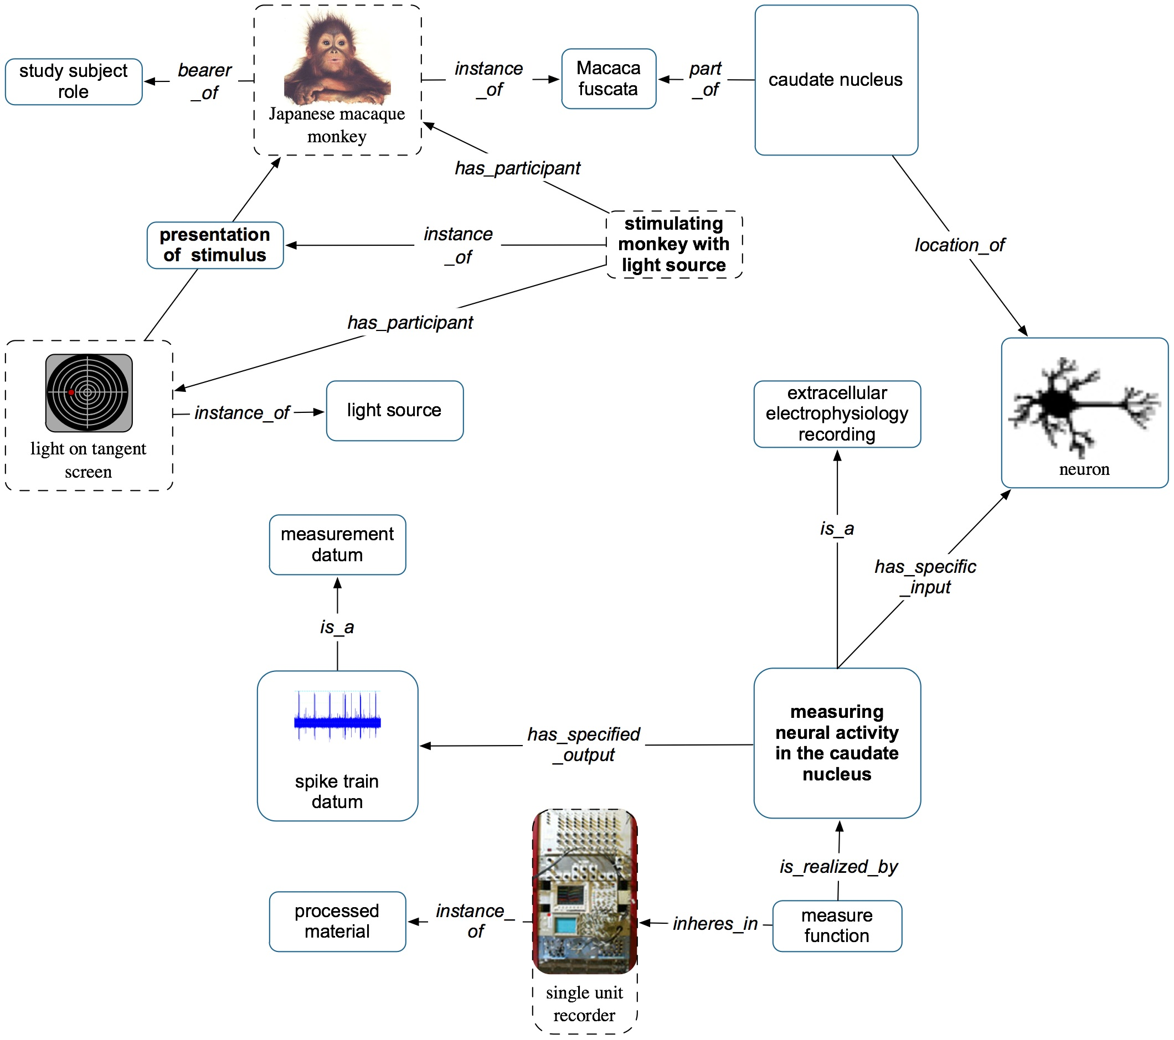

Figure 1. OBI modeling of a single trial in the neuroscience study. Processes in this experimental trial are shown in bold (e.g., stimulating monkey with light), while terms for objects, roles, or processes (e.g., macaque, stimulus role, extracellular electrophysiology recording) are shown in regular font and relationships are in italics (e.g., is_realized_by, has_specific_input). Diagrams such as those for the light, or the monkey, or the neuron indicate that those are instances of the ontological classes.

odeledt from a neuron, which in in the caudate nucleus which is part of the monkey.
al definition of the assay. The function of theelectrode used
example, is the location of the mi

Use case 2: Vaccine protection investigation
A vaccine protection investigation (also known as a vaccine challenge experiment) measures how efficiently a vaccine or vaccine candidate induces protection against a virulent pathogen infection in vivo. Figure 2 demonstrates how to use OBI to represent a typical vaccine protection investigation via the following three sub-processes:
- A vaccination is a kind of administering substance in vivo that realizes some material to be added role borne by a vaccine (e.g., VacX) as well as a target of material role borne by an organism that also bears a host role (e.g., mouse). The term vaccination is a term imported from the Vaccine Ontology (VO, http://www.violinet.org/vaccineontology). A contain function that inheres in a bottle is realized by the vaccination process. An injection function that inheres in a syringe (a processed material or device) is also realized by the vaccination process.
- A pathogen challenge is also a kind of administering substance in vivo process. It realizes a number of roles - a pathogen role and material to be added role borne by the challenge organism (e.g., Influenza Virus), and a target of material role and host role borne by another organism (e.g., mouse). An injection function that inheres in a syringe is realized by the pathogen challenge process.
- A survival assessment is an assay that measures the survival rate (occurrence of death events) in one or more organisms that are monitored over time. The survival assessment is a protection efficiency assay that has specified input a number of organisms (e.g., mouse) and has specified output a survival rate, in this case a measurement datum that records that 75% of mice survived the pathogen challenge.

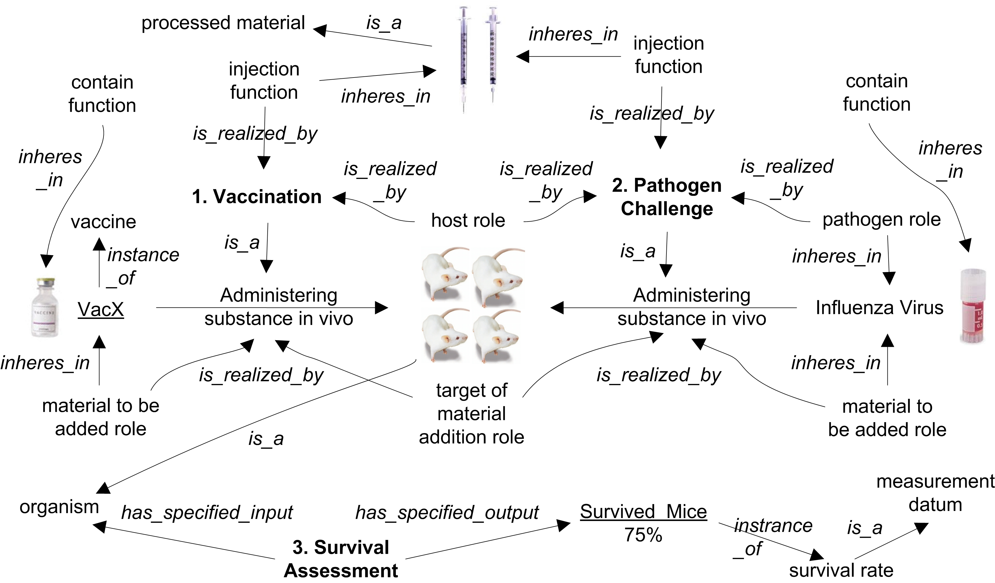

Figure 2. OBI modeling of vaccine protection investigation. The three major processes are highlighted in bold. All italicized terms are properties. Two underlined terms are instances.

Use case 3: An automated functional genomics investigation

Robot Scientist “Adam” is designed to perform high-throughput growth curves measurements (phenotypes) of selected microbial strains (genotypes) in a defined media (environment) [King et al., 2009]. The robot requires a complete and precise description of all experimental actions, and this use case demonstrates how OBI can be used to provide elements of such a description. Here we have represented an investigation in which Adam tests hypotheses about which metabolites can restore a function of the removed yeast gene (Figure 3).
- Adam’s planning yields a plan specification that has, as part, an objective specification to test an inferred statements which are modeled as hypothesis textual entity. Each statement is about whether metabolite will affect yeast strain growth. Adam’s plan specifies an assay to test these hypotheses: to grow yeast with and without addition of the metabolite.
- The planned process automated investigation of the enzyme EC.6.1.39 is an instance of the class hypothesis driven investigation with the objective to test the hypothesis specified in the planning process (we represent a single hypothesis textual entity which serves as a design pattern). The specified output of the investigation is the study result – whether the metabolite affected the growth of the yeast strain (see Figure 3, panel: process 3). The upper growth curve shows the growth rate with the addition of the metabolite, and the lower curve shows the rate with no metabolite. The results interpretation is modeled as conclusion textual entity that states that the statement inferred by Adam has been confirmed and the robot can update its background knowledge.
- The investigation process has part several assays that provide data used to test the hypotheses. The assay has specified inputs the metabolite and the yeast strain specified in the hypothesis, and specified output is a data set consisting of several optical density measurement data. The yeast bears the evaluant role, and the metabolite the nutrient role.
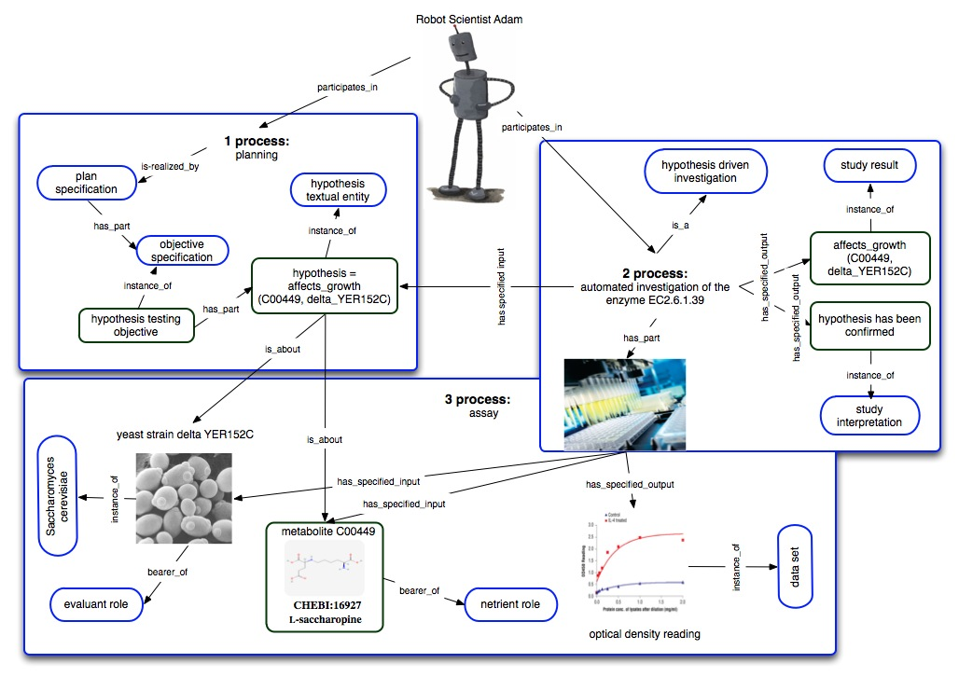

Figure 3. OBI modeling of the Robot Scientist automated investigation (a fragment). The three major processes are highlighted in bold, instances are in green boxes and classes are in blue boxes.

Discussion

OBI was built to provide a comprehensive and versatile representation of biomedical investigations. Our three biological use cases are represented by statements in terms defined in OBI. Individual experimental steps - the two processes in the neuroscience use case, the three processes in the vaccine protection case, and the three processes in the functional genomics case - all fall under planned process in OBI. The processes vaccination and pathogen challenge are disjoint subclasses of administering substance in vivo. Survival assessment is a type of assay (Table 1). We found that all these required processes, as well as all other entities described in the use cases could be represented using OBI idioms. Syringe is a device that participates in different processes. Entities such as vaccine are types of material entity. Host role, pathogen role, and material to be added are types of role.

In the example of the neuroscience investigation use case, the construction of logical definitions of the experimental process encouraged us to ask questions of domain experts because details we wished to capture were not explicit in the publication. For example, was the location of the micro-electrode extra- or intra- cellular? Were all spike train data recorded from the caudate nucleus? How does a spike train relate to the GO biological process regulation of action potential [GO:0001508]? Based on the answers, we augmented OBI’s existing assays and imported several terms from external ontologies, for example NIFSTD. When we needed relations that were not yet present in OBI, rather than define them ourselves we used relations from ro_proposed [http://obofoundry.org/cgi-bin/detail.cgi?ro_proposed]. For example unfolds_in specifies that an occurrent (process) happens in a certain location (i.e., the assay of spike trains in the caudate nucleus). Finally, we use the NCBI taxonomy [Sayers et al., 2008] to describe the species involved in this experiment. Re-use of external resources fulfills two purposes. First, as domain experts have already devoted time to defining terms in these external ontologies we save ourselves substantial efforts by not replicating that work. Second, by re-using existing resources that others already use, we improve the potential for future data integration by making it unnecessary to map between different identifiers denoting the same entity.

In developing the neuroscience use case we found decisions about choosing an appropriate level of detail challenging: in this use case we decided not to include instances of the classes, but instead to focus on adding classes that can be re-used for other use cases and communities. It is our intention that our analysis and the classes we defined serve as design patterns for other neuroscience assays.

That OBI can be used to represent experimental processes for different applications and domains is appealing because it suggests that we can better leverage the work we each do. Approximately 400 vaccines have been manually curated and stored in the VIOLIN vaccine database system [Xiang et al., 2008]. Currently, the vaccine protection experimental data in VIOLIN is stored in plain text and can be difficult to interpret. The lack of a common ontology to aid in representing this data has prevented optimal use of the VIOLIN vaccine data. We plan to apply the representation described in this paper to that data in order to enable advanced querying both within the data as well as across data from
other biomedical communities that represent their data using OBI. As an example, consider that a vaccine candidate against Alzheimer disease may induce specific changes on the brains of transgenic mice or human patients (http://www.ncbi.nlm.nih.gov/pubmed/12379846). Therefore enabling query across the domains of vaccinology and neuroscience would be of utility in conducting such research.
The representations of the investigations run by Adam were stored as instances of the defined classes in a relational database [Soldatova et al., 2006]. Accurate and complete recording of all experimental processes involved in the investigations allows efficient re-use of produced data and results for different investigations with different objectives.
OBI’s approach to representation for automation suggests new possibilities for automated investigations, desirable because such methods offer high throughput mechanisms not only for data generation, but also for hypotheses generation and the results analysis. As using terminology from a wide range of biology is a central part of OBI’s methodology, we can easily imagine that it is reasonable to extend the reach of such an approach. For example, DNA microarray experiments may also be performed using Robot Scientists in order to generate and test hypotheses regarding the transcript expression level in brain or other tissues, and knowledge encapsulated the Gene Ontology or other ontologies could be applied to interpreting the results of such experiments.

Conclusions

Here we provide three real world use cases as examples of how to represent experimental processes with OBI. Experience such as this helps validate OBI’s current design choices as well show how to extend it in domain specific ways. It also generates competency questions that allow us to identify parts of OBI that are insufficiently expressive and to identify external resources that can be used to extend OBI’s coverage. We found that a major technical challenge is the requirement to import terms from other ontologies to construct logical definitions: due to its broad scope OBI spans multiple existing ontological resources. There is a significant cost preventing those large imports, as reasoning becomes slower and the ontology is harder to navigate. To solve this problem the OBI consortium developed the MIREOT mechanism [Courtot et al., 2008], which preserves namespaces of imported terms and allows their direct use into OBI. We also hope that technologies such as views [Detwiler & Brinkley, 2008] and modules [Parsia et al., 2009] as well as improvements to existing reasoners will address these issues. OBI will be further developed to expand the coverage and depth of biomedical investigations and the use cases presented here helped us in testing the forthcoming release candidate 1.0 version of the ontology.

List of abbreviations

GO: Gene Ontology
IAO: Information Artifact Ontology
LABORS: LABoratory Ontology for Robot Scientist
MGED: Microarray Gene Expression Society
MIREOT: Minimum Information to Reference an External Ontology Term
MSI: Metabolomics Standards Initiative
NCBI: National Center for Biotechnology Information
NCBI_Taxon: NCBI Taxonomy
NIFSTD: Neuroscience Information Framework standardized
OBI: Ontology for Biomedical Investigations
OBO: Open Biomedical Ontologies
VO: Vaccine Ontology

Competing interests

The authors declare that they have no competing interests.

Authors' contributions
The three use cases were primarily provided by DD/JT, YH, and LNS. All authors contributed to the development of OBI.

Acknowledgements
This work is partially supported by grant funding from the National Institute of Biomedical Imaging and Bioengineering, National Human Genome Institute, NIH (R01EB005034, NIH P41 HG003619), NIH-NIAID R01AI081062, HHSN26620040006C, the Intramural Research Program of the NIH and NIEHS, (HHSN273200700046UEC), NIMH (NIH) R01MH084812-01A1, NCRR (NIH) the Bio-Informatics Research Network Coordinating Center (U24 RR025736-01), EMERALD project (LSHG-CT-2006-037686), EC FELICS, MUGEN, BBSRC (BB/E025080/1, BB/C008200/1, BB/G000638/1), RC UK, NERC-NEBC, EU IP CarcinoGenomics (PL 037712), EU NoE NuGO (NoE 503630), CARMEN project EPSRC (EP/E002331/1), NERC-NEBC, EU IP CarcinoGenomics (PL 037712), EU NoE NuGO (NoE 503630), the Michael Smith Foundation for Health Research, the Public Health Agency of Canada / Canadian Institutes of Health Research Influenza Research Network (PCIRN).
We thank Midori Harris, David Hill, Jane Lomax and Maryann Martone for discussions on the neuroscience use case. We thank Ross D. King for the discussions on the automated functional genomics use case.
We thank the OBI Consortium members Jeff Grethe, Daniel Rubin, Bill Bug, Stefan Wiemann, Tina Hernandez-Boussard, Richard Scheuermann, Richard Bruskiewich, Frank Gibson, Norman Morrison, Dawn Field, Tanya Gray, Eric Deutsch, Daniel Schober, Luisa Montecchi, Chris Taylor, Trish Whetzel, John Westbrook, Gilberto Fragoso, Joe White, Mervi Heiskanen, Liju Fan, Helen Causton, Allyson Lister, Kevin Clancy, Cristian Cocos, Jay Greenbaum, Pierre Grenon, Chris Mungall, Matthew Pocock, Holger Stenzhorn, Lawrence Hunter, Monnie Mc Gee, Barry Smith, Robert Stevens, Elisabetta Manduchi for the contribution to OBI.

References

- Brazma, A., Hingamp, P., Quackenbush, J., et al. (2001) Minimum information about a microarray experiment (MIAME) - toward standards for microarray data. Nat Genet, 4: 365-371.
- Bug, W., G. A. Ascoli, et al. (2008). The NIFSTD and BIRNLex Vocabularies: Building Comprehensive Ontologies for Neuroscience. Journal of Neuroinformatics 6: 175-194.
- Courtot, M., Gibson, F., Lister, A., et al. (2009) MIREOT: the Minimum Information to Reference an External Ontology Term. In Proc. ICBO'09 http://icbo.buffalo.edu/
- Detwiler, L.T., Brinkley, J.F. (2006) Custom views of reference ontologies. In Proc. AMIA Annu Symp: 909. PMID: 17238528
- Grenon, P., Smith, B., and Goldberg, L. (2004) Biodynamic Ontology: Applying BFO in the Biomedical Domain. Ontologies in Medicine, IOS Press: 20-32.
- King, R.D., Rowland, J., Oliver, S.G., et al. (2009) The Automation of Science. Science, 324/ 5923: 85-89.
- Lauwereyns, J., Watanabe, K., Coe, B. & Hikosaka, O. (2002). A neural correlate of response bias in monkey caudate nucleus. Nature, 418, 413-417.
- Matos, P., Ennis, M., Darsow, M., et al. (2006) ChEBI - Chemical Entities of Biological Interest. Nucleic Acids Research, Database Summary: 646.
- Parsia, B., Sattler, U., Schneider, T. (2009) Mechanisms for Importing Modules, Owl Experiences and Directions. Available at: http://www.webont.org/owled/2009/papers/owled2009_submission_10.pdf
- Peters, B., Sidney, J., Bourne, P., et al (2005) The immune epitope database and analysis resource: from vision to blueprint. PLoS Biol. 3(3):e91
- Sansone, S., Schober, D., Atherton, H.J., et al. (2007) Metabolomics Standards Initiative - Ontology Working Group. Work in Progress. Metabolomics, 3(3): 249-256.
- Sayers, E.W., Barrett, T., Benson, D.A., et al. (2009). Database resources of the National Center for Biotechnology Information. Nucleic Acids Res. 37 (Database issue): D5-15.
- Schober, D., Smith, B., Lewis, S., et al. (2009) AS: Naming Conventions for OBO Foundry Ontology engineering. BMC Bioinformatics, 10:125.
- Smith, B., Ashburner, M., Rosseet, C., et al. (2007) The OBO Foundry: coordinated evolution of ontologies to support biomedical data integration. Nature Biotechnology, 25: 1251 - 1255.
- Smith, B., Ceusters, W., Klagges, B., et al. (2005) Relations in Biomedical Ontologies. Genome Biology, 6: R46.
- Soldatova L.N., Clare A., Sparkes A. & King, R.D. (2006) An ontology for a Robot Scientist. Bioinformatics (Special issue ISMB) 22/14: e464-e471.
- The Gene Ontology Consortium (2000) Gene Ontology: Tool for the Unification of Biology. Nature Genetics, 25: 25-29.
- Whetzel, P. L., Parkinson, H. E, Causton, H. C., et al. (2006) The MGED Ontology: a resource for semantics-based description of microarray experiments. Bioinformatics, 7: 866-873.
- Whetzel, P. L., R. R. Brinkman, et al. (2006). Development of FuGO: an ontology for functional genomics investigations. Omics 10(2): 199-204.

Table 1. Ontology terms used in the three use cases (note: instances are not included):
Ontology terms | Sources and term IDs | Parent class | Use cases
Classes
administering substance in vivo | OBI: OBI_0600007 | material combination | 2
assay | OBI: OBI_0000070 | planned process | 3
caudate nucleus | NeuroLex: birnlex_1373 | anatomical entity | 1
centrifuge | OBI: OBI_0400106 | processed material
conclusion textual entity  (alternative term: conclusion) | IAO: IAO_0000144 | textual entity | 3
contain function | OBI: OBI_0000370 | function | 2
data set | IAO: IAO_0000100 | data item | 3
environment control function | OBI: OBI_0000401 | function
evaluant role | OBI: OBI_0000067 | role | 3
extracellular electrophysiology recording | OBI: OBI_0000454 | assay | 1
function | snap#Function | realizable_entity
host role | OBI: OBI_0000725 | role | 2
hypothesis driven investigation | OBI: OBI_0000355 | planned process | 3
hypothesis textual entity  (alternative term: hypothesis) | IAO:TMPIAO_0000005 | textual entity | 3
independent_continuant | snap#IndependentContinuant | continuant
injection function | OBI:OBI_0005246 | function | 2
interpreting data | OBI: OBI_0000338 | process
investigation | OBI: OBI_0000066 | planned process
light source | OBI: OBI_0400065 | processed material | 1
Macaca fuscata | NCBI_Taxon: NCBITaxon_9542 | organism | 1
material combination | OBI: OBI_0000652 | planned process
material to be added role | OBI: OBI_0000319 | role | 2
material_entity | snap#MaterialEntity | IndependentContinuant
measure function | OBI: OBI_0000453 | function | 1
measurement datum | IAO: IAO_0000109 | data item | 1,2
measuring neural activity in the caudate nucleus | OBI: OBI_0000812 | extracellular electrophysiology recording | 1
micro electrode | OBI: OBI_0000816 | processed material | 1
neuron | FMA: FMA:54527 | anatomical entity | 1
objective specification | IAO: IAO_0000005 | directive information entity | 3
organism | OBI: OBI_0100026 | material_entity | 2
pathogen challenge | OBI: OBI_0000712 | administering substance in vivo | 2
pathogen role | OBI: OBI_0000718 | role | 2
patient role | OBI: OBI_0000093 | role
plan specification | IAO: IAO_0000104 | directive information entity | 3
planning | OBI: OBI_0000339 | planned process | 3
presentation of stimulus | OBI: OBI_0000807 | process | 1
process | span#Process | processual_entity
processed material | OBI: OBI_0000047 | material_entity | 1,2,3
role | snap#Role | realizable_entity
Saccharomyces cerevisiae | NCBI_Taxon: NCBITaxon_4932 | organism | 3
separation function | OBI: OBI_0000372 | function
specimen role | OBI: OBI_0000112 | role
spike train datum | OBI: OBI_0000801 | measurement datum | 1
study result | OBI: OBI_0000682 | information content entity | 3
study subject role | OBI: OBI_0000097 | role | 1
survival assessment | OBI: OBI_0000699 | assay | 2
survival rate | OBI: OBI_0000789 | measurement datum | 2
syringe | OBI: OBI_0000422 | processed material | 2
T cell epitope recognition assay | OBI: OBI_1110037 | assay
target of material addition role | OBI: OBI_0000444 | role | 2
test tube | OBI: OBI_0000836 | processed material
vaccination | VO: VO_0000002 | administering substance in vivo | 2
vaccine | VO: VO_0000001 | material_entity | 2
Property terms
bearer_of | RO: OBO_REL#bearer_of |  | 1,3
has_part | ro.owl#has_part |  | 3
has_participant | ro.owl#has_participant |  | 1
has_specified_input | OBI: OBI_0000293 |  | 1,2
has_specified_output | OBI: OBI_0000299 |  | 1,2
inheres_in | RO: OBO_REL#inheres_in |  | 1,2
is about | IAO: IAO_0000136 |  | 3
Is_a | RO: OBO_REL:is_a |  | 1,2,3
is_realized_by | IAO: IAO_0000122 |  | 1, 2, 3
location_of | ro.owl#location_of |  | 1
part_of | ro.owl#part_of |  | 1
participates_in | ro.owl#participates_in |  | 3
unfolds_in | RO: OBO_REL#unfolds_in |  | 1

