Ontology representation and ANOVA analysis of vaccine protection investigation
Tentative: Yongqun He^{1*}, Zuoshuang Xiang¹, Thomas Todd¹, Melanie Courtot³, Ryan Brinkman³, Jie Zheng⁴, Chris Stoeckert⁴, James Malone⁵, Jennifer Fostel⁶, Larisa N. Soldatova⁷, Bjoern Peters⁸, Alan Ruttenberg⁹
¹ University of Michigan, Ann Arbor, USA;

abstract
It is still challenging to apply ontology into statistical analysis of experimental data. As a first step towards this goal, ontological representation of statistical ANOVA analysis is proposed. In a vaccine protection use case, 151 instance data of Brucella vaccine protection investigation were collected from the literature and analyzed using the ontology-based ANOVA. Out of 16 parameters, 10 were found significant in contributing to the protection. An ontology-based representation and statistical analysis of biomedical data allows data consistency checking and data sharing in Semantic web.

introduction
The Ontology for Biomedical Investigations (OBI) is being developed to address the need for a common, integrated ontology for the description of biological and clinical investigations. OBI has been used in experimental investigations in different communities. For example, in our recent study, we used OBI and other ontologies to represent an investigation of vaccine protection against influenza viral infection (Brinkman et al, 2010). The vaccine protection investigation measures how efficient a vaccine or vaccine candidate induces protection against virulent pathogen infection in vivo.
While ontology representation of experimental assays provide a foundation for further data sharing and semantic web studies of specific domains, it is still challenging to use the ontologies for statistical analysis of instance data. OntoDM is a newly proposed ontology of data mining that provides a framework and describes entities from the domain of data mining and knowledge discovery. OntoDM is aligned with OBI. The updated OBI has included many statistical terms (e.g., ANOVA) and relevant supports that facilitate statistical analysis.
The community-based Vaccine Ontology (VO; http://www.violinet.org/vaccineontology/) is biomedical ontology that covers the vaccine domain. Development of VO has emphasized classification of vaccines and vaccine components, vaccination investigation, and host responses to vaccines. The VO development follows the OBO Foundry principles [Smith et.al., 2007]. VO uses the Basic Formal Ontology (BFO) [Grenon et.al, 2004] as the top-level ontology. OBI is used as another top level ontology for vaccine investigation. VO uses relations defined by primarily the Relation Ontology (RO) [Smith et.al., 2005] and also by OBI and IAO ontologies. The close association with these ontologies facilitates data integration and automated reasoning.
In this report, we first introduce our ontology representation of the ANOVA statistical analysis, then apply it to investigate the Brucella vaccine protection results curated from the literature. Brucella is an intracellular bacterium that causes brucellosis, the most common zoonotic disease worldwide. In this study, we hypothesized that some experimental variables significantly contribute to Brucella vaccine protection efficacy while others do not. Our study indicates that ontology is a useful approach to support biomedical statistical data analyses.

Methods
The following methods were applied in this study:
Ontology representation of ANOVA Statistical analysis: ANOVA was modeled in OBI. A design pattern was generated.
Ontology-based representation of vaccine protection investigation: All variables in this use case are represented using different ontologies as needed. The main ontologies used include VO, OBI, and the Information Artifact Ontology (IAO).
Literature curation of individual Brucella vaccine protection data: Peer-reviewed Brucella vaccine protection research papers were obtained from PubMed search. These papers were manually curated to obtain individual values for variables modeled in ontology for each vaccine protection investigation. The data were stored in an OWL file.
Ontology-based ANOVA analysis of Brucella vaccine protection results: Ontology-based ANOVA analysis was applied to study the Brucella vaccine protection investigation instance data. The results were also represented in ontology.

Results
We will first introduce how ANOVA is modeled in OBI. The ontology representation of vaccine protection investigation using VO and OBI is then described. Using literature mined data, we will last introduce how the vaccine protection results are analyzed by ANOVA and modeled using ontology.

Ontology design pattern of ANOVA data analysis:
An ANOVA analysis measures how a dependent variable(s) is dependent on independent variables. The ontology-based ANOVA data analysis design pattern is illustrated in Fig. 1. ANOVA is a subclass of data transformation in OBI. ANOVA has specified input of data item. The individual data items come from two sources. The data items are possibly the output of individual processes (e.g., CFU reduction assay). Alternatively, a data item can be an output of a discretization process that descretizes non-measurable data (e.g., mouse age) into categorized measurement data (e.g., 1 for young mouse, 2 for middle-aged mouse, and 3 for old mouse). One approach to obtain the data items necessary for ANOVA analysis is through data item extraction from journal article. In this case, the input is journal article, and the output is data. The ANOVA output is a p-value data set, which includes a set of p-value results for an independent variable data set that is predefined.
ANOVA is concretization of ANOVA protocol. The ANOVA protocol includes a predictive model that specifies a testable hypothesis model (Fig. 1).

Ontology representation of Brucella vaccine protection investigation
A vaccine protection investigation includes three processes (or steps): vaccination, pathogen challenge, and vaccine protection efficacy assessment. For those pathogens that kill a model animal (e.g., mouse), survival assessment is used for assessing vaccine protection efficacy (Brinkman et al, 2010). Since virulent Brucella does not kill mice, the survival of pathogen challenged mice is not a useful method to assess Brucella vaccine efficacy. Instead, a colony forming unit (CFU) reduction assay is used to determine the difference of live bacterial recovery from vaccinated mice and non-vaccinated mice (Schurig et al., 1991).
To prove vaccine protection efficacy, a vaccine protection investigation using a specific animal model is often required. In this process, many variables may affect the outcomes. We summarized 17 variables that are described in typical vaccine protection studies. The ontology terms of these 17 variables are summarized in Table 1.
As an example of this Brucella vaccine protection investigation, Brucella abortus cattle vaccine RB51 was used in a typical vaccine protection study as reported in reference (Schurig et al., 1991). In this typical mouse experiment, live RB51 (1 x 10⁸ CFU) was used to vaccinate Balb/C mice, and the mice were challenged with B. abortus strain 2308 (1 x 10⁵ CFU) seven weeks later. CFU reduction in mouse spleen was then counted to determine the vaccine protection. An ontology representation of this example is shown in Figure 1.
The experimental hypothesis is “Some experimental variables significantly contribute to Brucella vaccine protection efficacy”. This hypothesis can be laid out as an instance of the hypothesis entity text.

ANOVA analysis of Brucella vaccine protection results from literature curation
Brucella vaccine research is an active research area with more than 1,000 peer-reviewed papers stored in PubMed. To determine which variables play significant roles in changing the Brucella vaccine protection efficacy, more than 40 papers were manually curated to get instance data that correspond to these variables. In total, 151 instance data were collected from the literature. In this study, we only focused on mice as the animal model. Different mouse strains were analyzed in our use case investigation. Each instance of vaccine protection investigation has individual values for all 17 variables (Table 1).
To analyze which variables contribute to the vaccine protection, the significance of vaccine protection (three values: no protection, protection, enhanced protection) is set as a dependent variable, and the other 16 variables are independent variables.
An ANOVA analysis was performed and indicated that six variables do not significantly contribute to the protection (p-value > 0.05). These six variables include IL-12 vaccine adjuvant, mouse sex, vaccination route, mouse age at vaccination, vaccination-challenge interval, and challenge dose. The other 10 parameters significantly contribute to the vaccine protection (p-value < 0.05).
The predictive model is “Protection_Significance ~ .” indicating we are testing how each other variable affects the protection significance.
This use case was studied and represented in ontology based on the ontological representations of ANOVA analysis and vaccine protection investigation (Fig. 1 and 2, Table 1). Specifically, to represent the ANOVA data analysis using ontology, we have defined a ‘vaccine protection ANOVA’ under ‘ANOVA’ (Table 1). This ANOVA has input 17 different variable data sets (e.g., vaccine strain variable data set). Each data set corresponding to a data transformation processs (e.g., vaccine strain variable data set transformation) that takes individual data items (e.g., vaccine strain variable data item) and transform them to a data set for variable analysis. These individual data items are derived from a measurement (e.g., CFU reduction assay) or from a vaccine protection protocol specification (e.g., animal age at vaccination). (NOTE: what about vaccine strain? It is neither for now.) Different data sets are assigned for independent variables and dependent variables. A hypothesis was also generated as an instance of the ‘hypothesis textual entity’.
The 151 instance data of this use case study was represented in OWL format. Each set of instance data is defined under an instance of ‘vaccine protection investigation’. The ANOVA output is a p-value data set that corresponds to a list of p-values for different independent variables.

DISCUSSION
The advantage of ontology-based statistical analysis is that the results can be potentially shared and used worldwide through semantic web. Also, ontology based approach facilitates data consistency checking. For a specific instance variable (e.g., vaccine strain) from a vaccine protection investigation, a specific instance is generated for that variable (e.g., RB51 as an instance of vaccine strain). In our use case, many subclasses act as instances for parent class variables. For example, RB51 is a subclass of vaccine strain. If a vaccine strain instance does not belong to a vaccine strain, it may indicate the data is not right. Existing OWL software and programs can be used to add more reasoning and inference features to the statistical analysis.
There are still many challenges in modeling the hypothesis, and ANOVA test, and the statistical results based on the hypothesis. For example, XXXXXXX. However, the example we described in this report provides a first demonstration that it is feasible and provides more powerful features than traditional statistical analysis without ontology and semantic support.
Ontology representation of vaccine protection study provides an advanced approach to represent and mine vaccine-induced protection experimental processes. More than 400 vaccines and the data of protection studies with these vaccines have been manually curated and stored in the VIOLIN vaccine database system [Xiang et.al., 2008]. To make full use of the VIOLIN vaccine data for advanced query and integration with data from other data sources, we plan to apply the ontology-based approach learned from this Brucella study to other vaccine protection data available in VIOLIN.
Our method of ontology-based representation and statistical analysis is applicable for other ontology-based statistical studies. The logical definitions of the ontology entities involved allow computers to unambiguously understand and integrate different biological data with the help of an OWL reasoner.
acknowledgements
This research is supported by NIH grants R01AI081062 and U54-DA-021519.
References
Brinkman RR, Courtot M, Derom D, et al. (2010) Modeling biomedical experimental processes with OBI. Journal of Biomedical Semantics. In press.
Panov P, Soldatova LN, Dzeroski S. (2009) Towards an Ontology of Data Mining Investigations. Proceedings of the 12th International Conference on Discovery Science, Porto, Portugal.
Schurig GG, Roop RM, Bagchi T, et al. (1991) Biological properties of RB51; a stable rough strain of Brucella abortus. Vet Micobiol, 28(2) : 171-188.
Smith B, Ceusters W, Klagges B, Kohler J, Kumar A, Lomax J, Mungall CJ, Neuhaus F, Rector A, Rosse C (2005) Relations in Biomedical Ontologies. Genome Biology, 6: R46
Smith et al. (2007) The OBO Foundry: coordinated evolution of ontologies to support biomedical data integration, Nature Biotechnology, 25: 1251 - 1255.
Xiang Z, Todd T, Ku KP, Kovacic BL, Larson CB, et al. (2008) VIOLIN: vaccine investigation and online information network. Nucleic Acids Res. 36 (Database issue): D923-8.

Table 1. Ontology terms described in this paper:
# | Classes | Sources & term IDs | Parent class (Source)
1 | vaccine strain | VO: VO_0001180 | organism (OBI)
2 | vaccine viability | VO: VO_0001139 | viability (PATO)
3 | IL-12 vaccine adjuvant | VO: VO_0001147 | vaccine adjuvant (VO)
4 | vaccine protective antigen | VO: VO_0000457 | antigen (OBI)
5 | mutated gene in vaccine strain | VO: VO_0001195 | gene (SO)
6 | vaccination mouse strain | VO: VO_0001189 | organism (OBI)
7 | biological sex | PATO: PATO_0000047 | organismal quality (PATO)
8 | vaccination (subclass) | VO: VO_0000002 | administering substance in vivo (OBI)
9 | vaccination dose specification | VO: VO_0001160 | dose specification (OBI)
10 | animal age at vaccination | VO: VO_0000897 | age (PATO)
11 | pathogen strain for challenge | VO: VO_0001194 | organism (OBI)
12 | pathogen challenge (subclass) | OBI: OBI_0000712 | administering substance in vivo (OBI)
13 | challenge dose specification | VO: VO_0001161 | dose specification (OBI_0000969)
14 | vaccination-challenge interval | VO: VO_0001191 | time measurement datum (IAO)
15 | CFU per volume | UO: UO_0000212 | Note: We need CFU values instead of a unit.
16 | CFU reduction | VO: VO_0001164 | titer (OBI)
17 | vaccine protection efficacy | VO: VO_0000456 | Efficacy (PATO)
18 | vaccine protection investigation | VO: VO_0000591 | assay (OBI)
19 | vaccination protocol | VO: VO_0000572 | protocol (OBI)
20 | pathogen challenge protocol | VO: VO_0001163 | protocol (OBI)
21 | intraperitoneal vaccination | VO: VO: VO_0001166 | intraperitoneal injection (OBI)
22 | intraperitoneal pathogen challenge | VO (or OBI): | pathoge challenge (OBI)
23 | hypothesis textual entity | IAO: IAO_0000415 | textual entity (IAO_0000300)
24 | independent variable specification | OBI: OBI_0000750 | directive information entity (IAO)
25 | dependent variable specification | OBI: OBI_0000751 | directive information entity (IAO)
26 | ANOVA | OBI: OBI_0200201 | data transformation (OBI_0200000)
27 | p-value | OBI: OBI_0000175 | quantitative confidence value (OBI)
28 | literature curation | IAO: IAO_0000443

Notes: The first 16 classes represent 16 dependent variables; the 17th class represents an independent variable.
-- If CFU per volume (UO_0000212) is only a unit, it is not what we want. What we need is CFU values with the unit being CFU.
-- CFU reduction needs to go to OBI.

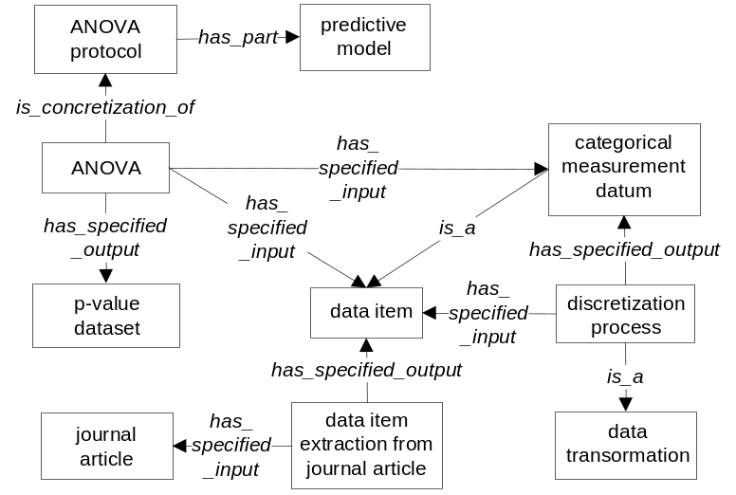

Fig. 1. Representation of ANOVA analysis process

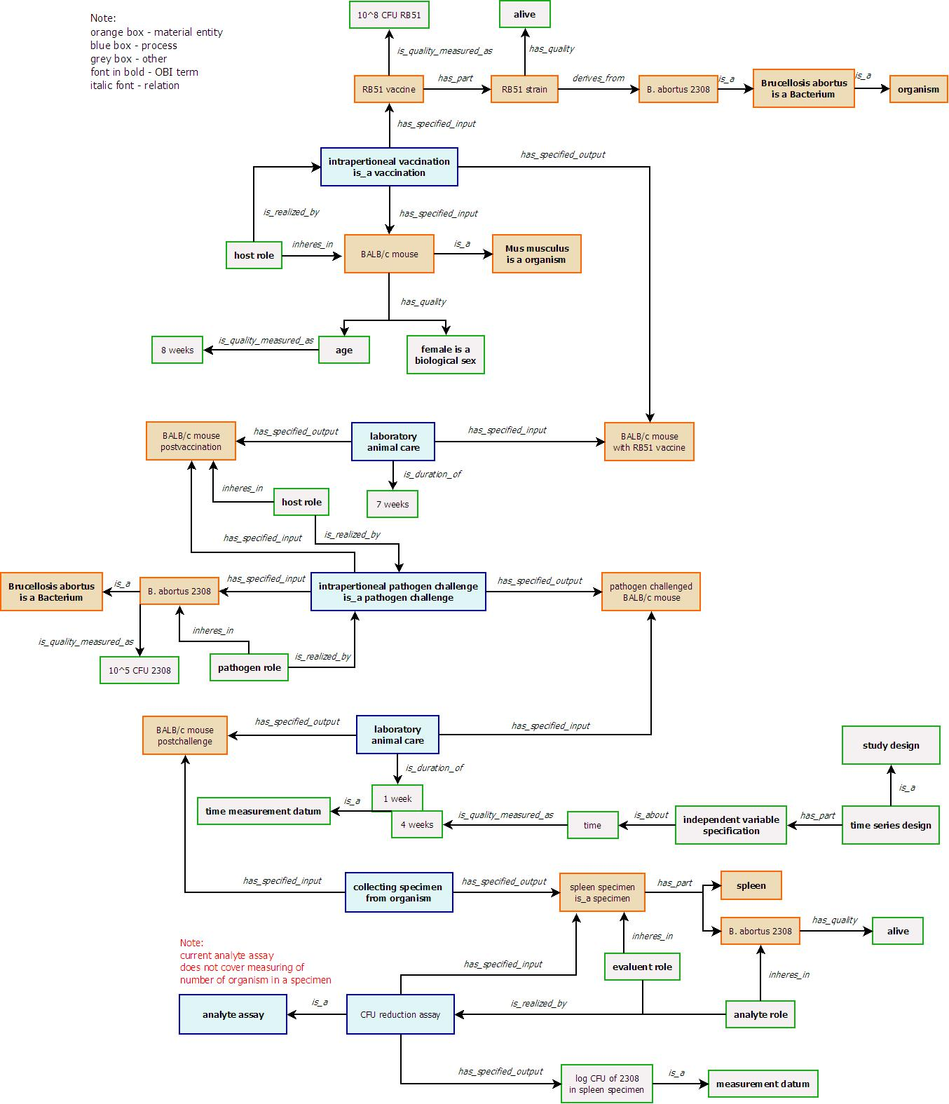
Fig. 2: Representation of protection assay with Brucella vaccine RB51.

* To whom correspondence should be addressed.

