In Protégé-3.3 beta version 371, open ProtocolApplicaiton.owl,
Warning: Do NOT change OWL “Preferences” now.

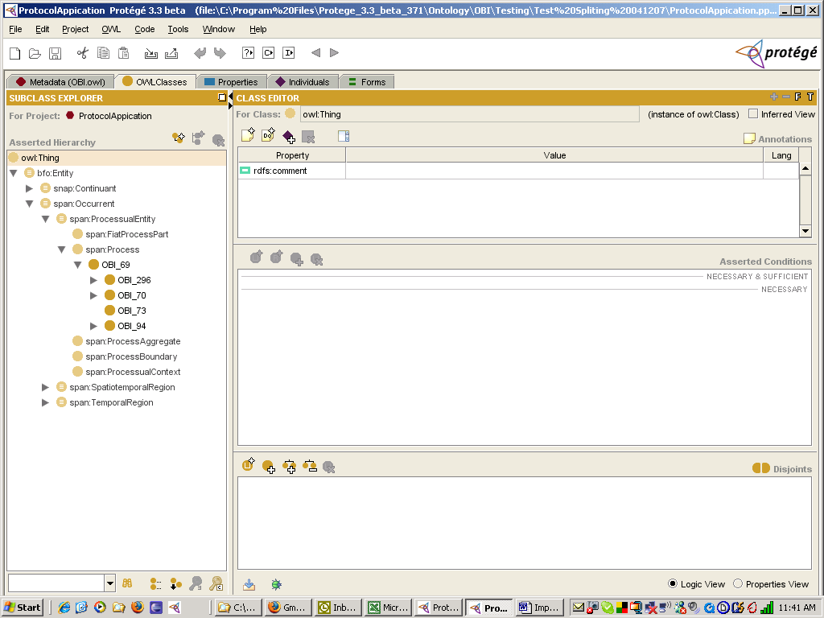

Click on tab “Metadata (OBI.owl)”,

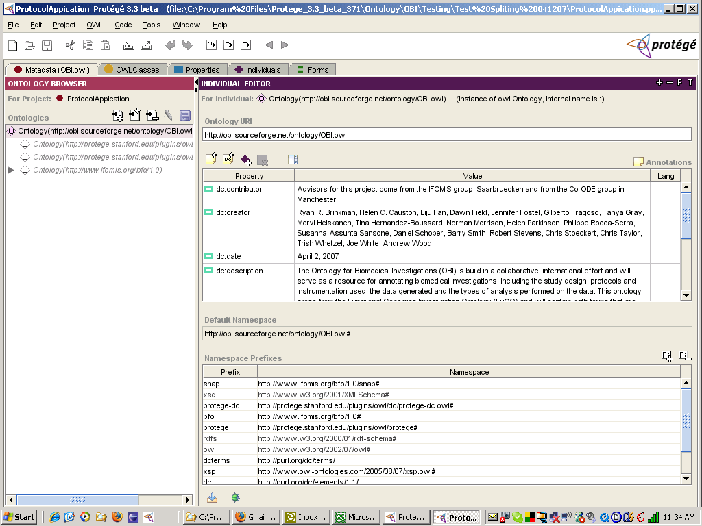

Click on “Import ontology”,

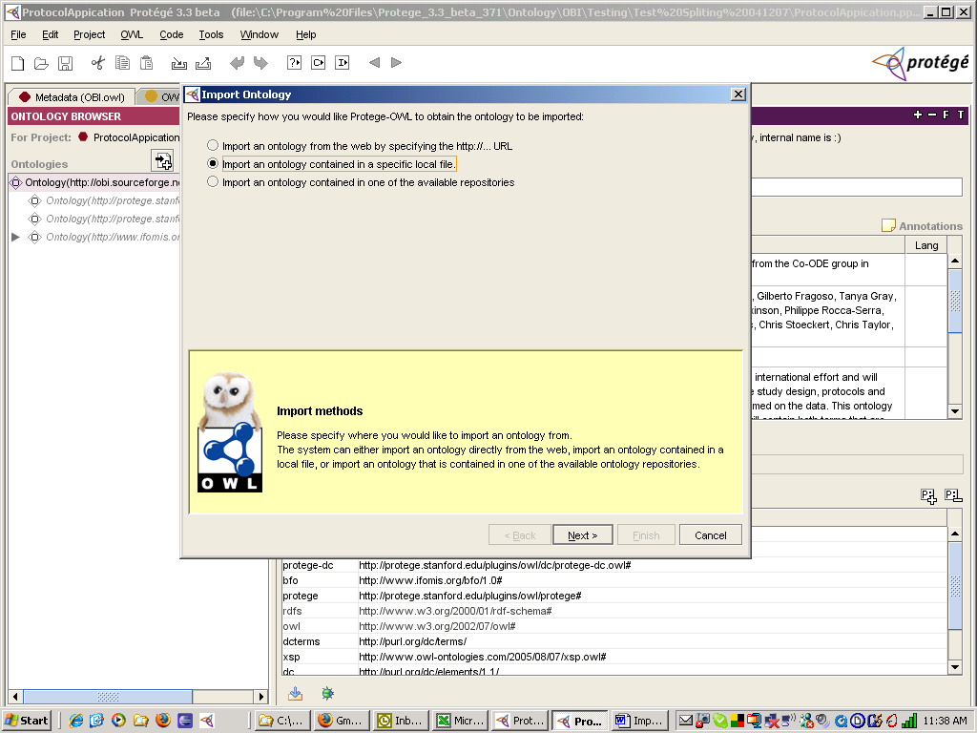

Click on “Next”.

Enter “specified file path” for “OBIwithoutProtocolApplicaiton.owl,

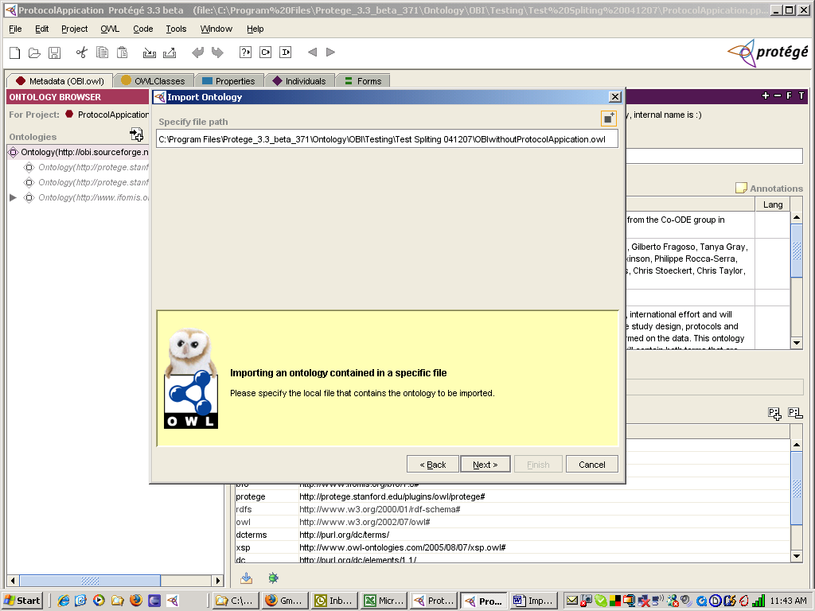

Click on “Next”.

Click on “Finish”,

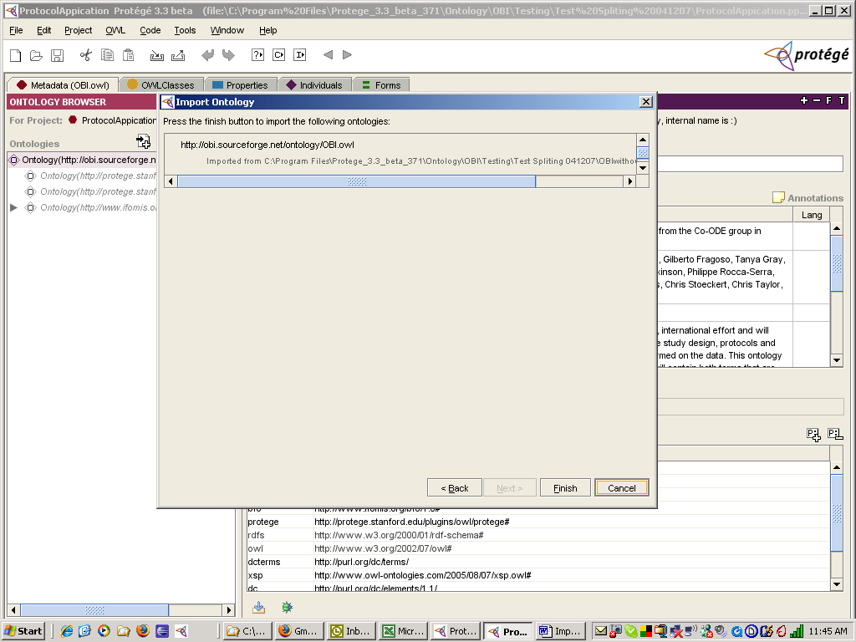

The import has been done,

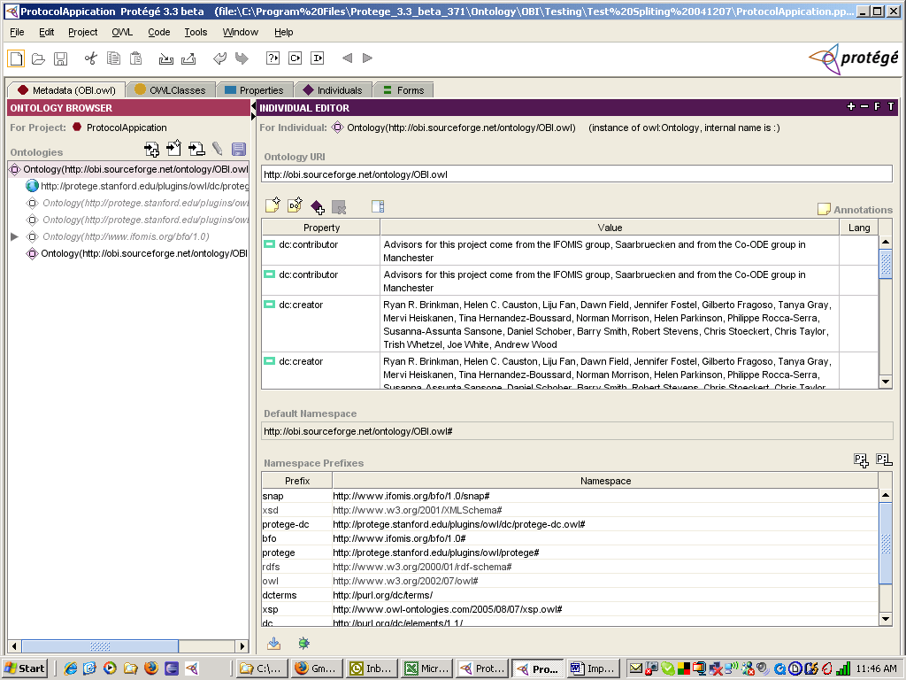

Now, it is safe to change OWL “Preferences” to view rdfs:label,

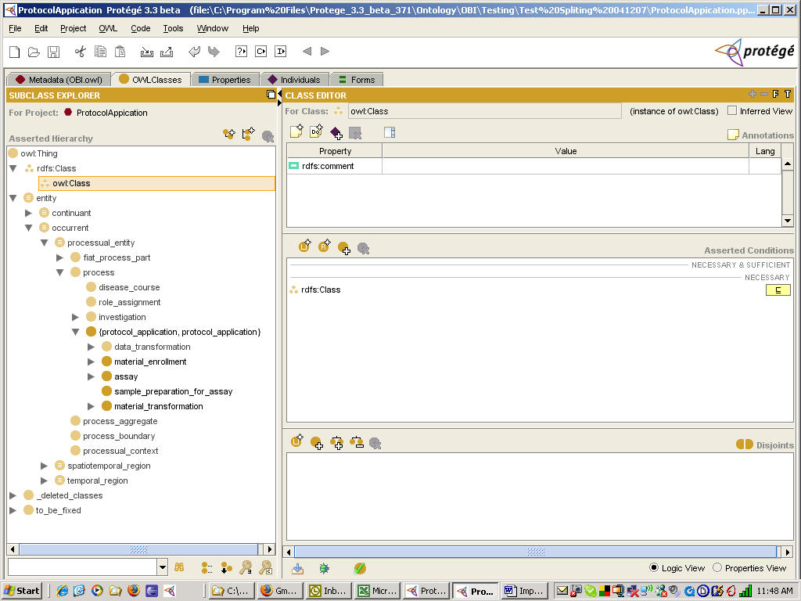

Expanded view of protocol_application without data_transformation,

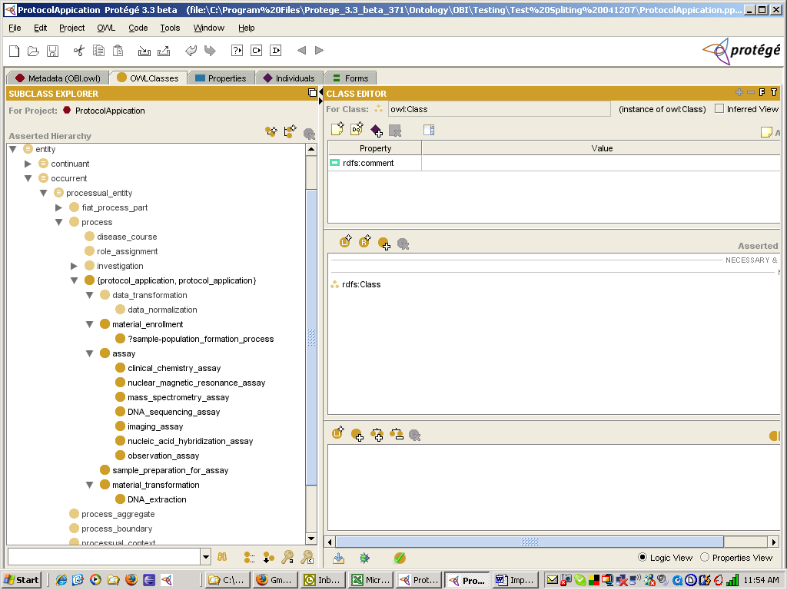

Now, edit and save periodically.

When done with editing, remove the imported OBIwithoutProtocolApplication.owl by clicking on the imported file as shown below,

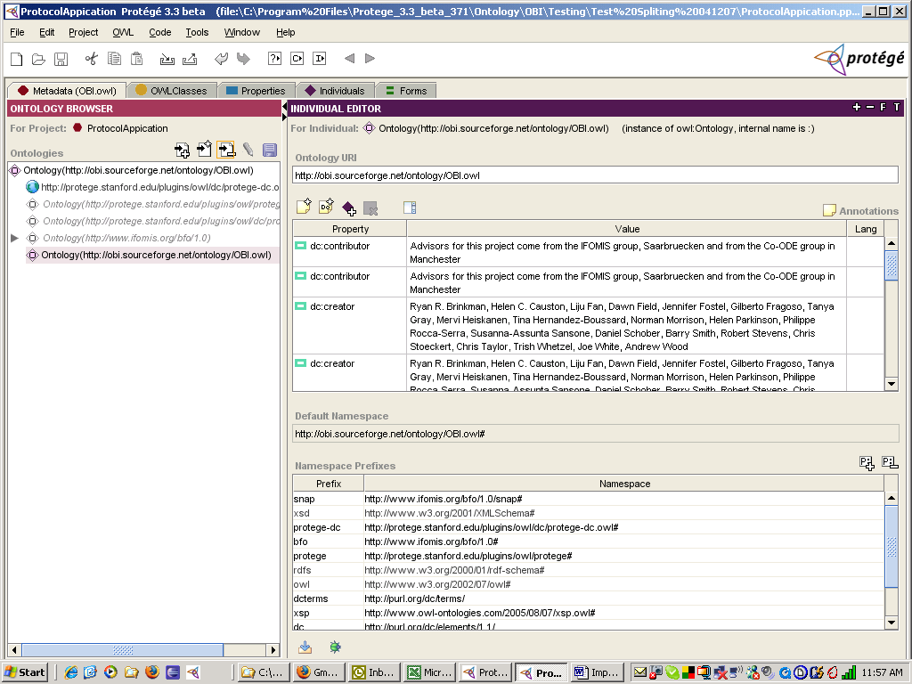

Click on “Remove import”,

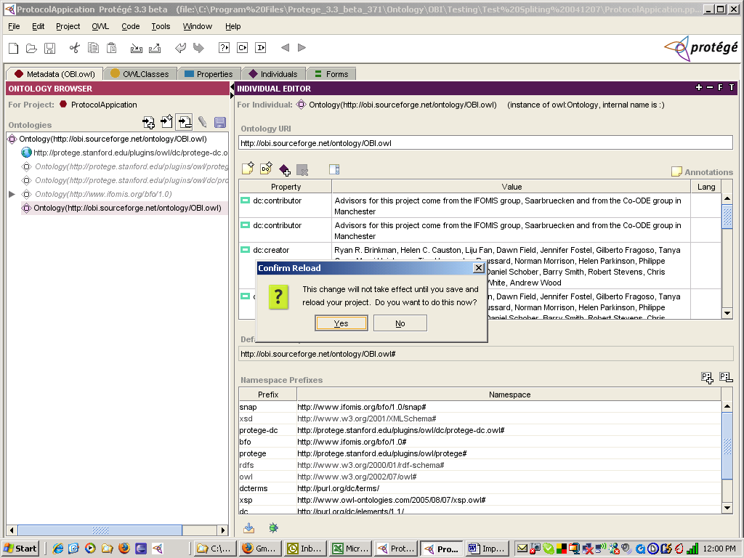

Click on “Yes”.
The import has been removed, which can be verified using tab “Metadata (OBI.owl)”

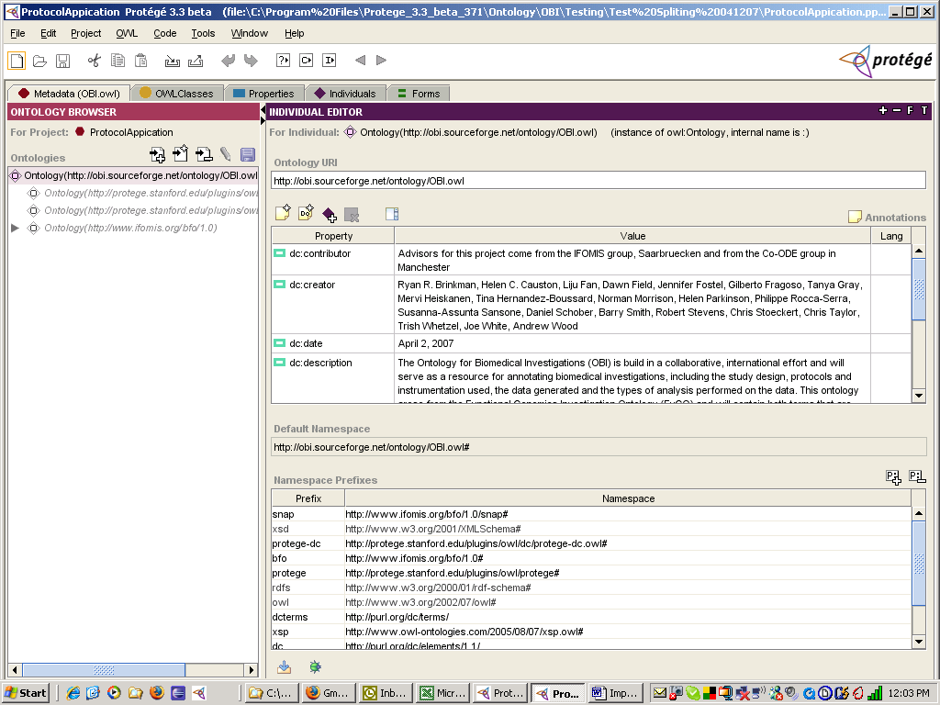

and

by “OWL Classes” tab,

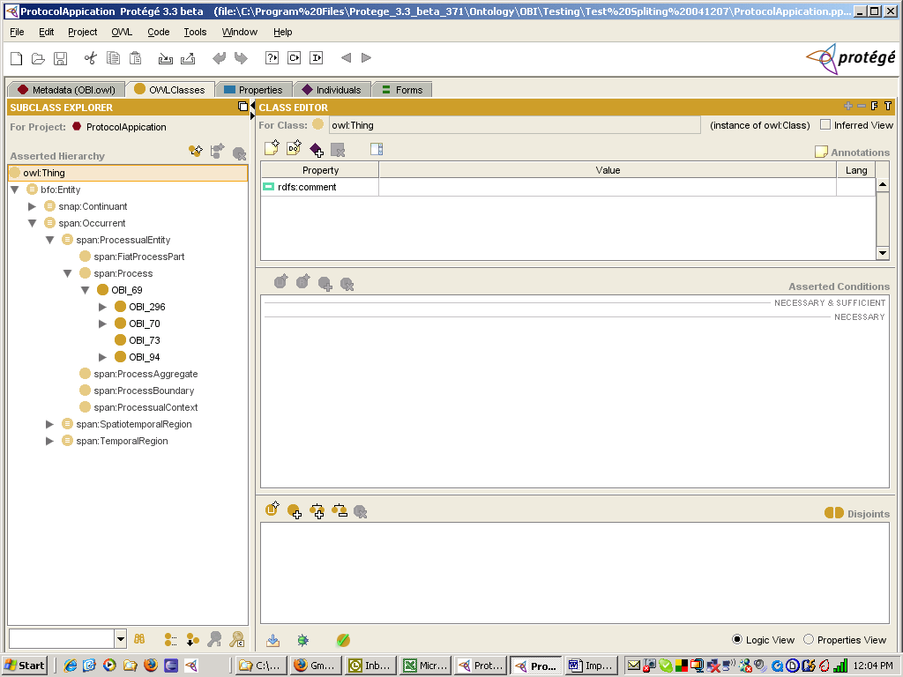
Save the current owl file for protocol_application branch under a different name,
Click on “File” and “Save Project As”.

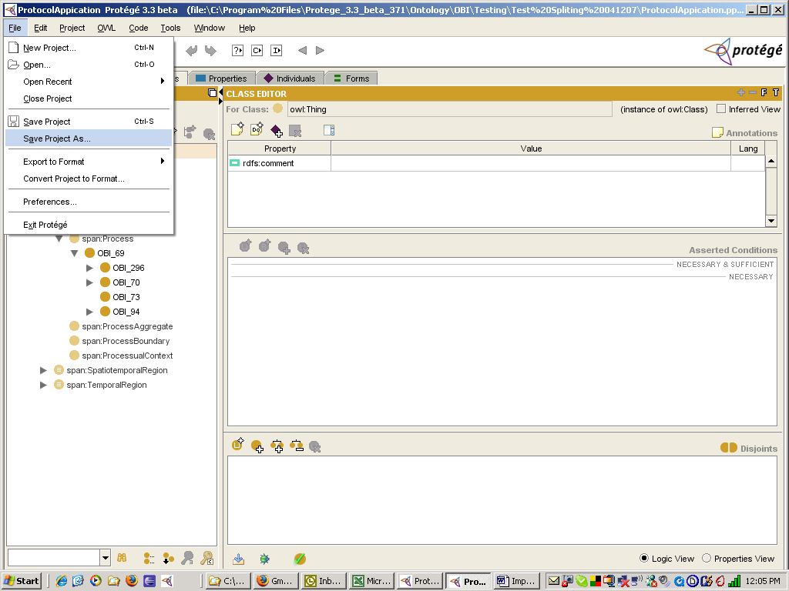

Rename the owl file by changing “Project” name to ProtocolApplicationTest.
(The owl name will change automatically)

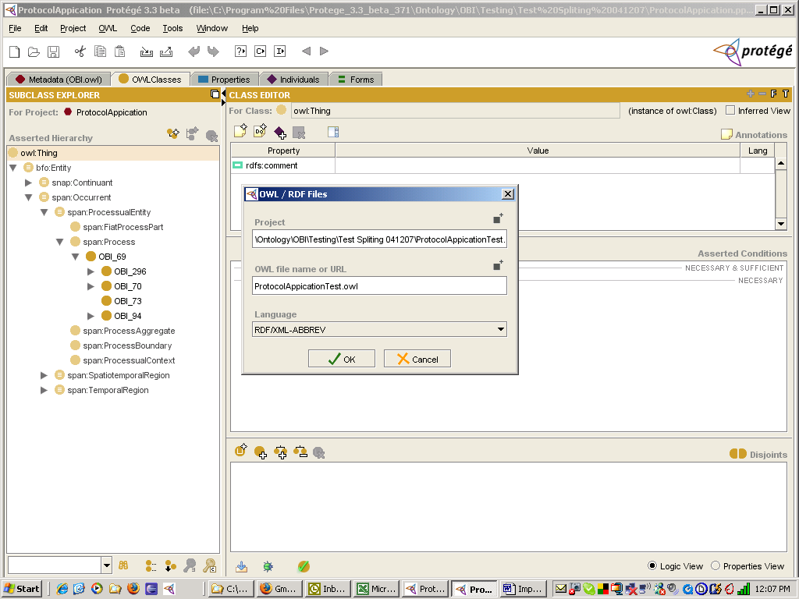

Open the newly saved owl file.
Click on tab for “Metadata (OBI.owl)”

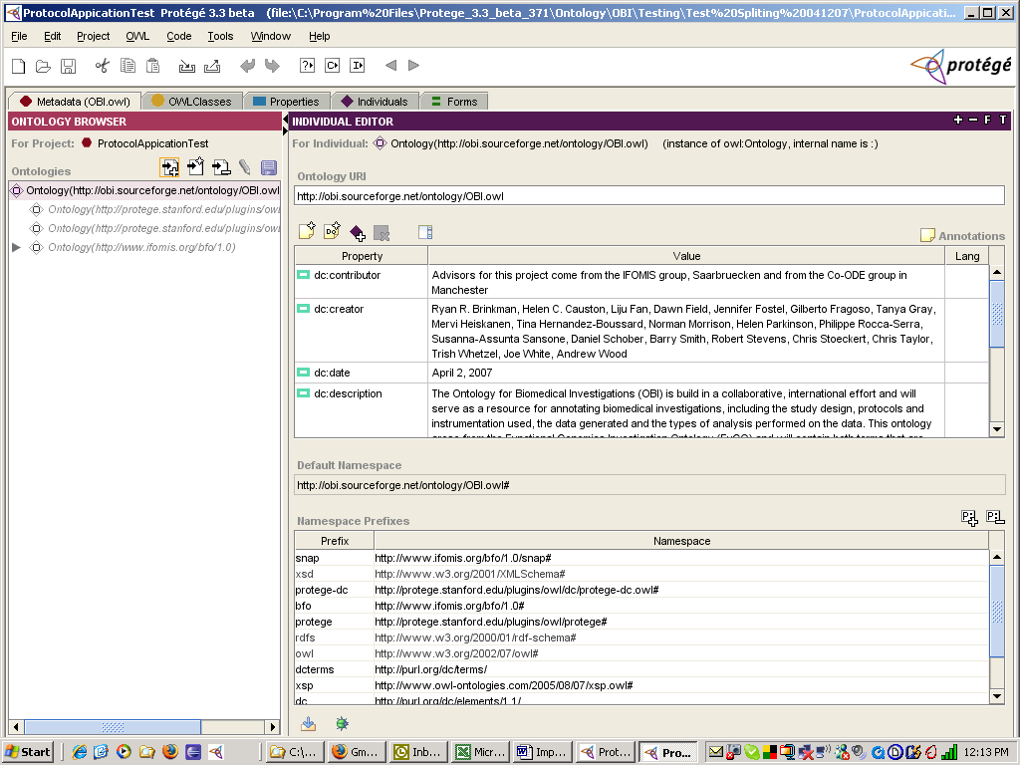

Click on tab “OWL Classes”

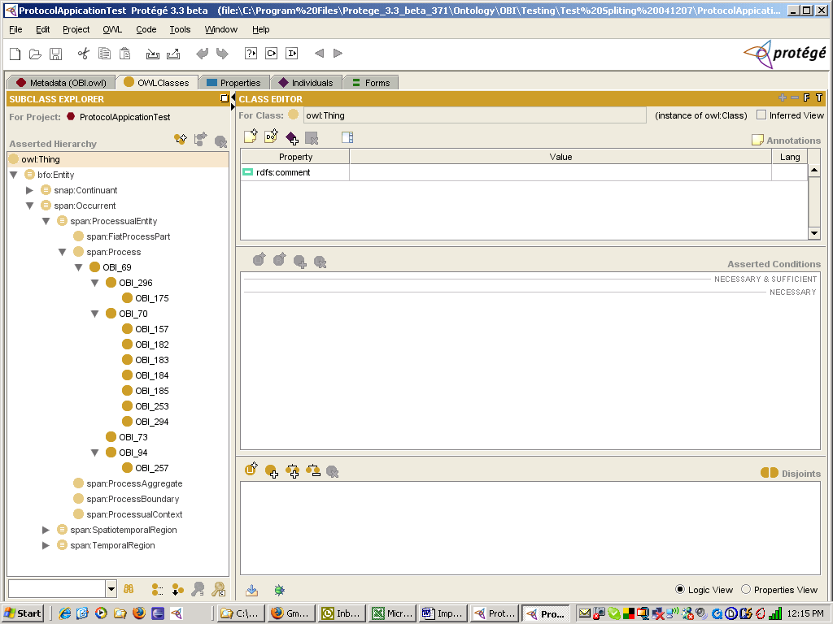

Important: Commit this saved owl file with OBI CVS Administrator.

