An Ontology of Biomedical Investigations

Authors
The OBI Consortium: Ryan R. Brinkman¹, Bill Bug², Helen Causton⁵, Kevin Clancy, Christian Cocos, Mélanie Courtot¹, Eric Deutsch, Liju Fan, Dawn Field, Jennifer Fostel, Gilberto Fragoso, Frank Gibson³, Tanya Gray, Jason Greenbaum⁹, Pierre Grenon, Jeff Grethe, Mervi Heiskanen, Tina Hernandez-Boussard⁷, Allyson L. Lister⁴, James Malone⁵, Elisabetta Manduchi, Luisa Montecchi, Norman Morrison, Chris Mungall, Helen Parkinson⁵, Bjoern Peters⁹, Matthew Pocock, Philippe Rocca-Serra⁵, Daniel Rubin, Alan Ruttenberg⁶, Susanna-Assunta Sansone⁵, Richard Scheuermann, Daniel Schober, Barry Smith, Holger Stenzhorn, Christian J. Stoeckert Jr.⁸, Chris Taylor, Randi Vita⁹, John Westbrook, Joe White, Trish Whetzel, Stefan Wiemann.
Affiliations
¹Terry Fox Laboratory, British Columbia Cancer Research Center, Vancouver, Canada
²National Center for Microscopy Imaging Research, UCSD, CA, USA
³School of Computing Science, Newcastle University, Newcastle upon Tyne, UK
⁴CISBAN and School of Computing Science, Newcastle University, Newcastle upon Tyne, UK
⁵The European Bioinformatics Institute, Cambridge, UK
⁶Science Commons, Cambridge, MA, USA
⁷Stanford University Medical School, Stanford, Ca, USA
⁸Dept. of Genetics, Center for Bioinformatics, University of Pennsylvania School of Medicine, Philadelphia, PA, USA
⁹La Jolla Institute for Allergy and Immunology, La Jolla, CA, USA
Reviewers (if you don't wish to write any section): RB, HP, TW

Abstract
write after results / conclusions

Introduction (Section editor: AL, CS,TB...)

The Ontology for Biomedical Investigations (OBI) has been developed to enable consistent annotation of experiments and investigations in the entire biomedical domain, which will in turn facilitate queries of databases, usage of laboratory information management systems, text mining, and queries and analysis via the semantic web. The motivation to produce OBI came from a need to manage and analyse the large number of data sets generated by high throughput technologies such as microarrays. An early effort, the MGED Ontology (Whetzel et al., Bioinformatics 2006), sought to provide terms for consistent annotation of microarray experiments that could be used in conjunction with a microarray data format (MAGE-ML). As the number of interested communities and the number of formats grew and plans for the process of building the ontology started to solidify, it became clear there was a need to expand the scope first to functional genomics experiments (FuGO, Whetzel et al., OMICS 2006), and now to the wider biomedical domain.
This manuscript is divided into three parts; first we describe the methodology we applied in our development of OBI, second, we describe the structure of the 1.0 version of the ontology, and third we present three use cases that demonstrate the successful application of OBI.

Methodology

Choice of language and metadata conventions

OBI has development spanned the last 5 years and is achieved by means of weekly teleconferences and twice yearly face-to-face meetings. To date 19 communities and XXX researchers have been actively involved in the development process. The requirement for remote development required formalization of the concept meta data (per concept author, progress information etc) conventions as a lightweight meta data schema tailored to development needs. The complete specification of the metadata scheme is available [http://obi-ontology.org/page/OBI_Minimal_metadata].
OBI is developed using the Ontology Web Language 1.0 (OWL) (Horrocks 2003) as OWL provides richer semantic support than OBO format - the other commonly used alternative in the biomedical domain. The OWL-DL subset was selected to gain maximum expressivity while allowing machine readabilility and use of reasoning for maintenance and development. The metadata scheme is implemented as OWL annotation type properties.
Concurrent development of OBI is necessary given the number of developers. OBI development is therefore organized into branches, with each sub-team working independently. Each branch is organized by subject area, such as data transformations, instruments or roles. Using this strategy tasks such as redundancy or inconsistency checking are manageable, as members in each branch can focus on a subset of terms.
We also required version control, offline development, use of different tools and editors, and script-based augmentation of the ontology content. A review of the existing collaborative ontology development tools failed to identify a single application that met OBI’s requirements. Instead, we split the ontology into multiple OWL files, one per branch, and rely on subversion to manage version control, distributed and offline development, as well as logging history for change management. The current development version of OBI is available from subversion at [ref].

Integration with existing ontologies
OBI was developed to be complementary to, and integrated with, a framework of existing ontologies in the biomedical domain. The description of experiments and investigations provided by OBI ties into the description of ‘natural’ biomedical information, as produced by the Gene Ontology for gene function (Blake and Harris 2008) and others for example in for cell types and anatomy. Contacts to other ontology development activities were therefore established early, and OBI was one of the driving projects in the establishment of the OBO Foundry (Smith, Ashburner et al. 2007). The desire to re-use existing diverse ontologies and integrating them into a single framework posed several challenges.
A top level ontology can provide guidance in how individual terms or whole ontologies interrelate and is useful when integrating external ontologies. BFO [ref] was chosen as the top level ontology as it is stable, publicly available in OWL syntax, and aligned to existing OBO Foundry ontologies. The OBO Relations ontology[ref] was chosen provide relations for OBI, and these were extended where required.
Four key ontologies are directly imported using the owl:import mechanism, including BFO and RO mentioned above, plus the ro_bfo bridge mapping to set ranges and domains for properties using BFO classes, and the Information Artifact Ontology (IAO, [ref]).
The owl:imports mechanism was not suitable for all external ontologies for several reasons: Firstly, current editing tools are not effective for working with very large ontologies such as the NCBI Taxonomy [3], therefore direct OWL import is impractical. Secondly, some ontologies used by OBI are activly develoed and may not be aligned with OBI’s design (e.g., not using BFO as an upper ontology, or not using OWL DL). Importing such ontologies as a whole could lead to inconsistencies or unintended inferences. Instead, the MIREOT import mechanism was developed [ref], which is based on the practice of the Gene Ontology (GO) [5] in that the intended meanings of classes remain stable. Even when the source ontology is repaired or reorganized, the effects of such modifications do not change the intended meaning of terms.

Term requests and triaging for concurrent development
The majority of terms in OBI were collected from the various communities that intend to use it. Term lists were solicited and collated by a representative of each community (OBI consortium page] and terms were also submitted through a public term tracker [(http://sourceforge.net/tracker/?group_id=177891&atid=886178). Each term was then assessed to determine if it was in the scope of OBI. For example, terms like ‘peptide’ and ‘antibody’ are needed to describe immunological experiments describe an experiment, but were available in ChEBI (Degtyarenko, de Matos et al. 2008) and GO respectively, and were therefore imported (see above) rather than added to OBI directly.
Submitted terms were distributed to an appropriate OBI branch for curation and inclusion in the OWL file and interaction between branches was achieved through conference calls.

Release and Quality Control

Users require a traceable, static version of OBI. We have therefore established a monthly release process where multiple branch development OLW files are merged into a single file, which makes it easier to view the ontology in common tools. A second version of the ontology is released in which classes are organized in the inferred hierarchy. Each release is versioned, and is available from a specific URI using the release date as a tag. The most up-to-date file prior to monthly release is always available from http://purl.obofoundry.org/obo/obi.owl. Releases of OBI are also uploaded to the NCBO BioPortal (Musen, Shah et al. 2008) and the OBO Foundry repository (Smith, Ashburner et al. 2007).
Checks are made prior to release to assure compliance of the released version with OBI policies. Specifically, classes are identified that do not comply with the minimal metadata policy, have invalid OWL syntax or lead to inconsistency when reasoning using Pellet (Evren Sirin 2007) or Fact++[ http://owl.man.ac.uk/factplusplus/].
Identifier format and deprecation policies are also enforced. OBI identifiers are prefixed with “New classes are automatically assigned a permanent identifier in the format OBI0000001” on their first release. Similarly, the release process verifies that all IDs that were present in the previous release are still in use. This conforms with the GO deprecation policy that OBI has adopted. Deleted classes are moved under the ObsoleteClass in the OBI hierarchy and stored in a separate file.

OBI classes and relations
The OBI 1.0 release has XXX classes and YYY relations. The high level class organization of OBI is depicted in Figure X. The upper level consists of the BFO classes material entity, process, role and function, and the IAO class information content entity. Throughout this text, italics are used to indicate a reference to a class or relations in OBI. The following gives an overview of core OBI classes and relations grouped by their parent class. Formal textual and logical definitions of each term are provided in the Supplemental material X.

Material entity
The class material entity was created in BFO at the request of OBI developers as the union of object, object part and object aggregate, encompassing all entities made up of matter. The BFO distinction between the latter is useful if all the objects dealt with in an ontology are of similar scale. In biomedical investigations, however, organisms, cells and other entities can either be described as objects or aggregates of smaller parts and material entity satisfies this..
Several subclasses of material entity are imported from external ontologies (ref). For example, classes under organism are imported from the NCBI taxonomy (Wheeler, Barrett et al. 2006), anatomical entity (aka macroscopic part of multicellular organism) and its subclasses are imported from the Foundational Model of Anatomy (FMA) (Rosse and Mejino 2003) and the Common Anatomy Reference Ontology (CARO) (Haendel and Mejino et al. 2008), and molecular entities and subclasses are imported from ChEBI. Based on these imports, local OBI terms can be constructed. For example, a PBS buffer and other chemical entities in solution can be defined by referencing the molecules from which they are made of (defined in ChEBI), and specifying their molecular concentration, as a quality of the mixture.
Material entities that were intentionally created, and can therefore be tied to their creation process are types of processed material. This covers specimens such as a blood sample which are tied to a collection process as well as devices such as a flow cytometer that was manufactured with the intend to perform a function in an experiment. Some material entities such as a protein can either be intentionally created, for example in a recombinant expression system, or naturally expressed in an organism. The processed material class is therefore logically defined with the necessary and sufficient condition to be the output of an intentional creation process, and only classes for which every instance is intentionally created will be classified as a processed material.

Process
The definition of processed material given above requires that a process by which something is intentionally created can be distinguished from others. The great majority of processes in OBI’s scope are planned processes, defined as being initiated by an agent in order to achieve an objective specification. The objective specification achieved in a material processing is the material transformation objective. There are different subclasses of this objective and associated processes, including material separation such as using a cell sorter to separate out CD8+ cells from a blood sample, or material combinations such as adding a chemical to a cell culture.
OBI’s scope is limited to successfully completed investigations, which are a type of planned process. This includes investigations with negative results, but not those which involve falsifications or gross errors. Therefore, every planned process can be assumed to achieve one or more goals, which are specified via the achieves_planned_objective relation. The entities necessarily present at the end of a planned process in order to achieve the objective are specified via the has_specified_output and has_specified_output data relations. The focus on the desired result of a process allows to model exchangeable paths to a similar outcome.
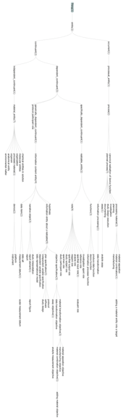
Information processing is a subclass of planned process and is distinguished from other planned processes by producing information as an output based on input information. Consider the OBI class hierarchical clustering, definition: hierarchical clustering is a process which takes as input a collection of objects and builds a hierarchy of clusters. Hierarchical clustering, in practice, can be used two achieve two different objectives; to cluster data (OBI class: class discovery data transformation) and to partition data (OBI class: partitioning data transformation). A hierarchy of planned processes based on their achieved objective is desirable as a user can immediately see how information processing processes can be applied to achieve an objective specification. It is also computationally effective as the description logic reasoner, which positions classes appropriately after classification, manages it.
** HP stopped edit here at BP’s request.

Information content entity
Any description of biomedical investigations needs to include entities related to information, such as the design of the investigation, collected data ,and reports of investigation results . Such entities were not originally in the scope of BFO, and they pose challenges to a realism based ontology because of X. To facilitate work on information related entities in OBI while at the same time ensuring that this work will be generally usable outside of the context of biomedical research, the Information Artifact Ontology (IAO, [ref]) was created to serve as a high level layer beneath BFO, which is maintained by OBI developers together with philosophers and other scientists. It encompasses terms such as plan and objective specifications, ...

Information about investigations relates to their design, data collection, and documentation. Terms related to investigation design are 'study design', which and 'objective specification' Also part of the design, the 'hypothesis' and 'independent variable' for parts of an investigation.

Central to an investigation is the data generated and therefore terms included 'data item' and distinctions were made for 'measured data item' and 'derived data item'. Measured data items need a 'numeral' and a 'measurement unit label'. Organization of the data is important leading to the inclusion of 'data collection' and 'data representational model'.

Documentation of the investigation is captured by the core terms, 'study result', 'study interpretation', 'report', and 'report element'.

Also of importance to information processing, is the class software definition: a series of encoded instructions that can be directly executed by a CPU, or transformed in to a form that can be. Information processing can be related to software using the is_about relationship (definition: a representation is_about anything exactly when some part of the information_artifact denotes the entity). Specifically, a piece of software, for instance an R implementation of k-means clustering would be modelled in OBI as the instance R k-means clustering module which is_about an instance of the k-means clustering class.

Roles and Functions
The definition of a role in the context of OBI is: A realizable entity [snap:RealizableEntity] the manifestation of which brings about some result or end that is not essential to a continuant [snap:Continuant] in virtue of the kind of thing that it is but that can be served or participated in by that kind of continuant [snap:Continuant] in some kinds of natural, social or institutional contexts. Translated, this means a role is not an essential quality of the entity in which the role inheres, but rather defined by the circumstances in which the role is realized.
The OBI Role Branch contains roles strictly for humans, such as Principal Investigator Role or Author Role, realized by leading or reporting on a Biomdical Investigation. Additionally, OBI contains roles defined by the design of a study/investigation, such as Study Subject Role and Reference Role. These roles can inhere in humans, rodents, plants, sections of tissue, whatever is the object of the study design (Study Subject Role) or used for Reference. OBI also contains roles defined by the process or prpotocol used in the investigation, for example Cloning Insert Role, Centrifuge Pellet Role, Specified Output Role. Roles inhere in continuent entities only, so OBI currently does not include roles for a process.

Organization
Another subclass of material entity is organization. While it remained controversial if an organization is ‘material’, it is clear the definition and placement of organization has been subject to a lot of controversy. An organization has been declared as a MaterialEntity in OBI. Legal status of organizations is left open for discussions and out of scope for OBI. The organization class will be used and instantiated (e.g. Affymetrix instance) as needed.

Relations
[by FG, AR, MC, LS]
The relations branch of OBI is responsible for defining relationships or restrictions (Object- and Datatype- Properties) between classes and instances to facilitate class definitions and ultimately knowledge inference over OBI. As discussed previously, if a common top level ontology is used for multiple ontologies, then integration is made easier and the classes are more likely to align. In the same respect, if the ontologies use the same set of relations, integration and inference is made easier and by default, class definitions are likely to be more consistent across disparate ontologies.
Relations can be considered on class-class, class-instance and instance-instance levels. Two classes are connected by some relation <Class 1 relation Class 2> if each instance of the Class 1 stands in the instance-instance level relation to some corresponding instance of the Class 2; an instance is related to a class <Class relation Instance> if each instance of the Class stands in the instance-instance level relation with the Instance [Smith, 2005]. Thus relations connect instances or particular entities which exist in space and time.
The relations branch of OBI aims to provide a set of relations which is sufficient for the description of diverse biomedical investigations. Such a set of relations should be consistent (no intersections in the semantic meaning between relations), minimal (contain as few relations as possible), but expressive (cover all types of relations between instances in biomedical domains).

The OBI policy is the re-use, rather than a re-invention of the existing relations, and the definition of new relations in terms of existing relations wherever possible. OBI re-uses the RO to form relationships between classes and to maintain the ethos of orthologous ontology development. For example OBI defines the relation has specified output information (see the definition below) as sub-relation of the RO relation has participant (a relation between a process, a continuant, and a time at which a continuant participates in some way in the process) [Smith, 2005]. The OBI relations branch also uses the relations which have been proposed for the inclusion into RO but are not yet in released circulation
(RO_proposed), i.e. bearer of, inheres.
The OBI branches request to define a new relation if the definition of an OBI class requires new restrictions. If the requested relation is neither in RO or RO_proposed the relations branch will work upon creating, defining and adding a new relation in OBI.
For example, OBI defines relations connecting information content entities to other entities:
Has specified input/ output information A relation between a participant in a process, that produces/consumes a data set. The process is the realization of a concretization of a realizable information entity (objective specification or plan specification). In general, not all data present at the beginning/end of the process are specified data.
The relation achieves planned objective links a process that realizes a plan which is a concretization of a plan specification with an objective specification that is part of the plan specification. The criteria specified in the objective specification are met at the end of the process.
Realises is a relation between a process and a function, where the unfolding of the process requires the execution of the function. The process of 'histidine catabolism' (GO:0006548) realizes the function 'histidine ammonia lyase activity' (GO:0004397) (note: here 'activity' denotes a function and not a process).
Is proxy for is a relation between continuant instances c1 and c2 where within an experiment/ protocol application, measurement of c1 is used to determine what a measurement of c2 would be. A position on a gel is proxy for mass and charge of molecule in a western blot.
Is concretization of is a relationship between a generically dependent continuant and a specifically dependent continuant. A generically dependent continuant may inhere in more than one entity. It does so by virtue of the fact that there is, for each entity that it inheres, a specifically dependent concretization of the generically dependent continuant that is specifically dependent.
The relations has specified input/ output were added into OBI to specify relations between a process and a process participant present at the beginning/ end of that process.
The relations supplies and is manufactured by are for the description of process which have organizations as participants:
Supplies is a relation between an organisation or person and a material entity who owned or has license to the material entity and there was a legal transfer of ownership or licensing of the material entity to the current owner.
Is manufactured by some organization means that there was a process in which continuant was built in which a person, or set of people or machines did the work.
OBI also defines data type properties, i.e. has feature value datatype proprty is used to describe the feature values which the feature class can contain, for example has_base can have feature values of nonNegativeInteger values.
The OBI-created relations in effect are proposals for inclusion into the RO. If over time a relation that is in OBI is accepted in the RO, then OBI will deprecate its own relation and use instead the one provided by the import of the RO.
Refrences:
[Smith, 2005]
Smith B, Ceusters W, Klagges B, Kohler J, Kumar A, Lomax J, Mungall CJ, Neuhaus F, Rector A, Rosse C Relations in Biomedical Ontologies.Genome Biology, 2005, 6:R46
Example for Material separation & analyte measuring assay: draw blood from a mouse and determine the concentration of glucose in it. (JF)
- A material separation is done to obtain a blood specimen from the mouse. The blood will be used as the evaluant in the analyte measuring assay to determine the concentration of glucose in the blood. The glucose concentration in the blood specimen will then be used to describe the mouse from which the blood was taken.
- Two devices are used in the material separation: a syringe and a glucometer dipstick. The syringe is used to access the blood from the mouse, contain it and transfer it to the glucometer dipstick. At the end of the process the dipstick contains the blood specimen.
- The blood on the dipstick is specified as input to the glucose measuring assay. The blood bears the role evaluant in the analyte measuring assay, the material entity in which the assay measures the concentration of the analyte molecule. The analyte role inheres in the glucose molecules scattered throughout the blood specimen. The glucometer device is used to measure the concentration of glucose in the sample transferred to the dipstick, and to calculate the concentration of glucose in the evaluant. The specified output is the measurement datum giving the glucose concentration in the evaluant.
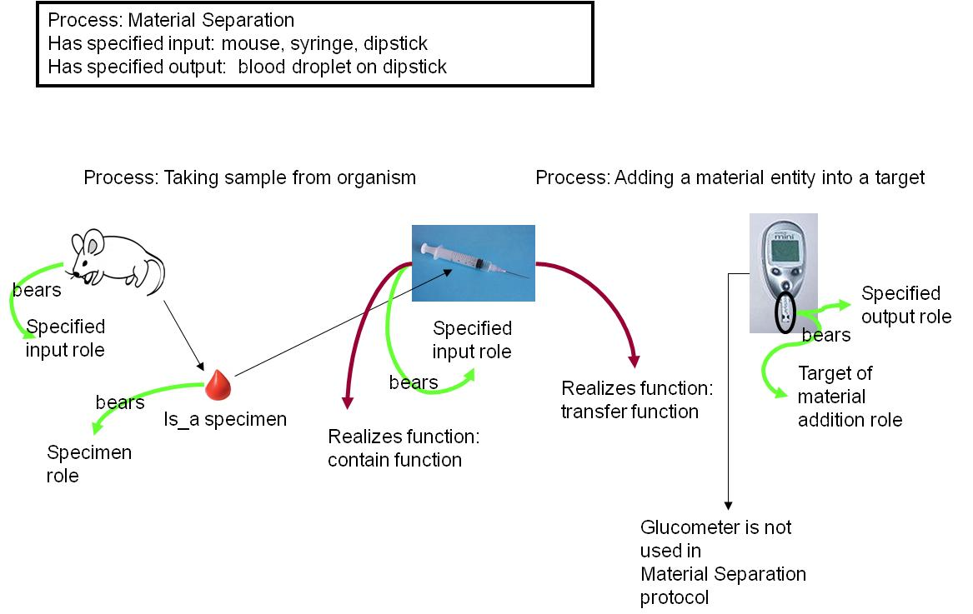
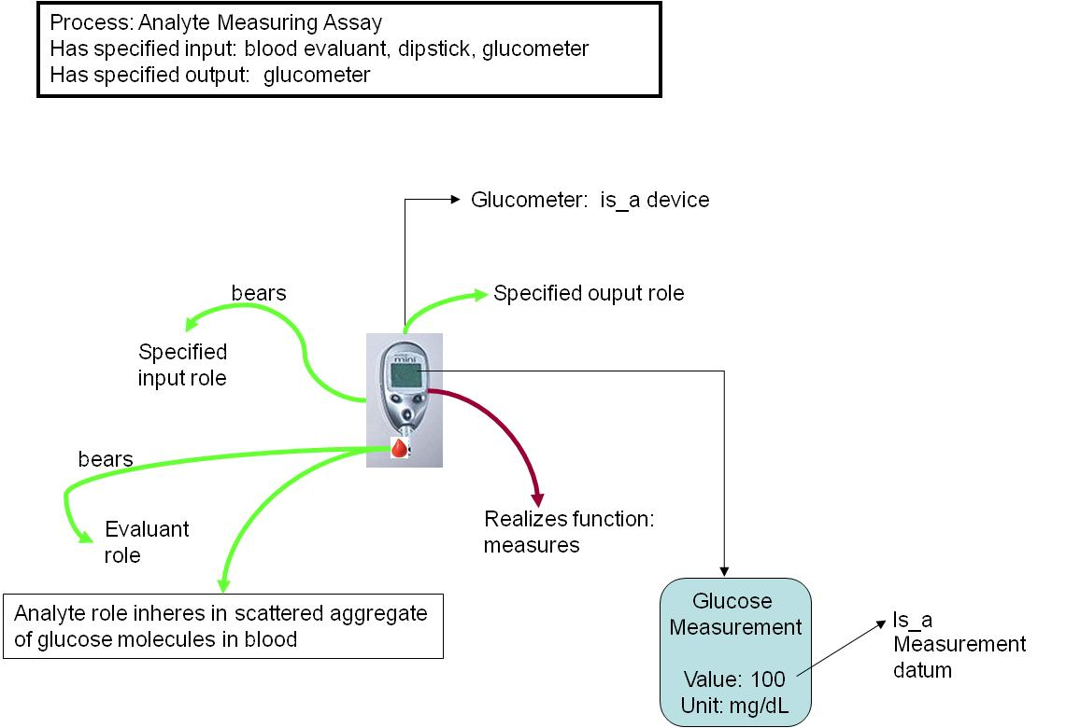

Use Case #1: GenePattern (JM)
Our first use case focuses on the annotation of a GenePattern software module. GenePattern is a powerful scientific workflow platform which provides access to over 90 genomic analytic and visualization tools (Reich M, Liefeld T, Gould J, Lerner J, Tamayo P, Mesirov JP GenePattern 2.0 Nature Genetics 38 no. 5 (2006): pp500-501). This provides interoperability between many popularly used tools within in silico analysis, including GeneCluster, Matlab, Bioconductor and many others.
Of particular interest to users of this resource is the ability to define a protocol using generic terms that can give appropriate options for each step. For example, a user may wish to define a protocol in which steps such as 'normalization' and 'clustering' occur during the workflow. The ability to use such general terms and be presented with choices for processes that can perform these steps would be advantageous to users.
The specific use case we consider here is as follows:
The user is able to define generic protocols referencing OBI identifiers, instead of specific LSIDs, for the following workflow steps:
- Normalize data - the user is able to select from a range of process which can be used to normalize data. This might include, for example, mean centering, loess transformation, and so on.
- Cluster data - the user is able to select from a range of process which can be used to cluster the normalized data. This might include k-means clustering, hierarchical clustering and so on.
- Visualize data - the user is able to select from a range of process which are able to visualize data based on the results from step 2, for example histogram, scatterplot and so on.
Such protocols should be tool-independent such that any software that is able to perform a given process can be selected to perform the step.
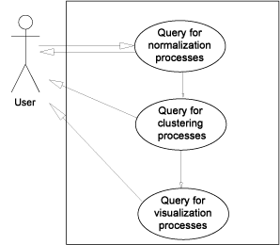
Figure XX. The GenePattern use case for defining a pipeline using ontology classes.
In order to demonstrate this use case using OBI, we must first consider the annotation of processes that can be considered as a valid option in one or more of the three generic protocol steps above. Firstly, normalize data. In OBI, data transformation classes are defined by the following elements; the input data; the process that is undertaken, i.e. the actual data transformation; the output data produced from this process; and by the objective specification to which the data transformation is used to achieve. Note, within OBI, data transformations can have more than one objective, reflecting the fact that a single process can be used to achieve different goals. For this query, data transformations with the objective of normalization are required as these satisfy the use case. Table 1 describes the data transformation processes currently captured in OBI that serve this query.
Table 1. Queries from the GenePattern use case, and the returned OBI terms
User Query | OBI returned terms
Normalization Processes | b transformation  biexponential transformation  box-cox transformation  cosine transformation  eh transformation  exponential transformation  hyperlog transformation  linlog transformation  loess transformation  mean centering  median centering  pareto scaling  quantile transformation  replicate analysis  s transformation  sine transformation  SIMCA  total intensity transformation paired  total intensity transformation single  unit-variance scaling  variance stabilizing transformation
Clustering Processes (in OBI class discovery data  transformations) where input data is normalized | discriminant function analysis  hierarchical clustering  k-means clustering  linear discriminant functional analysis  principal component regression
Visualization Processes where input is clustered data | dendogram  heatmap  scatterplot  histogram
There clearly are a wide range of data transformations, captured in OBI, that are able to perform this step given the query of normalization processes, however, the next step is a little more complicated. For this step in the workflow, we require processes that can perform clustering (called class discovery in OBI) where the input is of a particular type, in this case where the input is normalized data. This means our query restricts us to particular types of data transformations which have to have these sorts of features. This is achievable using the ontology. Here we ask for data transformations that have (in OBI we use the achieves_planned_objective relation to tie a process to an objective specification) the objective specification of class discovery and can have as input to the process normalized data set.
Table 1 demonstrates the results of this query on OBI and the classes returned. From the results, we can see that appropriate data transformations have been returned. We finally consider the visualizations that are capable of rendering the clustered data. Again, we use the ontology to restrict the results to visualizations that are able to render clustered data into an image and we see in Table 1 that this subset meets this restriction. Perhaps more interesting is those data transformations that are not returned as valid results; clearly it is impractical and not useful to list all of the inappropriate data transformations, suffice to say that there are ~200 classes, hence a large number were rejected as they did not fulfill the query. This is demonstrable of a key advantage of ontologies, that results should both return valid classes that satisfy the query, but should also filter out the invalid and thereby ensure that answers are accurate.

Use-Case #2: The Immune Epitope Database
As a second use case, we chose the Immune Epitope Database (IEDB, Peters, Nat Rev Immunol. 2007 Jun;7(6):485-90), which catalogs experiments manually curated from the scientific literature that characterize immune epitopes. Over 250,000 experiments from over 6,000 literature references have thus far been entered into the database. Each experiment is described by entries in over 300 database table columns. The IEDB website implements a comprehensive query by example interface to retrieve this data. However, many queries cannot be formulated directly as query by examples, and can require extensive manual post-processing.
It is therefore desirable to allow the user to formulate more expressive queries against the IEDB. As a translation of IEDB data into OBI format exists, this use case evaluates if meaningful queries can be formulated directly in OBI. The specific queries considered in this use case are: 1) What assays have been used to measure IFN-gamma production? 2) What investigations have used studied both human and non-human T cell responses?
- assay and has_specified_output some ‘measurement datum’ and ‘is about’ some ‘IFN-gamma production’
- investigation and has_part some (realizes some ‘host role’ and ‘role of’ some ‘homo sapiens’) and has part some (realizes some ‘host role’ and ‘role of’ some ‘mus musculus)
The IFN-gamma production term is taken from GO, the organism terms (homo sapiens, mus musculus) reference the NCBI taxonomy, while the remaining terms are taken from OBI. Executing this query retrieves XXX (need to finalize results as we finish export. We are struggling with Protégé’s ability to handle large files).
Importantly, such a query mechanism can also be used to seamlessly query across multiple resources. For example, it would be possible to query for certain processes in GO, and link that to a query of the IEDB for assays that give information about these processes.
Alternative / secondary IEDB use case:To achieve validity and consistency of the manual curation between the different members of the curation team, a set of curation rules was established (Vita, Cytometry A. 2008 Nov;73(11):1066-70) which is enforced through peer review. It is desirable to enforce curation rules computationally in order to reduce the time spent on peer review, and to decrease the likelihood of curation errors being overlooked. In order to unequivocally communicate such rules between curators and system engineers, the rules are expressed as OBI statements which are meaningful to domain experts, and exact enough to be translated into code by programmers. The specific use case we consider is to formulate a curation rule on how to curate the assay antigen in an infectious challenge assay in OBI. Challenge assays measure the protective efficacy of an immune response against an infectious agent by exposing the host to the infectious agent, and measuring ’ …

Use-Case #3 JF
- Clinician studying drug X effects on blood clotting measured by prothrombin time in human subjects. Compare effects to those of aspirin (positive control) and placebo (negative control).
- Process:
- Plan study
- Secure approval from ethics committee
- Select balanced cohorts
- Collect materials; ensure that tablets appear similar
- Begin study:
  - Administer drug X, aspirin or placebo to one cohort
  - Wait 2 hours
  - Measure prothrombin time
- Analyze data
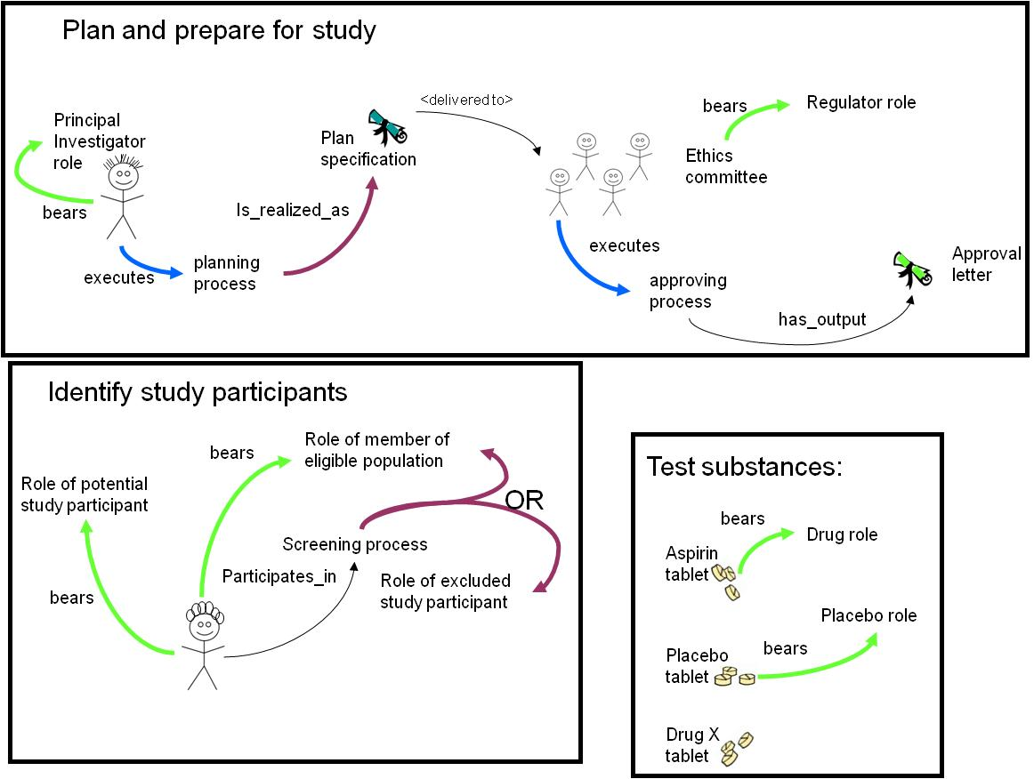
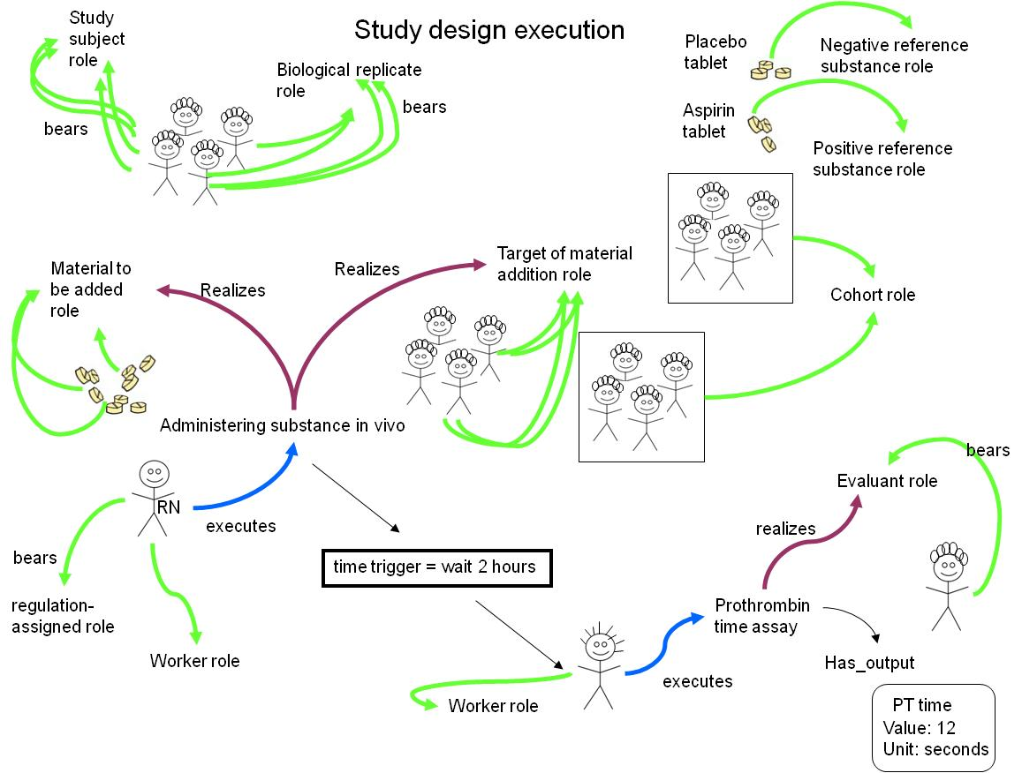

Use-Case #4: PRS
Conclusion
(Section editor:.... and ...,AL,JM, TB...)*we rock* (Garth and Wayne, 2008)
Existing alternatives to OBI are: EXPO, MGED (but community specific and limited), ...?
Also, integrating classes from other ontologies also raised the need for cross-talk between the different teams building OBO Foundry resources. This naturally led to the organization of an OBI OBO Foundry ontologies development meeting in order to precisely identify common issues faced by practitioners and developers alike. This OBO Foundry/ OBI joint meeting will be held at EBI with support from BBSRC and possibly ELIXIR project (Sansone).
However, by providing standard methods of describing data (the semantics of OBI), structuring those descriptions (the syntax of FuGE), and suggesting a checklist of information to provide (via the MIBBI project), sharing experimental data and metadata irrespective of data type becomes easier and more productive. Instead of many standards from many communities, OBI, FuGE and MIBBI provide a new ‘many communities – one standard’ model that simplifies experimental description. Researchers will be helped by the common language provided by OBI in creating a common ground for tagging and annotating their work. In the same way that GO has opened up a whole new level of searching and analysis via the annotation of genes and gene products, OBI provides a method of tagging experimental descriptions with terms that are both understandable to the human reading about the experiment and the computer program designed to analyse 1000s of experiments.

Collaboration with syntax and content standards
OBI provides a way of sharing a common meaning, or semantics, when describing experiments produced by different research groups, institutes, or even experiment types. However, a shared language is not the whole picture: in order for users of experimental data and metadata to be able to understand what a data producer has provided, a common syntax and minimal level of information is also helpful. OBI works closely with FuGE (the Functional Genomics Object Model, http://fuge.sourceforge.net) [ref], which provides a common syntax for describing experiments, and the MIBBI (Minimum Information for Biological and Biomedical Investigations, http://www.mibbi.org) [ref], which works with communities to develop checklists of minimal descriptive information for different experiment types. Providing researchers with a standard syntax, semantics, and content for experiment description eases computational analyses of such experiments, encourages collaboration between groups, and aids in the reproducibility of experiments by others.

Acknowledgments
This work is partially supported by grant funding from the National Institute of Biomedical Imaging and Bioengineering, National Human Genome Institute, NIH (R01EB005034, NIH P41 HG003619), EC EMERALD project (LSHG-CT-2006-037686), EC FELICS, MUGEN, BBSRC (BB/E025080/1, BB/C008200/1), NERC-NEBC, EU IP CarcinoGenomics (PL 037712), EU NoE NuGO (NoE 503630), CARMEN project EPSRC (EP/E002331/1), the Michael Smith Foundation for Health Research
Blake, J. A. and M. A. Harris (2008). "The Gene Ontology (GO) project: structured vocabularies for molecular biology and their application to genome and expression analysis." Curr Protoc Bioinformatics Chapter 7: Unit 7 2.
Degtyarenko, K., P. de Matos, et al. (2008). "ChEBI: a database and ontology for chemical entities of biological interest." Nucleic Acids Res 36(Database issue): D344-50.
Evren Sirin, B. P., Bernardo C Grau, Aditya Kalyanpur, Yarden Katz (2007). "Pellet: A practical OWL-DL reasoner " Web Semantics: Science, Services and Agents on the World Wide Web 5(2): 51-53.
Haendel, M. A., Neuhaus, F., Osumi-Sutherland, D., Mabee,P.M. and M. Mejino Jr. J.L.V., C.J. and Smith, B. (2008). CARO - The Common Anatomy Reference Ontology. Anatomy Ontologies for Bioinformatics: Principles and Practice. D. D. a. R. B. Albert Burger. New York, Springer.
Horrocks, I., Patel-Schneider,P.F and van Harmelen, F. (2003). "From SHIQ and RDF to OWL: The making of a web ontology language." Journal of Web Semantics 1(1): 7-26.
Musen, M., N. Shah, et al. (2008). "BioPortal: Ontologies and Data Resources with the Click of a Mouse." AMIA Annu Symp Proc: 1223-4.
Rosse, C. a. and J. L. Mejino, Jr. (2003). "A reference ontology for biomedical informatics: the Foundational Model of Anatomy." J Biomed Inform 36(6): 478-500.
Smith, B., M. Ashburner, et al. (2007). "The OBO Foundry: coordinated evolution of ontologies to support biomedical data integration." Nat Biotechnol 25(11): 1251-5.
Wheeler, D. L., T. Barrett, et al. (2006). "Database resources of the National Center for Biotechnology Information." Nucleic Acids Res 34(Database issue): D173-80.

, 992 (2006).

