
OBI – The Ontology for Biomedical Investigations

What is OBI?
The Ontology for Biomedical Investigations (OBI) project is developing an integrated ontology for the description of biological and clinical investigations. This includes a set of 'universal' terms, which are applicable across various biological and technological domains, and domain-specific terms relevant only to a given domain.
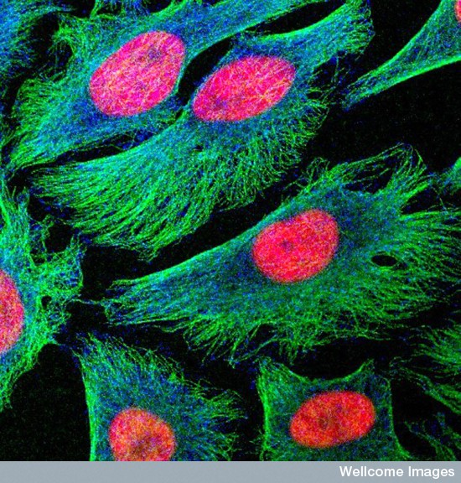
This ontology will support the consistent annotation of biomedical investigations, regardless of the particular field of study. The ontology will model the design of an investigation, the protocols and instrumentation used, the material used, the data generated and the type analysis performed on it. More than 40 representatives of 18 biological communities develop OBI collaboratively.
Where do I get OBI?
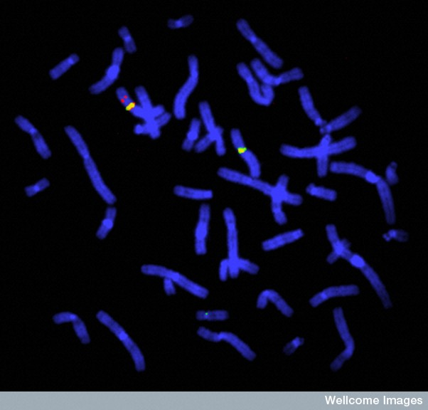
The latest complete version of ontology (.owl) file is available from http://purl.obofoundry.org/obo/obi.owl All the information relevant to the OBI project and associated resources can be found at http://purl.obofoundry.org/obo/obi.
An HTML version of the ontology is available at http://purl.obofoundry.org/obo/obi/report.html
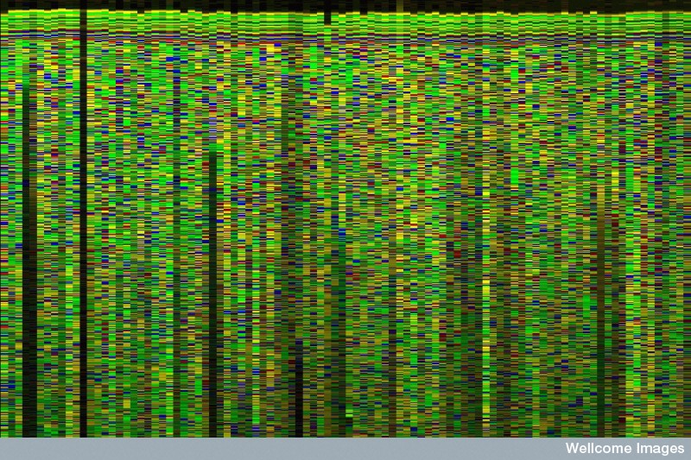
I need support!
No problem :-) You can get in touch with us via our users mailing lists:
obi-users@googlegroups.com. Archives are available there as well.
I want to contribute, where do I start?
You can tell us more about your potential contribution at
obi-users@googlegroups.com. Alternatively, if you want to directly submit terms to the ontology, use our tracker at http://purl.obofoundry.org/obo/obi/tracker.
OBI – The Ontology for Biomedical Investigations

What is OBI?
The Ontology for Biomedical Investigations (OBI) project is developing an integrated ontology for the description of biological and clinical investigations. This includes a set of 'universal' terms, which are applicable across various biological and technological domains, and domain-specific terms relevant only to a given domain.
This ontology will support the consistent annotation of biomedical investigations, regardless of the particular field of study. The ontology will model the design of an investigation, the protocols and instrumentation used, the material used, the data generated and the type analysis performed on it. More than 40 representatives of 18 biological communities develop OBI collaboratively.
Where do I get OBI?
The latest complete version of ontology (.owl) file is available from http://purl.obofoundry.org/obo/obi.owl All the information relevant to the OBI project and associated resources can be found at http://purl.obofoundry.org/obo/obi.
An HTML version of the ontology is available at http://purl.obofoundry.org/obo/obi/report.html
I need support!
No problem :-) You can get in touch with us via our users mailing list:
obi-users@googlegroups.com. Archives are available there as well.
I want to contribute, where do I start?
You can tell us more about your potential contribution at
obi-users@googlegroups.com. Alternatively, if you want to directly submit terms to the ontology, use our tracker at http://purl.obofoundry.org/obo/obi/tracker.

