An Ontology of Biomedical Investigations

Authors
The OBI consortium (in alphabetical order): Ryan Brinkman¹, Bill Bug², Helen Causton³, Kevin Clancy, Cristian Cocos, Mélanie Courtot¹, Dirk Derom⁴, Eric Deutsch⁵, Liju Fan⁶, Dawn Field⁷, Jennifer Fostel⁸, Gilberto Fragoso³, Frank Gibson⁹, Tanya Gray, Jason Greenbaum¹⁰, Pierre Grenon, Jeff Grethe⁷, Yongqun He¹¹, Mervi Heiskanen, Tina Hernandez-Boussard⁷, Phillip Lord²⁰, Allyson Lister^{12,20}, James Malone, Elisabetta Manduchi, Luisa Montecchi, Norman Morrison³, Chris Mungall¹³, Helen Parkinson³, Bjoern Peters¹⁰, Matthew Pocock, Philippe Rocca-Serra³, Daniel Rubin, Alan Ruttenberg¹⁴, Susanna-Assunta Sansone³, Richard Scheuermann¹⁵, Daniel Schober¹⁶, Barry Smith¹⁷, Larisa N. Soldatova¹⁸, Holger Stenzhorn, Christian J. Stoeckert Jr.¹⁹, Chris Taylor³, Randi Vita¹⁰, John Westbrook, Joe White, Patricia L. Whetzel⁷, Stefan Wiemann, Jie Zheng¹⁹

Affiliations
¹BC Cancer Agency, Vancouver, Canada; ²National Center for Microscopy Imaging Research, UCSD, CA, USA; ³The European Bioinformatics Institute, Cambridge, UK; ⁴Victoria University of Wellington, New Zealand; ⁵ISB, Seattle, WA, USA; ⁶Ontology Workshop, LLC, Columbia, MD, USA; ⁷Stanford University Medical School, Stanford, CA, USA; ⁸SRA Global Health Sector, Durham, NC, USA; ⁹Abcam plc, Cambridge, UK; ¹⁰La Jolla Institute for Allergy and Immunology, La Jolla, CA, USA; ¹¹University of Michigan, Ann Arbor, USA; ¹²Centre for Integrated Systems Biology of Ageing and Nutrition, Newcastle University, UK; ¹³Lawrence Berkely National Lab, Berkely, CA, USA;¹⁴Science Commons, Cambridge, MA, USA; ¹⁵Southwestern Medical Center, USA; ¹⁶IMBI, University Medical Center, Freiburg, Germany; ¹⁷University at Buffalo, Buffalo, NY, USA; ¹⁸Aberystwyth University, Wales, UK; ¹⁹University of Pennsylvania School of Medicine, Philadelphia, PA, USA; School of Computing Science, Newcastle University, UK

Abstract
The goal of OBI is to enable a formal representation of biomedical investigations, facilitating the recording of experimental evidence and research findings in a computationally amenable form. The scope of OBI is the representation of: materials made in and produced for investigations, research objectives, experimental protocols, roles of people in investigations and the processing and publication of data gathered in investigations. The OBI project is a open collaborative effort, currently encompassing 19 distinct research communities. OBI follows the principles laid out by the OBO foundry, and integrates with foundry candidate ontologies such as GO and ChEBI .. The paper reports the results of three years development, presents the key OBI classes and relations, and demonstrates applications of OBI for four use cases. The paper also discusses the challenges the OBI project encountered. The use of OBI by the scientific community to represent or annotate their investigations within electronic data resources will facilitate interdisciplinary data synthesis, enable access to their data on the semantic web and improve third-party understanding of information related to life-science and clinical investigations. Use of OBI will allow comparison of experimental data from the wide array of scientific disciplines represented by domain experts in the OBI consortium.

Introduction
Information derived in biomedical investigations is increasingly being captured in structured electronic format and made available through public database resources as a complement to its reporting in traditional print journal publications. For many years, different formats to describe experiments have been developed in parallel, as research communities tended to focus on one type of methodology at a time [1, 2]. However, even though the ‘many communities – many standards’ development methodology meant that each community could create something focused on their needs, these standards overlapped - the common features of different investigations were being described in different ways. This situation lead to difficulty for representing cross- disciplinary experiments, and for those who would do integrative meta-analyses that spanned the work of multiples scientific communities, such as translational medicine efforts. In order to work with different database systems, key features of an investigation need to be described in a common, unambiguous manner. Minimally, this requires shared standards for the representation of the source and preparation of samples used in an investigation, assay methods, and data analyses applied in the course of coming to published conclusions.
The need to represent cross disciplinary experiments, in a consistent and unambiguous manner, in a computational form, provided the motivation to develop the Ontology for Biomedical Investigations (OBI; http://purl.obolibrary.org/obo/obi.owl), .
A controlled vocabulary is a set of names and typically identifiers, associated with their definitions. An ontology can be thought of as a controlled vocabulary augmented with logical constraints that described their interrelationships. OBI can be utilized as a controlled vocabulary for entities in biomedical investigations, as each entity is associated with a textual definition and an identifier. Therefore, as a results OBI is suitable for term or keyword based indexing of data associated with investigations. However, OBI goes beyond being simply a terminology by also including logical definition that formally describe how different entities relate to each other, and which support more powerful computational use, such as enhanced querying capability and reasoning.
.
OBI allows representation of entire investigations, thereby placing scientific results, data items such as measurements into context, and enabling third-party understanding of the reported data. OBI provides a rich query language for data repositories that apply it, enabling semantic web searches. OBI enables tools for standard compliant annotation of data by community scientists, including the capacity for error checking, while at the same time hiding the complexity of working with a logical description language from the end-user. Also, OBI enables the construction and consistency checking of workflows. Several such applications of OBI are used in practice or are in the final stages of development, some of which are described in detail in the Use Case section. .
The terms and relations in OBI were defined in an open, community-driven process, which follows the principles set out by the Open Biomedical Ontology (OBO) Foundry [3].
The OBO Foundry oversees and maintains a set of key principles designed to facilitate integration of biomedical ontologies. Any ontology developed within the OBO Foundry is made freely available in a standardized format, is developed with broad representation and input by the relevant communities, and is orthogonal to the domains covered by other OBO Foundry ontologies. This latter principle ensures that disparate communities do not develop multiple terms referring to the same entity. OBI was developed using the Web Ontology Language (OWL), although also has an OBO-Format conversion. With participation from 19 different experimental communities, OBI strives for a cross-disciplinary consensus covering investigations involving basic, translational and clinical research.

The following sections described the development process and design decisions applied to create OBI, several use cases are described as an example of the current applications using OBI and as an illustration of the potential wider application of an ontology of biomedical investigations.

Further enhancements of OBI in terms of breadth and depth of coverage are driven by the participating consortium members, and we want to welcome and encourage broader community participation in this open collaborative ontology development effort.

Results

Development process and framework
The scope of OBI is to formally represent entities participating in biomedical investigations. In addition, and in line with the OBO Foundry principles, it re-uses existing resources, such as other OBO foundry candidate ontologies wherever possible, to avoid term duplication within the biomedical (covering both biology and medicine) domain. Therefore, OBI was developed to be complementary to, and integrated with, a framework of existing biomedical ontologies. For example, if an investigation includes taking a human tissue sample from a specified anatomical entity, the definition of the anatomical entity is referenced from the Foundational Model of Anatomy [4]. New terms are only created in OBI if they denote entities specifically related to investigations and that do not already exist in other OBO Foundry candidate ontologies The following sections describe the development process of OBI and the integration with other resources.
Re-using existing ontologies and integrating them into a single framework poses several challenges. Communication from OBI to other ontology development activities was necessarily established early, and OBI became one of the driving projects in the establishment of the OBO Foundry [3].
To provide a foundation upon which to build OBI development, BFO [5] was used as a top level classification of entities. Relations were imported from the OBO relations ontology (RO, [6]), including relations which have been proposed for inclusion into RO but are not yet released. When new relations were defined between classes in OBI, these were based on RO relations wherever possible; OBI-created relations are in effect proposals for inclusion in RO. Use of upper-level ontologies eases interoperability of OBI terms with external ontologies based on the same foundation. BFO and RO were chosen specifically as are widely adopted by other OBO Foundry candidate ontologies.
To construct OBI terms were collected by each of the 19 communities within the OBI consortium and term submissions were also accepted through a public tracker. Before terms were incorporated as entities into OBI, they were checked for occurrence in other ontologies, assessed for suitability for inclusion, and evaluated against the OBI scope.
A detailed description of the import processes, the metadata and ID policies, the distributed development process, conflict resolution, the release process, tools used for versioning and the use of automated reasoning is given in the Methods section.

OBI classes and relations
The OBI 1.0 release has XXX classes and YYY relations. The high level class organization of OBI is depicted in Figure 1. The upper level consists of the BFO classes material entity, process, role and function, and the class information content entity. Throughout this text, italics are used to indicate a term denoting a class, instance or relation in an ontology. Supplemental Table 1 identifies the source ontology (for imported entities), identifier, and formal textual definitions for each term. For readability, the plural of the class label is sometimes used in the text, but the official OBI class labels are singular. This section gives an overview of several higher-level OBI classes that outline the scope of OBI and illustrate the modeling approach.

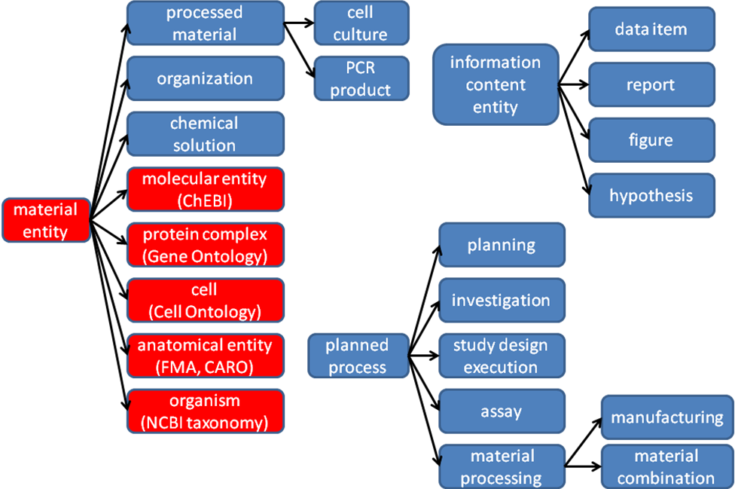

Figure 1 – High level structure of OBI classes . Depicted is the high level class structure of OBI and IAO classes (in blue). Classes imported from other external ontologies are shown in red. Some example subclasses, such as PCR product and cell culture are included to illustrate the use of the class ‘processed material’.

Material entity
Within BFO, entities made up of matter are represented using the BFO classes of object, object part and object aggregate. The use of these BFO classes is appropriate if all entities are of similar scale and a simple representation of granularity at three levels is adequate. However entities relevant to the domain of biomedical investigations span sizes from molecule to a population of organisms. Depending on the level of granularity chosen, these might be considered unitary objects or aggregates of smaller parts. Therefore, the class material entity was created in BFO at the request of OBI developers as the union of object, object part and object aggregate. By using material entity as our root class we avoid committing to the currently inadequate granularity schema in BFO.
Several subclasses of material entity are imported from external ontologies: Classes under organism are imported from the NCBI taxonomy [7], anatomical entity and its subclasses are imported from the Foundational Model of Anatomy [4] or the Common Anatomy Reference Ontology [8], and the molecular entity hierarchy is imported from ChEBI [9]. Based on these imports, OBI-specific sub-classes were constructed. For example, chemical solution such as a PBS buffer can be defined by referencing the molecules from which it is made of (defined in ChEBI), and specifying their molecular concentration as a quality. Table 1 gives the complete class definition of PBS buffer and illustrates OBI meta data.
Table 1: Example meta data for class OBI_0100046. * indicates mandatory meta data.
Annotation property | Example | Usage
Preferred Term* | phosphate buffered saline solution | The concise, meaningful, and human-readable name for a class or property that reflects community usage, or disambiguates the term if necessary
Definition* | Phosphate buffered saline (abbreviated PBS) is a buffer solution commonly used in biochemistry. It is a salty solution containing sodium chloride, sodium phosphate and potassium phosphate. The buffer helps to maintain a constant pH. The concentration usually matches the human body (isotonic). | The official OBI Aristotelian definition, explaining the meaning of a class or property
Definition editor* | Philippe Rocca-Serra; Tina Boussard; Melanie Courtot | The editors
Definition Source* | http://en.wikipedia.org/wiki/Phosphate_buffered_saline | An unambiguous and traceable reference to the source of the definition
Curation Status* | Ready for release | The curation status of a class or property, one of uncurated, meta data incomplete, meta data complete, pending final vetting, ready for release
Example | PMID: 16279733.Dent Mater J. 2005 Sep;24(3):414-21.PBS buffer solutions with different pH values can change porosity of DNA-chitosan complexes. | A phrase describing how the term is used
Alternative term | PBS buffer | A synonym for the class or property

Material entities that come into existence as the result of intentional acts are processed material. For example a specimen collected in a clinical protocol is a processed material as is measurement device such as an array scanner which is manufactured with the intent to perform a function. A material entity such as a protein can be produced intentionally, for example using a recombinant expression system, and can be naturally expressed in an organism. In order to avoid a class hierarchy with multiple inheritance, which can become difficult to maintain consistently, processed material is logically defined with necessary and sufficient conditions, exactly those material entities that are the specified output of a process of material processing i.e. an intentional process. This allows automated reasoners to infer subclasses. For example peptide construct (which is asserted as a sub class of material entity) is inferred by the reasoner to be a sub class of processed material, as it is the specified output of some enzymatic ligation.

Planned Processes
OBI’s definition of material processing is an example of a planned process. Such processes are initiated by an agent (typically a person) in order to achieve a certain goal. OBI captures such goals by defining a subclass of information content entity – objective specification – subclasses of which specify these goals. An example of such a specification is the header “Hybridize RNA to chip” in a manuscript describing a microarray gene expression protocol [10]. A process that is carried out to meet an objective specification is a planned process. The majority of processes represented in OBI belong to this class. OBI defines the relation achieves planned objective as holding between an instance of planned process and a corresponding objective specification. Note that a single planned process can achieve more than one objective.
OBI’s scope includes the representation of successfully completed investigations, which are a type of planned process. A successful investigation may produce negative results, but processes that result in falsified data or during which there were gross errors are considered to be out of scope for OBI. For example, if a PCR-SSCP assay fails to detect a sequence variation, it is in the scope of OBI. However, if controls performed as part of the assay indicate that an error occurred then OBI would no longer consider the process an instance of a PCR-SSCP assay. We are representing only experiments which have succeeded by their own criteria, as representing failed experiments would introduce unnecessary complexity into all definitions, similar to GO’s decision to only model canonical biological processes[ref].
OBI’s process hierarchy has classes that represent realizations of broad objectives. These include material component separation, where, for example, a cell sorter is used to separate CD8+ cells from a blood specimen, and material combination, such as when a chemical is added to a cell culture.
While processes can have many participants, objective and plan specifications explicitly identify participants that are particularly important. OBI defines two relations, has specified input and has specified output, relating process instances to such participants. Specified participants are listed in plan specifications. Specified outputs must be present at the end of the process to achieve an objective specification. Specified inputs are identified in the plan specification and are not created during the process. Figure 2 gives an example how two planned processes, drawing blood and measuring the glucose concentration in it, are modeled in OBI.
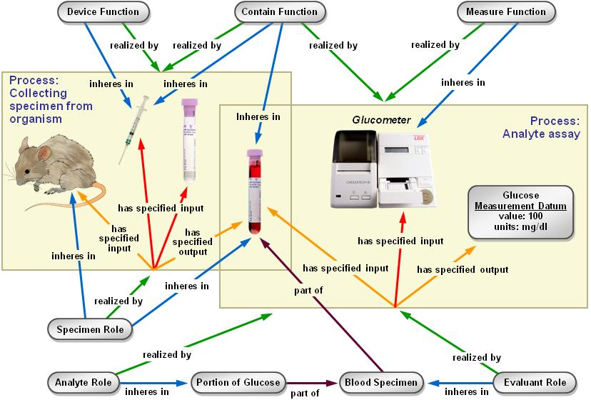
Figure 2. Measuring the glucose concentration in blood. The large boxes represent processes and contain their participants. The collecting specimen from organism process takes place first. In this process, a syringe is used to draw blood from the mouse which bears the specimen role. At the end of this process, a tube contains the blood specimen. In a second process, the blood specimen will be used in an analyte assay in which the concentration of glucose in the blood will be measured. A glucometer device is used to make this measurement. The analyte role inheres in the glucose molecules scattered throughout the blood specimen. This planned process achieves the analyte (i.e. glucose) measurement objective.
Data transformation is a subclass of planned process distinguished by having data items as the input and output of the process. For example, the OBI class mean centering is defined as a process that achieves a data normalization objective.
Information entities
Any ontology of biomedical investigations needs to represent pieces of information such as data, investigation designs, and reports of investigation results. When we began our work, the BFO, being a realism based ontology, did not have a way of representing such entities. As developing a general theory of information entities is outside the scope of OBI, and will be of use to many projects, the Information Artifact Ontology (IAO) [ref: http://purl.obofoundry.org/obo/iao] was created as a separate effort.
The IAO is intended as a middle level ontology, based on BFO, imported and used by OBI and other projects. It is structured by two types of existential dependencies – that information entities are generically dependent (i.e. they can be borne by several entities and exist as long as there is at least one bearer for them), and that they are about other entities.
A common problem when sharing data is that there is no information about what the data relates to. This is captured explicitly in IAO with the is about relation. For example, the glucose concentration measurement in Figure 2 is about a molecular concentration quality of the specimen.
The root class of IAO is information content entity, which encompasses all information that is intentionally created. For OBI, an important subclass is directive information entity, for example plan specification and objective specification, which an experimenter would read to learn how or why to perform a certain experiment. IAO also defines classes such as document, journal article or patent, parts of documents - textual entities such as paragraphs of displayed text, as well as terms that more specifically apply to documents with special purposes. Particularly relevant to OBI are terms such as report and parts thereof, report element such as report table, figure and scatter plot.
OBI then defines subclasses of information content entity that are specific to investigations. These include protocol and study design, which are types of plan specification, representing specification of a single procedure or an entire investigation, respectively. An important part of many study designs is the identification of dependent and independent variables specifications. Central to investigations are the types of data generated. This includes measurement datum, obtained in an assay, and a growing set of subclasses for specific types of assays, For example, scalar measurement datum represents measurement data composed of a single numeral and a unit label (e.g. length measurement datum, about length quality instances). Finally, the interpretation of information generated during the study design execution is a conclusion of the investigation.

Roles and Functions
A role is defined in OBI through two properties: first, by the entity which bears the role, and second by the process through which the role is realized. A role is not essential to the entity bearing the role, but rather is defined by the circumstances under which the role is realized. For example, humans can bear specific roles relating to investigations. These roles include the principal investigator role, realized by leading an investigation, and the author role, realized by writing a report. Additionally, OBI contains roles defined by the study design of an investigation. The results of a study can be about humans, plants, sections of tissue, molecules, or any other material entity, and so bear a study subject role. Similarly, the reference role can be borne by different entities specified in the study design that are included to support the observation of similarities, differences, relative magnitude of change for other entities being studied, such as a placebo. OBI also contains roles defined in specific experimental procedures, such as the analyte role or reagent role.
Functions differ from roles in BFO in that they are intrinsic to an entity based on its structural organization[11]. For example, OBI defines that a polystyrene tube and an animal cage bear the contain function, while a measurement function which inheres in a gamma counter

Organization
OBI needs to represent organizations in order to identify for example Affymetrix as the manufacturer of a certain microarray. Placing organization into the BFO hierarchy proved controversial, as good arguments were made for treating it either as a material entity or an immaterial kind of social construct related to other legal entities, which are not currently well described in BFO. Our solution is to define an organization by all the things that are true about it: an organization is a continuant entity which can bear roles and has members. Members of organizations are either organizations in themselves or individual human beings. Members can play organization-specific member roles. This definition is broad enough to include for example a regulatory agency like the U.S. Food and Drug Administration.

Use Cases
In order to evaluate OBI, we performed tests of the ontology against three use cases that help demonstrate the wide applicability of an ontology of biomedical investigations. The first uses the ontology to enable workflow construction via restrictions placed on ontology classes; the second explores query mechanisms on a database enabled by the ontology, and the third tests the coverage OBI provides for annotating an entire investigation.

Use Case #1: Constructing a Genomic Data Analysis Workflow
Our first use case focuses on the annotation of a GenePattern software module enabling creation of data analysis workflow. GenePattern is a powerful scientific platform which provides interoperable access to over 90 genomic analytic and visualization tools including GeneCluster, Matlab, Bioconductor and many others [12]. Users want to have a list of appropriate options for each step during workflow construction. By These steps can be specified at different levels of granularity when using OBI terms

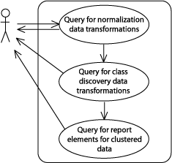
Figure 3. The GenePattern use case for defining a workflow using OBI classes. The figure illustrates how a user would create a workflow from data transformations selected based on ueries of the OBI ontology. The queries are formulated in terms of three classes in OBI, namely normalization data transformation, class discovery data transformation, and clustered data visualization. The appropriate software modules are returned to the user.
For the use case considered here, the user wishes to define a workflow to analyze and visualize microarray data. This requires normalization of the data then clustering and choosing a graphical representation. Figure 3 illustrates the workflow steps. In OBI, data transformation classes are defined by the following: the specified input data; the specified output data produced in the process; and the objective specification that the data transformation achieves. Data transformations can have more than one objective, reflecting the fact that a single process can be used to achieve different goals. The user can identify appropriate data transformation in OBI by querying for those with a data normalization objective and, then a class discovery objective. Finally, data visualization classes are retrieved that represent the rendering of clustered data.This is possible because the output and input data types are represented explicitly in OBI and are specified for each data transformation class. For example, a clustered data set is the specified output of a class discovery data transformation. The user is able to define generic protocols using OBI terms, instead of needing to choose specific software modules for each workflow step.

Use-Case #2: Querying a database of curated investigations
As a second use case, we use OBI to construct queries of the Immune Epitope Database (IEDB, [13]), which is devoted to cataloging information about experiments characterizing epitopes targeted by adaptive immune responses. Information in the IEDB is manually curated from the literature and currently encompasses over 286,000 experiments characterizing over 51,000 epitopes. The IEDB website provides the ability to query the curated data using a form based ‘fill in the blank’ interface, which lets users ask a set of predefined common queries. However, this IEDB interface hard-codes the relations between fields in the form, and thereby limits the kinds of questions users can ask. Using OBI allows an advanced user to formulate queries to ask specific questions beyond this pre-defined set.
Query class expression:
‘journal article content’ and 'is about' some (investigation
and (has_part some (assay and (has_specified_output some ('is about' some 'cytokine production'))))
and (has_part some (assay and (has_specified_output some ('is about' some 'T cell mediated cytotoxicity')))))
Instances classified as members of this class (identified by Pubmed IDs):
10432283 - Kerksiek, J Exp Med, 1999
11851899 - Lancaster, J Viral Hepat, 2002
15627979 - Engelhardt, Eur J Immunol, 2005

Figure 4 – Formulating a database query using OBI. The top part states a class expression that represents a query. It retrieves all journal articles about investigations in which assays are performed to gather data on both cytokine production and T cell mediated cytotoxicity. This query was run on an export of data from six journal articles curated in the IEDB (supplemental file X) by running a reasoner to determine which journal articles are instances of the query class. As shown on the bottom, three journal articles meet these criteria. This way of formulating queries is more powerful than is possible on the IEDB website as it allows concatenation of essentially unlimited conditions. It also provides a vocabulary of query terms outside of those used by IEDB, such as the GO term cytokine production, which is the parent term of several processes used in the definition of assays in the IEDB e.g. for T cell epitope IFN-g ELISPOT assays and Tumor Necrosis Factor cytometric bead arrays. This illustrates the importance of OBI as a semantic integration tool between OBO foundry ontologies and the experimental process.

For the use case considered here, the user wishes to perform queries that are not directly possible on the IEDB website, namely for journal articles that describe investigations in which both cytokine responses and T cell mediated cytotoxicity were measured. An export of the majority of IEDB data into OBI structured OWL has been completed [14]. This export allows advanced users to answer any question that can be formulated as a class expression in OWL, or as a SPARQL [15] query, using the vocabulary provided by OBI and its imported terms. For this specific use case, the user constructs a query class as shown in Figure 4. This can be done in Protege. When running an automated reasoner such as Pellet on data exported from the IEDB in OWL format (Supplemental file X), instances of journal articles that meet the query criteria are classified as instances of the query class.

Use-Case #3 Representing a clinical investigation
In this use case, we demonstrate that OBI can represent complex investigations, including planning, execution, data collection, analysis, and reporting of conclusions. The use case is a clinical investigation: a study of the anticoagulant activity of fucoidan (ref). Figure 5 illustrates the use of OBI to describe this investigation.
The investigation consists of a planning phase (Fig 5, panel 1) during which the study design specification is created. During the execution, study subjects are enrolled and then assigned to treatment groups (panel 2). In this case, fucoidan is focus of the investigation with guar gum used as a negative reference. Subjects are assayed for their antithrombin-III level as part of the investigation (panel 3). The results of these assays then undergo a statistical test which produces a p-value (panel 4). This measures differences between the two groups. On the basis of this p-value, a study interpretation is draw; in this case that fucoidan has a small statistically significant effect on coagulation. Finally, the investigation is documented in a report that is published as a journal article.

ref = Irhimeh MR, Fitton JH, Lowenthal RM. Pilot clinical study to evaluate the anticoagulant activity of fucoidan.Blood Coagul Fibrinolysis. 2009 Aug 18. [Epub ahead of print]
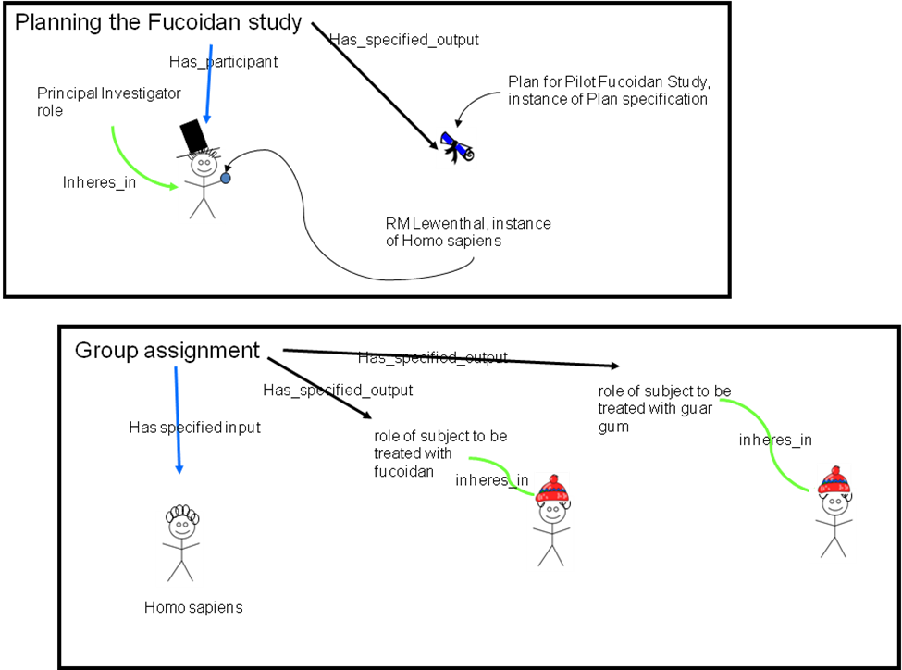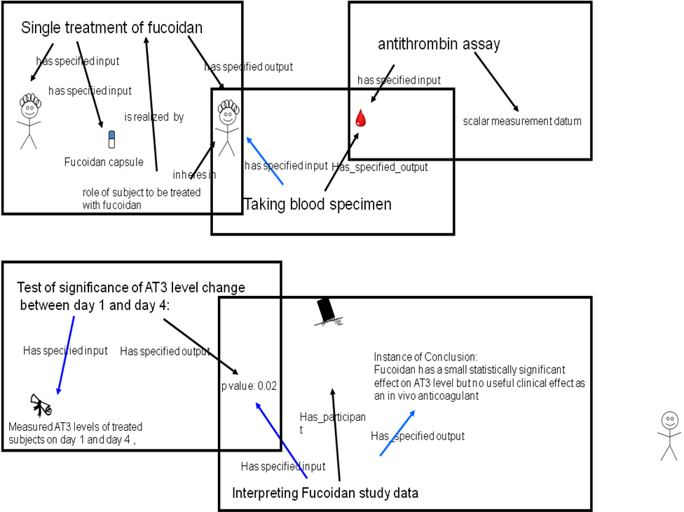

Figure 5: The clinical investigation use case to test OBI coverage. This figure is a simplification of the full OBI description which is available as supplementary material XXXX.

By expressing this use case in OBI, we can link between an original study, the subjects, treatments, measurements and conclusions finally published in a paper. This computational representation is capable of distinguishing between humans as either investigators or subjects and between treatments as active or negative references. This level of explicit detail in description of investigations is necessary to fully describe for example, toxicological, pharmacological or developmental studies. Future work will be to investigation the application of these descriptions to database such as the Chemical Effects in Biological Systems (CEBS) at the NIEHS, in order to support queries over these data, in a similar way as described in Use case 2.

Discussion

Development Challenges for OBI
A major challenge in the development of OBI has been the requirement to solve upper level ontology problems. The development of the IAO has provided a flexible intermediate layer to describe data. OBI imports IAO which has clear benefits – IAO is available to the wider ontology community and is being used by (… list users). However, as OBI imports IAO wholesale, and OBI derives local classes from IAO parent classes we have had to deal with an immature resource (add some stats re obsoletion and required to decide where the boundary between generic classes in IAO and specific classes in OBI is. This has resulted in the transfer of classes between the two on occasion. We have dealt with this by adding OBI specific classes and deprecating or retaining these after discussion with IAO, at some stages we have effectively been building two ontologies which are closely aligned. Dealing with orthogonality is one of OBI’s and the OBI Foundry’s greatest challenges.

The experimental processes for which OBI provides semantics cross many technical domains, and could include what is intended to be done in an investigation (planning), and general ideas about what might, or should be done. It is hard to name and define high level classes and we have used description logics to do this formally, for example, classes which describe different material processing are provided. There are cases where the commonly used scientific term is insufficiently clear to be used by OBI e.g. Objective. This therefore defined as objective specification - which is intended to answer the question why did you do the experiment. Therefore we understand objective specification to describe specific intent in the context of an experimental processes, rather than cognitive science - ideas about what could be done. As OBI is intended to support the scientific record and exchange of data, we use this class rather than the more general ‘objective’ and the same is true of hypothesis specification.

OBI is a large-scale, community-driven ontology, developed with the goal to represent biomedical investigations in a computationally amenable form. The scope of OBI is the representation of investigations across disparate biological disciplines. This includes both hypothesis driven and data driven investigations, and includes the vast array of experimental procedures, devices and reagents applied in these contexts. In addition, OBI supports the philosophy of the OBO Foundry and endeavors to maximize the re-use of complementary ontologies which pre-date OBI or are outside of the scope of OBI.

The most prominent ontology in the biomedical domain is the Gene Ontology (GO) [ref] which is a resource for searching and analysis via the annotation of genes and gene products to related datasets. [refs to that effect]. By representing devices, specimens, planned processes, roles, functions and information content entities that comprise biomedical investigations, OBI provides a valuable resource for the reporting of scientific research which has been applied in domain specific databases (ref IEDB). Advantages of using OBI are an explicit formalization of knowledge which has proved useful in database development and data annotation, and as a test case for integrating different OBO foundry ontologies in the context of the experimental process.
OBI provides a method of annotating experimental descriptions with terms that are both human readable about the experiment and the computer program designed to analyze thousands of experiments.
The user cases we have provided and the community experience of applying OBI demonstrates its applicability entire investigations, from domains as complex as genomics, immunology, bioinformatics and clinical trials. OBI has the potential to represent any biomedical investigation by the additional of relevant terms and consensus, via any community that wishes to contribute to the ontology development. Four examples are of particular relevance to the scientific community. Firstly, the application of OBI as a controlled vocabulary to describe experiments within scientific reporting guidelines. The life-sciences produce high throughput large data sets. This has posed new challenges, as the data gathered is only useful when annotated with contextual experimental information. One solution to this problem is the use of professional curators who annotate experimental data after it is published in specialized databases. This is expensive and not all information necessary to understand experimental information is published. An alternative approach is to enable annotation of experimental data at the source, by those investigators who are generating the data. The crux here lies in achieving consistent and sufficient recording of information while not placing too high a burden on the experimentalists annotating the data. For this purpose, communities have established checklists of minimal information that are required to report an array of experimental techniques including microarrays [16] and proteomics [17]. However, achieving consistency across such different community reporting standards requires bringing them together in a common framework. This is the goal of the MIBBI project [18], which aims to standardize the syntax and semantics of data gathered according different minimal information checklists. The MGED Society is in the process of migrating from the MGED Ontology [ref] to OBI. Similarly, the BioInvestigation Index database (http://www.ebi.ac.uk/bioinvindex/) aims to move away from technology-centric data silos and towards metadata capture irrespective of experiment type. Assembly of candidate datasets for meta analysis will occur instead through MIBBI compliance and reliance on OBI. This method potentially allows users to search repositories more effectively, such as the identification of all experiments focusing on protein profiling irrespective of the technique used.
In this specific use case, OBI is applied in the definition of a minimal information checklist according to MIBBI requirements, followed by completing such a checklist for a specific experiment. This functionality is implemented in a suite of tools available from http://isatab.sf.net. As shown in Figure 6, the ISAconfigurator tool enables defining a checklist following MIBBI requirements in the ISA-Tab syntax [19]. Data entry fields (ISA-Tab elements) can be configured to consume ontological artifacts, available from brokering services such as OLS [20] and Bioportal [21], for example, the instrument class and its children from OBI. Once community vetted the implementation of the checklist can be distributed and completed using the ISAcreator tool.
Figure 6: Using ISA-configurator to define and ISAcreator to complete minimal information checklists

Secondly, OBI enables cross-database queries. Notably, if multiple information resources are mapped to the same underlying ontology, queries can then be formulated across the different resources. For example, once the OWL export of the IEDB is integrated into the Neurocommons triple store [22], it becomes possible to answer queries linking incorporated databases such as GO. A query could discover known immune epitopes in kinases by linking a protein identified as the source of an epitope in the IEDB with GO Annotations for that protein [23].
Thirdly, OBI can aid the identification of errors in annotations. If a model of an experiment is created using OBI, inconsistencies in annotations can be discovered through the use of automated reasoners, as described earlier in this document. Such error identification has already been used in the development of the IEDB. Finally, OBI may be used to convert and extend GO evidence codes [ref]. Evidence codes indicate the basis, or proof, upon which statements such as “protein A interacts with protein B” are made. They provide a high level classification on the type of experiments, computational analysis, or quality of annotation performed. Through the use of OBI, these annotations can be made much more expressive, in principle allow much more detail to be conveyed through the use of GO evidence codes.
Several alternative efforts for formal representations of investigations exist; several of these are listed on the OBO Foundry library. Two specific examples are EXPO [24] and the MGED Ontology [25] which are also formal ontologies created to model experiments. However, these ontologies are more community specific (or experiment specific), and developers from both projects are now actively participating in OBI development, contributing their expertise and ensuring OBI has broad applicability and enforcing the open collaborative development community. Other alternatives ontologies that are relevant to biomedical investigations are provided by controlled medical terminologies, such as SNOMED [ref] and LOINC [ref]. These provide broad coverage of existing tests, and are in widespread practical use within the medical community. There are obvious terminology overlaps between an investigation in a life-science context and a medical context. Therefore, initial efforts have been made in order to explore mapping of codes from these terminologies into OBI classes. Such a collaboration would aid developers on all sides, sharing commonality and avoiding “re-inventing the wheel” As a result the coverage of OBI would be greatly enhanced, while the other terminologies would gain a deeper semantic meaning based on the more expressive definitions used in OBI, producing a greater benefit to the end user.
OBI is the first OBO Foundry ontology to address the challenge of producing an orthogonal ontology in the face of many overlapping existing ontologies. As such, a number of challenges were encountered. Firstly, working with very large ontologies such as the NCBI Taxonomy [3] can be difficult and sometimes impossible with current technology. There are technical challenges such as running out of memory or processing power when attempting to load very large ontologies into the most commonly-used editors. Semantic challenges are also faced when importing large or incompatible ontologies in their entirety; such large-scale imports could lead to inconsistencies or unintended inferences. To address this challenge, the OBI Consortium developed the MIREOT import mechanism [ref]. MIREOT defines how to partially import an external ontology into OBI or any other ontology implementing its guidelines, providing access to the wealth of terms available in very large external ontologies.
The integration of disparate ontologies is a difficult problem within the domain of ontology development. This is further compounded when different ontology languages are used; alternative design principles are in practice or the use of different upper ontologies are applied, across resources that are required to be integrated.. Such cases must be studied individually, but there are a number of solutions that exist. For instance, if the ontology to be incorporated within OBI is associated with the OBO Foundry, then eventual alignment with BFO is required, and OBI can work with the developers of that ontology to hasten compliance. To address incompatibility of language rather than semantics, conversion to OWL-DL may be possible and indeed trivial. If the ontology to be aligned is written in OBO, for example, there are converters between the two formats [ref]. If all other procedures fail, the use of the MIREOT specification on an ontology of any size can provide a solution. A third challenge was the past incompatibility of BFO with information artifacts such as a text document or a TIFF image. When it became apparent that BFO did not contain the necessary concepts to describe them, a new ontology effort call the Information Artifact Ontology (IAO) [ref] was developed to include these information artifacts within the BFO structure. As such, the IAO is aligned and integrated within OBI.
Several challenges remain that are best addressed in the OBO foundry network. Specifically, there is a need for cross-species anatomical terms. For example, descriptions of experimental protocols working with human or mouse blood tend not to distinguish between the two. However, there is no generic term ‘blood’ that can be used for this purpose, but only e.g. ‘human blood’ in the FMA. Resolving this issue is outside the scope of OBI, and working through the foundry is the most suitable mechanism for modes of communication and a potential solution for these types of problems.
Concerns that have been expressed about the use of OBI include questions over its complexity and seemingly non-standard terminology. A model, such as OBI, that is complete enough to describe experimental processes will necessarily contain some amount of complexity. However, there are ways of hiding such complexity from end users if required. Tools such as ISACreator [ref] allow community scientists to create fully annotated investigations, while hiding the complexity of working with the ontology in OWL. Terminologies differ among communities, and OBI strives to account for community-specific meanings and usages of widely-used terms by employing labels and definitions designed to avoid these confusions. This sometimes results in terms that do not sound “natural”, or terms that sound as though they were written primarily for computers. This is due to the design principle that OBI concentrates on the semantic meaning of definition of a term as a priority over “labels” or term names To address human accessibility without losing precision, OBI will employ, and users can request, annotation properties such as ‘alternative term’. These properties provide a method for communities to provide, additional term names, or a synonym for any OBI definition to suit their specific needs and preferences.
There are many shared concepts for describing investigations across the entirety of the scientific community: there are protocols to be followed, analyses to be run and equipment to be used in the application of these protocols. OBI is the first semantically-meaningful model for describing these common structures, irrespective of experiment type. Without this shared description, data sharing and integration becomes difficult, reducing the ability of researchers to make use of data from other communities. Instead of many representations of experiments from many communities, the use of OBI either on its own or in conjunction with complementary formats such as FuGE [ref], ISA-TAB or SyMBA [http://symba.sourceforge.net/], provides a new ‘many communities – shared semantics’ model that simplifies experimental description. Further, MIBBI checklists complement OBI, both by providing a structure against which researchers can compare their annotations and know when they have reached a minimal level of description and as a set of requirements for a particular technology that OBI should be able to represent. OBI provides researchers with a single semantic resource for experimental description, thus easing computational analyses, encouraging collaborations, and aiding reproducibility of experiments.OBI is a framework upon which any scientific experiment can be modeled and described, providing a single point of commonality and an integration point across disciplines.
We are missing a big sign of conclusion and a call for collaborative development participation, with the appropriate email address to sign up for….

Acknowledgments
This work is partially supported by grant funding from the National Institute of Biomedical Imaging and Bioengineering, National Human Genome Institute, NIH ( R01EB005034, NIH P41 HG003619, HHSN26620040006C), EC EMERALD project (LSHG-CT-2006-037686), EC FELICS, MUGEN, BBSRC (BB/E025080/1, BB/C008200/1), NERC-NEBC, EU IP CarcinoGenomics (PL 037712), EU NoE NuGO (NoE 503630), CARMEN project EPSRC (EP/E002331/1), RC UK, the Michael Smith Foundation for Health Research JF’s contributions to this work are supported by the Intramural Research Program of the NIH and NIEHS, under contract HHSN273200700046U

Methodology
Add section:
We represent an objective specification rather than an objective because we understand the former better than the latter. This is a case of a repeated pattern in OBI – when faced with complex representation problems we define related terms which are better understood, and which are still adequate to fulfill anticipated use cases. Defining high level terms is particularly problematic.

Choice of language and metadata conventions
OBI development has spanned the last 5 years and is achieved by means of weekly teleconferences and twice yearly face-to-face meetings. To date 19 communities and XXX researchers have been actively involved in the development process. The requirement for remote development required formalization of the concept meta data (per concept author, progress information etc) conventions as a lightweight meta data schema tailored to development needs. The complete specification of the metadata scheme is available [http://purl.obolibrary.org/obo/obi/policy/metadata]. Note that this ontology metadata standard is evolving under the OBO foundry, and we will adhere to these standards.
OBI is developed using the Ontology Web Language 1.0 (OWL) [26] as OWL provides richer semantic support than OBO format - the other commonly used alternative in the biomedical domain. The OWL-DL subset was selected to gain maximum expressivity while allowing machine readability and use of reasoning for maintenance and development. The metadata scheme is implemented as OWL annotation type properties.
Concurrent development of OBI is necessary given the number of developers. OBI development is therefore organized into branches, with each sub-team working independently. Each branch is organized by subject area, such as data transformations, instruments or roles. Using this strategy tasks such as redundancy or inconsistency checking are manageable, as members in each branch can focus on a subset of terms.
We also required version control, offline development, use of different tools and editors, and script-based augmentation of the ontology content. A review of the existing collaborative ontology development tools failed to identify a single application that met OBI’s requirements. Instead, we split the ontology into multiple OWL files, one per branch, and rely on subversion to manage version control, distributed and offline development, as well as logging history for change management. The current development version of OBI is available from subversion at [ref].

Integration with existing ontologies
OBI was developed to be complementary to, and integrated with, a framework of existing ontologies in the biomedical domain. The description of experiments and investigations provided by OBI ties into the description of ‘natural’ biomedical information, as produced by the Gene Ontology for gene function [27] and others for example in for cell types and anatomy. Contacts to other ontology development activities were therefore established early, and OBI was one of the driving projects in the establishment of the OBO Foundry [3]. The desire to re-use existing diverse ontologies and integrating them into a single framework posed several challenges.
A top level ontology can provide guidance in how individual terms or whole ontologies interrelate and is useful when integrating external ontologies. BFO [ref] was chosen as the top level ontology as it is stable, publicly available in OWL syntax, aligned to existing OBO Foundry ontologies, and because there is a responsive community of developers and users of it [cite bfo-discuss list]. The OBO Relations ontology[ref] was chosen provide relations for OBI, and these were extended where required.
Four key ontologies are directly imported using the owl:import mechanism, including BFO and RO mentioned above, plus the ro_bfo bridge mapping to set ranges and domains for properties using BFO classes, and the Information Artifact Ontology (IAO, [ref]).
The owl:imports mechanism was not suitable for all external ontologies for several reasons: Firstly, current editing tools are not effective for working with very large ontologies such as the NCBI Taxonomy [3], therefore direct OWL import is impractical. Secondly, some ontologies used by OBI are actively developed and may not be aligned with OBI’s design (e.g., not using BFO as an upper ontology, or not using OWL DL). Importing such ontologies as a whole could lead to inconsistencies or unintended inferences. Instead, the MIREOT import mechanism was developed [ref], which is based on the practice of the Gene Ontology (GO) [5] in that the intended meanings of classes remain stable. Even when the source ontology is repaired or reorganized, the effects of such modifications do not change the intended meaning of terms.

Term requests and triaging for concurrent development
The majority of terms in OBI were collected from the various communities that intend to use it. Term lists were solicited and collated by a representative of each community (OBI consortium page] and terms were also submitted through a public term tracker [(http://sourceforge.net/tracker/?group_id=177891&atid=886178). Each term was then assessed to determine if it was in the scope of OBI. For example, terms like ‘peptide’ and ‘antibody’ are needed to describe immunological experiments describe an experiment, but were available in ChEBI [9] and GO respectively, and were therefore imported (see above) rather than added to OBI directly.
Submitted terms were distributed to an appropriate OBI branch for curation and inclusion in the OWL file and interaction between branches was achieved through conference calls.

Release and Quality Control
Users require a traceable, static version of OBI. We have therefore established a monthly release process where multiple branch development OWL files are merged into a single file, which makes it easier to use and view the ontology in currently available tools. A second version of the ontology is released in which classes are organized in the inferred hierarchy. Each release is versioned, and is available from a specific URI using the release date as a tag. The most up-to-date file prior to monthly release is always available from http://purl.obolibary.org/obo/obi.owl. Releases of OBI are also uploaded to the NCBO BioPortal [28] and the OBO Foundry repository [3].
Checks are made prior to release to assure compliance of the released version with OBI policies. Specifically, classes are identified that do not comply with the minimal metadata policy, have invalid OWL syntax or lead to inconsistency when reasoning using Pellet [29] or Fact++[ http://owl.man.ac.uk/factplusplus/]. Identifier format and deprecation policies are also enforced. OBI identifiers are prefixed with “New classes are automatically assigned a permanent identifier in the format OBI_0000001” on their first release. Similarly, the release process verifies that all IDs that were present in the previous release are still in use. This conforms to the GO deprecation policy that OBI has adopted. Deleted classes are moved under the ObsoleteClass in the OBI hierarchy and stored in a separate file.

References

1. Jones, A.R., et al., The Functional Genomics Experiment model (FuGE): an extensible framework for standards in functional genomics. Nat Biotechnol, 2007. 25(10): p. 1127-33.
2. Spellman, P.T., et al., Design and implementation of microarray gene expression markup language (MAGE-ML). Genome Biol, 2002. 3(9): p. RESEARCH0046.
3. Smith, B., et al., The OBO Foundry: coordinated evolution of ontologies to support biomedical data integration. Nat Biotechnol, 2007. 25(11): p. 1251-5.
4. Rosse, C.a. and J.L. Mejino, Jr., A reference ontology for biomedical informatics: the Foundational Model of Anatomy. J Biomed Inform, 2003. 36(6): p. 478-500.
5. Grenon, P. and B. Smith, SNAP and SPAN: Towards Dynamic Spatial Ontology. Spatial Cognition & Computation: An Interdisciplinary Journal, 2004. 4(1): p. 69-104.
6. Smith, B., et al., Relations in biomedical ontologies. Genome Biol, 2005. 6(5): p. R46.
7. Wheeler, D.L., et al., Database resources of the National Center for Biotechnology Information. Nucleic Acids Res, 2006. 34(Database issue): p. D173-80.
8. Haendel, M.A., Neuhaus, F., Osumi-Sutherland, D., Mabee,P.M. and M. Mejino Jr. J.L.V., C.J. and Smith, B., CARO - The Common Anatomy Reference Ontology, in Anatomy Ontologies for Bioinformatics: Principles and Practice, D.D.a.R.B. Albert Burger, Editor. 2008, Springer: New York.
9. Degtyarenko, K., et al., ChEBI: a database and ontology for chemical entities of biological interest. Nucleic Acids Res, 2008. 36(Database issue): p. D344-50.
10. Byrne, M.C., M.Z. Whitley, and M.T. Follettie, Oligonucleotide arrays for expression monitoring. Curr Protoc Hum Genet, 2001. Chapter 11: p. Unit 11 2.
11. Arp, R. and B. Smith (2008) Function, Role, and Disposition in Basic Formal Ontology. Nature Precedings.
12. Reich, M., et al., GenePattern 2.0. Nat Genet, 2006. 38(5): p. 500-1.
13. Peters, B. and A. Sette, Integrating epitope data into the emerging web of biomedical knowledge resources. Nat Rev Immunol, 2007. 7(6): p. 485-90.
14. Greenbaum, J.A., et al. Representing the Immune Epitope Database in OWL. in ISMB. 2009. Stockholm, Sweden.
15. Prud’Hommeaux, E. and A. Seaborne, SPARQL query language for RDF. W3C working draft, 2006. 4.
16. Brazma, A., et al., Minimum information about a microarray experiment (MIAME)-toward standards for microarray data. Nat Genet, 2001. 29(4): p. 365-71.
17. Taylor, C.F., et al., The minimum information about a proteomics experiment (MIAPE). Nat Biotechnol, 2007. 25(8): p. 887-93.
18. Taylor, C.F., et al., Promoting coherent minimum reporting guidelines for biological and biomedical investigations: the MIBBI project. Nat Biotechnol, 2008. 26(8): p. 889-96.
19. Sansone, S.A., et al., The first RSBI (ISA-TAB) workshop: "can a simple format work for complex studies?". OMICS, 2008. 12(2): p. 143-9.
20. Cote, R.G., et al., The Ontology Lookup Service: more data and better tools for controlled vocabulary queries. Nucleic Acids Res, 2008. 36(Web Server issue): p. W372-6.
21. Noy, N.F., et al., BioPortal: ontologies and integrated data resources at the click of a mouse. Nucleic Acids Res, 2009. 37(Web Server issue): p. W170-3.
22. Ruttenberg, A., et al., Life sciences on the Semantic Web: the Neurocommons and beyond. Brief Bioinform, 2009. 10(2): p. 193-204.
23. Barrell, D., et al., The GOA database in 2009--an integrated Gene Ontology Annotation resource. Nucleic Acids Res, 2009. 37(Database issue): p. D396-403.
24. Soldatova, L.N., et al., An ontology for a Robot Scientist. Bioinformatics, 2006. 22(14): p. e464-71.
25. Whetzel, P.L., et al., The MGED Ontology: a resource for semantics-based description of microarray experiments. Bioinformatics, 2006. 22(7): p. 866-73.
26. Horrocks, I., Patel-Schneider,P.F and van Harmelen, F., From SHIQ and RDF to OWL: The making of a web ontology language. Journal of Web Semantics, 2003. 1(1): p. 7-26.
27. Blake, J.A. and M.A. Harris, The Gene Ontology (GO) project: structured vocabularies for molecular biology and their application to genome and expression analysis. Curr Protoc Bioinformatics, 2008. Chapter 7: p. Unit 7 2.
28. Musen, M., et al., BioPortal: Ontologies and Data Resources with the Click of a Mouse. AMIA Annu Symp Proc, 2008: p. 1223-4.
29. Evren Sirin, B.P., Bernardo C Grau, Aditya Kalyanpur, Yarden Katz, Pellet: A practical OWL-DL reasoner Web Semantics: Science, Services and Agents on the World Wide Web, 2007. 5(2): p. 51-53.

Supplemental Table 1 – OBI terms, IDs and definitions. See Excel File ‘OBITerm-ids.xls’

