OBI QTT Template import using Mapping Master

1. Check-out from OBI svn to retrieve the following files:

A template: OBI-QTT-Analyte-Assay-Template2.xls
An ontology: QTT.owl
QTT.repository

2. Download Protégé-3.4.2 from:

http://www.stanford.edu/~sunid/Protege_3.4.2.zip

3. Unzip the archive

4. Start Protégé-3.4.2 from a terminal using command line (so you can see how things are going).

> java -jar -Xms256m -Xmx512m protege.jar

5. Open QTT.owl file (it takes some time to import and parse the files, check the process from the terminal prompt)

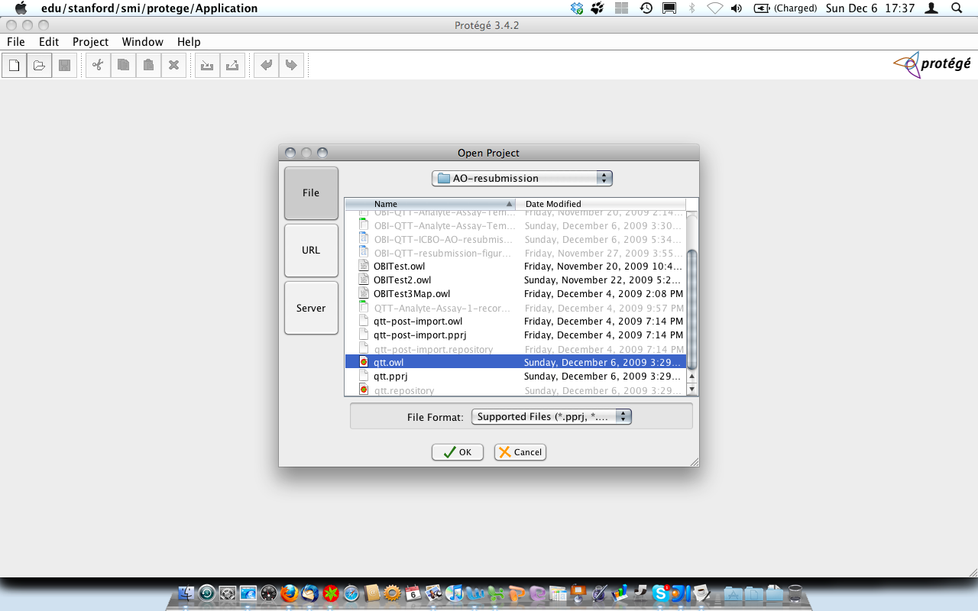

6. From Protégé ‘OWL’ Menu, Go to ‘Preference’

Select the ‘Tab’ item in the Preference window (2nd from right)

Tick the select box ‘SpreadsheetMaster’

Click ‘Close’ button

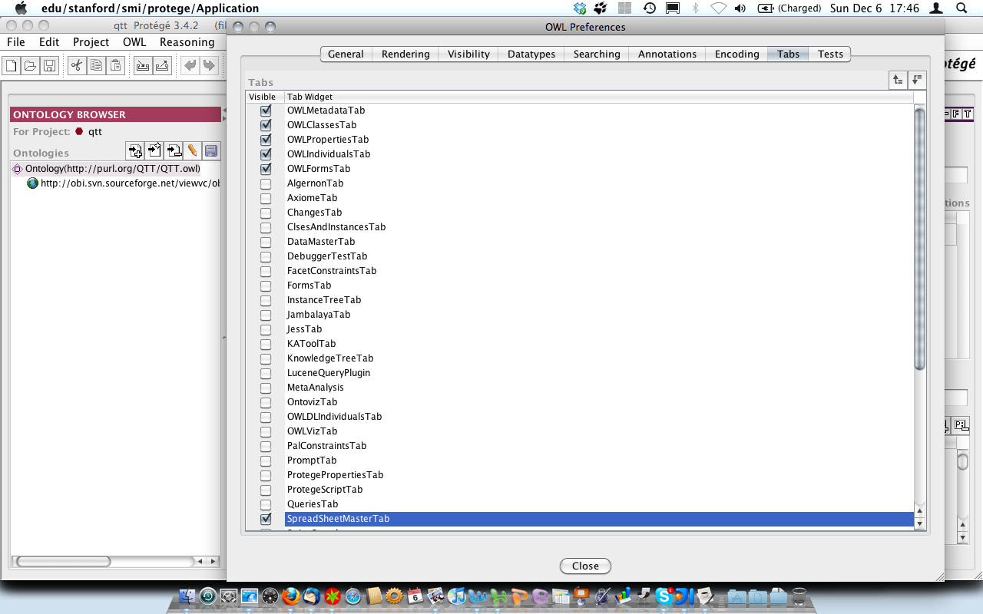

7. In Protégé Main view, go to the ‘Mapping Master’ tab.

8. In the upper pane of the Mapping Master Tab (Workbook).

Upload OBI-QTT-Analyte-Assay-Template2.xls

9. In the Mapping pane (lower section), first set the mapping control:

In our OBI example, using default settings meets the needs.

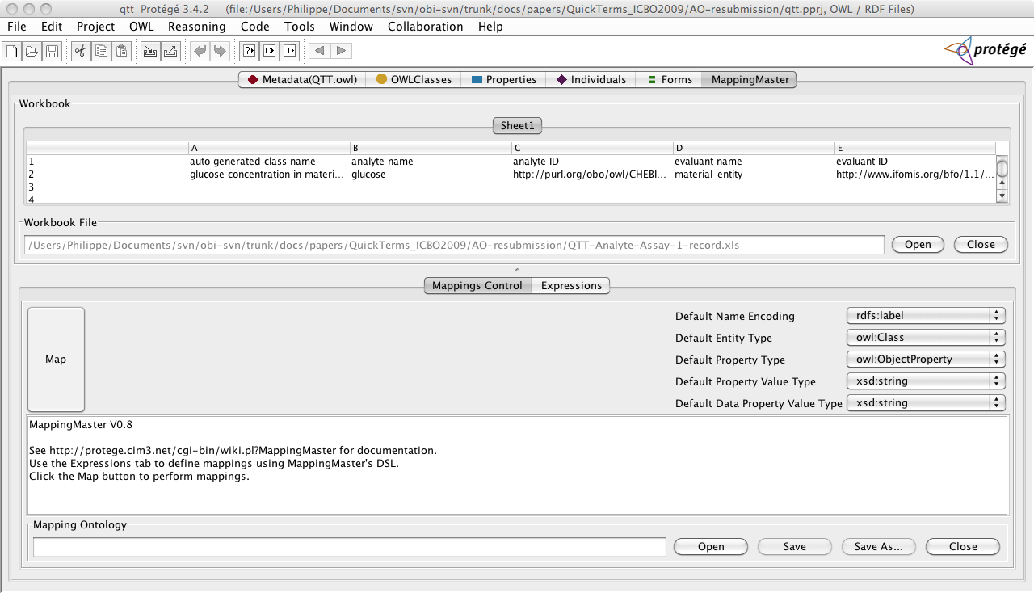

10. Then click ‘Expressions’ button (next to Mappings Control):

Click ‘Add’ and set as shown in figure 2 and set the expression to be:
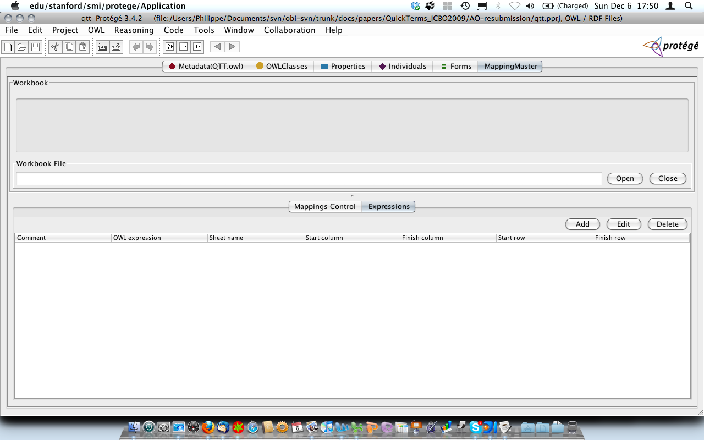

11. Provide necessary information. Note that the ‘Sheet name’ field is automatically populated with the name of the Excel worksheet names found in the uploaded document.
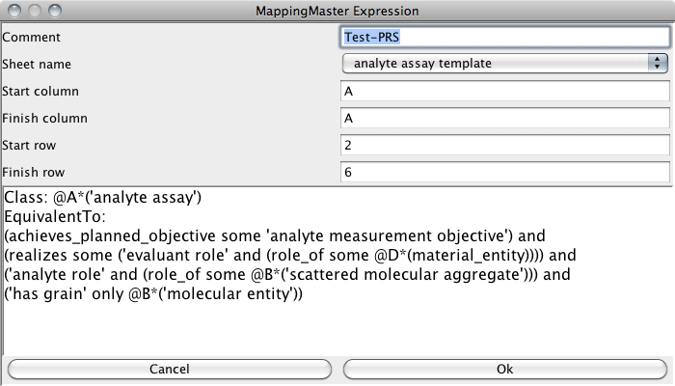

IMPORTANT: Start Column and End Column field should (apparently) get the same value (A).

In the expression section, paste the following:

Class: @A*('analyte assay')
EquivalentTo:
(achieves_planned_objective some 'analyte measurement objective') and
(realizes some ('evaluant role' and (role_of some @D*(material_entity)))) and
('analyte role' and (role_of some @B*('scattered molecular aggregate'))) and
('has grain' only @B*('molecular entity'))

Note :
@A indicate to get the values from column A in the incoming template
@B indicate to get the values from column B in the incoming template
@D indicate to get the values from column D in the incoming template

12. Go back to ‘Mapping Controls’ tab and then click ‘Map' button on the left:

Troubleshooting: ISSUES on how classes are created

Error may occur. We review here a number of issues we came across when using QTT.owl file (Class or Property name expected) and OBI QTT template and events users should be watchful of when carrying out the procedure.

An important requirement in order to use Mapping Master and QTT consists in making sure that filler classes used to set restriction of ‘to be added’ defined classes must be present in OBI for the procedure to run successfully.

1. Creation of ‘duplicated’ classes

If a filler class label does not match exactly the target OBI class label, new (redundant) classes are created as shown below.
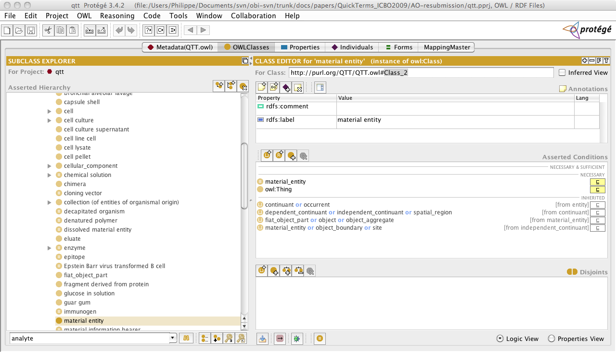

Material entity class already exists as an import from BFO but its label is Material_entity

When the curation is carried out, the display looks like this:
material_entity = material_entity, as shown below:
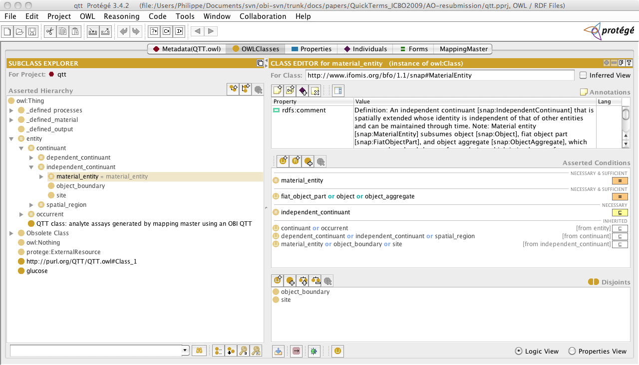

2. Problems caused by the absence of a classes used as as restriction fillers:

error parsing expression: error rendering OWL class declaration Class: @A*('analyte assay') EquivalentTo: ((achieves_planned_objective SOME 'analyte measurement objective') AND (realizes SOME ('evaluant role' AND (role_of SOME @D*(material_entity)))) AND ('analyte role' AND (role_of SOME @B*('scattered molecular aggregate'))) AND ('has grain' ONLY @B*('molecular entity')));
rendered as: Class: http://purl.org/QTT/QTT.owl#Class_1 EquivalentTo: ((achieves_planned_objective SOME 'analyte measurement objective') AND (realizes SOME ('evaluant role' AND (role_of SOME snap:MaterialEntity))) AND ('analyte role' AND (role_of SOME http://purl.org/QTT/QTT.owl#Class_2)) AND ('has grain' ONLY http://purl.org/QTT/QTT.owl#Class_2));
error = OWL class expression '((achieves_planned_objective SOME 'analyte measurement objective') AND (realizes SOME ('evaluant role' AND (role_of SOME snap:MaterialEntity))) AND ('analyte role' AND (role_of SOME http://purl.org/QTT/QTT.owl#Class_2)) AND ('has grain' ONLY http://purl.org/QTT/QTT.owl#Class_2))' not valid: Class or property name expected

BUT still, defined classes are created in the QTT.owl file as shown below:

At “root” node level:
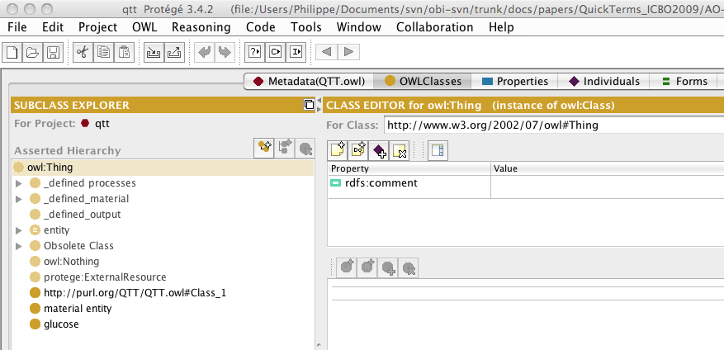

As child of “analyte assay”:

