An Ontology of Biomedical Investigations

Authors
The OBI consortium (in alphabetical order): Ryan Brinkman¹, Bill Bug², Helen Causton³, Kevin Clancy, Cristian Cocos, Mélanie Courtot¹, Dirk Derom⁴, Eric Deutsch⁵, Liju Fan⁶, Dawn Field⁷, Jennifer Fostel⁸, Gilberto Fragoso³, Frank Gibson⁹, Tanya Gray, Jason Greenbaum¹⁰, Pierre Grenon, Jeff Grethe⁷, Yongqun He¹¹, Mervi Heiskanen, Tina Hernandez-Boussard⁷, Phillip Lord²⁰, Allyson Lister^{12,20}, James Malone, Elisabetta Manduchi, Luisa Montecchi, Norman Morrison³, Chris Mungall¹³, Helen Parkinson³, Bjoern Peters¹⁰, Matthew Pocock, Philippe Rocca-Serra³, Daniel Rubin, Alan Ruttenberg¹⁴, Susanna-Assunta Sansone³, Richard Scheuermann¹⁵, Daniel Schober¹⁶, Barry Smith¹⁷, Larisa N. Soldatova¹⁸, Christian J. Stoeckert Jr.¹⁹, Chris Taylor³, Randi Vita¹⁰, John Westbrook, Joe White, Patricia L. Whetzel⁷, Stefan Wiemann, Jie Zheng¹⁹

Affiliations
¹BC Cancer Agency, Vancouver, Canada; ²National Center for Microscopy Imaging Research, UCSD, CA, USA; ³The European Bioinformatics Institute, Cambridge, UK; ⁴Victoria University of Wellington, New Zealand; ⁵ISB, Seattle, WA, USA; ⁶Ontology Workshop, LLC, Columbia, MD, USA; ⁷Stanford University Medical School, Stanford, CA, USA; ⁸SRA Global Health Sector, Durham, NC, USA; ⁹Abcam plc, Cambridge, UK; ¹⁰La Jolla Institute for Allergy and Immunology, La Jolla, CA, USA; ¹¹University of Michigan, Ann Arbor, USA; ¹²Centre for Integrated Systems Biology of Ageing and Nutrition, Newcastle University, UK; ¹³Lawrence Berkely National Lab, Berkely, CA, USA;¹⁴Science Commons, Cambridge, MA, USA; ¹⁵Southwestern Medical Center, USA; ¹⁶IMBI, University Medical Center, Freiburg, Germany; ¹⁷University at Buffalo, Buffalo, NY, USA; ¹⁸Aberystwyth University, Wales, UK; ¹⁹University of Pennsylvania School of Medicine, Philadelphia, PA, USA; ²⁰School of Computing Science, Newcastle University, UK

Abstract
OBI is an ontology whose purpose is to support the detailed description of biomedical investigations. It provides a formal representation enabling precise and shared meaning to these descriptions. This will support data annotation, repository querying and multi-disciplinary data analysis. The scope of OBI includes many parts of the investigation process. The project is an open collaborative effort, currently encompassing 19 distinct research communities from around the globe. It integrates with other biomedical ontologies such as GO and ChEBI. The paper reports the culmination of three years of development, resulting in the first full release of the ontology and describes a number of applications. OBI tackles the challenges presented by the large scale multi-omic data that now characterizes biomedicine.

Introduction
Information derived from biomedical investigations is increasingly being captured in structured electronic format. This is made available through public database resources as a complement to its reporting in traditional print journal publications. For many years, different formats to describe experiments have been developed in isolation, as research communities tended to focus on one type of methodology at a time [1, 2]. The ‘many communities, many standards’ methodology may support the needs of individual communities but common features of different investigations may be described in different ways. This situation creates difficulties for representing cross- disciplinary experiments, for example, integrative meta-analysis spanning multiple scientific communities. In different database systems, the key features of an investigation need to be described in a common, shared and unambiguous manner. Minimally, this requires standards for the representation of samples used in an investigation, assay methods and data analysis. It is this background that provides the motivation for the Ontology for Biomedical Investigations (OBI; http://purl.obolibrary.org/obo/obi.owl).
OBI addresses the requirement for a cross-disciplinary standard for representing biomedical investigations and has been under development for several years by a large consortium. It is both broad, describing the parts of an investigation from conception to conclusion, and deep, describing from test tube to transgenic organism. As an ontology, OBI is a controlled vocabulary with additional logical constraints. It supports and augments existing community standards such as MAGE-TAB [1] and ISA-TAB [2]. The effort has resulted in an ontology using OWL, which is a W3C ontology language developed for the semantic web.
OBI is a community based, grass-roots project following in the tradition of efforts such as the MGED Society[3]. It has representatives from many disciplines, covering much of biomedicine and including expertise from areas such as informatics. The consortium has an open membership policy and a transparent development process. As a result, contributors are distributed globally. OBI development is driven by specific examples of experiments from contributors which are then generalized to be useful outside these examples. As such, OBI is not complete and is an ongoing process, extending as new examples are introduced.
The primary use of ontologies in bioinformatics has been for annotation of existing resources. OBI supports, and is presently being used for, this task. In addition, OBI has a rich underpinning of computational logic; this can support the annotation process by automatically checking for consistency as well as enabling rich querying over data repositories. OBI follows, and has helped to form, the framework set out by the Open Biomedical Ontology (OBO) Foundry [3] and as such is able to interoperate and support additional ontology development efforts. Being built on W3C standards, it can also use, and is of use to, other data available on the semantic web.
In this paper, we describe the current state of OBI in its first full release. OBI now has over 3,000 classes (both imported and native to OBI), is publicly available and is free to use. We outline the process design decisions followed by the OBI consortium which has enabled this development. We give an overview of the organization of the ontology and detail some of the classes and relation which form the structure of OBI. We also describe three uses which exemplify the different ways in which OBI can be applied with biological investigations.
Further enhancements of OBI in terms of breadth and depth of coverage are driven by the participating consortium members; we welcome and encourage broader community participation in this open, collaborative ontology development effort.

Results

Establishing a development framework for OBI
The scope of OBI is to formally represent entities participating in biomedical investigations. In line with the OBO Foundry principles, it re-uses existing resources, such as OBO foundry candidate ontologies when possible, avoiding term duplication within the biomedical domain. Therefore, OBI was developed to be complementary to, and integrated with, a framework of existing biomedical ontologies. For example, if an investigation includes taking a human tissue sample, the anatomical source of the sample is described by reference to the Foundational Model of Anatomy [4]. New terms are only created in OBI for entities specifically related to investigations and that do not already exist in other OBO Foundry candidate ontologies. The following sections describe the development process of OBI and how it enables integration with these resources.
Re-using existing ontologies and integrating them into a single framework poses many challenges. Communication from OBI to other ontology development activities was necessarily established early, and OBI became one of the driving projects in the establishment of the OBO Foundry [3]. To provide a foundation upon which to build OBI development, BFO [5] was used as a top level classification of entities. Relations were imported from the OBO relations ontology (RO, [6]), as well as relations which have been proposed for inclusion into RO but are not yet released. When new relations were defined between classes in OBI, these were based on RO relations wherever possible. The relations created within OBI are proposals for inclusion in RO. Use of upper-level ontologies eases interoperability of OBI terms with external ontologies based on the same foundation. BFO and RO were chosen as they are widely adopted by other OBO Foundry candidate ontologies.
OBI was constructed by collecting terms from each of the 19 communities within the OBI consortium, as well as through a public tracker. Before terms were incorporated as entities into OBI, they were checked for occurrence in other ontologies, assessed for suitability, and evaluated against the defined scope of OBI.
A detailed description of the import processes including metadata and ID policies, distributed development process, conflict resolution, release process, tools used for versioning and the use of automated reasoning is given in the Methods section.

OBI classes and relations
The OBI 1.0 release has XXX classes and YYY relations. The high level class organization of OBI is depicted in Figure 1. The upper level consists of the BFO classes material entity, process, role and function, and the class information content entity. Throughout this text, italics are used to indicate a term denoting a class, instance or relation in an ontology. Supplemental Table 1 identifies the source ontology (for imported entities), identifier, and formal textual definitions for each term. The plural of the class label is sometimes used in the text for readability, but the official OBI class labels are singular. This section gives an overview of several higher-level OBI classes that outline the scope of OBI and illustrate the modeling approach.

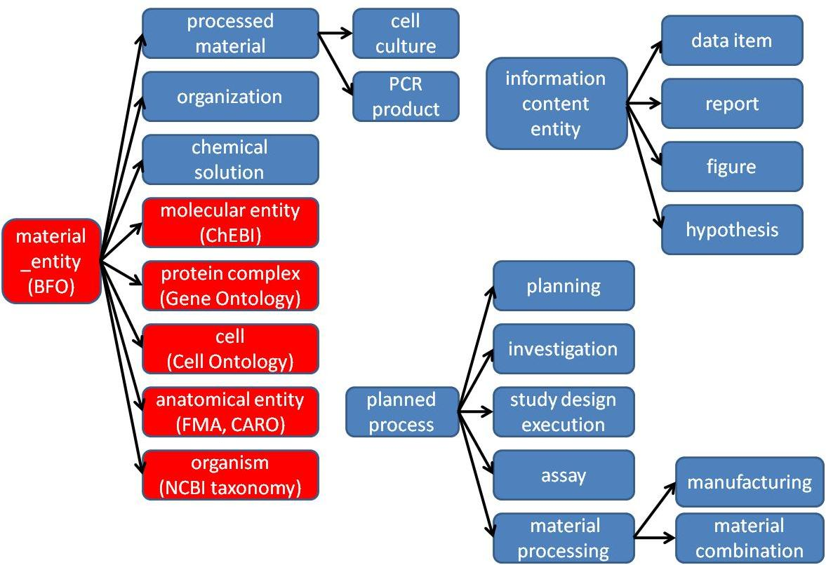

Figure 1 – Partial high level structure of OBI classes. OBI and IAO classes are shown in blue. Classes imported from other external ontologies are shown in red. Some example subclasses, such as PCR product and cell culture are included to illustrate the use of the class processed material.

Material entity
Within BFO, entities made up of matter are represented using the BFO classes of object, object part and object aggregate. The use of these BFO classes is appropriate if all entities are of similar scale. However, biomedical investigations, entities span sizes from molecule to a population of organisms. Depending on the level of granularity chosen, these might be considered unitary objects or aggregates of smaller parts. Therefore, the class material entity was created in BFO at the request of OBI developers as the union of object, object part and object aggregate. By using material entity as our root class we avoid committing to the currently inadequate granularity schema in BFO.
Several subclasses of material entity are imported from external ontologies: Classes under organism are imported from the NCBI taxonomy [7], anatomical entity and its subclasses from the Foundational Model of Anatomy [4] or the Common Anatomy Reference Ontology [8], and the molecular entity hierarchy from ChEBI [9]. OBI-specific sub-classes of these imports were constructed. For example, chemical solution such as a PBS buffer can be defined by referencing the molecules defined in ChEBI from which the buffer is made. Table 1 gives the complete meta data captured with the PBS buffer class.
Table 1: Example meta data for class OBI_0100046. * indicates mandatory meta data.
Annotation property | Example | Usage
Preferred Term* | phosphate buffered saline solution | The concise, meaningful, and human-readable name for a class or property that reflects community usage, or disambiguates the term
Definition* | Phosphate buffered saline (abbreviated PBS) is a buffer solution commonly used in biochemistry. It is a salty solution containing sodium chloride, sodium phosphate and in some preparations potassium chloride and potassium phosphate. The buffer helps to maintain a constant pH. The concentration usually matches the human body (isotonic). | The Aristotelian definition, explaining the meaning of a class or property
Definition editor* | Philippe Rocca-Serra; Tina Boussard; Melanie Courtot | The editors
Definition Source* | http://en.wikipedia.org/wiki/Phosphate_buffered_saline | A traceable reference to the source of the definition
Curation Status* | Ready for release | The curation status of a class or property, one of: uncurated; meta data incomplete; meta data complete; pending final vetting; ready for release; placeholder
Example | PMID: 16279733.Dent Mater J. 2005 Sep;24(3):414-21.PBS buffer solutions with different pH values can change porosity of DNA-chitosan complexes. | A phrase describing how the term is used
Alternative term | PBS buffer | A synonym for the class or property

Material entities that result from intentional acts are processed material. For example, a specimen collected in a clinical protocol is a processed material, while a measurement device such as an array scanner is manufactured with the intent to perform a function. A material entity such as a protein can be produced intentionally, for example using a recombinant expression system, or naturally expressed in an organism. Class hierarchies with multiple inheritance can become difficult to maintain; therefore, processed material is logically defined with necessary and sufficient conditions, as exactly those material entities that are a specified output of a process of material processing. This allows automated reasoners to infer subclasses. For example peptide construct (which is asserted as a subclass of material entity) is inferred by the reasoner to be a subclass of processed material, as it is the specified output of some enzymatic ligation.

Planned Processes
The OBI definition of material processing is a kind of planned process. Such processes are initiated by an agent (typically a person) to achieve a certain goal. OBI captures such goals by defining a objective specification, which is a subclass of information content entity. An example objective specification is the phrase “Hybridize RNA to chip” in a manuscript describing a microarray gene expression protocol [10]. When a process is performed to meet an objective specification it is a planned process. The majority of processes represented in OBI are planned processes. OBI uses the relation achieves planned objective between a planned process and a corresponding objective specification. A single planned process can achieve more than one objective.
The scope of OBI includes the representation of successfully completed investigations, which are a type of planned process. A successful investigation may produce negative results, but processes that result in falsified data or during which there were gross errors are out of scope for OBI. For example, if a PCR-SSCP assay fails to detect a sequence variation, it is in scope for OBI. However, if controls performed as part of the assay fail then it is not in scope. We are representing only experiments which have succeeded by their own criteria, to avoid unnecessary complexity in all definitions. This is similar to the decision of the GO consortium to model only canonical biological processes [ref].
The Process hierarchy of OBI represents realizations of broad objectives. These include material component separation, where, for example, a cell sorter is used to separate CD8+ cells from a blood specimen, and material combination, such as when a chemical is added to a cell culture.
While processes can have many participants, objective and plan specifications explicitly identify important participants. OBI defines two relations, has specified input and has specified output, relating process instances to their participants. Specified participants are listed in plan specifications. Specified outputs must be present at the end of the process to achieve an objective specification. Specified inputs are identified in the plan specification and are not created during the process. Figure 2 gives an example of how two planned processes, drawing blood and measuring its’ glucose concentration, are modeled. OBI also includes processes such as Data transformation which have data items, as opposed to material entities, as the input and output. For example, the OBI class mean centering is defined as a process that achieves a data normalization objective.

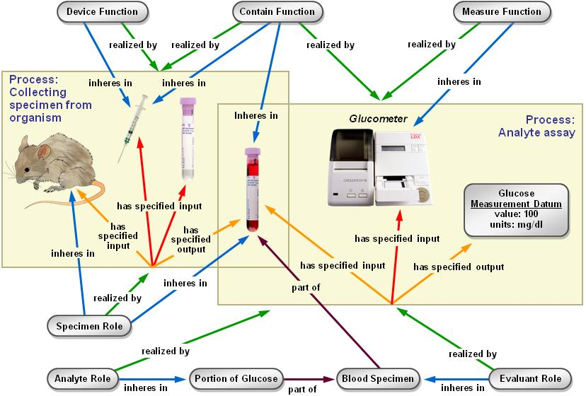
Figure 2. Measuring the glucose concentration in blood. The large boxes represent processes and their participants. The collecting specimen from organism process takes place first. In this process, a syringe is used to draw blood from the mouse which bears the specimen role. At the end of this process, a tube contains the blood specimen. In a second process, this specimen will be used in an analyte assay which measures the concentration of glucose in the blood. A glucometer is used to make this measurement. The analyte role inheres in the glucose molecules scattered throughout the blood specimen. This planned process achieves the analyte (i.e. glucose) measurement objective.
Information entities
Any ontology of biomedical investigations needs to represent information such as data, investigation designs and reports of investigation results. When we began our work BFO did not have a way of representing such entities. The Information Artifact Ontology (IAO) [ref: http://purl.obofoundry.org/obo/iao] was created as a separate effort, as developing a general theory of information entities is outside the scope of OBI.
The IAO is as a middle level ontology, based on BFO, imported and used by OBI and other projects. Information Entities, in IAO, all share two features; they are generically dependent, so they must be borne by at least one other entity; and, that they are about other entities.
The about relationship does not describe the structure or format of the information; rather, it describes the entity the information itself describes. So, the glucose concentration measurement in Figure 2 is about a molecular concentration quality of the specimen.
The root class of IAO is information content entity, which describes all information that is intentionally created. For OBI, an important subclass is directive information entity, for example a plan specification or an objective specification, which an experimenter would read to learn how or why to perform a certain experiment. IAO also defines classes such as documents and their parts, journal articles or patents, as well as documents with other special purposes. Particularly relevant to OBI are reports and report element such as report table, figure or scatter plot.
OBI then defines subclasses of information content entity that are specific to investigations. These include protocol and study design, which are types of plan specification, representing specification of a single procedure or an entire investigation, respectively. An important part of many study designs is the identification of dependent and independent variable specifications. Central to investigations are the types of data generated. This includes measurement datum, obtained in an assay, and many subclasses for specific types of assays, For example, scalar measurement datum represents measurement data composed of a numeral and a unit label (e.g. length measurement datum, about length quality instances). Finally, the interpretation of information generated during the study design execution is a conclusion of the investigation.

Roles and Functions
A role as used in OBI and defined in BFO has two properties: first, the entity which bears the role, and second the process in which the role is realized. A role is not essential to the entity bearing that role, but results from the circumstances in which the role is realized. For example, humans can bear specific roles relating to investigations. These roles include the principal investigator role, realized by leading an investigation, and the author role, realized by writing a report. Additionally, OBI contains roles defined by the study design of an investigation. The results of a study can be about any material entity, including humans, tissue or molecules; so they would bear a study subject role. Similarly, the reference role can be borne by different entities specified in the study design that are included to support the observed differences between entities being studied. OBI also contains roles defined in specific experimental procedures, such as the analyte role or calibration substance role.
Functions differ from roles in BFO in that they are intrinsic to an entity because of structural organization [11]. For example, OBI defines that a polystyrene tube and an animal cage bear the contain function, while a measurement function inheres in a gamma counter

Organization
OBI needs to represent organizations to identify for example Affymetrix as the manufacturer of a microarray. Placing organization into the BFO hierarchy proved controversial, as good arguments were made for treating it either as a material entity or an immaterial kind of social construct related to other legal entities. The latter are not currently well described in BFO. Our solution is to define an organization by all the things that are true about it: an organization is a continuant entity which can bear roles and has members. Members of organizations are either organizations in themselves or individual human beings. Members can play organization-specific member roles. This definition is broad enough to include for example a regulatory agency like the U.S. Food and Drug Administration.

Use Cases
To evaluate OBI, we tested the ontology with three use cases that also help demonstrate its’ wide applicability. The first uses case shows how ontology enables workflow; the second describes queries of database enabled by OBI, and the third tests that the coverage of OBI allows annotation of an entire investigation.

Use Case 1: Constructing a Genomic Data Analysis Workflow
Our first use case focuses on the annotation of a GenePattern software modules, that enable the creation of data analysis workflow. GenePattern is a powerful scientific platform which provides interoperable access to over 90 genomic analytic and visualization tools including GeneCluster, Matlab, Bioconductor and many others [12]. Users want to have a list of appropriate options for each step during workflow construction. These steps can be specified at different levels of granularity when using OBI terms.

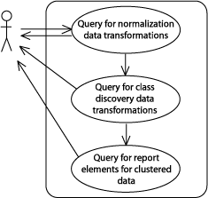
Figure 3. The GenePattern use case for defining a workflow using OBI classes. The figure illustrates how a user would create a workflow from data transformations based on queries of the OBI ontology. The queries use three classes in OBI, namely normalization data transformation, class discovery data transformation, and clustered data visualization. The appropriate software modules are returned to the user.
For the use case considered here, the user wishes to define a workflow to analyze and visualize microarray data. This requires normalization of the data, then clustering, then choosing a graphical representation. Figure 3 illustrates the workflow steps. In OBI, a data transformation is defined by the following: the specified input data; the specified output data; and the objective specification that the data transformation achieves. Data transformations can have more than one objective, reflecting the fact that a single process can be used to achieve different goals. The user can identify appropriate data transformations in OBI by querying for classes with a data normalization objective and, then, a class discovery objective. Finally, data visualization classes are retrieved which allow the rendering of clustered data. This is possible because the output and input data types are represented explicitly in OBI and are specified for each data transformation class. For example, a clustered data set is the specified output of a class discovery data transformation. The user is able to define generic protocols using OBI terms, instead of needing to choose specific software modules for each workflow step.

Use Case 2: Querying a database of curated investigations
As a second use case, we use OBI to construct queries of the Immune Epitope Database (IEDB, [13]). IEDB is devoted to cataloging information about experiments characterizing epitopes targeted by adaptive immune responses. Information in IEDB is manually curated from literature and currently encompasses over 286,000 experiments characterizing over 51,000 epitopes. The IEDB website allows querying of the curated data using a form-based interface, which lets users ask a set of predefined queries. However, this IEDB interface hard-codes the relations between fields in the form, and thereby limits the kinds of questions users can ask. Using OBI allows an advanced user to formulate queries to ask specific questions beyond this pre-defined set.
Query class expression:
‘journal article content’ and 'is about' some (investigation
and (has_part some (assay and (has_specified_output some ('is about' some 'cytokine production'))))
and (has_part some (assay and (has_specified_output some ('is about' some 'T cell mediated cytotoxicity')))))
Instances classified as members of this class (identified by Pubmed IDs):
10432283 - Kerksiek, J Exp Med, 1999
11851899 - Lancaster, J Viral Hepat, 2002
15627979 - Engelhardt, Eur J Immunol, 2005

Figure 4 – Formulating a database query using OBI. The top shows a class expression usable as a query. It retrieves all journal articles about investigations in which assays are performed to gather data on both cytokine production and T cell mediated cytotoxicity. This query was run on an export of data from journal articles curated in the IEDB (supplemental file X) by running a reasoner to determine which journal articles are instances of the query class. Three journal articles meet these criteria as shown..

An export of the majority of IEDB data into OBI structured OWL has been completed [14]. This export allows advanced users to ask any question that can be formulated as a class expression in OWL, or as a SPARQL query [15], using the vocabulary provided by OBI and its imported terms. This can be done in Protégé [ref]. When running an automated reasoner such as Pellet [29] on data exported from the IEDB in OWL format (Supplemental file X), instances of journal articles that meet the query criteria are classified as instances of the query class.
An example is shown in Figure 4. This way of formulating queries is more powerful than is possible on the IEDB website as it allows unlimited conditions. It also provides a vocabulary of query terms outside of those used by IEDB. For instance, cytokine production, defined in GO, is the parent term of several processes used in assays in IEDB, such as T cell epitope IFN-g ELISPOT assay. This illustrates the importance of OBI as a semantic integration tool between OBO Foundry ontologies and the experimental process.

Use-Case #3 Representing a clinical investigation
In this use case, we demonstrate that OBI can represent complex investigations, including the planning, execution, data collection, analysis and reporting of conclusions. The use case is a clinical investigation: a study of the anticoagulant activity of fucoidan [ref]. Figure 5 illustrates the use of OBI to describe this investigation.
The investigation consists of a planning phase (Fig 5, panel 1) during which the study design specification is created. During the execution, study subjects are enrolled and then assigned to treatment groups (panel 2). In this case, fucoidan is the focus of the investigation with guar gum used as a negative reference. Subjects are assayed for their antithrombin-III level as part of the investigation (panel 3). The results of these assays then undergo a statistical test which produces a p-value (panel 4). This measures differences between the two groups. On the basis of this p-value, a study interpretation is drawn; in this case that fucoidan has a small statistically significant effect on coagulation. Finally, the investigation is documented in a report that is published as a journal article.
ref = Irhimeh MR, Fitton JH, Lowenthal RM. Pilot clinical study to evaluate the anticoagulant activity of fucoidan.Blood Coagul Fibrinolysis. 2009 Aug 18. [Epub ahead of print]
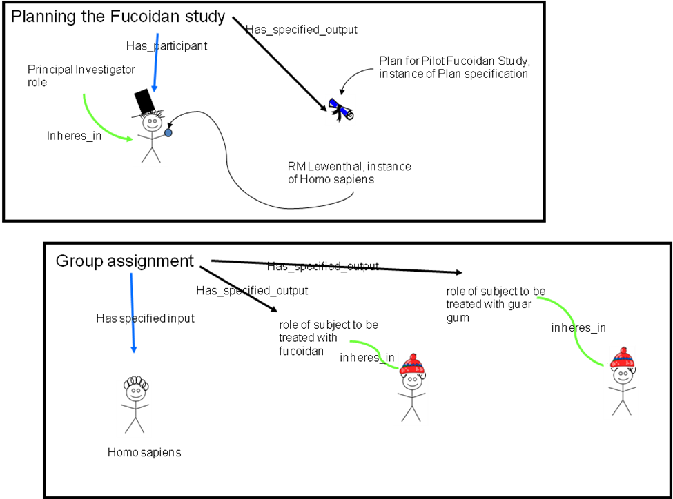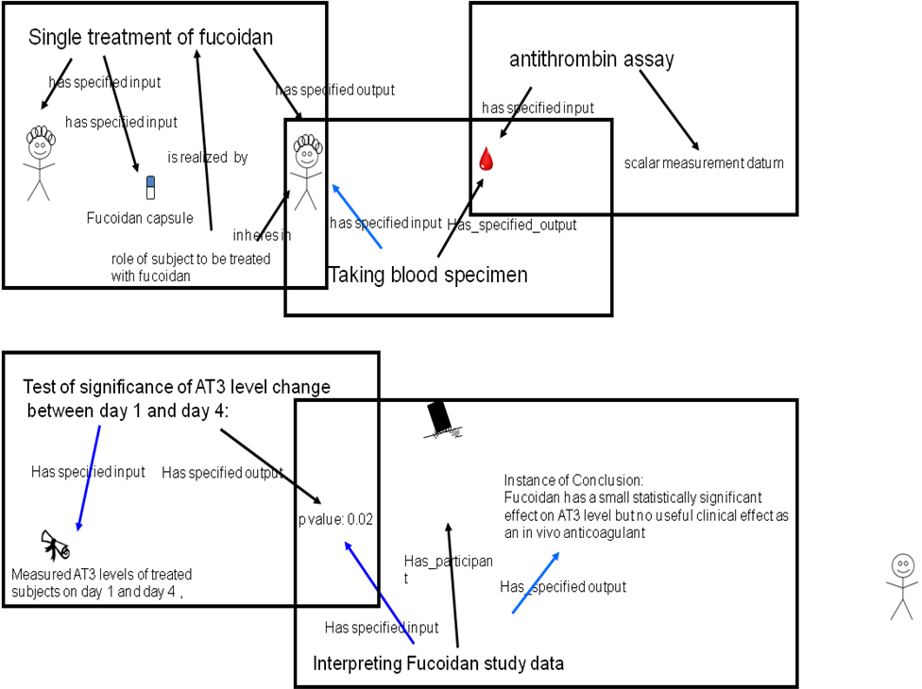
Figure 5: The clinical investigation use case to test OBI coverage. This figure is a simplification of the full OBI description which is available as supplementary material XX.

By expressing this use case in OBI, we can link between an original study, the subjects, treatments, measurements and conclusions finally published in a paper. This computational representation is capable of distinguishing between humans as either investigators or subjects and between treatments as active or negative references. This level of explicit detail in description of investigations is necessary to fully describe for example, toxicological, pharmacological or developmental studies. Future work will be to investigate the application of these descriptions to databases such as the Chemical Effects in Biological Systems (CEBS) at the NIEHS [ref], in order to support queries over this data, in a similar way as described in Use Case 2.

Discussion
OBI is a community-driven ontology that represents biomedical investigations in a computationally amenable form. It enables the representation of investigations across disparate biomedical disciplines and is capable of doing so in a rich, precise and explicit way. As such it is the first substantial cross-community attempt to support the annotation of the experimental context of biomedical data.
OBI fits in a broader framework. Since GO demonstrated the utility of a controlled, shared and explicit description of gene function, there has been a substantial growth in efforts to describe knowledge in biology. OBI integrates, supports and extends many of these efforts. It provides a vocabulary for use with minimum information standards [ref MIBBI]. It complies with, and has helped to drive, the OBO Foundry principles [ref OBOF] and is, therefore, maximally useful within the ontology community. As more data described using OBI becomes more available, as exemplified by the use cases described earlier, its utility to the broader biomedical community will continue to increase.
Covering all biomedical investigation gives OBI a broad scope. This is important and necessary if it is to enable data integration across biomedicine. It is unlikely that it would have been possible to address a scope of this breadth, without the wider ontology community; although clearly necessary for biomedical investigations, we have not had to describe, for example, taxonomy, anatomy or genetics; rather, we have reused exiting ontologies.
Despite this, the breadth still poses a significant challenge. In order to garner the experience and knowledge to describe biomedicine, we have necessarily taken a community-based approach. Authors on this paper, for example, cover many disciplines within and without biomedicine. In itself, this community approach presents a substantial challenge; it is hard to generate consensus, both of terminology and meaning, between individuals from divergent backgrounds. We have addressed this by focusing, firstly, on a clear, precise and unambiguous meaning to classes in the ontology. Secondly, where terminology in sub-disciplines fails to make distinctions in meaning or is inconsistent between communities, we have addressed this with a liberal addition of synonyms and examples of usage for every class within the ontology. When OBI is being used, these support both the English and logical definitions that it provides.
While reuse of other ontologies has been critical to OBI, it also creates challenges. External ontologies are often large and are subject to change with independent release policies: importing such large ontologies impacts on the scalability of the tools; independence requires consequent changes in OBI. We have addressed these issues with the development of the MIREOT mechanism which enables partial import of external ontologies [ref]. Despite this, the size of the resulting ontology is significant and this has identified some shortcomings in the tooling. While Protégé has worked well as an editing tool, it requires craft knowledge for use with an ontology of this complexity. In particular, integration with versioning systems, essential for distributed development, is currently limited. Similarly, the choice of OWL has enabled computational reasoning which is valuable, as described in the use cases, and also as an aid to development. However, current reasoning tools do not provide a transparent explanation and debugging facility; likewise, performance is unpredictable and can change significantly between versions of OBI. Finally, many existing tools for serving and viewing biomedical ontologies over the web are based around a simpler inheritance hierarchy, while OBI has a richer logical structure. This causes significant problems for tools such as ISACreator which rely on such resources to access ontologies [ref]. The community continues to improve these tools and OBI has benefited from communication with these developers.
A model such as OBI, that is complete enough to describe experimental processes across biomedical disciplines, will necessarily be complex. There are ways of hiding such complexity from end users, if required. Tools such as ISACreator allow community scientists to create fully annotated investigations, without using the ontology in OWL. Future work will investigate extensions to OBI to further support this hiding, for instance, providing alternative definitions appropriate to a user’s background. As well as annotation, we wish to ease the submission of new terms from the community. One possible solution is the use of the quick terms template submission [quick terms ref]. Finally, we have also developed methods for automatically importing classes from external efforts such as the ArrayExpress repository [EFO ref] and IEDB [IEDB ref].
Despite the challenges, OBI represents a substantial and significant effort to describe biomedicine in a consensual, wide-ranging and computationally amenable way. OBI supports, rather than overlaps with, related efforts such as FuGE [ref], SyMBA [ref] and MAGE-TAB [ref]. OBI addresses the challenges of large-scale biology. If we are to safeguard the inheritance of our experimental data for the future, and maximize its usefulness in the present, ontologies such as OBI are essential.

Acknowledgments
We dedicate this work to the memory of Bill Bug.
This work is partially supported by grant funding from the National Institute of Biomedical Imaging and Bioengineering, National Human Genome Institute, NIH ( R01EB005034, NIH P41 HG003619, HHSN26620040006C), EC EMERALD project (LSHG-CT-2006-037686), EC FELICS, MUGEN, BBSRC (BB/E025080/1, BB/C008200/1), NERC-NEBC, EU IP CarcinoGenomics (PL 037712), EU NoE NuGO (NoE 503630), CARMEN project EPSRC (EP/E002331/1), RC UK, the Michael Smith Foundation for Health Research JF’s contributions to this work are supported by the Intramural Research Program of the NIH and NIEHS, under contract HHSN273200700046U.

Methodology
OBI development has spanned the last 5 years and is achieved by means of weekly teleconferences and twice yearly face-to-face meetings. To date 19 communities and XXX researchers have been actively involved in the development process. Developers are dispersed geographically and, as result, over time zones. As a result, OBI has adopted a specific methodology and many formal conventions, to manage what would otherwise be a chaotic process. This has been critical in ensuring that OBI is a homogenous resource. We describe these conventions here.

Choice of language and metadata conventions
OBI developed requires a consistent metadata associated with classes. The complete specification of the metadata scheme is available [http://purl.obolibrary.org/obo/obi/policy/metadata]. This metadata scheme is itself evolving independently as part of the OBO Foundry, and is being used by other ontologies.
OBI is developed using the Ontology Web Language 1.0 (OWL) [26] as this provides richer semantic support than OBO format - the other commonly used alternative in the biomedical domain [ref]. The OWL-DL subset is used allowing maximum expressivity consistent with the of use of reasoning for maintenance and development. The metadata scheme is implemented as OWL annotation properties.

Concurrent Development
Concurrent development of OBI is necessary given the number of developers. A review of the existing collaborative ontology development tools failed to identify a single application that met OBI’s requirements. Originally, OBI development was, therefore, organized into branches, with each sub-team working independently on a specific subject area, such as data transformations or roles. With the increasing maturity of OBI, and during the move to the 1.0 release, there was more stability and we adopted a single development line. For change management, we used the industry standard subversion tool; the current development version of OBI is available from subversion at [ref].

Integration with existing ontologies
OBI was developed to be complementary to, and integrated with, a framework of existing ontologies in the biomedical domain. The methodological challenges associated with this reuse are discussed here.
A top level ontology can provide guidance in how individual terms or whole ontologies interrelate and is useful when integrating external ontologies. BFO [ref] was chosen as the top level ontology as it is stable, publicly available in OWL syntax, aligned to existing OBO Foundry ontologies, and because there is a community of developers and users [cite bfo-discuss list]. The OBO Relations ontology[ref] provides relations for OBI. These were extended where required.
Four key ontologies are directly imported using the owl:import mechanism, including BFO and RO mentioned above, plus the ro_bfo bridge mapping to specify domains and ranges for properties using BFO classes, and the Information Artifact Ontology.
The owl:imports mechanism was not suitable for all external ontologies for several reasons: firstly, current editing tools are not effective for working with very large ontologies such as the NCBI Taxonomy [3], therefore a direct import is not scalable; secondly, some ontologies used by OBI are actively developed and may not be aligned with OBI methodology, for example not using BFO as an upper ontology, or not using OWL DL. Importing such ontologies as a whole can lead to inconsistencies or unintended inferences. Instead, the MIREOT import mechanism was developed [ref], which relies on a deprecation policy following the practice of the Gene Ontology (GO) [5] in that the intended meanings of classes remain stable. Even when the source ontology changes, modifications are not intended to change the meaning of terms.

Term requests and triaging for concurrent development
The majority of terms in OBI were collected from the various communities that intend to use it. Term lists were solicited and collated by a representative of each community (OBI consortium page] and terms were also submitted through a public term tracker. Each term was then assessed to determine if it was in the scope of OBI. For example, terms like ‘peptide’ and ‘antibody’ are needed to describe immunological experiments, but were available in ChEBI [9] and GO respectively, and were therefore imported. Submitted terms were distributed to an appropriate OBI branch for curation and inclusion in the OWL file and interaction between branches was achieved through conference calls.

Release and Quality Control
Users require a traceable, static version of OBI. We have therefore established a monthly release process where multiple OWL files are merged into a single file. The release version of the OBI is reasoned over and contains the fully inferred hierarchy. These make it easier to use and view the ontology in available tools. Each release is available from a specific URI using the release date as a tag. The most up-to-date file is always available from http://purl.obolibary.org/obo/obi.owl. Releases of OBI are also uploaded to the NCBO BioPortal [28] and the OBO Foundry repository [3].
Checks are made prior to release to ensure compliance with OBI policies. Specifically, classes are identified that: do not comply with the minimal metadata policy; have invalid OWL syntax; or, lead to inconsistency when reasoning using Pellet [29] or Fact++[ http://owl.man.ac.uk/factplusplus/]. Identifier format and deprecation policies are also enforced[ref]. New classes are automatically assigned a permanent and unique identifier on their first release. The release process verifies that all IDs that were present in the previous release are still in use. This follows GO deprecation policy that OBI has adopted: deleted classes are moved to the ObsoleteClass in the OBI hierarchy and stored in a separate file.

References

1. Jones, A.R., et al., The Functional Genomics Experiment model (FuGE): an extensible framework for standards in functional genomics. Nat Biotechnol, 2007. 25(10): p. 1127-33.
2. Spellman, P.T., et al., Design and implementation of microarray gene expression markup language (MAGE-ML). Genome Biol, 2002. 3(9): p. RESEARCH0046.
3. Smith, B., et al., The OBO Foundry: coordinated evolution of ontologies to support biomedical data integration. Nat Biotechnol, 2007. 25(11): p. 1251-5.
4. Rosse, C.a. and J.L. Mejino, Jr., A reference ontology for biomedical informatics: the Foundational Model of Anatomy. J Biomed Inform, 2003. 36(6): p. 478-500.
5. Grenon, P. and B. Smith, SNAP and SPAN: Towards Dynamic Spatial Ontology. Spatial Cognition & Computation: An Interdisciplinary Journal, 2004. 4(1): p. 69-104.
6. Smith, B., et al., Relations in biomedical ontologies. Genome Biol, 2005. 6(5): p. R46.
7. Wheeler, D.L., et al., Database resources of the National Center for Biotechnology Information. Nucleic Acids Res, 2006. 34(Database issue): p. D173-80.
8. Haendel, M.A., Neuhaus, F., Osumi-Sutherland, D., Mabee,P.M. and M. Mejino Jr. J.L.V., C.J. and Smith, B., CARO - The Common Anatomy Reference Ontology, in Anatomy Ontologies for Bioinformatics: Principles and Practice, D.D.a.R.B. Albert Burger, Editor. 2008, Springer: New York.
9. Degtyarenko, K., et al., ChEBI: a database and ontology for chemical entities of biological interest. Nucleic Acids Res, 2008. 36(Database issue): p. D344-50.
10. Byrne, M.C., M.Z. Whitley, and M.T. Follettie, Oligonucleotide arrays for expression monitoring. Curr Protoc Hum Genet, 2001. Chapter 11: p. Unit 11 2.
11. Arp, R. and B. Smith (2008) Function, Role, and Disposition in Basic Formal Ontology. Nature Precedings.
12. Reich, M., et al., GenePattern 2.0. Nat Genet, 2006. 38(5): p. 500-1.
13. Peters, B. and A. Sette, Integrating epitope data into the emerging web of biomedical knowledge resources. Nat Rev Immunol, 2007. 7(6): p. 485-90.
14. Greenbaum, J.A., et al. Representing the Immune Epitope Database in OWL. in ISMB. 2009. Stockholm, Sweden.
15. Prud’Hommeaux, E. and A. Seaborne, SPARQL query language for RDF. W3C working draft, 2006. 4.
16. Brazma, A., et al., Minimum information about a microarray experiment (MIAME)-toward standards for microarray data. Nat Genet, 2001. 29(4): p. 365-71.
17. Taylor, C.F., et al., The minimum information about a proteomics experiment (MIAPE). Nat Biotechnol, 2007. 25(8): p. 887-93.
18. Taylor, C.F., et al., Promoting coherent minimum reporting guidelines for biological and biomedical investigations: the MIBBI project. Nat Biotechnol, 2008. 26(8): p. 889-96.
19. Sansone, S.A., et al., The first RSBI (ISA-TAB) workshop: "can a simple format work for complex studies?". OMICS, 2008. 12(2): p. 143-9.
20. Cote, R.G., et al., The Ontology Lookup Service: more data and better tools for controlled vocabulary queries. Nucleic Acids Res, 2008. 36(Web Server issue): p. W372-6.
21. Noy, N.F., et al., BioPortal: ontologies and integrated data resources at the click of a mouse. Nucleic Acids Res, 2009. 37(Web Server issue): p. W170-3.
22. Ruttenberg, A., et al., Life sciences on the Semantic Web: the Neurocommons and beyond. Brief Bioinform, 2009. 10(2): p. 193-204.
23. Barrell, D., et al., The GOA database in 2009--an integrated Gene Ontology Annotation resource. Nucleic Acids Res, 2009. 37(Database issue): p. D396-403.
24. Soldatova, L.N., et al., An ontology for a Robot Scientist. Bioinformatics, 2006. 22(14): p. e464-71.
25. Whetzel, P.L., et al., The MGED Ontology: a resource for semantics-based description of microarray experiments. Bioinformatics, 2006. 22(7): p. 866-73.
26. Horrocks, I., Patel-Schneider,P.F and van Harmelen, F., From SHIQ and RDF to OWL: The making of a web ontology language. Journal of Web Semantics, 2003. 1(1): p. 7-26.
27. Blake, J.A. and M.A. Harris, The Gene Ontology (GO) project: structured vocabularies for molecular biology and their application to genome and expression analysis. Curr Protoc Bioinformatics, 2008. Chapter 7: p. Unit 7 2.
28. Musen, M., et al., BioPortal: Ontologies and Data Resources with the Click of a Mouse. AMIA Annu Symp Proc, 2008: p. 1223-4.
29. Evren Sirin, B.P., Bernardo C Grau, Aditya Kalyanpur, Yarden Katz, Pellet: A practical OWL-DL reasoner Web Semantics: Science, Services and Agents on the World Wide Web, 2007. 5(2): p. 51-53.

Supplemental Table 1 – OBI terms, IDs and definitions. See Excel File ‘OBITerm-ids.xls’

1. Rayner TF, Rocca-Serra P, Spellman PT, Causton HC, Farne A, et al. (2006) A simple spreadsheet-based, MIAME-supportive format for microarray data: MAGE-TAB. BMC Bioinformatics 7: 489.
2. Sansone SA, Rocca-Serra P, Brandizi M, Brazma A, Field D, et al. (2008) The first RSBI (ISA-TAB) workshop: "can a simple format work for complex studies?". OMICS 12: 143-149.
3. Ball CA, Sherlock G, Parkinson H, Rocca-Sera P, Brooksbank C, et al. (2002) Standards for microarray data. Science 298: 539.

