Modeling biomedical experimental processes with OBI
[the latest authors list and acknowledgments should be taken from the SIG webpage]
Part of the OBI consortium (in alphabetical order): Ryan Brinkman¹, Mélanie Courtot¹, Dirk Derom⁴, Jennifer Fostel⁸, Yongqun He¹¹, James Malone³, Helen Parkinson³, Bjoern Peters¹⁰, Alan Ruttenberg¹³, Larisa N. Soldatova*¹⁶, Christian J. Stoeckert Jr.¹⁷, Jessica Turner¹⁹, Jie Zheng¹⁷.

¹British Columbia Cancer Research Center, Vancouver, Canada; ³The European Bioinformatics Institute, Cambridge, UK; ⁴Victoria University of Wellington, New Zealand; ⁵ISB, Seatle, WA, USA; ⁸SRA Global Health Sector, Durham, NC, USA; ⁹Abcam plc, Cambridge, UK; ¹⁰La Jolla Institute for Allergy and Immunology, La Jolla, CA, USA; ¹¹University of Michigan, Ann Arbor, USA; ¹³Science Commons, Cambridge, MA, USA; UT, ¹⁶Aberystwyth University, Wales, UK; ¹⁷Department of Genetics and Center for Bioinformatics, University of Pennsylvania School of Medicine, Philadelphia, PA, USA, ¹⁹ Department of Psychiatry and Human Behavior, University of California, Irvine, CA, USA.

*Corresponding author

Email addresses: (NOTE: All authors’ email addresses are needed according to the instruction: http://www.jbiomedsem.com/info/instructions/ )
CJS: stoeckrt@pcbi.upenn.edu
MC: mcourtot@gmail.com
YH: yongqunh@med.umich.edu
JM: malone@ebi.ac.uk

NOTEs:

http://www.jbiomedsem.com/info/instructions/

http://obi-ontology.org/page/Sig_paper_vote

NOTE: If you don’t see your name in the author list, please acknowledge in the above website and then put your name in the author list.

Abstract

Background
Experimental results are stored in many different ways typically without using standardized terminology, creating challenges in comparison, reproduction and analysis. These difficulties impose severe limitations on the usability of such information in a wider context.

Results
The Ontology for Biomedical Investigations (OBI), developed as part of a global, cross-community effort, provides an approach to represent biological and clinical investigations in an explicit and integrative framework which facilitates computational processing and integration within the semantic web. Here we detail three real-world applications of OBI and show how OBI satisfies such use cases.

Conclusion
We demonstrated how OBI can be applied to different biomedical investigations and increase the computer accessible semantics of the information. The logical definitions of the entities involved allow computers to unambiguously understand and integrate different biological experimental processes and their relevant components.

Availability
OBI is available at http://obi-ontology.org

Background

Biomedical investigations use empirical approaches to investigate causal relationships among a large range of variables. The breadth of investigations presents a number of challenges when attempting to describe experimental processes; there are varying levels of complexity, granularity, a wide range of material and equipment used. Furthermore, the use of disparate terminology across the numerous communities presents a further ambiguity challenge when attempting to consistently represent biomedical investigations, regardless of the specific field of study.

An ontological approach for the representation of a consensus-based controlled vocabulary of terms and relations has previously shown to be successful in achieving some of these goals [the GO consortium, 2000; Matos et.al., 2006]. The requirement for an efficient representation of investigations is recognized as a pressing problem, and there are multiple efforts developing ontologies to increase semantic content and standardization (GO, MGED, LABORS, MSI ontology) [Whetzel et.al., 2006; King et. al., 2009; Sansone et.al., 2007].

This work by the transcriptomics, proteomics and metabolomics communities was originally developed in parallel, producing similar ontologies with overlapping scope. Though each focuses on particular types of experimental processes, many generic terms such as investigation, assay or are common to them all. Merging common aspects of these formalisms is useful as it provides a mechanism by which a class can be defined and understood by all, removing ambiguity and potential conflict. This practice is endorsed by policy providers such as the OBO Foundry [Smith et.al., 2007] which requires all member ontologies to define a single class only once among them (orthogonality). Besides common naming conventions [Schober et al. 2009], OBO Foundry members are required to use the same defined set of relations and upper-level ontology in order to facilitate integration and to promote automated reasoning. Relations that may be used within an OBO Foundry-compliant ontology are imported from the Relation Ontology (RO) [Smith et.al., 2005], while the Basic Formal Ontology (BFO) [Grenon et.al, 2004] provides all of the top-level classes under which member ontologies should build.

The Ontology for Biomedical Investigations (OBI) is being developed to address the need for a common, integrated ontology for the description of biological and clinical investigations (Whetzel, Brinkman et al. 2006). OBI is developed through collaborations among 19 biomedical communities and is a candidate ontology for the OBO Foundry. The representatives from the ontology projects mentioned above (MGED, LABORS, MSI ontology) are now involved into the OBI project. OBI includes a set of 'universal' semantic identifiers applicable across various biomedical and technological domains, and domain-specific terms relevant only to a given domain. OBI aims to represent experimental processes e.g., investigation, study, assay, and the entities involved into those processes e.g., the study design, the protocols and instrumentation used, the material used, the data generated and the type of analysis performed on the data. OBI supports the logically consistent annotation of biomedical experimental processes regardless of the particular field of study. In this paper, OBI v. 0.9 will be applied to three exemplar use cases, originating from three different communities: 1) a neuroscience use case, 2) a vaccine protection study, and 3) an automated functional genomics investigation. Details of the structure and organization of OBI are provided at the OBI project website (http://obi-ontology.org) and are not discussed in this paper.

Results

Biomedical experimental processes can involve numerous sub-processes, each of them involving various material entities e.g., whole organisms, organ sections, cell culture, cell pellets, devices. OBI defines investigation as a process with the objective to generate information by planning an overall study design, executing it, and documenting the results. An investigation can include a study interpretation, i.e. a sub process of interpreting the data to draw conclusions. There can be multiple study designs in one investigation and investigations can be parts of another investigation. Material entity is defined in OBI as an ‘independent continuant’ that is spatially extended whose identity is independent of that of other entities and can be maintained through time (e.g. an organism). Material entity subsumes BFO derived object, fiat object part, and object aggregate, because the three level theory of granularity in BFO [bfo ref] is inadequate for complex biological use cases. Material entities bear distinct roles which are realized in the context of a process, e.g. study subject role, host role, specimen role, patient role; and distinct functions inhering on their physical structure e.g. measure, separation, environment control (see the definitions of other entities at
http://purl.obofoundry.org/obo/obi.owl and in the use cases described below).

In order to a) test whether OBI (release 0.9, revision x) in its present state is sufficiently complete for a practical annotation effort and b) to demonstrate the use of OBI for annotation, we selected three representative use cases. These show how to model the entities and relations between entities involved in the experimental processes using OBI. The first use case models a neuroscience experiment pulled from the literature, and exemplifies interaction of OBI with external resources. The second use case focuses on a specific implementation from one of the OBI communities, and details how OBI is used to model Vaccine studies. The third use case describes the Robot Scientist [ref] which designs and executes experiments.

Use case 1: Neuroscience investigation use case
This investigation studied the role of the primate caudate nucleus in the expectation of reward following action [ref]. It is found that while the caudate nucleus responds preferentially to eye movements in different directions, the response begins prior to eye movement and is dramatically increased when there is expectation of reward for the preferred direction. Here we model a part of the investigation: specifically, a single trial in which the visual target is presented to the animal and the neural response is recorded. This single trial model contains two processes: A presentation of stimulus process in which the primate realizes its study subject role, and a

measuring neural activity process, modeled as a sub class of extracellular electrophysiology recording process which has specific input from a neuron, which in this study has location in the caudate nucleus which is part of the monkey. Thus, the process of measuring the neural activity unfolds in the caudate nucleus. The anatomical term caudate nucleus is imported from the NIFSTD [ref] to complete the logical definition of the assay. The function of the microelectrode used to measure the neural activity is realized as a measure function which inheres in the recording device, and the process has the specified output of a spike train datum.

To build logical definitions for this experimental processes required us to ask a series of questions of the domain experts and which are not explicit in the publication. For example, is the location of the micro-electrode extra or intracellular? Are all spike train data generated from the caudate nucleus? How does a spike train relate to the GO process regulation of action potential [ref]? This resulted in the extension and OBI’s existing assays, and the import of several terms from external ontologies, specifically NIFSTD. Decisions on the appropriate level of granularity are challenging: in this use case we have not included instances of our classes in the ontology itself, and have specifically added general entities so that these can be re-used for other use cases and communities. We also use some relations from ro_proposed [ref]: in this case we chose to import ‘unfolds_in’ to specify that an occurrent (process) happens in a certain location (i.e., the assay of spike trains in the caudate nucleus) rather than ‘located_in’ currently in RO which relates only continuants. Finally, we use the NCBI taxonomy [ref] to describe the species involved in this experiment. Reusing external resources fulfill two purposes. First, we rely on domain experts in specific areas to model the information, thus avoiding duplication of efforts. Second, by re using existing resources, we improve future data integration by preventing the need for mapping between several identifiers denoting the same entity.

Use case 2: Vaccine protection investigation:
A vaccine protection investigation (also known as a vaccine challenge experiment) measures how efficiently a vaccine or vaccine candidate induces protection against a virulent pathogen infection in vivo. Figure 2 demonstrates how to use OBI to represent a typical vaccine protection investigation via the following three sub-processes:
- vaccination is modeled as administering substance in vivo that realizes some material to be added role borne by some vaccine (e.g., VacX) and bears some target of material role borne by some organism that also bears a host role (e.g., mouse). The term vaccination is a term imported from the Vaccine Ontology (http://www.violinet.org/vaccineontology).
- pathogen challenge is also an administering substance in vivo process that realizes some material to be added role borne by some ‘organism’ and bears some ‘pathogen role’ (e.g., Influenza Virus) and realizes some target of material role borne by some organism that bears some host (e.g., mouse).
- survival assessment is an assay that measures the survival rate (occurrence of death events) in one or more organisms that are monitored over time. The survival assessment a common protection efficiency assay that has specified input some organism (e.g., mouse) and has specified output some survival measurement, in this case, 75% of mice survived from pathogen challenge.

Use case 3: An automated functional genomics investigation

Robot Scientist “Adam” is one of the most advanced laboratory automation systems in existence [King et al 2009]. Adam is designed to measure, in high-throughput, growth curves (phenotypes) of selected microbial strains (genotypes) in a defined media (environment). Adam is able to run “lights out” for days at a time, and is capable of designing and initiating >1,000 new strain/defined growth-medium experiments each day (from a selection of several thousand yeast strains). The Robots require a complete, precise, and fully formalized description of all experiment actions and provide a use case for OBI in modeling experimental automation. Here we have selected an investigation in which Adam abduces (= makes inference with abduction) hypotheses about which metabolites can restore a function of the removed yeast gene. Three processes are modeled using OBI (Figure 3):

- planning is modeled as a realization of a plan specification which has an objective to test a hypothesis. The hypothesis is about a metabolite and a specified yeast strain – specifically if a metabolite will affect yeast strain growth. Using this hypothesis Adam designs an assay to test this hypothesis: to grow yeast with addition and and with no addition of the metabolite
- automated investigation of the enzyme EC.6.1.39 is modeled as a hypothesis driven investigation with the objective to test the hypotheses specified in the planning process (we consider here only one hypothesis for the simplicity sake). The hypothesis is the specified input for the investigation. The specified output of the investigation is the study result about wether the metabolite indeed affected the growth of the yeast strain (see the figure on the bottom right in Figure 3 – the upper growth curve shows the growth rate with the addition of the metabolite, and the lower curve shows the rate with no metabolite). The result interpretation is that the hypothesis has been confirmed and Adam can update its background knowledge.
- The investigation process has part an assay to test the hypothesis. The assay has specified input of the metabolite and the yeast strain defined by the hypothesis, and specified output of optical density measurements modeled as a data set. The yeast has role of evaluant role.

Discussion

OBI aims for a robust and versatile symbolic representation of biomedical investigations. Three distinct biological use cases are modeled by representing statements using entities defined in OBI. Individual experimental steps are modeled as processes and its subclasses in OBI. The two processes in the neuroscience use case assay and the three processes in the vaccine protection study all fall under planned process in OBI. The processes vaccination and pathogen challenge are disjoint subclasses of administering substance in vivo, which is a subclass of material combination. Survival assessment is a type of assay.

We found that all these required processes, as well as all other entities described in the use cases could be represented using OBI idioms. Syringe is a device that participates in different processes. Entities such as vaccine are types of material entity. Host role, subject, pathogen role, and material to be added are types of role.

These entities are used to represent disparate experimental processes in a standard way in order to be suitable for computer-assisted reasoning. These use cases are examples at a high level of representation across a disparate set of domains; each of the examples can be modeled more completely, to include, for example the process delivering the reward in the neuroscience example, or specific details of the influenza virus development process in the vaccine example. The distinction between extracellular in vivo electrophysiological recording that unfolds in the caudate nucleus or other regions of the brain can be represented within this framework, as can different details of similar experiments.

OBI descriptions of experimental processes can be used for different applications. For example, the OBI modeling of a vaccine protection study provides an advanced approach to represent and mine vaccine-induced protection experimental processes. Approximately 400 vaccines have been manually curated and stored in the VIOLIN vaccine database system [Xiang et.al., 2008]. The vaccine protection experimental data in VIOLIN is currently stored in plain text without ontological definitions nor term hierarchy. The lack of a common ontology support becomes an obstacle of the full use of the VIOLIN vaccine data for advanced querying and for the task of integration with data from other data sources. Once the vaccine protection data and other biomedical data are represented using OBI, the information will be easily compared and analyzed among different vaccines and other biomedical domains.
[lss- put here how Robot Scientist representation was used]

Conclusions
We demonstrated how OBI can be applied to three different biomedical investigations and increase the computer accessible semantics of the information, for example for the analysis among different vaccines in different biomedical domains. The logical definitions of the entities involved allow computers to unambiguously understand and integrate different biological experimental processes and their relevant components with the help of an OWL reasoner.
We have considered here only three use cases as examples of the modeling of experimental processes with OBI. Representatives of the communities along with members of the OBI consortium ensure that OBI has sufficient coverage and is suitable for the description of experimental processes from a wide range of biomedical applications. OBI will be further developed to expand the coverage and depth of biomedical investigations.

List of abbreviations

GO: Gene Ontology
IAO: Information Artifact Ontology
LABORS
MGED
MSI
NCBI: National Center for Biotechnology Information
NCBI_Taxon: NCBI Taxonomy
OBI: Ontology for Biomedical Investigations
OBO: Open Biomedical Ontologies
VO: Vaccine Ontology

Competing interests
There are no competing interests.

Authors' contributions
The authors collaborated in all aspects of the work reported on in this paper.

[change the text above if the editors are not satisfied]

Acknowledgements
This work is partially supported by grant funding from the National Institute of Biomedical Imaging and Bioengineering, National Human Genome Institute, NIH (R01EB005034, NIH P41 HG003619), NIH-NIAID R01AI081062, EC EMERALD project (LSHG-CT-2006-037686), EC FELICS, MUGEN, BBSRC (BB/E025080/1, BB/C008200/1), RC UK, NERC-NEBC, EU IP CarcinoGenomics (PL 037712), EU NoE NuGO (NoE 503630), CARMEN project EPSRC (EP/E002331/1), the Michael Smith Foundation for Health Research, the Public Health Agency of Canada / Canadian Institutes of Health Research Influenza Research Network (PCIRN). We thank Midori Harris, David Hill, Jane Lomax and Maryann Martone for discussions on the neuroscience use case.

References
1. Shuman S: Structure, mechanism, and evolution of the mRNA capping apparatus. Prog. Nucleic Acid Res. Mol. Biol 2000, 66:1-40
(NOTE: The above reference is not a reference for this paper. Instead, it is from the reference template)

Brazma, A., Hingamp, P., Quackenbush, J., Sherlock, G., Spellman, P., et al. (2001) Minimum information about a microarray experiment (MIAME) - toward standards for microarray data. Nat Genet, 4: 365-371.
Grenon, P., Smith, B., and Goldberg, L. (2004) Biodynamic Ontology: Applying BFO in the Biomedical Domain, Ontologies in Medicine, IOS Press: 20-32.
King et al. (2009) The Automation of Science. Science, 324/ 5923: 85-89.
Matos, P., Ennis, M., Darsow, M., Guedj, M., Degtyarenko K. and Apweiler R. (2006) ChEBI - Chemical Entities of Biological Interest. Nucleic Acids Research, Database Summary paper 646.
Sansone et al. (2007) Metabolomics Standards Initiative - Ontology Working Group. Work in Progress. Metabolomics, 3(3): 249-256.
Schober D. Smith B, Lewis S, Kusnierczyk W, Lomax J, Mungall C, Taylor C, Rocca-Serra P, Sansone AS: Naming Conventions for OBO Foundry Ontology engineering. BMC Bioinformatics 2009, 10:125, http://www.biomedcentral.com/1471-2105/10/125
Smith B, Ceusters W, Klagges B, Kohler J, Kumar A, Lomax J, Mungall CJ, Neuhaus F, Rector A, Rosse C (2005) Relations in Biomedical Ontologies. Genome Biology, 6: R46
Smith et al. (2007) The OBO Foundry: coordinated evolution of ontologies to support biomedical data integration, Nature Biotechnology, 25: 1251 - 1255.
The Gene Ontology Consortium (2000) Gene Ontology: Tool for the Unification of Biology. Nature Genetics, 25: 25-29.
Whetzel, P. L., Parkinson, H. E, Causton, H. C., Fan, L., Fostel, J., et al. (2006) The MGED Ontology: a resource for semantics-based description of microarray experiments. Bioinformatics, 7: 866-873.
Whetzel, P. L., R. R. Brinkman, et al. (2006). "Development of FuGO: an ontology for functional genomics investigations." Omics 10(2): 199-204.
Xiang Z, Todd T, Ku KP, Kovacic BL, Larson CB, et al. (2008) VIOLIN: vaccine investigation and online information network. Nucleic Acids Res. 36 (Database issue): D923-8.
The OBI Consortium. http://purl.obofoundry.org/obo/obi
VO. http://www.violinet.org/vaccineontology.
King, et al. (2009) Make Way for Robot Scientists. Science 325: 945.
Johan Lauwereyns, Katsumi Watanabe, Brian Coe, & Okihide Hikosaka (2002). A neural correlate of response bias in monkey caudate nucleus. Nature, 418, 413-417. doi:10.1038/nature00892
Bug, W., G. A. Ascoli, et al. (2008). "The NIFSTD and BIRNLex Vocabularies: Building Comprehensive Ontologies for Neuroscience." Journal of Neuroinformatics 6: 175-194.

Sayers EW, Barrett T, Benson DA, Bryant SH, Canese K, Chetvernin V, Church DM, DiCuccio M, Edgar R, Federhen S, Feolo M, Geer LY,
Helmberg W, Kapustin Y, Landsman D, Lipman DJ, Madden TL, Maglott DR,Miller V, Mizrachi I, Ostell J, Pruitt KD, Schuler GD, Sequeira E,
herry ST, Shumway M, Sirotkin K, Souvorov A, Starchenko G, Tatusova TA, Wagner L, Yaschenko E, Ye J (2009). Database resources of the National Center for Biotechnology Information. Nucleic Acids
Res. 2009 Jan;37(Database issue):D5-15. Epub 2008 Oct 21.
Table 1. Ontology terms used in the three use cases:
Ontology terms | Sources and term IDs | Use cases
Classes
study subject_role | OBI  http://purl.obolibrary.org/obo/OBI_0000097 | 1
presentation of stimulus | OBI: NEED ID | 1
Macaca fuscata | NCBI_Taxon: http://purl.org/obo/owl/NCBITaxon#NCBITaxon_9542 | 1
light source | OBI: http://purl.obolibrary.org/obo/OBI_0400065 | 1
measuring neural activity in the caudate nucleus | OBI: NEED ID | 1
caudate nucleus | NeuroLex: http://ontology.neuinfo.org/NIF/BiomaterialEntities/NIF-GrossAnatomy.owl#birnlex_1373 | 1
extra cellular electrophysiology recording | OBI: http://purl.obolibrary.org/obo/OBI_0000454 | 1
micro electrode | OBI: NEED ID | 1
measurement datum | IAO: http://purl.obolibrary.org/obo/IAO_0000109
administering substance in vivo | OBI: http://purl.obolibrary.org/obo/OBI_0600007 | 2
material to be added role | OBI: http://purl.obolibrary.org/obo/OBI_0000319 | 2
pathogen role |  | 2
target of material addition role | OBI: http://purl.obolibrary.org/obo/OBI_0000444 | 2
host role | OBI: http://purl.obolibrary.org/obo/OBI_0000725 | 2
pathogen role | OBI: http://purl.obolibrary.org/obo/OBI_0000718 | 2
pathogen challenge | OBI: http://purl.obolibrary.org/obo/OBI_0000712 | 2
survival assessment | OBI: http://purl.obolibrary.org/obo/OBI_0000699 | 2
survival rate |  | 2
syringe | OBI: http://purl.obolibrary.org/obo/OBI_0000422 | 2
bottle (??) |  | 2
Mus musculus | NCBI_Taxon: http://purl.org/obo/owl/NCBITaxon#NCBITaxon_10090 | 2
vaccine | VO: http://purl.obolibrary.org/obo/VO_0000001 | 2
vaccination | VO: http://purl.obolibrary.org/obo/VO_0000002 | 2
hypothesis driven investigation | OBI_0000355 | 2
study design execution | OBI_0000471 | 3
study interpretation | IAO_0000035 | 3
evaluant role | OBI_0000067 | 3
Saccharomyces cerevisiae | NCBITaxon_4932 | 3
device | OBI_0400002 | 3
plan specification | IAO_0000104 | 3
objective specification | IAO_0000005 | 3
assay | OBI_0000070 | 3
planning | OBI_0000339 | 3
metabolite C00449 | CHEBI:16927 | 3
Relation terms
is_a | RO:
inheres_in | RO: http://purl.org/obo/owl/OBO_REL#inheres_in | 1,2
is_realized_by | IAO: http://purl.obolibrary.org/obo/IAO_0000122 | 1, 2, 3
has_specified_input | OBI: http://purl.obolibrary.org/obo/OBI_0000293 | 1,2
has_specified_output | OBI: http://purl.obolibrary.org/obo/OBI_0000299 | 1,2
participates_in | ro.owl#participates_in | 3
has_part | ro.owl#has_part | 3

NOTE: light source in OBI is a device. In use case 2, we need a term ‘light’, which may not be a device.
NOTE: Larisa, please add your use case terms in the above table.
NOTE: need to say those not listed are instances (e.g., VacX).

Figures
Figure 1. OBI modeling of a single trial in the neuroscience study. Processes in this experimental trial are shown in bold (e.g., stimulating monkey with light, measuring neural activity), while terms for objects, roles, or processes (e.g., macaque, stimulus role, extracellular electrophysiology recording) are shown in regular font and relationships are in italics (e.g., is_realized_by, has_specific_input). Diagrams such as those for the light, or the monkey, or the neuron indicate that those are instances of the ontological classes.

Figure 2. OBI modeling of vaccine protection investigation.

Figure 3. OBI modeling of RS automated investigation.

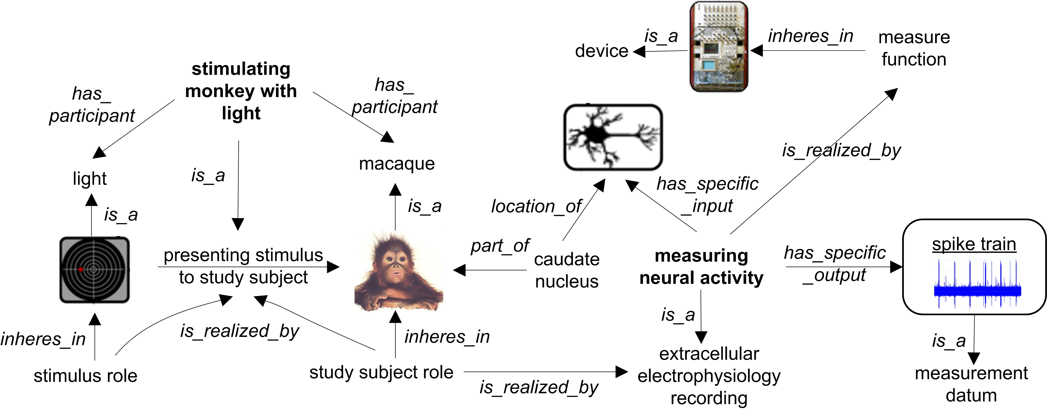

Figure 1. OBI modeling of a single trial in the neuroscience study. Processes in this experimental trial are shown in bold (e.g., stimulating monkey with light, measuring neural activity), while terms for objects, roles, or processes (e.g., macaque, stimulus role, extracellular electrophysiology recording) are shown in regular font and relationships are in italics (e.g., is_realized_by, has_specific_input). Diagrams such as those for the light, or the monkey, or the neuron indicate that those are instances of the ontological classes.

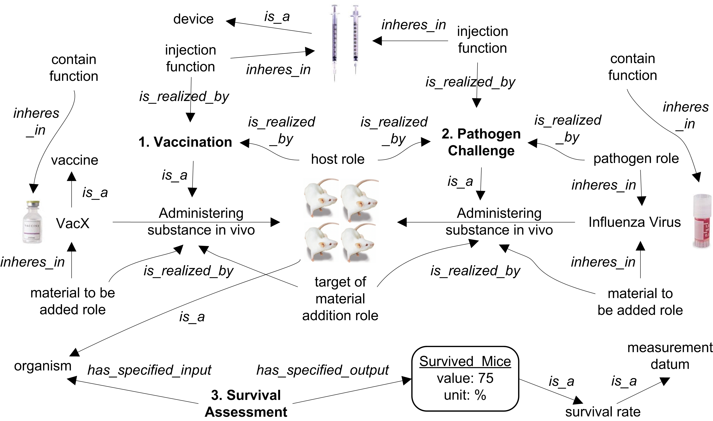

Figure 2. OBI modeling of vaccine protection investigation.

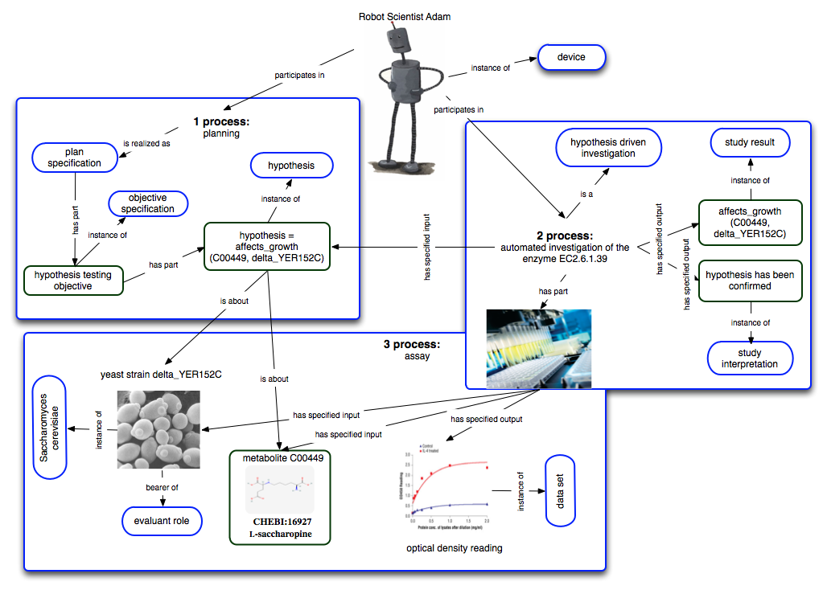

Figure 3. OBI modeling of vaccine protection investigation.

