**Post-OBI Workshop Summary**

1. **SERVICES**

1. **Design Pattern Decisions**

A. Services are planned processes. However, rather than making services subclasses of their related planned process as was previously proposed, they will be linked by a *has_part* relation to a related technique or planned process. The reasoning for this is that services have processual parts in addition to a single technique or planned process (such as a billing process, or an order placement process). Modeling services as having related techniques as parts will allow these additional processes included in services to be captured when desired.

* a 'service' is a ‘planned process’ and *has_part* some 'planned process' and *realizes* some 'service provider role' and realizes some 'service consumer role'
* 'service provider role' and 'service consumer role' *inheres_in* some ('homo sapiens' or organization)

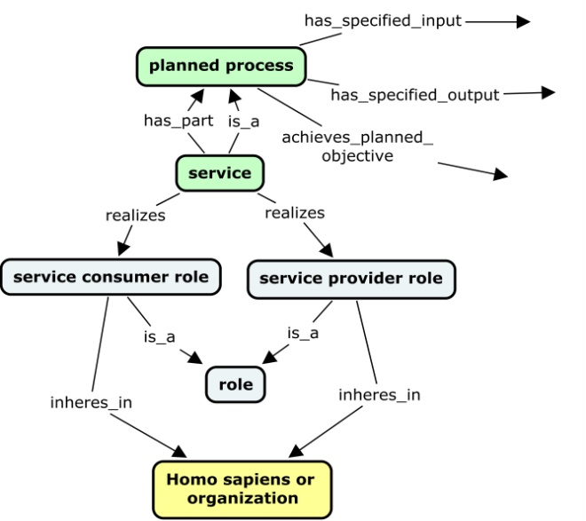

An example of DNA Sequencing Service will look as follows:

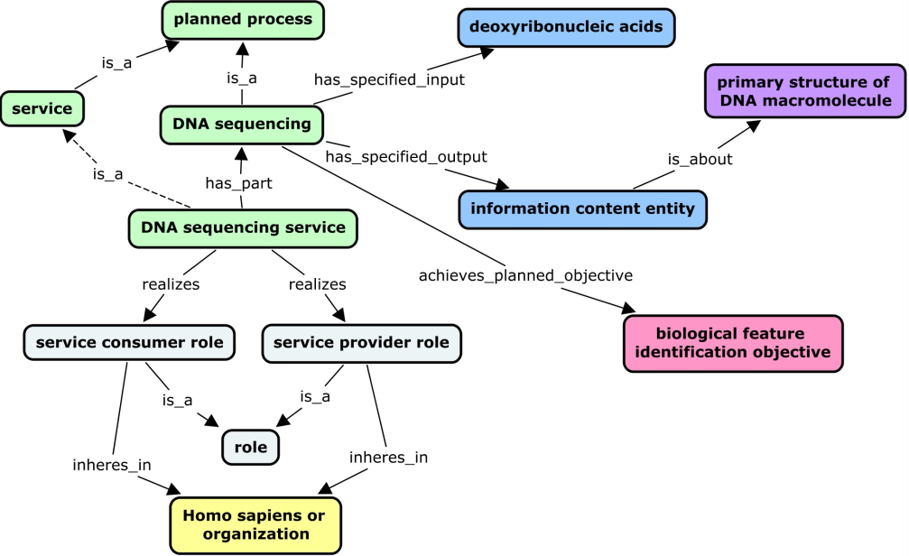

B. An asserted service hierarchy will be built under 'planned process'>'service' to capture services, and axioms attached that define services in relation to other planned processes/techniques, roles, etc.

1. **Service Hierarchy Decisions**

* 1. **OBI Service Hierarchy**

Two principles for classification were discussed :

* 1. A **process-based approach** that uses the nature of the process performed by the service (analysis, production, storage, etc);
  2. An **input/output-based approach** that relies on the nature of the input and output of the service (material vs data).

We decided that classifying services first according to their input/output was more intuitive and useful, and that the type of process performed would be a secondary axis for classification. Thus, the following preliminary hierarchy was proposed (examples in red, definitions in italics)

**Service**

**Access Service** *(def: access provided to a resource -material entity or data or software - for a limited time)*

**Materials Service** *(def: material is input OR output of the service)*

Material Analysis Service (DNA sequencing, cell cycle analysis)

Material Processing Service

Material Production Service (cell line creation)

Material Modification Service (cell line immortalization)

Material Maintenance Service (model organism colony maintenance)

Material Storage Service (liquid nitrogen storage service)

Material Transport Service (chemical disposal service)

**Data Service** *(def: data is input AND output of the service)*

Data Analysis/Transformation Service (statistical analysis service)

Data Maintenance Service (database management)

Data Storage Service (data backup service)

**Training Service**

**Support Service**

Note that this hierarchy is a work in progress, particularly with respect to treatment of the terms 'processing', 'production', 'modification', and 'maintenance' (how these terms relate to each other, how they are defined, etc.)