Table 1 gives the complete metadata describing the *DNA sequencing* class.

**Table 1: Example metadata for class OBI_0000626.**

|  |  |  |
| --- | --- | --- |
| **Annotation property** | **Example** | **Usage** |
| Preferred Term* | DNA sequencing | The concise, meaningful, and human-readable name for a class or property that reflects community usage, or disambiguates the term |
| Definition* | DNA sequencing is a sequencing process which uses deoxyribonucleic acid as input and results in the creation of DNA sequence information artifact using a DNA sequencer instrument. | The Aristotelian definition, explaining the meaning of a class or property |
| Definition Editor* | Philippe Rocca-Serra | The editors |
| Definition Source* | OBI Branch derived | A traceable reference to the source of the definition |
| Curation Status* | Ready for release | The curation status of a class or property, one of: uncurated; metadata incomplete; metadata complete; pending final vetting; ready for release; placeholder |
| Example | PMID: 19023858. Genomic deletions of OFD1 account for 23% of oral-facial-digital type 1 syndrome after negative DNA sequencing. Thauvin-Robinet C, Franco B, Saugier-Veber P, Aral B, Gigot N, Donzel A, Van Maldergem L, Bieth E, Layet V, Mathieu M, Teebi A, Lespinasse J, Callier P, Mugneret F, Masurel-Paulet A, Gautier E, Huet F, Teyssier JR, Tosi M, Fr��bourg T, Faivre L. Hum Mutat. 2008 Nov 19. | A phrase describing how the term is used |
| Alternative Term | deoxyribonucleic acid sequencing | A synonym for the class or property |

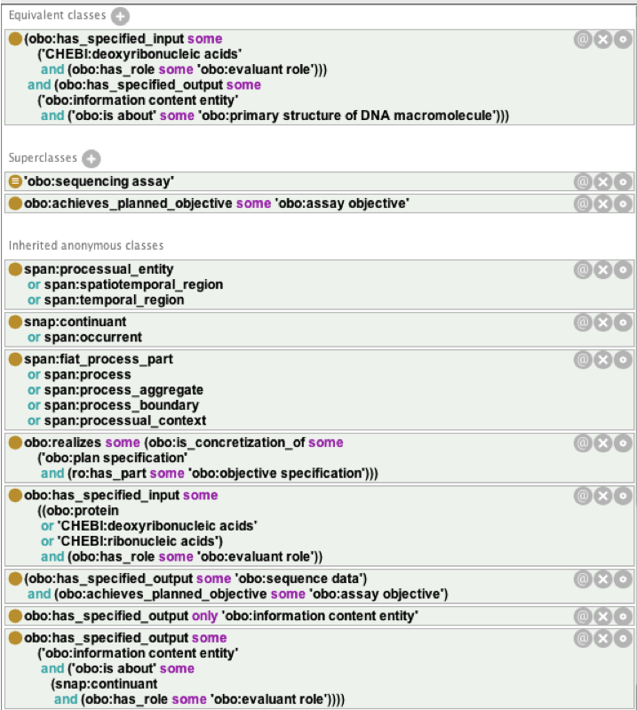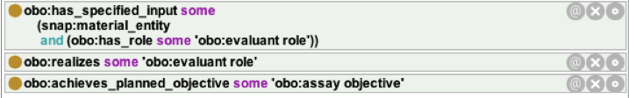

Figure XX: **DNA sequencing** class formal definition, stated in Manchester Syntax, as viewed in Protégé 4.1.0, from the description pane. The first expression (from top to bottom) formally described the class.