OBI QTT Template import using Mapping Master

1. Check-out from OBI subversion repository to retrieve the following files:

A template: OBI-QTT-Analyte-Assay.xls
An ontology: QTT.owl

2. Download Protégé-3.4.2 from:

http://protege.stanford.edu/download/download.html

3. Install Protégé-3.4.2

4. Start Protégé-3.4.2 from a terminal using command line (so you can see how things are going). The Protégé JAR file will be in the base of the Protégé install directory. Alternatively, you can you can execute it as normal by clinking on the Protégé icon.

> java -jar -Xms256m -Xmx512m protege.jar

5. Open QTT.owl file (it takes some time to import and parse the files, check the process from the terminal prompt)

Figure 1. Opening the QTT.owl file in Protégé-3.4.2

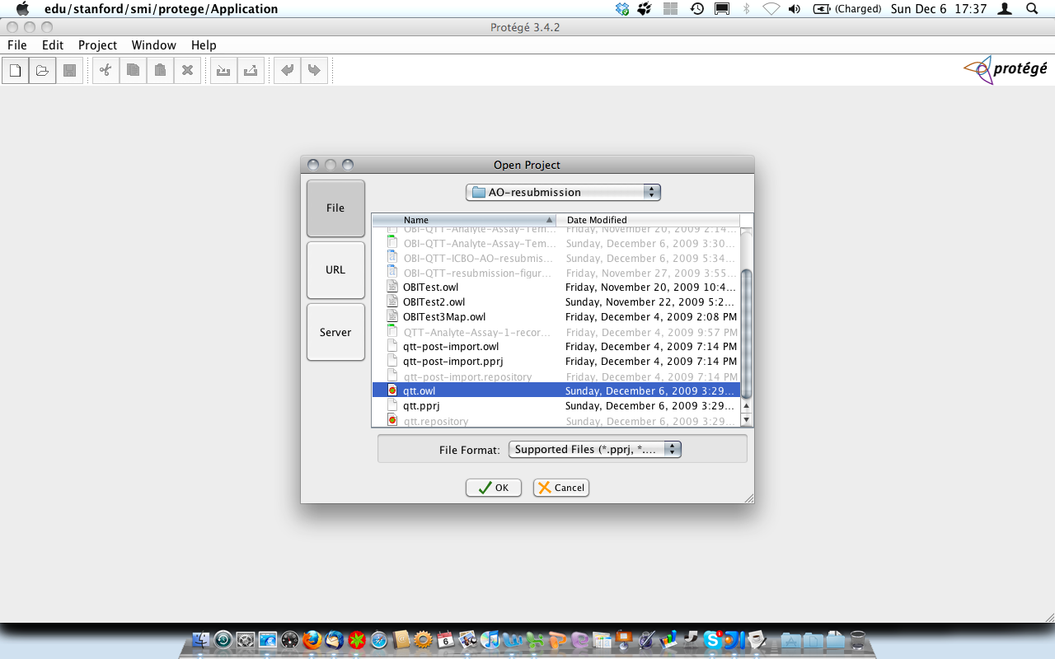

6 From Protégé ‘OWL’ Menu, Go to ‘Preferences…’

Select the ‘Rendering’ item in the Preference window (2nd from left)

Set "Render names in this ontology with" to ‘rdfs:label’.
Set “Render names in all OWL files…” to ‘rdfs:label’.
Set “Global default language…” to ‘en’.

Click ‘Close’ button

Figure 2. Setting the rendering parameters
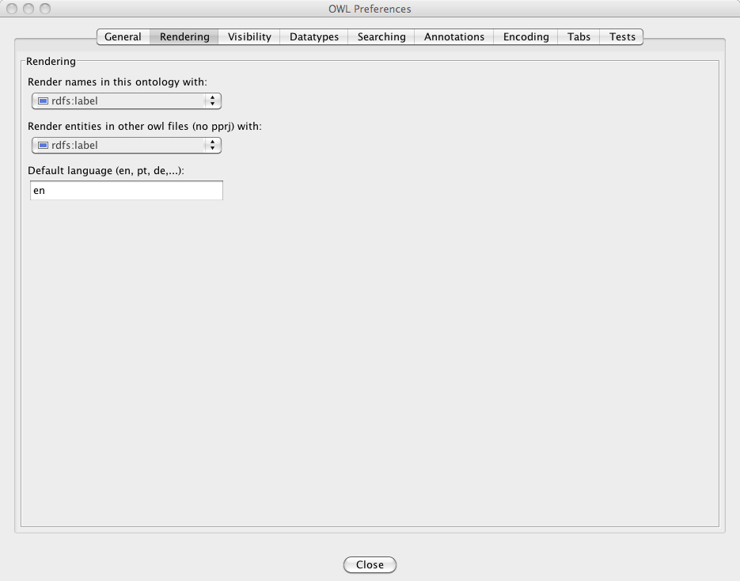

7. From Protégé ‘OWL’ Menu, Go to ‘Preferences…’

Select the ‘Tab’ item in the Preference window (2nd from right)

Tick the select box ‘SpreadsheetMaster’

Click ‘Close’ button

Figure 3. Activating the MappingMaster Tab from the OWL Preferences window.

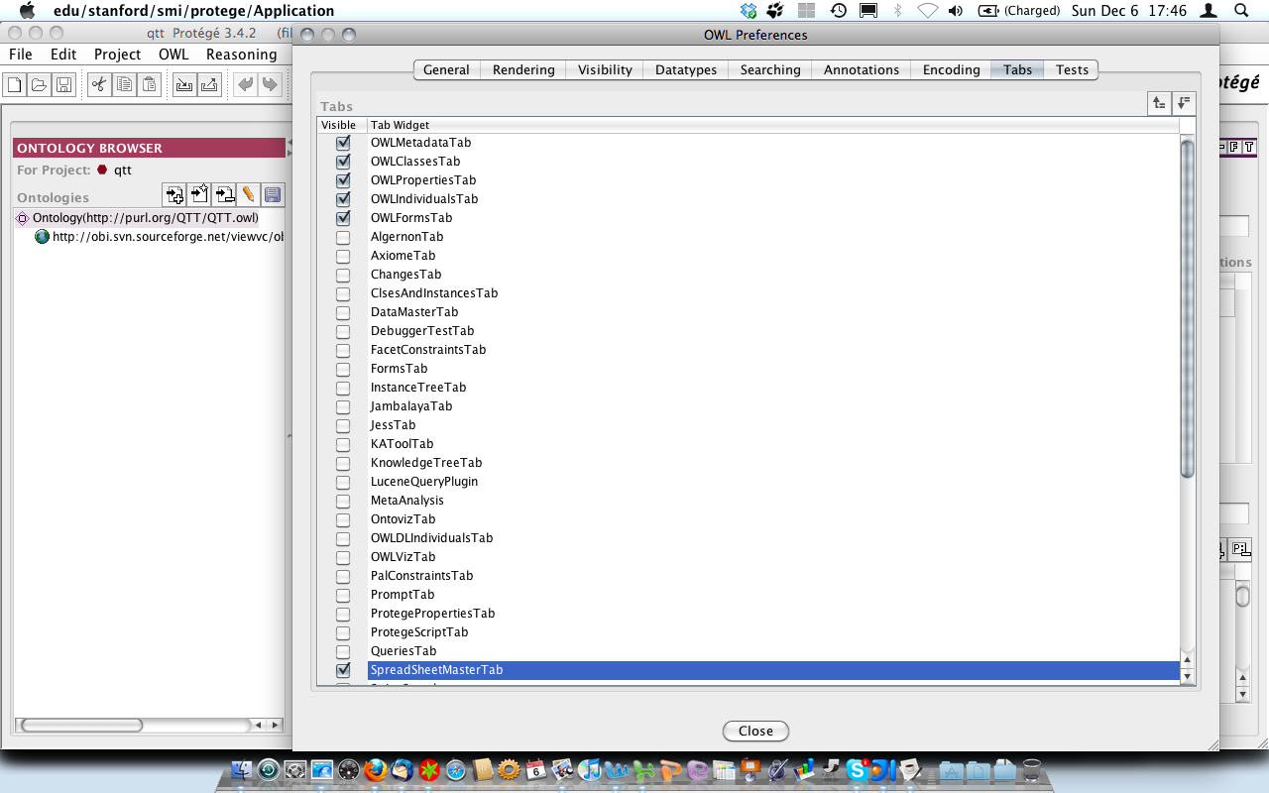

8. In Protégé Main view, go to the ‘MappingMaster’ tab.

9. In the upper pane of the MappingMaster Tab (Workbook).

Upload OBI-QTT-Analyte-Assay.xls

Figure 4. View of the Workbook pane in MappingMaster showing OBI-QTT-Analyte-Assay.xls template

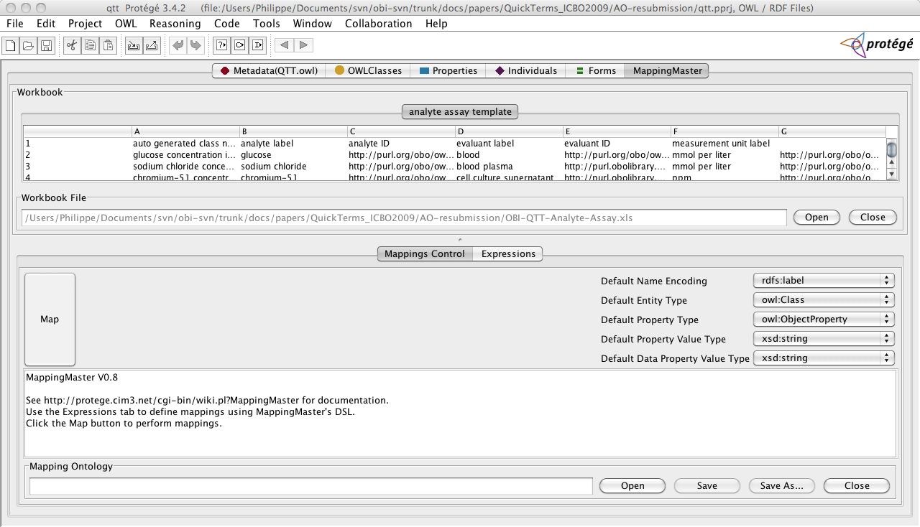

10. In the Mapping pane (lower section), first set the mapping control:

In our current application example, default settings are used.

11. Then click ‘Expressions’ button (next to Mappings Control):

Click ‘Add’ and set the expression to be as shown in Figure 5:

12. Provide necessary information. Note that the ‘Sheet name’ field is automatically populated with the name of the Excel worksheet names found in the uploaded document.

IMPORTANT: Start Column and End Column field should get the same value (A).

In the expression section, paste the following:

Class: @A*(rdfs:label 'analyte assay')
EquivalentTo:
(achieves_planned_objective some 'analyte measurement objective') and
(realizes some ('evaluant role' and (role_of some @D*(material_entity)))) and
(realizes some ('analyte role' and (role_of some ('scattered molecular aggregate' and ('has grain' only @B*('molecular entity'))))))
SubClassOf:
has_specified_output some ('scalar measurement datum' and
('is quality measurement of' some 'molecular concentration') and
('has measurement unit label' some @F*('measurement unit label')))

Note :
@A indicate to get the values from column A (label for the created class) in the incoming template
@B indicate to get the values from column A (analyte) in the incoming template
@D indicate to get the values from column B(evaluant) in the incoming template
@F indicate to get the values from column F(unit label) in the incoming template

Figure 5. Setting the DSL expression to be used for created OWL classes from the information found in the analyte assay template workbook

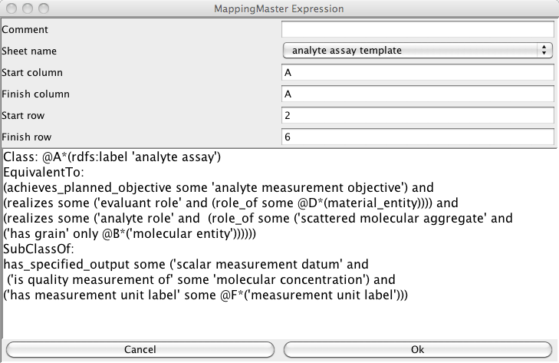

13. Go back to ‘Mapping Controls’ tab and then click ‘Map' button on the left:

A successful mapping will be indicated as follows:

Figure 6. Success message.

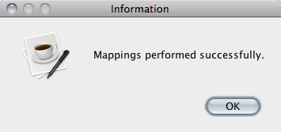

14. Click the OWLClasses Tab to view the hierarchy and newly added classes.

The result consists of the creation of a set of defined classes; all children of ‘analyte assay’ class are shown below.

Figure 7a. Inspecting the OWL class hierarchy to review the newly added classes: analyte assays.

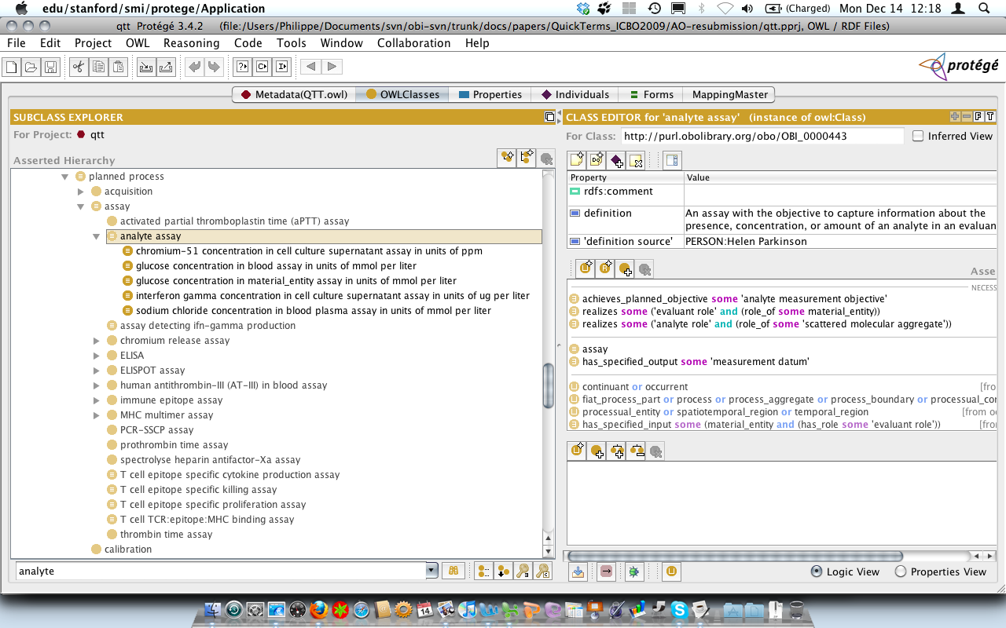

Figure 7b. Inspecting the OWL class hierarchy to review the newly added classes: molecular_entity.

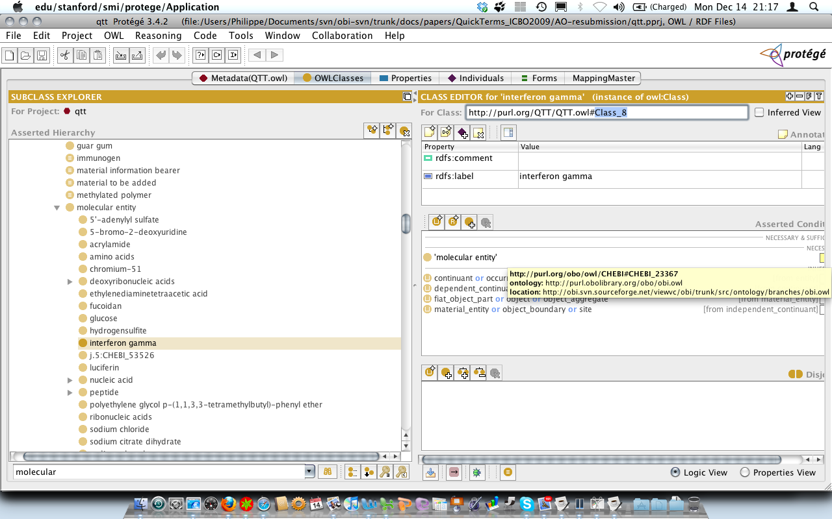

Figure 7c. Inspecting the OWL class hierarchy to review the newly added classes:
-Measurement unit label.
