Building a model framework for the governance of biobanks
S Wallace, K Bédard and BM Knoppers, Ethics and Policymaking Core, Centre de recherche en droit public (CRDP), Université de Montréal

I. Introduction
The Ethics and Policymaking Core of the Centre de recherche en droit public (CRDP), Université de Montréal, has been examining the issue of governance in relation to large-scale population biobanks. Specifically, we have been working to develop a model governance framework that population biobanks can use as a guide when considering their own governance needs. This research has been based on the practice of existing P³G-member biobanks and we thank them for their contribution to this work. This paper discusses the background to our work and presents a draft model framework based on our findings.

Governance has been defined as:
The process of policy orientation and management that guides and regulates research under ethical and scientific norms so that the results can be used for the benefit and improvement of the health of the population.

If due consideration is not given to the governance of biobanks, the consequences are serious. First, through scientific or ethical misconduct, or mismanagement, the biobank might lose their funding; or the trust, support and participation of the public. Second, without a clear governance framework, population biobanks may err by adding multiple layers of oversight, mistakenly believing these will enhance public trust when it may instead be limiting its ability to conduct research, due to added bureaucracy.

The different aspects of biobank governance have been investigated from many angles and we appreciate their insights into this topic. The goal of the Ethics and Policymaking Core has been to determine if a model governance framework can be extrapolated from existing practice. If so, such a model could be used as a tool to aid the biobank community. Our research into this question builds on our previous work, as well as information provided to us by those affiliated with P³G-member biobanks on the specific governance mechanisms that they use.

Drawing preliminary conclusions, we acknowledge that there are many different governance mechanisms and an exhaustive examination is beyond our remit. For this paper, we will focus on the more generally applicable mechanisms used by biobanks, examining in greater detail some of the frameworks and mechanisms used by them. We look at governance mechanisms from two perspectives: those external to the biobank and those internal to it. Next, we examine when these mechanisms are used in the lifecycle of a biobank. Finally, we propose some recommendations and a generic model for biobank governance.

II. Governance mechanisms and frameworks
Governance frameworks have been described generally as, “…the agreements, procedures, conventions or policies that define who gets power, how decisions are taken and how accountability is rendered.” Within these frameworks are individual mechanisms, each designed to address specific issues. There is no one policy and no one response to any policy. Governance requirements and the responses to those requirements flow continuously between actors. Every actor that is imposing responsibilities on a biobank is also itself responding to a requirement (Figure 1). As this is a complex series of interactions, we have tried to define some of these actions, indicate whether they are external or internal drivers and when they might be occurring.

Figure 1. Interactions between some societal and biobank-specific governance mechanisms
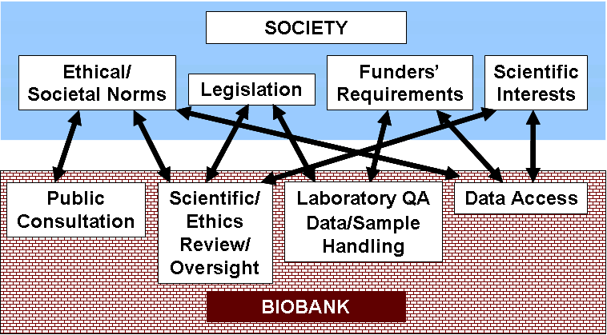

A. External governance mechanisms
For this paper we define an external governance mechanism as one that creates a responsibility over which a biobank has no control but must fulfill. We highlight five examples:
- Legislation and regulations – Several countries have in place specific legislation governing biobanks. Other countries rely on existing legislation (e.g., data protection, research with human subjects). All countries will have in place some legislation, regulations, professional guidelines and other instruments that must be taken into account when conducting or overseeing biobanking activities. Overarching international ethics guidelines and codes of conduct are also relevant.
- Socio-cultural norms – Every society or culture has differing value and norms. In order to gain acceptance, the goals of the biobank, and the ways in which those goals will be met, must fit within these legal, ethical and social boundaries. Social acceptance and public support is necessary in order for projects to receive funding and recruit participants, although its importance or necessity can differ between or within countries. For example, public engagement can be seen as a necessity in western societies, but not in others.
- Funders’ requirements – Funders can fall into many categories. Their contribution can be considered public, private, charitable, etc. All funders will have guidelines and requirements that grantees must follow. Non-compliance may jeopardize the research. More indirect forms of governance are the ability of funders to direct the path of science through allocating money in areas of interest to them and thus to society (e.g., funding streams dedicated to a particular disease such as cancer, or a technology such as nanotechnology) or requiring that the institutes where researchers are located adhere to their requirements.
- Scientific peer review (of the biobank) – The project must receive approval from a peer review committee. This is often part of the funding process, with peer review organized by the funding body.
- Ethics and privacy review (of the biobank) –Biobanks are considered research studies. Thus projected plans (e.g., overall plans for the biobank itself, its consent materials, recruitment plans, security measures, etc.) must undergo ethics review and receive approval. Then, as plans change or are refined, additional rounds of ethics and privacy review may be required.

Figure 2. External governance mechanisms
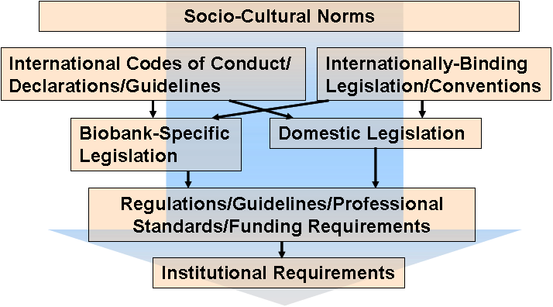

B. Internal governance mechanisms
An internal governance mechanism is one that the biobank has created to fulfill a certain requirement or role. Some internal mechanisms may be mandated; some may be needed because no existing body can fulfill the requirement and it is judged necessary in order to achieve ‘good governance.’ The following are examples of some internal governance mechanisms:
- Public engagement – Public engagement helps researchers to judge the public’s concern and acceptance of the biobank and allows them to design their study appropriately. Public engagement can take many forms based on the context and culture of the country or population, such as forums, interest group activities, town hall meetings, surveys, committees, etc.
- Scientific advisory/oversight (of biobank) – These committees provide advice to the project’s team members on the scientific plan for the biobank. Their membership is often international, including experts in, for example, genetics, epidemiology and biostatistics.
- Ethics advisory/oversight (of biobank) – As with the scientific advisory committee, this committee provides advice in the areas of law, ethics, public understanding, etc. Members may be lawyers, ethicists, social scientists and representatives of the population being studied. These committees may be internal to the biobank, or, in some cases, external and independent.
- Sample and data storage/laboratory practices – These committees oversee the quality control, quality assurance and data protection policies used when handling and storing samples and their derived data, as well as other data from participants (e.g., questionnaires, body measurements, etc.)
- Data access – Data access committees oversee the processes that govern researcher access to the biobank’s samples and data. These can be internal or external to the biobank itself. The review of access requests must be proportionate, balancing the needs of researchers with the potential benefits and risks to participants and society.
Figure 3. Internal governance mechanisms
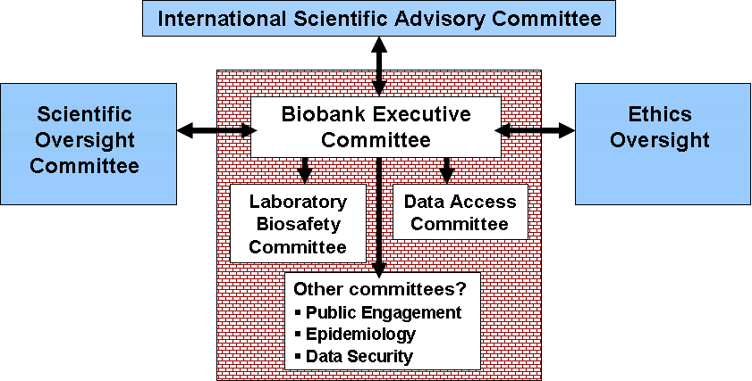

C. Governance mechanisms and the lifecycle of a biobank
Just as with other long-term projects, at any one time various requirements will appear and different mechanisms will be needed. Some will be one-time events, while others will remain stable throughout the life of the biobank. Every biobank process is unique, but based on existing data, some generalities can be made. We group the mechanisms we have already discussed into three stages: before, during and after. We recognize that some mechanisms will naturally cross between these time periods; for example, the ethics approval process for the biobank will begin near the end of the ‘before’ stage and end sometime at the beginning of the ‘during’ stage. But, as with other mechanisms that cross stages, it has been placed in the ‘before’ stage as that is where it first appears.
- ‘Before’ – This is the planning, design and creation stage. A majority of the mechanisms in this category will be external ones to which biobanks must respond (or of which they must be aware). Very early in the process there will be discussions with funders, examinations of existing law and regulations, and public engagement exercises. As plans and designs are consolidated, formal applications must be made to funders as well as ethics committees for approval to commence work.
- ‘During’ – Next is the set-up and operations phase. Here the focus will naturally shift to internal mechanisms, once it is clear what the biobank needs to deal with (external requirements) in order to proceed with work. The biobank now needs to put into place mechanisms to fulfill those requirements. These include putting in place an executive committee to manage operations, scientific and ethics evaluation and approval, and sample and data handling processes.
- ‘After’ – After, in this context, refers to the time after the biobank has been operational and data and samples have been collected. At this point, researchers, both internal and external, will want access to them for study and validation purposes. Data access policies and procedures and intellectual property management will need to be created and put into place. Procedures also might be put in place to allow for research results to be returned to the biobank. Methods for communicating the results of research projects using biobank data and for ways to enable and encourage public input will also be explored.

Figure 4. Governance mechanisms and approximately when they appear in the lifecycle of a biobank
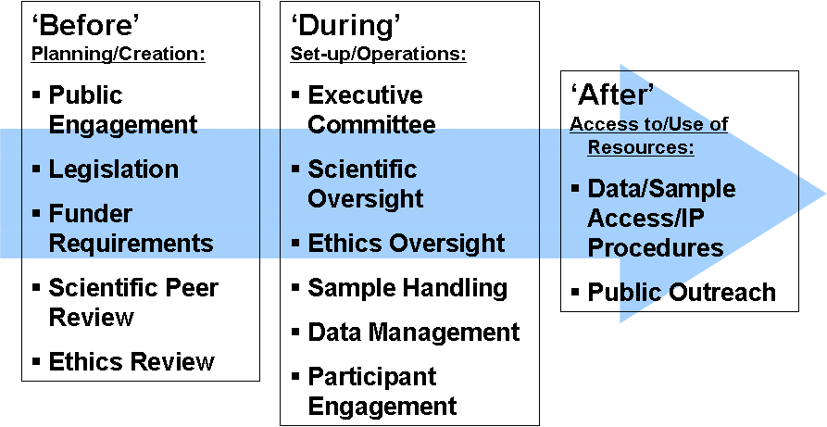

III. A model governance framework
Using a combination of the governance mechanisms we have discussed, a biobank will create a governance framework. This collection of mechanisms, the external and internal bodies, committees, legislation, guidelines, etc. that we have discussed, will serve to ensure that the biobank is acting within its remit, at any particular time. It also serves to keep the biobank within the applicable laws and regulations, as well as the cultural and ethical requirements, of the particular society in which it is located. It will reflect a biobank’s ‘character’ and give it its specific identity. To achieve this, based on examining existing biobanks, we suggest the following model governance framework:
Figure 5. Generic model of a biobank governance framework

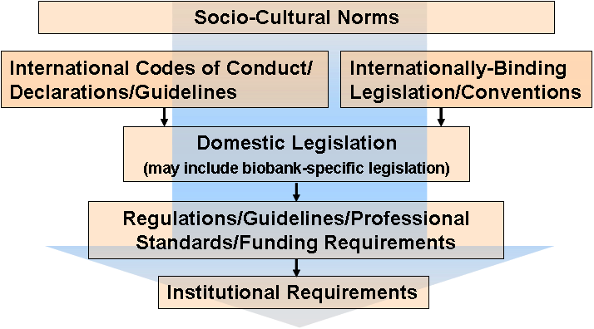

- International Scientific Advisory Committee –The Committee in this model provides advice on the science and the governance of the biobank. Its membership is international in nature and may have experts in fields such as epidemiology, genetics, medicine, law, ethics, and social sciences, as well as representatives of the population being studied.
- Scientific Oversight Committee – This Committee would provide more specific scientific advice, such as on the epidemiology of the project, the interactions with physicians, etc.
- Ethics Oversight – It would be the remit of an Ethics Oversight Committee to oversee the ethical conduct of the biobank, (e.g., data protection questions, consent issues, legal questions, etc.) Depending on the legislation and data security mechanisms in place, in some cases, this Committee may be needed to approve the ethics of requests for access to data and samples (in addition to the Data Access Committee).
- Biobank Steering Committee – The Steering Committee would manage the day-to-day operations of the biobank.
- Laboratory Bio-safety Committee – This Committee would oversee the handling (i.e., requirements for collection, storage, labeling, etc.) of the samples collected.
- Data Access Committee – The Data Access Committee would create guidelines for access to its data and samples, set up a system for access, and review and decide upon requests from researchers.

According to our research, these represent the ‘core’ committees that biobanks use. However, many biobanks have other types of committees, such as those looking at public engagement, epidemiology and data security issues. The question is whether a biobank must have a dedicated committee for each of its activities, or whether the core committees cover these issues as well. It will be up to the biobank as to whether it wishes many or few committees, as long as some mechanism is in place that addresses the fundamental requirements a biobank must meet.

We also recognize that there will be tensions between internal and external mechanisms, as well as the stakeholders within these groups. For example, in the area of data access, investigators want to have access to well-characterized data that is linked with up-to-date personal health, lifestyle and environmental information in order to carry out their studies. On the other hand, research ethics review bodies will require that personally identifiable information be kept confidential. Biobanks will need to be aware of such conflicts and establish ways, using the mechanisms available to them and within their own context, to balance these.

As no two biobanks are alike, they will not use all of the same mechanisms or design common mechanisms in the same way. However, at a minimum, we would suggest that biobanks, in creating their governance framework, seek to ensure the following:

Scientific Aspects
- The research conducted will advance science and benefit the population and individuals in the future.
- The resource’s procedures and activities will receive regular independent scientific review.
Ethical Aspects
- The confidentiality of personal information will be protected.
- The resource’s procedures and activities will receive regular independent ethics review.
- All requests for access to data and samples will be reviewed at some level.
- The resource will comply with all relevant legislation, guidelines and standards.
Expertise
- There will be expert representation on all governance and oversight committees as appropriate (i.e., epidemiologists, bioinformaticians, sociologists, geneticists, etc.)
Communication Aspects
- The population will be kept generally informed of the research conducted using their data and samples.
- Participants will be able to register their comments, queries and complaints to the resource, with the assurance that any complaints will be addressed.

IV. Conclusion
It is impossible to say what is ‘adequate’ in terms of a governance structure for biobanks. However, at a minimum, biobanks can seek to follow the general principles for good practice set out above by creating a governance structure that responds to the needs and expectations of participants as well as the requirements imposed on it. Most importantly, a careful examination of existing ethical norms including international guidance but especially applicable laws and regulations will serve to determine the degree of governance required. Before adopting biobank specific legislation or a heavy-handed system of committees, the adequacy of current ethics review structures, laws and other normative instruments and procedures should be carefully examined. It would be sad indeed if governance defeats the very purpose of the resources – providing an accessible tool for research.

P³G Lexicon. http://www.p3gobservatory.org/lexicon/list.htm.
For example, Kaye J, Gibbons SMC: Mapping the regulatory space for genetic databases and biobanks in England and Wales. Medical Law International 2008;9:111-130; Gibbons SMC: Are UK genetic databases governed adequately? A comparative legal analysis. Legal Studies 2007;27:312-342; Gibbons SMC, Kaye J, Smart A, Heeney C, Parker M: Governing genetic databases: Challenges facing research regulation and practice. Journal of Law and Society 2007;34:163-189; Gottweis H, Zatloukal K: Biobank governance: Trends and perspectives. Pathobiololgy 2007;74:206-211; Kent A: Biobanks: Governance Issues. Background paper presented at the meeting of the International Working Group on Ethics, Governance and Public Engagement, San Diego, CA, October 2007; Knoppers BM, Abdul-Rahman MH, Bédard K: Genomic databases and international collaboration. Kings Law Journal 2007;18:291-311; Cutter AM, Wilson S, Chadwick R: Balancing powers: Examining models of biobank governance. Journal of International Biotechnology Law 2004;1:187.
Wallace S, Bédard K, Kent A, Knoppers BM: Governance mechanisms and population biobanks: Building a framework for trust. GenEdit 2008;6:1-11; Bédard K , Lazor S, Knoppers BM: La gouvernance des infrastructures en génétique de populations (2008) Options politiques, submitted.
Institute on Governance. Principles for Good Governance in the 21st Century. August 2003. http://www.iog.ca./publications/policybrief15.pdf, Accessed 16 June 2008.
For example, see Generation Scotland’s Consultation Programme. http://129.215.140.49/gs/gpce.htm.
For example, see CARTaGENE’s International Scientific Advisory. Board(http://www.cartagene.qc.ca/index.php?option=com_content&task=view&id=18&Itemid=35
UK Biobank Ethics and Governance Council. http://www.egcukbiobank.org.uk/.
For example, the UK Biobank Sample Handling and Storage Sub-group. UK Biobank’s sample handling procedures are discussed in P Elliott, TC Peakman on behalf of UK Biobank. The UK Biobank sample handling and storage protocol for the collection, processing and archiving of human blood and urine. International Journal of Epidemiology 2008 37(2):234-244.
Op. cit. 3, Wallace et al.

