# **FNC**

* Regarding the assets: All the rules used to perform their naming convention are in the following table:

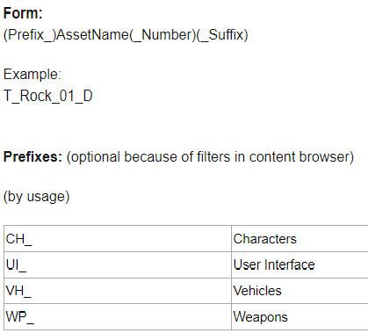

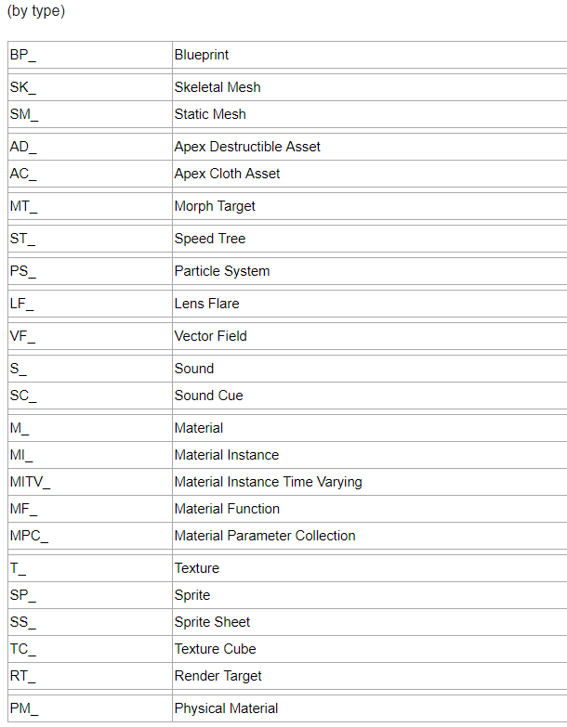

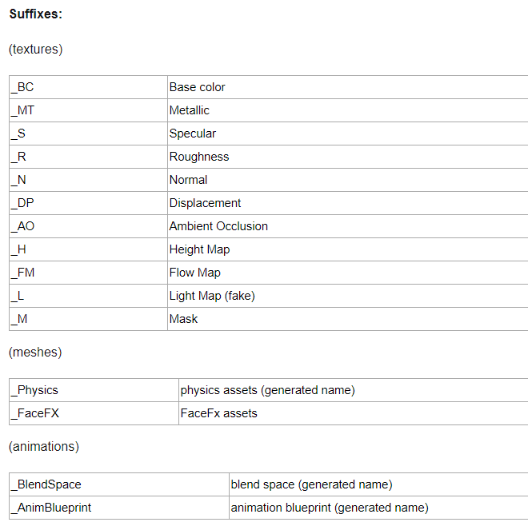

Regarding all the other files of the projects, (documents, support files etc…) the rules of their naming convention are the following:

* Do not use whitespaces or the camelCase notation to separate words, rather use the underscore ( “_” ) character.
* If required, be sure to use meaningful abbreviations, do not use abbreviation in files with short names or in special files (e.g. “game_story.docx” or “goal_outline.docx”).
* Do not use special characters in a name, including characters you can’t easily type using English or Italian keyboard layout.
* Do not write date, modifier’s name and version on the file name, we have already a versioning tool for that.