|  |
| --- |
| **Valeyard group** |

# **Data Management document**

# The Babel’s Tower

|  |  |
| --- | --- |
| Purpose | Document used to keep track of the flow of the work and to establish various standards among the group |
| Creation date | 19/10/2017 |
| Current owner | Stefano Palma |
| Last modification | 20/11/2017 |

|  |  |  |
| --- | --- | --- |
| **Revision History** | | |
| **Who** | **When** | **What** |
| Stefano Palma | 19/10/2017 | Created this document |
| Stefano  Palma | 22/10/2017 | Modified document’s graphical aspect |
| Sara Obici | 02/11/2017 | Modified document’s graphical aspect, updated software list and folder tree |
| Sara Obici | 20/11/2017 | Modified Directories Structures & FNC |

**1.1** **Asset development software**

-SketchUp 2016 Version 17.2.2555 64bit

-GIMP 2.8.22

-Blender 2.79 BuildID : 2112350

-Audacity 2.1.3

-MuseScore 2.1.0 Revision-871c8ce

**1.2 Development software**

-Neverwinter nights 2 toolset (version 1.23)

**1.3 Organization software**

-Word 2016 ( Version 1710, build 8625.2121)

-XMind 8 update 5 (R3.7.5.201709290120)

-AutoRealm 2.2.1

**1.4 Environments**

Windows 10 Home – 64 bit - Version 10.0.15063 Build 15063

**1.5 Repository platform**

-Github

**2.1 Texts**

*.docx (Word)

**2.2 Pictures**

*.tga 32 bit(loadscreens)(1600x800), (GIMP)

*.bmp 32 bit(icons and textures)(40x40 for icons 64x64 for terrain texture and 512x512 for other textures) (GIMP)

**2.3 Videos**

Currently there is no intention of producing video content

**2.4 Audio**

*.wav (sound effects -16bit 44.1Khz) (Audacity), *.bmu (bioware music – music) – converted from mp3 96kbps(MuseScore)

**2.5 3D models**

*.mdb (Blender)

*.skp (Sketchup)

**2.6 Video and image references**

*.mp4 (between 360p(480×360) and 720p(1280 x 720

*.png(between 640x480 and 1024x768))

**2.7 Design files (maps, diagrams, etc.)**

*.xmind (Xmind), *.AuRX (AutoRealm)

**2.8 Editor files (all handled by the editor)**

*.mod (Module format)

*.bic (Character file)

*.ini (Configuration file)

*.2DA(defines all sorts of basic rules for all sorts of aspects of the game)

*.tlk (Contains string used in the game)

**2.9 File Compression**

*.zip

To maintain data and folders a github repository has been created at the following link:

<https://github.com/obiciunict/GLD>

**3.1 Backup**

Backup of all work will be kept on everyone’s computer, the master backup is kept by Sara Obici.

* Last master backup: on an external memory (Toshiba) 20/11/2017

In the root directory there are three main folders. The first one is named “Story”, and, as the name itself suggests, it contains everything about the storytelling, characters, etc. To further make order between all this plot informations, this directory contains two other ramifications inside itself: World Diagram, Map and Goal Outline and Synopsis and (Visual) References. The second main directory is named “Development”, and, as previously done, is subdivided into two other directories: Game Assets and Tests and Experiments. It’s important to point out how the Game Assets folder can contain a whole group of other folders, listed in the following table.

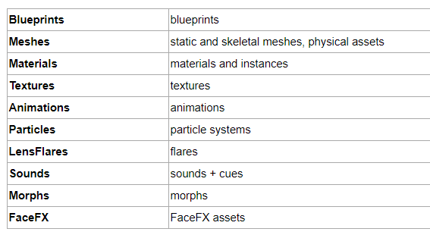

Obviously in our project we will not necessarily have all these folders, but there will be certainty that if files of these categories are to be introduced, then it is so that they will be catalogued.

The third and last main folder is named Support and contains useful documents for the development of our software and the general organization of work on it. For example, this last folder contains exactly also this document itself, the data management document. To get a clearer idea of the hierarchical structure just described, it’s useful to introduce the following schema, that can also help to specify which file types are actually present in all of these folders.

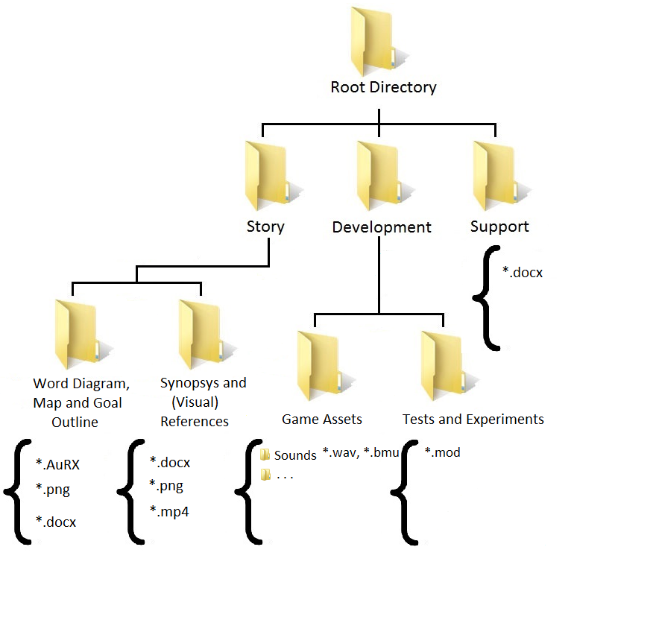

The exact features of each file type have already been specified in section 2 of this document; in this image the file types are inserted only to indicate, in a simplistic way, which types of files can be found in each folder. It’s also relevant to point out that the whole file naming convention is specified in the folder Support Development, with the file: “File Naming Convention”, which contains all the references from which we have drawn the rules. This file has the following contents:

* Regarding the assets: All the rules used to perform their naming convention are in the following table:

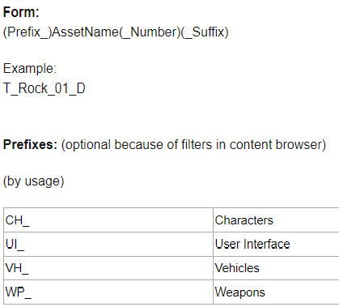

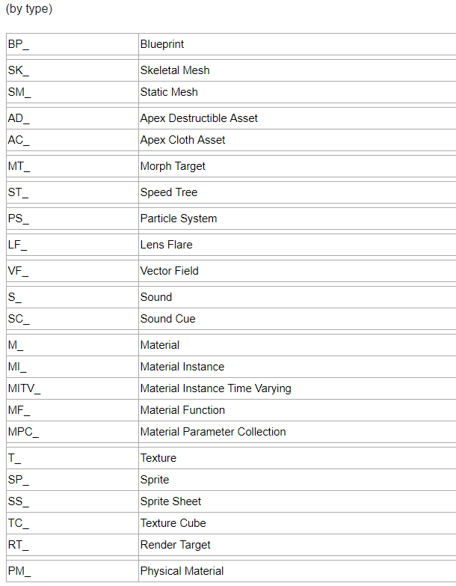

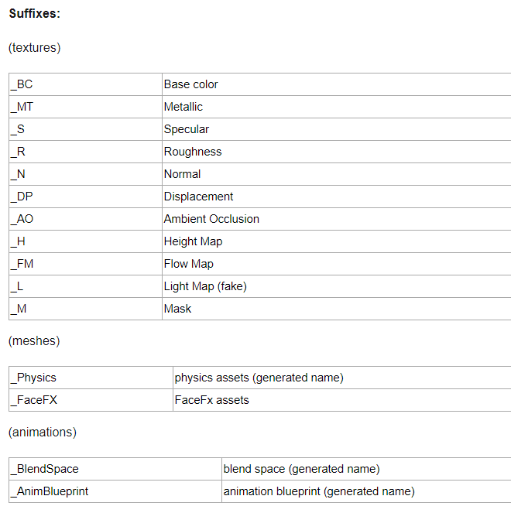

Regarding all the other files of the projects, (documents, support files etc…) the rules of their naming convention are the following:

* Do not use whitespaces or the camelCase notation to separate words, rather use the underscore ( “_” ) character.
* If required, be sure to use meaningful abbreviations, do not use abbreviations in files with short names or in special files (e.g. “game_story.docx” or “goal_outline.docx”).
* Do not use special characters in a name, including characters you can’t easily type using English or Italian keyboard layout.
* Do not write date, modifier’s name and version on the file name, we have already a versioning tool for that.
* If the file isn’t a simple text file, use “vid_” in case it is a video, “ima_” “mus_” in case it is a music file, or “spe_” in case it is a different type of file (this may be very important to order and handle different references).