SOMMARIO

DETAILED AREA DESCIPTION 1

THE GARDEN 1

AREA DESCRIPTION 1

MOOD 3

OBJECTS 3

THE LIBRARY 4

AREA DESCRIPTION 4

OBJECTS 4

TEXTS (ON TABLETS IN THE LIBRARY) 5

PLANTS IN THE GREENHOUSE 5

THE PROJECT’S SECRET ROOM 7

AREA DESCRIPTION 7

MOOD 7

TEXTS (THE PROJECTS) 7

THE PRIESTS’ DORMITORY 9

AREA DESCRIPTION 9

OBJECTS 10

THE TOWER’S BASIS 11

OBJECT TO BUILT IN ORDER TO ENTER 11

AREA DESCRIPTION 11

MOOD 11

CHARACTERS 11

PRIEST’S OUTFIT 11

CHARACTERS DESCRIPTION 12

EVENTS 14

EXITING FROM THE LIBRARY 16

EXTERNAL AND PRIEST’S DORMITORY 16

# 

# DETAILED AREA DESCRIPTION

## THE GARDEN

### AREA DESCRIPTION

The construction of the tower was interrupted due to the riot, so now in this area only Nimrod, the priests, and their attendants (normally, also the workers and the faithful can visit the garden) can enter.

The high priests live and study here; instead, the low priest can only visit the library, and live outside the second wall. The walls are built following the Babylonian architectural style, with big yellow clay bricks, and are higher than the other buildings (except the tower), also they are about 2 meters wide.

The area inside the second wall is a really big and lush garden, full of every kind of plants, shrub and herbs (dates palms, licorice, poplars, alders, banana trees, prickly pears, lotus flowers and coconut trees). The garden is really kept mowed; there are many gardeners who take care of it. In the garden there is also some pond: one in the center and two in the south-east and south-west corners; all the ponds are full of lotus flowers.

Starting from the entrance of the wall, you can walk on a black slate path, it leads to the central pond, from which three paths (made with the same material of the previous one) start, leading to the three buildings in this area: the library, the priest’s dormitory and the tower. Others little paths lead to specific area of the garden, some stone bench or some flowerbed, or maybe only cross the area to allow a relaxing walk in the nature.

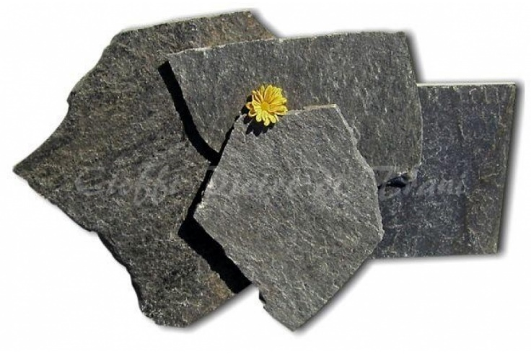By the side of the four big paths, there are rows of licorice shrub, and alders. Mainly, the trees are placed neatly around the dormitory or the library, or in the middle of the flowerbed, which breaks the monotony of the lawn. Near the walls, there are two rows of poplars to hide the yellow, bare wall. In the south east of the garden, there is a little area full of coconuts and banana trees.

As we already told, in the middle of the garden there is a pond, full of lotus flowers, and at his center, there is a stone pedestal with a big sculpture of Nimrod, **13** on a little island. On the top of the statue, which is made of white granite, there is a big green, luminescent stone. Four wood bridges cross the pond leading to this small island.

Along all the slate paths and the wood bridges, there are many wood street lamps similar to lances, and on the top of these small artificial fires shine, illuminating the whole garden.

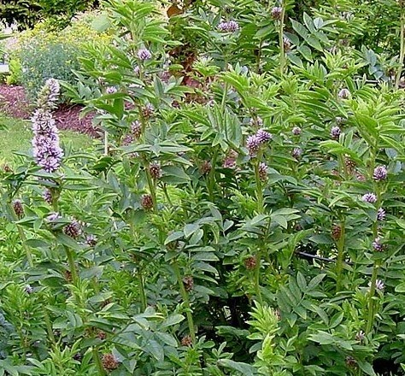On the east side, there is the library, which before was a temple: is built on an elevated plan, like the typical Babylonian Ziggurat, so to reach this building you must go along a stairway, black like the paths, and surrounded by street lamps. The library is a big and imposing building. The external walls are made in white calcareous bricks, with blue decoration on top, near the ceiling, which is made with battlements, like the other important building in Babylon. On the side of the single entrance, there are two blue cylindrical columns, and two soldiers overseeing the entrance. On all the wall there are two rows of arched windows, high and narrow, to allow the light to enter.

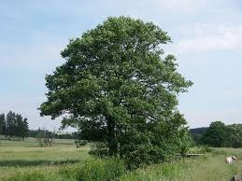On the west side of the garden there is the high priest’s dormitory. This building has a rectangular plant, and two floors, is very long, placed on north-south axis. The outside of the building is made of white limestone bricks, with many arched windows, high and narrow, with blue and purple decoration on top. A white stone door, with some inscriptions, closes the entrance and a purple gem glows in its center (the door can be opened only using the special rod of the high priests or the purple gem of the attendants).

The tower, in the south part of the garden, is surrounded by a bare land area, without trees, the lawn cannot grow due to the construction site. This building is a “work in progress” so the last floor is incomplete. The ground plan of this building is circular, the walls are made with white limestone bricks, the rows of windows follow the height of the tower in a spiral pattern, and so are the rows of bright blue gems. The tower is the tallest building in the city, even if you try to see the top, you can’t. The tower contrasts with the rest of the environment, giving a sense of modernity and progress out of place if placed near the nature of the garden, or the ancient and wise appearance of the other buildings.

### ****MOOD****

The garden is in contrast with all the environments explored so far by the player: the prison and the crypt are dark and creepy, the area outside the walls is surrounded by the desert, the city is built in clay, with poor materials, and very chaotic. Everywhere the dominant colors are yellow, beige, brown, ochre, light blue and white. Here, just entered, the player remains amazed by the triumph of nature, the dominant colors are the green of the vegetation and the thousand, colorful, shades of the flowers. The almost black slate paths do not create a gap between the natural environment and the road, as could happen with white paths. All buildings are white externally, and the water is abundant in the various ponds, so the impression of “city in the desert” is completely lost. Moreover, especially at night, the player has the feeling of being out of time: the contrast created by the ancient appearance of the buildings and the artificial luminescence of the street lamps and the tower create a surreal environment.

### ****OBJECTS****

**11** Banana: Normal fruit, yellow, not ripe, but mature. The player can pick it from many banana trees in the south of the garden.

**THE LIBRARY**

### AREA DESCRIPTION

The library is a large rectangular-based building, composed of three large rooms:

1. a greenhouse, located on the west side of the building, which is mainly used for the cultivation of alien plants;
2. a study room, positioned on the north side of the structure, which is used for consultation and study by ordained priests and novices. Next to the room just described (on the east side of it) we can find a small office for the librarian; but it’s considered as an integral part of the study room;
3. the central hall, the atrium, is the largest of these tree areas. This space is made up of high shelves used to store the tablets; the statue of Nimrod **9**stands out in the middle of it.

The library is very bright, due to the various rows of windows placed along all the external walls and to special braziers collocated along the walls and among the huge stone tables. These braziers contain electric bulbs similar to fires, but that, unlike these ones, do not emit actual heat: in fact, the traditional fire is not allowed in the library, because exposure to heat could dry the clay of the tablets and cause it to break. The entire building is located on a promontory, and to access it and arrive at the entrance it’s necessary to go up a large staircase. Two guards supervise the only main entrance, located on the south wall, and two other sentries are placed at the sides of the beginning of the staircase. As soon as the player enters the building, he will find himself into the imposing central hall, which consists essentially of white calcareous bricks.

The inside walls have been covered with white glazed bricks, and in the upper part of the wall white and blue tiles alternate to form a striped decoration. On the walls there are also numerous depictions of religious scenes and animals, made with enamels on the bricks. The ceiling follows the style of the aristocratic palaces of the Neo-Babylonian era: indeed, it’s made up of cedar wood coffers.

In the hall there are huge shelves of stone and wood, which reach the ceiling: to get to the highest cuneiform tablets you have to climb up some ladders arranged along the length of the shelves. The player will notice sometimes that some priests appear and disappear from the central hall. These sudden disappearances occur when the priest hits the rod twice on the ground close to Nimrod’s statue, the gem in the center lights up, and they disappear.

In the center of the study room there are two huge stone tables, surrounded by numerous benches. Here priests and novices can consult and study the tablets, since these cannot be taken outside the building. On the opposite side of the tables, we can find the librarian's office, which is accessed by passing through two ancient columns: the librarian has a stone desk and a chair, and a huge appetite: his abundant meals are usually placed on the stone table. Lastly, we have the greenhouse where the priests perform experiments and studies on a series of alien and non-native plants. The greenhouse has a thick ceiling full of artificial lights, which not only light the room, but also provide energy to plants who need it. The walls of the greenhouse are made of rough stone, without any decoration. The greenhouse is divided into two sections by a large central corridor oriented along the north-south axis, from which several smaller paths take up space. Next to the door there is a flowerbed that hosts a hungry carnivorous plant (about 2.5 / 3 meters high) that attacks anyone who enters with its tentacles (unless it is satiated, it does not need only the energy to survive, she must be fed with meat).

Purposes:

1. Whole library: To gather the knowledge necessary to form the priestly order
2. Secret room: contains all the technological knowledge connected to the Doctor and the tower
3. Study room: meeting point for priests and novices, a place of silence and concentration.
4. Here there is also the librarian's office, who monitors the state of conservation of the tablets and provides information
5. Greenhouse: used to contain the cultivation of alien plants brought by the Doctor for various purposes: medicinal, culinary, etc.

### OBJECTS

The abundant meal of the librarian: which is located on his office, upon the stone table. **5**

Priests’ Rod: Long blue rod decorated with golden lines. At the top there is a gem that changes color according to the destination of the teleport and an arc that encircles the gem. In addition, to the side, there are two wings as a decoration. Every high priest or priestess carry one of those with him.

### TEXTS (ON TABLETS IN THE LIBRARY)

The tablets are divided into section:

1. Botanic
   1. Pitcher Plant: Here talks about the carnivorous plant on the entrance of the greenhouse, it seems to be a kind of pitcher plant, very dangerous, useful for the healing properties of its roots and leaves. It becomes a lot more docile after a good meal **1a**
   2. Morpheus Berries: A tablet about some berries in the greenhouse, they seem to be a really powerful sleeping draught **1b**
   3. Hydraulic Screecher: A research about a plant that can be used to transport water. It doesn’t seem to go very well, the plant is very noisy and agitated, impractical to be used.**1c**
2. Politics
   1. Priests’ Orders: A tablet about the hierarchy of the priests. There seems to be only two orders of priests, the acolytes (or lower priests) and the high priests. The formers are still apprentice, while the latters have completed their education and they are in charge, with access to the secret room. It is unclear how they can access it, but it seems to have something to do with a symbol of recognition they have. **2**
3. Astronomy
4. History & Myths

### PLANTS IN THE GREENHOUSE

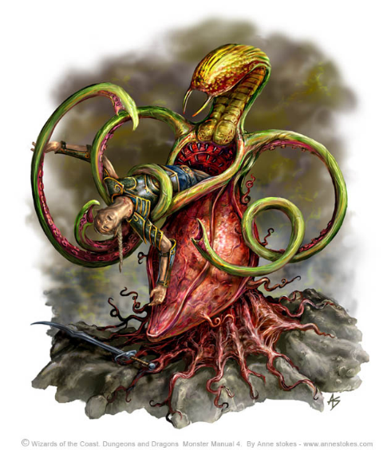Alien pitcher plant: very dangerous plant, vaguely similar to the earth’s pitcher plant, but significantly bigger, it can easily fit a medium sized adult inside itself. The leaves also are rather huge and strong, capable of lifting great weights without much effort. It seems to have some sort of sentience, but nothing more than an animal with strong predatory instinct. His roots have very strong medical properties, mostly for digestive problems and tissue healing. His leaves seem to have an even stronger medical power, but it’s a lot more difficult to get them. **8**

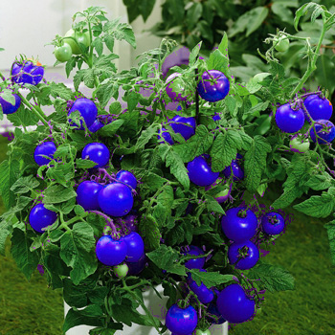Morpheus Berries: Simple blue berries with a strange motif on them, somewhat similar to the blue marble fruit. (Elaeocarpus angustifolius’s fruits). The plant is similar to a tomato plant. They are grown to help Nimrod sleep since he usually has nightmares. **7**

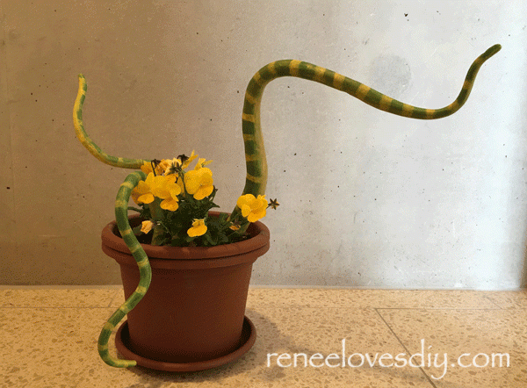Hydraulic Screecher: this plant has been developed as a part of a research about a water system. It appears as a tentacular plant, with tentacles that grow directly from a point inside the terrain... His leafs and roots have the ability to pump water at high pressure, unfortunately doing so the plant tends to produce a high frequency and very loud noise and provoke a rapid, strong movement in the plant and every attempt on diminishing that has proven unsuccessful so far**. 6**

## ****THE PROJECT’S SECRET ROOM****

### AREA DESCRIPTION

The point of arrival is a square room almost empty, only a statue **14** is placed on south-east border. On the north border of the room there is a corridor that leads to another room, this time circular.

Both the rooms are pretty large, the statue at the entrance is rather big, but the rest of the first room is empty, so it still feels spaced up.

This circular room contains a set of columns with a vaguely transparent screen on the top of them (the player can read from these column’s screens information about different projects, as we will detail soon). They are positioned in two concentric circles, five of them toward the center in a symmetric pentagon and 8 of them against the external wall, all over the perimeter. At the center there is a rectangular console with a display. This room it is slightly bigger than the first, but filled with these 13 (projects’) columns and a central console, so the space in which you can move is significantly lower.

This is reflected by colors choice. The walls are all made of a metallic material completely black, various red veins traverses all walls and floor, the statue is black too, but with a white light, that reflects the white in the library.

The project’s columns are red and black too, but the screen above is blue sky, same for console.

### MOOD

The colors chosen are red and black because they can help express a sense of danger, uneasiness and urgency, they are at the core of the knowledge of that world and even if there is no real danger in that place it still needs to instils some sense of threat. The first room is pretty basic and empty, very far spaced, it is used to present the environment’s color and style, but with still some calm, the second room instead is tighter and claustrophobic, to further express how much deep they are into the knowledge and to enhance the sense of secrecy of looking the projects. The light of the displays is sky blue both because they need to be seen as non-threatening and useful and because it is a color often associated with Nimrod’s technology.

### TEXTS (THE PROJECTS)

In the room there are 13 columns containing the following projects:

1. -Inner circle (from bottom left, clockwise):
   1. Tower
   2. Library
   3. Prison
   4. Dormitory
   5. Greenhouse
2. -Outer circle (from left, clockwise)
   1. Lights
   2. Rod
   3. Sonic Blaster
   4. Statue of Nimrod (energy generator)
   5. Transmat statues
   6. Energy Transfer system
   7. Circle of heaven
   8. Blue breakthrough project
3. Detailed Projects **15-26**
   1. Tower: “This contains the tower map and planning, with walls specs and positioning. Strangely it seems to cover only the lower levels.”
   2. Library: “Map of the library and list of sections and tablets, there seems to be four sections: Botanic, Politic, Astronomy, History & Myths”
   3. Prison: “Map of the prison, including what materials are used, blueprint and an emergency plan in case of breakout of very dangerous prisoners. Indeed, a special room for those is hidden inside the building.”
   4. Dormitory: “Map of the dormitory, apparently it has two floors, the ground floor contains everything is needed, like kitchen, a common room. The first floor contains all bedrooms. The focus is on the mechanism of its big stone door, with a triggerable purple gem on its center.”
   5. Greenhouse**:** “Map and position of various plants inside the greenhouse, as long as some guidelines on how to treat various specimens”
   6. Lights: “The project for the lighting system. Most of them are just used to light the place, but the greenhouse ones also provide energy to the plants and the lights on some statues are able to power up the rod”
   7. Rod: “This is the project of the rod, it seems to be an antenna used to guide a transmat system, the location of the teleport is indicated by the color of the gem”
   8. Sonic Blaster: “The project of a sonic blaster, a powerful weapon capable of open squares in walls. Probably used to speed up the building job”
   9. Statue of Nimrod: “The project of the energy system, the statue at the center of the park seems to be used as a battery or a generator that powers up everything in the area”
   10. Transmat Statues: “The project of the statues used to charge the rod allowing it to teleport to different locations”
   11. Energy Draining System: “It is a project for an energy draining system. It seems to use the material the tower is built with to absorb energy from the people”
   12. Circle of Heaven: “Very weird project about a system that uses energy to keep sealed an evil entity. It is very vague about this entity and it seems a little different compared with the others, almost magical”
   13. Blue break-in project: “This project seems to be deleted, weird. The name ‘blue break-in projects’ seems to be the only thing left”

## ****THE PRIESTS’ DORMITORY****

### AREA DESCRIPTION

The dormitory is a two-story white building, and it is a typical example of Babylon architecture: squared, rectangular plan, flat roof.

The outside of the building is made of white limestone bricks, with many windows and a big stone door of the same color, with a purple gem glowing in the center (the door can be opened only using the special rod of the high priests).

The inside: the floor is made of cut sandstone blocks, as well as the internal walls, which are not decorated.

The ground floor is divided as follows:

1. In the northern-west part, occupying half the size of the floor, a big living room, used to eat and to spend time in other activities.
2. In the south-east part, almost long as the living room, the bathroom.
3. Under the living room, in the west side, the kitchen with a little pantry to east.
4. Under the kitchen there are servants’ quarters (south-west room) linked to both the kitchen and the bathroom

Instead, high priests to sleep use the upper floor, and for this reason there are several beds inside. Every room of every floor is lit up by torches on all the four walls of the room.

The stairs connecting the levels stand in the north-west angle of the building, and are made of wood.

The living room: it is the biggest room of the ground floor, the big stone door leads directly to this room.  
There are 3 long wooden tables, with many wooden chairs around them; on these tables there is some ceramic crockery (dishes, cups and jugs of water and beer). On the east wall there is a wooden shelf full of the same kind of crockery found upon the table. There are two wooden doors in the south wall, leading to the kitchen and to the bathroom. Three priests and two priestesses are eating lamb stew and quietly talking (about the sudden rebellion, and the fact that they are worried about their comrades who must spend the night out of the dormitory for the celebration).

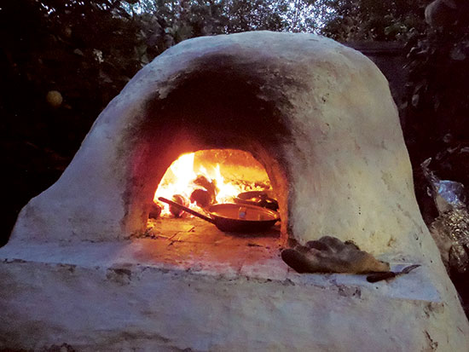The kitchen: it has a dome oven inside, used to cook everything, close to the west wall, in this wall there are two small windows from which you can see going by a lot of smoke and steam **12** while servants are cooking meals (it is important for the puzzle involving the smoke). To the north-east corner there are two tables where servants mix ingredients, or prepare the food before cooking it (etc.). On these tables there is the big ceramic pot where the lamb stew has been cooked. Upon the tables there are wooden shelves, where you can find colorful spice containers (e.g. cumin), ceramic crockery (pots and lids, and other containers) and wooden utensils.   
Inside the room there are two servants (an old lady and a young boy), cleaning and preparing food, they are preparing the dinner for the priests in the living room, and have just served the lamb stew. Now the lady is preparing a simple salad with fresh vegetables, while the boy is cleaning the dome oven. In the east wall there is a door leading to the pantry, a small room where are held salt beef and fishes, dried grains or other legumes, also fresh vegetables and fruits. There is a wooden beer barrel too.

Servants’ quarters: this messy room is made for the servants to sleep. Here there are ten straw mattresses on the ground, and 3 wooden chests close to the north wall, where servant’s dresses and belongings are hold. This room is connected to the bathroom, through a wooden door on the east wall, and to the kitchen, through another wooden door in the east part of the north wall. There are two servants resting inside the room, sleeping.

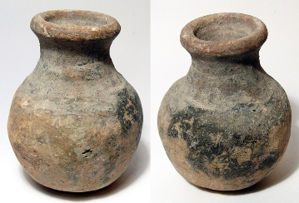The bathroom: the floor of this room is different from the floor of all the other rooms, because here the bricks are waterproofed with bitumen, which is plastered even in the lowest part of the walls. Close to the west wall there are two baths (dug in the ground, lined with the same bricks of the floor) with a drainage hole and its stone plug. On the south wall there are some wooden shelves, where you can find powders and oils for hygienic or cosmetic purposes (e.g. saltpeterfor washing clothes, scented oils). Under the shelves there are two barrels, which are used by servants while high priests want to have a shower.

The first floor: it is divided into two huge rooms, with a hallway to the west side leading to both. To the north, the female dormitory, where priestesses can sleep and rest. To the south, the male dormitory.  
Both the rooms contain many wooden raised beds (22 women and 22 men), with a wooden chest for each bed, where priests keep their personal belongings. Both the rooms are almost empty, with only two priests and two priestesses sleeping. One resting priest is the gardener of the library’s greenhouse, who is idly missing work for a simple conjunctivitis: he is sleeping with a smirk on his face. Upon his chest there is a pot of sulfurpowder.

**MOOD**

Here the choice of colors and materials is as historical accurate as possible, this is the place where all the higher priests live, they are natives, so the building has been built as familiar to their tastes as possible.

### OBJECTS

1. Sulfur: a pot of clay filled with sulfur in powder. The player can find it upon the gardener’s chest. **29**
2. Saltpeter: a pot of clay filled with saltpeter in powder. The player can find it upon a shelf inside the bathroom. **28**
3. Coal: solid chunks of black coal. The player can find it inside the dome oven, in the kitchen. **27**

## ****THE TOWER’S BASIS****

### ****OBJECT TO BUILT IN ORDER TO ENTER****

1. Gun: Colt gun, more or less from 1850, long thin metal barrel, big metal cylinder and wooden handle. Built with: banana, saltpeter, sulfur and carbon.
2. Sonic Blaster: Classic sonic blaster from doctor who (first appearance in the first season, episode “the empty child”). Built with the gun and a piece of the Hydraulic Screecher.

### ****AREA DESCRIPTION****

As for every level of the tower, this one too is circular. There are several huge columns positioned in a circle, around the midpoint between the walls and the center where is placed the Doctor’s TARDIS.

The TARDIS is placed inside a metal cage (a faraday cage) and connected to it there are many cables placed all over the room, from the center to the borders, connected to the TARDIS. The walls are covered with a sky-blue light, similar to the one on the exterior.

### ****MOOD****

The materials used for the construction of the walls are somewhat similar to those used to build the other buildings, to give the impression of something that belongs there, but they are covered with various arrays of blue sky lights to give it a sense of holy and valuable. This is reflected on the internal walls too and this feeling goes in direct contrast with the technological interior. At the center there is the TARDIS, surrounded by a cage, this has been made both to give a sense of protection, to keep away unwanted guests, but also, and mostly, to constraint him and every type of communication (since has been sending helping requests). The wires around try to convey a sense of technology as well as constraint and control (or attempt to).

# CHARACTERS

### PRIEST’S OUTFIT

Typical priest outfit

Every important class of the Babylon society keep their beard as shown by the picture. Priests are no exception. Regarding their outfit, they wear long white long robes, with golden details.

Typical high priest outfit 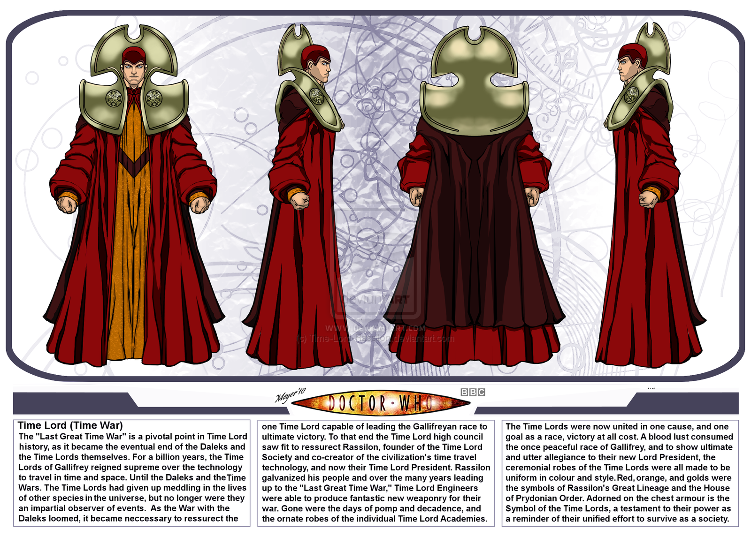

High priest outfit contains a small quote from the doctor who universe. They dress with a white tunic like the other priests, but with more opulent details, and particularly they wear on the shoulders the strange metal plate worn by Time Lords too. They always have a shining rod with them.

Typical servants outfit   
Servants wear a simple and poor robe, in poor colors, like grey or light brown. They wear a charm made with a gem like the gem set in high priests’ rod, except that this gem is purple.

### CHARACTERS DESCRIPTION

Librarian: The librarian is a pretty cultured high priest, who has repeatedly read every tablet of the library. He is very careless about everything outside his loved tablets. His duty is to help other people to find what they search for inside the library, but he loves to dwell on tablets’ content when he should simply give people the tablet they want. He usually brings very huge meals, to don’t have to come back to the dormitory to eat during the day. He is a middle-aged man, a bit overweight and short.

The gardener: He has the reputation for being lazy, indeed he never loses an opportunity to skip work. He has conjunctivitis, and he think this is a sufficient reason to bed rest the whole day. Despite his sloth, he is very proficient in doing plants, the most expert priest. His tasks include feeding the carnivorous plant, which becomes intractable and aggressive when hungry. He is a middle aged and muscular guy.

The high priestess who must die (in Ashildr’s path: She is a quicksilver and lively, she can’t just sit still. Even when she has to study a tablet, she usually reads some line, and immediately gets up and start walking around the library, thinking what she has just read. She is a very young priestess, tall and healthy.

The two gossip priests: They are old friends, and love to gossip about everything possible. They don’t care of being listened when chatting, in fact they have fun seeing how people react while hearing what they are saying.  
The two are very different in physical appearance: one is tall and fat, the other is short and thin. The first time they are met inside the library, laughing about the gardener’s laziness, the second time they are met in the Clara’s path, gossiping about the other priests sleeping in the library (once that Clara and Ashildr are come from the secret room, after having put the priests into sleep).

The servants in the kitchen: They are an old lady, Aruru, and a young boy, Narubtum. The boy follows the lady’s lead, who, persistently but fondly, reproaches the boy. They are really busy, and wonder if they should wake up the other two servants sleeping to help them.

The priests in the living room: They are very worried about the current situation.

Two priestesses talking in the park (Belili and Humusi): They are taking a walk before dinner, and are talking about the gardener’s laziness, one priestess thinks that the gardener is not lying, while the other one has never believed him (the player can understand where the gardener is bed resting in the dormitory, listening to them). Both seem to love their job and their duties.

# EVENTS – LEVEL DESCRIPTION

Available areas: The **garden** and the **library**.

Events available in the garden:

* 1. Picking up some flower (also if they are useless)
  2. Walking on slate paths and grass, but not in the water or into the flowerbed, trying to walk on the flowerbed will trigger this single sentence dialogue: Clara – “I think it is impolite to step on these marvelous flowers”.
  3. Talking to the “Two priestesses talking in the park” (see character paragraph), to trigger the following dialogue: Priestess 1: “And again today our gardener skips work, I can’t understand why Nimrod hasn’t sent him away.”Priestess 2: “You know that he has a soft heart, but it is unbelievable that one cannot access the greenhouse for this” Priestess 1: “He could at least assign him to a less important task”.
  4. Picking up bananas from the banana trees in the southern area of the garden.
  5. Entering the library, (At the beginning of this level the player can’t enter the tower or the priest’s dormitory).
  6. Hyperscanning [Clara’s Skill] the smoke outside the dormitory using the Nanite AI. (If our Clara has already the berries)
  7. Using the sonic blaster (if crafted) to open a passage leading inside the tower
  8. Interacting with the Nimrod statue at the center of the park to teleport to a secret room (if the rod is present in the inventory)

Events available in the library:

1. Events available immediately: reading the tablets, talking to the NPCs, attempting to enter the greenhouse, exiting the library, entering the study room and the librarian's office.
   1. Talking with the librarian: **“Amazing how much knowledge is collected in one building, this has been such a great idea”**
2. Bottleneck: entering the greenhouse and fail, because the alien pitcher plant tries to eat the characters (when the player opens the greenhouse door, a scene shows the plant attacking the characters, that run away)
   1. Events available from now: stealing the librarian’s food.
      1. Interacting with his food will trigger the following dialogue:

* Clara: “We should use this to feed the carnivorous plant!”.
* Ashildr: “Nice idea, we need to distract the librarian in order to steal its food, I guess”.
* Clara: “Follow me!”
  + 1. Now interacting with the guardian will trigger the following dialogue/scripted scene:
* Clara: “Sorry lord, could you show me where to find some reading regarding our myths, I really need to check them.”
* Librarian: “No problem lady, did you know how much our lord Nimrod loves the Gilgamesh myth?”
* Clara: “I honestly didn’t, tell me more if you don’t mind, please”.
  + 1. Now the player controlling Ashildr can interact with the meal to steal it, if he/she tries to leave the room, Ashildr will stop and think: “I must steal the meal now that I can, fast”, in this way the player won’t be able to leave the room.
    2. Once stolen the meal, Clara and the librarian come back:
* Clara: “Thank you so much!”
* Librarian” No problem, I really wanted to tell you more about that”
* Clara: “You will tell me another time, don’t worry, bye! [whispering to Ashildr] This guy is really boring!”

[The librarian comes back to his seat, Clara rejoins the party]

1. Bottleneck: manage to enter the greenhouse by feeding the alien pitcher plant with the meal stolen from the librarian.
   1. From now: collecting objects in the greenhouse, the player can find:
      1. Morpheus Berries
      2. Hydraulic Screecher
2. Bottleneck: scripted scene (starts when the player exits for the first time the greenhouse) in which the player sees a priest changing the light of the rod, pointing it at the statue of Nimrod in the central hall and beating the rod on the ground twice. After, the gem on the rod lights up and the priest disappears.
   1. If the player has not read the priest's tablet, Clara start a dialogue: “There is really something strange there… Maybe we can find some useful information in the tablets”.
   2. If the player has read the tablet, Clara starts a dialogue: “I think that maybe these rods are used to reach some secret place… I mean, all this vanished priest must have gone somewhere, right?”  
      Ashildr: “right… so, no matter what, we need one of these!”
3. Scripted scene: the two characters think the respective solutions to steal one rod ([their thoughts](http://context.reverso.net/traduzione/inglese-italiano/their+thoughts) are explained in a dialogue on the screen) and the player can choose one of the two (by picking out with which character play from now)
   1. **Ashildr:** “we can simply kill one of these priests and take the rod… I do not think someone will miss one of these fatty and foolish priests…”.

**If the player chooses this path** the following dialogue will be triggered:

- Clara: “You, always think about killing people… You really cannot go one step further! Only for this time, try to consider the consequences of your action for other people! “   
- Ashildr: (Thinking) “I need to get rid of someone to take their rod. But Clara must be somewhere else while I do this”. [as always, the Ashildr’s path is more aggressive and reckless]

Events required in order to follow this path:

* + 1. Sending away Clara using an excuse

- Ashildr: “Ok, maybe this time we can try your way… but if takes too long I cannot guarantee to stay patient”

- Clara: “I cannot believe that, finally, this moment has come! “

- Ashildr: “Don’t get overexcited, I just sad “try” … anyway, let’s split up, try looking for other priests in the garden, I will search here.”

- Clara: “OK! See you later” (Clara goes outside leaving the party).

* + 1. Killing a priestess There is only one possibility: one priestess that periodically passes in front of the greenhouse, hidden from other priests’ sight. Indeed, when you try to kill any priest in plain sight, [by selecting the skill “kill”] the character of Ashildr thinks: “if I kill him/her here, chaos will break out".
    2. Once killed the priestess, Ashildr thinks: “I need to get rid of this corpse, where can I hide it?”.
    3. Feeding the alien pitcher plant with the dead corpse. (If the player tries to get away from the library, the previous Ashildr’s thought will appear again, and the character won’t leave the library).
    4. Taking the dead woman’s rod (**now the player can access the dormitory**)
    5. Finding Clara in the garden and talk to her, in order to rejoin her:

– Ashildr: “I have stolen a rod, come with me, as fast as you can!”

* Clara: “Oh, nice Ashildr! Gotta go fast!”
  + 1. Interacting with the statue to teleport into the secret room (Charging the gem on the rod with the red gem on the Nimrod’s sculpture, beating the rod twice on the ground.)
  1. **Clara**: “We need to knock out someone and take a rod. There must be a way to render them harmless” [this path is more diplomatic and explorative].

**If the player chooses this path**, the following dialogue is triggered:

* Clara: “We don’t need to harm anyone Ashildr”.
* Ashildr: “What a bore you are! What do you want now?”
* Phone: “I think Clara is right, we can use the berries of the garden house to put to sleep the priests in the study, if only I had some gas or smoke…”

Events required to proceed in this path:

* + 1. Picking up the Morpheus’s Berries in the greenhouse (a clue is given by reading the tablet about the plants, and the player can find the name and description on the flowerpot in the green house)
    2. Finding the gas/smoke: the player can use the steam that leave the window of the kitchen’s dormitory.
    3. Combining the berries and the steam with Nanite to make a soporific bomb,
    4. Intoxicating the priests in the study room.
    5. Taking a rod **(now the player can access the dormitory)**
    6. Interacting with the statue to teleport into the secret room (Charging the gem on the rod with the red gem on the Nimrod’s sculpture, beating the rod twice on the ground.)

**SECRET ROOM**

Events available in the secret room:

* 1. Interacting with project’s columns, this action will trigger a dialogue in which Clara reads the description of the corresponding project [written in the area description of the secret room];
  2. Interacting with the central console to download all the projects on Clara’s phone
  3. Interacting with the Nimrod statue in the square room to return to the library.

### EXITING FROM THE LIBRARY

1. Now the sun is fallen down, if the player chose Clara’s path, can hear conversation of two priests in the garden (by passing near them) who speak of those “silly priest fallen asleep”, and assume that is due to an accident with the plants.

### EXTERNAL AND PRIEST’S DORMITORY

The player has all the projects and can read them [triggering the same dialogue he would have triggered in the event “a” of the secret room events], and he can now collect the items that are needed to enter the tower. Most importantly, as we told before, **now the player can enter the priests’ dormitory** interacting with the door.

1. Events available inside the dormitory:
   1. The player can talk to the worried priests in the living room, triggering the following dialogue:
      1. Priest 1 – “I am really worried about this riot”
      2. Priestess 1 – “Me too! Today was the worst day possible for a riot. All our colleagues out in the city are in danger! It can’t be really happening…”
      3. Priest 2 – “Well, at least they are not alone: they have some servants and some guards protecting them, I really hope nobody will get injured.”.
      4. Priestess 1 – “I guess you are right, may Nimrod watch over them all!”.
      5. Priest 1 – “May Nimrod watch over US all!”.
   2. The player can talk to the (two) cooking servants, triggering the following dialogue:
      1. Old lady - “Oh come on, Narubtum! How many times will you get burnt before you’ll finally learn how to clean that oven?”.
      2. Young Servant - “I am sorry lady Aruru!”
      3. Old lady – “You should apologize to yourself, it is not I who is getting burnt everyday”.
      4. Young servant – “Yes, you are right Aruru, I am helpless! Should I call our colleagues to help us?”
      5. Old lady – “No, let them rest, we can quietly handle a dinner for only 5 people!”
   3. The player can interact with other inactive NPCs, like the lazy gardener, the sleeping servant, triggering a single sentence dialogue:
      1. Interacting with the lazy (sleeping) gardener: Clara – “He seems to really enjoy his rest”.
      2. Interacting with (both) sleeping servants: Clara – “They look very tired!”
   4. The player can interact with the dome oven to collect some coal;
   5. The player can interact with the shelf (a jar on the shelf) in the bathroom to gather saltpeter;
   6. The player can interact with the gardener’s chest (a small pot upon it) to gather sulfur powder.
   7. Once the player has collected the three previous objects, the following dialogue is triggered:
      1. Phone – “Saltpeter, sulfur and coal… You can make some explosive gunpowder with those! Are you planning to make a gun? I would really like some gun-shaped object to make you a gun!”
      2. Clara – “Gun-shaped object? Where the heck can I find a gun-shaped object in ancient Babylonia?”
2. Bottleneck: The player must have picked up the banana, to make the sonic blaster.
3. [Event available in the garden] Building the sonic blaster and interacting with the tower to enter it. [we did not provide any suggestions for the player at this stage, because we think is sufficient to read all the project, but is necessary to playtest]
4. The level ends when the player enters the tower, seeing the Doctor’s TARDIS.