**INDEX**

1 Overview 3

2 General game description 4

2.1 Designing story 4

2.1.1 High concept 4

2.1.2 Main themes 4

2.1.3 Pre-events 5

2.2 Game’s story 6

2.2.1 Set-up 6

2.2.2 First level confrontation 7

2.2.3 Confrontation with villain - nimrod’s trap 9

2.2.4 Resolution 9

2.2.5 Alternative ending with AESOP 11

2.3 Characters 12

2.3.1 Player characters 12

2.3.2 NPCs - primary 13

2.3.3 NPCs – secondary 16

2.3.4 Interpersonal circumplex 17

2.4 Goals outline 21

2.5 World annotated map 22

3 Level five in detail 23

3.1 NPCs in this level 23

3.1.1 Description 23

3.1.2 Outfit description 24

3.2 Detailed area description 24

3.2.1 The garden 24

3.2.2 Library 26

3.2.3 The secret room 28

3.2.4 Dormitory 29

3.2.5 Tower base 31

3.3 Event progression and diagram 31

3.3.1 Event progression 31

3.3.2 Event diagram 39

3.4 Flowchart 40

3.5 NPCs automata 41

3.6 Puzzle detailed description 42

3.6.1 Entering the greenhouse 42

3.6.2 Killing a priest [Ashildr’s path] 42

3.6.3 Put to sleep the priests [Clara’s path] 43

3.6.4 Building the sonic blaster 43

3.6.5 Useless creation with nanite 47

# Overview

**Development platform:** PC

**Game genre:** puzzle-adventure game. We chose this kind fame because in the doctor who series in general there are no fighting-scene, protagonists always use clearness and intelligence to solve their problems. A more “violent” approach is possible, but it leads the player to a bittersweet end.

**Target:** mostly the Doctor Who fans, the game is full of references and citations to the episodes. Therefore, it is possible to solve the puzzle also if the player hasn’t ever seen one episode of the series, so this game can be appreciated also by other gamers. Obviously they cannot fully understand some atmosphere or citations.

**NB: in all this document different text colors indicate different ways to communicate events, emotions, gameplay features… pay attention!**

**Gameplay features: how the player will do this (practice).   
Animation/visual aspects/scripted scene: how characters/object move on the screen, scripted sequences description.   
Sound/music: sound and music important to communicate something in this part of the game.   
Voice acting: how the dialogue is played, what is the attitude and tone of voice used by the character.**

# General game description

**NB:   
Gameplay features  
Animation/visual aspects  
Sound/music  
Voice**

## Designing story

### High concept

This story is about Clara and Ashildr that have to face their differences to solve the situation. It is a story about freedom and rebellion, but not only a story about "good vs evil", because the evil is not, really, how it seems: the “Big Villain” is only someone who is afraid of destiny, of death, and afraid of what he can become. He is so afraid that he puts aside his entire ideal and tries to find a way to put off the problem, not recognizing that by doing, he eventually becomes that villain he is so frightened of.

#### Idealism vs cynicism: two paths to follow

The player has two different paths to follow, which will lead to two different endings and two radically different destinies for the villain himself:

* Clara’s path: Clara approaches situation in a thoughtful and diplomatic way. She usually prefers to help people rather than exploiting them for her purposes. [Since Clara chooses to solve problems with kindness, caring about other people, she will face a rocky path, but this path will bring the player to the good ending].
* Ashildr’s path: Ashildr is extremely pragmatic and straightforward to attain her objectives. She doesn't care too much of helping people but she just uses them for her purposes. [Since she chooses always the fastest way to solve problem, and she doesn't care about feelings and lives of other people, she will surely walk an easier path, but this will bring the player to a bitter end].

### Main themes

We have analyzed the theme and recurrent moral in the doctor who episodes, and applied some of them designing our story.

#### Freedom and importance of individuality

By controlling people's mind, the doctor contradicts one of his major ideals: everyone is important by himself, and has something to teach/offer to his world, and this can happen only if people are free. Stealing the Babylonyan's freedom makes the doctor similar to his enemies, the daleks and the cybermans. In this story a human (Clara) will take the doctor back on the right way, confirming this main idea.

#### Importance of teamwork

In the series, every time there is a big danger, and every time only a team can face it, not the doctor or his companion himself. Here our protagonists have a big problem, and can solve it only if they can overcome their different opinion and behaviors.

#### “Breaking the time”

The breaking of the temporal-space continuum is one of the recurrent theme/problem in the series, here we use this as a reason given to the doctor by Clara in order to stop him.

#### Conflict

We have different conflicts inside the story: between Clara and Ashildr, (man vs man, it can be considered as Idealism vs cynicism) between the rebellious and Nimrod (that can be Abram vs Nimrod) and between Nimrod and the Doctor (man vs himself).

### Pre-events

#### Ninth season of doctor who: where were we?

Clara, suspended in time by the Time Lords, has no heartbeat, and will need to be re-positioned in its timeline to die as intended and to avoid a rift in time continuum. Clara and Ashildr start a new journey on board a second TARDIS to return to Gallifrey, but to fully exploit its suspension condition, she decides to "take the long way": travel in time and space with his new companion and live many other adventures.

The doctor has lost his memory of likeness of Clara (but not those of the adventures with her) and leaves with his TARDIS, where he finds a new sonic screwdriver and a message that Clara left him on his blackboard: "run, clever boy, and be a doctor."

#### Setting: situation in Babylon when the two protagonists arrive

The story is set in the Babylon of the 6th century BC, in the moment of maximum expansion of the city.

The city has a quadrangular plan, is crossed by the Euphrates River and surrounded by two walls: in the outer part live all the population, in the inner wall live only the high priests, but workers, servants and novices can enter to work or study. In the city center rises the strangely technological Tower of Babel (Babel and Babylon are synonyms), and near the tower, there is the Babylon library, the biggest and richest of the time.

Babylon is under the government of Nimrod, a traveler arrived from far away, which, thanks to its technological knowledge and the fact that after his arrival every language becomes understandable, is worshipped as a god by the locals. Nimrod began construction of a tower, that rises from the center of town and that grows more and more, thanks to all the followers who come from all over to settle there.

The population is very devout, but there is a small rebel movement, led by a man named Abram, who does not believe in the divine nature of the new sovereign and tries in every way to open eyes to the rest of the people.

Nimrod is actually the Doctor, at his penultimate reincarnation, who, afraid of becoming the Valeyard (the evil last reincarnation of the doctor), is trying everything to extend his own life.

His plan is to be worshipped by people and to use their vital energy to live forever (in order to do that he designs a particular material, and make workers to use that material to build the tower, this material slowly drains energy from the person who is touching it). The “magic” behind the fact that everyone can understand each other is indeed the translation circuit of the TARDIS.

Some years after the first landing, the TARDIS perceives the corruption growing strongly inside the doctor soul, and for this reason it closes itself and keeps out the doctor. But the TARDIS is now linked too strongly with base of the tower, so it can’t escape, and the doctor quickly manage to pull the translation mechanism out the TARDIS, which, in this occasion, succeeds to send out a call for help.

## Game’s story

### Set-up

#### Call for help

After leaving the doctor, Clara and Ashildr are traveling, and the TARDIS receives a call, which is a request for help from Babylon in the 650 BC: Enchanted, the protagonists insert the coordinates from which the signal arrives and leave. [initial, non-playable movie sequence] Once they leave the cabin, they find themselves on top of a very tall tower, in the center of a city surrounded by the desert.

#### Meeting with nimrod

The landing of the TARDIS has not gone unnoticed, in fact the two protagonists are immediately stopped by a handful of guards who, amazed and somewhat scared, lead them inside the tower, by their sovereign, Nimrod, who all the guards call god. The man receives the two guests in a huge room, but not particularly sumptuous. He asks those many questions about who they are and about the presence of the TARDIS: Clara and Ashildr try to answer in various ways, but Nimrod shows he does not believe one word. [The player can choose the answer in the dialogue, and can also say the truth, but in any case he will be imprisoned] The god-king puts them in the underground prison of the city.

#### The prison

In prison [with some strangely advanced technologies inside] Clara and Ashildr meet another prisoner: Abram, who, surprised at their way of dressing and behaving, is at first confused, but when he realizes that they have been also locked up because considered hostile to the king, he "softens" and tells them that he is the leader of a rebellion against the current sovereign-god, who (according to Abram) is just a man like the others, and, most importantly, is exploiting people to make them build its useless tower.

This story is strange enough to the protagonists, who in fact have received a request for help, and therefore they suspect that it may be related to the "government" situation of the city.

At this point, Clara, Ashildr and Abram set up an escape plan. During the night the three of them escape from the prison, passing through a series of traps and security systems that are out of place in the 650 BC [puzzle / enigma in which we put sci-fi elements to give some hint about the king using alien technology]

The tunnel outside leads out outside the city's first wall, near the river Euphrates. The three fugitives begin to run away, but the guards gave the alarm, and they go for the pursuit. For this reason, during the escape Abraham is hurt by an arrow and left behind. Clara and Ashildr dive into the river to flee and they swim across it.

#### The merchant’s caravan

After walking for a bit, Clara and Ashildr arrive at the door of the city. Now, their priority is to understand how to reach the TARDIS, not to leave (they have received a request for help, they must investigate), but to avoid leaving the TARDIS in the hands of unknown people, and a king who may be alien and surely could be very dangerous.

So, the two protagonists are looking for a way to get back into town: it seems that the only way is to go through the main door, but it is certainly not easy, because the guards are watching it day and night. They see a caravan of merchants coming in: they try to join one of them, but with their appearance and the fact that they are two women alone, they do not have much cooperation. The only way they could use is by fooling a procurer (and owner) of a group of prostitutes, who takes them in "service", once convinced that they are two repudiated wives for their frivolous habits. [to convince the procurer is quite a challenge, the player must talk to the other caravan members and find out what his “weaknesses” are and how to convince him (eg: bring a bottle of wine, try to charm him…). With these dialogues we introduce a little more the player to the lore of the game] Dressed up and mixed with other slave girls, Clara and Ashildr enter the city, chained inside a wagon.

### First level confrontation

#### Entering the city

Shortly after passing the city gates, the two try to get away from the wagon: Clara wants to find a diplomatic or non-violent way, without bloodshed, but Ashildr, who had managed to free herself from chains, instead pounds the merchant in his throat without thinking too much.

For this reason, the two protagonists quarrel badly: Clara finds Ashildr has no respect for life, and Ashildr is disappointed because she thinks the comrade is too much kind-hearted, and that with that attitude they would have never come out that wagon.

Gameplay: In this moment Clara remains non-playable, the player can only move Ashildr inside the wagon, and, behind the procurer’s back, it appears the option “put to sleep”, which makes Ashildr kill the man, surprising the player.

#### Inside the slums

Once inside the city, they find that there is a second wall, much more guarded and fortified than the first, where riches and nobles reside, and where is situated the very tall "Tower of God", as it is called by the locals. They understand that they can do little on their own, so start investigating, [going around the city and talking to people, this moment is influent in the path choice] to find out more about the rebellion and the current situation. Thus, they come to know: how the god-king came, and that after his arrival every language became understandable; how the city began to grow more and more; and how the tower, which began as a project to give work to the faithful, has been rising for a long time, thanks to all the people who come to pay tribute to the god.

Now, Clara and Ashildr understand that there is really something strange, everyone in town seems really exhausted and tired, but despite this, they are increasingly persuaded to work on the tower and to make the "Divine City" thrive, to achieve the best for themselves and for humanity. They decided that before they left they would have to come to the bottom of the question, even though they have not yet found out who sent the help message.

Speaking to the locals, they find out where Abram lived with his wife, before becoming wanted, and go to his home.

**Ashildr's path**

Here the only soldier guarding the house is killed.

if the guard is dead, no one arrives

**Clara’s path**

The only soldier guarding the house is avoided, but he notices some movements inside and goes looking for reinforcements. [start of a timer, representing the time left before the soldiers’ arrival: when the deadline is over, the player must be out]

In the house, they are looking for clues about members of the rebellion and they find a particular object that make them remember about a caravan merchant they talked to before and who has entered the city with them.

No one arrives, the player exits Abram's house.

The guards arrive, Clara and Ashildr run away

In the square just behind the house of Abram, a gathering of Nimrod worshippers is taking place, the king makes its appearance from the terrace of a poor home, to speak to the crowd and to preach a sermon. While Nimrod's speech and the comments of the people present are in background [so we have some more information, and a deeper idea of Nimrod's character].

Nimrod's speech is interrupted by a guard that tells him about the murder.

The player must get lost in the crowd and throw off the guards in the square.

.

#### A way to the tower

Having reached the man they were looking for, a middle-wealth merchant, a bit freakish and not particularly smart, they has to convince him to help them cross the second wall, as long as they can help Abraham escape again. The player can choose:

**Ashildr’s path**   
convince him almost intimidating him.

**Clara’s path**   
convince him with (feminine) charm.

The merchant then takes them to the crypt where the rebellion meets, and both Sarah, Abram’s wife, and other members, for having led two foreigners to their shelter, heavily scorns it.

At this point Clara and Ashildr convince the rebellion to help them: they deliver the "key" and the location to enter the underground from where they fled to Abraham's companions, and in return they promise to create a diversion (an attempt to revolt) to allow them to enter the inner part of the city. [to pass the door they must overcome, in a stealthy way, the clutch of guards left, and open the gate]

**NB: starting from this point, until paragraph “The tower” we decided to develop in detail the level, like a prototype to give an idea of the entire game. To see detailed story, gameplay and environment description, please check** **chapter three**

#### The library

At this point of the story, Clara and Ashildr have finally crossed the second wall, and now they need to figure out how to enter in the Babel’s tower. Therefore, the two protagonists head themselves towards the Babylon’s Library, that it’s the most big, full and impressive collection of knowledge ever seen so far.

In the library, they find that the high priest’s rod is the key to go somewhere, a transporter that lead maybe to a secret room. Here the player can choose [through a dialogue]:

**Clara’s path**

Put to sleep the priests in the library with a soporific gas and steal one rod.

**Ashildr’s path**

Kill one priestess, steal the rod and hide the corpse.

#### The project

One entered the secret room, From the project, Ashildr finds out that the tower is a life-draining device which drains energy from the workers, through the contact with the special material (he designed) the tower bricks are made of, and that Nimrod is using this energy for himself. They also find and download on the phone a lot of useful projects and information.

#### The tower

After that, the two protagonists reach the base of the Babel’s tower, and after they finally manage to enter [puzzle: build the sonic blaster object description here]. Once inside they see a very strange and unexpected scene: In the dark room in front of them there is only one object properly enlightened, and it’s unmistakable: the Doctor’s TARDIS. It is tied up to the base of the tower, with some cables going to the upper floor, next to him there is Nimrod beating (with punches) the door, complaining to the TARDIS about the fact that even the other one is keeping him out.

**NB: end of game prototype.**

### Confrontation with villain - nimrod’s trap

Nimrod, realizing the presence of the two girls, mocks them for taking too much time to reach him. He never doubted that they would escape from the prison, but this time he has a proper cage for them, actually he has set up a trap that is able to confine them into a temporal loop. After having seen them trapped, Nimrod goes upstairs, towards the inner plans of his tower. The trap works for Ashildr, but not for Clara: she is herself a temporal paradox, because she is frozen in her last moments of life, so this kind of trap doesn’t affect her. Once free, she enters in the blue cabin (the TARDIS opens its doors, as inviting her to enter), thinking that Nimrod is an impostor that had trapped the real doctor in his own home. However, what she sees once steps in the TARDIS is astounding: the mood is really depressing and everything is turned off. The chalkboard, the one she had written on “Run, clever boy” so many time ago, now has room only for a few, but bulky and creepy words: “The doctor is no more”. At this point Clara understands that was the TARDIS itself that called for help and she fears for the life of the doctor. What the hells it means “the doctor is no more”?! After a moment of fear, Clara puts herself together, like always, and figures out that she can free Ashildr from the trap with the help of the TARDIS. [puzzle on the console of the TARDIS, the console assumes a more intuitive form]. After releasing Ashildr, Clara tells her everything. Now it’s time to find all the answers.

### Resolution

#### first climax-the reveal

Nimrod, located in his control room, (the upper room of his tower), notices that Clara just activated the TARDIS to free Ashildr. He is angry, upset, but also surprised. He runs downstairs to reach the two girls and enter the TARDIS, but before he can do anything, Ashildr puts a knife to his neck, threatening and intimating him to tell the whole truth; this time Clara does not seem particularly in the mood to stop her. Nimrod doesn’t have any choice, so he starts talking. The things he has to say are astounding: Nimrod is the Doctor, a real old one. He is in his penultimate regeneration. The two girls do not believe him, so he shows them his sonic screwdriver as incontrovertible proof.

[the following “dialogue” is just a concept, to be rewritten for the real game, the content and the dialogue itself will change depending the answers given by the player, who can choose (here too) between Clara's and Ashildr's approaches.]   
Why the doctor is doing all this? Why he is trapping them, why he is pretending to be a god? Because he doesn’t want to arrive at his last regeneration, because he knows that the last version of himself is an evil creature, called the Valeyard, with no more humanity left. The Doctor has already fought him, and he knows what he is capable of: His last regeneration is nothing else than an evil Time Lord power-hungry and incapable of resigning to the idea of death. To avoid the moment in which he will transmute in this wicked creature, he set up a plan. He arrived in Babylon; he became the god-king of this city, and gathered so many people around him, using their ingenuity and even a little mental control. The folk was helpful because he could extract a little bit of life force from every one of them, energy useful to avoid the last regenerations forever. He used the construction of the tower as a pretext to gather people, and the module of translation of the TARDIS was helpful to create cohesion in this group of people and attract other people from other regions. In addition, this was the only one feature left in function of the TARDIS, because, when the blue cabin felt this bad behavior, shout him out and after some time it called for help. [The doctor has recognized Ashildr the first time he saw her but, right now, he also recognizes Clara! Because He knows that she is the only person in the whole universe who can be immune to a time loop].

#### Continuous climax

After this great revelation, Clara and Ashildr are incredulous and indignant: The doctor is doing everything to avoid the evilness of his last regenerations, including assuming an awful behavior to avoid become the evil version of himself! This is a paradox, but he is not seeing it that way because he is too busy with his plans, and too distracted by his ego, that has taken control of this mind.

Clara is scared, but she realizes that she cannot just tell the truth to the doctor right now, because he is out of control; and she isn’t sure how he will react eventually. Therefore, she pretends to be fine with that, and the three of them go upstairs, towards the inner plan of the tower. While Clara is distracting the Doctor, Ashildr search for the console (which monitors the energy suction mechanism) and switch it off. [Because of the mental contraction, all the people who have worked on the tower (almost the whole population) pass out] Clara realizes what Ashildr has done, and finally she feels free to say what she really thinks to the Doctor, and slaps him in the face. She tells him that he is acting like an idiot, and that all he's doing is just a useless way to run away, not having the courage to face death. The doctor, disappointed that neither of them had understood him, takes Clara and leads her toward her TARDIS, to bring her to the point at which she can see the worst side of the Valeyard, so that he can make her understand why he needs to do this.

As soon as they enter the TARDIS, however, the doctor pushes out Clara and tries to escape. The TARDIS, however, remains embedded to the tower: all the huge structure is built around it, and it only manages to rise a little, chained to the tower.

#### Denouement – final battle

Clara and Ashidr must enter once again into the TARDIS [through a puzzle]. At the end of the puzzle:

**Ashildr’s path**

Clara tries to enter the TARDIS but Ashildr pushes her away, thinking that she is too soft to deal with the Doctor, and enter the TARDIS in her place.

Once inside, Ashildr tries to convince the Doctor that what he is doing is wrong. She fails, because she hasn't the bond that Clara has with the Doctor, also she doesn't really understand what she is trying to say (she has always lived without respecting life). The only way to stop the Doctor is by killing him, so that he will die as a good person, without becoming the Valeyard. She pursuits the Doctor running away inside the TARDIS' rooms [maze/puzzle]. She finally reaches the Doctor and stabs him. But she fails in the trap set by the Doctor, who wants to steal her Mire repair kit, and so, her immortality.

**Clara’s path**

Clara an Ashildr enter the TARDIS.   
Once inside Clara convinces the doctor that what he is doing is wrong. Thanks to the bond Clara has with the TARDIS, they succeed in making him revive the best moments of the Doctor, to remind him who he really is [final level]. She shows him the truth: with his greedy lust for life and fear of death, he is much more like Valeyard than the Doctor. Moreover, it is likely to destroy the continuum of time, creating a paradox: if he continues to live and never reaches his last regeneration, how can he fight it and realize how much evil it is? That is an event that has already happened, a fixed point in time (like Clara's death) that will eventually have to be reached, otherwise the universe itself is at risk.

### Alternative ending with AESOP[1]

**Ashildr’s path**

She faints for both the shock and the pain, and the Doctor throws her out the TARDIS, and he leaves with it.

The day after, Ashildr wakes up, while Clara is watching her. She doesn’t remember anything, and doesn’t recognize Clara. Clara, sad and upset, decide to leave her there, hoping she will finally learn again to feel empathy for people, once that she doesn’t remember about her immortal life. Knowing that they have freed the population from Nimrod's yoke, furthermore knowing the myth of Babel's tower and what must happen now (in particular, their TARDIS, with its own translation circuit is disturbing the history) Clara leaves with her TARDIS.

[END] After end titles: image of a Babylonian tombstone, on whom the name “Semiramis” and the face of Ashildr are carved.

**Clara’s path**

At this point the doctor understands and realizes that he is doing only evil to that mankind he has always defended, because he’s exploiting their vital energy. He understands the inevitability of his destiny, and that the best thing he can do, always at every juncture, is to strive to live the rest of his life in peace, always following his true self.   
The doctor leaves with his newfound friend TARDIS, as well as Clara and Ashildr do with their one. Without the TARDIS, the Babel tower core, and its translation circuit, the Babel tower fulfill its destiny, with its fall.

## Characters[2]

### Player characters

#### Clara

##### Role

Protagonist, hero

##### Tropes

* Good is not dumb
* I have boobs, you must obey!
* Badass bookworm

##### Abilities

* Kind with people: speaking to people using Clara and not Ashildr activate more kind answers and approach, so it’s easier to gain collaboration or information.
* Phone: using Nanite abilities [see description]

##### Character relationship

* Ashildr: At the beginning, she thinks that she is too reckless and that she needs to learn to value human life. Even though she accepted her death and her fault in it she still thinks that her behavior was really irresponsible. When Ashildr kills the procurer she thinks she crossed the line and she needs to chill. When she manages to convince her to spare the priest she starts to think that maybe there is hope for her.
* Nimrod/the Doctor: When she thinks he is Nimrod she sees him as egocentric and greedy. When she recognizes him she becomes disappointed by him and his behaviour, but she still cares about him. At the end she is relieved that she managed to bring back the old doctor
* Abram: She admires him because he keeps fighting even if the situation is really desperate and she wants to help him and all the people
* Sara: She admire her for her leadership, but she can't help but think of her as a bit coward because she mostly keeps hiding

#### Ashildr

##### Role

Protagonist, anti-hero/trickster

##### Tropes

* Action girl
* Fog of ages

##### Abilities

* Stealing: Ashildr is really good at it, so in many case she can open locked door or steal things from people.
* Killing: when allowed, Ashildr can activate this ability to kill the npcs.
* Acrobatics: during exploration there are some little passages and high walls that only Ashildr can overcome.

[All these abilities can be activated by interacting with the object/npc using Ashildr as a player character: a list of option appears on the screen.]

##### Character relationship

* Clara: At the beginning she thinks that she is too kind-hearted and naive and she doesn't understand why she wants to spare those idiots who followed a false God. Even though she still doesn't agree with her vision, later she decides to comply with her because she is too much afraid that she could lose the only travelling companion she ever had.
* Nimrod/the Doctor: At the beginning she sees him as a hideous, but pretty clever guy that managed to rise an empire. When she finds out his plan of becoming immortal she pities him and thinks of him as a fool for wanting that. When she discovers his true nature as the doctor she thinks that he's gone totally mad and she is angry because of his hypocritical behaviour (after all his blabbing about doing the right thing). When he redeems himself she is still a little mad at him and a bit skeptical on his redemption
* Abram: She thinks as an idealistic fool too much committed to a lost cause. She also thinks that he must not be very smart because he keeps being caught
* Sara: She respects her because she sees her as a smart and strong woman, very cautious and capable. But she thinks that she is slightly blinded by love and that she follows too much Abram in his fight

### NPCs - primary

#### Nimrod/The doctor

##### Role:

Anti-villain

##### Tropes associated

* Hell face turn
* Amnesiac hero
* Well intentioned extremist
* The mentally disturbed
* Catch-phrases

##### Physical description

Nimrod looks very old (maybe a little hunched too). He has the eyes of someone who has seen the whole universe, and a body who has sustained the burden of ages of time. We must show his “antiquity” not only through his body, but through his outfit too, using sad colors (as buckthorn or bronze brown, oyster white, lead for small details, e.g. buttons, and dark pastel green) and consumed vintage clothes (e.g. corduroy jacket, no tie, dirty white blouse).

Regarding the psychological side, he is a very melancholic character, who looks someway tired but as clever as the doctor should be and with a little glimmer of hope inside. The most interesting issue is his “relationship” with the time itself: as a Time Lord, he has always felt a sense of power and control over the time itself, but now he is slowly, irreversibly aging, and he feels the time throwing off his yoke. Furthermore, like every creature living for very long time, he perceives every moment ephemeral and insignificant compared to its ancient live. For these two reasons, he cannot feel the time passing (he does not perceive, for example, hours going by). We have two main ways to show this part of the character, the first one is making him very long-winded (e.g. in speeches to people), and, most interestingly, giving him an old-fashioned pocket watch, he will often look at in order to feel minutes and hours going by.

As told before, he cannot be just a sad character, we want to give him some glimmer of hope, a hint of his own struggle against aging, and we may represent this through a catch phrase in his dialogues: “it won’t be the last time that…” (Nimrod hopes that his “last times” will never come).

##### Character relationship

* Clara: At the beginning, he does not recognize her so she thinks she is annoying and that makes him wonder why Ashildr would bring her on her side. When he recognizes her, he's surprised and disappointed because she doesn't understand his reasons. When he understands that she's right he is grateful for bringing him back on the right track
* Ashildr: At the beginning, he sees her as a troublemaker and a possible problem. When he recognizes Clara he becomes a little jealous of their relationship. At the end he accepts her as Clara's companion
* Abram: He sees him as the most annoying among all the troublemakers in town and a fool for trying to stop him. At the end he understands that he was right from the beginning and he respects him for fighting back
* Sara: He doesn't think too much of her, even if she rules everything when Abram is not there she is very careful and more cautious than Abram, so she isn't noticed too much

#### Nanite

##### Role

Helper

##### Tropes

* Haunted technology.
* Merging machine.

##### Description

It is an alien Ai attached to Clara’s phone, Nanite in Doctor’s who lore is a form of nanotechnology which could potentially deconstruct objects on a molecular level and then reconstruct them into a new form. In our game, in the first level [the prison], Clara and Ashildr find an almost broken piece of this material (in the shape of a little metallic spider) that runs to the Clara’s phone and plug itself to it, to gain some electric energy.

Its actual power is heavily bounded by the computational power of the hardware it is attached to, furthermore, it is a little faulty and unpredictable sometime, because of the time it has spent without energy. In terms of gameplay this means that when Clara wants to craft something, she doesn’t have to use the exactly molecular ingredients for it, but she has to think in a more abstract way, because the nanite makes strange (but always logical) associations between ingredients and results, e.g. to craft a gun the player can use: a banana and gunpowder [banana has the shape of a gun] or a bow and gunpowder [the gun as the evolution of the bow].

##### Abilities

* Sound registration and playback.
* Taking and keeping in memory photo and video.
* Hyperscan: to scan objects in order to combine different material and create new object.
* Diary: the player can save his progresses though the game and read a resume of the precedent events.
* Torch.
* Tablets resume: the phone remember perfectly what the player read on the tablet, so it is possible to read it again.

[the phone interface can be activated by selecting his icon on the screen. Than all the nanite’s abilities are shown on specific icons of the phone’s menu. To hyperscan the player can interact using Clara with the object and select the option “hyperscan”. To craft a new object the player must open the phone interface, select the option “combine” and select the objects to combine.]

#### Abram

##### First appearance

The prison

##### Role

Helper

##### Tropes associated

* The rebel leader

##### Physical description

Very tall, slim, with a lot of brown and curly hair, dark eyes and tanned skin. Usually wears poor clothes, in light, natural colors.

##### Character relationship

* Clara: He is a bit afraid because she is a stranger, but she seems worth of trust. At the end, he feels grateful, but a bit envious of her accomplishments.
* Ashildr: He doesn't trust her until the very end because she seems too selfish, but he cooperates with her anyway
* Nimrod/the Doctor: He thinks that he's deceiving everyone for his own good, so he sees him as pretty greedy and evil. Towards the end he tries to forgive him after hearing about him from Clara, but he still is very suspicious and he still doesn't trust him
* Sara: He respects his wife, but he sometimes feels like she holds him back a little

#### Sara

##### First appearance

A way to the tower

##### Role

Helper

##### Tropes associated

* Young spirited lady
* Number 2

##### Physical description

Young and beautiful lady. Even if she dresses with poor clothes, she still is pretty charming.

##### Character relationship

* Clara: She sees her as a person worth of trust, but she thinks that she is a little bit immature and that she is not capable of holding back her friend
* Ashildr: She sees her as pretty reckless and uncaring and a very dangerous girl, but she understands how much useful she can really be
* Nimrod/the Doctor: She thinks that he is selfish and coward and she hates him because he imprisoned and endangered her husband various times
* Abram: She respects her husband, but she thinks that he takes too many risks

#### Procurer

##### First appearance

The merchant’s caravan

##### Role

Boss

##### Tropes associated:

* Corrupt corporate executive

##### Physical description

A really fat and lazy man, bald with tanned skin and dark eyes (typical of the Babylonians) covered with tawdry jewelry and colorful (but cheap) garments.

#### The rebellion merchant

##### First appearance

The merchant’s caravan

##### Role

Helper

##### Tropes associated

* Stranger safety
* Stupid good

##### Physical description

Old and skinny man, who cares about his appearance, he is usually well dressed and cleaned. He has not much hair left, but he seems to care a lot about it.

### NPCs – secondary

Detailed description is developed only for the secondary NPCs in level five, which we develop. See “NPCs in this level”

### Interpersonal circumplex

Show the relationship between principal characters. The one in the center is which one is referred the relation, for example: in the firs picture, Ashildr is, during the game, “leading, separate, almost friendly” referring to Clara.

#### Clara’s path

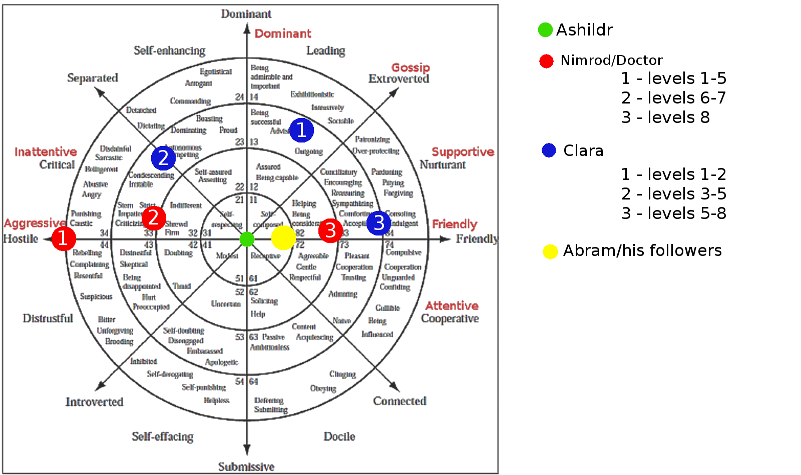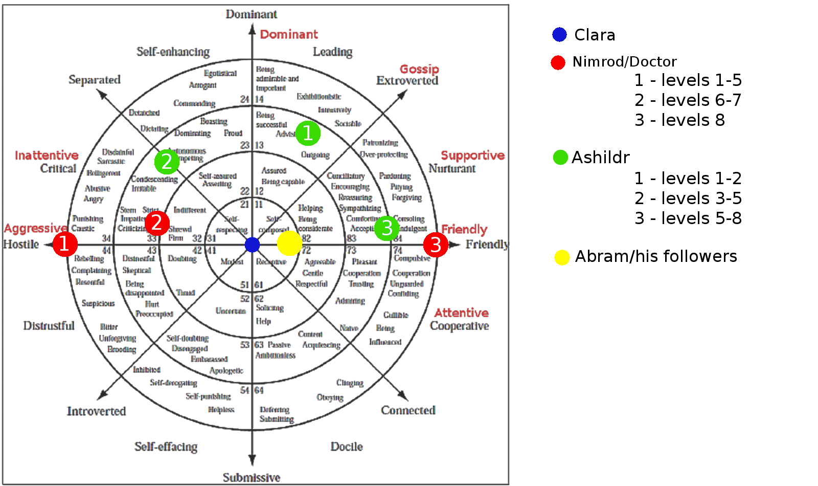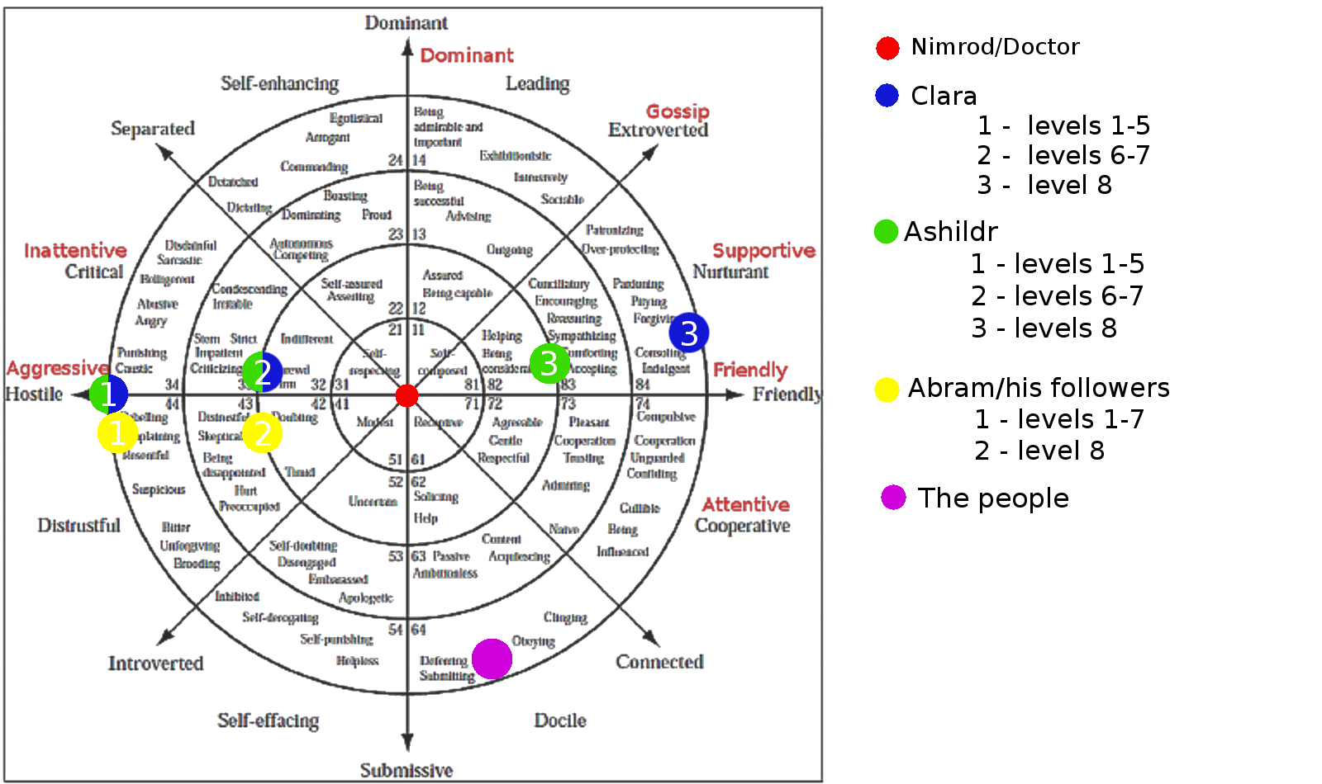

­

#### Ashildr’s path

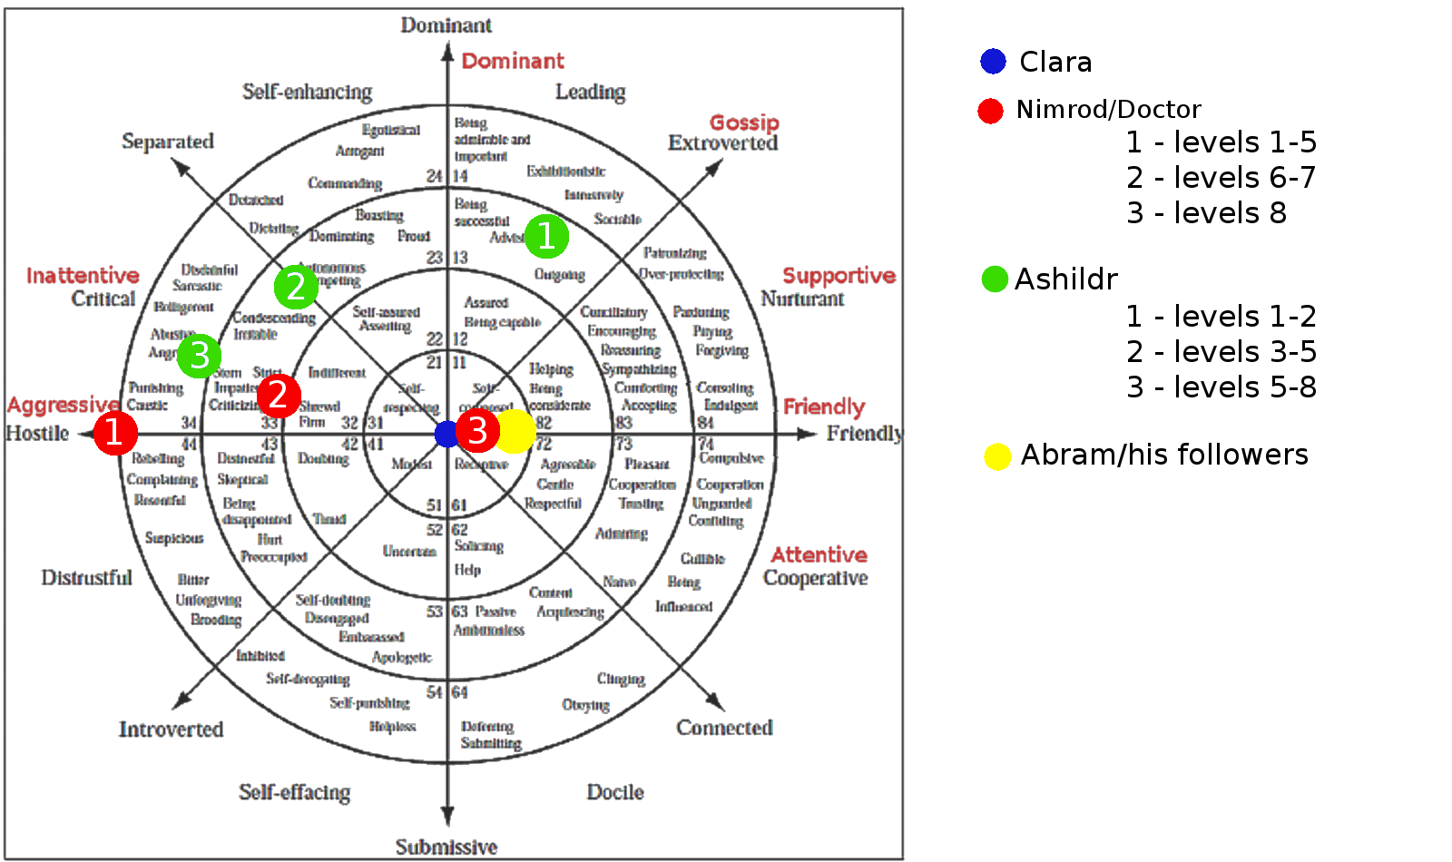

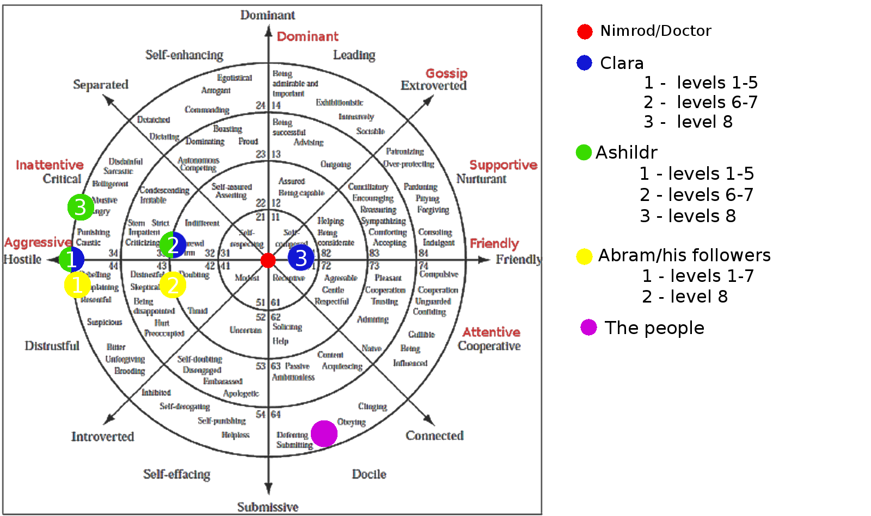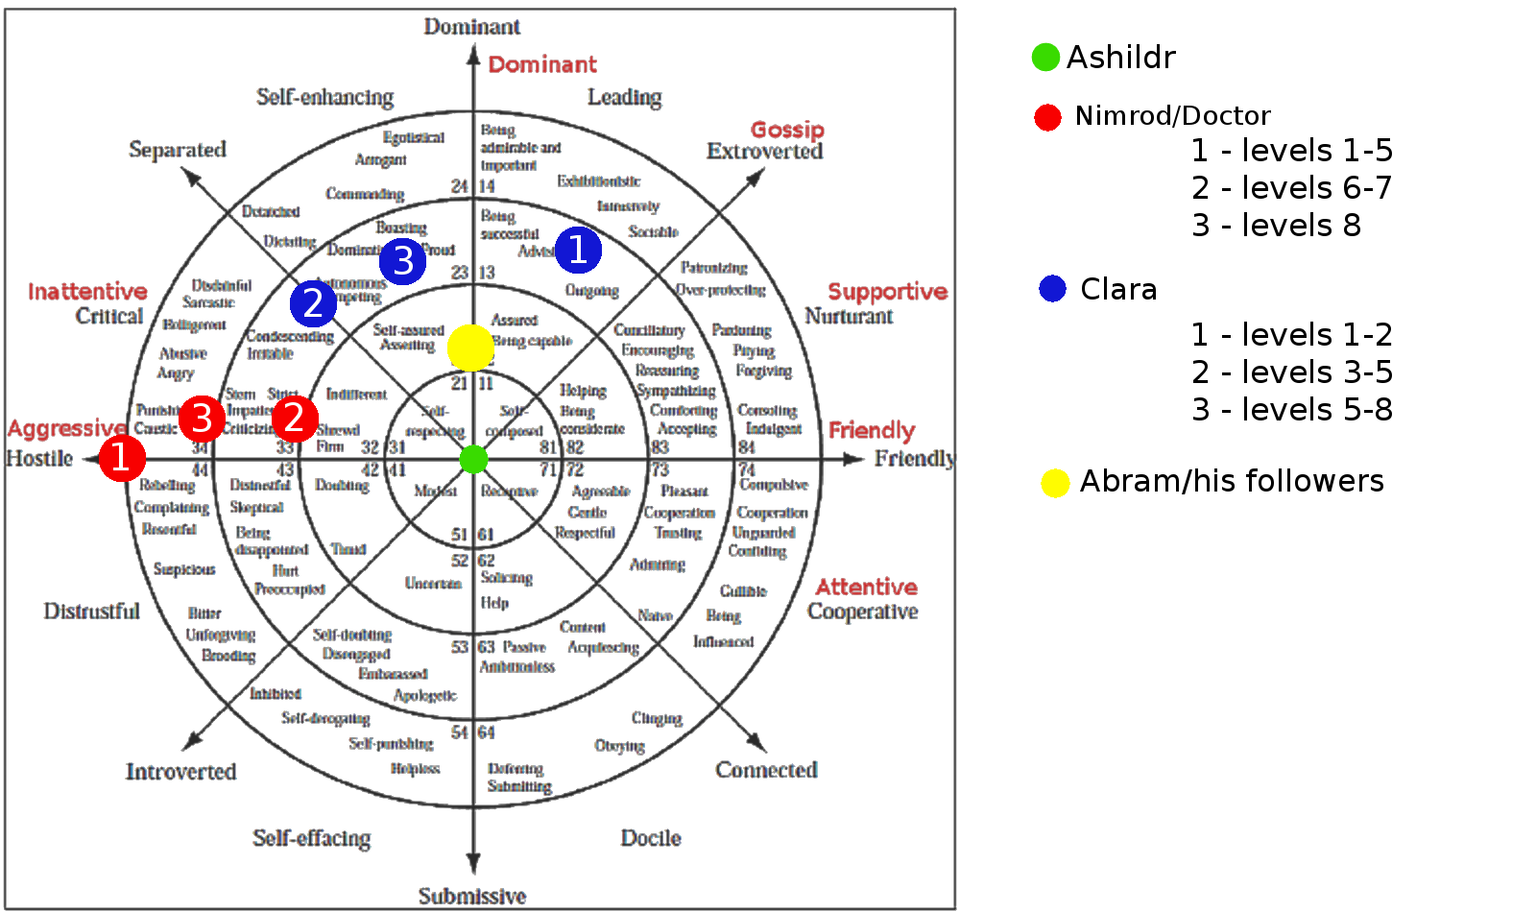

## Goals outline

In this section we show the objectives of the player through the story.

1. **First Level: Prison**
   1. Escape from prison
      1. Learn how to use nanite
      2. Free Abram
      3. Flee the guards
2. **Second level: At the gates of Babylon**
   1. Find a way to enter the city
      1. Trick the pimp and get enslaved
         1. Talk to caravan’s merchants to find a way to fool (and charm) him
   2. Escape from the pimp’s wagon
3. **Third level: Roaming inside the slums**
   1. Investigate what's happening in the city
   2. Find Abraham's house
   3. Discover all the clues in the house before the guards’ arrival
   4. Flee the guards
4. **Fourth level: The rebellion**
   1. Find out where is the merchant's house
   2. Persuade him to take you to the rebels’ crypt
   3. Convince the rebels to help you enter the inner part of the city
   4. Help them firing a riot against inner gate’s guards to distract them
   5. Enter through the second wall
5. **Fifth level: The centre of knowledge**
   1. Look for a way to enter the tower
      1. Explore the library
      2. Enter the greenhouse
      3. Steal a rod to enter the secret room
      4. Find ingredients for the sonic blaster
         1. Explore the dormitory
   2. Solve the enigma to enter the tower
6. **Sixth Level: The tower basis**
   1. Free Ashildir from temporal trap
      1. Enter and explore the doctor’s TARDIS
      2. Use the console to free Ashildr
7. **Seventh level: Revelation**
   1. Talk Nimrod and fool him
      1. Switch off the energy suction mechanism [Ashildr’s path]
      2. Distract Nimrod [Clara’s path]
8. **Final level: THE END**
   1. Enter the TARDIS again
   2. Fight the Doctor and make it clear to him how bad he is acting

## World annotated map

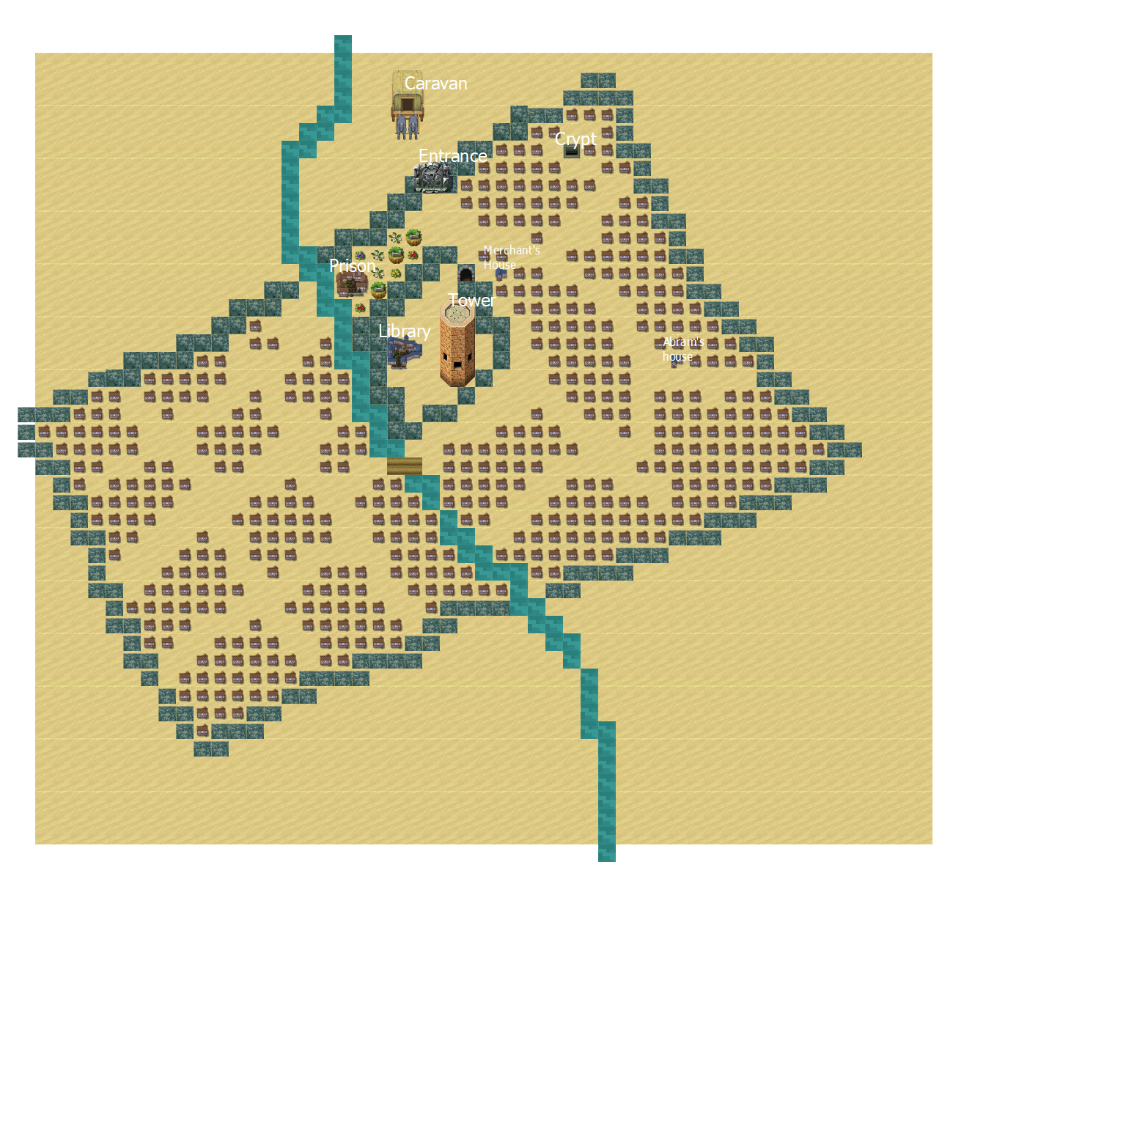

# Level five in detail

**NB:   
Gameplay features  
Animation/visual aspects  
Sound/music  
Voice**

We have chosen to design this level in detail because it represents the perfect mix of the sci-fi aspect and the historical aspect of our game (the key-aspects of the doctor who series too). It is the moment when the player, after levels roaming around an historically accurate reconstruction of Babylon, is introduced to some alien and sci-fi technology, e.g. the electric lamps, the tower’s lights, the alien plants in the greenhouse and the secret room.

## NPCs in this level

### Description

#### Librarian

The librarian is a cultured high priest, who has repeatedly read every tablet of the library. He is very careless about everything outside his loved tablets. His duty is to help other people to find what they search for inside the library, but he loves to dwell on tablets’ content when he should simply give people the tablet they want. He usually brings very huge meals, to don’t have to come back to the dormitory to eat during the day. He is a middle-aged man, a bit overweight and short. He is in his study **inside the library**.

#### The gardener

He has the reputation for being lazy, indeed he never loses an opportunity to skip work. He has conjunctivitis, and he think this is a sufficient reason to **bed** rest the whole day. Despite his sloth, he is very proficient in doing plants, the most expert priest. His tasks include feeding the carnivorous plant, which becomes intractable and aggressive when hungry. He is a middle aged and muscular person.

#### The high priestess who must die (in Ashildr’s path)

She is a quicksilver and lively, she can’t just sit still. Even when she has to study a tablet, she usually reads some line, and immediately gets up and start walking around the library, thinking what she has just read. She is a very young priestess, tall and healthy. She walks along **the library central hall**.

#### The two gossip priests

They are old friends, and love to gossip about everything possible. They don’t care of being listened when chatting, in fact they have fun seeing how people react while hearing what they are saying.   
The two are very different in physical appearance: one is tall and fat, the other is short and thin. The first time they are met inside **the library**, laughing about the gardener’s laziness, the second time they are met in the Clara’s path, **in the garden**, gossiping about the other priests sleeping in the library (once that Clara and Ashildr are come from the secret room, after having put the priests into sleep), the third time, the player find them waiting their turn to the ritual of the shower outside **the dormitory’s bathroom**.

#### The servants in the kitchen

They are an old lady, Aruru, and a young boy, Narubtum. The boy follows the lady’s lead, who, persistently but fondly, reproaches the boy. They are busy, and wonder if they should wake up the other two servants sleeping to help them.

#### The priests in the living room

They are very worried about the current situation.

#### Two priestesses talking in the park (Belili and Humusi)

They are taking a walk before dinner, and are talking about the gardener’s laziness, one priestess thinks that the gardener is not lying, while the other one has never believed him (the player can understand where the gardener is bed resting in the dormitory, listening to them). Both seem to love their job and their duties.

#### The bathing priests

Two fatty and bald priests, really devote to nimrod: they’re really worried about their aspect and presentation in the ceremony, so their bating time is really too long. There also two servants that are washing them. They are in **the bathroom**.

### Outfit description

#### Priest

Every important class of the Babylon society keep their beard as shown by the picture. Priests are no exception. Regarding their outfit, they wear long white long robes, with golden details.

#### High priest

High priest outfit contains a small quote from the doctor who universe. They dress with a white tunic like the other priests, but with more opulent details, and particularly they wear on the shoulders the strange metal plate worn by Time Lords too. They always have a shining rod with them.

#### Servant

Servants wear a simple and poor robe, in poor colors, like grey or light brown. They wear a charm made with a gem like the gem set in high priests’ rod, except that this gem is purple.

## Detailed area description

Map Number:

### The garden

The construction of the tower was interrupted due to the riot, so now in this area only Nimrod, the priests, and their attendants (normally, also the workers and the faithful can visit the garden) can enter. Silent area, only natural sound: light wind, water in the ponds, moving leaves.

The high priests live and study here; instead, the low priest can only visit the library, and live outside the second wall. **The walls** are built following the Babylonian architectural style, with big yellow clay bricks, and are higher than the other buildings (except the tower), also they are about 2 meters wide.

The area inside the second wall is a really big and lush **garden**, full of every kind of plants:

* dates palms, banana trees, coconut trees
* licorice, prickly pears
* poplars, alders
* lotus flowers

The garden is really kept mowed; there are many gardeners who take care of it. In the garden there is also some pond full of lotus flowers.

Four black slate **path**, starting from the central pond, lead to the entrance of the wall and the three buildings in this area: the library, the priest’s dormitory and the tower. Others little paths lead to specific area of the garden, some stone bench or some flowerbed, or maybe only cross the area to allow a relaxing walk in the nature.

By the **side of the four big paths**, there are rows of licorice shrub, and alders. Mainly, the **trees are placed** neatly around the dormitory or the library, or in the middle of the flowerbed, which breaks the monotony of the lawn. **Near the walls**, there are two rows of poplars to hide the yellow, bare wall. In the **south east** of the garden, there is a little area full of coconuts and banana trees.

In the middle of the garden there is a **pond**, full of lotus flowers, and at his center, there is a stone pedestal with a big sculpture of Nimrod, on a little island. On the top of the statue, which is made of white granite, there is a big green, luminescent stone. Four wood **bridges** cross the pond leading to this small island.

Along all the slate paths and the wood bridges, there are many wood **street lamps** similar to lances, and on the top of these small artificial fires shine, illuminating the whole garden.

#### Buildings external description

On the east side, there is the **library**, MAP REFERENCE which before was a temple: is built on an elevated plan, like the typical Babylonian Ziggurat, so to reach this building you must go along a stairway, black like the paths, and surrounded by street lamps. The library is a big and imposing building. The external walls are made in white calcareous bricks, with blue decoration on top, near the ceiling, which is made with battlements, like the other important building in Babylon. On the side of the single entrance, there are two blue cylindrical columns. On all the wall there are two rows of arched windows, high and narrow, to allow the light to enter.

On the west side of the garden there is the **high priest’s dormitory**. MAP REFERENCE This building has a rectangular plant, and two floors, is very long, placed on north-south axis. The outside of the building is made of white limestone bricks, with many arched windows, high and narrow, with blue and purple decoration on top. A white stone door, with some inscriptions, closes the entrance and a purple gem glows in its center (the door can be opened only using the special rod of the high priests or the purple gem of the attendants).

**The tower,** MAP REFERENCE in the south part of the garden, is surrounded by a bare land area, without trees, the lawn cannot grow due to the construction site. This building is a “work in progress” so the last floor is incomplete. The ground plan of this building is circular, the walls are made with white limestone bricks, the rows of windows follow the height of the tower in a spiral pattern, and so are the rows of bright blue gems. The tower is the tallest building in the city, even if you try to see the top, you can’t. The tower contrasts with the rest of the environment, giving a sense of modernity and progress out of place if placed near the nature of the garden, or the ancient and wise appearance of the other buildings.

#### Area’s mood

The garden is in contrast with all the environments explored so far by the player: the prison and the crypt are dark and creepy, the area outside the walls is surrounded by the desert, the city is built in clay, with poor materials, and very chaotic. Everywhere the dominant colors are yellow, beige, brown, ochre, light blue and white. Here, just entered, the player remains amazed by the triumph of nature, the **dominant colors** are the green of the vegetation and the thousand, colorful, shades of the flowers. The almost black slate paths do not create a gap between the natural environment and the road, as could happen with white paths. All buildings are white externally, and the water is abundant in the various ponds, so the impression of “city in the desert” is completely lost. Moreover, **especially at night**, the player has the feeling of being out of time: the contrast created by the ancient appearance of the buildings and the artificial luminescence of the street lamps and the tower create a surreal environment.

#### Objects

* Banana: Normal fruit, yellow, not ripe, but mature. The player can pick it from many banana trees in the south of the garden.
* Nimrod statue: lead to Easter egg room.
* Smoke from dormitory: produced by the kitchen, used to build the soporific bomb.
* Sticks: some wooden stick fallen from the trees, collect around the garden.

### Library

for external description, see the garden paragraph

The library is a large rectangular-based building, composed of three large rooms:

* **The central hall**, is the largest of these tree areas. It’s a very imposing hall, which consists essentially of white calcareous brick. This space is made up of high shelves used to store the tablets; the statue of Nimrod stands out in the middle of it. In the hall there are huge shelves of stone and wood, which reach the ceiling: to get to the highest cuneiform tablets you have to climb up some ladders arranged along the length of the shelves. The player will notice sometimes that some priests appear and disappear from the central hall. These sudden disappearances occur when the priest hits the rod twice on the ground close to Nimrod’s statue, the gem in the center lights up, and they disappear.
* **Study room**, which is used for consultation and study by ordained priests and novices. In the center of the study room there are two huge stone tables, surrounded by numerous benches. Here priests and novices can consult and study the tablets, since these cannot be taken outside the building. On the opposite side of the tables, we can find the **librarian's office**, which is accessed by passing through two ancient columns: the librarian has a stone desk and a chair, and a huge appetite: his abundant meals are usually placed on the stone table.
* **The greenhouse**, located on the west side of the building, which is mainly used for the cultivation of plants and where the priests perform experiments and studies on a series of alien and non-native plants. The greenhouse has a thick ceiling full of artificial lights, which not only light the room, but also provide energy to plants who need it. The walls of the greenhouse are made of rough stone, without any decoration. The greenhouse is divided into two sections by a large central corridor oriented along the north-south axis, from which several smaller paths take up space. Next to the door there is a flowerbed that hosts a hungry carnivorous plant (about 2.5 / 3 meters high) that attacks anyone who enters with its tentacles (unless it is satiated, it does not need only the energy to survive, she must be fed with meat).

The library is very bright, due to the various rows of windows placed along all the external walls and to special braziers collocated along the walls and among the huge stone tables. These **braziers** contain electric bulbs similar to fires, but that, unlike these ones, do not emit actual heat: in fact, the traditional fire is not allowed in the library, because exposure to heat could dry the clay of the tablets and cause it to break

**The inside walls** have been covered with white glazed bricks, and in the upper part of the wall white and blue tiles alternate to form a striped decoration. On the walls there are also numerous depictions of religious scenes and animals, made with enamels on the bricks. The ceiling follows the style of the aristocratic palaces of the Neo-Babylonian era: indeed, it’s made up of cedar wood coffers.

#### Object

* The abundant meal of the librarian: which is located on his office, upon the stone table.
* Priests’ Rod: Long blue rod decorated with golden lines. At the top there is a gem that changes color according to the destination of the teleport and an arc that encircles the gem. In addition, to the side, there are two wings as a decoration. Every high priest or priestess carry one of those with him.

#### Plants (in the greenhouse)

* **Alien pitcher plant:** very dangerous plant, vaguely similar to the earth’s pitcher plant, but significantly bigger, it can easily fit a medium sized adult inside itself. The leaves also are rather huge and strong, capable of lifting great weights without much effort. It seems to have some sort of sentience, but nothing more than an animal with strong predatory instinct. His roots have very strong medical properties, mostly for digestive problems and tissue healing. His leaves seem to have an even stronger medical power, but it’s a lot more difficult to get them.
* **Morpheus Berries:** Simple blue berries with a strange motif on them, somewhat similar to the blue marble fruit. (Elaeocarpus angustifolius’s fruits). The plant is similar to a tomato plant. They are grown to help Nimrod sleep since he usually has nightmares.
* **Hydraulic Screecher:** this plant has been developed as a part of a research about a water system. It appears as a tentacular plant, with tentacles that grow directly from a point inside the terrain... His leaves and roots have the ability to pump water at high pressure, unfortunately doing so the plant tends to produce a high frequency and very loud noise and provoke a rapid, strong movement in the plant and every attempt on diminishing that has proven unsuccessful so far.

MAP 1 LIBRARY

#### Texts: on tablets

The tablets are divided into section:

1. Botanic
   1. Pitcher Plant: The pitcher plant is very dangerous, it can easily fit a medium sized adult inside itself. It seems to have some sort of sentience, but nothing more than an animal with strong predatory instinct. His roots have very strong medical properties, mostly for digestive problems and tissue healing. His leaves seem to have an even stronger medical power, but it’s a lot more difficult to get them and this is why, despite its dangerousness, the pitcher plant is widely used for medicinal purposes.
   2. Morpheus Berries: Morpheus Berries have a mysterious chemical composition, almost impossible to conceive. Some scientists ironically says that organisms of this type must have been created only by a madman or a genius. Although studies on the structure of the molecules that compose those are still ongoing, what is certain is that this sort of berries act as a powerful draught.
   3. Hydraulic Screecher: The Hydraulic Screecher is an ongoing research, a plant that can be used to transport water. It doesn’t seem to be going very well though, the plant is very noisy and agitated, impractical to be used.
   4. Grain: A research about a wheat that grows really fast and with little to none water. Still in a really early stage, but seems promising.
   5. Current: A closed research about a conductive type of plant. It’s not clear if it conducts electricity or another type of energy, but it seems to work pretty well.
2. Politics
   1. Priests’ Orders: A tablet about the hierarchy of the priests. There seems to be only two orders of priests, the acolytes (or lower priests) and the high priests. The formers are still apprentice, while the latters have completed their education and they are in charge, with access to the secret room. It is unclear how they can access it, but it seems to have something to do with a symbol of recognition they have.
   2. National day: A list of all festivities established by the religions. It seems that one is near
   3. Careers: A list of the most important jobs, seems that the most ambitious ones are the gardener and the librarian
   4. Servants: A tablet about all servant’s rights. They are not treated that bad after all.
   5. Laws: Seems like a raw version of a law system. Must be still under processing.
   6. Kings: A list of kings and rulers of Babylon, nimrod is the last one
3. Astronomy
   1. Calendars: A tablet with two calendars, one has only 30 days months, the other one appears as a modified version of the first one
   2. Venus: An observation of the motions of the planet Venus
   3. Stars: A catalogue of stars and constellations, some of them are still present in the modern days
   4. Prediction: A system of interpretation of the sky’s movements it seems like it has gone under a lot of revisions trying to approach a more scientific method

1. History & Myths
   1. Gilgamesh: A tale about a demigod named Gilgamesh and his journeys and accomplishments
   2. …Enlil places its tail in the sky and creates the Milky Way, and from its tears the source of the Tigris and Euphrates is born.
   3. Nimrod: Here it tells the tale of a magnificent king descended from the sky bringing joy and peace. His name is Nimrod. Not the most modest person ever.
2. Medicine
   1. … Anise: to be swallowed. Stomachache.  
      Cassia: to be swallowed. Laxative.  
      Myrrh: to be applied on the skin. Perfume.  
      Saltpeter: to wash clothes. Detergent.  
      Sulfur: to apply on the eyes. Conjunctivitis.  
      …
   2. …the main purpose of the ritual of the shower is to purify the person before taking part of a holy ceremony. Secret room

### The secret room

The point of arrival is a square room almost empty, only a Nimrod statue is placed on south-east border. On the north border of the room there is a corridor that leads to another room, this time circular.

Both the rooms are pretty large, the statue at the entrance is rather big, but the rest of the first room is empty, so it still feels spaced up.

The **circular room** contains a rather large screen [1.5m x 1.2m] at the center, positioned at man height. All around are placed cables connecting the screen with the walls. These cables are varying in size, between 1cm and 10cm, often entangled.

**Colors choice**: the walls are all made of a metallic material completely black, various red veins traverses all walls and floor, the statue is black too, but with a white light, that reflects the white in the library. The project’s columns are red and black too, but the screen above is blue sky, same for console.

#### Area’s mood

The colors chosen are red and black because they can help express a sense of danger, uneasiness and urgency, they are at the core of the knowledge of that world and even if there is no real danger in that place it still needs to instils some sense of threat. The first room is pretty basic and empty, very far spaced, it is used to present the environment’s color and style, but with still some calm, the second room instead is tighter and claustrophobic, to further express how much deep they are into the knowledge and to enhance the sense of secrecy of looking the projects. The light of the displays is sky blue both because they need to be seen as non-threatening and useful and because it is a color often associated with Nimrod’s technology.

#### Texts: the projects

In the room there are 13 columns containing the following projects:

* Tower: “This contains the tower map and planning, with walls specs and positioning. Strangely it seems to cover only the lower levels.”
* Library: “Map of the library and list of sections and tablets, there seems to be four sections: Botanic, Politic, Astronomy, History & Myths”
* Prison: “Map of the prison, including what materials are used, blueprint and an emergency plan in case of breakout of very dangerous prisoners. Indeed, a special room for those is hidden inside the building.”
* Dormitory: “Map of the dormitory, apparently it has two floors, the ground floor contains everything is needed, like kitchen, a common room. The first floor contains all bedrooms. The focus is on the mechanism of its big stone door, with a trigger-able purple gem on its center.”
* Greenhouse: “Map and position of various plants inside the greenhouse, as long as some guidelines on how to treat various specimens”
* Lights: “The project for the lighting system. Most of them are just used to light the place, but the greenhouse ones also provide energy to the plants and the lights on some statues are able to power up the rod”
* Rod: “This is the project of the rod, it seems to be an antenna used to guide a transmat system, the location of the teleport is indicated by the color of the gem”
* Sonic Blaster: “The project of a sonic blaster, a powerful weapon capable of open squares in walls. Probably used to speed up the building job”
* Statue of Nimrod (energy generator): “The project of the energy system, the statue at the center of the park seems to be used as a battery or a generator that powers up everything in the area”
* Transmat statues: “The project of the statues used to charge the rod allowing it to teleport to different locations”
* Energy Transfer system: “It is a project for an energy draining system. It seems to use the material the tower is built with to absorb energy from the people”
* Circle of heaven: “Very weird project about a system that uses energy to keep sealed an evil entity. It is very vague about this entity and it seems a little different compared with the others, almost magical”
* Blue breakthrough project: This project seems to be deleted, weird. The name ‘blue break-in projects’ seems to be the only thing left”

### Dormitory

for external description, see the garden paragraph

The dormitory is a two-story white building, and it is a typical example of Babylon architecture: squared, rectangular plan, flat roof. **The floor** is made of cut sandstone blocks, as well as the internal walls, which are not decorated.

**The ground floor** is divided as follows:

* + - In the northern-west part, occupying half the size of the floor, a **big living room**, used to eat and to spend time in other activities. it is the biggest room of the ground floor, the big entrance stone door leads directly to this room. There are 3 long wooden tables, with many wooden chairs around them; on these tables there is some ceramic crockery (dishes, cups and jugs of water and beer). On the east wall there is a wooden shelf full of the same kind of crockery found upon the table. There are two wooden doors in the south wall, leading to the kitchen and to the bathroom. Three priests and two priestesses are eating lamb stew and quietly talking, and a couple of priests waiting (outside the bathroom door) their turn to take a shower. [description here]
    - In the south-east part, almost long as the living room, there is the **bathroom**. The floor of this room is different from others, because here the bricks are waterproofed with bitumen, which is plastered even in the lowest part of the walls. Close to the west wall there are two baths (dug in the ground, lined with the same bricks of the floor) with a drainage hole and its stone plug. On the south wall there are some wooden shelves, where you can find powders and oils for hygienic or cosmetic purposes (e.g. saltpeter for washing clothes, scented oils). Under the shelves there are two barrels, which are used by servants while high priests want to have a shower. In the bathroom there are two priests that are taking a shower [description here]
    - After the living room, in the west side, the **kitchen** with a little pantry to east. : it has a dome oven inside, used to cook everything, close to the west wall, in this wall there are two small windows from which you can see going by a lot of smoke and steam 12 while servants are cooking meals (it is important for the puzzle involving the smoke). To the north-east corner there are two tables where servants mix ingredients, or prepare the food before cooking it (etc.). On these tables there is the big ceramic pot where the lamb stew has been cooked. Upon the tables there are wooden shelves, where you can find colorful spice containers (e.g. cumin), ceramic crockery (pots and lids, and other containers) and wooden utensils. Inside the room there are two servants (an old lady and a young boy), cleaning and preparing food, they are preparing the dinner for the priests in the living room, and have just served the lamb stew. Now the lady is preparing a simple salad with fresh vegetables, while the boy is cleaning the dome oven. In the east wall there is a door leading to the pantry, a small room where are held salt beef and fishes, dried grains or other legumes, also fresh vegetables and fruits. There is a wooden beer barrel too.
* Near the kitchen there are **servants’ quarters** (south-west room) linked to both the kitchen and the bathroom Servants’ quarters: this messy room is made for the servants to sleep. Here there are ten straw mattresses on the ground, and 3 wooden chests close to the north wall, where servant’s dresses and belongings are hold. This room is connected to the bathroom, through a wooden door on the east wall, and to the kitchen, through another wooden door in the east part of the north wall. There are two servants resting inside the room, sleeping.

Instead, high priests to sleep use the **upper floor**, and for this reason there are two big **bedrooms,** divided into man and woman. Every room is lit up by torches on all the four walls of the room. The first floor: it is divided into two huge rooms, with a hallway to the west side leading to both. To the north, the female dormitory, where priestesses can sleep and rest. To the south, the male dormitory.

Both the rooms contain many wooden raised beds (22 women and 22 men), with a wooden chest for each bed, where priests keep their personal belongings. Both the rooms are almost empty, with only one priest (the gardener) and two priestesses sleeping. One resting priest is the gardener of the library’s greenhouse, who is idly missing work for a simple conjunctivitis: he is sleeping with a smirk on his face. Upon his chest there is a pot of sulfur powder.

The **stairs** connecting the levels are made of wood.

#### Area’s mood

Here the choice of colors and materials is as historical accurate as possible, this is the place where all the higher priests live, they are natives, so the building has been built as familiar to their tastes as possible.

#### OBJECTS

* + - Sulfur: a pot of clay filled with sulfur in powder. The player can find it upon the gardener’s chest.
    - Saltpeter: a pot of clay filled with saltpeter in powder. The player can find it upon a shelf inside the bathroom.
    - Coal: solid chunks of black coal. The player can find it inside the dome oven, in the kitchen.
    - Bucket: an old and dirty wood bucket, it can be found into the kitchen’s pantry.
    - Blanket: a white linen blanket, on every bed in the dormitory
    - Rope: an ordinary rope into the pantry

### Tower base

for external description, see the garden paragraph

As for every level of the tower, this one too is circular. There are several huge columns positioned in a circle, around the midpoint between the walls and the center where is placed the Doctor’s TARDIS.

The TARDIS is placed inside a metal cage (a faraday cage) and connected to it there are many cables placed all over the room, from the center to the borders, connected to the TARDIS. The walls are covered with a sky-blue light, similar to the one on the exterior.

#### Area’s mood

The materials used for the construction of the walls are somewhat similar to those used to build the other buildings, to give the impression of something that belongs there, but they are covered with various arrays of blue sky lights to give it a sense of holy and valuable. This is reflected on the internal walls too and this feeling goes in direct contrast with the technological interior. At the center there is the TARDIS, surrounded by a cage, this has been made both to give a sense of protection, to keep away unwanted guests, but also, and mostly, to constraint him and every type of communication (since has been sending helping requests). The wires around try to convey a sense of technology as well as constraint and control (or attempt to).

#### Objects

*Used to enter: in this level there are no object to collect in the tower*

* + - Gun: Colt gun, more or less from 1850, long thin metal barrel, big metal cylinder and wooden handle. Built with: banana, saltpeter, sulfur and carbon.
    - Sonic Blaster: Classic sonic blaster from doctor who (first appearance in the first season, episode “the empty child”). Built with the gun and a piece of the Hydraulic Screecher.

## Event progression and diagram

**NB: Crafting events can be activated everywhere (if the player has collected all the objects needed) so they aren’t noted on the maps.**

### ****Event progression****

Available areas: The **garden** and the **library**.

1. Events available in the garden:
   1. Picking up some flower [also if they are useless]
   2. Walking on slate paths and grass, but not in the water or into the flowerbed, trying to walk on the flowerbed will trigger this single sentence dialogue: Clara – “I think it is impolite to step on these marvelous flowers”.
   3. Talking to the “Two priestesses talking in the park” (see character paragraph), to trigger the following dialogue:

- Priestess 1: “And again today our gardener skips work for a simple conjunctivitis, I can’t understand why Nimrod hasn’t sent him away yet.”

- Priestess 2: “You know Nimrod has a soft heart, but it is unbelievable that one cannot access the greenhouse for that man’s sloth”

- Priestess 1: “If Nimrod won’t think of getting rid of him, maybe will be the carnivorous plant to do it”.

* 1. Picking up bananas from the banana trees in the southern area of the garden.
  2. Picking up different sticks around the garden.
  3. Entering the library, (At the beginning of this level the player can’t enter the tower or the priest’s dormitory).

[The following events will become available later in the level’s progression]

* 1. [Clara’s path] Hyperscanning [Clara’s Skill] the smoke outside the dormitory using the Nanite AI. (If our Clara has already the berries)
  2. Filling the bucket with water
  3. Throw the Screecher in the water
  4. Using the sonic blaster (if crafted) to open a passage leading inside the tower
  5. Interacting with the Nimrod statue at the center of the park to teleport to a secret room (if the rod is present in the inventory)

[Events available in the library:]

1. Events available immediately:

[Immediately before entering the library, scripted scene where two priests (gossip priests) exit from the library, laughing:

* Priest1: “We can’t access the greenhouse today either! That plant is as hungry as aggressive as it has never been! When will Nimrod decide to take another priest as gardener?”
* Priest2: “Yes, that gardener is so lazy, I guess he is slacking off on the bed right now!”
  1. Reading the tablets, interacting with bookshelves [the dialogue which will be triggered depends on the particular tablet with whom the player is interacting -> see map annotated with objects]
  2. talking to the NPCs:
     + 1. Talking with the librarian: **“Hello, don’t you think this place is majestic? One can’t simply understand how much knowledge can be collected in one building, this has been such a great idea”**
       2. Talking with studying priests in the study:

Interacting with Priest 1 - “I’m sorry, I am trying to memorize some speech for tomorrow’s celebrations. “

Interacting with Priest 2 – “Haven’t you ever considered how much Nimrod has improved our society since his arrival? Gender equality and anti-slavery are only small examples of what he taught us.”

Interacting with Priest 3 – “Why are you hanging around slacking off? I can’t believe Nimrod hasn’t assigned some task to you for tomorrow’s celebrations.”

* Clara: “Sure lord, we are just looking around for some tablets we are supposed to study.”

[It is important to underline that this replica of Clara occurs in two circumstances: before the bottleneck expressed by the scripted scene number 7, and when the Clara’s path has been chosen thereafter. Instead if you have chosen the path of Ashildr, the dialogue that will have Ashildr with the priest will be:

* Ashildr: “Good point lord, I'm just looking for my target, oh sorry, I mean my task...”]
  + - 1. Talking with the worried priest walking in the hall [her answers depend by her position, you can check the automata to understand how she moves around the library]:

Astronomic section: “Where was those constellations destroyed by the tyrant plant? I really can’t find anything… maybe I should study more how the tyrant plant acts… but I can’t find anything in the botanic section!! Argh, I guess it’s me who can’t find it, there has to be something there. Let’s check it out.”

Botanic section: “I can’t find anything about the tyrant plant here… it was I tyrant, should I check better the politics section?”

Politics section: “Nothing about the tyrant plant… I didn’t know what I expected again. I must check the myth another time”

Myths section: “The tyrant plant was a plant which colonized an entire stellar system, destroying it and making some entire constellation disappear… that is everything I can find, I think I have memorized them by reading them so many times! But I really can’t find anything about those constellation in the astronomic maps! I’ll try to check them again”

* + - 1. **Priestess relaxing on the right – “I love this place, the decorations are wonderful and it’s so peaceful”**
      2. **Priest studying at the south-west corner of the library - “**I still remember what it was like before Nimrod came”
      3. Priest at the west corner of the Astronomy section: - **- “I’m going to study everything in here and I’ll get promoted in no time!”**
      4. Priestess close to the medicine section – “I have sore throat, maybe one of these tablets could help me”
  1. attempting to enter the greenhouse;
  2. exiting the library
  3. Trying to take the rod on the study room table [when the player tries this action, the following reaction will be triggered by the priest3:

Priest 3: “What do you think you are doing?? Earn your own rod and meantime don’t touch mine!”]

1. Bottleneck: trying to enter the greenhouse [when the player opens the greenhouse door, a scene shows the pitcher plant’s tentacles attacking the characters that run away] and fail. Clara says: “I guess it is the plant the two priests were talking about. How can we feed it?”
   1. Events available from now: stealing the librarian’s food.
      1. Interacting with his food will trigger the following dialogue:

-Clara: “We should use this to feed the carnivorous plant!”.

-Ashildr: “Nice idea, we need to distract the librarian in order to steal his food, I guess. Wait, I have a better idea, let’s use him to feed the plant!”.

-Clara: “Are you kidding me? Be quiet and follow me!”

* + 1. Now interacting with the guardian will trigger the following dialogue/scripted scene:

-Clara: “Sorry lord, could you show me where to find some reading regarding our myths, I really need to check them.”

-Librarian: “No problem lady, did you know how much our lord Nimrod loves the Gilgamesh myth?”

-Clara: “I honestly didn’t, tell me more if you don’t mind, please”.

[Clara and the librarian leave the librarian’s study, Ashildr is alone]

* + 1. Now the player controlling Ashildr can interact with the meal to steal it.
       1. If the player tries to leave the room, Ashildr will stop and think: “I must steal the meal now that I can, fast”, in this way the player won’t be able to leave the room.
       2. Once stolen the meal, Clara and the librarian come back:

- Clara: “Thank you so much!”

- Librarian” No problem, I really wanted to tell you more about that”

- Clara: “You will tell me another time, don’t worry, bye! [whispering to Ashildr] This guy is really boring!”.

[The librarian comes back to his study, Clara rejoins the party]

1. Bottleneck: manage to enter the greenhouse by feeding the alien pitcher plant with the meal stolen from the librarian [interacting with the door will start the scripted sequence where: the pitcher plant’s tentacles/take the meal from Clara’s hands, the protagonists enter the room, the plant is chewing/eating]
   1. From now: collecting objects in the greenhouse, the player can find:
      1. Morpheus Berries, to read the plant’s name, and interact again with it to gather the berries.
      2. Hydraulic Screecher, to read the plant’s name.
2. Scripted scene (starts when the player exits for the first time the greenhouse) in which the player sees a priest changing the light of the rod, pointing it at the statue of Nimrod in the central hall and beating the rod on the ground twice. After, the gem on the rod lights up and the priest disappears.
3. [The player could have read the tablet regarding the priest’s creed. If the player has not read the priest's tablet, Clara starts a dialogue: “What? Did he just disappear? Where did he go? Maybe we can find some useful information in the tablets”. If or when the player reads the tablet, after this sequence, Clara will start this dialogue:

* Clara: “So, is that rod that allows the priests to enter the secret room? I mean, that priest can’t be simply disappeared. He must have gone somewhere, right?”
* Ashildr: “I think it’s kinda obvious… we should get one of those rods”

1. Scripted scene: the two characters think the respective solutions to steal one rod [the [their thoughts](http://context.reverso.net/traduzione/inglese-italiano/their+thoughts)scripted scene/dialogue following and the player can choose one of the two by picking out with which character play from now]
   1. **Ashildr:** “we can simply kill one of these priests and take the rod… I do not think someone will miss one of these fatty and foolish priests…”. **If the player chooses this path** the following dialogue will be triggered:

- Clara: “You, always think about killing people… You really cannot go one step further! Only for this time, try to consider the consequences of your action for other people! “

- Ashildr: (Thinking) “I need to get rid of someone to take their rod. But Clara must be somewhere else while I do this”. [as always, the Ashildr’s path is more aggressive and reckless]

[Events required in order to follow this path:]

* + 1. Sending away Clara using an excuse: [dialogue follows]:

-Ashildr: “Ok, maybe this time we can try your way… but if takes too long I cannot guarantee to stay patient”

- Clara: “I cannot believe that, finally, this moment has come! “

- Ashildr: “Don’t get overexcited, I just sad “try” … anyway, let’s split up, try looking for other priests in the garden, I will search here.”

- Clara: “OK! See you later” (Clara goes outside leaving the party).

* + 1. Killing a priest. There is only one possibility: one priestess that periodically passes in front of the greenhouse, hidden from other priests’ sight. Indeed, when you try to kill any high priest [the priests with the rod] in plain sight, [by selecting the skill “kill”] the character of Ashildr thinks: “I can’t kill anyone with witnesses around, I should find someone alone", if Ashildr tries to kill a priest/ess without the rod, she will say: “It is useless to kill this priest/ess, since he/she doesn’t have a rod”.
    2. Once killed the priestess, Ashildr thinks: “I need to get rid of this corpse, where can I hide it?”, she takes the corpse/drags it with her.
       1. Interacting with priests dragging the dead corpse.
          1. Priest at the south-west side of the Library: “Is she ok?”
          2. Priest at the west corner of the Astronomy section: “I think your friend is a little pale, she needs rest”
          3. Priestess relaxing on the right: “Has your friend seen the carnivorous plant? Even I, too, actually got scared”
          4. Priest number 3 inside the study [remember event 2Bb]): “Today's youth faint like nothing...”
          5. Priest number 2 inside the study [remember event 2Bb]): “Does She feel sick? With the new medicine taught us by Nimrod I guess she'll be fine in a bit”
          6. Priest number 1 inside the study [remember event 2Bb]): “If She is that bad, she shouldn't have left the dormitory”
          7. Librarian: “Not everyone is able to stand this amount of study...”
          8. Priestess close to the medicine section: “Do you need some help to search for medicine’s tablets?”
    3. Feeding the alien pitcher plant with the dead corpse. [If the player tries to get away from the library, the previous Ashildr’s thought will appear again, and the character won’t leave the library]. After this event, the player receives the dead woman’s rod [**now the player can access the dormitory**]

Immediately the following Ashildr’s thought is shown to the player:

* Well, I got the rod in a faster way than it would have been able to do Clara, now I should go and call her…
  + 1. Interacting with the statue without having looked for Clara to rejoin the party:
* “First, I should go to find Clara”
  + 1. Finding Clara in front of the dormitory’s door and talk to her, in order to rejoin her:
* Ashildr: “Once again I am faster than you. Clara, won’t you become a burden, right?”
* Clara: “How edgy you are. Did you find a rod? Nice, let’s try to enter that secret room”
  + 1. Interacting with the statue to teleport into the secret room [Charging the gem on the rod with the red gem on the Nimrod’s sculpture, beating the rod twice on the ground.]
  1. Clara: “As always, it’s all on my shoulders: I have to find a way to take a rod without hurting anyone” [this path is more diplomatic and explorative]. **If the player chooses this path**, the following dialogue is triggered:
* Clara: “We don’t need to harm anyone Ashildr”.
* Ashildr: “What a bore you are! What do you want now?”
* Phone: “I think Clara is right, we could someway put to sleep those priests inside that study room…”

[Events required to proceed in this path:]

* + 1. Picking up the Morpheus’ Berries in the greenhouse [a clue is given by reading the tablet about the plants, and the player can find the name and description on the flowerpot in the green house]
    2. Finding the gas/smoke: the player can use the steam that leave the window of the dormitory’s kitchen.

When Clara approaches the following dialogue is triggered:

* Clara: “It seems like some steam is coming from this window…”
* Phone: “I can hyperscan this for you ladies”
  + 1. Combining the berries and the steam with Nanite to make a soporific bomb. The phone says: “Let me think, what we have here? Morpheus Berries and steam... hum... inspiration! Soporific bomb!!!”
    2. Intoxicating the priests in the study room.

[When the player tries to enter the study room, and He/she has already created the soporific bomb the following dialogue appears:

* Phone: “Ok ladies, are you ready for this?”
* Ashildr: “Finally! A shred of action! I was almost dying of boredom”
* Clara: “Ohoh how funny of you… Come on, since you behaved well here in the library, I grant you the honor to throw the bomb”
* Ashildr: “Here we go!”]
  + 1. Taking a rod **(now the player can access the dormitory)**
    2. Interacting with the statue to teleport into the secret room [Charging the gem on the rod with the red gem on the Nimrod’s sculpture, beating the rod twice on the ground.]

1. **SECRET ROOM (events available here)**
   1. Entering the circle room: dialogue:

* Phone: “OOOOHHHH looks like there are a lot of interesting projects here!” [the nanite spider unplugs itself from the phone and runs fast to the column]
  1. Now the player must interact with the column to start the following scripted sequence [If the player tries to leave the room without having recovered the nanite spider, Clara will say: “Why are we leaving? We need to know more, and we can’t leave Nanite here”]:
* Clara, to the phone: “Hum, what are you doing?”
* Phone: “I am downloading a lot of data from this console! It contains all the projects of all the buildings built by Nimrod, and other technologic stuff.”
* Ashildr: “Nice! You have found the project of the tower too, am I right?”

[the phone, unplugs itself and returns to Clara’s phone, while Clara is holding it]

* Phone: “Yes you are. But looks like the tower can be only opened from the inside…”
* Clara [sad]: “Oh no…what can we do, now?”
* Phone: “Wait a sec! I’ve found something interesting, check it!”

[Clara and Ashildr are looking at the phone].

* Ashildr: “Sonic blaster…used to make holes in the walls.”
* Clara: “That’s our way in! But a sonic blaster is quite a strange object, how can we help you to build one, Nanite?”
* Phone: “Hum, sonic blaster… easy! I want some sonic and some blaster!”
* Ashildr: “Blaster… how can we make a blaster in ancient Babylon?”
* Phone: “Using what you have in this age you can easily make some gunpowder, then give it to me with something that shoots and I will be fine.”
* Clara: “As I can remember, gunpowder is composed by sulfur, coal and saltpeter. But what about the “sonic” thing?”
* Phone: “How boring! Can’t you really understand? Just record a terrible screech and you will have your “sonic” part.”
* Clara: “Hum, ok…”

[From now on, the phone’s interface has a new function: “projects”, where all the downloaded projects are listed, selecting one project will trigger a dialogue where Clara resumes the content of the projects, depending on the specific project [check the Secret room area description to read the project description which Clara will read.]]

* 1. Interacting with the Nimrod statue in the square room to return to the library.

1. EXITING FROM THE LIBRARY
   1. [Now the sun is fallen down] If the player has previously chosen Clara’s path, he/she can hear a conversation of two priests (gossip priests, check character description):

* Priest 1: “Looks like the laziness is contagious! Everyone is dozed off inside the study!”
* Priest 2: “(laughing) True, it is incredible! I will tell Nimrod everything!”

1. PRIEST’S DORMITORY

[As we told before, now the player can enter the priests’ dormitory interacting with the door.]

[Events available inside the dormitory:]

* 1. Inside the living room:
     1. The player can talk to the worried priests in the living room, triggering the following dialogue:
* Priest 1: “I am really worried about this riot”
* Priestess 1: “Me too! It is the worst happening after that day when the previous gardener accidentally dropped the hydraulic screecher into the lake! Today was the worst day possible for a riot. All our colleagues out in the city are in danger! It can’t be really happening…”
* Priest 2: “Well, at least they are not alone: they have some servants and some guards protecting them, I really hope nobody will get injured.”.
* Priestess 1: “I guess you are right, may Nimrod watch over them all!”.
* Priest 1: “May Nimrod watch over US all!”.
  + 1. Interacting with the two priests in front of the bathroom’s door to start the puzzle/dialogue [link to the puzzle description], **to make the bathroom reachable.**
  1. Inside the kitchen:
     1. The player can talk to the (two) cooking servants, triggering the following dialogue:
* Old lady: “Oh come on, Narubtum! How many times will you get burnt before you’ll finally learn how to clean that oven?”.
* Young Servant: “I am sorry lady Aruru!”
* Old lady: “You should apologize to yourself, it is not I who is getting burnt everyday”.
* Young servant: “Yes, you are right Aruru, I am helpless! Should I call our colleagues to help us?”
* Old lady: “No, let them rest, we can quietly handle a dinner for only 5 people!”
  + 1. The player can interact with the dome oven to trigger the following dialogue:
* Clara: “Here’s some ember, we could cool it with some water to take the coal we need for the gunpowder!”
  + 1. Picking up the bucket from the closet.
    2. Picking up the rope from the closet.
    3. [**OUTSIDE**, in the garden] interacting with a pool of water to fill the bucket
    4. [Back inside the kitchen] interact with the dome oven to put water on it, then gather the coat.
  1. The player can interact with other secondary NPCs all over the dormitory, like the lazy gardener, the sleeping servants, the bathing priests and their servants triggering the following dialogues:
     1. Interacting with the lazy (sleeping) gardener: Clara – “He seems to really enjoy his rest”.
     2. Interacting with (both) sleeping servants: Clara – “They look very tired!”
     3. Interacting with the first bathing priest: “Sorry, could you exit please?”
     4. Interacting with the second bathing priest: “Where were you when Nimrod taught us about privacy?”
     5. Interacting with the first servant in the bathroom: “I would really like to be washed by some servant, I think it is very relaxing”
     6. Interacting with second servant in the bathroom: “Why you two entered the bath with two priests inside? Should we leave you alone?”
* Clara: “ABSOLUTELY DO NOT WORRY, we will go out very soon”.
  1. Once inside the bathroom, **reachable only if the puzzle/dialogue with the two priests has been solved:**
     1. the player can interact with the shelf (a jar on the shelf) in the bathroom to gather saltpeter;
  2. Upstairs:
     1. The player can interact with the gardener’s chest to gather the sulfur powder’s pot.
     2. The player can pick up a blanket from a (empty) bed. [Even if the blanket can be taken from every empty bad, the unmade bed can draw the player’s attention and can guide him to take its blanket.]
  3. Once the player has collected the three previous objects, the following dialogue is triggered:

Phone – “Saltpeter, sulfur and coal… and gunpowder is done” [the three items are removed from the inventory, replaced with the gunpowder]

1. This event is available after reading the project of the sonic blaster: making the Screecher screech.
   1. Interacting the first time with the Screecher, triggers this dialogue:

* Clara: “Screecher? I’m pretty sure it can make the “screech” we are looking for!”

[Interacting with the bucket full of water, Clara put water into the hydraulic screecher’s pot, the Screecher makes some kind of screech, not so loud]:

* Nanite: “This is not the screech I am looking for! I need an awful lot stronger one!”
* Clara: “How can we do it? We should make it drain a whole lake!”

[After the first interaction, without the blanket or the bucket full of water]:

* Ashildr: “It seems like we can take the plant, but I think nobody would be happy seeing us doing that”

[Once owned the blanket:]

* Ashildr: “Hey, let’s use the blanket we have to hide the plant. This way we can take it out without problems.”

[the plant is covered with the blanket by Clara].

* 1. Taking the plant out the greenhouse and throwing it into the water [the plant’s root grows quickly and grab the ground, the plant starts to soak water, spreading wide, and firing the water high in the sky, making a terrible screech, the two priestesses in the garden walk to the lake. After 30 seconds from the dormitory exits the gardener, who from now on can’t be found in his bed]
     1. The player can interact with the two priestesses just come:
        1. Interacting with Priestess1: “Oh no, another time!”
        2. Interacting with Priestess2: “It will take days to remove this plant and to stop this painful screech!!”
        3. Interacting with the gardener: “What the heck is happening? I can’t even take a rest for a day?”
  2. Recording the screech [Clara’s skill]

1. Bottleneck: Crafting the sonic blaster [the player must have everything required to do the sonic blaster and he has to understood how actually craft it:

* Bow: Stick+Rope [Craft already met in the previous levels]
* Gun: Bow+ Gunpowder
  + Phone’s comment: “Bow and gunpowder? I can feel the technological evolution! Here you got a gun!”
* Gun: Banana+ gunpowder
  + Phone’s comment: “Banana and gunpowder? It looks like you are enjoying my power! Well, haven’t you ever used a banana as a gun? Now you can!
* Sonic Blaster: Gun+ screech recorded
  + Phone’s comment: “Oh that’s what I wanted. Nice job! Take this sonic blaster.]

1. [Event available in the garden] Built the sonic blaster, the player can interact with the tower to enter it. [scripted sequence in whom you see Clara using the sonic blaster, making a huge hole in the tower wall, entering it and seeing the interior-> the level ends when the Doctor’s TARDIS is shown]

### Event diagram

Those diagrams shows:

* Time: ideal time that the player need to complete this part
* Impact: emotional impact of story in this point

of different part in the gameplay. Number and colors indicate different kind of action/interaction:

* 1-blue: exploration
* 2-red: scripted scene
* 3-yellow: puzzle solving
* 4-green: dialogue with choices
* 5-violet: killing sequence

#### Ashildr’s path

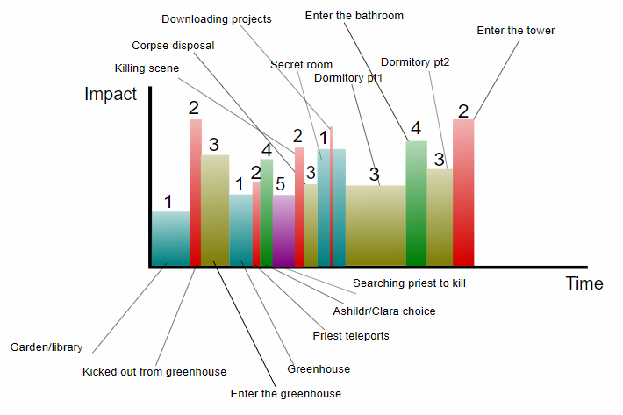

#### Clara’s path:

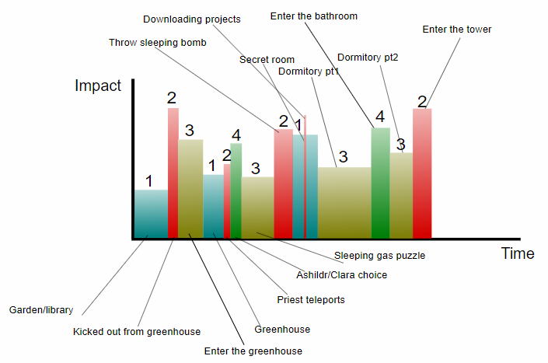

## Flowchart

POSTER?

LINK AL FILE DIGITALE

## NPCs automata

#### Pitcher plant

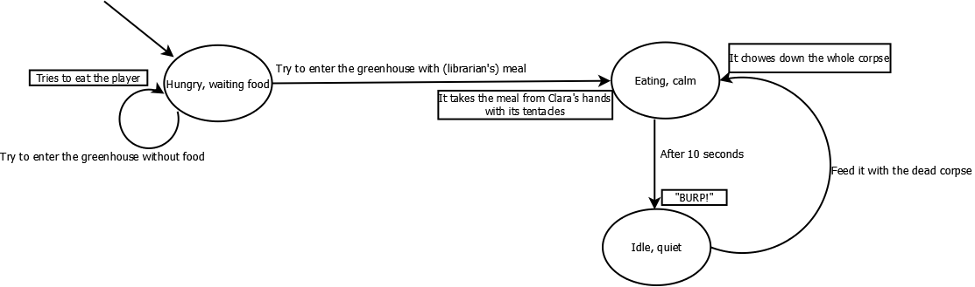

#### Priestess

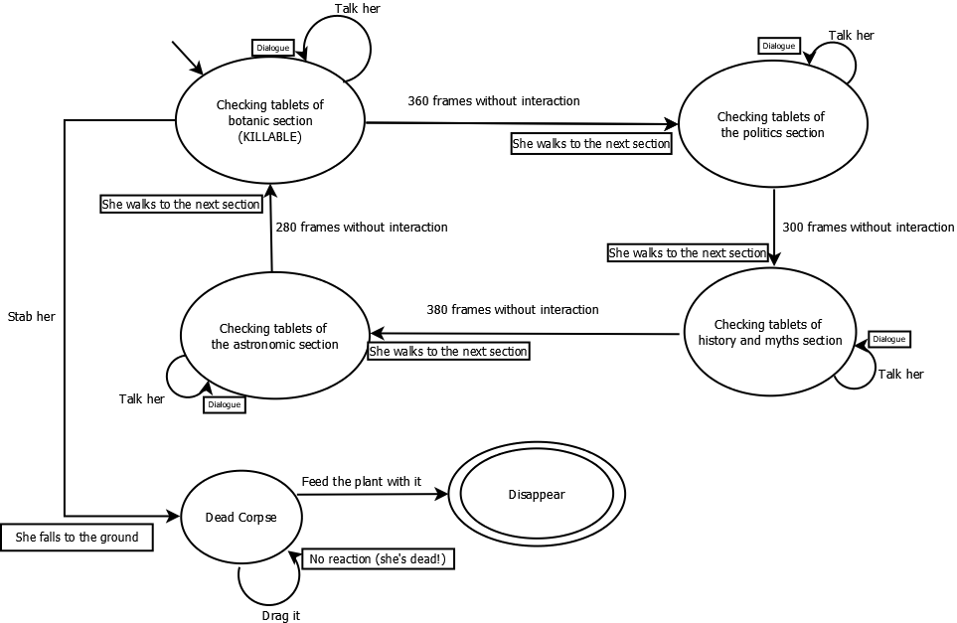

#### Spot the second lie- dialogue puzzle

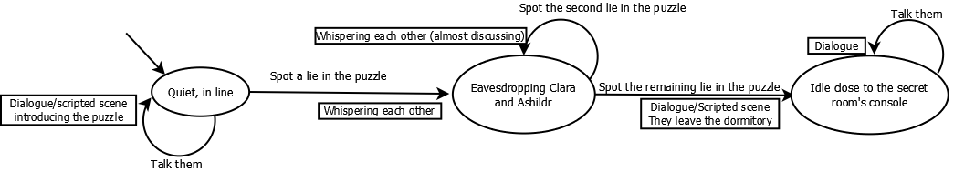

## Puzzle detailed description

### Entering the greenhouse

#### Why the player need to do this?

* in the greenhouse there are object needed for the following puzzle
* a locked area must contain something useful

#### Hint

* Plant description on the tablet about botanic.

#### Object used and where to find these

* Librarian’s lunch 🡪 on the table in the librarian’s office

#### Solution

* Talk with the librarian and play with Clara to distract him
* Playing with Ashildr steal the librarian’s lunch
* When Clara and the librarian return, rejoin the party and exit the study
* Feed the plant to calm it

### Killing a priest [Ashildr’s path]

#### Why the player need to do this?

* In order to steal the priest’s rod needed to enter the secret room.

#### Hint

* Ashildr thinking in the dialogue before the path choice
* Give the corpse to the plant 🡪 before the player feed it with the librarian’s meal

#### Object used and where to find these

* No object involved, she only uses the skill “killing”

#### solution

* kill the priestess that recurrently passes near the greenhouse (is the only one hided from others)
* hide her corpse by feeding the pitcher plant with it
* taking the rod
* rejoin with Clara (she is outside the dormitory’s room)

#### Statistic outcomes prediction: Chance of managing to murder a priest without thinking.

* Total amount of priests with rods: 6
* Priestess killable: 1 Chance of choosing the right priestess:

But the priestess is not always killable, most of the time she is close to someone else and Ashildr doesn’t want witnesses. For this reason, given that she has been targeted in a generic moment (and position) to be murdered she is killable with a chance. [ 8.75 seconds are the time she spends in the botanic section, where no one can see her, 55 seconds are the total time she takes to travel all along her circular path]

For these reasons the chance of being able to murder a priest without thinking can be estimated as:

### Put to sleep the priests [Clara’s path]

#### Why the player need to do this?

* In order to steal the priest’s rod needed to enter the secret room.

#### Hint

* Clara thinking in the dialogue before the path choice
* Use of Morpheus berries in the botanic tablets.
* Phone explain how to build a soporific bomb in a dialogue

#### Object used and where to find these

* Morpheus berries 🡪 in the greenhouse Smoke from the kitchen
* Kitchen smoke 🡪 coming outside the kitchen’s window in the dormitory

#### solution

* hyperscan the smoke
* collect the berries
* build the soporific bomb
* use the bomb to put to sleep all the priests in the study
* steal the rod on the table

### Building the sonic blaster

#### Why the player need to do this?

To enter the tower🡪The sonic blaster can create hole in the walls.

#### Hint

* Dialogue with the phone when downloading/reading the blaster’s project
* Plant description on tablet in the library
* Clara’s dialogue about gunpowder

#### Object used/ needed and where to find these

1. Sonic Blaster, craft it with:
   1. Gun 🡪 look n.2)
   2. Sonic screech 🡪 from Hydraulic Screecher in the greenhouse [puzzle C]
      1. Blanket 🡪 from one bed in the dormitory
2. Gun, craft it with:
   1. Easter egg option:
      1. Banana 🡪 collect from banana plant in the garden (simple pick up)
      2. Gunpowder 🡪look n.4)
   2. Normal option:
      1. Bow 🡪 look n. 3)
      2. Gunpowder 🡪 look n.4)
3. Bow, craft with:
   1. Rope 🡪 collect in the pantry
   2. Stcks 🡪pick up around the garden
4. Gunpowder, craft it with:
   1. Coal 🡪 oven in the dormitory’s kitchen [puzzle A]
      1. Bucket 🡪 Kitchen’ s pantry
      2. Water 🡪 taken from the pond
   2. Saltpeter 🡪 bathroom [puzzle B]
      1. Phone🡪 to record
   3. Sulfur powder 🡪 sick priest’s chest (simple pick up)

#### Puzzle A solution: coal

* 1. Pick up the bucket
  2. Exit and fill it with water
  3. Throw the water on the fire in the oven inside the kitchen to put off thee fire
  4. Collect the coal

#### Puzzle B solution: saltpeter

* + 1. Talk to the two waiting priests:
       - Clara: “Sorry, could we enter?”
       - Priest1: “Don’t you see we too are in line for the ritual of the shower? Wait your turn and don’t be rude”
       - Clara: “Oh sorry, we don’t want to jump the line, we just want to take… a look inside”
       - Priest2: “(laughing) A look inside!? Are you kidding us?”
       - Ashildr: “(whispering) Looks like these guys won’t make us enter this bathroom, what should we do in your opinion?”
       - Clara: “I don’t know, let’s look around”

1. [While Clara and Ashildr are moving away]
   * + - Priest1: “So, as I was saying, Nimrod will soon make me become the second gardener of our garden house, it is such a honor!”
2. [Clara and Ashildr stand in their feet, eavesdropping the conversation]
   * + - Priest2: “Oh congrats my friend… I’m… I mean… happy for you!” [pretending to be glad for his friend, the prosody here is very important]
       - Priest1: “Thank you, finally Nimrod as recognized my talent! What about you? Still bound to the tower’s construction? That is a very boring job…” [Smugly]
       - Priest2: “Oh well… Actually, he is planning to include me in the new blue break-in project! Didn’t you check the project’s console?”
       - Priest1: “As I can remember, the project is still deleted… Aren’t you lying to me, again?” [Upset]
       - Priest2: “Oh no I swear to you, you can trust me…” [a little subdued]
       - Ashildr: “(whispering to Clara) May I be wrong, isn’t the project actually empty? And isn’t the other priest pretty upset by his mate’s lies? Start recording their conversation, I’ve an idea”
3. [Both the protagonists go and sit at the closest table, Clara touch his smartphone and start recording]
4. **Start puzzle dialogue**: spot the lies, marked in **bold**
   * + - Priest1: “It is a very huge project I guess… does it regards the new starship just come?”
       - Priest2: “Yes, didn’t Nimrod invite you to see it at the top of the tower?”
       - Priest1: “Ehm… actually… he did not.”
       - Priest2: “Oh this may be not to distract you from your new job!”
       - Priest1: “Sure, you’re right… How does this new starship look like?”
       - **Priest2: “Ah… it is very similar to the other, a big blue box.”**
       - Clara: “(whispering to Ashildr) Are they talking about our TARDIS? [Ashildr nods] It is actually at the top of the tower, but it is not a big blue box… Wait a sec, the other starship they are talking about maybe the doctor’s TARDIS??”
       - Ashildr: “(whispering to Clara) I guess it is the doctor’s TARDIS. And I guess our guy is lying even now: he has never seen our TARDIS. I guess it will be fun to unmask the liar and make them quarrel, maybe we could use this to get rid of them… Be quite they are talking”
       - Priest1: “Oh ok, as I thought. So, Nimrod wants to open it.”
       - Priest2: “Sure… But let’s change topic. Have you studied the plants in the greenhouse enough? They could be very dangerous…”
       - Priest1: “Sure, what do you think I am? I’ve studied a lot every plant. For example, did you remember the hydraulic Screecher? That extremely noisy plant? It will be used to build a so-called “aqueduct”, which will be used to bring water all over the city. The problem is its terrible noise.” [smartass]
       - Priest2: “So, he finally decided to start experimenting on that plant! And what about the Pitcher Plant: can you handle it?” [curious]
       - **Priest1: “Sure, for example, I’ve seen it hates eating cooked food, it eats only fresh meat.”**
       - Priest2: “The problem is not what it eats, the problem is how it behaves”
       - Priest1: “Yes, I know, but if our lazy friend can run the greenhouse alone, I’m sure I will manage too.”
       - Priest2: “From what I remember you were a little lazy too, my dear, weren’t you?”
       - **Priest1: “What are you talking about? Don’t you remember that I am the only one who has been chosen by Nimrod to know how to open the prison cells?”** [In the first level, a dialogue was shown with the head guard saying that Nimrod doesn’t want anyone to know how to open the cells, so that no one will ever be able to escape or to help some friend to escape; in the project the way to open the cells is omitted]
       - Priest2: “Sure, sure… You love to drag out this story every moment, the fact that we can’t enter the prison to verify that by person make this story impossible to contradict!”
       - Priest1: “Oh come on! Now are you the one who doesn’t believe me? With all the lies you like saying? [upset] It is better to close our mouth and wait in line in silence!” [upset]
       - Priest2: “I agree!” [upset]
       - Ashildr: “Oh they are quite now, let’s reproduce the conversation to listen when a lie is told, then we’ll talk loudly about the truth!” [Amused]

[The player, as Clara, can now activate the phone, close to the priests, to go and sit to the closest table and to listen again their conversation, this time, for every sentence, he can: continue and listen the next sentence; interrupt the listening to guess if they are hearing a lie (if it is not a lie Ashildr will say: “I don’t think there is something wrong in this sentence” if a lie is spotted, a small dialogue will be shown, depending on the lie, these dialogues follow); interrupt the listening and return to the normal game.]

**[Tardis’s form lies]**

* Clara: “Did you see the starship landed few days ago? How strange is it compared to the blue and squared one? With so many colors, white, black, brown, and that sign: “snack and gas”, these starships have really strange signs on them!” [Clara is amused, Priests whispering each other, almost discussing]

**[Pitcher plant’s meal]**

* Clara: “How much has the pitcher plant enjoyed the cooked beef of the librarian? It must love cooked food”  
  [Clara is amused, Priests whispering each other, almost discussing]

**[Prison’s cells lie]**

* Clara: “I was talking to the head guard yesterday, he told me that no one actually knows how to open the cells, and that Nimrod really doesn’t want someone to know it, in order to be the only one able to free prisoners! That’s why he didn’t taught this even to high priests!” [Clara is amused]

[Priests whispering each other, almost discussing, Priest2, satisfied, says: “I KNOWED IT!”]

[After the three lies has been found out]

* Ashildr, to the two priests: “Ah, and I’ve read the blue break-in project an hour ago, it is still empty!”
* Priest1, upset: “From what I can hear, you haven’t lost the habit of lying!”
* Priest2, upset: “You’re no better, my old friend, I can’t trust you anymore!”
* Priest1: “Do you really trust these two women more than your old friend?”
* Clara: “Why don’t you go to the library to check which of you or us is actually lying?”
* Priest2: “You’re right, I’ve had enough of his huge ego!”
* Priest1: “And I have had enough of yours!”

[The two priests exit the dormitory. Now they can be found in the secret room, reading and studying hard the projects, if the player tries to interact with them, the following dialogue will be triggered:

* Priest1: “Sorry, I am really busing in exposing his lies”
* Priest2: “As well as I am busy in exposing yours!”]

3) Entering the bathroom and collect the saltpeter.

#### Puzzle C Solution: Making the Screecher screech

* 1. Collect a blanket from one of the bed in the dormitory
  2. Interacting with the Screecher
     + - 1. Cover it with the blanket
  3. Taking the plant out the greenhouse and throwing it into one of the pond
  4. Recording the screech with the phone

#### Statistic outcomes prediction: chance of solving the puzzle without reading the dialogue

* Total amount of sentences in the dialogue: 18 [We don’t want the player to face a wall of text]
* Total amount of lies to be spotted: 3
* Chance of randomly spotting the first lie:
* Chance of randomly spotting the second lie:
* Chance of randomly spotting the third and last lie:

So, the chance of randomly solving the puzzle without errors is:

Obviously, solving the puzzle by trial and error (remembering which sentence chosen before wasn’t containing a lie) is a viable way, because it reduces the total amount of sentences to check trial by trial (one by one, e.g. chance of spotting the first lie randomly, after having checked that a sentence does not contain lies = ), but this way takes enough time to encourage the player to read the conversation, because a single trial and error cycle doesn’t improve very much the chance of spotting which sentence is a lie.

### Useless creations with nanite

In this section are described some alternative and useless object that can be crafted with the Nanite ability.

* Fishing rod: rope+ banana
* Scepter: flower + stick
* Cigarette: smoke + stick
* Decorated, pink bucket: flower + bucket
* Singing flower: flower + screech
* Coat rack: banana + stick

1. Definition: term used in storytelling to indicate an ending that teach some morals.
2. All the terms and definition used to describe character are from the periodic table of storytelling, a tool used to organize and define character and aspect of stories and character.