|  |
| --- |
| **Valeyard group** |

# **Data Management document**

# The Babel’s Tower

|  |  |
| --- | --- |
| Purpose | Document used to keep track of the flow of the work and to establish various standards among the group |
| Creation date | 19/10/2017 |
| Current owner | Stefano Palma |
| Last modification | 20/11/2017 |

|  |  |  |
| --- | --- | --- |
| **Revision History** | | |
| **Who** | **When** | **What** |
| Stefano Palma | 19/10/2017 | Created this document |
| Stefano  Palma | 22/10/2017 | Modified document’s graphical aspect |
| Sara Obici | 02/11/2017 | Modified document’s graphical aspect, updated software list and folder tree |
| Sara Obici | 20/11/2017 | Modified Directories Structures & FNC |
| Marco  Faleri | 23/11/2017 | Review. Document Layout and FNC updated. |

**1.Software List**

**1.1** **Asset development software**

-SketchUp 2016 Version 17.2.2555 64bit

-GIMP 2.8.22

-Blender 2.79 BuildID: 2112350

-Audacity 2.1.3

-MuseScore 2.1.0 Revision-871c8ce

**1.2 Development software**

-Neverwinter nights 2 toolset (version 1.23)

**1.3 Organization software**

-Word 2016 (Version 1710, build 8625.2121)

-XMind 8 update 5 (R3.7.5.201709290120)

-AutoRealm 2.2.1

**1.4 Environments**

Windows 10 Home – 64bit - Version 10.0.15063 Build 15063

**1.5 Repository platform**

-Github

**2. Data types and formats**

**2.1 Texts**

*.docx (edited with Word)

**2.2 Pictures**

*.tga 32bit (loadscreens) (1600x800), (edited with GIMP);

*.bmp 32bit (icons and textures) (40x40 for icons 64x64 for terrain texture and 512x512 for other textures) (edited with GIMP).

**2.3 Videos**

Currently there is no intention of producing video content

**2.4 Audio**

*.wav (sound effects -16bit 44.1Khz) (edited with Audacity);

*.bmu (bioware music–music) converted from mp3 96kbps (handled with MuseScore)

**2.5 3D models**

*.mdb (edited with Blender)

*.skp (edited with Sketchup)

**2.6 Video and image references**

*.mp4 (between 360p (480×360) and 720p (1280 x 720))

*.png(between 640x480 and 1024x768)

**2.7 Design files (maps, diagrams, etc.)**

**\***.xmind (Xmind);

*.AuRX (AutoRealm)

**2.8 Editor files (all handled by the editor)**

*.mod (Module format)

*.bic (Character file)

*.ini (Configuration file)

*.2DA, two-dimensional array (defines all sorts of basic rules for all sorts of aspects of the game)

*.tlk (Contains string used in the game)

**2.9 File Compression**

*.zip

**3. Data Storage and Access**

To maintain data and folders a github repository has been created at the following link:

<https://github.com/obiciunict/GLD>

**3.1 Backup**

Backup of all work will be kept on everyone’s computer, the master backup is kept by Sara Obici.

* Last master backup: on an external memory (Toshiba) 20/11/2017

**4. Directory Structure**

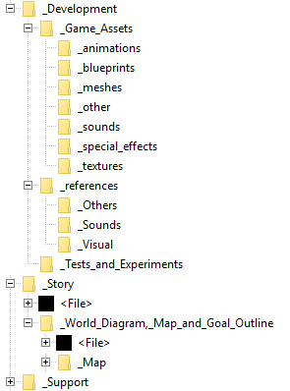

In the root directory there are three main folders:

* Development, which contains everything useful for the level development. It contains 3 subdirectories, which are characterized by their names: “game assets”, “references” and “test and experiments”. Game assets is organized in subdirectories, as the following table shows:

|  |  |
| --- | --- |
| _blueprint | For Blueprints |
| _meshes | For meshes |
| _animations | Animations |
| _sounds | Effects and Music |
| _special effects | Special effects files, particle base effects etc. |
| _textures | For textures |
| _other | For everything else |

* Story, containing everything involved in the game storytelling, from the world diagram and goals outline, to the storytelling document.
* Support, which contains useful documents for the development of our software and the general organization of work on it, for example this document itself.

**5. File Naming Convention**

* Regarding the assets: All the rules used to perform their naming convention are the following:

Form:

asset_PrefixUsage_PrefixType_AssetName(_Number)

PrefixUsage stands for the usage.

|  |  |
| --- | --- |
| IT_ | Item |
| CH_ | Characters |
| UI_ | User Interface |
| EN_ | Environment |
|  |  |

PrefixType stands for type

|  |  |
| --- | --- |
| IM_ | For image files |
| SX_ | Sound and music |
| 3D_ | 3-dimensional models |
| MOD_ | Modules for testing in neverwinter |
| BP_ | Blueprints |
| SC_ | Scripts |
| VX_ | Visual effects |
| UT_ | Utility (ex, configuration files, language files etc.) |
| OT_ | Others |

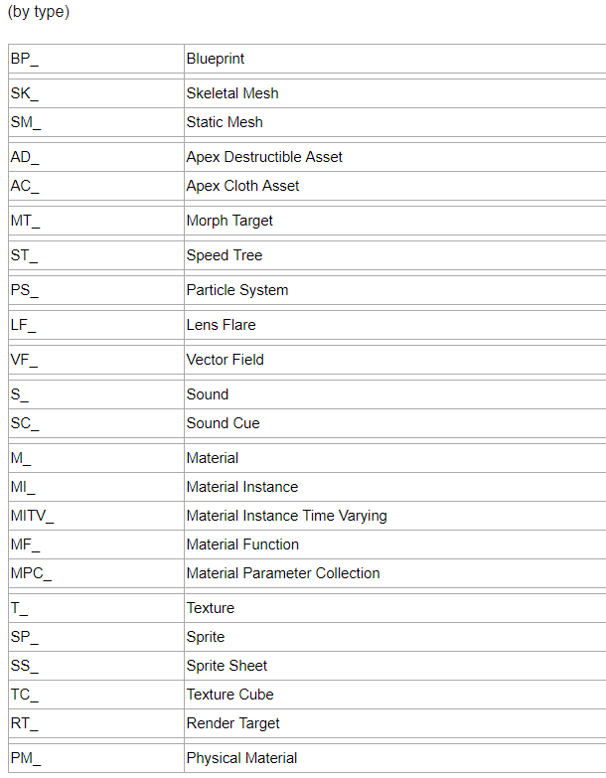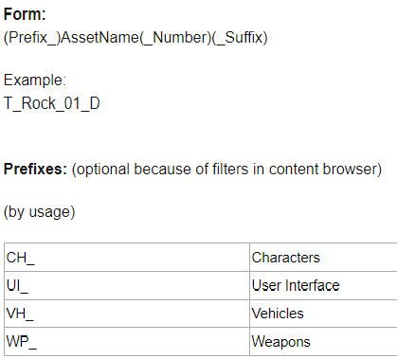

Regarding all the other files of the project, (documents, support files etc…) the rules of their naming convention are the following:

* Do not use whitespaces or the camelCase notation to separate words, rather use the underscore ( “_” ) character.
* If required, be sure to use meaningful abbreviations, do not use abbreviations in files with short names or in special files (e.g. this document).
* Do not use special characters in a name, including characters you can’t easily type using English or Italian keyboard layout.
* Do not write date, modifier’s name and version on the file name, we have already a versioning tool for that.
* If the file isn’t a simple text file, use “vid_” in case it is a video, “ima_”, in case it is an image, “mus_” in case it is a music file, “_” in case it is a simple directory or “spe_” in case it is a different type of file (this may be very important to order and handle different references).