|  |
| --- |
| **Valeyard group** |

# **Data Management document**

# The Babel’s Tower

|  |  |
| --- | --- |
| Purpose | Document used to keep track of the flow of the work and to establish various standards among the group |
| Creation date | 19/10/2017 |
| Current owner | Stefano Palma |
| Last modification | 5/12/2017 |

|  |  |  |
| --- | --- | --- |
| **Revision History** | | |
| **Who** | **When** | **What** |
| Stefano Palma | 19/10/2017 | Created this document |
| Stefano  Palma | 22/10/2017 | Modified document’s graphical aspect |
| Sara Obici | 02/11/2017 | Modified document’s graphical aspect, updated software list and folder tree |
| Sara Obici | 20/11/2017 | Modified Directories Structures & FNC |
| Marco  Faleri | 23/11/2017 | Review. Document Layout and FNC updated. |
| Stefano  Palma | 5/12/2017 | Updated softwares and file types |

**1.Software List**

**1.1** **Asset development software**

-SketchUp 2016 Version 17.2.2555 64bit

-GIMP 2.8.22

-Blender 2.79 BuildID: 2112350

-Audacity 2.1.3

-MuseScore 2.1.0 Revision-871c8ce

**1.2 Development software**

-Rpg maker MV (Version 1.5.1)

**1.3 Organization software**

-Word 2016 (Version 1710, build 8625.2121)

-XMind 8 update 5 (R3.7.5.201709290120)

-Tiled map editor(Version 2018.01.01)

-Inkscape (Version 0.91 r13725)

**1.4 Environments**

Windows 10 Home – 64bit - Version 10.0.15063 Build 15063

**1.5 Repository platform**

-Github

**2. Data types and formats**

**2.1 Texts**

*.docx (edited with Word)

**2.2 Pictures**

*.png (terrain/characters tilesets 48x48 for each tile)(edited with GIMP)

**2.3 Videos**

Currently there is no intention of producing video content

**2.4 Audio**

*.ogg 128kbps (for music and sound effects)

**2.5 3D models**

*.mdb (edited with Blender)

*.skp (edited with Sketchup)

**2.6 Video, image and sound references**

*.mp4 (between 360p (480×360) and 720p (1280 x 720))

*.png(between 640x480 and 1024x768)

*.mp3(192Kbps)

**2.7 Design files (maps, diagrams, etc.)**

**\***.xmind (Xmind);

*.tsx (Tiled tileset);

*.tmx(Tiled map)

*.svg(Inkscape – event diagram)

*.dia(Dia - flowchart)

**2.8 Editor files (all handled by the editor)**

*.rpgproject(project file)

*.m4a(background music)

*.json(data file)

*.css, *.ttf(font file)

*.js (scripts)

**2.9 Infos(researches)**

*.pdf;

*.url;

**2.10 File Compression**

*.zip

**3. Data Storage and Access**

To maintain data and folders a github repository has been created at the following link:

<https://github.com/obiciunict/GLD>

**3.1 Backup**

Backup of all work will be kept on everyone’s computer, the master backup is kept by Sara Obici.

* Last master backup: on an external memory (Toshiba) 2/1/2018

**4. Directory Structure**

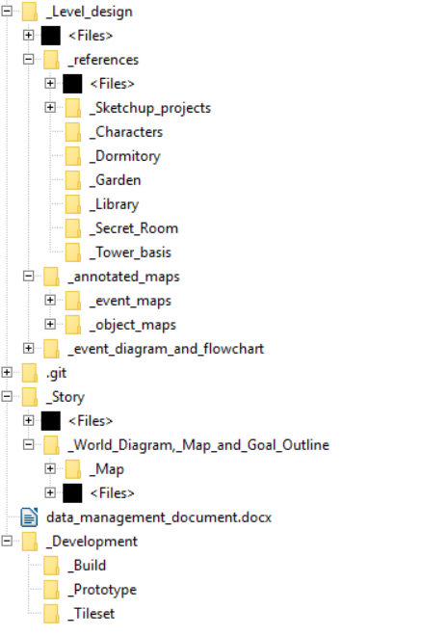

In the root directory there are three main folders:

* Development, which contains every file used to develop the prototype, there are three folders in here:

- _Build: It contains the executable produced by the engine

- _Prototype: It contains the project files and all resources needed to compile, this folder is handled by RPGmaker.

-_Tileset: It contains all the images of the tilesets used to develop the prototype

* Story, containing everything involved in the game storytelling, from the world diagram and goals outline, to the storytelling document.
* Level design, which contains all design files used to actually design the level, such as the level design documents, and folders containing annotated maps, event diagrams and flowcharts, and references. References are divided in:
* Sketchup files, containing Sketchup projects for every building of the level;
* Folders for each area of the level, containing references for the area and the objects inside it;
* Characters’ folder, containing references for the characters.

The current file is placed in the root folder, to be easily accessible and to help to navigate the folder structure.

**5. File Naming Convention**

* Regarding the tilesets: All the rules used to perform their naming convention are the following:

Form:

til_PrefixUsage_TilesetSpecificName

ex:

til_CH_naked_priest

PrefixUsage stands for the usage.

|  |  |
| --- | --- |
| IT_ | Item |
| CH_ | Characters |
| UI_ | User Interface |
| EN_ | Environment |

The TilesetSpecificName should represent the specific usage and purpose of the tileset.

Regarding all the other files of the project, (documents, support files etc…) the rules of their naming convention are the following:

* Do not use whitespaces or the camelCase notation to separate words, rather use the underscore ( “_” ) character.
* If required, be sure to use meaningful abbreviations, do not use abbreviations in files with short names or in special files (e.g. this document).
* Do not use special characters in a name (everything different form alphanumeric characters or “_” to separate words), including characters you can’t easily type using English or Italian keyboard layout.
* Do not write date, modifier’s name and version on the file name, we have already a versioning tool for that.
* If the file isn’t a simple text file, use “vid_” in case it is a video, “ima_”, in case it is an image, “mus_” in case it is a music file, “_” in case it is a simple directory or “spe_” in case it is a different type of file (this may be very important to order and handle different references).