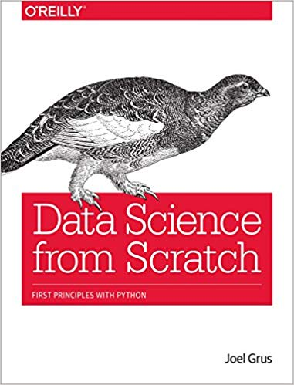

[1] This is the first book I read on python and data science. I covered a large swath of the content in this book, by focusing only on the sessions on Python programming. I enjoyed it; it’s bringing me up to speed on data science.

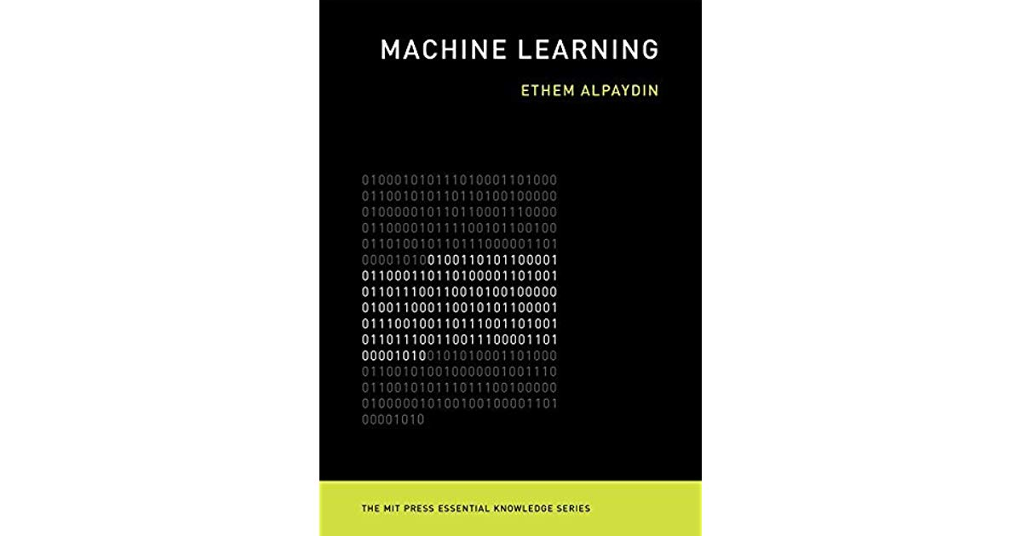

[2] Great introduction to Machine Learning. To read through seamlessly, some very basic knowledge of CS and stats would help a great deal. Having taken a graduate level class in statistical learning this was a light read, except for a few sections on deep learning. My favorite parts of the book are Ethem's salutary use of analogies like, 'learning with a critic' for reinforcement learning; 'learning with a teacher' for supervised learning; 'learning without a teacher' for unsupervised learning; and a whole lot of those handy goodies. In general, this is a little nice book on a technology that is rapidly changing the way we live! From digital medical diagnosis, to Alexa, to amazon go.

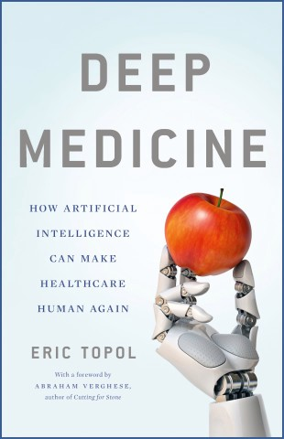

[3] This one is a good read. I have read a few materials on AI and biology (medicine), but this one stands out. The fourth industrial revolution had begun, and Dr Topol managed to map out how AI is impacting, and will impact, medicine. Perhaps you know of how instagram photos had been used to reveal predictive markers of depression. Or how scientists are using AI to predict time of death. Skin cancer detection with your smartphone. Mobile apps for medical diagnosis. Drug discovery insilico. What can I say: new world, new times.