# API GUIDE

The questions and answer storage structure is such that it allows a proper sectioning of contents. However, the usefulness or approach inculcated by this structure can be reviewed.

1. The structure is always two folders deep. The “PACKAGE” being the first level then followed by the “BRANCH”. This is shown below in the excel documentation sheet 2.

|  |  |  |  |  |  |
| --- | --- | --- | --- | --- | --- |
|  |  |  |  |  |  |
| packages |  |  |  |  |  |
|  | branch |  |  |  |  |
|  |  | pools.json |  |  |  |
|  |  |  | category |  |  |
|  |  |  |  | sub-category |  |
|  |  |  |  |  | content |
|  |  |  |  |  |  |

1. Inside the branch are then the “POOLS” whose content are json files. The “POOL” has two levels which can be seen above as “CATEGORY” and “SUB-CATEGORY”.
2. Now here is the tricky thing. In order to support the version we had initially where we have the question proper in the category level as the year, this structure is also available

|  |  |  |
| --- | --- | --- |
| Jamb.json |  |  |
|  | years(2000 - 20XX) |  |
|  |  | content |

1. For the API, there are two major starting point “/packages/*” and “/resources/*”. The packages handles the creation (PUT), renaming/editing(POST), fetching(GET), deletion(DELETE) of package, branch, pool, category and sub-category while resources handles the upload of files into a pool or category or subcategory in the content directory. Refer to the excel document sheet 4 and 5. The API end points in the excel sheet appears like “/packages/{package}/{branch}” . The items in {} are optional arguments that can be supplied to depict which resource is being worked on.

# EXAMPLES WITH POST MAN

1. Package creation

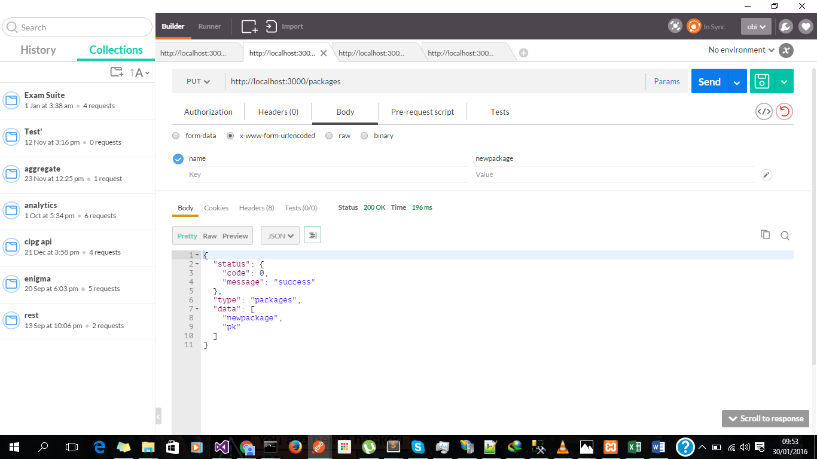

1. Branch creation

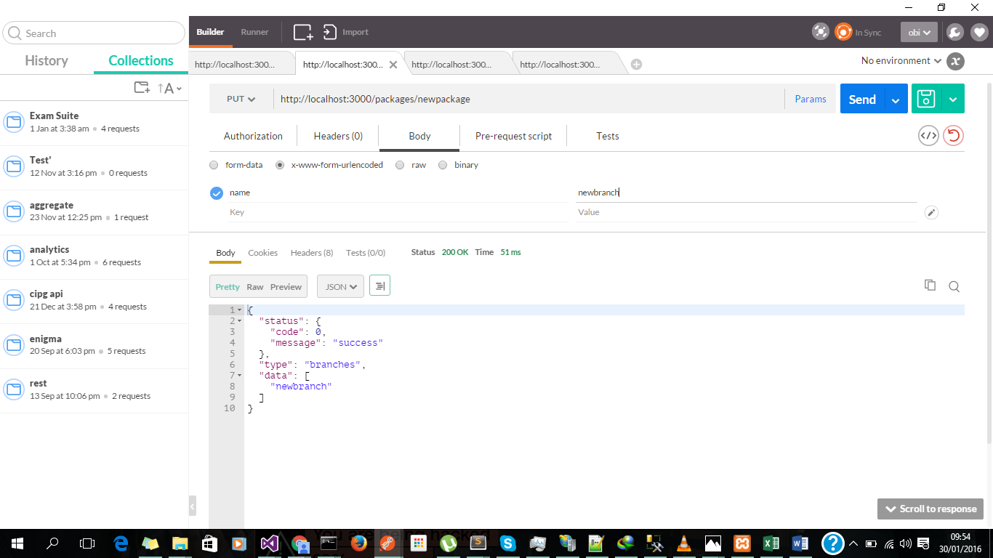

1. Pool creation

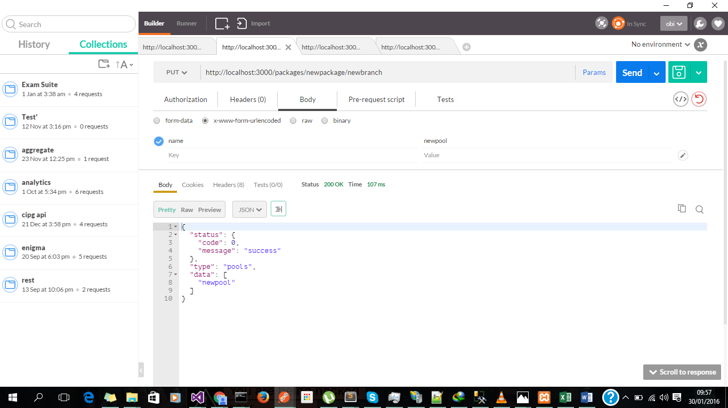

1. Category creation

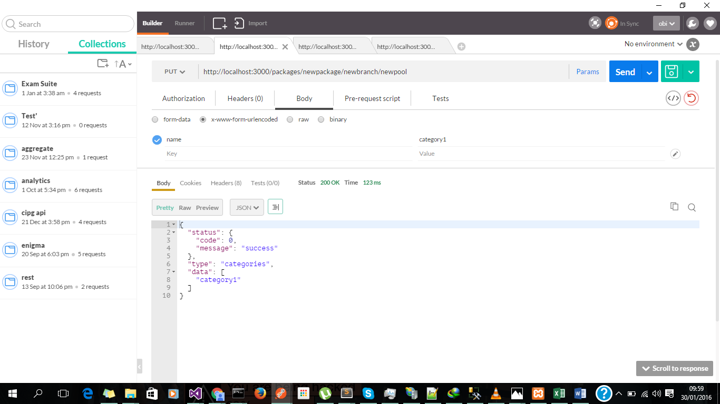

1. Sub-category creation

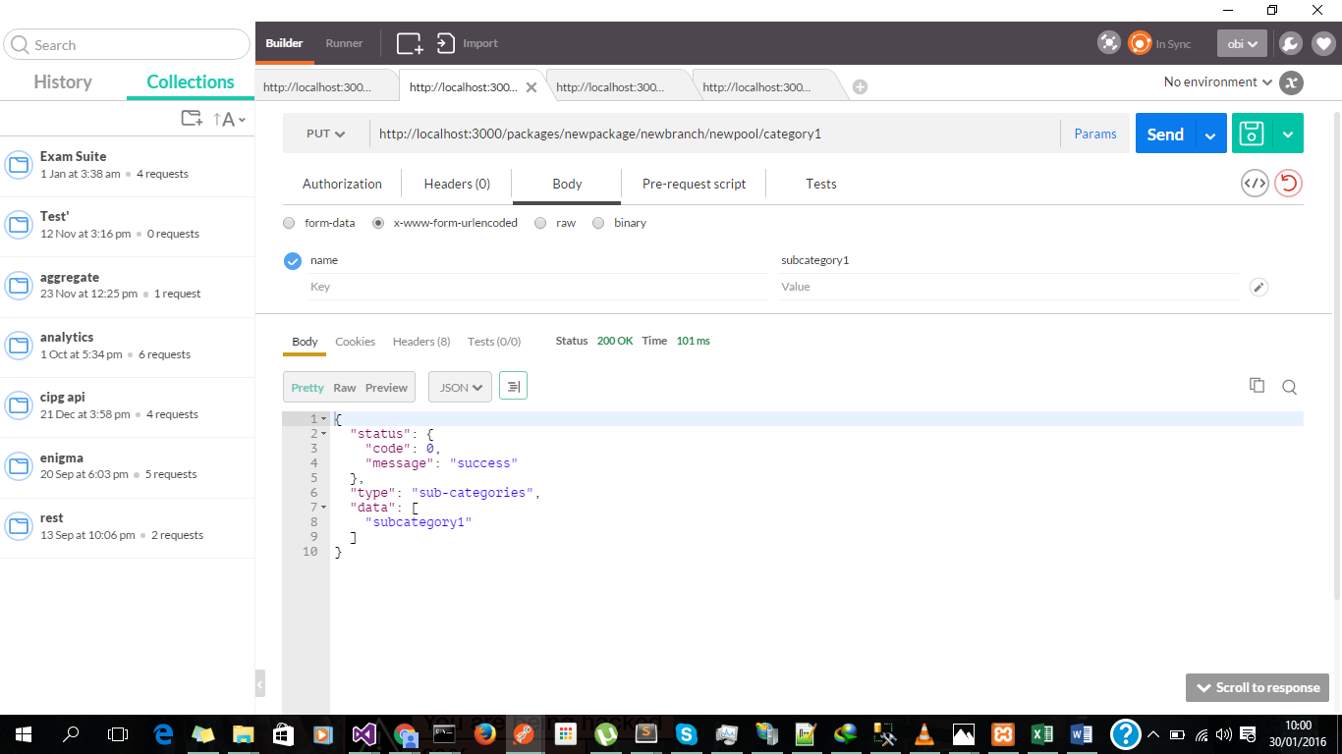

1. Question data creation: Note that this would be a json string with a question attribute to work. Moreover any other attribute can be specified in the json. For now I’ll specify only a question attribute which is necessary to create a question. Also take note of the PUT parameter which is “content”

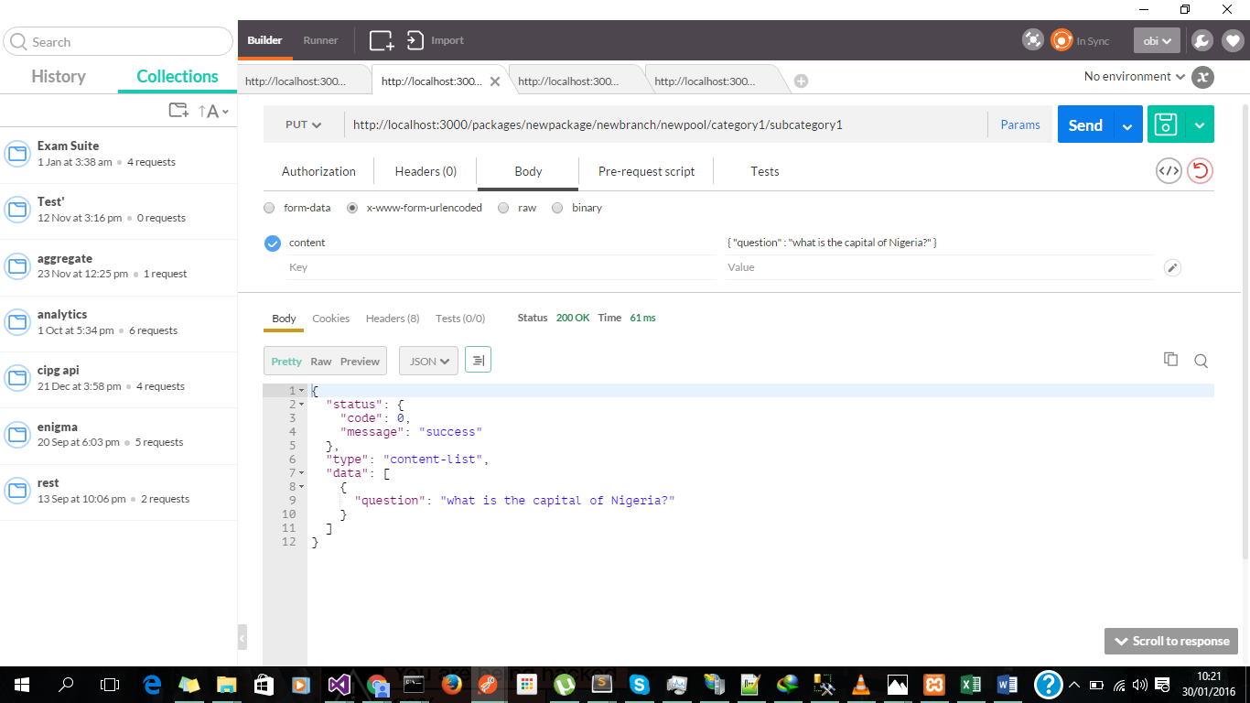

1. Editing a question is just about referencing its index in the url and making a POST. Refer to the API excel documentation sheet 4

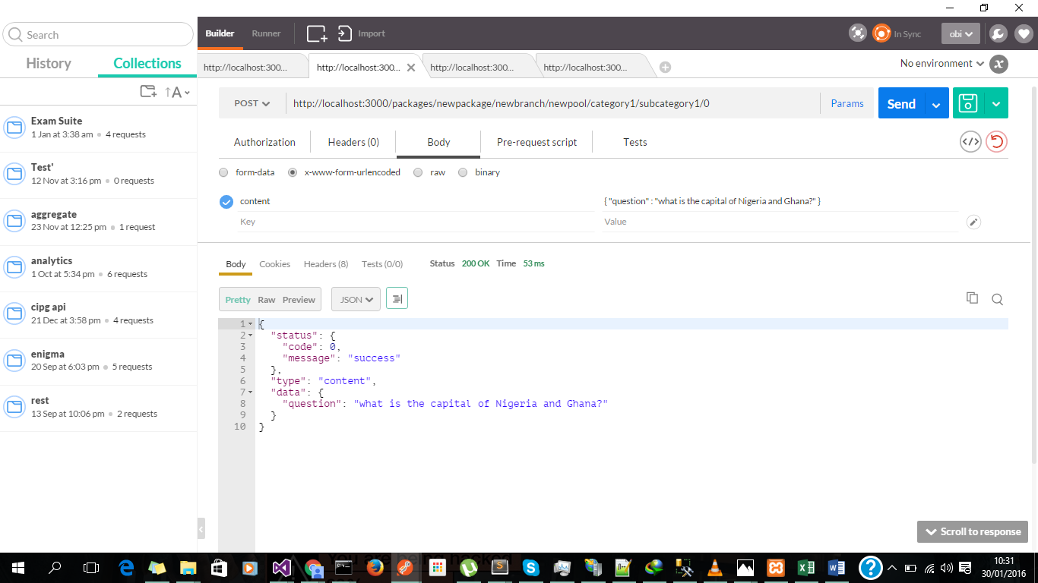

1. Renaming things also involves making a POST to the appropriate URL. Example rename of “newpool” to “mathematics” below

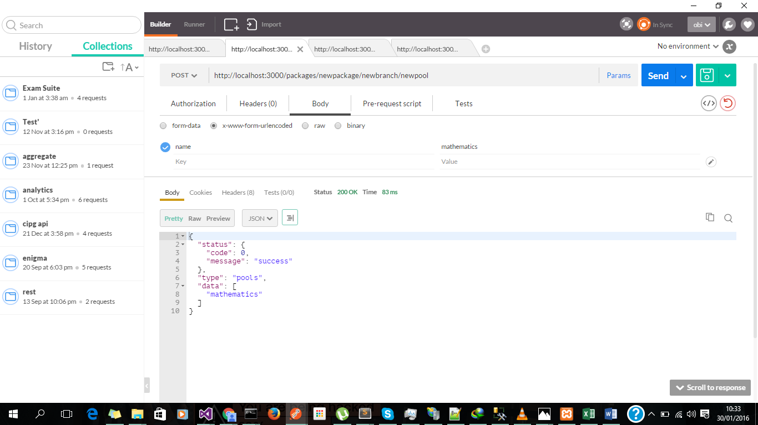

1. Getting the pool list “/packages/newpackage/newbranch” with a GET shows that “newpool” changed to “”mathematics”

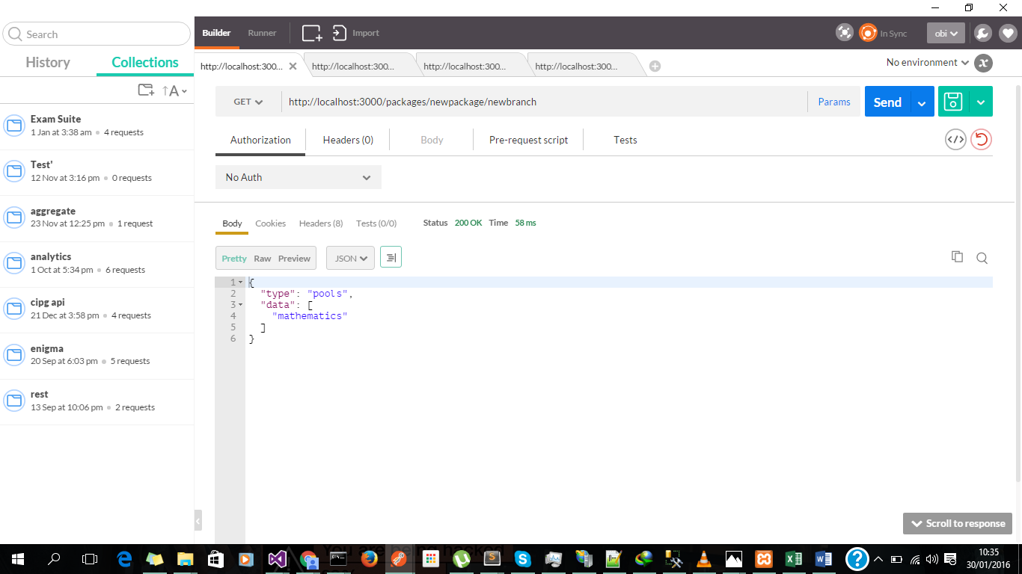

# MORE UPDATES SOON………………….