Mã hóa AES:

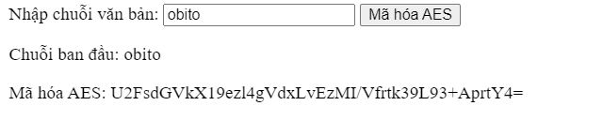

Mã hóa MD5:

Mã hóa RSA:

