Chapter Four: System Figures
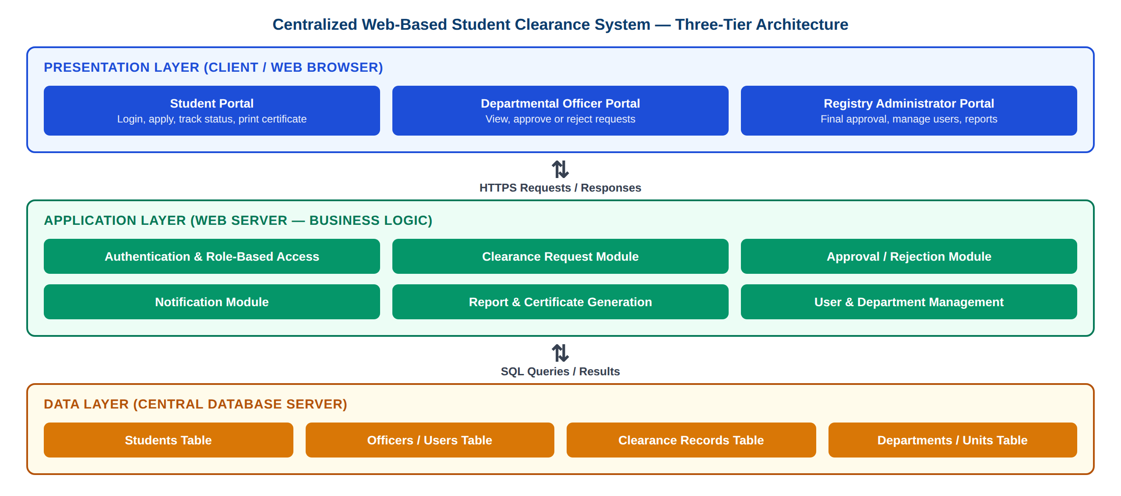
Figure 4.1: System Architecture of the Proposed Centralized Web-Based Student Clearance System
The system follows a three-tier architecture. The Presentation Layer consists of three web portals (Student, Departmental Officer and Registry Administrator) accessed through a web browser. All requests pass over HTTPS to the Application Layer, which handles authentication and role-based access, clearance requests, approval or rejection by officers, notifications, report and certificate generation, and user management. The Application Layer reads from and writes to a central relational database in the Data Layer, which stores student records, officer accounts, clearance records and departmental units.

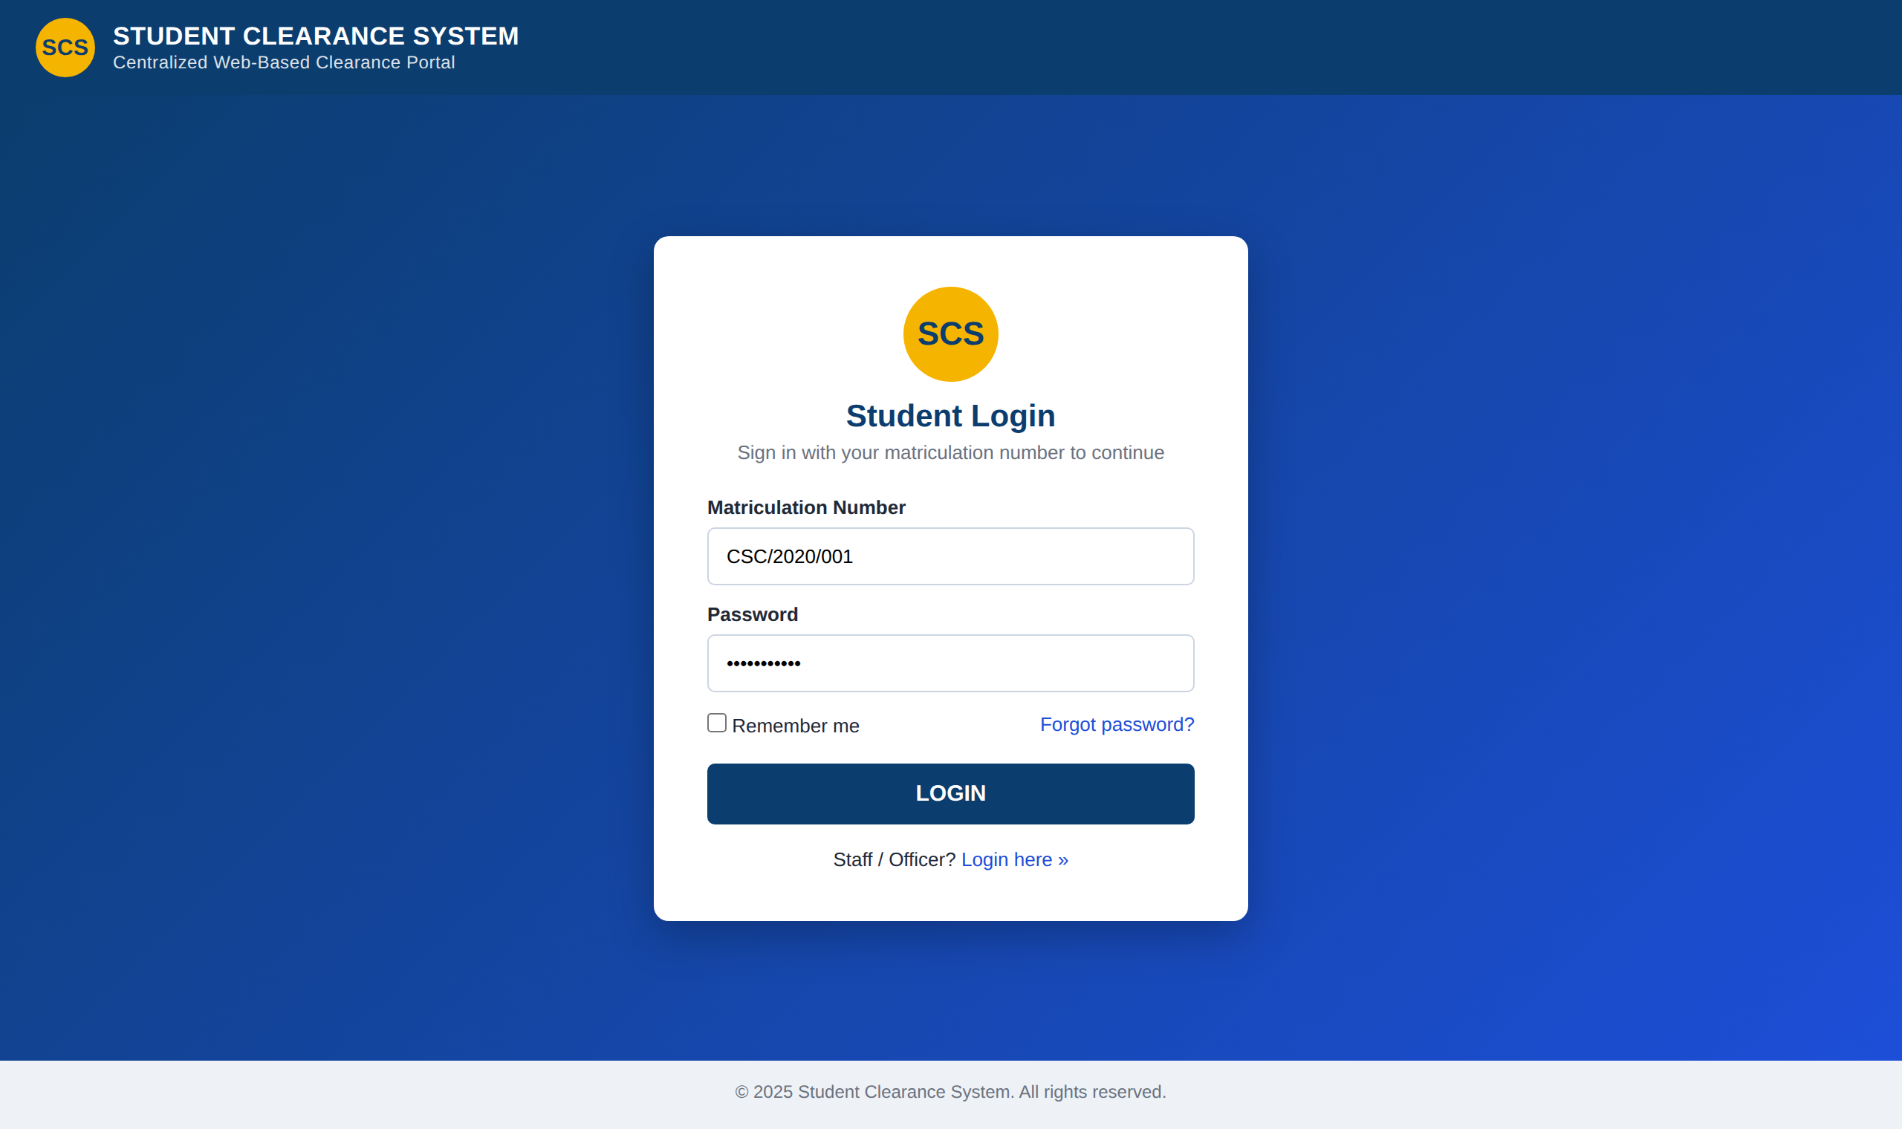
Figure 4.2: Screenshot Showing Student Login Page
The login page is the entry point for students. The student enters their Matriculation Number and Password and clicks LOGIN. The system validates the credentials against the database and, if they are correct, redirects the student to the Clearance Status Dashboard; otherwise an error message is displayed. Links are provided for password recovery and for staff/officer login.

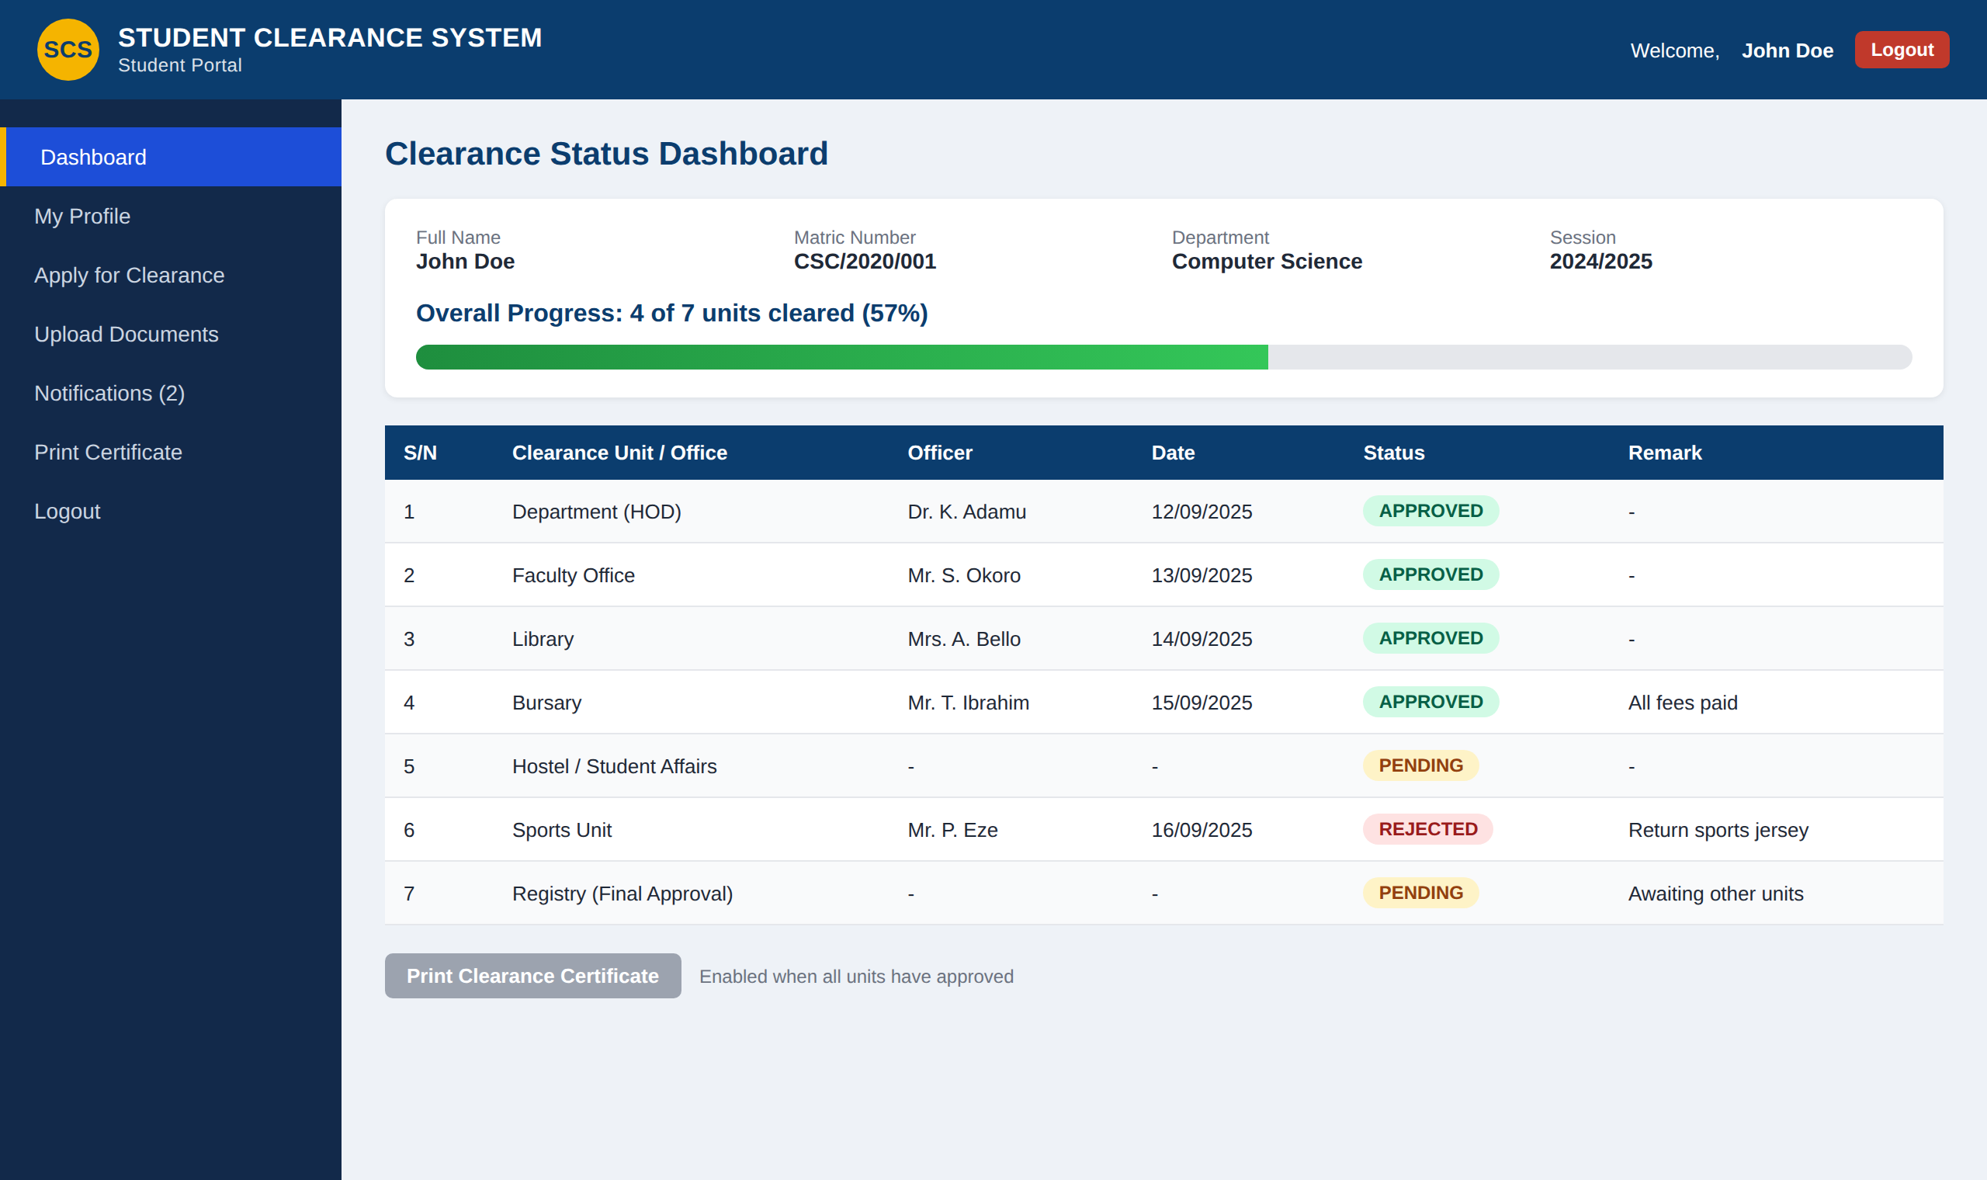
Figure 4.3: Screenshot Showing Student Clearance Status Dashboard
After logging in, the student sees the clearance status dashboard. It shows the student's details, an overall progress bar, and a table listing each clearance unit with its status (Approved, Pending or Rejected), the officer who acted, the date, and any remark. The Print Clearance Certificate button is enabled only after every unit, including the Registry, has approved.

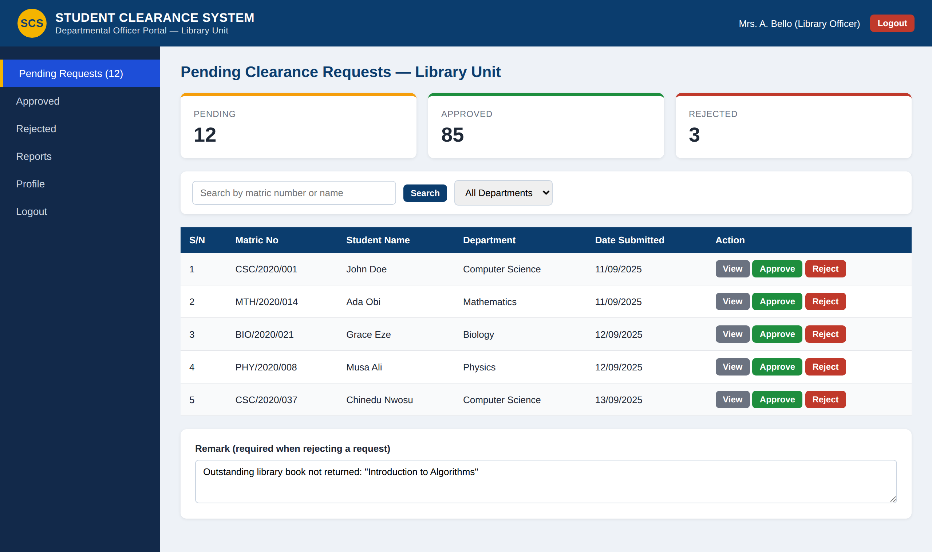
Figure 4.4: Screenshot Showing Departmental Officer Approval Interface
Each departmental officer (e.g. Library, Bursary, Hostel, Sports, HOD) sees only the requests for their unit. For each student the officer can View the submitted details, Approve the request, or Reject it with a remark stating the reason. Decisions are saved immediately and reflected on the student's dashboard. Summary cards show the number of pending, approved and rejected requests.

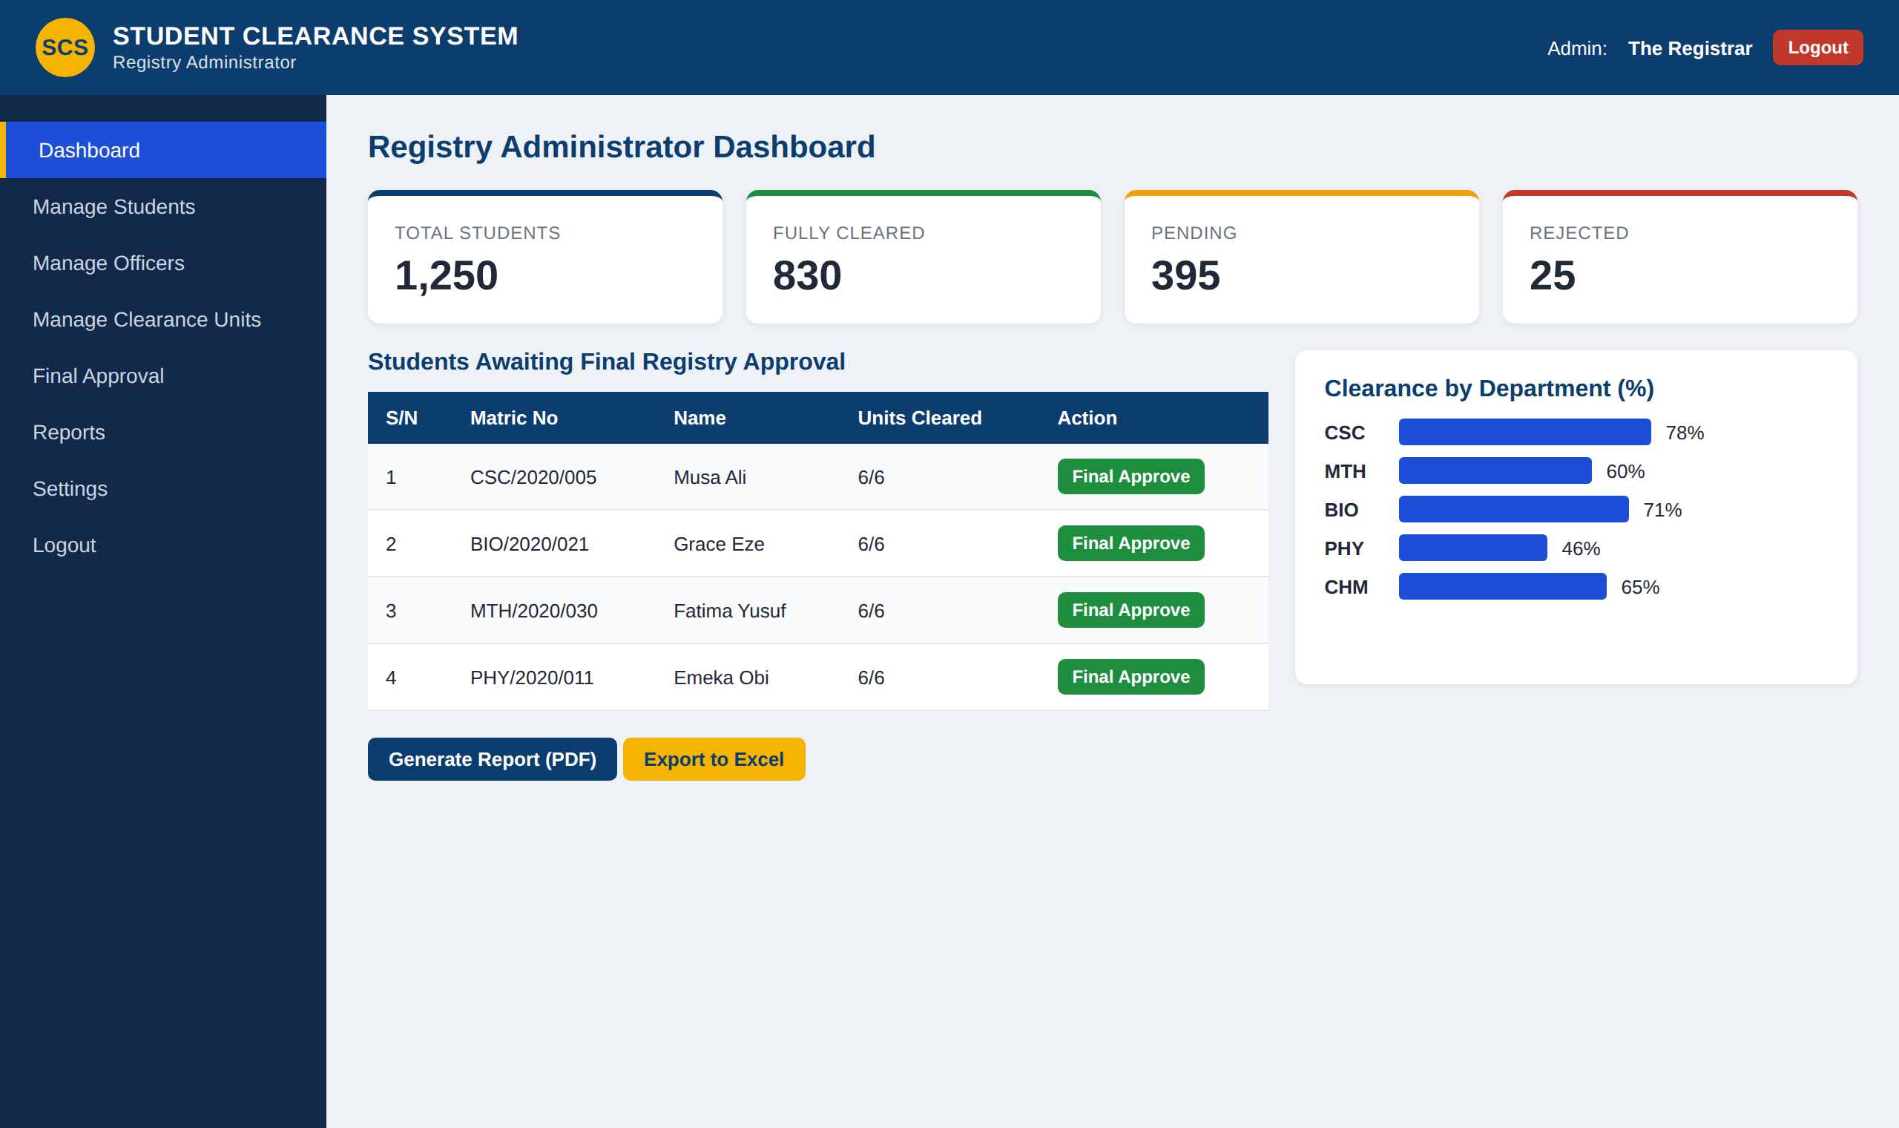
Figure 4.5: Screenshot Showing Registry Administrator Dashboard
The Registry Administrator has the highest level of access. The dashboard shows summary statistics (total students, fully cleared, pending and rejected), a list of students cleared by all units and awaiting final Registry approval, and a chart of clearance progress by department. From the sidebar the administrator can manage students, officers and clearance units, grant final approval, and generate or export reports.

