## VlcMediaPlayer

VlcMediaPlayer is a plugin that can smoothly play videos without lags when the video jumps，based on vlclib implementation.

Enabling the Plugin of VlcMediaPlayer

To enable an Unreal Engine plugin, follow these steps:  
1. Copy the plugin of VlcMediaPlayer to the plugin folder of the project.

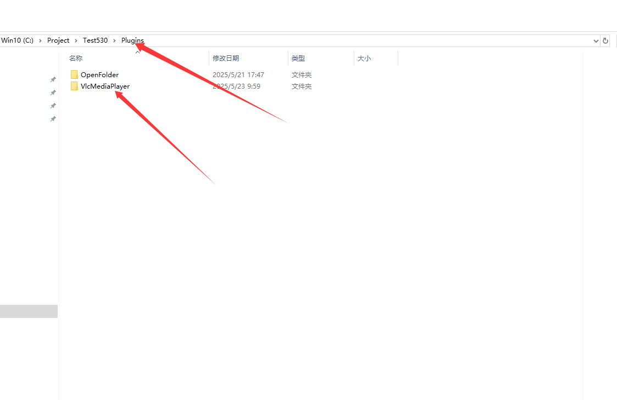

2.From the main menu, go to Edit > Plugins. This opens the Plugins window.

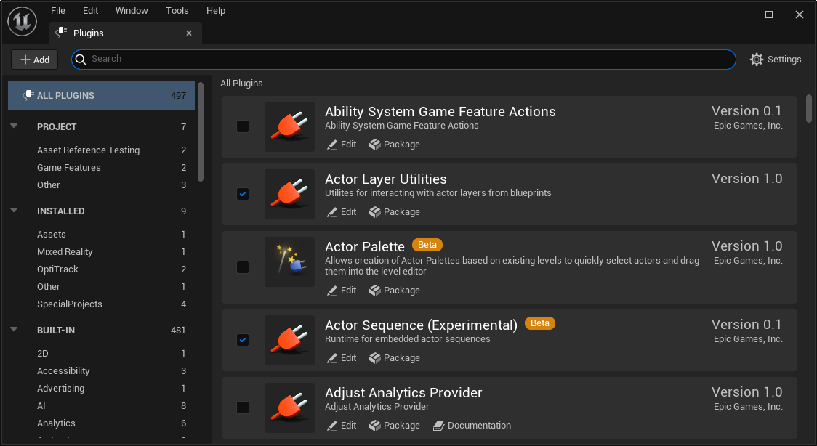

3.Find the plugin of VlcMediaPlayer you want to enable using the list on the left of the screen. Alternatively, enter “VlcMediaPlayer” in the Search box to search for all plugin names.

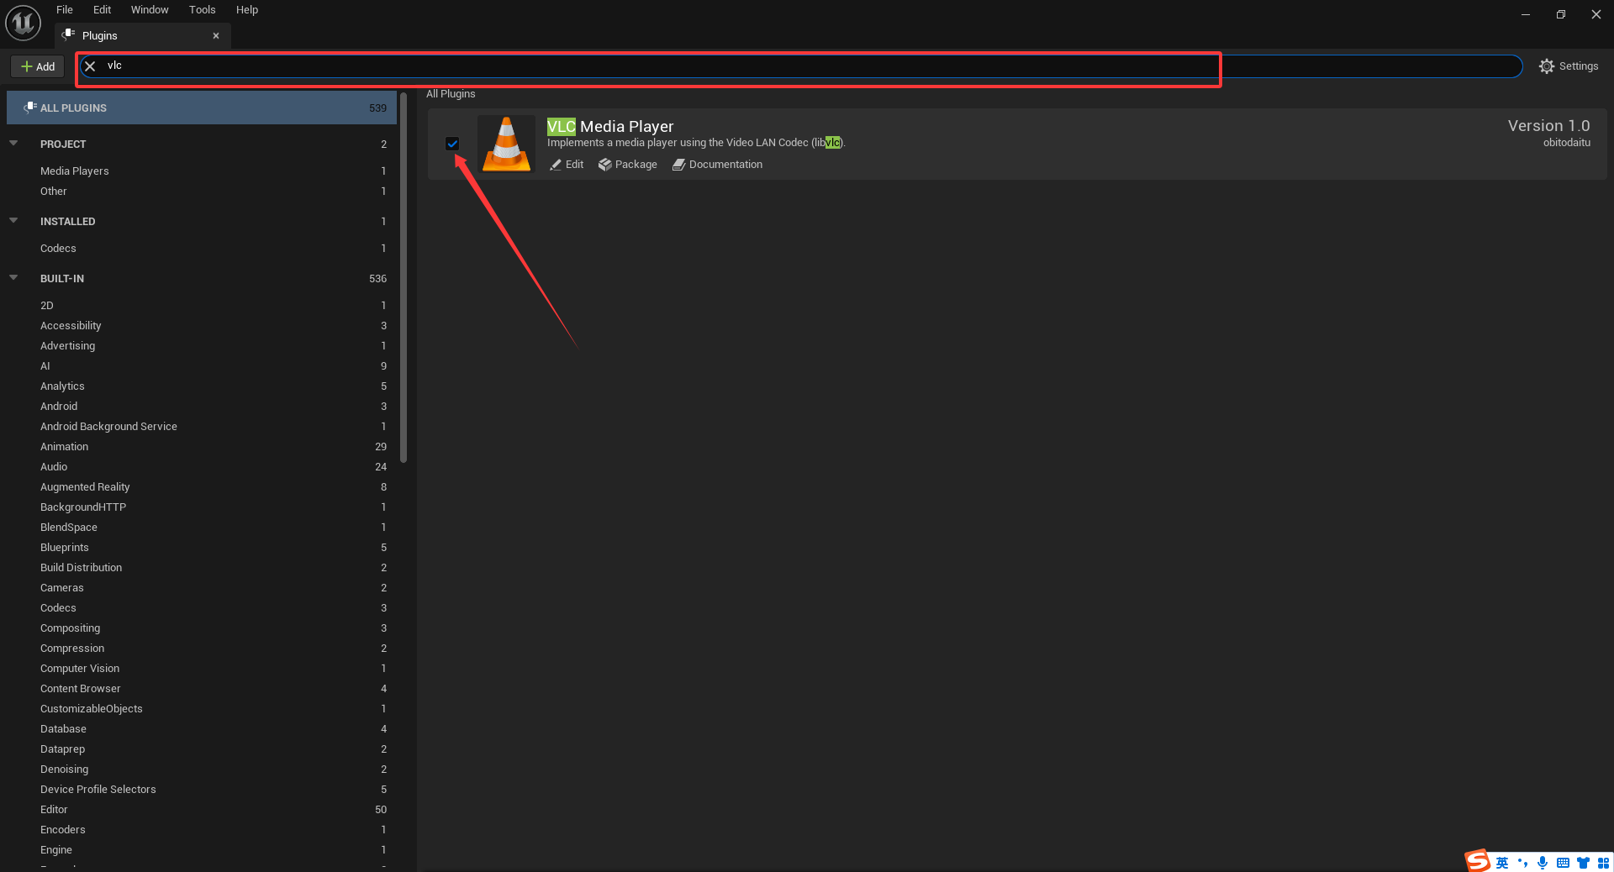

4.Then restart the unreal engine.  
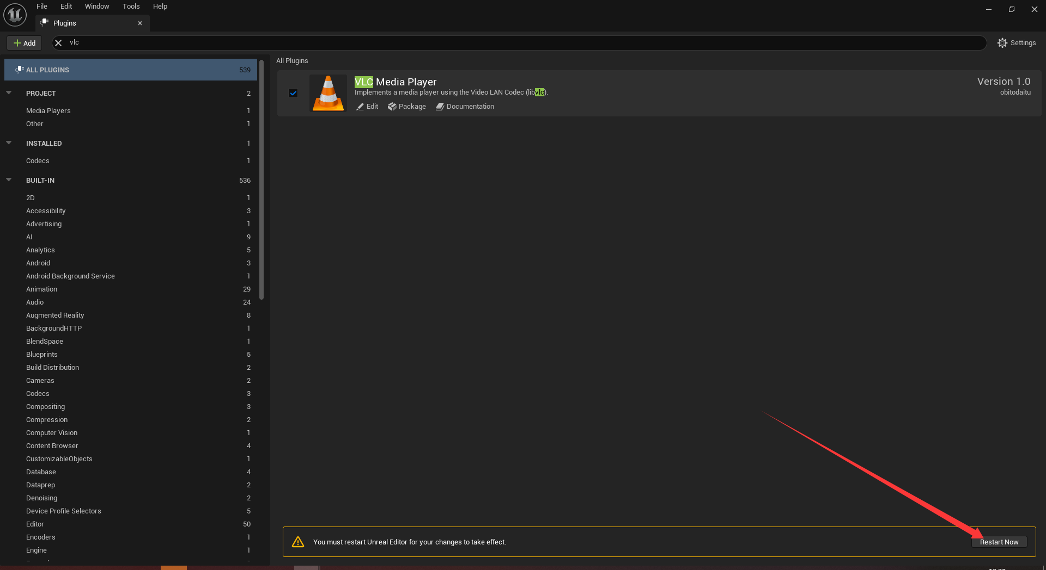

**Use VlcMediaPlayer as follows:**

1. Add a file media source.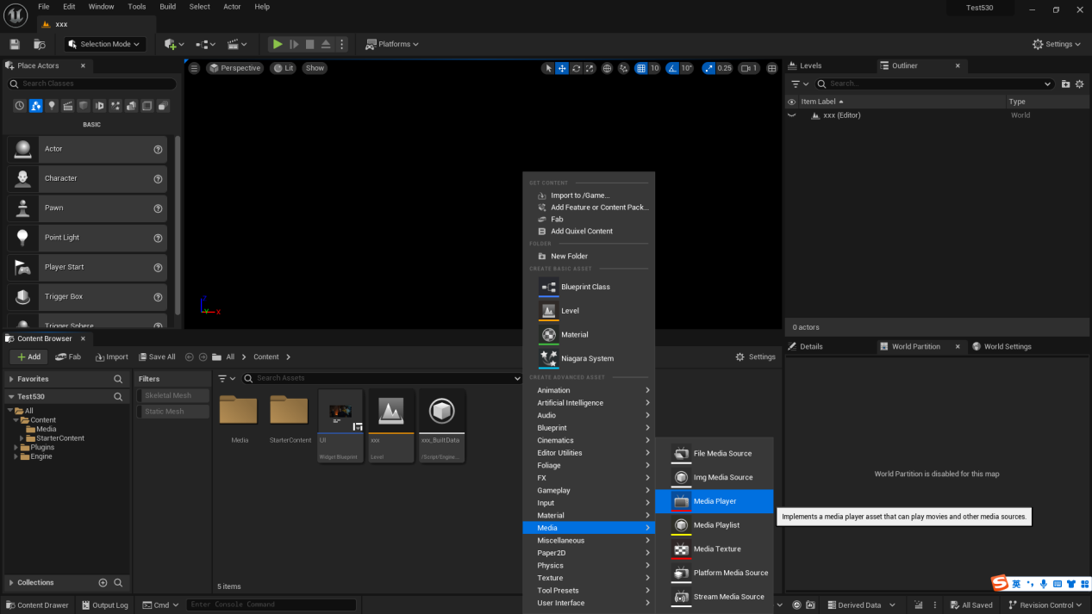

2.Select VleMedia for Platforms in FileMediaSource.

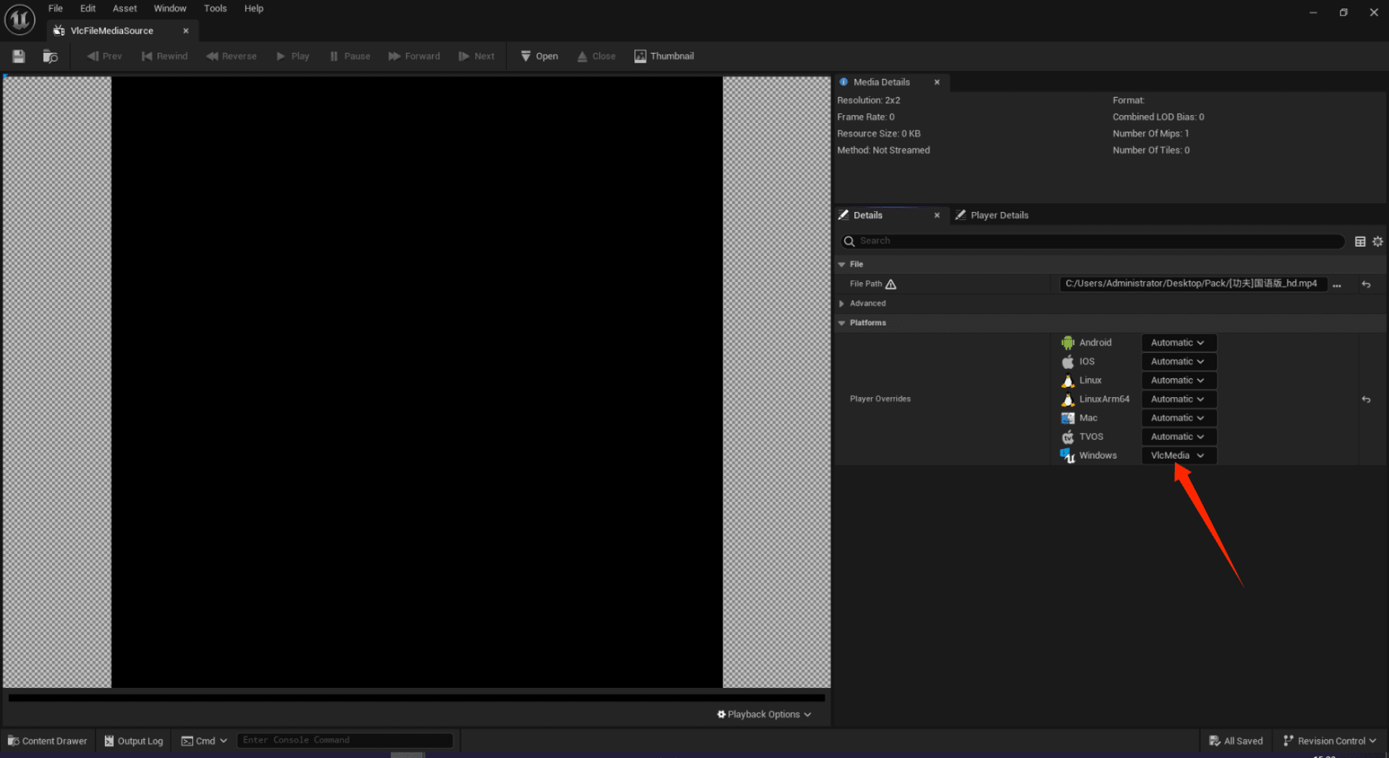

3.The other steps are the same as Unreal Engine's MediaPlayer.

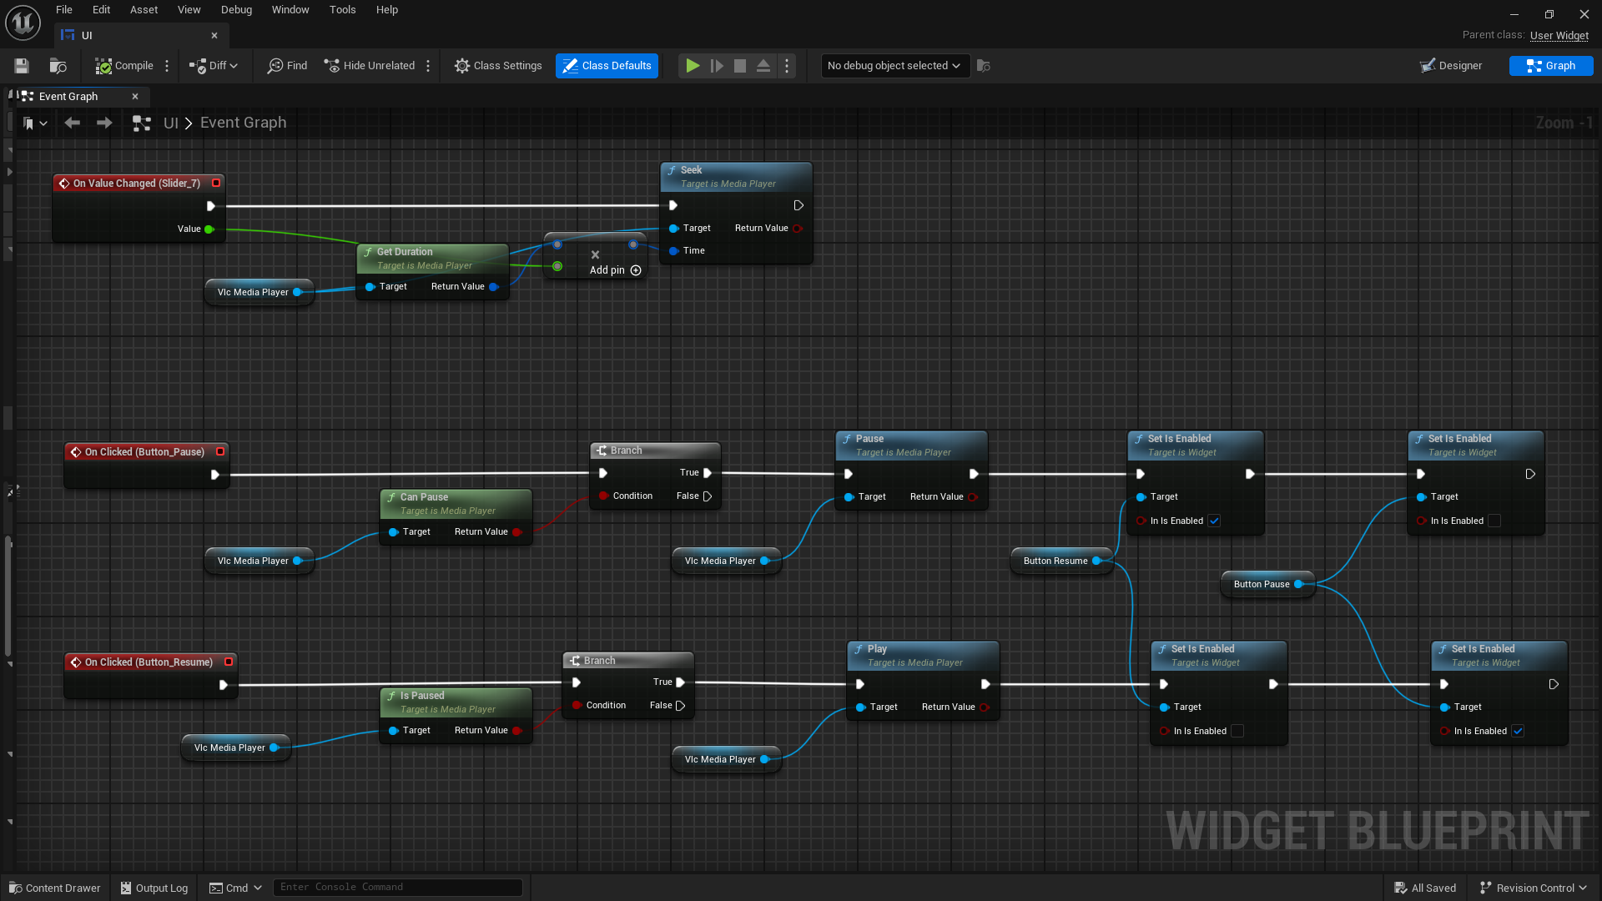

Finally you can play video smoothly as follow:  
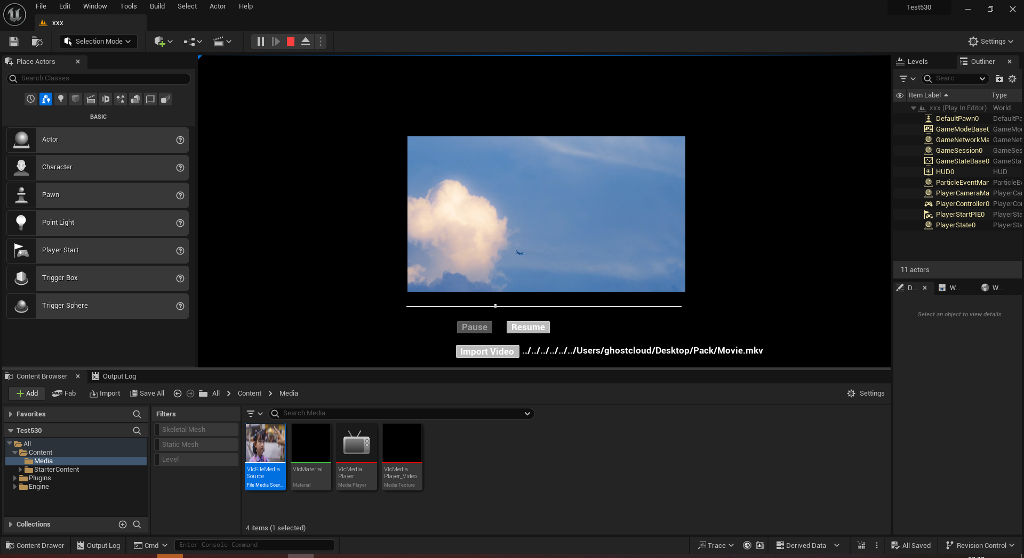  
  
**About ThirdPary:** if you want to use newer version of vlc, you can replace the library of vlc as follow:  
1.You can download the precompiled library. URL is: **<https://download.videolan.org/pub/videolan/vlc/3.0.0/win64/>**

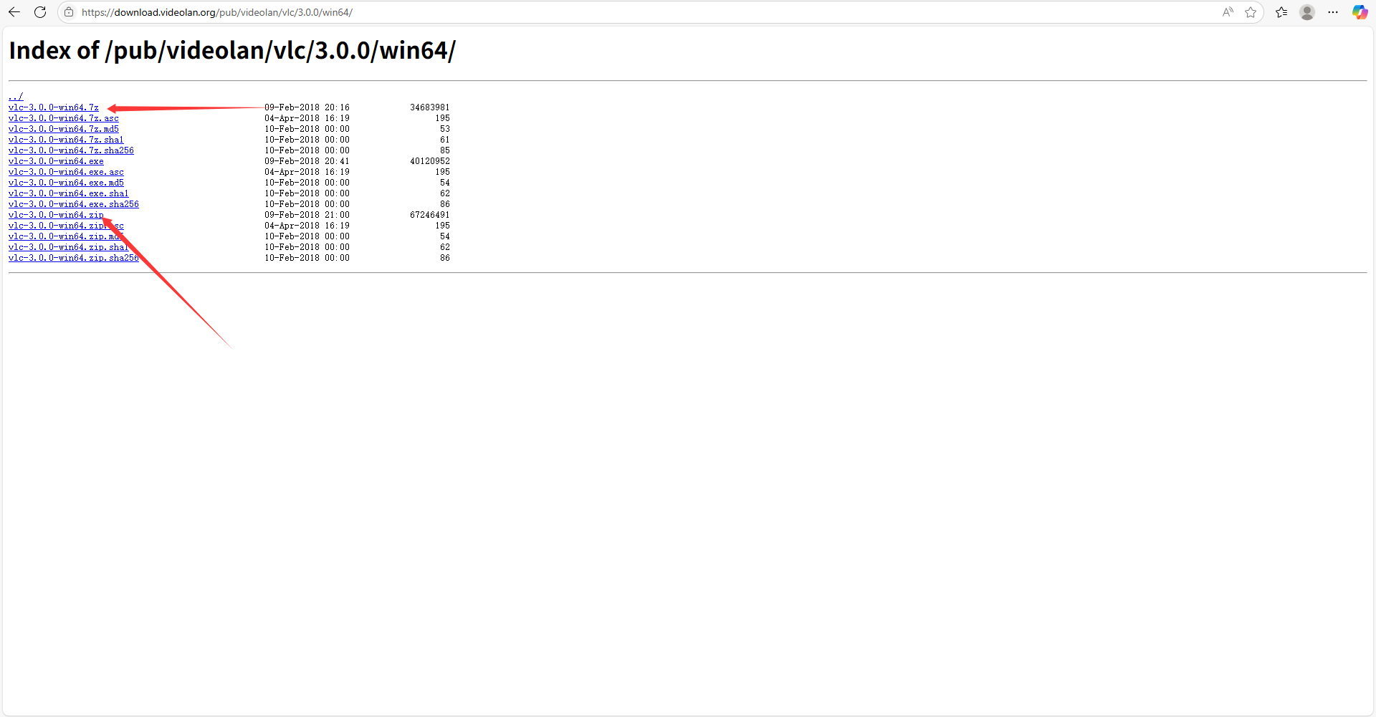

2.you can also compile vlclib by yourself. Opensource URL is <https://github.com/videolan/vlc>  
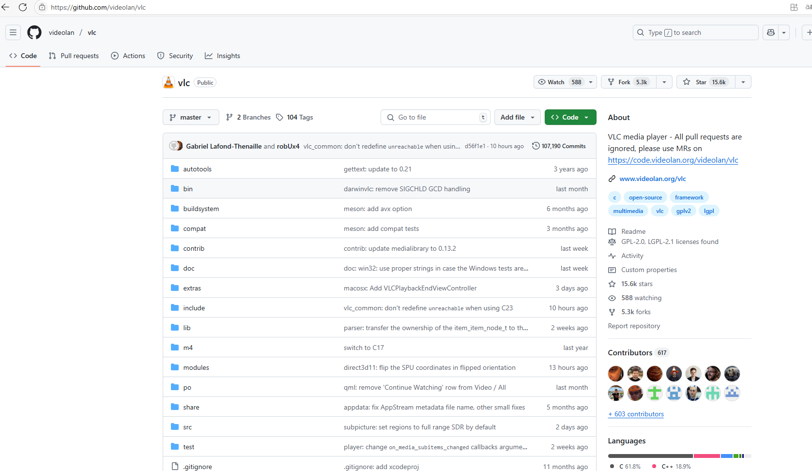  
3.Unzip the vlc-3.0.0-win64.7z, copy the file and folder to dir of thirdparty.  
