PROJECT DOCUMENTATION
Smart Door Lock System
Using Arduino Nano, RFID, Keypad, PIR Sensor and Solenoid Lock

Table of Contents
Table of Contents 2
1. Introduction 3
2. Objective 3
3. Components Used 4
Software / Libraries 4
4. Circuit Diagram 5
5. Pin Connection Summary 6
6. System Block Diagram 7
7. Working Principle 8
Step 1 – System Startup 8
Step 2 – PIR Motion Detection 8
Step 3 – RFID Authentication 8
Step 4 – Password Verification 8
Step 5 – Door Unlock and Auto Re-lock 8
Step 6 – Exit Button 8
8. Input and Output Devices 9
Input Devices 9
Output Devices 9
9. Software Flow 10
10. Prototype Implementation 11
11. Firmware Source Code 12
12. Advantages 14
13. Limitations 14
14. Applications 15
15. Future Enhancements 15
16. Conclusion 16

1. Introduction
The Smart Door Lock System is an embedded access-control project built around an Arduino Nano microcontroller. It replaces a traditional mechanical key with an electronic system that verifies a user's identity before releasing an electric door lock. The system combines three independent layers of security – RFID card authentication, keypad password entry, and PIR-based motion sensing – with a 16×2 I2C LCD for status feedback and a relay-driven 12V solenoid lock as the physical actuator. An exit push button allows the door to be opened from inside without any authentication, so the system also functions as a normal fire-safe exit.
This document describes the objective, hardware components, circuit design, firmware logic, and possible extensions of the project, and is intended to accompany the source code and circuit diagram in the project repository.

2. Objective
The objective of this project is to improve door security by replacing traditional keys with an electronic access-control system that:
- Grants entry only to users who present an authorized RFID card and enter the correct password.
- Continuously monitors the area near the door using a PIR motion sensor.
- Automatically re-locks the door a fixed time after it is opened, removing the risk of a door being left unlocked.
- Provides a simple, key-free exit path from inside the room using a dedicated push button.

3. Components Used
The table below lists every component used in the build, based on the circuit diagram and the physical prototype.
Component | Qty | Purpose
Arduino Nano | 1 | Main microcontroller
RC522 RFID Module | 1 | 13.56 MHz RFID reader
RFID Card / Tag | 1–2 | Authorized access credential
4×4 Matrix Keypad | 1 | Password entry
16×2 LCD (I2C) | 1 | Displays system status
PIR Motion Sensor | 1 | Detects human movement
1-Channel Relay Module | 1 | Switches the solenoid lock
12V Solenoid Door Lock | 1 | Electronic locking mechanism
Active Buzzer | 1 | Audio indication
Exit Push Button | 1 | Opens door from inside
12V DC Power Adapter | 1 | Powers the system
Breadboard / PCB | 1 | Circuit assembly
Jumper / Connecting Wires | As required | Power and signal wiring
Prototype Enclosure | 1 | Housing for the project

Software / Libraries
- Arduino IDE
- MFRC522 library – RFID communication
- Keypad library – 4×4 matrix keypad scanning
- LiquidCrystal_I2C library – 16×2 I2C LCD driver
- Wire / SPI libraries – I2C and SPI bus communication
- EEPROM library – reserved for storing UIDs / password on-chip

4. Circuit Diagram
The diagram below shows the complete wiring between the Arduino Nano and every peripheral: the RC522 RFID reader, the 4×4 keypad, the I2C LCD, the PIR sensor, the buzzer, the relay module driving the solenoid lock, the exit push button, and the 12V DC power supply.
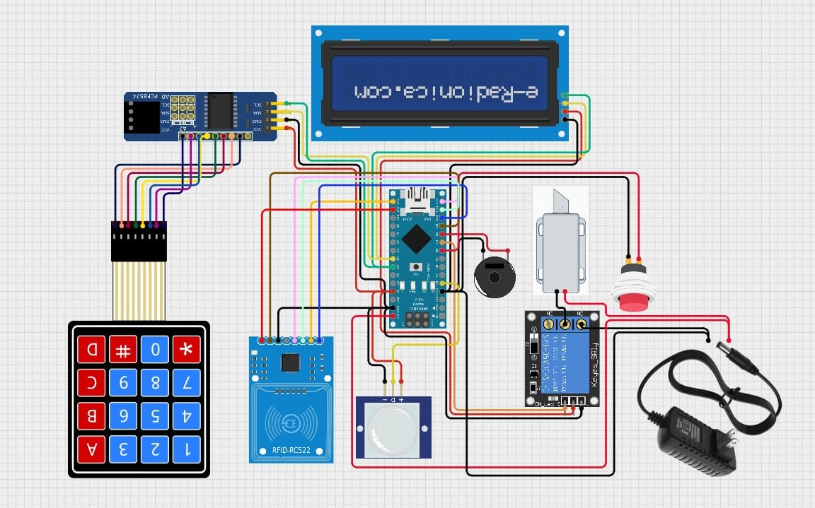
Figure 1. Complete circuit / wiring diagram of the Smart Door Lock System.

5. Pin Connection Summary
The table below summarizes how each module is wired to the Arduino Nano, taken directly from the pin definitions in the firmware.
Signal | Nano Pin | Notes
RC522 RFID – SDA (SS) | D10 | Chip-select for SPI
RC522 RFID – RST | D9 | Reader reset
RC522 RFID – MOSI / MISO / SCK | D11 / D12 / D13 | Hardware SPI bus
PIR Sensor – OUT | D2 | Motion detect input
Relay Module – IN | D7 | Drives the solenoid lock
Exit Push Button | D6 | INPUT_PULLUP, active LOW
Keypad Rows (1–4) | D3, D4, D5, D8 | Row scan lines
Keypad Columns (1–4) | A0, A1, A2, A3 | Column scan lines
I2C LCD – SDA / SCL | A4 / A5 | I2C bus (address 0x27)

6. System Block Diagram
At a system level, the Arduino Nano is the central controller: it reads the RFID reader, keypad, PIR sensor and exit button as inputs, and drives the LCD, buzzer and relay (solenoid lock) as outputs.
+----------------+
| RFID Card |
+-------+--------+
|
RC522 RFID Reader
|
+---------+ +------------+ +--------------+
| Keypad |------->| |------->| Relay Module |
+---------+ | Arduino | +------+-------+
| Nano | |
+---------+------->| | |
| PIR | | | v
+---------+ +------------+ Solenoid Door Lock
| |
I2C LCD Display Door Opens / Locks

Exit Button ------> Arduino Nano
Figure 2. Signal flow between the Arduino Nano and all peripherals.

7. Working Principle

Step 1 – System Startup
On power-up the Arduino initializes the SPI bus, the RFID reader and the LCD, and briefly shows “SMART DOOR” before clearing to the idle screen. The relay is held LOW, so the door starts in the locked state.

Step 2 – PIR Motion Detection
The PIR sensor is polled continuously. When it detects movement near the door, the LCD briefly shows “Motion Detect”. This step only reports activity near the door – it does not, by itself, unlock anything.

Step 3 – RFID Authentication
When a card is presented, the RC522 reads its 4-byte UID. The firmware compares this UID against a single authorized UID stored in the sketch. A match unlocks the door immediately; a mismatch shows “Access Denied” on the LCD and the door stays locked.

Step 4 – Password Verification
Independently of the RFID path, a user can type a 4-digit password on the keypad and press ‘#’ to submit it. If the entered digits match the stored password, the door unlocks; otherwise the LCD shows “Wrong Password” and the door remains locked. Pressing ‘*’ clears whatever has been typed so far.

Step 5 – Door Unlock and Auto Re-lock
Whenever authentication succeeds (by card or password), the Arduino drives the relay HIGH, which energizes the 12V solenoid lock and retracts its plunger. The door stays unlocked for a fixed 5-second interval, after which the relay is turned back off and the door re-locks automatically – no separate action is needed to secure the door again.

Step 6 – Exit Button
A push button wired to an INPUT_PULLUP pin lets anyone inside the room open the door without a card or password. Pressing the button drives the relay HIGH using the same unlock routine used for successful authentication, after which the door re-locks automatically.

8. Input and Output Devices

Input Devices
- RFID Reader (RC522) – reads the card UID and provides the first authentication factor.
- 4×4 Keypad – accepts the numeric password, the second authentication factor.
- PIR Sensor – detects human presence / movement near the door.
- Exit Push Button – opens the door from inside without authentication.

Output Devices
- 16×2 I2C LCD – shows status messages such as ready, motion detected, access granted/denied, and wrong password.
- Active Buzzer – provides audible feedback alongside the LCD messages.
- Relay Module – acts as an electrical switch, isolating the low-current Arduino output from the higher-current solenoid circuit.
- 12V Solenoid Lock – the physical actuator; normally locked, and retracts to unlock when the relay energizes it.

9. Software Flow
1. Initialize SPI, RFID reader and LCD; show the startup message; keep the door locked.
2. Continuously prompt “Scan/Password” on the LCD.
3. Check for an RFID card on every loop iteration – if a valid UID is read, unlock the door.
4. Check the keypad – digits are appended to the input buffer; ‘#’ submits the password for comparison, ‘*’ clears the buffer.
5. If the password matches, unlock the door; otherwise show “Wrong Password”.
6. Check the exit button – if pressed, unlock the door immediately, no authentication required.
7. Check the PIR sensor – if motion is detected, briefly display “Motion Detect”.
8. On any successful unlock: energize the relay, hold for 5 seconds, then de-energize the relay so the door re-locks, and loop back to step 2.

10. Prototype Implementation
A working prototype was assembled in a cardboard enclosure to validate the wiring and firmware before final packaging. The LCD, RFID reader and keypad are mounted on the front face, the PIR sensor sits below them, and the solenoid lock is mounted separately on the door frame.

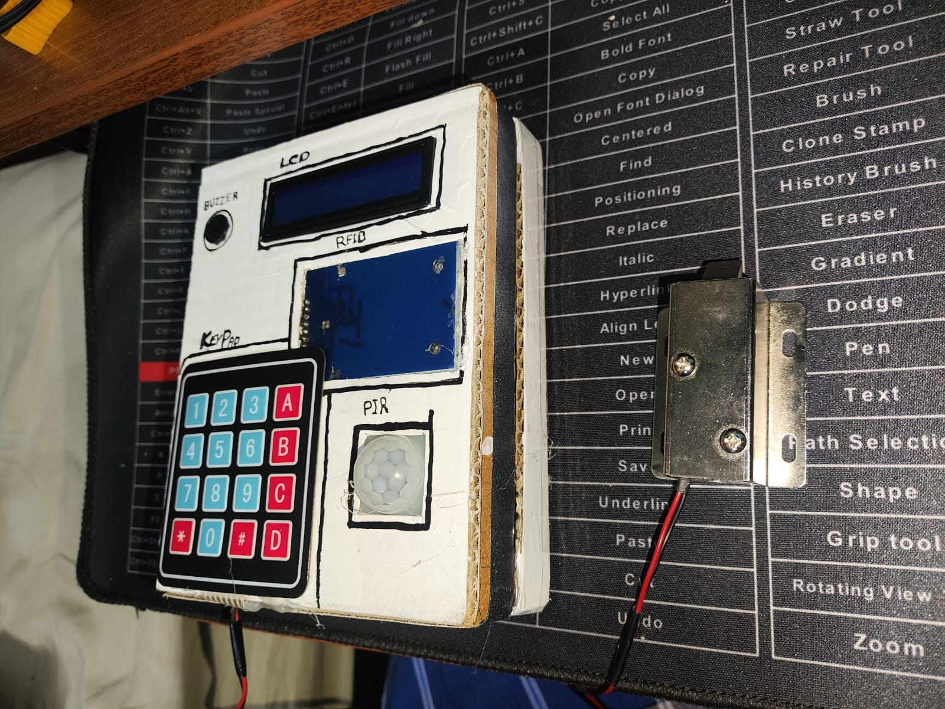
Figure 3. Prototype enclosure with LCD, RFID reader, keypad, PIR sensor and solenoid lock.

11. Firmware Source Code
The complete Arduino sketch is reproduced below for reference. It is also included separately as Smart_Door_Lock_System.ino in the project repository. Indentation has been normalized and the password-mask character on the LCD corrected to '*' for readability; the functional logic is unchanged.
#include <SPI.h>
#include <MFRC522.h>
#include <Wire.h>
#include <LiquidCrystal_I2C.h>
#include <Keypad.h>
#include <EEPROM.h>

#define SS_PIN 10
#define RST_PIN 9
#define PIR_PIN 2
#define RELAY_PIN 7
#define EXIT_PIN 6

MFRC522 rfid(SS_PIN, RST_PIN);
LiquidCrystal_I2C lcd(0x27,16,2);

const byte ROWS=4,COLS=4;
char keys[ROWS][COLS]={
{'1','2','3','A'},
{'4','5','6','B'},
{'7','8','9','C'},
{'*','0','#','D'}
};
byte rowPins[ROWS]={3,4,5,8};
byte colPins[COLS]={A0,A1,A2,A3};
Keypad keypad=Keypad(makeKeymap(keys),rowPins,colPins,ROWS,COLS);

String password="1234";
String input="";
byte AUTHORIZED_UID[4]={0xDE,0xAD,0xBE,0xEF};

void unlockDoor(){
digitalWrite(RELAY_PIN,HIGH);
lcd.clear();
lcd.print("Access Granted");
delay(5000);
digitalWrite(RELAY_PIN,LOW);
lcd.clear();
lcd.print("Door Locked");
}

bool checkRFID(){
if(!rfid.PICC_IsNewCardPresent()) return false;
if(!rfid.PICC_ReadCardSerial()) return false;
if(rfid.uid.size!=4) return false;
for(int i=0;i<4;i++){
if(rfid.uid.uidByte[i]!=AUTHORIZED_UID[i]){
lcd.clear();
lcd.print("Access Denied");
delay(2000);
rfid.PICC_HaltA();
return false;
}
}
rfid.PICC_HaltA();
return true;
}

void setup(){
pinMode(PIR_PIN,INPUT);
pinMode(RELAY_PIN,OUTPUT);
pinMode(EXIT_PIN,INPUT_PULLUP);
digitalWrite(RELAY_PIN,LOW);
SPI.begin();
rfid.PCD_Init();
lcd.init();
lcd.backlight();
lcd.print("SMART DOOR");
delay(1500);
lcd.clear();
}

void loop(){
lcd.setCursor(0,0);
lcd.print("Scan/Password ");

if(checkRFID()){
unlockDoor();
}

char key=keypad.getKey();
if(key){
if(key>='0' && key<='9'){
input+=key;
lcd.setCursor(input.length()-1,1);
lcd.print("*");
}else if(key=='#'){
if(input==password){
unlockDoor();
}else{
lcd.clear();
lcd.print("Wrong Password");
delay(2000);
}
input="";
lcd.clear();
}else if(key=='*'){
input="";
lcd.clear();
}
}

if(digitalRead(EXIT_PIN)==LOW){
unlockDoor();
delay(300);
}

if(digitalRead(PIR_PIN)==HIGH){
lcd.clear();
lcd.print("Motion Detect");
delay(1000);
lcd.clear();
}
}

12. Advantages
- Higher security than a traditional mechanical lock.
- Dual authentication – RFID card and password.
- Automatic re-locking removes the risk of a door left open.
- Simple to operate, with clear LCD status messages.
- Low overall component cost.
- Expandable with future IoT features.
- Suitable for homes, offices, labs, and lockers.

13. Limitations
- Requires continuous power – no battery backup in the current build.
- RFID cards can be lost or damaged.
- The password must be remembered; the current sketch stores a single fixed password.
- No remote monitoring or logging in the current version.
- Does not include biometric authentication.

14. Applications
- Home security
- Office access control
- College laboratories
- Library restricted rooms
- Hotel rooms
- Bank lockers
- Industrial control rooms

15. Future Enhancements
- Wi-Fi / IoT-based remote control
- Fingerprint authentication
- Face recognition
- Mobile app integration
- OTP verification
- GSM / SMS alerts
- Camera image capture on unauthorized attempts
- Cloud-based access logs

16. Conclusion
The Smart Door Lock System is a secure, low-cost embedded access-control solution built around an Arduino Nano. It combines RFID authentication, password verification, PIR-based motion detection, an LCD user interface, and a relay-controlled solenoid lock to provide reliable, automated door security. The system improves on traditional mechanical locks while remaining simple to build and easy to extend with future technologies such as IoT connectivity, biometrics, and remote monitoring.

