FIRE FIGHTING ROBOT
An Intelligent, Autonomous Fire Detection and Extinguishing System
PROJECT REPORT

Table of Contents
Table of Contents 2
Abstract 4
1. Introduction 4
1.1 Background 4
1.2 Problem Statement 4
1.3 Proposed Solution 4
2. Objectives 5
3. How Does It Work? 5
3.1 Fire Detection 5
3.2 Navigation and Movement 5
3.3 Extinguishing Mechanism 5
3.4 Remote Control and Monitoring 5
4. Required Components 6
5. Circuit Connections and Assembly Procedure 7
Step 1: MLX90614 Temperature Sensor 7
Step 2: Servo Motor 7
Step 3: Flame Sensors 7
Step 4: Motor Driver (L298N) 7
Step 5: Relay Module (Water Pump) 7
Step 6: Mode Switch (Manual/Automatic) 7
Step 7: Bluetooth Module (HC-05) 8
6. Circuit Diagram 8
7. Working Methodology 8
7.1 Manual Mode 9
7.2 Automatic Mode 9
8. Arduino Source Code 9
9. Key Benefits 12
9.1 Human Safety 12
9.2 Faster Response 12
9.3 Cost-Effectiveness 13
9.4 Scalability 13
10. Applications 13
11. Limitations and Future Scope 13
11.1 Limitations 13
11.2 Future Scope 13
12. Conclusion 14
13. References 14

Abstract
Fire accidents are among the most destructive emergencies, frequently causing severe loss of life, property, and the environment. Conventional firefighting methods place human responders directly in harm's way, exposing them to smoke inhalation, toxic gases, extreme heat, and structural collapse. This project presents the design and development of an Intelligent Fire Fighting Robot capable of autonomously detecting and extinguishing fires while keeping human operators safely out of danger.
The robot integrates flame sensors, a contactless infrared temperature sensor, and a mobile-controlled Bluetooth interface to identify the direction and intensity of a fire. Once a fire is detected, the system directs a water pump, mounted on a servo-controlled nozzle, toward the flame and sprays water until the fire is extinguished. The robot can operate in two modes: a fully autonomous mode in which it navigates toward the fire and extinguishes it on its own, and a manual mode in which it is remotely controlled through a Bluetooth-enabled mobile application. Built using low-cost, easily available components such as an Arduino Uno, this system demonstrates an affordable and scalable solution suitable for homes, offices, and small industrial spaces.

1. Introduction

1.1 Background
Fire safety remains a critical concern across residential, commercial, and industrial environments. Statistics consistently show that delayed detection and response are major contributors to the scale of damage caused by fire accidents. Traditional firefighting requires human personnel to physically approach the fire, which is inherently dangerous, especially in confined spaces, chemical storage areas, or locations with high temperatures and toxic fumes.

1.2 Problem Statement
There is a pressing need for a system that can detect fire at an early stage and respond immediately, without placing human lives at risk. Manual intervention is often too slow and too hazardous, particularly in environments prone to rapid fire spread.

1.3 Proposed Solution
This project proposes an autonomous robotic platform that combines fire-sensing technology, mobility, and an automated extinguishing mechanism. The robot uses flame sensors and a temperature sensor to locate and assess a fire, then either navigates toward it autonomously or is guided manually via a Bluetooth mobile application, before activating a water pump to extinguish the flame.

2. Objectives
- To design a mobile robotic platform capable of detecting fire using flame and temperature sensors.
- To enable autonomous navigation of the robot toward the source of a detected fire.
- To implement an automated water-spraying mechanism to extinguish fire without human involvement.
- To provide a manual override mode through a Bluetooth mobile application for operator-controlled use.
- To build the system using low-cost, easily sourced components, making it affordable and scalable.

3. How Does It Work?

3.1 Fire Detection
- Flame sensors continuously scan the surrounding area for the infrared signature of flames.
- A contactless infrared temperature sensor (MLX90614) measures the object and ambient temperature to assess heat levels and confirm the presence of fire.

3.2 Navigation and Movement
- The robot moves using DC motors and wheels controlled through a motor driver module.
- IR flame sensors positioned on the left, front, and right help determine the direction of the fire so the robot can orient itself accordingly.

3.3 Extinguishing Mechanism
- A water pump, switched on and off through a relay module, sprays water onto the detected fire.
- A servo motor adjusts the angle of the nozzle, sweeping it across the flame for more effective coverage.

3.4 Remote Control and Monitoring
- A Bluetooth module (HC-05) allows the robot to be controlled through a mobile application.
- The robot can be switched between manual operation and fully autonomous operation using a physical switch.

4. Required Components
The following table lists the major hardware components used in the construction of the Fire Fighting Robot, along with their function in the system.

Component | Function
Arduino Uno R3 | Main microcontroller; controls and coordinates all other components.
IR Flame Sensors (x3) | Detect the presence and approximate direction of a fire.
MLX90614 Temperature Sensor | Contactless infrared sensor that measures object and ambient temperature.
Servo Motor | Adjusts the angle of the water nozzle to aim at the fire.
Water Pump Module | Sprays water onto the fire to extinguish it.
Relay Module (5V) | Switches the water pump ON and OFF under Arduino control.
Motor Driver (L298N) | Drives the DC motors that move the robot.
DC Motors and Wheels | Provide locomotion, allowing the robot to move toward the fire.
Bluetooth Module (HC-05) | Enables wireless remote control via a mobile application.
Buzzer | Sounds an alert when fire is detected.
Power Supply / Battery (6V-12V Li-ion) | Supplies rechargeable power to all components.
Breadboard and Jumper Wires | Used to connect components without soldering.
Switch | Toggles between manual and automatic operating modes.

5. Circuit Connections and Assembly Procedure
The robot was assembled by wiring each module to the Arduino Uno as described below.

Step 1: MLX90614 Temperature Sensor
- VCC → 5V
- GND → GND
- SCL → Analog Pin A5
- SDA → Analog Pin A4

Step 2: Servo Motor
- VCC (Red) → 5V
- GND (Black) → GND
- Signal (Yellow/White) → Digital Pin 11

Step 3: Flame Sensors
- Flame Sensor 1 (Left) → Digital Pin 8
- Flame Sensor 2 (Front) → Digital Pin 9
- Flame Sensor 3 (Right) → Digital Pin 10
- VCC → 5V, GND → GND

Step 4: Motor Driver (L298N)
- IN1 → Digital Pin 7, IN2 → Digital Pin 6, IN3 → Digital Pin 5, IN4 → Digital Pin 4
- Motor 1 Output → Left Motor Terminals, Motor 2 Output → Right Motor Terminals
- VCC (L298N) → External Battery (6V-12V); GND (L298N) → GND (Arduino); 5V Output → 5V (Arduino)

Step 5: Relay Module (Water Pump)
- VCC → 5V, GND → GND
- IN (Control Pin) → Digital Pin 6
- Relay Output → Water Pump Power Control

Step 6: Mode Switch (Manual/Automatic)
- One Terminal → GND, Other Terminal → Digital Pin 7

Step 7: Bluetooth Module (HC-05)
- VCC → 5V, GND → GND
- TX → Arduino Digital Pin 12
- RX → Arduino Digital Pin 13
Note: Pins 6 and 7 are referenced for more than one module in the original wiring notes; before final assembly, verify pin assignments against the Arduino sketch to avoid conflicts, and reassign any duplicated digital pins as needed.

6. Circuit Diagram

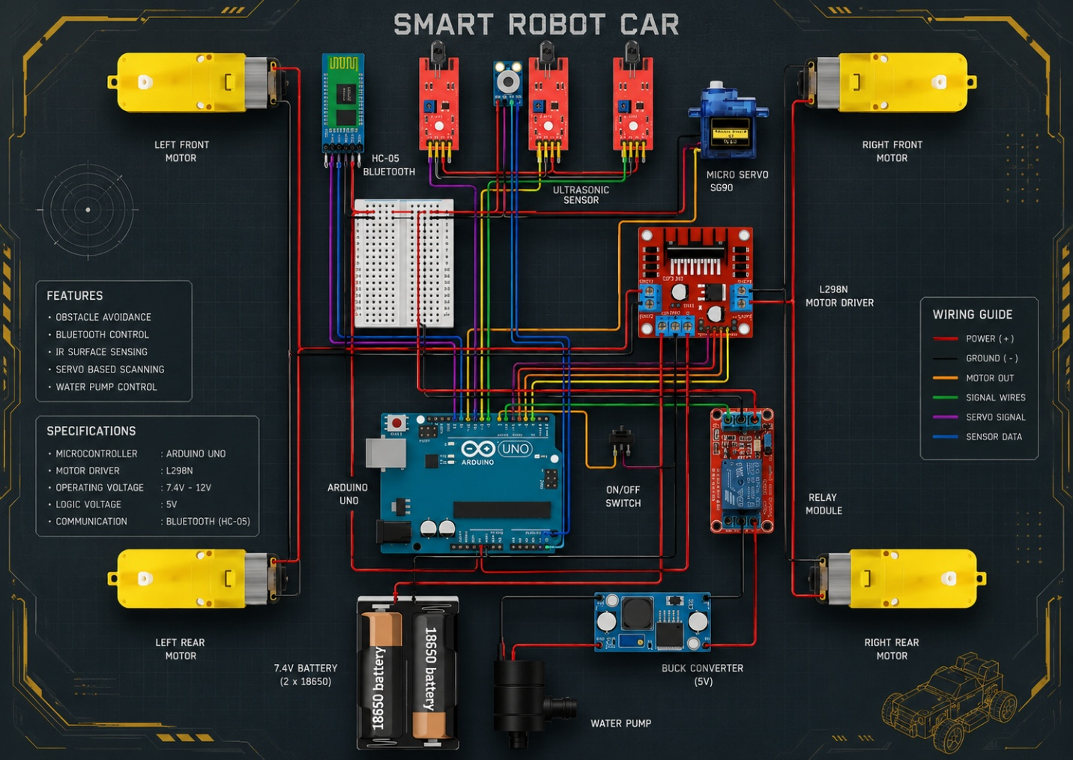

7. Working Methodology
On power-up, the Arduino initializes all sensors and sets the servo and motors to their default positions. The system then continuously checks the position of the mode switch.

7.1 Manual Mode
When manual mode is selected, the robot listens for commands sent over Bluetooth from the mobile application. Commands move the robot forward, backward, left, or right, stop it, or trigger the extinguishing sequence (sweeping the nozzle while the pump sprays water).

7.2 Automatic Mode
In automatic mode, the robot continuously reads the flame sensors and the temperature sensor. If the measured object temperature exceeds 50°C, or if a flame sensor reading falls below the threshold indicating a nearby flame, the robot stops, activates the pump, and sweeps the nozzle across the fire until it is extinguished. If a moderate temperature rise is detected, the robot moves forward to approach the fire source. If a flame is detected on the left or right sensor, the robot turns toward it; otherwise, it continues scanning the area.

8. Arduino Source Code
The complete Arduino sketch used to program the microcontroller is provided below.
#include <Wire.h>
#include <Adafruit_MLX90614.h>
#include <Servo.h>

Adafruit_MLX90614 mlx = Adafruit_MLX90614();
Servo servo;

#define IN1 7
#define IN2 6
#define IN3 5
#define IN4 4
#define FLAME1 A0
#define FLAME2 A1
#define FLAME3 A2
#define RELAY_PIN 11
#define SWITCH_PIN 13

bool manualMode = true;
int servoPin = 12;
int angle = 90;

void setup() {
Serial.begin(9600);
if (!mlx.begin()) {
Serial.println("Error connecting to MLX90614 sensor!");
while (1);
}
servo.attach(servoPin);
servo.write(90);
pinMode(IN1, OUTPUT);
pinMode(IN2, OUTPUT);
pinMode(IN3, OUTPUT);
pinMode(IN4, OUTPUT);
pinMode(FLAME1, INPUT);
pinMode(FLAME2, INPUT);
pinMode(FLAME3, INPUT);
pinMode(RELAY_PIN, OUTPUT);
digitalWrite(RELAY_PIN, LOW);
pinMode(SWITCH_PIN, INPUT);
Serial.println("System initialized!");
}

void loop() {
manualMode = (digitalRead(SWITCH_PIN) == HIGH);
if (manualMode) {
if (Serial.available()) {
char command = Serial.read();
handleManualControl(command);
}
} else {
handleAutomaticControl();
}
}

void sweepServo() {
for (int pos = 50; pos <= 130; pos++) {
servo.write(pos);
delay(10);
}
for (int pos = 130; pos >= 50; pos--) {
servo.write(pos);
delay(10);
}
}

void put_off_fire() {
stopMotors();
digitalWrite(RELAY_PIN, HIGH);
sweepServo();
digitalWrite(RELAY_PIN, LOW);
servo.write(90);
}

void handleManualControl(char command) {
switch (command) {
case 'F': stopMotors(); moveForward(); break;
case 'B': stopMotors(); moveBackward(); break;
case 'L': stopMotors(); turnLeft(); break;
case 'R': stopMotors(); turnRight(); break;
case 'S': stopMotors(); break;
case 'X': put_off_fire(); break;
case 'x': digitalWrite(RELAY_PIN, LOW); servo.write(90); break;
}
}

void handleAutomaticControl() {
int flame1 = analogRead(FLAME1);
int flame2 = analogRead(FLAME2);
int flame3 = analogRead(FLAME3);
float objectTemp = mlx.readObjectTempC();
float ambientTemp = mlx.readAmbientTempC();

Serial.print("Object Temp: "); Serial.print(objectTemp);
Serial.print(" C, Ambient Temp: "); Serial.println(ambientTemp);
Serial.print(flame1); Serial.print("\t"); Serial.print(flame2);
Serial.print("\t"); Serial.println(flame3);
delay(1000);

if (objectTemp > 50.0) {
stopMotors();
digitalWrite(RELAY_PIN, HIGH);
Serial.println("High temperature detected! Activating pump...");
put_off_fire();
delay(1000);
servo.write(90);
} else if (objectTemp > 35.0 && objectTemp <= 50.0) {
digitalWrite(RELAY_PIN, LOW);
moveForward();
delay(500);
} else {
stopMotors();
digitalWrite(RELAY_PIN, LOW);
Serial.println("Low temperature detected. Stopping motors...");
}

if (flame1 < 350 || flame3 < 350) {
stopMotors();
digitalWrite(RELAY_PIN, HIGH);
put_off_fire();
delay(500);
servo.write(90);
} else if (flame2 < 350) {
stopMotors();
digitalWrite(RELAY_PIN, HIGH);
put_off_fire();
delay(500);
servo.write(90);
} else if (flame1 >= 351 && flame1 <= 800) {
digitalWrite(RELAY_PIN, LOW);
moveForward();
delay(100);
turnRight();
delay(200);
} else if (flame2 >= 351 && flame2 <= 800) {
digitalWrite(RELAY_PIN, LOW);
moveForward();
delay(100);
} else if (flame3 >= 351 && flame3 <= 800) {
digitalWrite(RELAY_PIN, LOW);
moveBackward();
delay(100);
turnLeft();
delay(200);
} else {
digitalWrite(RELAY_PIN, LOW);
stopMotors();
}
delay(100);
}

void moveForward() {
digitalWrite(IN1, HIGH);
digitalWrite(IN2, LOW);
digitalWrite(IN3, HIGH);
digitalWrite(IN4, LOW);
}

void moveBackward() {
digitalWrite(IN1, LOW);
digitalWrite(IN2, HIGH);
digitalWrite(IN3, LOW);
digitalWrite(IN4, HIGH);
}

void turnLeft() {
digitalWrite(IN1, LOW);
digitalWrite(IN2, HIGH);
digitalWrite(IN3, HIGH);
digitalWrite(IN4, LOW);
}

void turnRight() {
digitalWrite(IN1, HIGH);
digitalWrite(IN2, LOW);
digitalWrite(IN3, LOW);
digitalWrite(IN4, HIGH);
}

void stopMotors() {
digitalWrite(IN1, LOW);
digitalWrite(IN2, LOW);
digitalWrite(IN3, LOW);
digitalWrite(IN4, LOW);
}

9. Key Benefits

9.1 Human Safety
- Keeps firefighters away from dangerous fire zones.
- Prevents health risks associated with smoke inhalation and toxic gases.

9.2 Faster Response
- Detects and reacts to fire instantly using onboard sensors.
- Extinguishes flames before they spread, minimizing overall damage.

9.3 Cost-Effectiveness
- Built using affordable, readily available components, keeping overall costs low.
- Reduces dependence on expensive firefighting equipment and manual intervention.

9.4 Scalability
- Suitable for deployment in homes, offices, and industrial settings.
- Can be upgraded with additional sensors and greater automation in future iterations.

10. Applications
- Residential fire safety and early-stage fire suppression.
- Office buildings and commercial spaces with restricted access during fire emergencies.
- Industrial units, warehouses, and chemical storage facilities where human entry is hazardous.
- Supplementary support for professional fire and emergency response teams.

11. Limitations and Future Scope

11.1 Limitations
- Limited water tank capacity restricts continuous operation time.
- Bluetooth-based control has a limited operating range compared to Wi-Fi or GSM-based systems.
- Current sensors are best suited to detecting open flames and may be less effective with smouldering or hidden fires.

11.2 Future Scope
- Integration of a camera module and image processing for visual fire confirmation.
- Use of Wi-Fi or GSM modules to extend the control range and enable remote monitoring over the internet.
- Addition of smoke and gas sensors for more comprehensive hazard detection.
- Upgrading to a larger water reservoir or alternative extinguishing agents (foam or CO2) for industrial use.

12. Conclusion
The Intelligent Fire Fighting Robot demonstrates a practical and affordable approach to automated fire detection and suppression. By combining flame sensing, contactless temperature measurement, autonomous navigation, and a Bluetooth-controlled manual override, the system offers a flexible solution that reduces risk to human life while responding quickly to fire emergencies. With further development, including improved sensing, extended communication range, and larger extinguishing capacity, this platform can be adapted for broader residential, commercial, and industrial use.

13. References
1. Arduino Uno R3 documentation, Arduino official resources.
2. MLX90614 Infrared Thermometer datasheet, Melexis.
3. L298N Dual H-Bridge Motor Driver datasheet.
4. HC-05 Bluetooth Module documentation and application notes.

