# SQL QUERIES :-

# **Revenue Performance by Genre**

1. *Objective:*  
   Identify which movie genres generate the highest and lowest average revenue to inform decisions on future genre investments.
   * Calculate total and average revenue for each genre.
   * Rank genres based on profitability.
   * Identify high-performing and underperforming genres.

SELECT GENRE,

SUM(REVENUE_INR) AS TOTAL_REVENUE,

ROUND(AVG(REVENUE_INR) ,2) AS AVERAGE_REVENUE,

SUM(PROFIT) AS PROFIT,

RANK() OVER(ORDER BY SUM(PROFIT) DESC) AS RANKS

FROM BOLLYWOOD

GROUP BY GENRE;

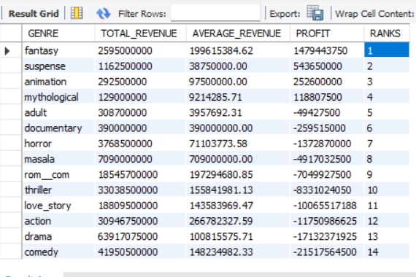

**Insights** :-

* Fantasy, Animations , Suspence movies are making good profit / revenue.
* These movies are returning investment Amount to producers/sponsers with Profit.

1. Impact of Release Period on Revenue  
   *Objective:*  
   Evaluate how different release periods, such as holiday seasons or regular periods, influence movie revenue. This will guide optimal release timing for maximizing box office revenue.  
   * Compare average revenue for holiday-released movies versus non-holiday releases.
   * Provide insights on the best periods for movie releases to maximize profitability.

SELECT

RELEASE_PERIOD,

ROUND(AVG(REVENUE_INR)) AS AVERAGE_REVENUE,

SUM(PROFIT) AS TOTAL_PROFIT ,

COUNT(*) AS NO_MOVIES ,

(100 * COUNT(*) / (SELECT COUNT(*) FROM BOLLYWOOD)) AS CONTRIBUTION

FROM BOLLYWOOD

GROUP BY RELEASE_PERIOD;



-- LETS FIGURE WHICH DAY AND WHAT KIND MOVIE GIVE PROFIT

SELECT

GENRE,

RELEASE_PERIOD,

ROUND(AVG(REVENUE_INR)) AS AVERAGE_REVENUE,

SUM(PROFIT) AS TOTAL_PROFIT ,

COUNT(*) AS NO_MOVIES ,

(100 * COUNT(*) / (SELECT COUNT(*) FROM BOLLYWOOD)) AS CONTRIBUTION

FROM BOLLYWOOD

GROUP BY GENRE , RELEASE_PERIOD

ORDER BY TOTAL_PROFIT DESC;

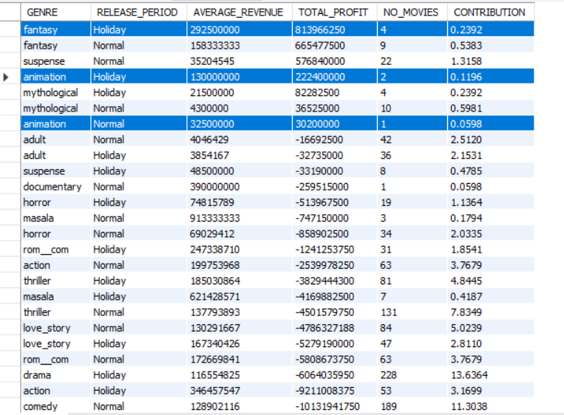

**Insights** :-

* Drama Genre Movies are giving huge losses 24%.
* Animation, Fantasy Movies are Returning Huge profits but this genre movies Are Very low

1. Franchise vs. Standalone Movie Performance  
   *Objective:*  
   Compare the financial performance of franchise movies against standalone films to assess the benefits of producing sequels or franchise films.*:*
   * Calculate the average revenue and profitability of franchise movies.
   * Compare with standalone movies to measure financial impact.
   * Identify trends or patterns that may justify investments in franchise films.

select

is_franchise,

release_period ,

sum(revenue_inr) as Total_Revenue ,

round(avg(revenue_inr)) as Average_Revenue ,

sum(profit) as Total_Profit ,

round(avg(profit)) as Total_Profit,

count(*) as no_of_movies

from bollywood

group by is_franchise , release_period;

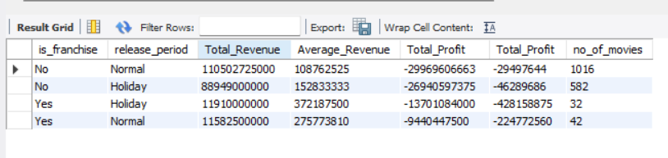

**Insights** :-

* Bollywood Not Making Profit Because of Genre Audience Don’t Want to Watch Drama’s.

1. Star Power vs. New Talent  
   *Objective:*  
   Analyze the impact of lead actors, directors, and music directors (established stars vs. new talent) on movie revenue.  
   *Tasks:*
   * Compare the revenue of movies featuring established stars versus new talent.
   * Assess the impact of experienced versus new directors and music directors on revenue generation.
   * Provide insights into whether it’s financially viable to invest in new talent.

**select**

(**case** when new_actor = 'Yes' then 'New_actor' **else** 'Experienced_Actor' **end**) as Actors,

(**case** when new_director ='Yes' then "New Director" **else** "Experienced Director" **end**) as Directors,

(**case** when new_music_director ='Yes' then "New Music Director" **else** "Experienced Music Director" **end**) as Music_Directos,

**sum**(revenue_inr) as revenue

**from** bollywood

**group** by Actors , Directors ,Music_Directos

**order** by revenue **desc;**

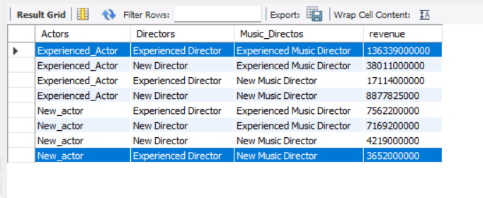

**Insights** :-

* New Talent Making Less Revenue Than Experienced Star’s

1. Remakes vs. Original Movies  
   *Objective:*  
   Examine the financial performance of remakes compared to original movies to determine whether remakes offer a profitable business model.*:*
   * Calculate the total and average revenue for remakes and original movies.
   * Compare the ROI of remakes versus original films.
   * Identify patterns that indicate whether remakes or original content generate higher returns.

**SELECT**

(**CASE** WHEN is_remake = 'No' Then "Original Movie" **else** "Remake Movie" **end**) as Movie_Type,

**sum**(revenue_inr) as Total_Revenue_Generated,

**avg**(revenue_inr) as Average_Revenue_Generated,

((**sum**(revenue_inr) - **sum**(budget_inr))/ **sum**(budget_inr)) *100 as ROI

**FROM**

BOLLYWOOD

**GROUP** BY Movie_Type

**order** by Total_Revenue_Generated desc;

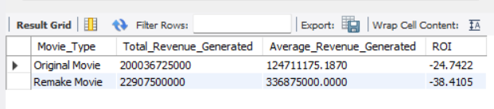

**Insights** :-

* Original Movie Making More Revenue Than (>) Remake Movies(Dubbed).
* Original Movie’s ROI(Return of Investment) of Loss is lesser Than Remake Movie.

1. Budget vs. Revenue Analysis  
   *Objective:*  
   Assess the relationship between the production budget and box office revenue. This will help in evaluating financial efficiency and ROI.*:*
   * Calculate profit for each movie.
   * Compute the ROI for each movie.

**SELECT**

MOVIE_NAME AS MOVIE,

Budget_inr as Budget,

Revenue_inr as Revenue ,

PROFIT , -- (REVENUE_inr - BUDGET_INr)

**concat**(**round**(((**SUM**(REVENUE_INR) - **SUM**(BUDGET_INR))/ **SUM**(BUDGET_INR))*100 ,2**),"%")**AS ROI

**from** bollywood

**group** by MOVIE , Budget ,Revenue , PROFIT;

