# MAIN DASHBOARD

TOTAL OVERALL SALES

SELECT SUM(TOTAL_SALES) as total_sales FROM fast_food;

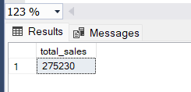

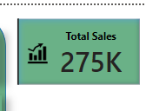

--Average Sales

SELECT AVG(TOTAL_SALES) AS AVG_SALES FROM fast_food;

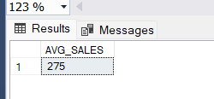

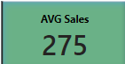

--MAXIMUM ITEM PRICE FROM FASTFOOD

SELECT MAX(ITEM_PRICE) AS MAX_ITEM_PRICE FROM fast_food;

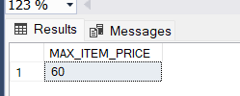

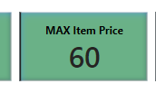

total quantity

SELECT SUM(QUANTITY) AS TOTAL_QUANTITY FROM fast_food;

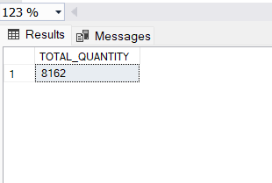

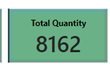

NO of Orders

SELECT COUNT(ORDER_ID) AS NO_OF_ORDERS FROM fast_food;

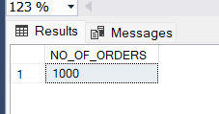

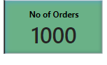

SALES BY ITEM

SELECT ITEM_NAME , SUM(TOTAL_SALES) AS SALES FROM fast_food

GROUP BY ITEM_NAME ORDER BY SALES DESC ;

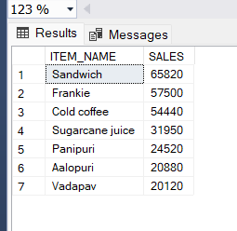

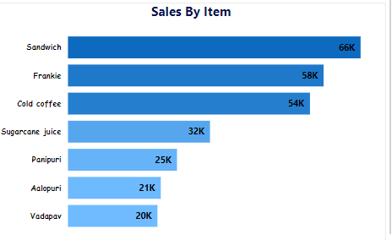

Sales By Time (ex : - Afternoon)

SELECT TIME_SALES , SUM(TOTAL_SALES) AS SALES FROM fast_food

GROUP BY TIME_SALES ORDER BY SALES DESC ;

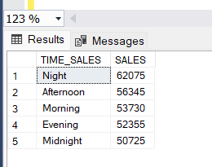

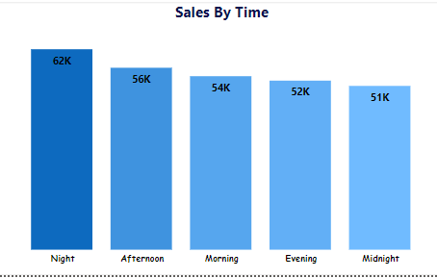

GENDER DISTRIBUTION

SELECT RECEIVED_BY,

COUNT(*) GENDER_COUNT

FROM fast_food

GROUP BY RECEIVED_BY ORDER BY GENDER_COUNT DESC;

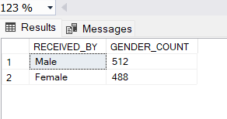

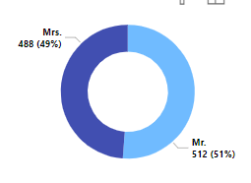

## Cold Coffee Item

-- Coffee total sales KPI

SELECT SUM(TOTAL_SALES) AS TOTAL_SALES_COFFEE FROM fast_food WHERE item_name ='Cold Coffee';

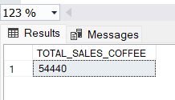

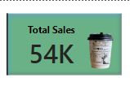

-- cold coffee Avg Sales

SELECT AVG(TOTAL_SALES) AS AVG_COFFEE_SALES FROM fast_food WHERE item_name = 'COLD COFFEE';

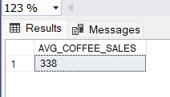

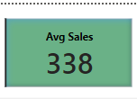

--ITEM PRICE COLD COFFEE

SELECT TOP 1 ITEM_PRICE FROM fast_food WHERE ITEM_NAME ='COLD COFFEE';

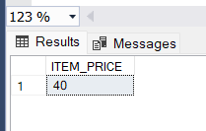

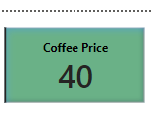

-- COUNT ORDERS

SELECT COUNT(ORDER_ID) AS NO_OF_ORDERS

FROM fast_food WHERE ITEM_NAME ='COLD COFFEE';

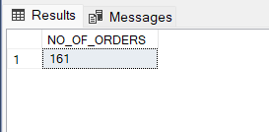

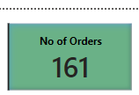

-- COFFEE Gender Distribution

SELECT RECEIVED_BY ,COUNT(*) AS RECEIVED_PERSON

FROM fast_food WHERE ITEM_NAME = 'COLD COFFEE' GROUP BY received_by ORDER BY RECEIVED_PERSON DESC;

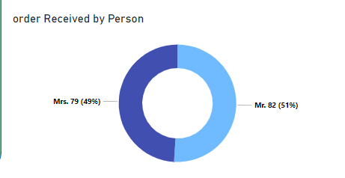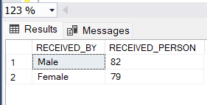

-- TABLE VALUES (GROUP BY) ITEM_NAME , TIME, QUANTITY , TOTAL SALES

SELECT ITEM_NAME ,

TIME_SALES ,

SUM(QUANTITY) TOTAL_QUANTITY ,

SUM(TOTAL_SALES) TOTAL_SALES

FROM fast_food

WHERE item_name ='COLD COFFEE'

GROUP BY ITEM_NAME,

TIME_SALES;

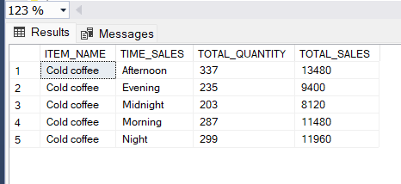

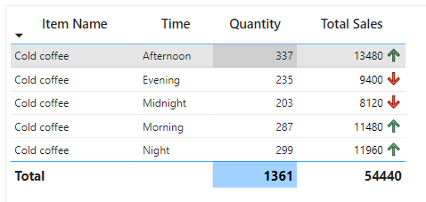

## VADAPAV ITEM

--TOTAL SALES

SELECT SUM(TOTAL_SALES) AS SALES

FROM fast_food WHERE ITEM_NAME ='VADAPAV';

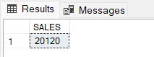

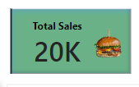

--AVERAGE SALES

SELECT AVG(TOTAL_SALES) AS AVG_SALES

FROM fast_food WHERE ITEM_NAME ='VADAPAV';

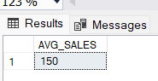

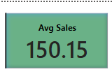

-- VADAPAV PRICE

SELECT TOP 1 ITEM_PRICE FROM fast_food WHERE ITEM_NAME ='VADAPAV';

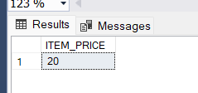

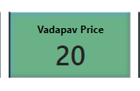

-- ORDERS

SELECT COUNT(ORDER_ID) AS NO_OF_ORDERS

FROM fast_food WHERE ITEM_NAME ='VADAPAV';

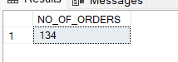

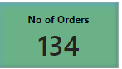

-- GENDER DIST

SELECT RECEIVED_BY ,COUNT(*) AS RECEIVED_PERSON

FROM fast_food WHERE ITEM_NAME = 'VADAPAV' GROUP BY received_by ORDER BY RECEIVED_PERSON DESC;

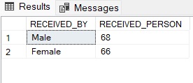

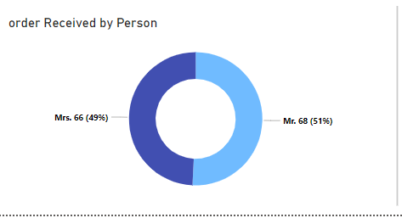

-- TABLE VALUES (GROUP BY) ITEM_NAME , TIME, QUANTITY , TOTAL SALES

SELECT ITEM_NAME ,

TIME_SALES ,

SUM(QUANTITY) TOTAL_QUANTITY ,

SUM(TOTAL_SALES) TOTAL_SALES

FROM fast_food

WHERE item_name ='VADAPAV'

GROUP BY ITEM_NAME,

TIME_SALES ORDER BY TOTAL_SALES DESC;

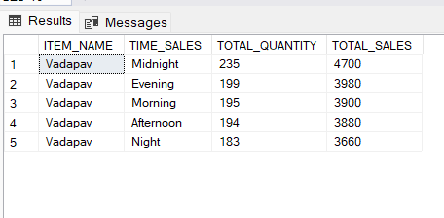

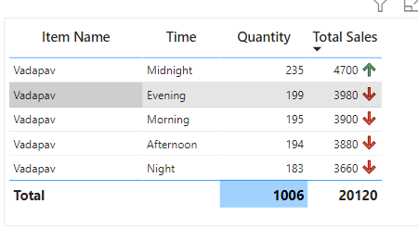

## SUGARCANE JUICE ITEM

--TOTAL SALES

SELECT SUM(TOTAL_SALES) AS SALES

FROM fast_food WHERE ITEM_NAME ='SUGARCANE JUICE';

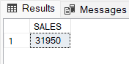

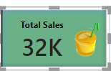

--AVERAGE SALES

SELECT AVG(TOTAL_SALES) AS AVG_SALES

FROM fast_food WHERE ITEM_NAME ='SUGARCANE JUICE';

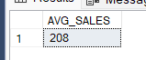

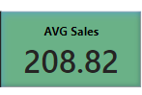

-- JUICE PRICE

SELECT TOP 1 ITEM_PRICE FROM fast_food WHERE ITEM_NAME ='SUGARCANE JUICE';



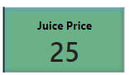

-- ORDERS

SELECT COUNT(ORDER_ID) AS NO_OF_ORDERS

FROM fast_food WHERE ITEM_NAME ='SUGARCANE JUICE';

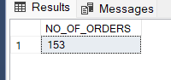

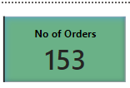

-- GENDER DIST

SELECT RECEIVED_BY ,COUNT(*) AS RECEIVED_PERSON,

SUM(

FROM fast_food WHERE ITEM_NAME = 'SUGARCANE JUICE' GROUP BY received_by ORDER BY RECEIVED_PERSON DESC;

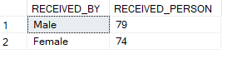

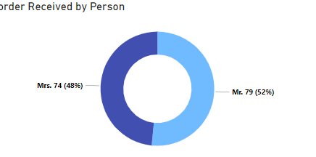

-- TABLE VALUES (GROUP BY) ITEM_NAME , TIME, QUANTITY , TOTAL SALES

SELECT ITEM_NAME ,

TIME_SALES ,

SUM(QUANTITY) TOTAL_QUANTITY ,

SUM(TOTAL_SALES) TOTAL_SALES

FROM fast_food

WHERE item_name ='SUGARCANE JUICE'

GROUP BY ITEM_NAME,

TIME_SALES ORDER BY TOTAL_SALES DESC;

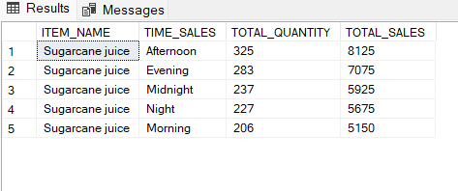

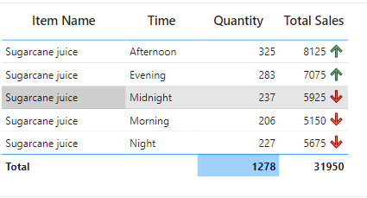

## PANIPURI ITEM

--TOTAL SALES

SELECT SUM(TOTAL_SALES) AS SALES

FROM fast_food WHERE ITEM_NAME ='PANIPURI';

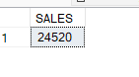

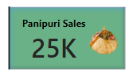

--AVERAGE SALES

SELECT AVG(TOTAL_SALES) AS AVG_SALES

FROM fast_food WHERE ITEM_NAME ='PANIPURI';

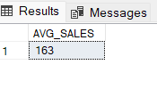

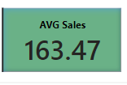

-- PANIPURI PRICE

SELECT TOP 1 ITEM_PRICE FROM fast_food WHERE ITEM_NAME ='PANIPURI';

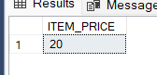

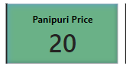

-- ORDERS

SELECT COUNT(ORDER_ID) AS NO_OF_ORDERS

FROM fast_food WHERE ITEM_NAME ='PANIPURI';

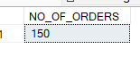

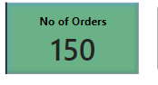

-- GENDER DIST

SELECT RECEIVED_BY ,COUNT(*) AS RECEIVED_PERSON

FROM fast_food WHERE ITEM_NAME = 'PANIPURI' GROUP BY received_by ORDER BY RECEIVED_PERSON DESC;

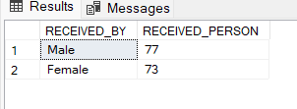

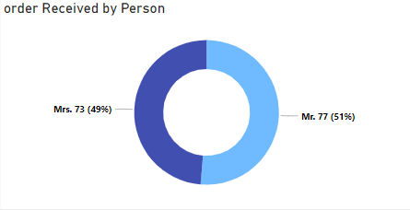

-- TABLE VALUES (GROUP BY) ITEM_NAME , TIME, QUANTITY , TOTAL SALES

SELECT ITEM_NAME ,

TIME_SALES ,

SUM(QUANTITY) TOTAL_QUANTITY ,

SUM(TOTAL_SALES) TOTAL_SALES

FROM fast_food

WHERE item_name ='PANIPURI'

GROUP BY ITEM_NAME,

TIME_SALES ORDER BY TOTAL_SALES DESC;

