Objective 1: To determine the Z-Parameters of a Two-Port Network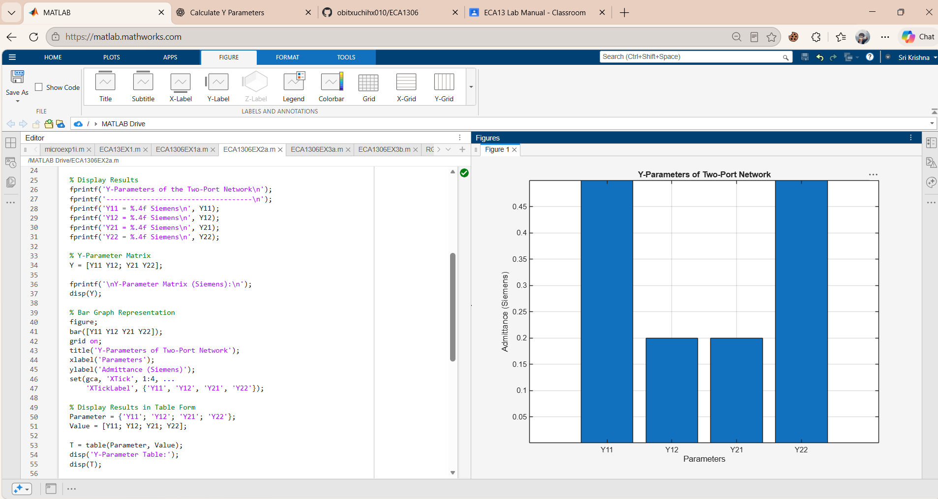
Objective 2: Determination of Y-Parameters of a Two-Port Network
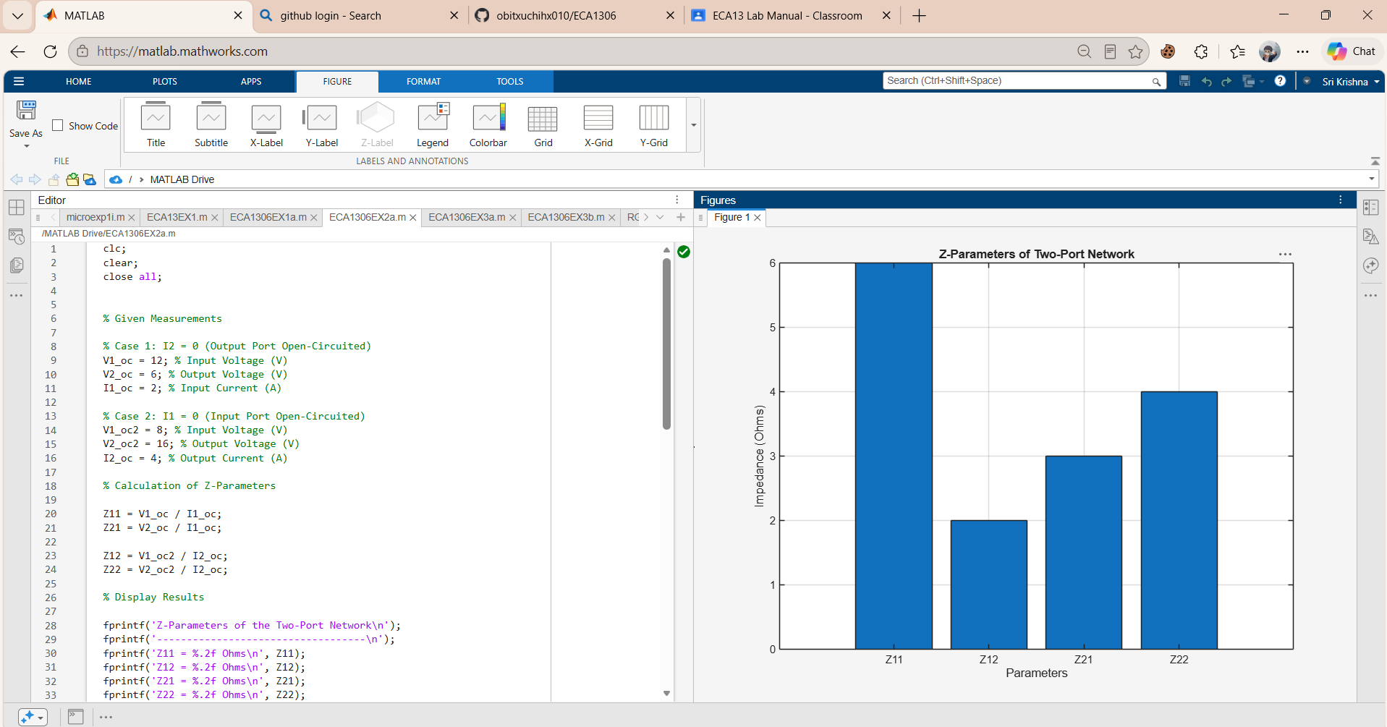
Objective 3: To determine the h-Parameters of a Two-Port Network
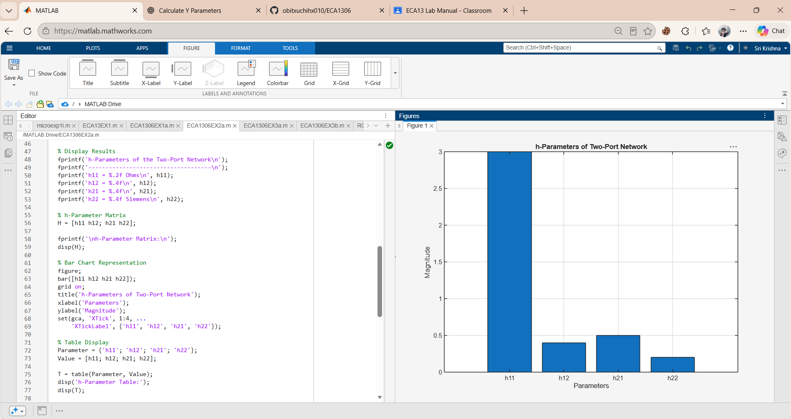
Objective 4: To determine the ABCD Parameters of a Two-Port Network
