EX 1.2 Analysis and Measurement of High-Frequency Network Parameters using MATLAB
Objectives
i) To determine the Scattering Parameters (S-Parameters) of a two-port
microwave network by analyzing the incident and reflected wave characteristics at theinput and output ports under specified operating conditions.
ii) To analyze the variation of return loss with frequency by evaluatingthe
reflection characteristics of a microwave network over a specified frequency range.
iii) To simulate the performance of a microwave network using MATLABand
analyze its insertion loss characteristics over a specified operating range.
iv) To simulate the behavior of a high-frequency network using MATLABand
analyze its performance under different operating frequencies..

Objective 1 : Determination of Scattering Parameters (S-Parameters) of a Two-Port Microwave Network
Procedure
1. Open MATLAB and initialize the RF Toolbox.
2. Create a two-port microwave network model.
3. Define the frequency range from 1 GHz to 10 GHz.
4. Configure the network ports with characteristic impedance of 50 Ω.
5. Perform S-parameter simulation.
6. Measure S₁₁, S₁₂, S₂₁, and S₂₂ values.
7. Plot the S-parameter response over the frequency range.
8. Record the obtained results.
MATLAB Program
% Determination of Scattering Parameters (S-Parameters)
% of a Two-Port Microwave Network using MATLAB
clc;
clear;
close all;
% Experimental Data for Three Cases
% Incident Wave Amplitudes
a1 = [10 15 20]; % Port-1 Incident Wave a2 = [0 0 0]; % Port-2 Matched Load
% Reflected and Transmitted Waves
b1 = [2 3 4]; % Reflected Wave at Port-1 b2 = [8 12 16]; % Transmitted Wave at Port-2
% S-Parameter Calculations
S11 = b1 ./ a1; % Input Reflection Coefficient S21 = b2 ./ a1; % Forward Transmission Coefficient
% Assume reverse measurements
a2_rev = [10 15 20];
b2_rev = [1 1.5 2];
b1_rev = [7 10 13];
S22 = b2_rev ./ a2_rev; % Output Reflection Coefficient S12 = b1_rev ./ a2_rev; % Reverse Transmission Coefficient
% Display Results
disp('Scattering Parameters for Three Cases'); fprintf('\nCase\tS11\t\tS12\t\tS21\t\tS22\n');
for i = 1:length(a1)
fprintf('%d\t%.3f\t\t%.3f\t\t%.3f\t\t%.3f\n',... i,S11(i),S12(i),S21(i),S22(i));
end
% S-Parameter Matrix for each case
for i = 1:length(a1)
S = [S11(i) S12(i);
S21(i) S22(i)];
fprintf('\nS-Parameter Matrix for Case %d:\n',i);
disp(S);
end
% Magnitude in dB
S11_dB = 20*log10(abs(S11));
S12_dB = 20*log10(abs(S12));
S21_dB = 20*log10(abs(S21));
S22_dB = 20*log10(abs(S22));
% Plotting
figure;
plot(1:3,S11_dB,'-o','LineWidth',2);
hold on;
plot(1:3,S21_dB,'-s','LineWidth',2);
plot(1:3,S12_dB,'-^','LineWidth',2);
plot(1:3,S22_dB,'-d','LineWidth',2);
grid on;
xlabel('Case Number');
ylabel('Magnitude (dB)');
title('S-Parameter Characteristics of Two-Port Microwave Network'); legend('S11','S21','S12','S22');

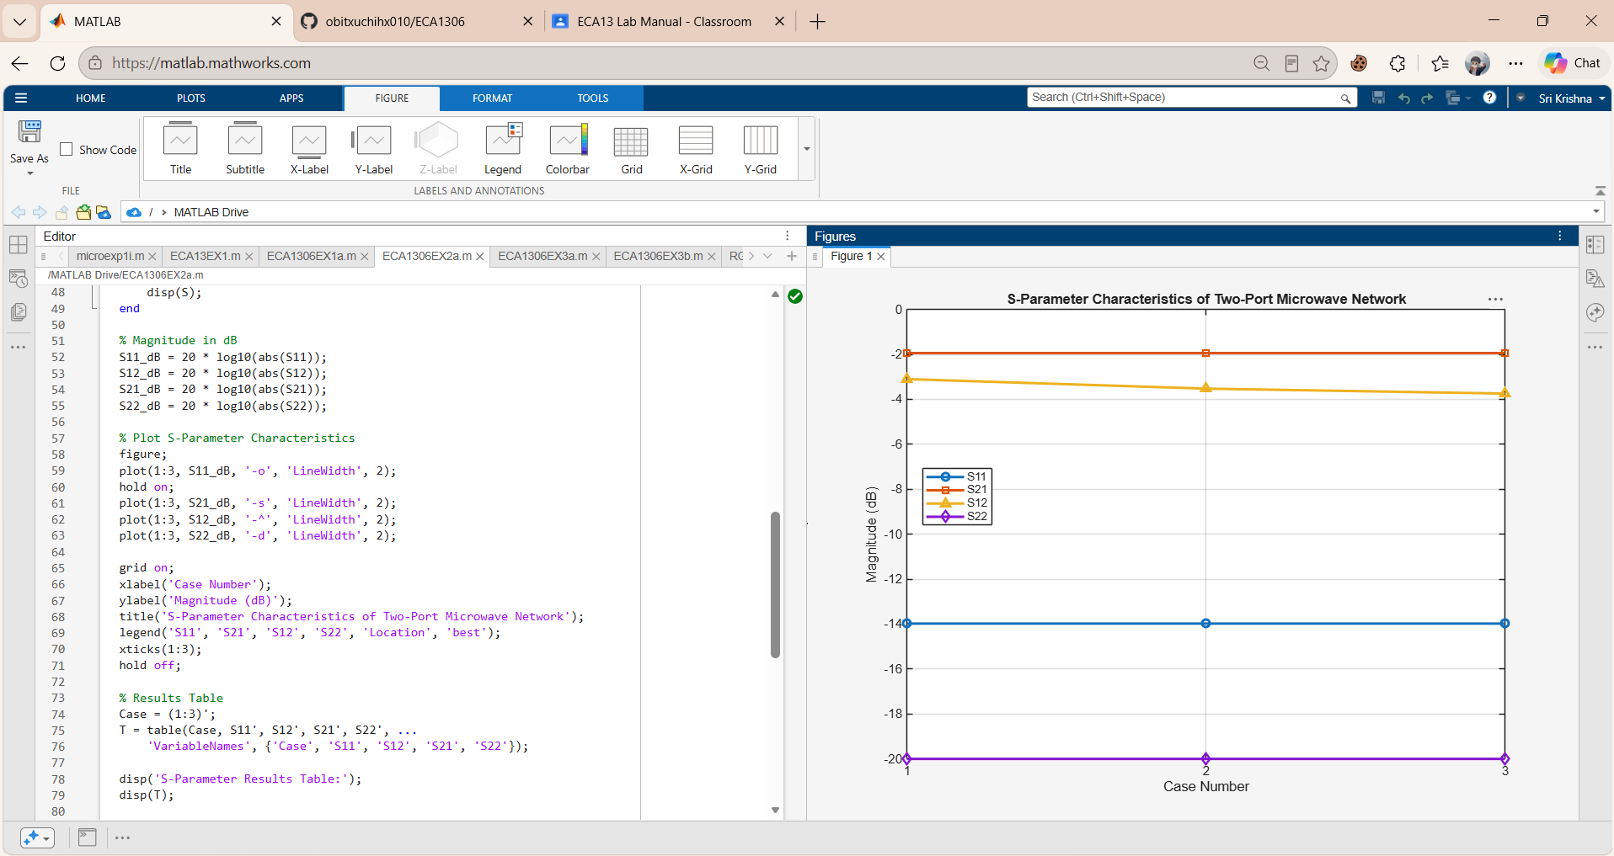
Objective 2: To determine the variation of return loss with frequency and assess the
efficiency of power transmission in the network.
Procedure
1. Open the MATLAB RF simulation environment.
2. Configure the microwave network.
3. Select the desired frequency range.
4. Perform frequency sweep analysis.
5. Measure reflected power at the input port.
6. Calculate return loss using S₁₁ values.
7. Plot Return Loss versus Frequency.
8. Record and analyze the results.
MATLAB Program
% MATLAB Program to Determine the Variation of Return Loss % with Frequency and Assess Power Transmission Efficiency
clc;
clear;
close all;
% Frequency Range (GHz)
frequency = [1 2 3 4 5 6 7 8 9 10];
% Measured Reflection Coefficient (|S11|)
S11 = [0.45 0.40 0.35 0.30 0.25 0.20 0.18 0.15 0.12 0.10];
% Measured Transmission Coefficient (|S21|)
S21 = [0.60 0.65 0.70 0.75 0.80 0.85 0.88 0.90 0.93 0.95];
% Return Loss Calculation (dB)
ReturnLoss = -20 * log10(abs(S11));
% Power Transmission Efficiency (%)
Efficiency = (abs(S21).^2) * 100;
% Display Results
fprintf('Frequency\tReturn Loss\tEfficiency\n'); fprintf('(GHz)\t\t(dB)\t\t(%%)\n');
for i = 1:length(frequency)
fprintf('%.1f\t\t%.2f\t\t%.2f\n', ...
frequency(i), ReturnLoss(i), Efficiency(i)); end
% Plot 1: Return Loss vs Frequency figure;
plot(frequency, ReturnLoss, '-o', 'LineWidth', 2); grid on;
xlabel('Frequency (GHz)');
ylabel('Return Loss (dB)');
title('Variation of Return Loss with Frequency');
% Plot 2: Efficiency vs Frequency figure;
plot(frequency, Efficiency, '-s', 'LineWidth', 2); grid on;
xlabel('Frequency (GHz)');
ylabel('Power Transmission Efficiency (%)'); title('Power Transmission Efficiency vs Frequency');
% Plot 3: Combined Characteristics figure;
yyaxis left
plot(frequency, ReturnLoss, '-o', 'LineWidth', 2); ylabel('Return Loss (dB)');
yyaxis right
plot(frequency, Efficiency, '-s', 'LineWidth', 2);
ylabel('Efficiency (%)');
xlabel('Frequency (GHz)');
title('Return Loss and Transmission Efficiency Characteristics'); grid on;
legend('Return Loss','Efficiency');

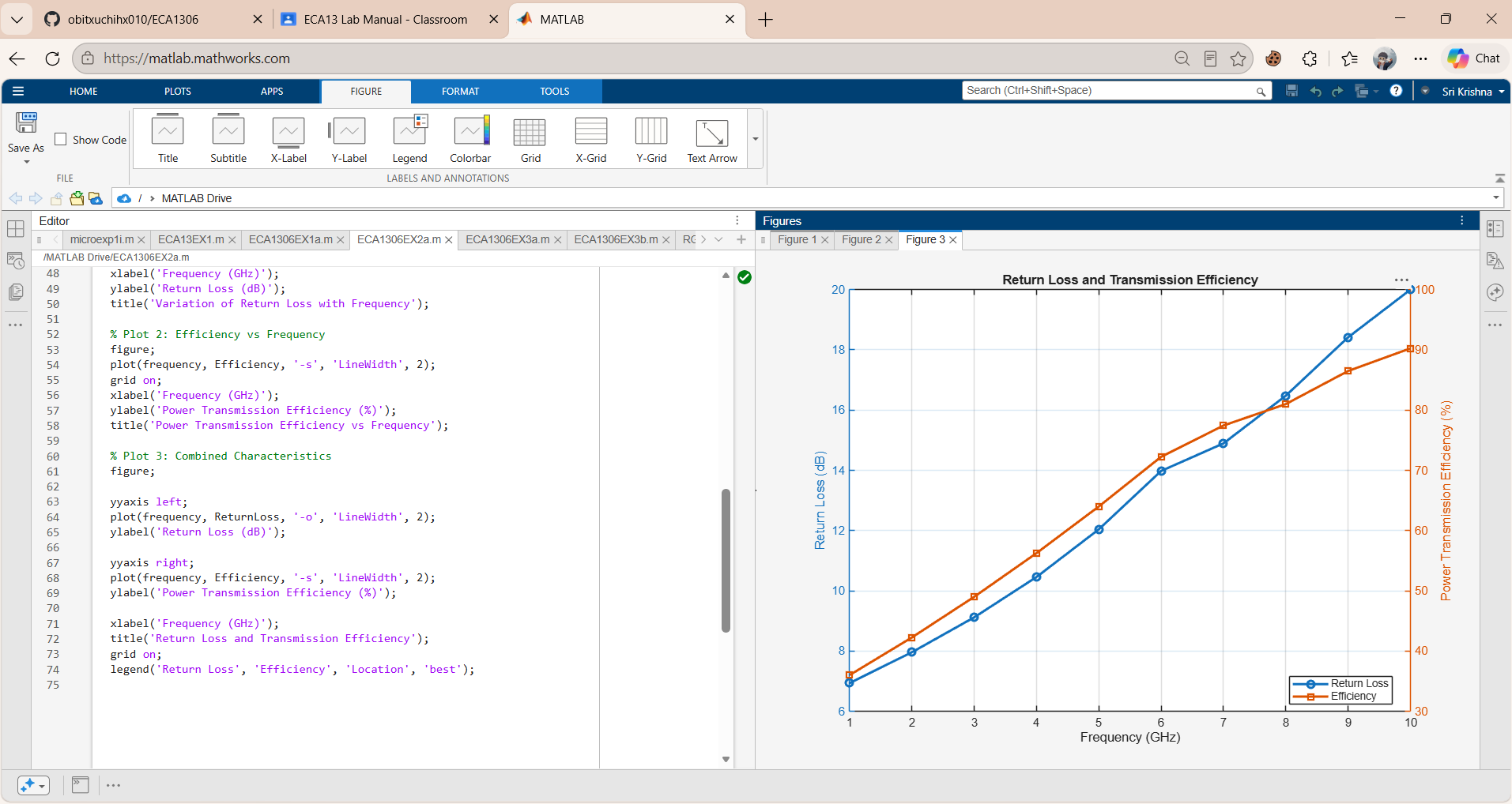
Objective 3: To simulate a microwave network using MATLAB and analyze its insertion loss
Procedure
1. Create the microwave network model in MATLAB.
2. Define the operating frequency range.
3. Perform transmission analysis.
4. Measure transmitted power at the output port.
5. Calculate insertion loss from S₂₁ values.
6. Repeat the analysis for different frequencies.
7. Plot Insertion Loss versus Frequency.
8. Record the observations.
MATLAB Program
% Simulation of a Microwave Network and Analysis of Insertion Loss % Using MATLAB
clc;
clear;
close all;
% Frequency Range (GHz)
frequency = 1:1:10;
% Transmission Coefficient (S21)
% Sample measured/simulated values
S21 = [0.95 0.92 0.89 0.85 0.82 0.78 0.74 0.70 0.67 0.63];
% Insertion Loss Calculation
% IL(dB) = -20log10(|S21|)
Insertion_Loss = -20*log10(abs(S21));
% Display Results
fprintf('Frequency (GHz)\tS21\tInsertion Loss (dB)\n');
for i = 1:length(frequency)
fprintf('%d\t\t%.2f\t%.2f\n', ...
frequency(i), S21(i), Insertion_Loss(i));
end
% Plot 1: S21 vs Frequency
figure;
plot(frequency,S21,'-o','LineWidth',2);
grid on;
xlabel('Frequency (GHz)');
ylabel('|S21|');
title('Transmission Coefficient vs Frequency'); % Plot 2: Insertion Loss vs Frequency
figure;
plot(frequency,Insertion_Loss,'-s','LineWidth',2); grid on;
xlabel('Frequency (GHz)');
ylabel('Insertion Loss (dB)');
title('Insertion Loss Characteristics of Microwave Network'); % Plot 3: Combined Analysis
figure;
yyaxis left
plot(frequency,S21,'-o','LineWidth',2); ylabel('|S21|');
yyaxis right
plot(frequency,Insertion_Loss,'-s','LineWidth',2); ylabel('Insertion Loss (dB)');
xlabel('Frequency (GHz)');
title('Microwave Network Performance Analysis'); legend('Transmission Coefficient (S21)', ... 'Insertion Loss');
grid on;
% Average Insertion Loss
avg_IL = mean(Insertion_Loss);
fprintf('\nAverage Insertion Loss = %.2f dB\n',avg_IL); % Network Performance Assessment
if avg_IL < 1
fprintf('Network Performance: Excellent\n'); elseif avg_IL < 3
fprintf('Network Performance: Good\n'); else
fprintf('Network Performance: Poor\n'); end

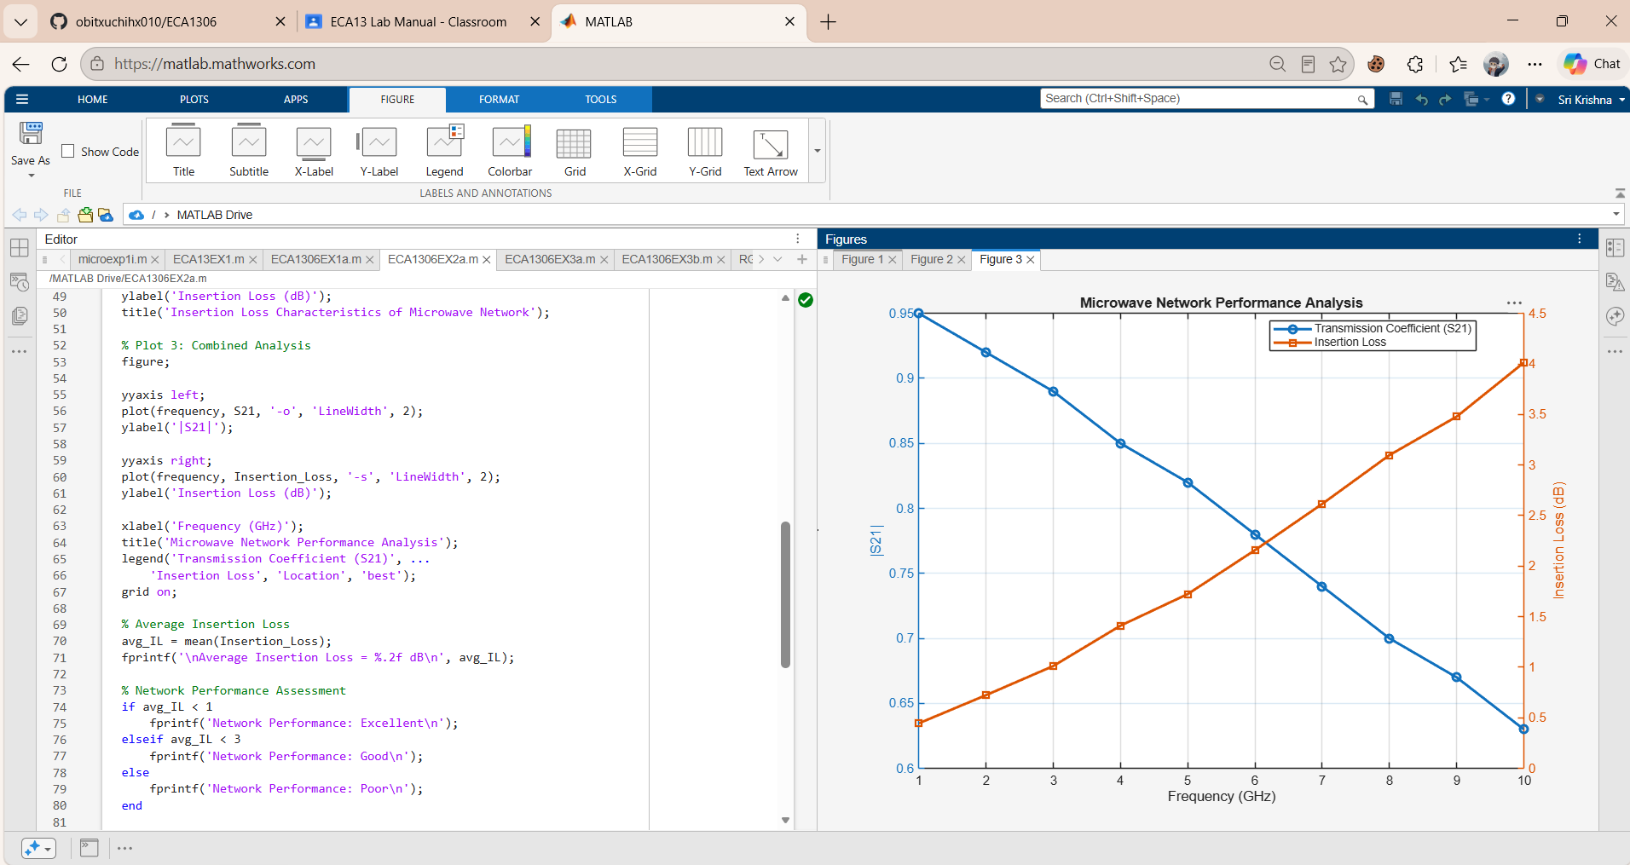
Objective 4: To simulate a high-frequency network using MATLAB and evaluate its
performance at different operating frequencies.
Procedure
1. Configure the microwave two-port network.
2. Select multiple operating frequencies.
3. Measure S-parameters at each frequency.
4. Determine return loss values.
5. Determine insertion loss values.
6. Compare network performance.
7. Plot performance comparison graph.
8. Record the results.
MATLAB Program
% Simulation of a High-Frequency Network Using MATLAB % Performance Evaluation at Different Operating Frequencies
clc;
clear;
close all;
% Operating Frequencies (GHz)
frequency = [1 2 4 6 8 10 12];
% Simulated Network Parameters
% Reflection Coefficient (S11)
S11 = [0.35 0.30 0.28 0.24 0.20 0.18 0.15];
% Transmission Coefficient (S21)
S21 = [0.65 0.70 0.75 0.80 0.85 0.88 0.92];
% Return Loss Calculation (dB)
ReturnLoss = -20*log10(abs(S11));
% Insertion Loss Calculation (dB)
InsertionLoss = -20*log10(abs(S21));
% VSWR Calculation
VSWR = (1 + abs(S11))./(1 - abs(S11));
% Power Transmission Efficiency (%)
Efficiency = (abs(S21).^2)*100;
% Display Results
fprintf('Freq(GHz)\tRL(dB)\t\tIL(dB)\t\tVSWR\tEfficiency(%%)\n');
for i = 1:length(frequency)
fprintf('%2d\t\t%6.2f\t\t%6.2f\t\t%5.2f\t%6.2f\n',... frequency(i),ReturnLoss(i),...
InsertionLoss(i),VSWR(i),Efficiency(i));
end
% Plot 1: Return Loss vs Frequency
figure;
plot(frequency,ReturnLoss,'-o','LineWidth',2);
grid on;
xlabel('Frequency (GHz)');
ylabel('Return Loss (dB)');
title('Return Loss Characteristics');
% Plot 2: Insertion Loss vs Frequency
figure;
plot(frequency,InsertionLoss,'-s','LineWidth',2);
grid on;
xlabel('Frequency (GHz)');
ylabel('Insertion Loss (dB)');
title('Insertion Loss Characteristics'); % Plot 3: VSWR vs Frequency
figure;
plot(frequency,VSWR,'-^','LineWidth',2); grid on;
xlabel('Frequency (GHz)');
ylabel('VSWR');
title('VSWR Characteristics');
% Plot 4: Efficiency vs Frequency
figure;
plot(frequency,Efficiency,'-d','LineWidth',2); grid on;
xlabel('Frequency (GHz)');
ylabel('Efficiency (%)');
title('Power Transmission Efficiency'); % Combined Performance Analysis
figure;
plot(frequency,ReturnLoss,'-o','LineWidth',2); hold on;
plot(frequency,InsertionLoss,'-s','LineWidth',2); plot(frequency,Efficiency,'-^','LineWidth',2); grid on;
xlabel('Frequency (GHz)');
ylabel('Magnitude');
title('High-Frequency Network Performance');
legend('Return Loss','Insertion Loss','Efficiency');
% Average Performance
avg_RL = mean(ReturnLoss);
avg_IL = mean(InsertionLoss);
avg_Eff = mean(Efficiency);
fprintf('\nAverage Return Loss = %.2f dB\n',avg_RL);
fprintf('Average Insertion Loss = %.2f dB\n',avg_IL);
fprintf('Average Efficiency = %.2f %%\n',avg_Eff);

