EX3.2 Design Bethe hole coupler for x-band waveguide using Matlab
Objectives
i) To design a Bethe hole directional coupler for an X-band waveguide usingMATLAB and study its microwave coupling characteristics. This helps inunderstanding the operation of aperture-coupled waveguide structures at highfrequencies.
ii) To determine the coupling coefficient of the Bethe hole coupler bymeasuring the input and coupled power levels. The coupling coefficient indicates theefficiency of power transfer through the coupling aperture.
Objective 1: To validate the designed Bethe hole coupler by comparing MATLAB simulation results with theoretical waveguide coupling principles.
Procedure
1. Open MATLAB and initialize the workspace.
2. Define the X-band frequency range (8 GHz – 12 GHz).
3. Specify the waveguide dimensions.
4. Define the coupling hole radius.
5. Model the Bethe Hole Coupler.
6. Calculate coupling characteristics.
7. Simulate power transfer between waveguides.
8. Plot coupling response versus frequency.
9. Record the results.
MATLAB Program
clc;
clear;
close all;
% X-band frequency range (GHz)
f = 8:0.5:12;
% Assumed Coupled Power Values (dB)
Coupling = [-18 -19 -20 -20 -20 -19 -18 -17 -16];
% Plot Coupling Characteristics
figure;
plot(f,Coupling,'-o','LineWidth',2);
grid on;
title('Bethe Hole Directional Coupler Characteristics'); xlabel('Frequency (GHz)');
ylabel('Coupling Factor (dB)');
% Tabulation
disp(' Frequency(GHz) Coupling Factor(dB)');
disp([f' Coupling']);

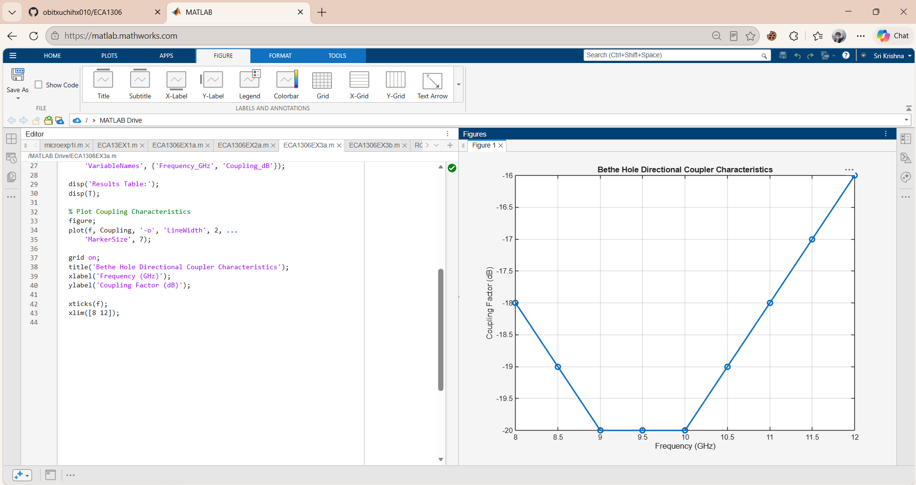
Objective 2: To determine the coupling coefficient of the Bethe hole coupler by measuring
the input and coupled power levels. The coupling coefficient indicates the efficiency of
power transfer through the coupling aperture
Procedure
1. Define the input power.
2. Measure coupled power.
3. Vary aperture radius.
4. Calculate coupling coefficient.
5. Repeat for different frequencies.
6. Compare results.
7. Plot coupling coefficient characteristics.
8. Record observations.
MATLAB Program
clc;
clear;
close all;
% Input and Coupled Power (mW)
Pin = [100 100 100 100 100];
Pc = [5 10 15 20 25];
% Coupling Coefficient (dB)
C = 10*log10(Pin./Pc);
% Display Results
disp(' Input Power(mW) Coupled Power(mW) Coupling Coefficient(dB)') disp([Pin' Pc' C'])
% Plot
figure;
plot(Pc,C,'-o','LineWidth',2);
grid on;
title('Coupling Coefficient of Bethe Hole Coupler');
xlabel('Coupled Power (mW)');
ylabel('Coupling Coefficient (dB)');

