I) To analyze the output power characteristics of different oscillation modes and determine
the optimum operating mode of the Reflex Klystron using MATLAB.
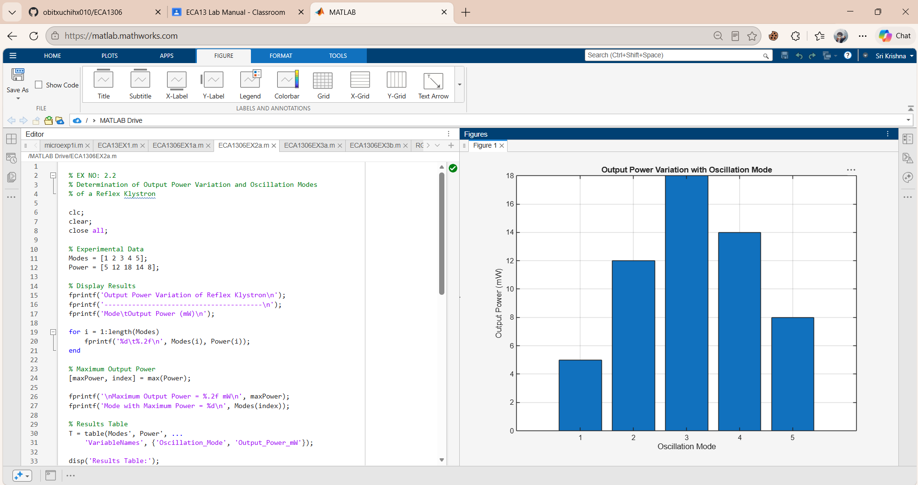
Ii) To determine the oscillation modes of the Reflex Klystron under different operating conditions and analyze the relationship between repeller voltage, transit time, and oscillation mode using MATLAB
