Objective 1: To model and simulate a directional coupler using MATLAB and study the
coupling of microwave power between its ports. This helps in understanding the signal
distribution characteristics of the coupler.
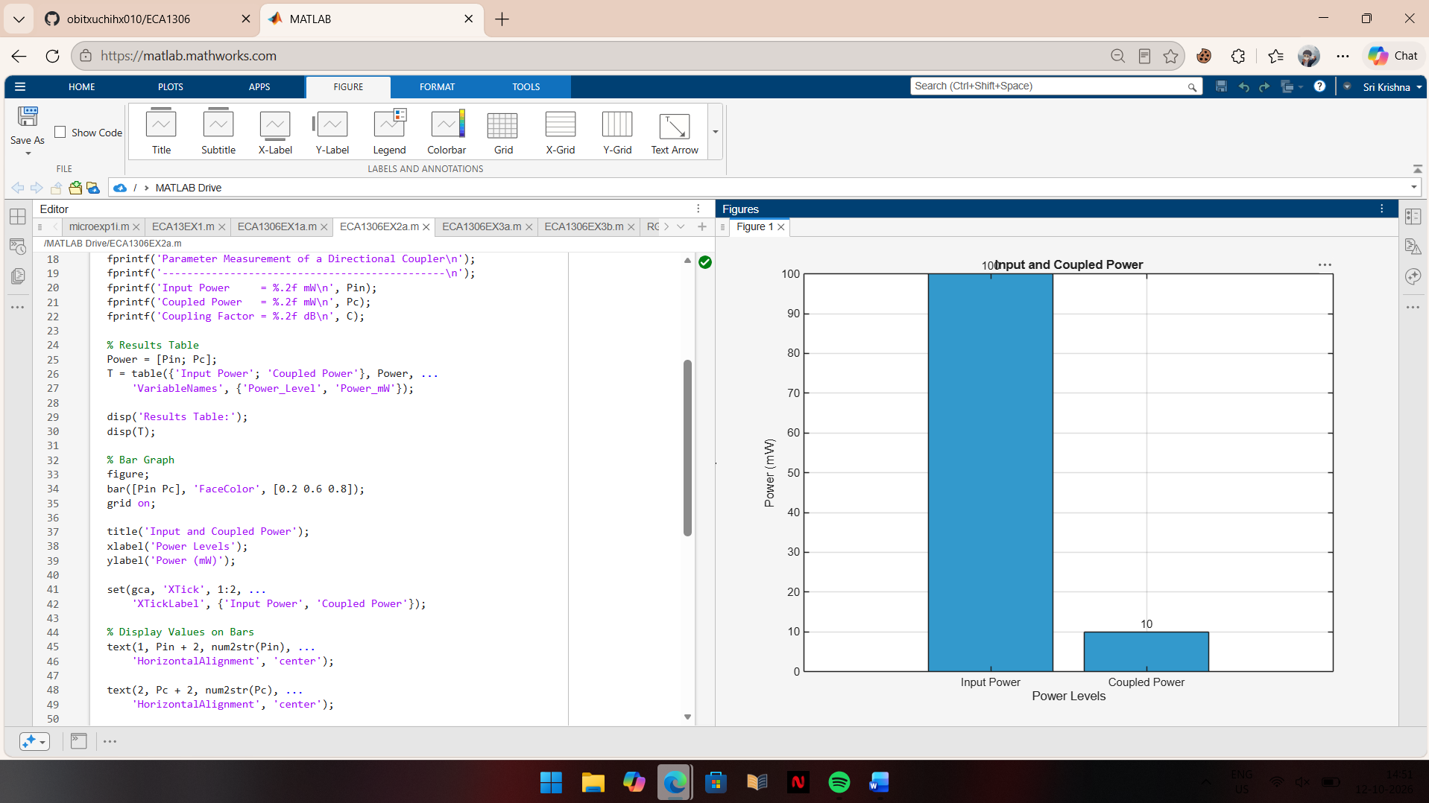
Objective 2: To determine the performance parameters of a directional coupler, namely
coupling factor, insertion loss, directivity, and isolation, through simulation by analyzing the
power distribution between its ports
