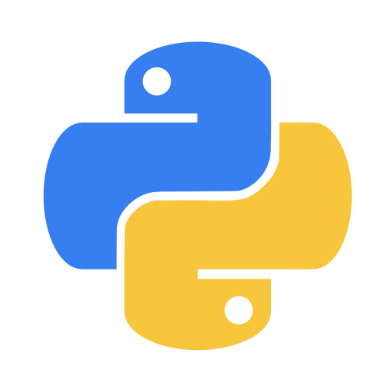
Version 1.0

PYTHON CHEATSHEET

By Bill

Python version used: 3.7.4 x64
OS: Windows NT 10 x64
Terminal: Powershel Core 6.2.2
Text-editor: Visual Studio Code 1.36.1 (user)
Writer: Apache Open Office 4.1.6

TABLE OF CONTENTS

WELCOME!
Welcome to this cheat-sheet! We will briefly go over each important command in Python.

Print
Before we go over print we must go over what a function is. A function is basically a set of commands with an input and an output.
print( )
“print” is the name of the function. Inside the parenthesis is the input.

