Making The mobile internet: An assessment of two alternative technologies for developing wireless applications
Featuring: J2ME versus .NET Mobile
by
Obinna A. Kalu
A thesis submitted in partial fulfillment of the requirements for the degree of
MSc. in Computing & Information Technology
University of Luton
September 2002
Supervisor :
Carsten Maple (Ph.D) Department of Computing & Information Systems

Acknowledgments
I wish to express my sincere appreciation to Dr Carsten Maple, my supervisor, for his invaluable counsel and guidance towards the successful completion of this project, and indeed for his immense assistance all through this MSc course. Special thanks also to all my MSc lecturers for sharing their knowledge with me during this last year. Thanks also to my colleagues for their valuable input.
I owe my deepest appreciation and gratitude to my dear brother Dr E. Kalu and sister, Mrs. G. Brisbane, for giving me so much love and support during this last year and indeed always. I would also like to extend a special thank you to my dear parents for being the best mum and dad I could ever wish for.
In addition, I owe thanks to the rest of my family: my sisters, Roselyn, Nkechi, Ngozi, Ihuoma & Ogo, my nephews, Alex & Victor, my nieces, Nicolle, baby Glo, Chidera & baby Nnenna, my in-laws Alastair, Ama, Ekong, Nono & Jeanne and the rest of my extended family and friends. You have all provided me with love and inspiration. Thank you.

Table of Contents
List of Figures v
List of Tables vi
Abstract vii

Chapter 1: Introduction 1
1.1: What is the mobile Internet? 4
1.2: Wireless Communication – Technologies, Standards & Protocols 8
1.3: Developing wireless applications 15
1.3.1: The Problems 15
1.3.2: Available Solutions 17
1.4: Purpose of Study 23

Chapter 2: Wireless Applications 25
2.1: m-Commerce applications 27
2.2: Location-based services 29
2.3: Security Issues 30

Chapter 3: The Java technologies community versus Microsoft & .NET 36
3.1: The Java Platform 38
3.2: The .NET Platform 41
3.3: Comparing the Java and the .NET Platforms 43

Chapter 4: Methodology 46
4.1: Survey of consumer expectations and requirements 47
4.2: Specimen m-Commerce application (MicroBanker) 49
4.3: Application performance metrics. ………………………50

Chapter 5: Design and development of MicroBanker... 51
5.1: Requirements analysis and design 52
5.2: Developing MicroBanker using J2ME and Java Servlet 58
5.2.1: Setting-up the J2ME and Servlet development environment 58
5.2.2: Coding (Java 2, Servlet & CLDC/MIDP API) 60
5.3: Developing MicroBanker using .NET Mobile 61
5.3.1: Setting-up the .NET mobile development environment 62
5.3.2: Coding (ASP.NET and C#) 63

Chapter 6: Performance Testing & Analysis of Test-results 65
6.1: Performance Testing 66
6.1.1: J2ME Tests 67
6.1.2: .NET Mobile Tests 69
6.2: Analysis of Test-results 70

Chapter 7: Conclusion and Recommendations 72
7.1: Findings and Discussion 73
7.2: Limitations 77
7.3: Recommendations 78
7.4: Suggested further research 79

References 81

Appendix A: Questionnaire used in Wireless Web Consumer survey 90
Appendix B: Code Listings 94
Appendix C: Record of Test results 101
Appendix D: Print-out of Sample Test Data 104
Appendix E: Screenshots of the MicroBanker wireless application 106

Artefact: Specimen m-commerce application (MicroBanker) packaged in a companion CDROM.
List of figures
Number Page
- Typical architecture of fixed Internet access 3
- Typical mobile Internet architecture 4
- Analog signal transmission using 1G wireless technology (AMPS) 12
- Typical set-up of a secure WAP application 33
- Components of the Java Platform 39
- Java platform editions arranged end-to-end showing position ofJ2ME 40
- Architecture of the .NET platform showing .NET Mobile 42
- Benchmark test results comparing J2EE on Oracle9iAS against .NET 43
- Doculab’s .NET versus J2EE benchmark test results 44
- Rich picture of wireless banking scenario 54
- User Interface design of the Microbanker wireless application 55
- Entity-Relationship Model for the Microbanker database 57
- Microbanker architecture using J2ME and Java servlet technology 59
- Screen-shot of J2ME Wireless toolkit, Code editor and Emulator 60
- Microbanker architecture using .NET Mobile 61
- Screen-shot of Visual Studio.NET IDE and Nokia mobile emulator 64
- Screen-shots of emulators running Microbanker J2ME MIDlets 67
- .NET version of Microbanker application running on Nokia emulators 69
- Graph of J2ME versus .NET Mobile performance test results 71

List of TABLes
Number Page
- Summary of wireless web consumer survey results 47
- Microbanker database design: Entitities, Attributes and Constraints 56
- Configuration of the Test Workstation 66
- Summary of J2ME performance test results 68
- Summary of .NET Mobile performance test results 70
- Summary of technical comparisons between J2ME and .NET Mobile 75
Abstract
That the Internet has revolutionised the way people communicate, work and transact business, is no longer news. The next big revolution currently taking-off, is the extension of these Internet services into the mobile/wireless arena, enabling users to access email and corporate intranets, perform business transactions, manage their tasks, locate objects, people or places and get entertainment (games, music, movies) at anytime, from anywhere and on any device they choose. This symbolizes the emergence of the mobile Internet, which brings with it exciting new opportunities, implications and challenges to information systems vendors, mobile device manufacturers, wireless network operators & carriers, wireless internet service providers, consumers and application developers.
This project investigates the key technologies driving the emergence of the mobile Internet, the problems and limitations. It attempts to assess, particularly, the effectiveness of two alternative software platforms/technologies (namely, Java 2 MicroEdition and .NET Mobile) for developing mobile internet applications with a view to carry-out a comparison based on factors such as: performance, scalability and support for varied client-device architectures, amongst others.
The first three chapters introduce the mobile Internet, give a general overview of wireless applications and explore the rivalry between the Java and .NET platforms. Chapters 4 & 5 cover the design, development and testing of a specimen m-commerce application using J2ME on one hand and .NET Mobile on the other. The test results are analysed in chapter 6.
Conclusions reached in chapter 7 are supported by a series of application performance tests, which are carried out in a controlled environment using mobile device simulators.

Chapter 1:
Introduction

Chapter 1
INTRODUCTION
The Internet, the open, global network of computer systems, has no doubt established itself as the dominant infrastructure for accessing or distributing information worldwide. Its main applications, electronic mail (e-mail) and the World Wide Web (WWW or the Web, for short), have become popular vehicles for providing cost-effective Internet services for communication, business transactions and entertainment. In effect, the Internet, by virtue of its globally adopted open protocols such as TCP/IP and HTTP, has become the key platform around which today’s information economy revolves. For instance, business transactions done over the Web, also known as electronic commerce (e-commerce for short), has experienced a rapid growth and is currently valued at over 2 trillion US dollars [Forrester Research, 2001]. This figure is projected to rise to about US$6.8 trillion by 2004, for both business-to-business and business-to-consumer transactions [Forrester Research, 2001]. The Internet has enabled exciting new means of communication through its electronic mail and instant messaging services, both of which have experienced such massive patronage, with millions of e-mail messages being exchanged daily and a vast number of chat rooms and discussion boards scattered all over the network. With its phenomenal growth and popularity, coupled with the rapid advancement in its enabling technologies, the world now sees a myriad of services being provided over the Internet.
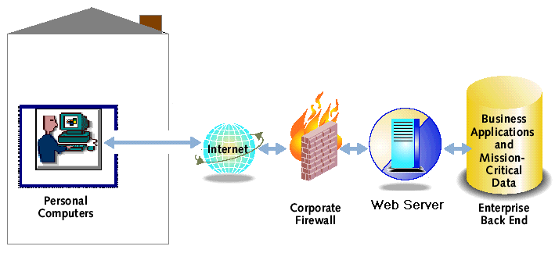
Until recently, users can only benefit from these services by being located at some familiar access point such as at home, in the office, a cyber-café or generally, at some fixed point where there is a terminal (computer) with an Internet connection or link installed. Desktop and laptop computers connected (typically wired) to a network with Internet access have been the main available means of accessing and utilizing Internet services. Figure 1 below shows the setup of a typical fixed Internet access from a desktop or laptop computer.

Figure 1: Typical architecture of fixed Internet access
Recent years have seen the global proliferation of mobile & wireless communication, information and computing devices. These include hand-held gadgets such as cellular phones, organizers, personal digital assistants (PDAs) and pagers. Initially, these devices were mostly designed, produced and used for voice (and very limited data) communication over wireless communication networks (using cell phones & pagers) or as portable personal computers for managing tasks (PDAs & organizers). With over 1.09 billion mobile phones in use presently worldwide [Marcussen, 2002], the tremendous success of mobile communication services is evident. This huge success coupled with the continuous drive to harness the limitless potentials of the Internet, has spurred the technology industry to begin nurturing the convergence of the Internet and the mobile/wireless communication networks. This convergence is giving rise to a new phenomenon known as the mobile Internet.
  - What Is the Mobile Internet?
The Mobile Internet is that open, global network of computers and mobile information/communication devices (cell phones, PDAs, pagers, etc) running via standard, open Internet and wireless communication protocols (TCP/IP, HTTP, WAP, WTLS etc.), over which various Internet services can be delivered to consumers at anytime, regardless of their location.
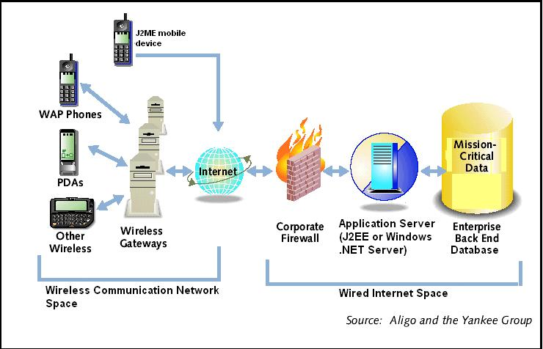
This implies that through the mobile Internet, users can access Internet services from anywhere using any Internet-enabled mobile information client-device, without having to go to some fixed access point, as was the case with the traditional fixed Internet. A typical mobile Internet architecture is shown below.

Figure 2: Typical Mobile Internet Architecture
Wireless or Mobile
The terms “wireless” and “mobile” are commonly used congruently. This is mainly because practically today, most mobile devices are wireless and vice versa. Mobile devices are defined as those digital (computing or communication or hybrid) devices that are small enough to be carried around easily and used while in transport. Mobile devices commonly contain their own power supply, in the form of a battery. A device is said to be mobile, chiefly with regards to its portability (determined by its size and weight).
On the other hand, “a wireless device is simply a device capable of communicating or networking without wires or cable” [White, 2002]. Therefore, a device is said to be wireless or not, mainly with regards to its mode of connectivity. However, it is worthy to note that not all wireless devices are mobile. For instance, an Internet television set is wireless but not mobile. Also, a cell phone equipped with a micro-browser capable of downloading special mini-web pages can be considered wireless, but not mobile. Aside from portability, a true “mobile device must provide some value, in the form of data or application function, when not connected to a network” [White, 2002]. On the other hand, some mobile devices may not be wireless. An example is a PDA containing a small amount of inventory or sales data and running an application to view and update the data. The PDA and its application are considered mobile but not necessarily wireless as the user may be required to connect the device to a network or to another device with some sort of cord (cable) in order to upload updated data or download fresh data. The mobile Internet as defined above supports devices and applications that are both mobile and wireless. However, it is envisaged that it will eventually encompass the vast range of consumer electronics and the various embedded devices. These include cell phones, pagers, personal digital assistants (PDAs), point-of-sale terminals, pocket PCs, screenphones, automobile navigation/entertainment systems, smartphones, pocket communicators, Internet television sets and TV set-top boxes.
The Mobile Internet: Its Business Prospects
There is no questioning whether a mobile Internet makes business sense especially when one considers the huge potentials such an infrastructure would offer. A market research report by the Computer Industry Almanac published in March 2002 puts the number of personal computers in use worldwide at over 603 million and the number of fixed Internet services users at about 580.78 million [C-I-A.com, 2002]. A simple analysis for the prospects of the mobile Internet is that, if about 580 million fixed internet users generate volume of business worth over US$2 trillion, notwithstanding the restrictions of the fixed Internet, then how much business will users with over 1.09 billion mobile Internet devices generate? According to a recent study by one of the foremost technology industry market research firms, the Yankee Group, “the number of people accessing the Web through wireless devices by 2003/2004 will be larger than the number who access the Web through desktop computers” [Yankee Group, 2001]. Investigations generally reveal that technology industry watchers and market research analysts differ greatly in their forecasts/projections with regards to mobile Internet growth. Mark Mulligan of Juniper Media estimates that a majority of wireless services subscribers will own Internet-enabled mobile devices by 2006 [Mulligan, 2001].
The ultimate goal in the mobile Internet drive is to have a completely connected planet where everything is connected to everything and to everybody, enabling seamless interaction and communication at all times. Such a network will include gadgets ranging from home appliances, mobile devices, automobiles, consumer electronics, to business information systems and communication satellites. This is in line with the concept of a pervasive computing environment. An example in this light could be where an intelligent home refrigerator automatically senses a shortage in the quantity of available milk, connects to the supermarket server via the Internet and places a fresh order for some more milk.
The march towards this future has started. There is a gradual progression towards the inclusion of the various consumer electronics and embedded devices into the Internet equation. For mobile communication devices, this movement started with the introduction of the Wireless Application Protocol (WAP) and the Wireless Markup Language (WML) in 1999 by a group of major wireless communication service providers, mobile device manufacturers and wireless software technology companies. Unfortunately, the WAP/WML technology has not experienced an overwhelming success as was expected due to a number of issues and limitations, which are discussed in section 1.3.2 of this chapter.
It is worthy to note, however, that the mobile Internet is still in progress and is beginning to gain momentum with the evolution of new wireless communication and application development technologies. Already, a growing number of fixed Internet services now have mobile versions being provided. For instance, popular Web portals like Yahoo! and MSN presently have wireless editions that can be accessed using suitable Internet-enabled mobile devices. Other major e-commerce and news websites such as etrade.com, amazon.com, buy.com, bbc.co.uk, cnn.com and travelocity.com have been made wireless-enabled. New technologies, standards and protocols for wireless communication and for enabling the mobile Internet are rapidly evolving given the recurrent need to address various issues and problems as will be seen later in this study.

1.2 Wireless Communication – Technologies, Standards and Protocols

Wireless communication networks certainly form the backbone over which the mobile Internet is being delivered. Wireless technologies are one of today’s most exciting innovations, as they offer the potential of bringing the power of communication, the Internet and the Web into the hands of consumers worldwide. Recent years have seen a rapidly progressing race to create and implement new wireless communication technologies, standards and protocols.
Conceptually, wireless communication can be divided into two parts – local and wide area. Local area wireless technologies include infrared, laser and short-range radio frequency transmissions. Some examples of local area wireless communication include a PDA using infrared to synchronize data with a PC, a 900MHz cordless telephone used within a house, a radio control toy and a key fob with a button operated within a short distance to lock/unlock a car.
Recently, there has been a rise in new local area wireless communication technologies. These include wireless Ethernet technologies for creating wireless local area networks (WLANs) and Bluetooth wireless technology. Wireless Ethernet has become a convenient and inexpensive technology for providing connectivity in local area networks around houses and office buildings. Despite its popularity, there is still a lack of a unifying standard for WLANs. Various competing standards include the IEEE 802.11, 802.11b, 802.11a, 802.11e, 802.11g and HiperLAN/2. There are other WLAN technologies based on radio frequency transmission, which are gradually gaining popularity. These include HomeRF and Wireless-Fidelity (Wi-Fi). HomeRF provides for wireless home networking and is designed specifically for home and small offices. Wi-Fi is a part of the IEEE 802.11b standard, which offers wireless network speeds of up to 11Mbps [Hui, 2002].
Bluetooth wireless technology enables communication between Bluetooth-enabled devices that are 10metres apart within a personal area network. It was developed in 1994 by Telefonaktiebolaget LM Ericsson, a leading Swedish wireless communication company, and serves as a viable alternative to the various WLAN technologies.
However, for the purpose of the mobile Internet, this study is concerned with wireless technologies for wide area communication using mobile devices. Wide area wireless technologies enable communication from remote, inaccessible locations, which offers several benefits. For instance, through Satellite technology it is possible to access information wirelessly over the Internet or otherwise from remote places such as the polar regions (Artic and Antarctic), deserts or the middle of oceans. Governments and businesses are exploiting the benefits of wide-area wireless communication technologies to send and receive mission-critical information to and from places far apart across the globe. Employees working at remote locations away from the office can access vital corporate data relating to sales or inventory or some other files via a wide area wireless link.
Wide area wireless communication generally covers a broad field of study, which includes television, microwave, satellite and radio transmissions. For the mobile Internet, this study focuses on, wireless communication technologies for mobile devices (cell phones, PDAs and pagers), which is mainly based on wide area radio frequency transmissions, and the impact of these on the development, deployment and consumption of mobile web applications. Therefore, every mention of wireless communication in this report will refer to wide area wireless communication via radio frequency transmissions and using mobile communication devices.
Generally, wireless communication requires the use of an access technology as one of the first steps in connecting to a given wireless network. Key access technologies in use around the world include Frequency Division Multiple Access (FDMA), Time Division Multiple Access (TDMA) and Code Division Multiple Access (CDMA). FDMA operates by assigning each communication transmission to a separate frequency slot or channel. It was the first access technology developed for wireless communication networks. The problem of interference between transmissions is commonplace under FDMA, as frequency slots assigned are usually too close to one another [Russell, 2002]. Most wireless networks today, use a mixture of FDMA and other access technologies to improve efficiency and speed of the communication process and reduce interference and interruption.
On the other hand, TDMA operates by taking multiple transmissions and assigning each to a different time slot on the same radio frequency. Since it manages transmissions based on specific time interval regardless of whether there is message to transmit or not, TDMA is seen to be somewhat inefficient as it sometimes causes a wastage of bandwidth capacity [Russell, 2002]. Like FDMA, TDMA is mostly used in conjunction with other access technologies.
Of the three access technologies, CDMA is the most popular. It is used across a variety of networks and can be combined with both FDMA and TDMA. CDMA uses spread-spectrum technology, which breaks up signals into smaller segments and spreads them over the entire bandwidth thereby enabling a larger volume of users to share the same bandwidth. CDMA also uses packet-switched data-transmission technology and ensures security by assigning a unique code to each wireless transmission on the network.

The Wireless Generations – 1G, 2G, 2.5G, and 3G
In addition to the access technologies, various wireless technologies for transmitting messages across a network have evolved in the last 19 years. These technologies are commonly classified into “generations” based on their period of evolution. The first forms of wireless communication networks were designed to handle only analog signals (radio transmissions that follow a sinusoidal wave-like form). The technologies behind these early networks are commonly referred to as First-generation wireless technology (1G). The most notable 1G wireless technology is the Advanced Mobile Phone Service (AMPS), which was first introduced in 1983 [Deitel, 2002a]. The AMPS system was an analog-only cellular phone network and it was one of the first to use FDMA as its access technology.
A cellular network is said to be one that is composed of individual compartments, or cells, which combine to form the communication network. Installed at the centre of each cell is a base station (also known as a cell site) that transmits signals to and from users within the cell. Every base station can only communicate with users within its cell. To ensure the continuous availability of communication link when a user goes beyond a given cell boundary, a process known as handoff occurs. This entails the transfer of signals from one base station to another, thereby enabling mobile users to continue communication without disconnection or network interruptions.
Being an analog technology, AMPS transmission quality was much lower when compared to digital transmissions used today. This is because analog signals in transit are error-prone and can hardly be reproduced at the destination in exactly the same form as they were sent. A typical analog signal transmission is shown in figure 3 below.
Base station

Original signal
Reproduced signal
Fig. 3: Analog signal transmission using 1G wireless technologies such as AMPS.

Wireless data communication with mobile devices using the AMPS required the use of a modem, which placed additional demand on the limited battery power. Nonetheless, the AMPS offered data transfer speeds of about 4.8kbps [Cummiskey, 2001], which by today’s standards could be considered slow and inadequate to run any meaningful mobile web application.
Second-Generation (2G) Wireless Technologies
These include most of the technologies in use in today’s wireless networks such as Personal Communication System (PCS), Global System for Mobile Communication (GSM) and the family of technologies & standards associated with CDMA (the CDMAOne™ family of technologies).
The Transition to third Generation – a.k.a 2.5G
2.5G refers to a set of intermediate technologies that offer better performance amongst a number of other advantages over 2G technologies and are intended to facilitate the transition to third generation technologies. 2.5G technologies include High Speed Circuit-Switched Data (HSCSD), General Packet Radio Service (GPRS), Enhanced Data Rates for Global Evolution (EDGE) and CDMA2000. These are mostly regarded as interim technologies that will not only provide backward compatibility to existing second generation network technologies, but will also enable the smooth transition to third generation technologies offering much higher transmission speeds, better connections and greater bandwidth. Most of today’s advanced wireless networks are already adding data services to voice as an intermediate step towards the full-featured multimedia services of the future [Helmig, 2002].
Third-Generation (3G) Wireless Technologies
These are regarded as the “holy-grail” of wireless communication networks. Third generation technologies, it is envisaged, will offer full support for running multimedia applications over wireless communication networks with capability for “always-on” data connections. Streaming video, it is said, will certainly be one of the several important multimedia applications supported in 3G networks [De-Gregorio, 2002]. Technologies and standards in this generation include:
W-CDMA:
W-CDMA (Wideband Code Division Multiple Access) is one of the fastest growing versions of the CDMA technology targeting 3G wireless networks. By adopting W-CDMA, existing CDMA networks can rapidly expand and offer increased transmission speeds. W-CDMA forms a part of the IMT-2000 standards [Glimstedt, 2001].
IMT2000:
IMT2000 stands for International Mobile Telephone Standard 2000. It is a project under the aegis of the International Telecommunication Union (ITU) aimed at facilitating co-operation among Third Generation (3G) wireless services and technologies developers [Russell, 2002]. The ITU uses the term IMT2000 to refer to a set of standards, for 3G mobile telecommunication services and equipment, whose goal is to provide the capability for global roaming within a single low cost mobile device.
UMTS:
UMTS stands for Universal Mobile Telecommunication System. It is a project of the Special Mobile Group (SMG), which is a committee of the European Telecommunication Standard Institute (ETSI). UMTS is Europe’s first implementation of the IMT2000 standard [Lembke, 2002]. It is intended to be the next generation global cellular technology and is expected to be fully in place by 2004. The UMTS, it is proposed, would handle transmission at a data rate of 2Mbps using a combination of both TDMA and CDMA access technologies operating at 2GHz frequency [Russell, 2002].
With the potential of offering higher bandwidth capacities and faster transmission speeds, these 3G technologies, it is envisaged will boost in a big way, the growth of the mobile Internet.
Protocols and Markup Languages
Aside from the various Wireless technologies and standards, other key drivers behind the emergence of the mobile Internet are the universally adopted data communication protocols and markup languages for mobile devices. These include protocols such as TCP/IP (both IPv4 today and IPv6 in future), HTTP, WAP (Wireless Application Protocol) and markup/scripting languages like WML (Wireless Markup Language)/WMLScript, HDML (Handheld Device Markup Language), cHTML (compact HyperText Markup Language) and XHTML-MP (eXtensible HyperText Markup Language-Mobile Profile). XHTML-MP has emerged as the W3C standard for marking-up web content for mobile devices [Openwave Systems, 2002]. The Mobile IP protocol was proposed in 1996 as an IP enhancement to provide support for mobility in view of the limitations in the existing IP v 4 protocol in this regard [Chao, 2001].

1.3 Developing Wireless Applications

Providing Internet services over wireless networks require the design and development of wireless applications. Wireless applications are basically applications that are delivered over a wireless communication network and can be accessed using wireless devices. Due to their peculiar nature, developing wireless applications pose an intriguing set of problems to application developers. Much of these are directly related to the diverse architectures that exist across the mobile devices population and the peculiarities of wireless communication networks.
The Problems
In developing wireless applications, developers are faced with the following problems posed by the devices and the networks over which the applications are designed to run:
- Devices have limited processing power and memory. This limitation obviously restricts the size and complexity of the application. Most mobile devices typically have 16 to 32Mbytes of memory that is shared between stored and active programs [Helmig, 2002].
- Devices have limited display (both screen size and graphics capability). Most devices offer very low colour depth and some only provide monochrome displays.
- Devices have limited input facility. For instance mobile phone keypads are single-hand used while some PDAs offer a stylus, which is still restrictive when compared to the standard computer keyboard and mouse available on desktop and laptop PCs.
- Devices typically have limited electric power supply. Most devices are battery-powered only, thereby requiring applications to be power-efficient and provide a means to cope with potential loss of power, which naturally results to loss of in-memory data. To keep power consumption at a minimum, wireless applications tend to return control to the devices OS as quickly as possible [Helmig, 2002]. Limited power supply is also the main factor that puts a heavy limitation on the amount of processor power that can be made available in mobile devices. The faster the processor the quicker the battery drains out.
- Connectivity across wireless networks is often intermittent and unreliable [Coley, 2002]. This poses a threat to the smooth running of networked wireless applications. Wireless applications need to be designed such that they can cope perfectly well with frequently breaking network connections. In view of this, good wireless applications tend to keep the frequency of their communication with remote back-end systems to a barest minimum.
- Wireless networks typically offer slow data transfer speeds. This is due to the fact that wireless networks are typically characterized by high latency (delay in transmission) and limited bandwidth. However, the introduction of 3G technologies is expected bring a substantial amelioration here.
- The wireless devices landscape is composed of a highly varied set of device architectures and operating platforms with little or no fixed standards. With this in mind, wireless applications need to find a means of providing support for this broad range of client devices.
- Wireless applications have to contend with a host of wireless network security issues, all of which present a huge cause for concern to potential wireless application consumers.
Available Solutions
Given the above problems, there are a number of available solutions for developing wireless applications. Some of these include:
- iMode/cHTML:
iMode is one of the first and fastest growing wireless Internet services developed in Japan by a leading telecommunication company, called NTT DoCoMo, for providing Internet services via its wireless network for access by consumers using iMode-compliant mobile devices. iMode currently accounts for over 60% of the world’s wireless Internet users [Young, 2002]. It is operated in partnership with various designated and registered iMode content providers and is centrally controlled by NTT DoCoMo at its iMode service centre. The content providers get 91% of the revenue generated from the service. The iMode network is an always-on wireless network, with a charge 0.3Yen per packet of 128bytes of data sent or received [Jonason, 2002]. Web content for iMode is created using the compact HyperText Markup Language (cHTML), which is a special kind of customized HTML, specifically optimised for delivering web content to iMode-enabled mobile devices. It is envisaged that future upgrades of the iMode service will support content written in a more widely supported markup language such as the W3C’s XHTML-MP [Chao, 2001].
- WAP/WML/WMLScript and XHTML-MP:
The Wireless Application Protocol (WAP) was developed in 1997 by a group of wireless products and services companies, which included Nokia, Ericsson, Motorola and Phone.com (presently known as Openwave Inc.). It was aimed at fostering the emergence of the wireless Internet by providing a set of communication protocols designed to enable communication between different kinds of wireless devices and systems within the wired Internet. Central in the WAP solution is the Wireless Markup Language (WML) and its scripting edition, WMLScript. WML is an XML-based markup language designed for formatting web content for delivery unto WAP-enabled mobile devices that have WAP microbrowsers running within them. The three basic components required for WAP communication include a WAP-enabled mobile device, a Web server and a WAP gateway. The WAP gateway serves as a link or a protocol translator between the mobile device and the Web server. The recently released version, WAP 2.0, now provides support for XHTML-MP, which is the latest standard markup language for mobile devices whose specification is defined by the World Wide Web Consortium - W3C [WAP Forum, 2002]. During its initial introduction, WAP was envisaged to strike an instant massive success in the market place and was expected to become a widely adopted wireless Internet technology. Unfortunately, its popularity was greeted with widespread disappointment by consumers as the quality of Internet access it offered fell well short of consumer expectations [Ramsay, 2001]. This was largely due to factors such as page-download speed that was awfully slow (no thanks to the limited bandwidth capacity of the underlying wireless infrastructure then) and poor consumer education. Most WAP users were mistakenly swayed by the hype to believe that WAP would offer a Web experience that is as fast, rich and as colourful as that enjoyed on the wired Internet. Studies on WAP usability showed that connection times were far too long and even when users manage to get connected to a WAP site, the connection is often timed out before any data is downloaded [Ramsay, 2001].
- ASP/XML/XSL:
This is basically a WAP-dependent solution. It employs ASP (Active Server Pages) technology as a server-side component to dynamically generate content from database query results, which it outputs in extensible markup language (XML) format. The output is in turn re-formatted or transformed using a suitable stylesheet written in the eXtensible Stylesheet Language (XSL) to produce the desired markup (probably WML or cHTML) for delivery to the target mobile device. This solution ultimately relies on WAP or some other wireless protocol for delivering the content to the wireless client-device.
- Java Servlet/JSP/XML/XSL
This is quite similar to the ASP/XML/XSL solution above. The main difference here is that the server-side component of the solution is implemented using Java-based Servlet technology or Java Server Pages (JSP). It also requires WAP infrastructure to enable delivery of the final markup to the client device [Mahmoud, 2000].
- BREW:
BREW stands for Binary Runtime Environment for Wireless. It is a technology developed by a leading wireless solutions company, Qualcomm Inc., which aims at providing a common runtime environment that shields applications from the variations in underlying device architectures and runtime environments. The runtime environment of a device is the platform on which it executes applications. Qualcomm developed BREW to help standardize runtime environments on different devices. BREW ensures that any wireless application written to the BREW API (Application Programming Interface provided by Qualcomm) can run hitch-free, without modification on any BREW-enabled mobile client device (one that has the Qualcomm chipsets implemented within) [Deitel, 2002a]. Qualcomm provides a freely downloadable BREW software development kit (BREW SDK) that be used on a Microsoft Windows NT 4.0 or higher platform, for developing BREW-enabled wireless application using the C/C++ programming language.
- J2ME:
Java 2 MicroEdition (J2ME) is a part of the wider Java platform, which defines a set of technologies and specifications for developing applications for small, resource-constrained devices. Generally speaking, the Java platform is made up of the Java programming language specification, the Java Virtual Machines (JVM) and the set of Java APIs (applications programming interfaces which consists of the base java classes). It is fundamentally a software platform that aims at facilitating the “Write Once Run Anywhere” paradigm using the concept of a virtual machine. The Java platform exists in three editions to cater for three categories of information systems. These are:
- Java 2 Standard Edition (J2SE): Designed for desktop computing.
- Java 2 Enterprise Edition (J2EE): The comprehensive platform for developing multi-user enterprise-wide applications. J2EE encompasses J2SE plus a number of server-side specific APIs.
- Java 2 MicroEdition (J2ME): Defines a set of specifications and provides APIs for developing applications for devices with limited computing resources.
In order to cater for the wide variety of target mobile devices, the J2ME architecture is divided into configurations and profiles. Configurations are specifications that detail a virtual machine and a base set of APIs that can be used with a certain class of devices [Day, 2001]. Simply put, configurations tend to group devices with common basic characteristics and then define a virtual machine and base API for them. For example, a configuration may represent devices that have less than 512Kbyte of memory and operate over an intermittent network connection. This includes cell phones and pagers. J2ME is a fairly new Java platform edition and as such is in the process of continuous, rapid evolution just like other Java technologies. So far, two J2ME configurations are defined. These are: the Connected Devices Configuration (CDC) and the Connected Limited Devices Configuration (CLDC). The CLDC is for small wireless devices with intermittent network connections such as pagers, mobile phones and Personal digital assistants (PDAs). On the other hand, the CDC is for comparatively larger devices (in terms of memory and processing power) with more robust network connections. These devices include Internet televisions, Set-top boxes, other Internet appliances and some high-end PDAs.
Each configuration has a set of device profiles defined within it. Profiles extend a configuration by adding more specific APIs thereby creating a complete environment for building applications [Knudsen, 2002b]. Profiles typically include APIs for application life cycle, user interface and persistent data storage. The first fully developed J2ME profile is the Mobile Information Device Profile (MIDP), which provides a ready-to-use application development environment for developing over-the-air (OTA) downloadable wireless applications called MIDlets for devices such as pagers, mobile phones and PDAs. It should be noted that MIDlets are not currently being provisioned over the air [Mahmoud, 2002a]. In order to enable over the air provisioning, there is need for an environment within the target device that allows the user to enter a URL for the MIDlet suite to be downloaded. Interestingly, this environment for most of today’s wireless networks is a WAP browser which enables MIDlet to be integrated within a WML page.
A major part of this study involves employing the MIDP in implementing a specimen m-Commerce application for wireless banking. A detailed examination of key Java technologies & the J2ME platform and how they compare to other alternatives such as Microsoft .NET family of technologies, is covered in Chapter 3 of this report.
- .NET Mobile (ASP.NET/Mobile Web Forms/MMIT)
.NET Mobile is an integral part of the recently launched Microsoft .NET (pronounced “dot Net”) Framework, designed to cater for the development of mobile web applications. .NET Mobile is basically an extension of ASP.NET, which is the dotNET Framework version of the Active Server Pages technology. It is worthy to note that, Microsoft’s full-fledged technology for supporting application development for resource-constrained devices is bundled within a set of products collectively known as the Microsoft .NET Compact Framework, which has just been released recently [Sivakumar, 2002]. However, this study will take the segment of ASP.NET that supports mobile web application development by providing a set of server-side mobile controls runtime for delivering custom-formatted markup for rendering on mobile device browsers, as .NET Mobile. The key tool for developing .NET Mobile applications is the MMIT (Microsoft Mobile Internet Toolkit), which is a freely downloadable add-on to the popular Visual Studio.NET IDE (Integrated Development Environment). The .NET Framework, its components and how they compare to corresponding Java technologies will be examined in greater detail in Chapter 3 of this report.
  - Purpose of study
This project will have as its purpose the following:
- To examine the key technologies driving the emergence of the mobile Internet.
- To review the range of wireless applications in use or in demand and attempt projecting into the future, to determine applications that will assume mainstream position.
- To carry out a wireless web consumer survey to determine what user requirements and expectations are, with regards to mobile web applications. Essentially, to verify if there is any demand at all for wireless applications.
- To assess the effectiveness of Java 2 MicroEdition and .NET Mobile in developing data-driven mobile web applications.
- To define a specification for a showcase m-commerce application and undertake its implementation using Java servlet and J2ME on one hand and then .NET Mobile on the other.
- To carry out application performance tests using mobile device simulators and analyse the results for both J2ME and .NET Mobile.
- To critically appraise the use of J2ME and .NET platforms/technologies for implementing robust end-to-end wireless web solutions.
- To draw valid conclusions based on the outcome of the performance tests for both J2ME and .NET Mobile.
- To consider any limitations and suggest areas for further research.

Chapter 2:
Wireless Applications

Chapter 2
WIRELESS APPLICATIONS
One key driving force behind the emergence of the mobile Internet is the wide range of wireless applications on offer. These wireless applications can be classified into two broad categories. These are:
- Consumer Applications.
- Enterprise wireless applications.
Consumer Applications:
The consumer segment of wireless applications consists of the following:
- Entertainment applications – Games, Music and Video
- Location-based services (for locating places, people or objects).
- Applications for communication (email, IM, chat etc.)
- Productivity applications e.g. Personal Information Manager.
Understandably, most of these applications will, in the short term, be controlled and distributed by wireless carriers [Al-Saleh, 2001]. A more detailed look at some of these applications is covered later in this chapter.

Enterprise Wireless Applications:
These are custom wireless client applications developed to provide connection to existing enterprise systems. They mainly serve as a means of providing wireless client-device users with access to vital back-end corporate data. Most enterprise wireless applications tend to use some sort of middleware to access company databases. An example of this is a wireless sales application that provides a mobile salesman with access to his company’s inventory data, so that he can easily check and confirm what is available in stock and what is not, from anywhere and at anytime, or even place orders from remote locations.
A wireless application is simply one that runs on a wireless device. Some wireless applications are embedded or hardwired within the host device. These are typically small, standalone ROM-based wireless applications, which are not easily alterable. They may or may not require connectivity across a wireless network to a remote server. Other wireless applications are device downloadable applications, which either run off a remote server or run within the device itself. Most Mobile Internet applications typically belong to this second group.
2.1 m-Commerce Applications:

Similar to e-Commerce applications, m-Commerce applications refer to business applications deployed across a mobile Internet infrastructure. M-Commerce applications span a wide range. They are commonly classified as either m-B2C (mobile Business to Consumer) applications or m-B2E (mobile Business to Employee) applications.

m-B2C Applications:
This is probably the largest and most common set of mobile business applications. m-B2C applications provide an efficient means of delivering products and services to consumers over the mobile Internet on a global scale. Considering that this type of applications leverages the power of mobility by targeting mobile client-devices and the ubiquity of wireless communication networks, it definitely offers a much wider reach than traditional e-B2C (electronic Business to Consumer) applications, which are only accessible from desktop or laptop client-computers. Some common m-B2C applications include:
- mobile Retail/shopping.
- mobile Advertising or marketing.
- mobile Banking, Insurance or Stock broking/trading.
- Entertainment and leisure products and services such as games, music and movies.
- Communication services such as mobile Email, Instant messaging, Chat and Picture messaging.
m-B2E Applications:
This type of applications aim at providing “anywhere, anytime” access to vital backend corporate data to a company’s mobile workforce. Mobile Business-to-Employee applications are aimed at out-of-office workers such as Sales teams and Field technicians and researchers [Shim, 2001]. M-B2E applications fall under the same category as Enterprise wireless applications mentioned above.

2.2 Location-based Services:

Location-based services make use of location-identification technologies to enable the determination of the approximate location of a person, an object or a place via a wireless device. Location-based services can help users to find directions, make reservations and monitor traffic and weather conditions. These are all possible by virtue of co-operation between cellular service providers, wireless network operators and mobile-device users and manufacturers.
One major boost for location-based services is the E911 (Enhanced 911) Act, which is a recent piece of legislation enacted in the US, which mandates all wireless network operators and device manufacturers to include capability for detecting wireless users’ location in their products and services. Its goal is to improve emergency response time to 911 calls made by cell phone users. Although the E911 Act will improve the efficiency of emergency services, it raises concerns about wireless users’ privacy, as a users’ location can be identified at almost any time.
To forster the development of location-based services, a number of location-identification technologies have been developed. Some of these include:
- Cell of origin (COO).
- Angle of Arrival (AOA).
- Time Difference of Arrival (TDOA).
- Enhanced Observed Time Difference (E-OTD).
- Location Pattern Matching.
- Global Positioning System (GPS).
Location-based services offer the opportunity for enhanced mobile advertising and marketing. They provide the ability to locate users and provide them with relevant information at any time. Some popular location-based applications include applications for fleet tracking, supply management, mobile employee management, shipping applications, mapping services and gaming.
The Quest for the “Killer” Application:
For some years now, wireless industry experts have speculated about the one application that will truly propel next-generation wireless systems into mass-market acceptance. This so called “killer app” it is said, must be one that is cost-effective for service providers to implement while consistently and effectively meeting the needs of both end-users and device manufacturers. Location-based services are touted to be the closest in fitting with this description [Coley, 2002].
2.3 Security Issues:

With the rapid growth in e-commerce, the security of sensitive information such as a customer’s credit card details being transmitted over an open network like the Internet, has continued to be a serious cause for concern. This is even more so for m-commerce transactions, which are done over the mobile Internet.
The goal of a good, reasonably secure information system is to always ensure that the following five basic tenets of information security are all well accounted for in the infrastructure, procedures, policies and people associated with its deployment:
- Authentication – the process of validating the true identity of a user requesting access.
- Authorization – the method of establishing the rights and privileges of a user during its interaction with the system.
- Confidentiality – the means of ensuring that all sensitive data being transmitted can only be read by authorized parties.
- Integrity – the process of preventing alteration of data in transit by unauthorized third parties.
- Non-repudiation – the means of proving the occurrence of a transaction and making it impossible for parties involved to deny carrying out the transaction.
Various standards and protocols have been put in place to ensure support for the above security requirements within the wired Internet infrastructure. These include SSL (Secure socket Layer), TLS (Transport Layer Security), S-HTTP (Secure HyperText Transport Protocol), Public-Key Cryptography, use of Digital Certificates and Digital Signatures etc. However, these technologies by the nature of their design can only be implemented over the wired Internet since it provides the required high bandwidth, low latency and stable connections with client machines having a comparatively higher processing power. Due to the absence of these features in the wireless networks, these security standards could not be applied directly onto the wireless Internet without modification. The Wireless Application Protocol (WAP) was designed as a lightweight protocol to enable communication between resource-constrained wireless devices and the wired Internet.
Considering that wireless networks are generally more vulnerable than wired networks [Zafar, 2002], a number of wireless security standards have been developed to ensure the security of information transmitted over the wireless Internet. For instance, Wireless Application Protocol (WAP) solutions use the wireless transport layer security (WTLS) in place of Secure Socket Layer (SSL) or Transport Layer Security (TLS) to ensure secure transmissions between WAP client devices and the WAP gateway. However, communication between the WAP gateway and the backend application or Web server is over a wired network and thus uses standard TCP/IP based Internet security protocol such as TLS or SSL. This scenario therefore creates a need for inter-protocol translation to be handled within the WAP gateway. This results in what is known as the “WAP gap”, which is a subtle security issue within WAP-based solutions. The WAP gap occurs due to the inter-protocol translation or conversion process, which causes encrypted data to be decrypted, albeit momentarily, and then re-encrypted before transmission from the WAP gateway to either the WAP client device or the backend application or Web server. The WAP gap represent the fact that every encrypted message transmitted using WTLS, between a WAP client device and the wired Internet through a WAP gateway, will at some brief instance exist as readable plaintext whose security could be compromised.
There are a number of possible workarounds to reduce the risk posed by the WAP gap issue and minimize the possibility of it being maliciously exploited. These include:
- Ensuring the WAP gateways at the wireless network operator’s premises are installed within a heavily secured data centre area with very restricted access.
- Designing the message translation process handled within the gateway such that all encryption, decryption and encoding take place within memory without the use of any temp files or explicit writes to disk.
- Ensuring that no details of the translation are ever logged to disk.
- Hosting the WAP gateway within the same secured wired network (i.e. wireless application owner’s own network) as the application server and taking full responsibility for its administration. This ensures that all the inter-protocol translation process is done within the wireless application owner’s secured network.
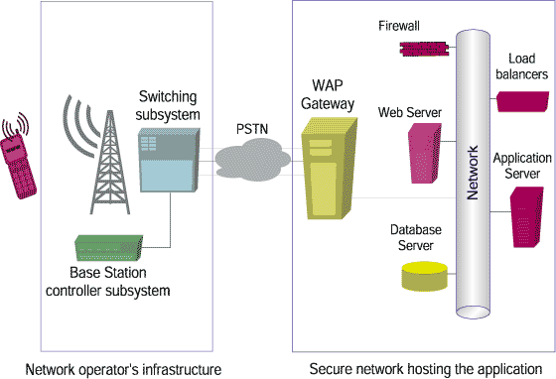
The diagram below shows a typical set-up of a secure WAP application.
.
Figure 4: Typical set-up of a secure WAP application (Zafar, 2002)
Another method for securing WAP solutions is by implementing WTLS tunneling. WTLS tunneling is a new technology that eliminates the WAP gap by providing a WTLS “tunnel” within the WAP gateway such that secure messages can be passed from the wireless device through the WAP gateway and then to the server without being decrypted. In a WTLS tunneling system, the encrypted data from a wireless client-device is sent to the server, just as in a regular WTLS session; however rather than switching from WTLS to SSL encryption, the server sends a new 128-bit WTLS key encrypted with the user’s public key. This new 128-bit WTLS key is then used to encrypt data for the rest of the transaction. WTLS tunneling ensures end-to-end WTLS encryption for communications, as data is not decrypted until it reaches its final destination.
It is envisaged that future versions of WAP will use a type of XML-based wireless security protocol known as Dynamic Proxy Navigation (DPN) [Zafar, 2002]. Using DPN, web servers will be able to send an XML message containing information required to connect to it directly, to DPN-enabled wireless devices. This message will be able to travel from a wireless network to a wired one without the WTLS-SSL switch. However, the implementation of DPN requires the upgrading of WAP browsers, WAP-enabled mobile devices, servers and wireless carrier gateways.
Another wireless security initiative is the use of Wireless Identity Modules (WIM). A WIM is a tamper-resistant hardware module that can be fitted to a mobile client device for the purpose of storing and processing user identification and authentication data such as a permanent private key [Mahmoud, 2002b]. WIMs are either built internally during device manufacture or provided as attachments by wireless service providers for connection through an external port or slot in the mobile device.
A major alternative to WAP’s WTLS-based security for enabling secure m-commerce transactions is kSSL. kSSL which stands for kilobyte Secure Socket Layer, is the result of work carried out by Sun Labs engineers, Vipul and Sumit Gupta, aimed at extending the tried, tested and proven Secure Socket Layer protocol used in secure e-commerce over wired Internet infrastructure to mobile Internet applications. kSSL has emerged as a viable alternative (albeit within the Java domain) to WAP’s proxy-based security architecture which is seen to lack true end-to-end security (Gupta, 2001).

Chapter 3:
Java Technologies community versus Microsoft & .NET

Chapter 3
JAVA TECHNOLOGIES COMMUNITY VERSUS MICROSOFT & .NET
For some time now, there has been a major divide within the software technologies industry. A look at the various players in the industry shows a clear split between two camps, with Java technologies & its advocates on one side and Microsoft, its technologies & partners on the other. These two camps have been locked in a long running battle to dominate the application software landscape. This rivalry spans the whole range of application software platforms, which include platforms for Enterprise server applications through desktop client applications to applications for small, consumer electronic devices such as cell phones and PDAs. A look at the key companies behind these two camps reveal on the Java technologies side, the following:
- Sun Microsystems Inc. (inventor of the Java technology).
- IBM
- Oracle Corporation
- BEA Systems
In the other camp, is Microsoft, the world’s largest software company and its partners, which are mostly Independent software vendors (ISVs). The Java camp is made up of proponents of the Java platform. Existing both as a programming language and a software platform, Java has experienced a phenomenal growth since its invention in 1995, and is said to have emerged as the premier programming platform in the industry today. It is said that Java 2 Enterprise Edition (J2EE) has achieved critical mass as a platform for developing robust, highly available enterprise Web applications [Dietzen, 2002). Evolution of the Java platform is managed under a process known as the Java community process (JCP) through which member companies of the Java community make inputs. However, final control of the Java platform’s evolution still remains with Sun Microsystems Inc.
On the Microsoft camp, is its recently launched .NET (pronounced “dot NET”) platform, which is touted to be the next generation platform for developing agile applications for the Windows operating system and the Web.
The subject of various long running debates has sought to find out which of these two platforms out-perform the other. Benchmark tests have been carried out aimed at comparing the two platforms, most of which have obviously been sponsored by supporters on either side. This study partly aims at undertaking a neutral comparison of the Java and .NET platforms, though mainly focusing at the level of web application development for mobile client devices.
3.1 The Java Platform:

The Java platform consists of the Java Virtual Machine (JVM) and the Java Application programming interfaces (APIs). The virtual machine is the runtime engine that creates an abstract layer over the host native platform (Pawlan, 2000). The virtual machine is the key factor behind Java platform’s “write once - run anywhere” paradigm. Thanks to the virtual machine, Java programs written and compiled on one native operating systems, such as Windows®, can be executed on any other native operating system such as Unix or Mac OS, as long as the latter has a java runtime environment (JRE) installed on it. The JRE provides the virtual machine. A virtual machine is available for almost every known operating system, from Microsoft Windows® to Unix, Solaris and Apple Macintosh.
The Java APIs are available as a large set of class libraries containing re-usable, compiled code, which comes bundled within the Java 2 software development kit (the SDK). Figure 5 below shows the make-up of typical Java platform.
Fig 5: Components of the Java platform. (Nourie, 2001)
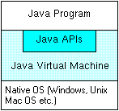
The Java platform is arranged into three editions. These are: Java 2 Standard Edition (J2SE), Java 2 Enterprise Edition (J2EE) and Java 2 Micro Edition (J2ME).
Java 2 Standard Edition (J2SE)
The J2SE provides API and tools for building and deploying client-side desktop applications and applets.
Java 2 Enterprise Edition (J2EE)
The J2EE provides API and tools for building and deploying server-side enterprise applications. J2EE offers support for standardized, modular and re-usable server-side components and technologies such as Enterprise Java Beans (EJB), Java Servlets and Java Server Pages (JSP) amongst others [Gupta, 2001]. Java platform proponents define J2EE as “a Java–based technology stack, built on top of J2SE, that provides developers with tools and runtime capabilities necessary for building enterprise applications that meet rigorous uptime, security, scalability and maintainability requirements” [Sheil, 2002].
Java 2 Micro Edition (J2ME)
J2ME provides API and tools for building and deploying applications for resource-constrained consumer devices.
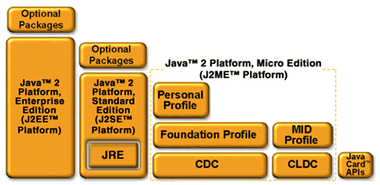
These include devices such as cell phones, pages, PDAs, smartcards, Internet TVs and set-top boxes. In order to support these varied set of devices, J2ME is divided into configurations and profiles. Configurations are specifications that detail a virtual machine and a base set of APIs that can be used with a certain class of devices. While Profiles represent an extension of a given configuration to include more specific APIs to enable the creation of a complete environment for building applications [Day, 2001]. Profiles typically include APIs for application life cycle, user interface, network connectivity and persistent data storage. Simply put, each configuration has a number of profiles that are defined within it to support development of applications for specific class of devices. Fig 6 below shows the various Java platform editions and how they relate to each other.
Figure 6: Java platform editions arranged end-to-end (Sun Microsystems, 2001a)

3.2 The .NET Platform:

The .NET platform consists of the .NET Framework, the development tools and the underlying operating system (mainly Microsoft Windows® at the moment). The .NET Framework forms the core of the platform. The framework is made up of the following:
- The Common Language Runtime
- The Framework Class Libraries.
- ADO.NET data access components.
- ASP.NET (server-side components for developing web applications).
The main development tool for the .NET platform is Visual Studio.NET, which provides a robust visual integrated development environment (IDE) for developing feature-rich applications for Windows and the web [Deitel, 2002b].
By virtue of its design, the .NET platform is a language agnostic platform. It provides support for a wide range of compliant programming languages by using a common language specification (CLS), a common type system (CTS) and facility for compiling source code to an intermediate language known as the Microsoft Intermediate Language (MSIL) rather than compiling to native machine code.
Programming languages currently supported by the .NET platform include C# (pronounced C sharp), VB.NET, C++, JScript.NET and J#. The C# programming language was designed specifically for the .NET platform. It is an event-driven, fully object-oriented visual programming language for coding .NET applications. Other programming languages, which are being ported to the .NET platform, include COBOL, Pascal, SmallTalk, Ada, and Python.
The .NET platform offers a new software development model that allows applications created in disparate programming languages to communicate with each other. A key aspect of the .NET architecture is its support for XML Web services, a new technology whereby applications can expose (i.e. make available) functionality for consumption by other applications over the Internet.
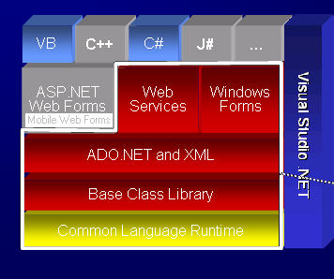
.NET Mobile is the part of the .NET platform that provides server-side components for developing mobile web applications. It is essentially an extension of ASP.NET. The Microsoft Mobile Internet Toolkit is a downloadable module that integrates with the Visual Studio.NET IDE on installation and provides a set of mobile web controls that can be used to develop web applications for mobile devices. ASP.NET mobile web forms and the mobile Internet controls runtime make use of an Adaptive User interface technology to enable the generation of custom markup for delivering web content to varied client device from a single code base. This is done through the use of device Ids to determine what type of client-device is requesting web content. Figure 7 below shows the architecture of the .NET platform and the place of .NET mobile within it.
3.3 Comparing the Java and the .NET Platforms:

Functionally, both the Java and the .NET platforms bear several similar characteristics. For instance, looking at a high level, both platforms compile source code to an intermediate language. While in the .NET platform the intermediate language is MSIL, in the Java system, it is Java Byte Code [Sessions, 2001]. In both cases, the intermediate language is executed within a runtime environment. In the .NET platform this environment is known as the Common Language Runtime (CLR). For the Java platform, the environment is the Java Virtual Machine (JVM). Generally speaking, the CLR and the JVM have similar functions and differ mainly in that unlike the JVM, which supports only code written in the Java programming language, the CLR supports code written in any .NET compliant programming language.
In a bid to ascertain which of the two platforms offers a better performance than the other, various industry bodies have carried out benchmark tests that compares in an overall term, J2EE and .NET. Figure 8 below shows the result of one such benchmark test published by Oracle Corporation, one of the key promoters/vendors of the Java platform.
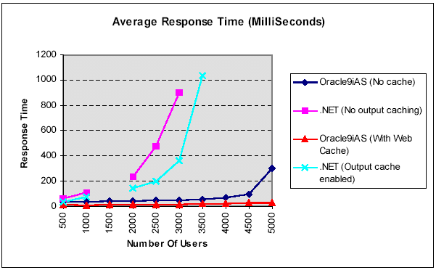
Figure 8: Benchmark test results comparing J2EE on Oracle9iAS against .NET
The above graph shows that Oracle’s implementation of the J2EE specification on its Oracle9i Application Server, offers much better performance (measured in average response times) and scalability than .NET (Oracle Corp.,2002).
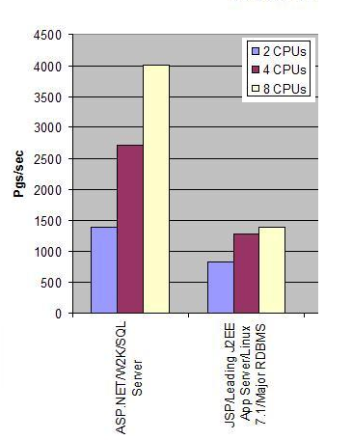
Another benchmark test comparing .NET and J2EE published by Doculabs Inc, shows .NET outperforming J2EE while measuring the number of web pages served per second at peak throughput by a server using 2, 4 and 8 CPUs. A summary of the test results is shown in figure 3.5 below.
Figure 9: Doculab’s .NET versus J2EE Benchmark test results
With regards to these benchmark tests, most independent writers believe they are usually flawed, as most vendors tend to tweak applications to skew the test to favour their preferred platform [Vaughan-Nicolls, 2002]. However, the best way to know which application platform is better is to carry-out an independent, unbiased test. Which clearly defines one of the main goals this project intends to achieve.
In certain quarters, Java and the .NET platform is not all about rivalry. Some industry watchers predict that in the long run Java and .NET technologies will need to be deployed side-by-side. For instance BEA Systems Inc.’s chief technology officer, Scott Dietzen believes that “despite the current competitive uproar, co-existence of J2EE and .NET will be the norm as most sophisticated organizations will deploy both development platform” [Dietzen, 2002].

Chapter 4:
Methodology

Chapter 4
METHODOLOGY
The task of studying the factors behind the emergence of the mobile Internet and assessing the effectiveness of J2ME and .NET platforms, was approached in three fronts. On one front, a wireless web consumer survey was carried out to ascertain whether there exists any demand for mobile web applications. The second front was concerned with defining a specification for a specimen mobile commerce application, named Microbanker and undertake its design and development using J2ME and .NET mobile respectively. The third and main front was to carry out performance tests on the application and analyse the results obtained.
4.1 Survey of Consumer Expectation & Requirements:

To find out what consumer expectations and requirements are, a wireless web consumer survey was carried out. This survey involved the design of a questionnaire and its distribution around the Luton Town area. Feedback gathered from administering the questionnaire was analysed. Table 1 below shows a summary of the responses from the questionnaires.
Total Number of respondents | 25
Number of respondents with fixed Internet access | 25
Number of respondents with mobile device | 25
Number of respondents who have accessed the mobile Internet | 1
Number of respondents willing to purchase an internet-enabled mobile device | 13

Mobile Internet services | Number of willing users
Communication services (Email, chat, IM etc.) | 24
m-Commerce services (banking, news, travel, stock trading etc.) | 16
Entertainment services (Games, music, movies etc) | 19
Table 1: Summary of wireless web consumer survey results

Copies of the completed wireless web consumer questionnaire can be found in Appendix A.

4.2 Specimen m-Commerce Application (MicroBanker):

Having gathered vital feedback with regards to wireless web applications from a pool of users, it was noticed that one of the key commercial services that could viably be implemented as an m-Commerce application is in the area of retail banking. With this is mind, a simple, easy-to-use wireless banking application named MicroBanker, was devised.
MicroBanker is a wireless application for providing basic retail banking services that customers can access at anytime and from any location using any compliant mobile client-device such as a cell phone, PDA or a pager. It is to be designed as a data-driven wireless application that can be used to assess the effectiveness of J2ME and .NET Mobile through undertaking its implementation using the two technologies respectively and performing a series of performance tests.
The MicroBanker application will provide the following functions:
- View Account Balance.
- Transfer Funds.
- Make Payments.
- View mini-Statement.
- Update your Contact Info.
- Request full bank statement.
- Request Stationery (cheque booklet, pay-in booklet etc.)
- Send short message.
However not all of these functions are implemented since it is intended to be simply a prototype wireless application for use in assessing J2ME and .NET Mobile platforms.

4.3 Application Performance Metrics:

Since the main focus of this study is concerned with assessing two alternative software technologies through evaluating the performance of an application implemented using both, the various issues regarding software metrics were considered. Software metrics deals with techniques for measuring various aspects of a piece of software, ranging from feasibility, implementation cost to performance and scalability (capacity to expand and support additional work-load and computing resources). “Measurement is the process by which numbers and symbols are assigned to attributes of entities in the real world in such a way as to define them according to clearly defined rules” [Fenton, 1997].
This study is concerned specifically with metrics related to application performance. To assess J2ME and .NET versions of the MicroBanker wireless application, performance tests will be carried out to measure the application’s response times against various increasing levels of work-load which will be presented in the form of higher numbers of bank account records in the database. These performance tests and their analyses are covered in chapters 5 and 6 ahead.

Chapter 5:
Design and development of specimen m-Commerce application (MicroBanker)

Chapter 5
DESIGN AND DEVELOPMENT OF SPECIMEN M-COMMERCE APPLICATION (MICROBANKER)
Microbanker is the name given to the wireless banking application, which was introduced in section 4.2 of the previous chapter. This chapter covers its requirements analysis, design, development and testing.
5.1 Requirements Analysis and Design:

The function of the application is to deliver basic retail banking services onto bank customers’ mobile devices over a secure wireless network. The following assumptions are made:
- Customer has a mobile device (cell phone, PDA or pager).
- Customer has access to wireless communication service via a subscription to a suitable wireless network operator (such as mmO₂, Vodafone, T-Mobile, Orange or any other).
- Customer’s mobile device has a WAP micro-browser or is J2ME MIDP compliant.
- Bank subscribes to the network operator to provide access to its wireless application through the operator’s wireless network infrastructure.

The Scenario:
The customer has an Internet-enabled mobile device and has access to a wireless communication network. The bank wants to provide the customer with secure access to its retail banking services at anytime and from anywhere. Briefly put, the bank wants to support mobility. The services the bank wants to deliver to its customer include:
- Access to account balance information for display only, on the customer’s mobile device.
- Means to transfer funds from one account to another.
- Means to make payments online for key public services such as electricity/gas bills, house rents, television licence fee, road tax, tuition fees etc.
- Means to browse last ten transactions done on customer’s account (To display short transaction history on mobile device).
- Ability for customer to connect and update their contact information (postal address, telephone number, email address etc.)
- Ability for customer to place a request for full bank statement or stationery.
- Ability for customer to send instructions in form of a short text message to customer account relationship officer.
From the above scenario, the following major entities are identifiable:
  - Bank
  - Customer
  - Wireless Network Operator/Carrier/WISP
A suitable rich picture illustrating the problem scenario is given in figure 10 below:
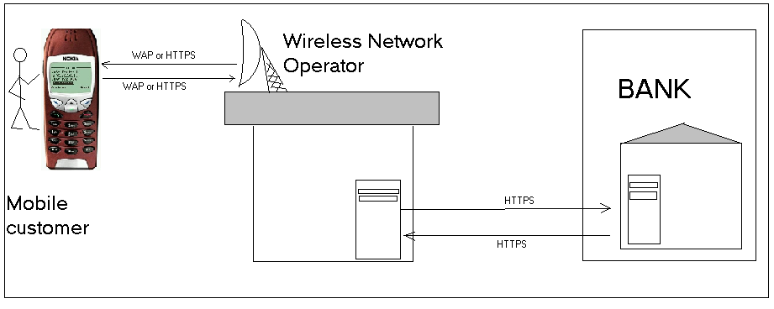

Figure 10: Rich picture illustrating wireless banking scenario
Design of the Application:
The design of Microbanker is divided into two parts, namely:
- User Interface design
- Database design
User Interface (UI) Design:
Considering the limitations of the target client devices, the User Interface of MicroBanker was designed such that the need for substantial amount of data entry was kept to a barest minimum. Each screen was designed with strict adherence to industry recommendation as specified in documents such as the J2ME MIDP user interface guide [Sun Microsystems, 2002a]. The UI design minimizes the need for users to enter long streams of text by providing Option Lists for selection in place of elaborate textboxes.
With the required functionalities in mind, the user interface was designed as shown in figure 11 below:

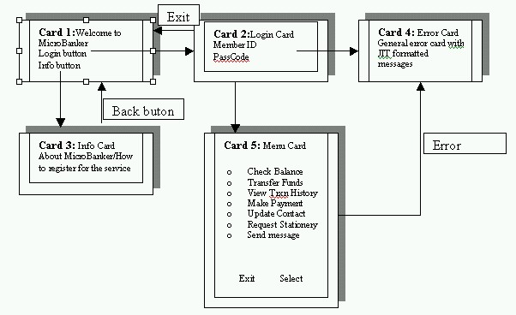

Figure 11: User Interface design for the microbanker wireless application

Database Design:
Being a data-driven application, it was noted that Microbanker would require the design and setting up of a persistent data store to hold the application’s data. Using the Entity-Relationship (E-R) database design approach, the following entities, their related attributes and constraints were defined:
Entity | Attributes | Constraints
Customer | Customer_id | Primary key
 | Firstname, middlename, surname, title, gender, date of birth, mothers maidenname, nationality, house, street, city/town, county, postcode, home tel., office tel., mobile, email, country.
Account | Account no | Primary key
Account | sortcode, joint acct, balance, account status
Transaction | Transaction no | Primary key
Transaction | Transaction type, trans date, amount, status
Transaction | Customer id | Foreign key
Transaction | Account no | Foreign key
Table 2: Microbanker database entities, attributes and constraints
In order to resolve the many-to-many relationship identified between the customer and the account entities, a new table named, CUST_ACCT was defined with two attributes – customer id, account no. Other tables created include: TRANSACTION TYPE, USERS, and PARAMS. The PARAMS table is to be used to store important data for use by the application such as the last transaction number.
An Oracle SQL Script was created and executed for creating the database objects obtained from the E-R design. Full code for the SQL script can be seen in Appendix B.
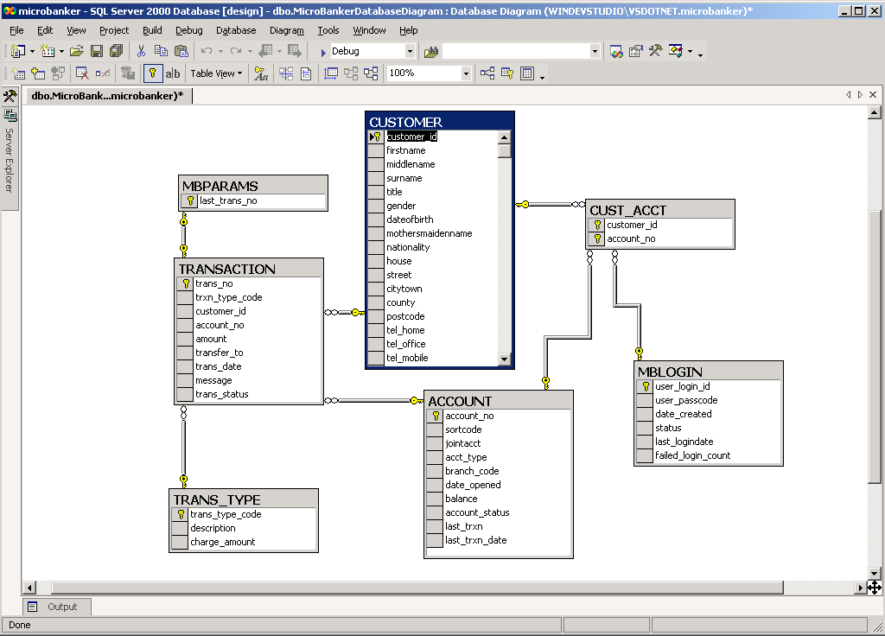
The final E-R model for the microbanker application is shown in figure 12 below:
Figure 12: Final Entity-Relationship Model for the Microbanker database
5.2 Developing MicroBanker using J2ME and Java Servlet:

In order to provide access to data across the network from the mobile application to the back-end database, a piece of middleware had to be developed. J2ME on its own does not provide API for back-end data access across the wireless network [Gupta, 2001]. J2ME’s MIDP only provides API for developing the thin front-end application, which is known as a MIDlet. The middleware is implemented as a Java servlet that handles service requests from the front-end MIDlet, perform the data access functions and return the results in a suitable format (possibly XML or plain text) back to the MIDlet for display on the mobile client-device. In MIDP 1.0, the only way to portably connect to server-side components is by making HTTP requests to a servlet running in an external Web server [Giguere, 2002]. Unlike MIDlets, Servlets have access to the JDBC API required for connecting and executing SQL queries on back-end relational databases.
To implement the required microbanker servlet, there was need to setup a servlet engine that will serve as a container for handling all HTTP requests from the MIDlet. In this project the main open source servlet engine known as Apache Tomcat, was used. Tomcat is freely downloadable, with versions for most major operating platforms – Windows, Unix, Solaris etc.
5.2.1 Setting-up the J2ME/Servlet development environment:

A development environment is made up of tools, underlying APIs and the operating platform necessary for developing applications [Knudsen, 2002b]. Developing Microbanker using the J2ME technology required the following:
- Java 2 software development kit (J2SE SDK v 1.3.1).
- Java 2 Micro Edition Wireless toolkit.
- Apache Tomcat 4.0.1 (Java servlet container).
- Oracle 8i Personal Edition (back-end RDBMS).
- Mobile Device Simulators: These are custom-built software packages that run on a mobile application development environment, which mimic the activities, functions and appearance of the given mobile device (cell phone, PDA, or pager) they are modeled on [Ridgeway, 2002]. Some authors prefer calling them emulators instead. Nonetheless, both emulators and simulators refer to the same thing as defined here. The following simulators built-in within the J2ME wireless toolkit were used – DefaultGray Phone, Color Phone, Minimum phone, Mororola i85s and the RIM Handheld.
Figure 13 below shows the architecture of the J2ME solution:
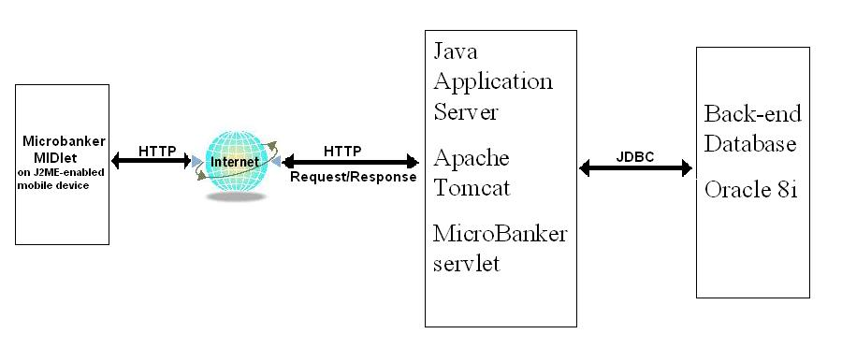

Fig. 13: MicroBanker architecture using J2ME and Java Servlet
5.2.2 Coding

The programming language used in coding Microbanker for J2ME is Java. The Java 2 SDK version used was 1.3.1. MIDP API version 1.0 and CLDC API version 1.0 were also used.
Coding adhered to the standard Java coding convention as recommended in Sun Microsystem’s Java coding convention document. The code editor used was EditPlus 2. Using the J2ME wireless toolkit, the MIDlet suite was compiled into a JAR file. This process also creates a Java Application Descriptor (JAD) file. The size of the JAR file determines the absolute size and hence the amount of memory the application will require [Knudsen, 2002]. A screenshot of the J2ME wireless toolkit, the Editplus code editor and the J2ME default colour phone emulator is shown in figure 14 below:
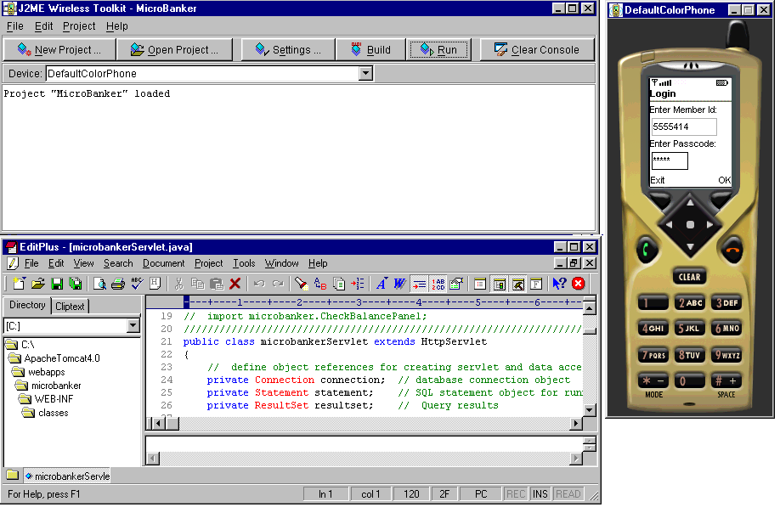

Figure 14: Screenshot of the J2ME wireless toolkit, the Editplus code editor and the J2ME default colour phone emulator.
Data access within the servlet component was implemented using a type 4 Oracle JDBC driver since it offers the best performance in linking the java Servlet code to the native Oracle database protocol [Moss, 2002].
Detailed code listing for both the MIDlet and Servlet components of the application is contained in Appendix B.
5.3 Developing MicroBanker using .NET Mobile:

Unlike with J2ME, implementing the MicroBanker application using .NET mobile still results in a WAP-dependent solution. Therefore, the architecture of the .NET version of the application bears a close resemblance to a typical WAP mobile application architecture. The architecture of the .NET Mobile version of the Microbanker application is shown in figure 15 below:
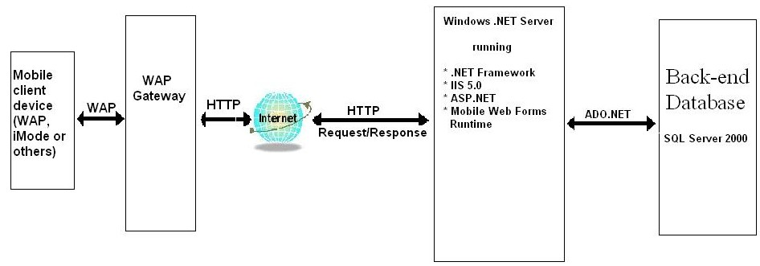

Fig. 15: MicroBanker architecture using .NET Mobile
A key feature in the .NET mobile solution is that since it uses a purely server-side architecture with an Adaptive User Interface generation capability (via ASP.NET and Mobile Web Controls Runtime), it can support a variety of mobile client-devices using a common code base. Considering that the mobile landscape is made of different types of devices and networks, with each type only capable of rendering web content formatted in its own unique markup language, the .NET mobile’s Adaptive UI technology provides for efficient development of a mobile web solution capable of supporting a wide range of mobile devices using the same ASP.NET code [Segala, 2002]. For instance iMode currently supports only web content written in cHTML, WAP devices require content to be marked up using WML while the RIM Blackberry handheld device which is common in the US supports HDML (Handheld Device Markup Language). While a common standard for marking up web content for mobile client devices is not yet in place, .NET Mobile can serve as an effective platform for developing and deploying mobile web application that can be run on all of this disparate devices. It does this by using the device type id of the client mobile device requesting content to determine which markup language to format the content with, for display on the device.
5.3.1 Setting-up the .NET mobile development environment:

Preparing the development environment for implementing MicroBanker application using the .NET mobile platform involved the following:
- Installation and configuration of Internet Information Service (IIS) on a Windows 2000 professional desktop PC with service pack 2.
- Installation of the Visual Studio.NET IDE. Visual Studio.NET comes bundled with Microsoft SQL Server 2000 relational database engine and the .NET Framework.
- Installation of the Microsoft Mobile Internet Toolkit add-on tool that plugs-in to the Visual Studio .NET IDE.
- Installation of mobile device simulators from Nokia Mobile Internet Toolkit and Openwave SDK. Both Nokia and Openwave tools provide a built-in WAP gateway that can be used of testing the application.
5.3.2 Coding (ASP.NET and C#)

Coding MicroBanker on the .NET platform basically entailed developing an ASP.NET Mobile Web application. This involved using the Mobile Web Forms designer to create the applications user interface and then writing Code-behind for handling events. The code-behind file can be written in any .NET compliant programming language. For coding Microbanker, the C# programming language was chosen since it offers neater and shorter syntax when compared to an alternative such as VB.NET [Powell, 2002].
It is worthy to note that when compared on a performance basis, both C# and VB.NET are fairly similar since code written in both languages ultimately compile to the Intermediate Language, MSIL [Deitel, 2002b]. Hence, the choice of C# over VB.NET was made largely based on personal preference.
Coding the data access functions of the application made use of the ADO.NET API which includes sqlDataAdapter, sqlDataReader and sqlCommand objects for connecting to the SQL Server 2000 database and executing the relevant SQL queries. The sqlDataset object was used in retrieving data from the Microbanker ACCOUNT table for display on the target mobile client device.
An SQL script named Insertdata.sql was created for use in populating the ACCOUNT table with the various number of account records required for carrying out the performance tests.
Detailed code listings for the .NET mobile application can be found in Appendix B.
Figure 16 below shows a screenshot of the Visual Studio.NET IDE and Nokia mobile Internet toolkit with emulator for the Nokia 6210 mobile phone.
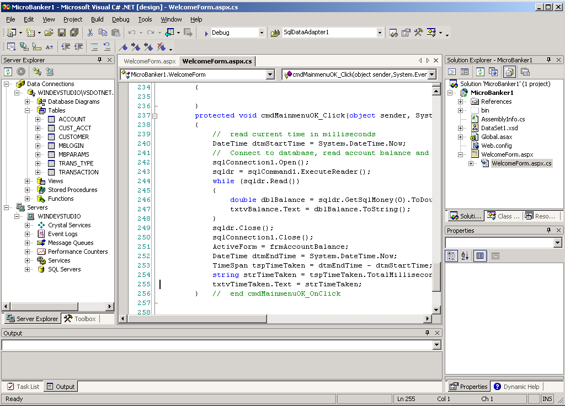

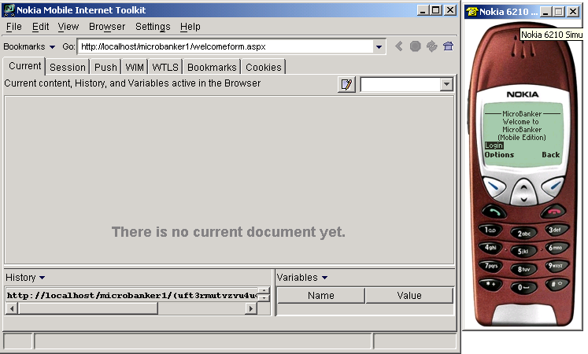

Chapter 6:
Performance Testing and Analysis of Test-Results

Chapter 6
PERFORMANCE TESING AND ANALYSIS OF TEST-RESULTS
In line with the project’s primary objective of assessing the two technologies, .NET Mobile and J2ME, to find out which of the two offers a better overall performance, both the .NET version and the J2ME version of the MicroBanker application had to be tested on the same machine.
The test machine’s configuration is as follows:
1. | Machine Type | Desktop PC
2. | Make | DELL Optiplex GXa
3. | Processor | Genuine Intel Pentium II 233MHz
4. | Memory | 128Mbytes RAM
5. | Hard disk | 42Gbytes Maxtor HDD at 5400rpm
6. | Operating system | Microsoft Windows 2000 Professional

Table 3: Configuration of the Test workstation

6.1 Performance Testing:

On completion of the development of both the J2ME version and the .NET Mobile version of the Microbanker application, performance tests were carried out to measure the change in the response times for each application against increased workloads. The Workloads were applied in the form of increased volume of data in the ACCOUNTS table.
The one functionality selected and used for the performance tests was the “VIEW ACCOUNT BALANCE” function. The applications’ response times measured represent how long it took between hitting the SELECT button on each application’s user Interface, through making the HTTP request, to obtaining and displaying the account balance information on the mobile device simulator’s screen.
To enable accurate measurement of each response time, the timings and calculations were handled within the application’s code. This avoided the inclusion of the time taken to download MIDlet before commencing execution [Bamrud, 2002]. See code listings in Appendix B.
6.1.1 J2ME Performance Tests

For the J2ME MIDlet, lines of Java code were embedded within the MIDlet code to read and calculate the time taken in milliseconds from SELECT button-click event through the HTTP servlet request/response to the display of the account balance. This time taken is displayed on the simulator screen along with the Account balance information. Figure 17 below shows sample screen-shots of the Microbanker J2ME MIDlet:
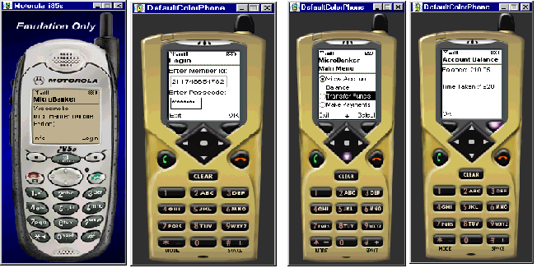

Tests were performed on a varying number of account data records. The number of Account data records tested ranged from 10 to 35,000. In order to facilitate the testing process, an SQL script was created to handle the populating of the ACCOUNT TABLE by inserting the required number of records needed for each test. Code listing for this SQL Script named InsertData.sql, can be found in Appendix B.
Three trials were performed for each number of data records being tested. The average response times for the J2ME MIDlet were calculated and recorded as shown in table 4 below:
S/N | Number of Account Records | J2ME Average response time (in seconds)
1. | 10 | 1.705
2. | 50 | 1.744
3. | 100 | 1.787
4. | 250 | 1.812
5. | 500 | 1.846
6. | 1000 | 1.895
7. | 5000 | 2.033
8. | 7500 | 2.048
9. | 15000 | 2.092
10. | 20000 | 2.124
11. | 25000 | 2.165
12. | 35000 | 2.214
Table 4: J2ME performance test results showing average response times

The full record of J2ME test results showing response times obtained for each trial can be seen in Appendix C.
6.1.2 .NET Mobile Performance Tests

For .NET Mobile, simulators used were: Openwave SDK 4.1 (containing the openwave WAP microbrowser), Nokia Mobile Internet toolkit (with emulators for the Nokia Phones 7113, 3330, 6210, 8163 and the Nokia mobile browser).
For test running WAP-enabled mobile web applications such as the .NET Mobile version of the Microbanker wireless application, a gateway is required. A gateway is special server software used for processing traffic (WAP content) between back-end servers in the wired Internet network and the client-devices in the wireless communication network. Both of the device simulators mentioned above (Openwave and Nokia), ship with built-in WAP gateway. (An exception here is the Ericsson simulator that provides its gateway as a separate download).
Performance tests for the .NET Mobile version of the application were carried in the same way as that of the J2ME version. The tests were also performed for numbers of account data records ranging from 10 to 35000. Figure 18 below shows screenshots of the .NET mobile version of the Microbanker application:
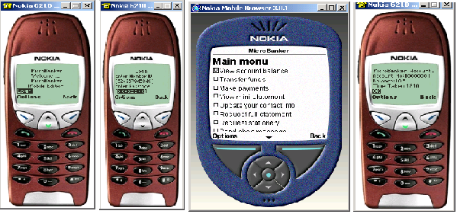

The average response times obtained for the .NET Mobile version of the Microbanker application are shown in Table 5 below.
S/N | Number of Account Records | .NET Mobile Average response time (in seconds)
1. | 10 | 1.821
2. | 50 | 1.864
3. | 100 | 1.902
4. | 250 | 1.965
5. | 500 | 1.997
6. | 1000 | 2.044
7. | 5000 | 2.141
8. | 7500 | 2.163
9. | 15000 | 2.217
10. | 20000 | 2.251
11. | 25000 | 2.308
12. | 35000 | 2.377
Table 5: Summary of .NET Mobile performance test result showing average response times

6.2 Analysis of Test Results:

Critical examination of the average response times obtained from the performance tests reveals that the J2ME application returns Account balance information on the mobile client-device screen slightly faster than .NET Mobile application does.
Considering that both applications were deployed and run from the same test machine, the above results indicate that the J2ME MIDP platform offers better performance over the .NET Mobile platform. It is worth noting that in measuring the response times, the initial application load times were not included for both applications.
However the rate of change of the average response times against the number of data records is almost the same for both the J2ME and the .NET mobile versions of the Microbanker application.
This can be seen by examining the gradients of the .NET and J2ME graphs shown in figure 19 below.
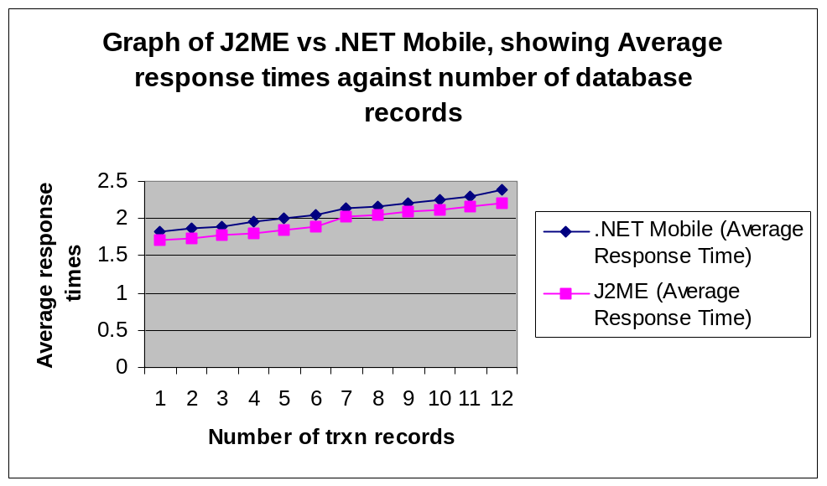

Figure 18: Graph of J2ME versus .NET Mobile showing average response times against number of data records.

Figure 19: Graph of J2ME versus .NET Mobile showing Average response times plotted against number of data records.

Chapter 7:
Conclusion and Recommendations

Chapter 7
CONCLUSION AND RECOMMENDATION
Having gone through the process of defining a specification for a typical data-driven mobile web application, implementing the application using both J2ME and .NET Mobile technologies, carrying-out separate performance tests on both versions of the application and recording and analyzing the test results, this study arrives at a position where certain valid conclusions can be drawn. The key conclusion being sought at this point is with regards to answering the original question posed, which was: “Which of the two platforms/technologies performs better? J2ME or .NET Mobile?”
7.1 Findings and Discussion:

Putting together all the activities that have been undertaken throughout this project, gives two main findings, which can be summarized thus:
- From the Wireless web consumer survey carried out, it was discovered that about 98% of fixed Internet services consumers have not yet considered accessing these services using a mobile device. This implies a large majority of Internet users still operate outside the mobile Internet zone despite the huge opportunities that this novel infrastructure offers for both service providers and consumers. Cost was identified as one major factor preventing users from patronizing mobile Internet services, as 52% of users sampled say they will only upgrade to a new Internet-enabled mobile device if the price is reasonable.
- Results obtained from the MicroBanker application performance tests reveal that J2ME-based solution perform slightly better than the .NET Mobile solution. The key identifiable factor behind this result is the fact that .NET Mobile web applications still have to communicate across WAP gateways unlike J2ME applications. Considering that each message exchanged between the micro-browser running the .NET Mobile application and the backend .NET Web server (IIS/ASP.NET), has to go through the process of communication protocol translation from WAP to HTTP (and vice versa) within the WAP gateway, it is evident that .NET Mobile web content will take a bit longer to arrive at either end of the channel. J2ME, on the hand, does not necessarily require communication via a WAP gateway though both technologies (WAP and J2ME) can co-exist within the same platform [Mahmoud, 2000].
Other issues of interest with regards to developing mobile web applications using J2ME or .NET mobile include:
- The J2ME MIDP API contains facility for implementing a RecordStore within a MIDlet [Gupta, 2001]. This provides a means to use a client-side data manager functionality to create a persistent data storage component, which could drastically minimize network roundtrip and thus offer much faster data retrieval times. A recordstore consist of a collection of records which remain persistent across multiple invocations of the MIDlet [Sun Microsystems, 2001a]. With capability to store chunks of data within the mobile device’s data storage unit J2ME MIDP application can conveniently run as standalone applications. This cannot be obtained from a purely server-side .NET Mobile solution unless the .NET Compact Framework is implemented on the client mobile device being used. The .NET Compact Framework supports a compact version of Microsoft’s flagship database application, named SQL Server CE. The .NET Compact Framework is a fairly new technology and as such its availability is limited at the moment to only a few mobile devices such as the Pocket PC and devices running the Windows CE operating systems.
- Using its Adaptive User Interface generation technique, .NET Mobile offers the advantage of writing a single mobile web application that can be supported by a range of micro-browsers and networks including those in iMode devices, WAP devices, RIM Blackberry devices, HDML-based devices amongst others [Sivakumar, 2002]. Currently, over 70 different types of mobile devices can support .NET Mobile. On the other hand, a J2ME MIDP application can only run on an MIDP-compliant device. To support devices that do not fall under the CLDC/MIDP configuration/profile, requires the creation of a separate application based on the specification & API of the target device’s configuration or profile. For instance, the J2ME MIDP version of the Microbanker application developed in this project can only run in MIDP-compliant devices such cell phones and pagers. To run the application on a PDA requires writing fresh code for the PDA Profile.
A summary of the technical comparison between .NET Mobile and J2ME platforms is given in Table 6 below:
S/N | J2ME | .NET Mobile
1. | Defines specifications for developing Java applications for resource-constrained devices. | A part of the .NET Framework and an extension of ASP.NET that provides a server-side Mobile Controls runtime and mobile web forms designer
2. | Its specifications are defined based on Configurations and Device Profiles. Configurations include CDC and CLDC running over the CVM and KVM virtual machines respectively. | Uses Adaptive UI generation technology to provide automatic support for various client- device types.
3. | Non-WAP/microbrowser dependent, but can co-exist within a browser-based environment. | Essentially server-side technology and runs over WAP using micro-browser as thin client.
4. | J2ME MIDP applications known as MIDlets can run both in transient mode over a wireless network and as standalone applications. Therefore do not require persistent network connection. | Applications require persistent network connection.
5. | Can handle persistent data storage on client device using a RecordStore object as a client-side data manager. | Can only provide client-side data storage if device contains .NET Compact Framework. Only devices (Pocket PCs and smartphones) running Windows CE.NET do at the moment.
6. | Supports Over The Air (OTA) provisioning with a resident Java application Manager tool running within the device handling download and installation of applications (MIDlets). | Application basically runs off the server, generating markup for web content delivered via WAP for rendering on microbrowser installed in client device.
7. | WAP gap is not an issue. | WAP gap is a potential security issue.
8. | Application requires initial downloading and installation before running. | Web content gets rendered on the device’s micro-browser upon delivery across the network.

Table 6: Summary of technical comparisons between J2ME and .NET Mobile

When all the features in the comparison outlined above are considered in the aggregate, it can be seen that for simple, short-spell mobile web applications such as a Bank Balance Checker, .NET Mobile offers a better overall performance since it will query and display an account balance in a shorter time than the time it will take for the J2ME application to download and install [Cowen, 2002].
However, for larger full-blown mobile applications such as Games, Personal Information Managers and Stock trading, that require substantial client-side data manipulation, J2ME will provide a better solution since its client-side data storage capability will minimize network roundtrip by providing access to local data thus justifying the time taken to download and install the application initially [Capone, 2002a].
7.2 Limitations:

Even though the performance tests carried out in this project for assessing J2ME and .NET Mobile were done within a controlled mobile application development and test environment, the overall test conditions can by no means be said to be perfect or ideal. There definitely exist a number of factors within the test environment that might have had an effect on the results obtained. Unfortunately, these factors could not be removed due to certain limitations, of which the major two are:
- Non-availability of facilities for testing the mobile web applications using real life J2ME and WAP devices: It is known that how a mobile application executes within a simulated mobile device environment can differ greatly from how it executes when tested in “the wild” [Wilson, 2002]. Testing in “the wild” implies running the application under real life conditions using real, physical mobile devices. Bearing this in mind, the conclusions that have been drawn from the test results thus obtained, cannot yet be generalised until similar performance tests carried out under real life conditions and using real devices, give the same results. This notwithstanding, it should be noted that the simulator-based tests still provide sufficient clue as per the performance of J2ME against .NET Mobile, though not totally conclusive.
- Non-availability of simulator for other client mobile device type such as iMode and RIM Blackberry. Simulators for iMode and HDML supporting devices could not be obtained. Therefore .NET Mobile’s support for other non-WAP mobile devices was not verified. However, the fact that the .NET Mobile version of the Microbanker application was rendered by both the Openwave and Nokia browsers without any major differences provides sufficient clue that the technology is truly microbrowser neutral.
7.3 Recommendations:

Based on the findings made in this project the following recommendations can be offered:
- Applications such as Microbrowsers for mobile devices should be implemented using J2ME technology. Considering that mark up language versions are prone to frequent changes, there is always need to upgrade microbrowsers that are used to display marked up web content on a mobile device. Upgrading a microbrowser developed as a J2ME application is as simple as downloading a version of the application over the air and installing onto the same device. On the contrary, upgrading microbrowsers that were developed using some other technology may require purchasing a new mobile device all together.
- If a mobile application is to be accessed by a wide variety of mobile networks/client device types (iMode, WAP, HDML etc.) and its function is merely to access and view data held in backend information systems, then its implementation using .NET Mobile technology is recommended. .NET Mobile applications will execute queries and return requested information for one-off data access faster than J2ME since J2ME applications first need downloading and installation before execution can begin [Young, 2002].

7.4 Suggested further research:

One interesting possible source of discrepancy in this project is the fact that a different backend database engine was used to implement each of the versions of the wireless application. The J2ME solution used an Oracle 8i database whereas the .NET Mobile version used Microsoft SQL Server 2000 database engine.
Given this setup, it can be seen that the performance tests carried out do not only test the effectiveness of J2ME against .NET Mobile, but also tests the efficiency of Oracle 8i database against SQL Server 2000. A pure J2ME versus .NET Mobile assessment can be performed by implementing both solutions over the same backend database technology.
Having looked at how J2ME compares against .NET Mobile in this study, other related research work that can be undertaken include:
- Assessing either of J2ME or .NET Mobile against another alternative technology for developing wireless applications such as Qualcomm’s BREW (Binary Runtime Environment for Wireless).
- Assessing J2ME’s PDA Profile against the full .NET Compact Framework with SQL Server CE supported on a PDA-type device such as the Pocket PC.

References

References
Al-Saleh, A. (2001). “Wireless Strategy: Guidelines for getting started.” Wireless Business & Technology Magazine. Accessed online at http://www.sys-con.com/2001/wireless on 18-August-2002.
Bamrud, J. (2002): “Java on Wireless devices”. TheFeature.com Accessed online at http://www.thefeature.com on 16-August-2002.
Capone, J. (2002a): “Will J2ME Bridge the Wireless Technology Gap?” An Aligo Inc whitepaper. Accessed online at http://www.aligo.com on 16-Aug-2002.
Capone, J. (2002b): “Addressing the Mobile application development and deployment challenge with Java 2 Enterprise Edition.” Accessed online at http://www.aligo.com on 16-Aug-2002.
Chao, Han-Chieh (2001): “An Overview and analysis of mobile Internet Protocols in Cellular Environments.” Internet Research: Electronic Networking Applications and Policy. Vol 11, No. 5, pp.435 – 450. MCB University Press.
C-I-A.com (2002). “PCs in use Surpassed 600M. Over 45% of Worldwide PCs are in homes”. Computer Industry Almanac. http://www.c-i-a.com/pr0302.htm [Accessed on 09-August-2002].
Coley, B. (2002): “Enabling the Killer Application” Accessed online at http://www.ti.com/omap/ on 19-July-2002.
Cowen, A. (2002): “Application testing in the Mobile space”. MPulse Magazine, July 2002 Issue. Accessed online at http://www.cooltown.hp.com/mpulse on 2-August-2002.
Cummiskey, J. (2001). “What does “3G” Wireless Mean to Pocket PC Users?” Pocket PC magazine. http://www.pocketpcmag.com/archives.asp [Accessed on 16-August-2002].
Day, B. (2001): “Developing Wireless Applications Using the Java 2 Platform Micro Edition”. Sun Microsystems Inc. Accessed online at http://www.sun.com/developers/evangcentral on 7-August-2002.
De-Gregorio, S., Budagavi, M. and Chaoui, J. (2002): “Bringing Streaming Video to Wireless Handheld Devices.” A Texas Instrument Inc. whitepaper. Accessed online at http://www.ti.com/omap on 19-July-2002.
Deitel, H. M. et al (2002b). “C#: A Programmer’s Introduction”. Chapter 1, pp.7- 10. Deitel Developer Series, Prentice Hall Inc. ISBN 0-13-046132-6.
Deitel, H. M., Deitel, P. J., Nieto, T. R. & Steinbuhler, K. (2002a). "Wireless Internet and Mobile Business - How to Program", Chapter 1, pp. 9-15. Prentice-Hall Inc., New Jersey. ISBN 0-13-062226-5
Dietzen, S. (2002). “.NET and J2EE: Interoperability in the Web Services World”. Web Services Journal, Volume 02, Issue No. 08, pp. 14-16. Sys-Con Media, Inc.
Doculabs® Inc. (2001). “Microsoft .NET versus Sun Microsystem’s J2EE: The Nile E-commerce application server Benchmark”. Accessed online at http://www.gotdotnet.com/compare on 28-August-2002.
Fenton, E. N. and Pfleeger, S. L. (1997). Software Metrics: A Rigorous & Practical Approach”. Chapter 1, p.5. PWS Publishing. ISBN 0-534-95425-1.
Forrester Research Inc. (2001). "Trends for Worldwide e-Commerce Growth". http://www.forrester.com/ER/Press/ForrFind/0,1768,0,00.html [Accessed on 17-August-2002].
Giguere, E. (2002): “J2ME Tech Tips” Java Developer Connection. Accessed online at http://java.sun.com/jdc on 7-August-2002.
Glimstedt, H. (2001): “Competitive dynamics of technological standardization: The case of 3rd generation cellular communication.” Industry and Innovation. Vol. 8, No. 1, pp. 49-54. Carfay Publishing.
Gupta, A. and Srivastava, M. (2001): “Integrated Java technology for end-to-end mCommerce.” Sun Microsystems Inc. Accessed online at http://wireless.java.sun.com/midp/articles/ on 17-July-2002.
Gupta, V. & Gupta, S. (2001). kSSL: Experiments in Wireless Internet Security”. Sun Microsystems Laboratories Inc. Accessed online at http://playground.sun.com/~vgupta/kssl/smli-tr-2001-103.pdf on 10-August-2002.
Helmig, J. (2002): “Programming considerations for developing Next-Generation Wireless Embedded Applications.” A Texas Instrument Inc. whitepaper. Accessed online at http://www.ti.com/omap 19-July-2002.
Hui, S. C., Fong, A. C. M. and Lau, C. T. (2002): “Unified Personal Mobile Communication Services for a wireless campus.” Campus-wide Information Systems. Vol. 19, No. 1, pp. 27 – 35. MCB University Press.
Jonason, A. and Eliasson, G. (2002): “Mobile Internet Revenues: an empirical study of the iMode Portal” Accessed online at http://www.emeraldinsight.com /mcb on 22-July-2002.
Kim, S. (2002): “Wireless/Mobile Technologies: Mobility moves forward”. A Yankee Group report. Accessed online at http://www.yankeegroup.com on 29-August-2002.
Knudsen, J. (2002a): “Understanding MIDlet Memory” Sun Microsystems Inc. Accessed online at http://wireless.java.sun.com/midp/articles on 7-August-2002.
Knudsen, J. and Nourie, D. (2002b): “Wireless Java development tutorial I & II” Sun Microsystems Inc. Accessed online at http://wireless.java.sun.com/midp/articles/tutorial1 on 7-August-2002.
Lembke, J. (2002): “EU Regulatory Strategy for Mobile Internet.” Journal of European Public Policy. Volume 9, No 2. p. 274. Taylor & Franck Group.
Mahmoud, Q. H. (2001): “WAP for Java developers”. Java World Magazine. Accessed online at http://www.javaworld.com/features on 9-August-2002.
Mahmoud, Q. H. (2002a): “J2ME MIDP and WAP”. Sun Microsystems Inc. Accessed online at http://wireless.java.sun.com/midp/articles on 7-August-2002.
Mahmoud, Q. H. (2002b): “Secure Java MIDP Programming using HTTPS with MIDP”. Sun Microsystems Inc. Accessed online at http://wireless.java.sun.com/midp/articles on 7-August-2002.
Marcussen, C. H. (2002). "Mobile Phones, WAP and the Internet - The European Market and Usage Rates in a Global Perspective 2000 - 2003. Centre for Regional & Tourism Research, Denmark. http://www.rcb.dk/uk/staff/chm/ wap.htm [Accessed on 22-August-2002]. Note: This site presents market research report with adjustments for unsold units of mobile phones in the global retail market, making its figures more accurate than others.
Moss, K. (2002): “Java Servlets Developer’s Guide” Chapter 9, p. 202. New Riders Publishing.
Mulligan, M. (2001). “Trends in the Wireless Market”. Juniper Metrix Media. Accessed online at http://www.junipermetrix.com/report on 21-July-2002.
Nourie, D. (2001). “Introducing the Java 2 Platform”. Accessed online at http://java.sun.com/infodocs/ on 09-August-2002.
Openwave Systems Inc. (2002): “XHTML Mobile Profile Reference version 1.0”. Openwave Systems Inc. Accessed online at http://www.openwave.com on 19-July-2002.
Oracle® Corp. (2002). “J2EE/Oracle 9iAS versus Microsoft .NET Benchmark Results”. Accessed online at http://otn.oracle.com/tech/java/oc4j/pdf/ 9ias_net_bench.pdf on 27-August-2002.
Pawlan, M. (2000): “Introduction to Wireless Programming in the MID Profile.” Sun Microsystems Inc. Accessed online at http://wireless.java.sun.com /midp/ articles on 17-July-2002.
Pawlan, M. (2000a). “Essentials of the Java Programming language – A hands-on guide, Part 1”. Accessed online at http://java.sun.com/dcs/boos/tutorial/ on 09-August-2002.
Piroumian, V. (2002): “Wireless J2ME Platform Programming”. Chapter 1, p. 9. Prentice Hall PTR. ISBN 0-13-044914-8.
Powell, R. and Weeks, R. (2002): “C# and the .NET Framework”. Chapter 4.1, pp.426-428. Sams Publishing. ISBN 0-672-32153-X.
Ramsay, M. and Huntingdon, P. (2001): “Mildly Irritating: a WAP Usability Study.” Aslib Proceedings: new Information Pespectives. Vol 53, No 4, pp.141 – 158. Emerald Publishing.
Ridgeway, M. (2002). “.NET Wireless Programming”. Chapter 4, p 47. Sybex Inc. ISBN: 0-7821-2975-7.
Russell, D. V. (2002). “Wireless Security Essentials; Defending Mobile Systems from Data Piracy” pp. 42 – 44. Wiley Publishing Inc. ISBN: 0-471-20936-8
Segala, J. (2002): “Thick versus Thin: Different Mobile Applications Need different clients”. Wireless Business and Technology Magazine, July 2002 Issue. Accessed online at http://www.sys-con.com/wireless/0702 on 15-August-2002.
Sessions, R. (2001): “Java 2 Enterprise Edition versus The .NET Platform: Two visions for eBusiness.” An ObjectWatch Inc whitepaper. Accessed online at http://www.objectwatch.com/issue_29.htm on 3-Sep-2002.
Sheil, H. and Monteiro, M. (2002): “Rumble in the jungle: J2EE versus .NET, Part 1.” Java World Magazine. Accessed online at http://www.javaworld.com/columns on 3-Sep-2002.
Shim, D. (2001): “Wireless Workforce: Application Strategies for achieving high ROI”. An Aligo Inc. whitepaper for developing Enterprise Mobile Applications. Accessed online at http://www.aligo.com on 16-August-2002.
Sivakumar, S. S. (2002): “Building Mobile Web Application with .NET Mobile Web SDK and ASP.NET”. Wireless Developer Network. Accessed online at http://www.wirelessdevnet.com/channels/wap/features/mobilesdk.html on 31-July-2002.
Sun Microsystems Inc. (2002a). "Java 2 Platform Micro Edition". http://java.sun.com/j2me. [Accessed on 15-August-2002] Note: This site presents an overview of the Java 2 Platform Micro-Edition (J2ME) with specification details for the CLDC and MIDP.
Sun Microsystems Inc. (2002b): “MIDP APIs for Wireless Applications: A technical whitepaper for software developers.” Accessed online at http://wireless.java.sun.com/midp/articles on 7-August-2002.
The Yankee Group (2001). “Mobile and Wireless Applications Market Report”. Accessed online at http://www.yankeegroup.com/report/wireless0201. htm [Accessed on 16-August-2002].
Vaughan-Nichols, S. J. (2002). “Java Watch: Lies, Damned Lies and Java Benchmarks”. Software Development Times. Accessed online at http://www.sdtimes.com/cols/javawatch.htm on 3-September-2002.
WAP Forum (2002): “Wireless Application Environment Specification version 2.0” Accessed online at http://www.oma.com on 9-August-2002.
White, J. P. and Hemphill, D. A. (2002). “Java 2 Micro Edition”. Chapter 1, pp. 7 – 10. Manning Publications Co. ISBN 1-930110-33-2.
Wilson, M. (2002): “The Pitfalls of J2ME”. ZDNet Tech InfoBase. Accessed online at http://cma.zdnet.com/texis/techinfobase on 2-August-2002.
Young, D. H. (2002): “WAP versus iMode versus J2ME.” A presentation by Kspar Consulting. Accessed online at http://www.kspar.net on 9-Sep-2002.
Zafar, K. (2002). “The WAP Gap: Wireless security and the wireless application protocol”. Accessed online at http://btob.barnesandnoble.com/offers/wap. asp. [Accessed on 17-August-2002].

Appendix A:
Questionnaire for Wireless Web Consumer Survey

Appendix A
QUESTIONNAIRE FOR WIRELESS WEB CONSUMER SURVEY
As part of an MSc project titled, “Making the Mobile Internet”, this questionnaire is aimed at gathering information to ascertain what consumer expectations and requirements are, with regards to accessing Internet services via wireless/mobile devices (cell phones, PDAs, pagers etc). We seek to find out if there is any demand for mobile web applications, which applications are most compelling and what the disappointing factors are.
To this end, kindly answer the following questions as objectively as possible. Your time will be greatly appreciated. Please consider this as your vital contribution to the development of the next-generation Internet.

1. Do you have access to a computer? Yes No
2. Do you go on the Internet? Yes No
- Which is your favourite website?
- Which Internet services/activities do you use/do mostly?
Email Chat Surf Shop Games/Music
5. Do you have a mobile device (cell phone, PDA, Palm-top, Pocket PC)? Yes No

- Have you gone on the Internet using your mobile device?
Yes No (if Yes, go to question 10 below)
- If No, Reason: (please tick all options applicable)
No Internet on mobile (i.e. My mobile is not Internet-enabled)
Do not know how to do it
Dissatisfied with the service quality (too slow, no colour etc.)
Not interested
- Would you buy an Internet-enabled mobile device?
Yes No
- If No, Reason:
Too expensive
I don’t need it
Waiting for 3G wireless services
Not interested
10. Are you satisfied with your experience on the mobile Internet?
Yes No
- If No, Reason: (please tick all options applicable)
Mobile Internet connection is too slow and erratic
Wireless connectivity is too expensive
No useful, interesting websites/applications
Too difficult to operate/navigate (e.g. no keyboard)
No colour display
12 Which mobile Internet services will/do you use mostly?
Email Chat Surf Shop Games/Music
Access your office data
Access m-Commerce services (banking, news, travel, etc)
Find directions and locate people and places
- What other/new Internet service would you like to use your mobile to access?
Describe briefly:

Appendix B:
Code Listings

Appendix B
CODE LISTINGS
The following pages contain a printout of all the microbanker wireless application code.
J2ME Code:
Java servlet Code:

.NET Mobile ASP.NET Code:
.NET Mobile (C# ) Code:
SQL Script for creating MicroBanker Database objects:

InsertData.sql Script

Appendix C:
Record of test results

Appendix C
RECORDS OF TEST RESULTS
Performance tests carried out on the Microbanker wireless application yielded the results, which were recorded as shown below:
.NET Mobile Test Results
Number of Account Records | Response Time |  |  | Average Response Time
 | Trial 1 | Trial 2 | Trial 3
10 | 1.82 | 1.824 | 1.819 | 1.821
50 | 1.863 | 1.861 | 1.868 | 1.864
100 | 1.899 | 1.903 | 1.904 | 1.902
250 | 1.966 | 1.963 | 1.966 | 1.965
500 | 1.997 | 1.996 | 1.998 | 1.997
1000 | 2.042 | 2.045 | 2.045 | 2.044
5000 | 2.139 | 2.143 | 2.141 | 2.141
7500 | 2.167 | 2.162 | 2.16 | 2.163
15000 | 2.215 | 2.218 | 2.218 | 2.217
20000 | 2.249 | 2.253 | 2.251 | 2.251
25000 | 2.305 | 2.307 | 2.312 | 2.308
35000 | 2.376 | 2.379 | 2.376 | 2.377

J2ME Test Results
Number of Account Records |  | Response Time |  |  | Average Response Time
 |  | Trial 1 | Trial 2 | Trial 3
10 |  | 1.704 | 1.709 | 1.702 | 1.705
50 |  | 1.741 | 1.747 | 1.744 | 1.744
100 |  | 1.779 | 1.79 | 1.792 | 1.787
250 |  | 1.816 | 1.807 | 1.813 | 1.812
500 |  | 1.865 | 1.838 | 1.835 | 1.846
1000 |  | 1.897 | 1.899 | 1.889 | 1.895
5000 |  | 2.029 | 2.035 | 2.035 | 2.033
J2ME Test Results cont’d
Number of Account Records | Response Time |  |  |  | Average Response Time
 | Trial 1 |  | Trial 2 | Trial 3
7500 | 2.047 |  | 2.049 | 2.048 | 2.048
15000 | 2.095 |  | 2.091 | 2.09 | 2.092
20000 | 2.127 |  | 2.123 | 2.122 | 2.124
25000 | 2.167 |  | 2.163 | 2.165 | 2.165
35000 | 2.211 |  | 2.218 | 2.213 | 2.214

Appendix D:
Print-out of Sample Test Data

Appendix D
PRINT-OUT of SAMPLE TEST DATA
The following pages contain a print-out of the sample test data used in the various performance test.

Appendix E:
Screen-shots of the MicroBanker Wireless Application

Appendix E
SCREEN-SHOTS OF THE MICROBANKER WIRELESS APLLICATION
The following pages contain printed screen-shots of both the J2ME and .NET mobile versions of the MicroBanker wireless applications.
.NET Mobile Screenshots

Visual Studio.NET Development Environment used for coding MicroBanker .NET Mobile version
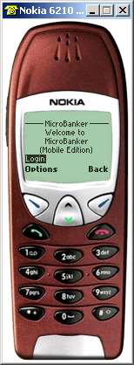
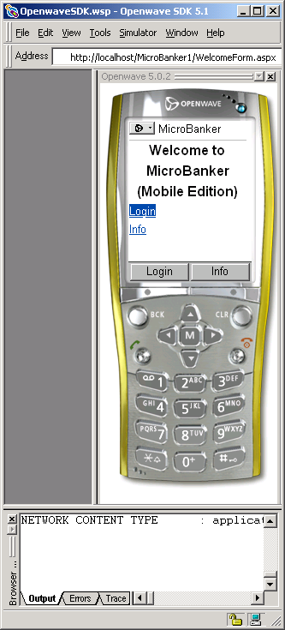

MicroBanker Startup Screen as rendered on both Nokia and Openwave microbrowsers
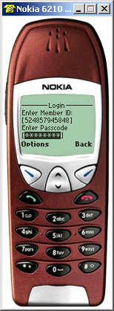
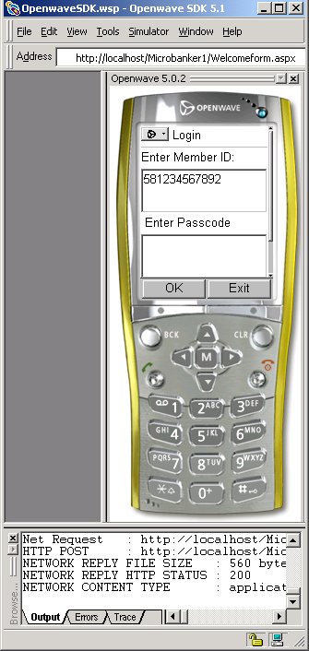
Microbanker Login screen as rendered on both Nokia and Openwave microbrowsers
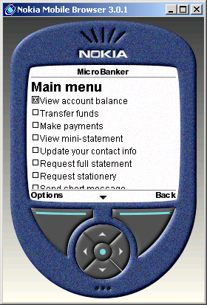
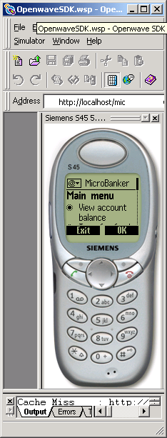
Microbanker main menu screen as rendered on both Nokia and openwave (using the Siemen S45 phone emulator) mobile browsers.
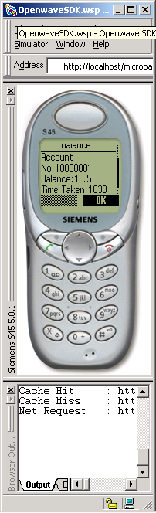
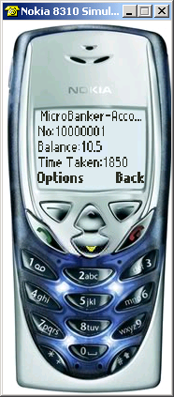
MicroBanker Account Balance screen as rendered on both Nokia 8310 and Openwave (using Siemen S45) mobile browsers.
J2ME Screenshots:
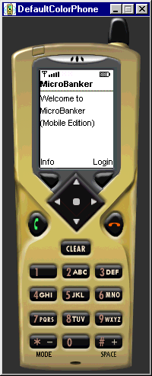
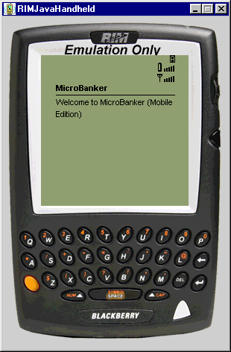
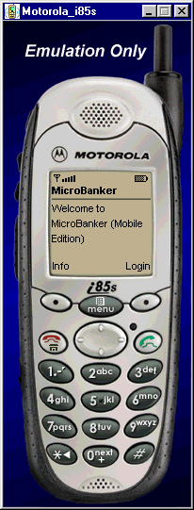
Microbanker start-up screen as rendered using J2ME default colour phone, the RIM Handheld device and Motorola i85s emulators.
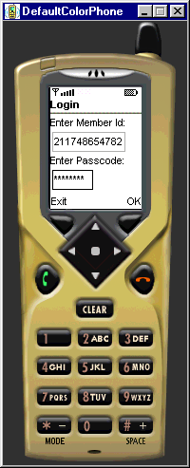
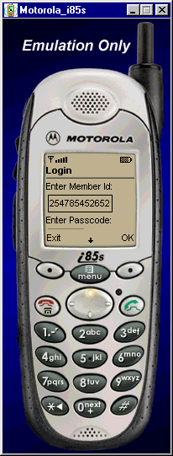
Microbanker Login screen as shown in the J2ME default colour phone and Motorola i85s emulators.
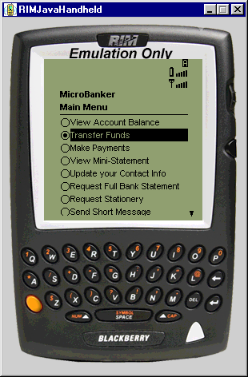
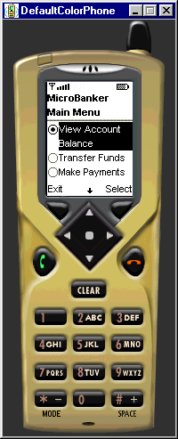
Microbanker main menu screen as shown in the J2ME default colour phone and the RIM Blackberry handheld device emulators.

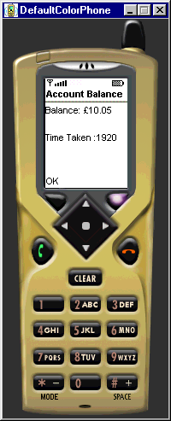
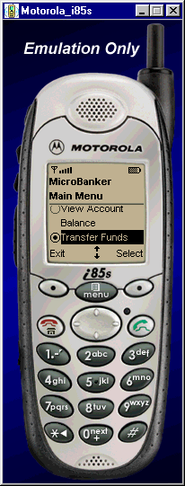
Microbanker Account balance screen shown in the J2ME default colour phone emulator and the Main menu screen shown in the Motorola i85s emulator.

