EE 484/584

Winter 2018-19

# Assignment 2

For this assignment, you will implement a trainer for a linear perceptron in your choice of MATLAB, C, Java, Excel, or any other computational means.

You will train the perceptron based on the “spine” dataset available on Blackboard (both .mat and .txt formats available). The input consists of 6 measurements of a patient’s spine. There are 310 patients in the dataset. The target is 1 for patients with abnormal spines, 0 for patients with normal spines.

To begin training, initialize all weights and the bias to zero. Then for the first patient, present the 6 spine measurements as the input to the network:

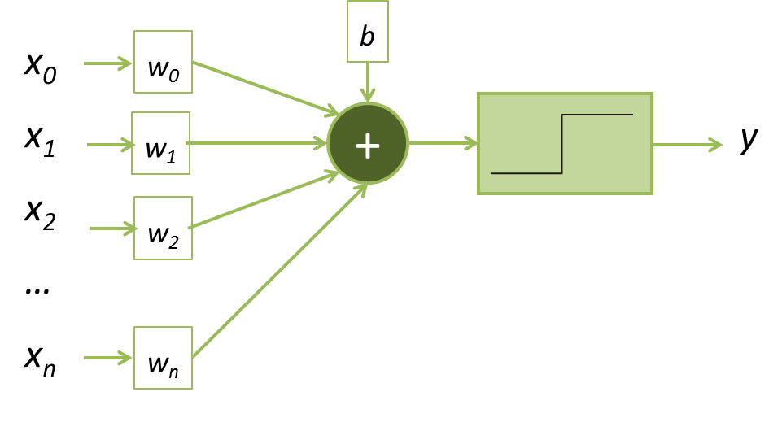

Compute the change in weights and add to the existing weights, following the rule we discussed in class:

∆***w*** = (*t-y*)***x***

∆*b* = (*t-y*)

where ***x*** is the input just applied to the perceptron, *t* is the actual target value, and *y* is the output the perceptron computed. Repeat this for each patient in the data set. Do only one run of the dataset (one epoch). Make sure to take each patient in order; don’t shuffle the order of the patients, or it won’t match MATLAB’s result (see next paragraph).

Compare your result to the result obtained using the MATLAB neural network toolbox. Use the toolbox function perceptron() to create the perceptron. Leave all settings as defaults, except change the number of epochs in trainParam to 1. Train the network on the data, and compare the resulting weights and bias to the values you obtained with your own implementation above.

Deliverables:

* Code or spreadsheet showing your implementation of the training using the perceptron learning rule, with enough comments so that I can understand it
* Table showing the weight and bias vectors obtained for both methods

Due: Tuesday, December 18, 2018.