Advanced Encryption Standard Cipher

Advanced Encryption Standard is a commonly used block cipher algorithm.
It uses 128 Bit input, called the “state” stored in a 4x4 matrix
The AES Algorithm Consists of four transformation steps called Sub Bytes, Shift Rows, Mix Columns and Add Round Key. Figure 1 shows a top level view of the Algorithm including the four steps. In the following paragraphs each of this steps will be explaind.

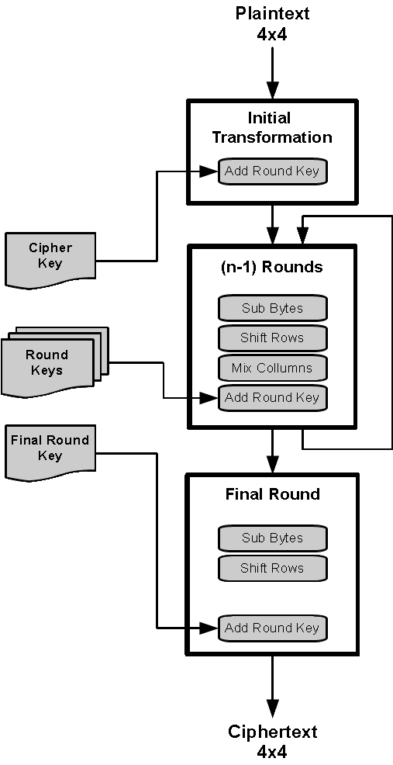
Sub Bytes:
Figure 1: AES Algorithm
Sub Bytes uses a substitution table (S-Box) consisting of several substitution values. In the Sub Bytes Step each byte of the state will be replaced with a byte from the S-Box. This provides a monalaphabetic encryption.

Shift Rows:
The rows of the state are left-shifted a specific
amount of bytes:
1. Row: none,
2. Row: 1 byte ,
3. Row: 2 bytes,
4. Row: 3 bytes

Mix Columns:
This step mixes the Data in the Rows via a multiplication of the bytes a_{j} with a constant (either 1,2 or 3).

Add Round Key:
In the Initial Transformation and after each Round a so called KeyAddition takes place. This is the only step that depends on the Cipher Key.
It generates a new Round key for every Round from the old Round Key

